

School of Graphic and Digital Arts

Visual Studies

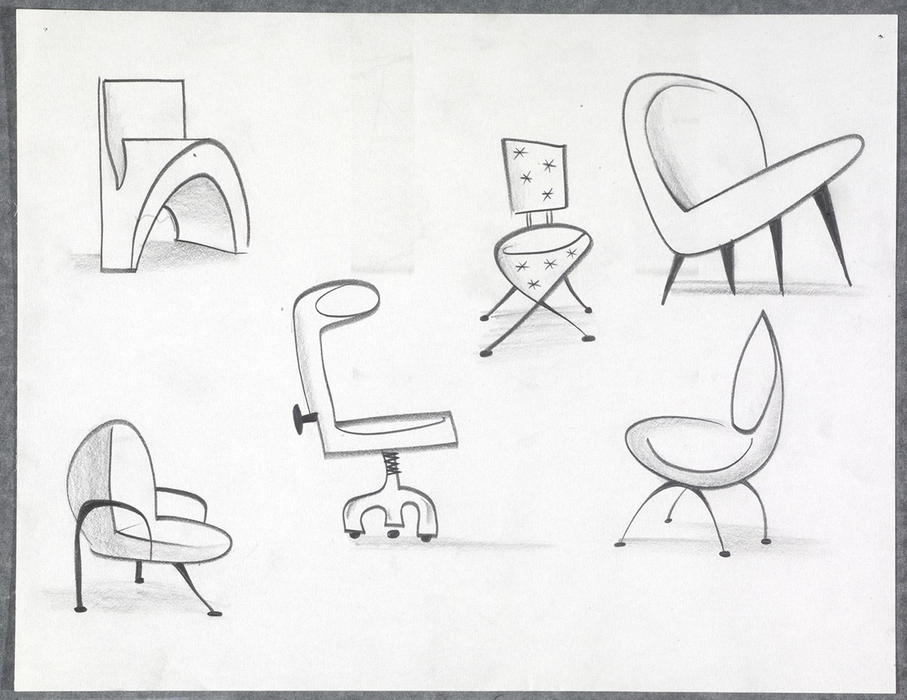

California Modern furniture designs,
Drawings by Teddy Newton, Disney/Pixar

Module Code: M7X00665 2017-18

Visual Studies
10 Credits [24 hours Scheduled Learning; 70 hours Independent Learning]
Room: AD204
Monday: 3pm – 5pm
Tutor: Scott Smith
Scott.L.Smith@uwtsd.ac.uk
SYLLABUS
This module will deliver the initial material via formal lectures, supplemented by tutorials and seminar style interactions after the initial phase. Through a series of exercises and demonstrations the students will develop their own advanced set of technical and aesthetic skills in the development of a portfolio of work.

Through private study and tutorial guidance students will develop their professional artistic ability

AIM(S)
- To enable students to advance their technical and artistic design awareness of the intrinsic relationship between design and observation.

2. To enhance the student’s creativity and depth of understanding of observation and replication, in traditional and digital forms.

LEARNING OUTCOMES
Upon successful completion of this module, the student will be able to exhibit:

- a comprehensive understanding and advanced artistic ability to independently generate and evaluate new and innovative stylistic methods in the creation of conceptual design work

- a mastery of the visual development of these forms with notable reference to the world of motion, character, and colour

TIMETABLE
The course is taught over a twelve week period, starting in week one of Semester one on Tuesdays from 3:00-5:00 in room AD204. Sessions will primarily be student-led, being a mixture of seminar style group discussion, individual tutorials, and presentations.

BIBLIOGRAPHY
Essential
Polson. T. The Noble Approach: Maurice Noble and the Zen of Animation Design, Chronicle Books (2013)
Lewis, M. ed, Beyond Art Fundamentals . 3DTotal Publishing (2016)
Stanchfield, W. Drawn to Life Focal Press vols 1 and 2 edited by Don Hahn (2009)

Recommended
Goldfinger, E. (1991). Human Anatomy for Artists: The Elements of Form, Oxford Press.

Roberts, S. (2004). Character Animation in 3D : Use traditional drawing techniques to produce stunning CGI animation, Focal Press.

Altiner, A. (2006), D'artiste: Matte Painting : Digtal Artists Master Class, Ballistic Press

Harrison, H. (2004), The Encyclopedia of Drawing Techniques, Running Press

Hart, C. (1997). How to Draw Animation: Learn the Art of Animation from Character Design to Storyboards and Layouts, Watson-GuptillPubns.

Itten, J. (1997), The Art of Color: The Subjective Experience and Objective Rationale of Color, Wiley Publisher.

Richer, P., Beverley, H. (1986). Artistic Anatomy, Watson-GuptillPubns.

ASSESSMENT
Portfolio 1
50%

Identify a creative research agenda for your visual work and demonstrate in Portfolio 1, which acts as a proposal.
Hand-out: 10/10/2017 | Submission: 31.10.17

Portfolio 2
50%

Finalize the creative and artistic research and development undertaken, evidence in Portfolio 2, submit on disc and present in approximately 5-10 minutes.
Hand-out: 10.10.17 | Submission: 12/12/2017

See assignment brief for details of assessment

FEEDBACK
Feedback is an essential part of all education and training programmes. It helps learners to maximize their potential at different stages of their development. It raises awareness of strengths and areas for improvement, and helps identify actions that can be taken to improve performance.

Feedback can be seen as informal (for example in day-to-day encounters between teachers and students or trainees, between peers or between colleagues) or formal (for example as part of a written assessment or presentation). However, there is no sharp dividing line between assessment and teaching in the area of giving feedback on learning. Feedback is part of the overall dialogue or interaction between teacher and learner, not a one-way communication.

