

Reflective Review Of My Learning Journey

Table of Contents
Introduction. ..……………………………………………………………………………………………………………………………………………………3
Self awareness ……………………………………………………………………………………………………………………………………………………3
Findings……………………………………………………………………………………………………………………………………………………………4-9
Personal development plan………………………………………………………………………………………………………………………….10-11
Conclusion…………………………………………………………………………………………………………………………………………………………12
References…………………………………………………………………………………………………………………………………………………………13
Bibliography ………………………………………………………………………………………………………………………………………………………13

Introduction
In order to reach my end goal of obtaining a degree in international travel and tourism management, then pursuing a career in the travel industry, It is necessary that I have steps in place to achieve the end result. By reflecting on my personal learning journey so far, I am able to to understand the importance of professional career development and how it is vital for my future role in a managerial position within my chosen industry. The requirements that are expected as a high achiever in university is extensive education and training that will enable the start of my journey follow on to my future career. Throughout this report I will look at specific skills and knowledge that I have developed so far, identify development needs by highlighting strengths and weaknesses, conducting various frameworks to self assess my learning journey, and supporting this by research and knowledge. I will also create my own personal development plan which is an in depth plan to guide me throughout my learning journey.
Self Awareness
From my research, the importance of self awareness must be activated within any career path this gives the ability to examine what strengths, weaknesses, thoughts and beliefs are needed within the role, it also shapes personalities and provides a realisation of motivation. Being self aware is an early progression in developing a chosen career path it presents passions and emotions and how personalities can assist in career journeys. When applying self awareness to education, it becomes a major role in learning, this is identified by teachers working with students enabling reflection and evaluation within work, students are then able to grow and become productive flexible and reliant. Once students are aware of emotions and behaviour they will then be able to take control of any weaknesses and make any necessary changes allowing them to continue in the right direction for the future (develop good habits, 2019).
in preparation for a leadership role in the international travel tourism industry, self awareness is key to understanding strengths and weaknesses, it is having the ability to explain success and failures, providing an understanding of who I am and what I need to have for a successful career, also an indication of skills that require any attention or additional support, that may also include any changes to emotions and behaviours of my personality (develop good habits, 2019).
How to increase self awareness for my role and to pin point the relevance for myself;-
- Looking at myself objectively. Looking at this point enables an insight Into behaviours and learning to accept my personality and identifying ways to improve it, I will make use of personality tests to identify the way I act and how to improve the weaknesses that I discover that will not fit into my future career.
- Keeping notes. Expressing thoughts, feelings, successes and failures in a diary will develop understanding the importance of moving forward within my career path.
- Keep track of my goals. Using personal development plans to breakdown larger goals into smaller goals will provide a clear and uncomplicated path to achieve

Findings
In order to identify my development needs in relation to a career in international travel and tourism management, firstly I will conduct a SWOT analysis. (Shaw 2017) explains SWOT analysis is an extremely useful tool made up of four components, strengths, weaknesses, opportunities and threats. Individuals can use the SWOT analysis to help a new career path or achieve goals. It’s a creative way to self-assess areas to help you and to visualise where your career is and where it could go. A SWOT is designed to enable strengths, assess weaknesses, display opportunities and remove any threats.
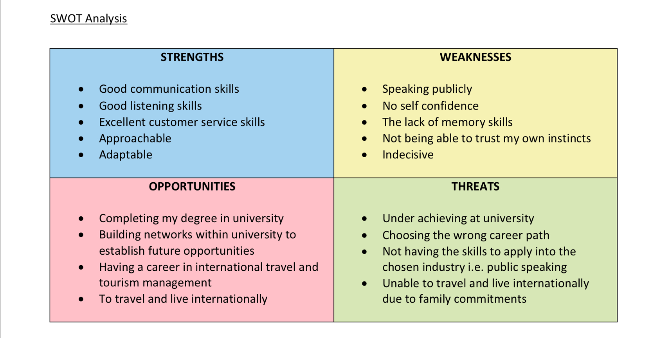

TOWS Analysis
On discovering information on how to complete a SWOT analysis (Shaw 2017), This enabled the process of answering each component by being open and honest and receiving feedback from trusted friends and family. This has provided an insight into areas that needs addressing and areas that are advantages for a future career. Using SWOT analysis provides an important observation into any weaknesses and threats that may effect a future career, however they can be converted by utilising strategies that eliminates any threats and weaknesses and enhancing strengths and opportunities, this can be best shown by using the TOWS analysis.
The TOWS analysis is a strategic analysis that I have found (Mind tools 2019). It can be applied once a SWOT analysis is completed, it helps you understand how to;-
- Take advantage of strengths
- Avoid weaknesses
- Benefit from opportunities
The strategies that follow on from the specific points are;-
- Strengths and Opportunities (SO)- using strengths to favour opportunities
- Strengths and Threats (ST)- using strengths to stay clear of threats
- Weaknesses and Opportunities (WO)- utilising opportunities to defeat weaknesses
- Weaknesses and Threats (WT)- reduce weaknesses to prevent threats
From completing a TOWS analysis with the information provided by the SWOT analysis I am now able to understand the conversion strategies, this shows in the example below;-

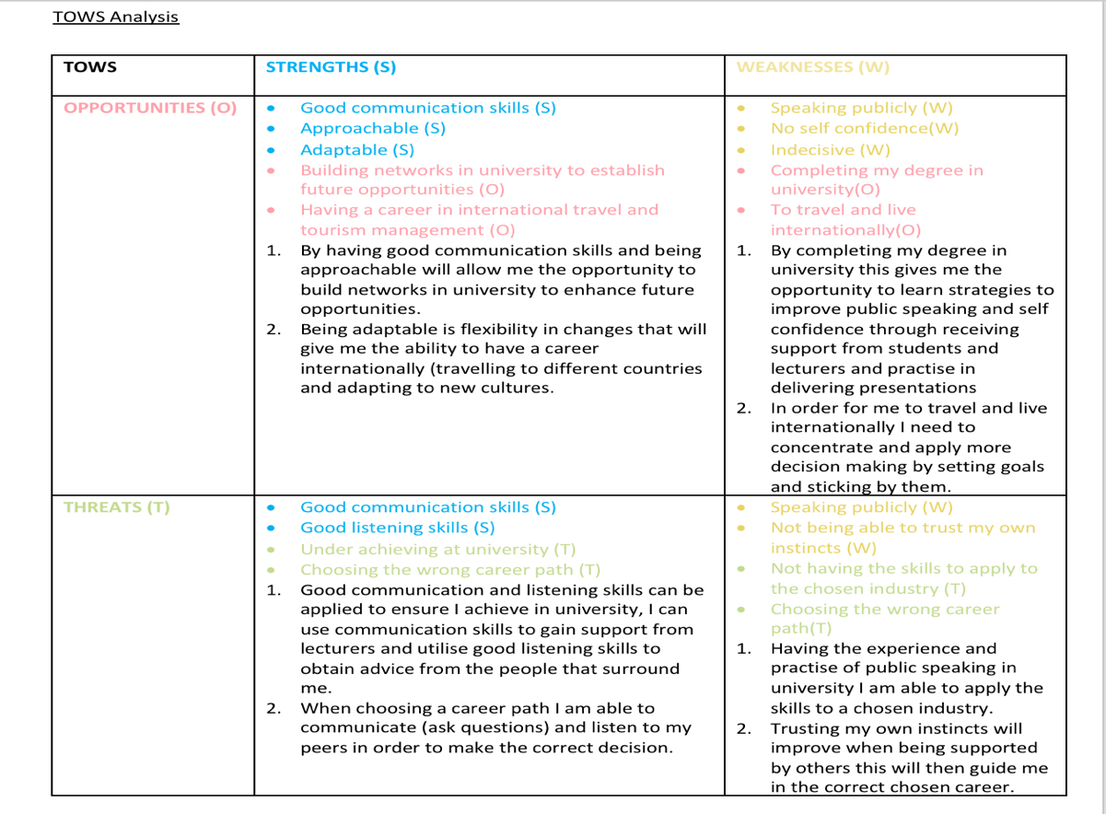
Learning styles

According to (Cherry 2019) Each individual has a specific learning style, it is important to discover which learning style is best suited to enable students to absorb information in the best way when studying. Learning style questionnaires are used to allow people to focus on how they prefer to learn and are made up of specific questions which are answered by giving a true and honest response. Learning style questionnaires are constructed to provide information on strengths and the best learning choices. Many theories (Cherry 2019) have suggested that peoples learning abilities can be placed into different categories, this gives the idea that there are various learning styles that can increase education when being a student.​
Teachers often use learning style questionnaires to discover how students understand how they will effectively learn, this became popular in the 1970s and shows enormous effect in the education system and remains a popular experiment while studying despite there being a small scale of evidence that matches learning methods to each student increases education, however students are still able to utilise the learning style questionnaires and discover which style best suits them in their study routines to increase effective learning skills.

There are various learning style questionnaires available, as part of my learning journey I will investigate what my learning styles determine, this will enhance my capability’s to absorb the information required for my future career in international travel and tourism management. The questionnaires that I will undertake are;-
- The VARK Questionnaire (Fleming 1987).This questionnaire directs you to answer 13 questions with your own preference, once completed it identifies one of four individual styles, visual, aural, read write and kinaesthetic.
- The Myers Briggs personality profiling test (Cherry 2019) is based on answering questions to discover which personality you are, according to (Cherry 2019) There are 16 personality types, to understand your personality it allows you to explore likes, dislikes, strengths and weaknesses, to understand this, no personality is better than the the other, simply a tool to help you discover more about yourself.
As a result of completing both Vark questionnaire and The Myers Briggs personality test I have now a better understanding the way I learn and the way I think. From researching The Vark questionnaire outcome (introduction to Vark 2019) the result revealed Read/Write is my learning preference, Read/Write translates as information visible in word format, a learning style that is used greatly by teachers and students. From past experience I agree with Vark questionnaire, frequently when preparing for an important test, training day or milestone in life, reading and writing helps to absorb information that I require in situations that are important, this way information can be relayed with ease. When discovering The Myers Briggs personality test outcome, (Cherry 2019) revealed that the ‘Mediator’ personality was the best match, this translates as reserved, idealistic, creative and driven by importance of high values, observing the strengths and weaknesses and defining them personally.

Strengths;-
- Loyalty and devotion- loyal to family and friends
- Responsive to feelings- emotional in the correct situations
- Good hearted and inquisitive in others- very intrigued in people, cultures and lifestyle
- Good at working alone- preferably when studying
- Values close relationships- appreciates honesty and trust with relationships
- Good at observing "the big picture"- highlighting what goals needs to be achieved and the end result
Weaknesses;-
- Can be overly visionary- writing information in word format excessively
- Taking offence often- over reacting when negativity is present, over thinking negative comments
- Hard to bond- on occasion reserved and self contained
- Loss of details in smaller matters- taking note of the end result and misplacing the smaller details
Defining the strengths and weaknesses into how I personally observe them, gives an understanding how I react in situations, what is important and how I can address areas that may need addressing in my leaning journey, in preparation for a leadership role in the international travel tourism industry, self awareness is key to understanding strengths and weaknesses, it is having the ability to explain success and failures, providing an understanding of who I am and what I need to have for a successful career, also an indication of skills that require any attention or additional support, that may also include any changes to emotions and behaviours of my personality. From researching (develop good habits 2019)on how to increase self awareness for my role and to pin point the relevance for myself are;-
- Looking at myself objectively. Looking at this point enables an insight Into behaviours and learning to accept my personality and identifying ways to improve it, I will make use of personality tests to identify the way I act and how to improve the weaknesses that I discover that will not fit into my future career.
- Keeping notes. Expressing thoughts, feelings, successes and failures in a diary will develop understanding the importance of moving forward within my career path.
- Keep track of my goals. Using personal development plans to breakdown larger goals into smaller goals will provide a clear and uncomplicated path to achieve.
Go M.A.D Results Framework
My studies in university has introduced me to Go M.A.D. a results framework that was constructed by Andy Gilbert (go MAD thinking 2019). Established in 1997 from developing a passion statement to enhance his own career, therefore led to research and study which then developed into the Go M.A.D. framework. From my research the frame work involves constructing a pathway to enhance clarification, discovering possibilities and being responsible for the actions that are forthcoming, Andy Gilberts intentions is to create a ‘real light bulb moment’, the realisation of what needs to be achieved and how to get there (go MAD thinking 2019).
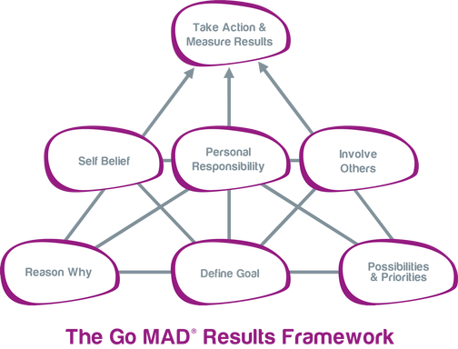
Go M.A.D. Results Framework (Go MAD thinking 2019)

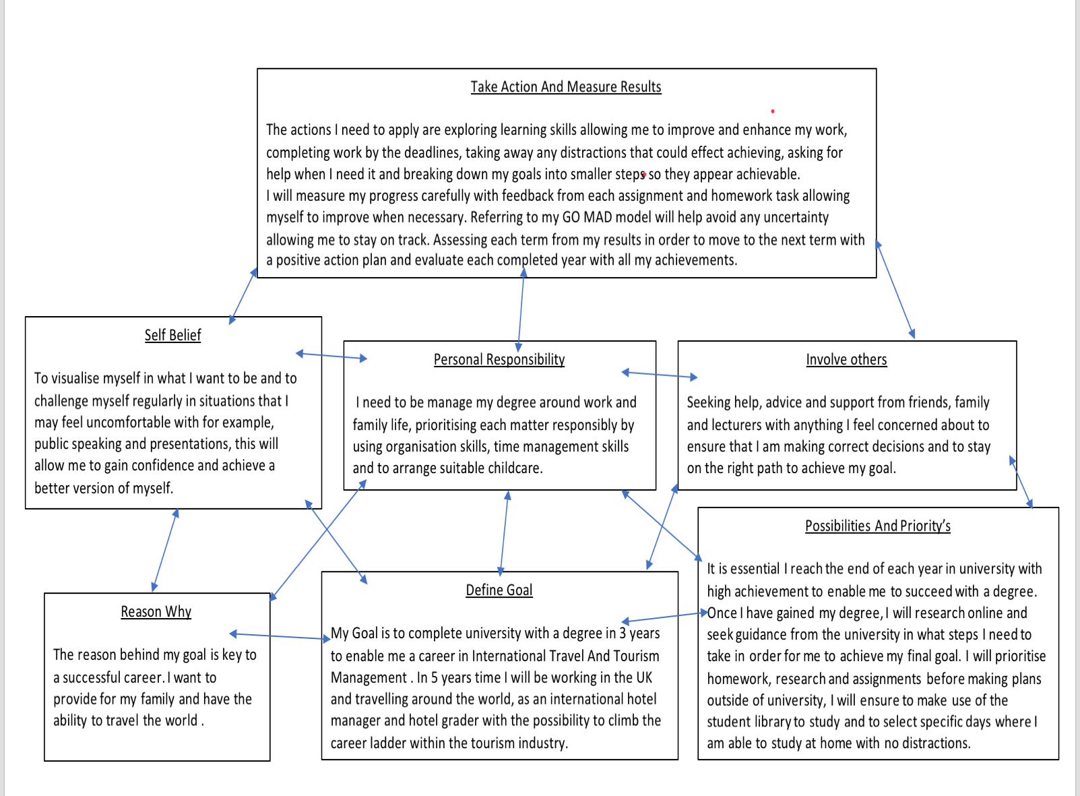
My Go M.A.D. Results Framework

By creating my own Go M.A.D. framework I am now able to clearly identify where I need to start from, the journey that I will take along the way and the actions I need to apply to measure my results, this enables me to achieve a light bulb moment as now I’m aware of the pathway to my end result and the actions I need to take along the way.
Personal development plan (Cottrell, 2015, p.10)
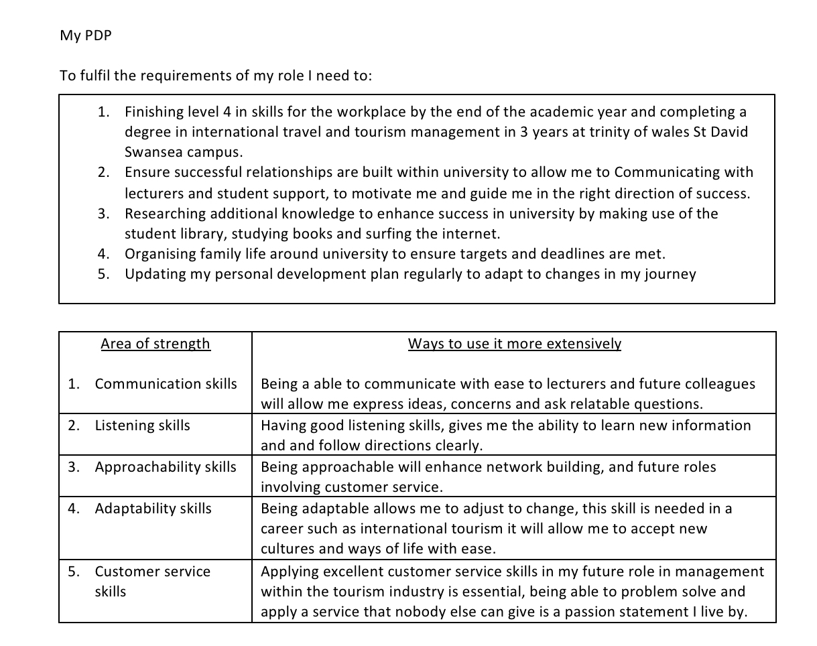
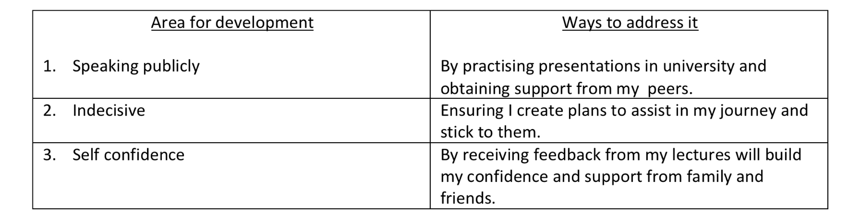
Having successfully constructed an end goal, undertaking a personal development plan offers an in depth understanding of performance academically, professionally and personally. It aims to clarify a strategy in order to evaluate and motivate an upwards spiral to success and identifying barriers that may effect growth throughout the journey.

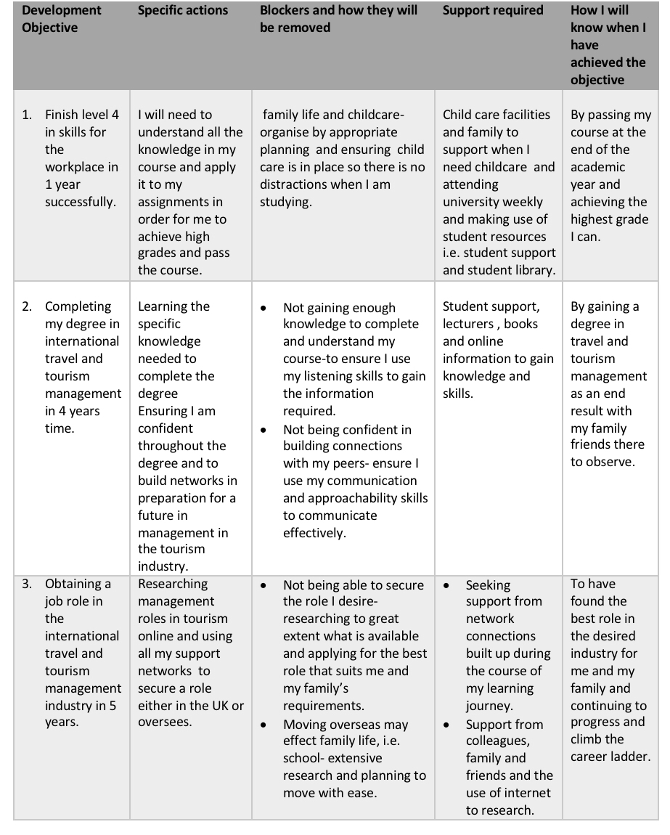
Personal Development Plan (PDP)

Conclusion
In conclusion of this report, my research and findings have presented key elements to continue to learn and to apply learning skills wherever you are in life, ensuring progression in education and career. Being self aware allowed me to discover strengths and weaknesses, by conducting a SWOT analysis helped me to highlight the strengths and weaknesses, and by utilising TOWS analysis assisted in building strategies to enhance my personality, improve my skills and to help create a better version of myself. Discovering various learning styles and completing questionnaires on myself, has provided a better understanding of the way I learn and the way I think, I am now able to apply this in my learning journey.
My Go M.A.D framework established a goal and enabled me to clarify from start to finish the actions I need to take throughout my journey, as a result, I am now able to construct and develop a personal development plan, an in depth plan to follow and make changes to when necessary, it defines my steps and offers an up to date system to supply direction and support. I have learned the importance of my journey is to have a clear vision of what skills and knowledge is needed and using the correct support available to ensure my dream becomes a reality.

.

References
Cherry, K. (2019) an overview of the IFNP personality type. Available at: https://www.verywellmind.com/infp-a-profile-of-the-idealist-personality-type-2795987 (Accessed: 15th June 2019).
Cherry, K. (2019) An overview of the Myers-Briggs type indicator. Available at: https://www.verywellmind.com/the-myers-briggs-type-indicator-2795583 (Accessed: 15th June 2019).
Cherry, K. (2019) overview of Vark learning styles. Available at: https://www.verywellmind.com/vark-learning-styles-2795156 (Accessed 14th June 2019).
Develop Good Habits (2019) what is self awareness. Available at: https://www.developgoodhabits.com/what-is-self-awareness (Accessed: 11th June 2019).
Fleming, N. (1987) The Vark questionnaire. Available at: https://www.utica.edu/faculty_staff/bemmons/fall2006/ucc101/general.pdf (Accessed: 14th June 2019).
Go MAD thinking (2019) coaching and facilitation. Available at: https://www.gomadthinking.com/accelerating-results/coaching-facilitation/ (Accessed: 16th June 2019).
Go MAD thinking (2019) our story. Available at: https://www.gomadthinking.com/about/our-story/ (Accessed: 15th June 2019).
Go MAD thinking (2019) the go M.A.D. Exults Framework. Available at: https://www.gomadthinking.com/about/our-approach/ (Accessed: 16th June 2019).
Introduction to Vark (2019) do you know how to learn. Available at: http://varklearn.com/introduction-to-vark/the-vark-modalities/ (Accessed: 15th June 2019).
Mind tools (2019) using the tows matrix. Available at: https://www.mindtools.com/pages/article/newSTR_89.htm (Accessed: 12th June 2019).
Shaw, J. (2017) How to complete a personal swot analysis. Available at: https://medium.com/thrive-global/how-to-complete-a-personal-swot-analysis-2f8769aebd5e (Accessed: 11th June 2019).
Bibliography
Cottrell, S. (2015) skills for success personal development and employability. 3rd edition. London: MacMillan education UK.

