Hilton London Hyde Park Hotel

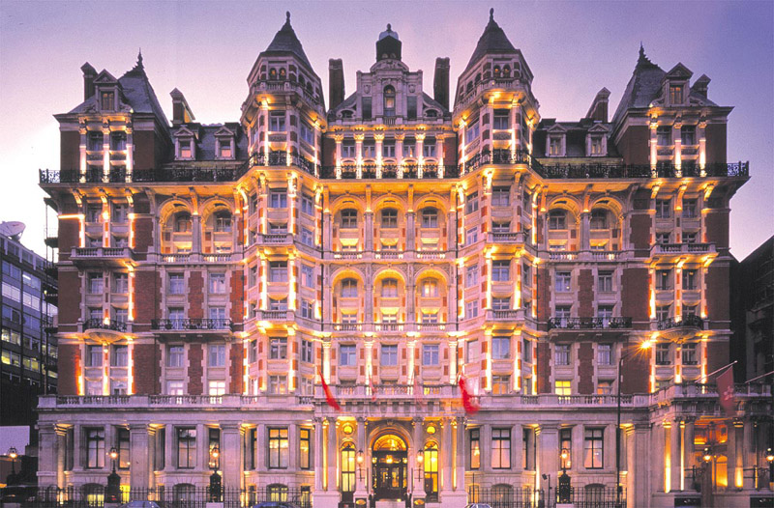

STUDENT NAME: IONELA VLAD
STUDENT CODE: 1905718
MODULE NAME: ORGANISATIONAL CONSULTANCY

Executive Summary
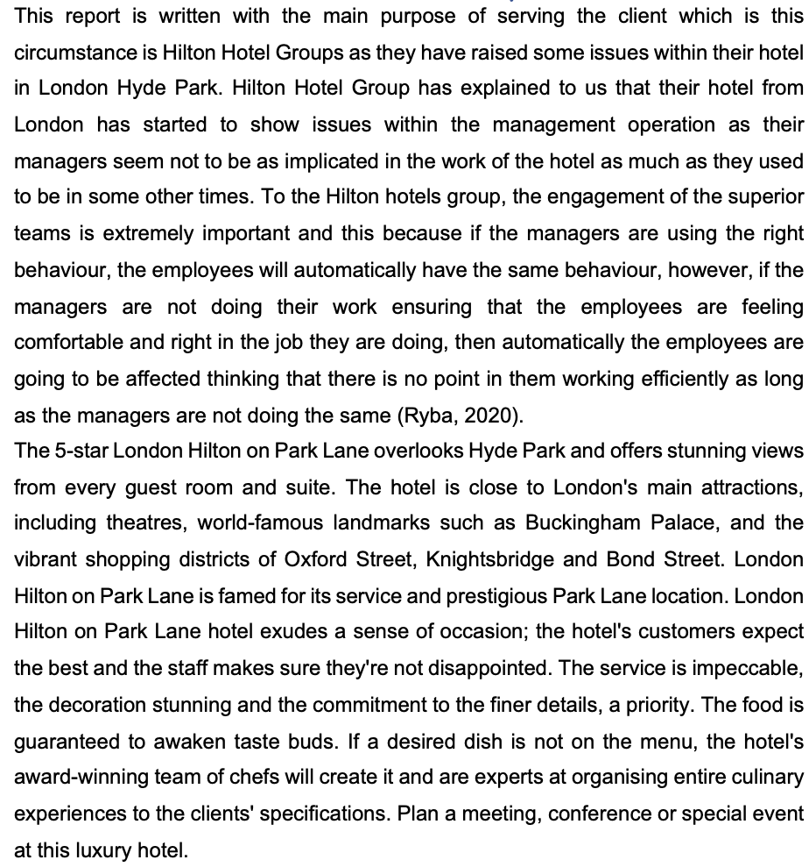
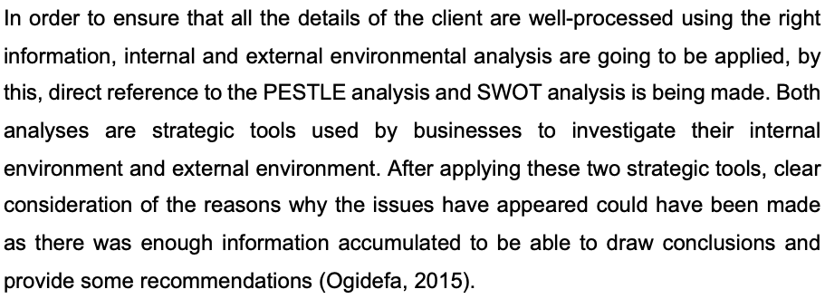
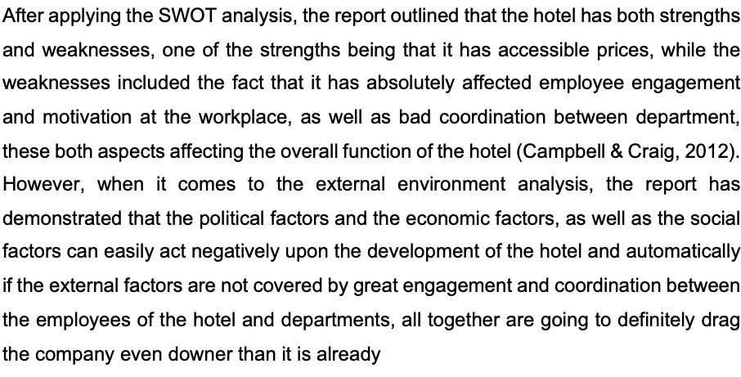

Table of Contents
Executive Summary 2
SWOT ANALYSIS 3
- Strengths of Hilton Worldwide 3
- Weaknesses of Hilton Worldwide 4
- Opportunities for Hilton Worldwide 5
- Threats to Hilton Worldwide 5
PESTLE ANALYSIS 6
- Political Factors: 6
- Economic Factors: 6
- Social Factors: 7
- Technological Factors: 7
- Legal Factors: 8
- Environmental Factors: 8
Findings and Recommendations 9
Action Plan 9
Conclusion 9
Reference List 9

SWOT ANALYSIS



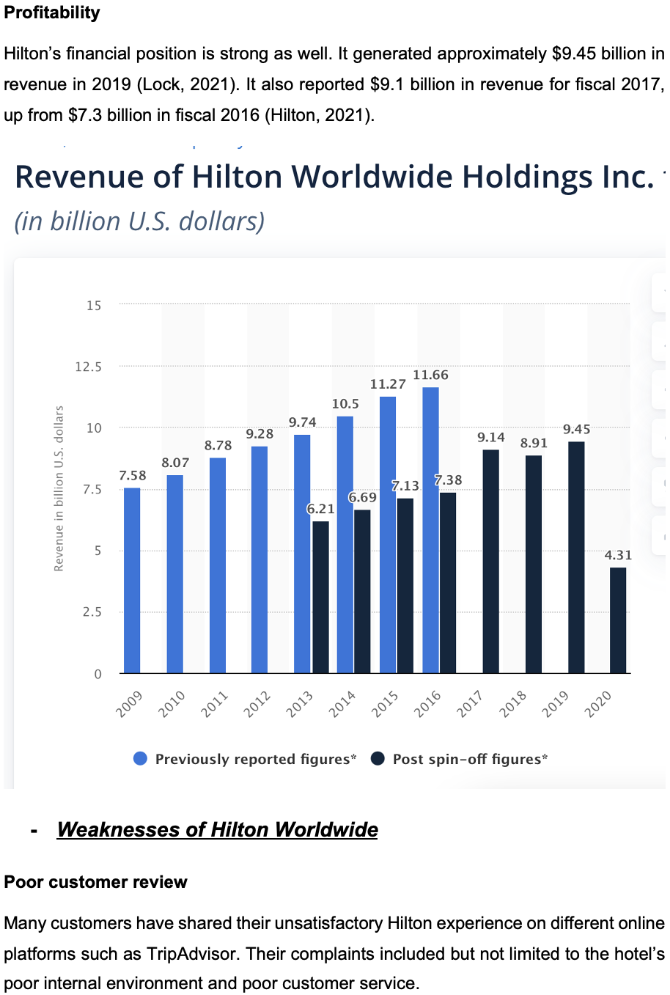


Threats to Hilton Worldwide



PESTLE ANALYSIS

Political Factors:
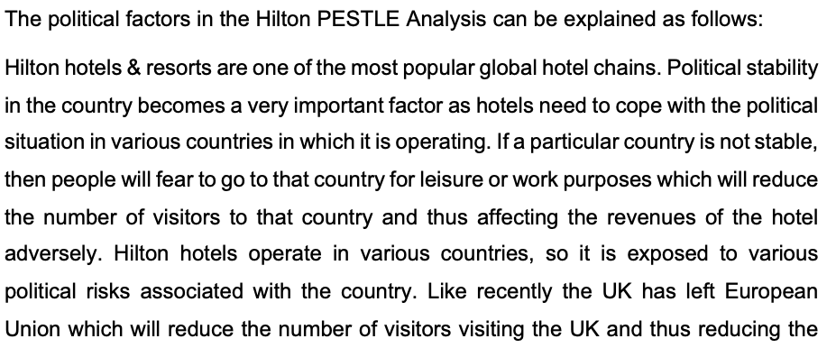
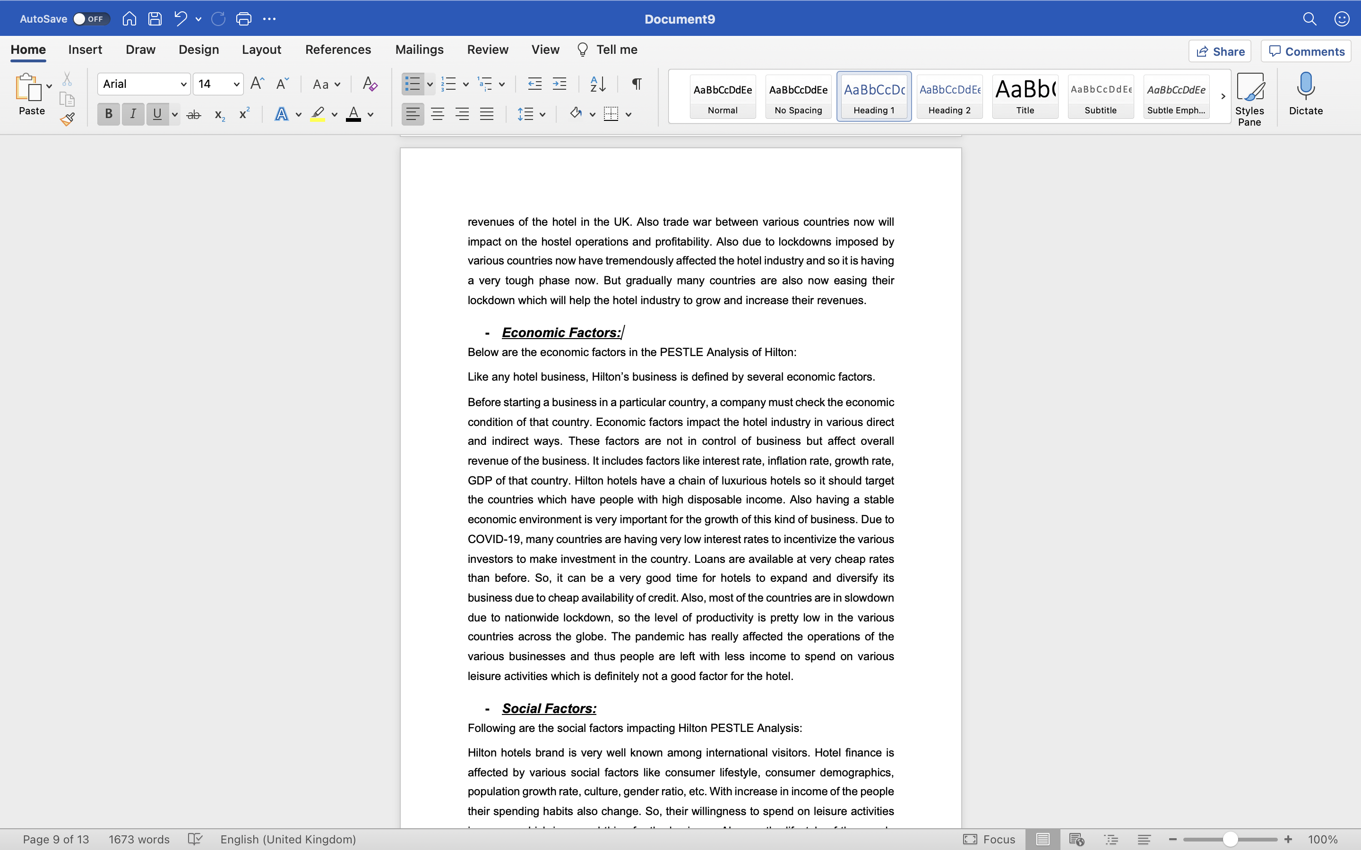

Economic Factors:

Social Factors:
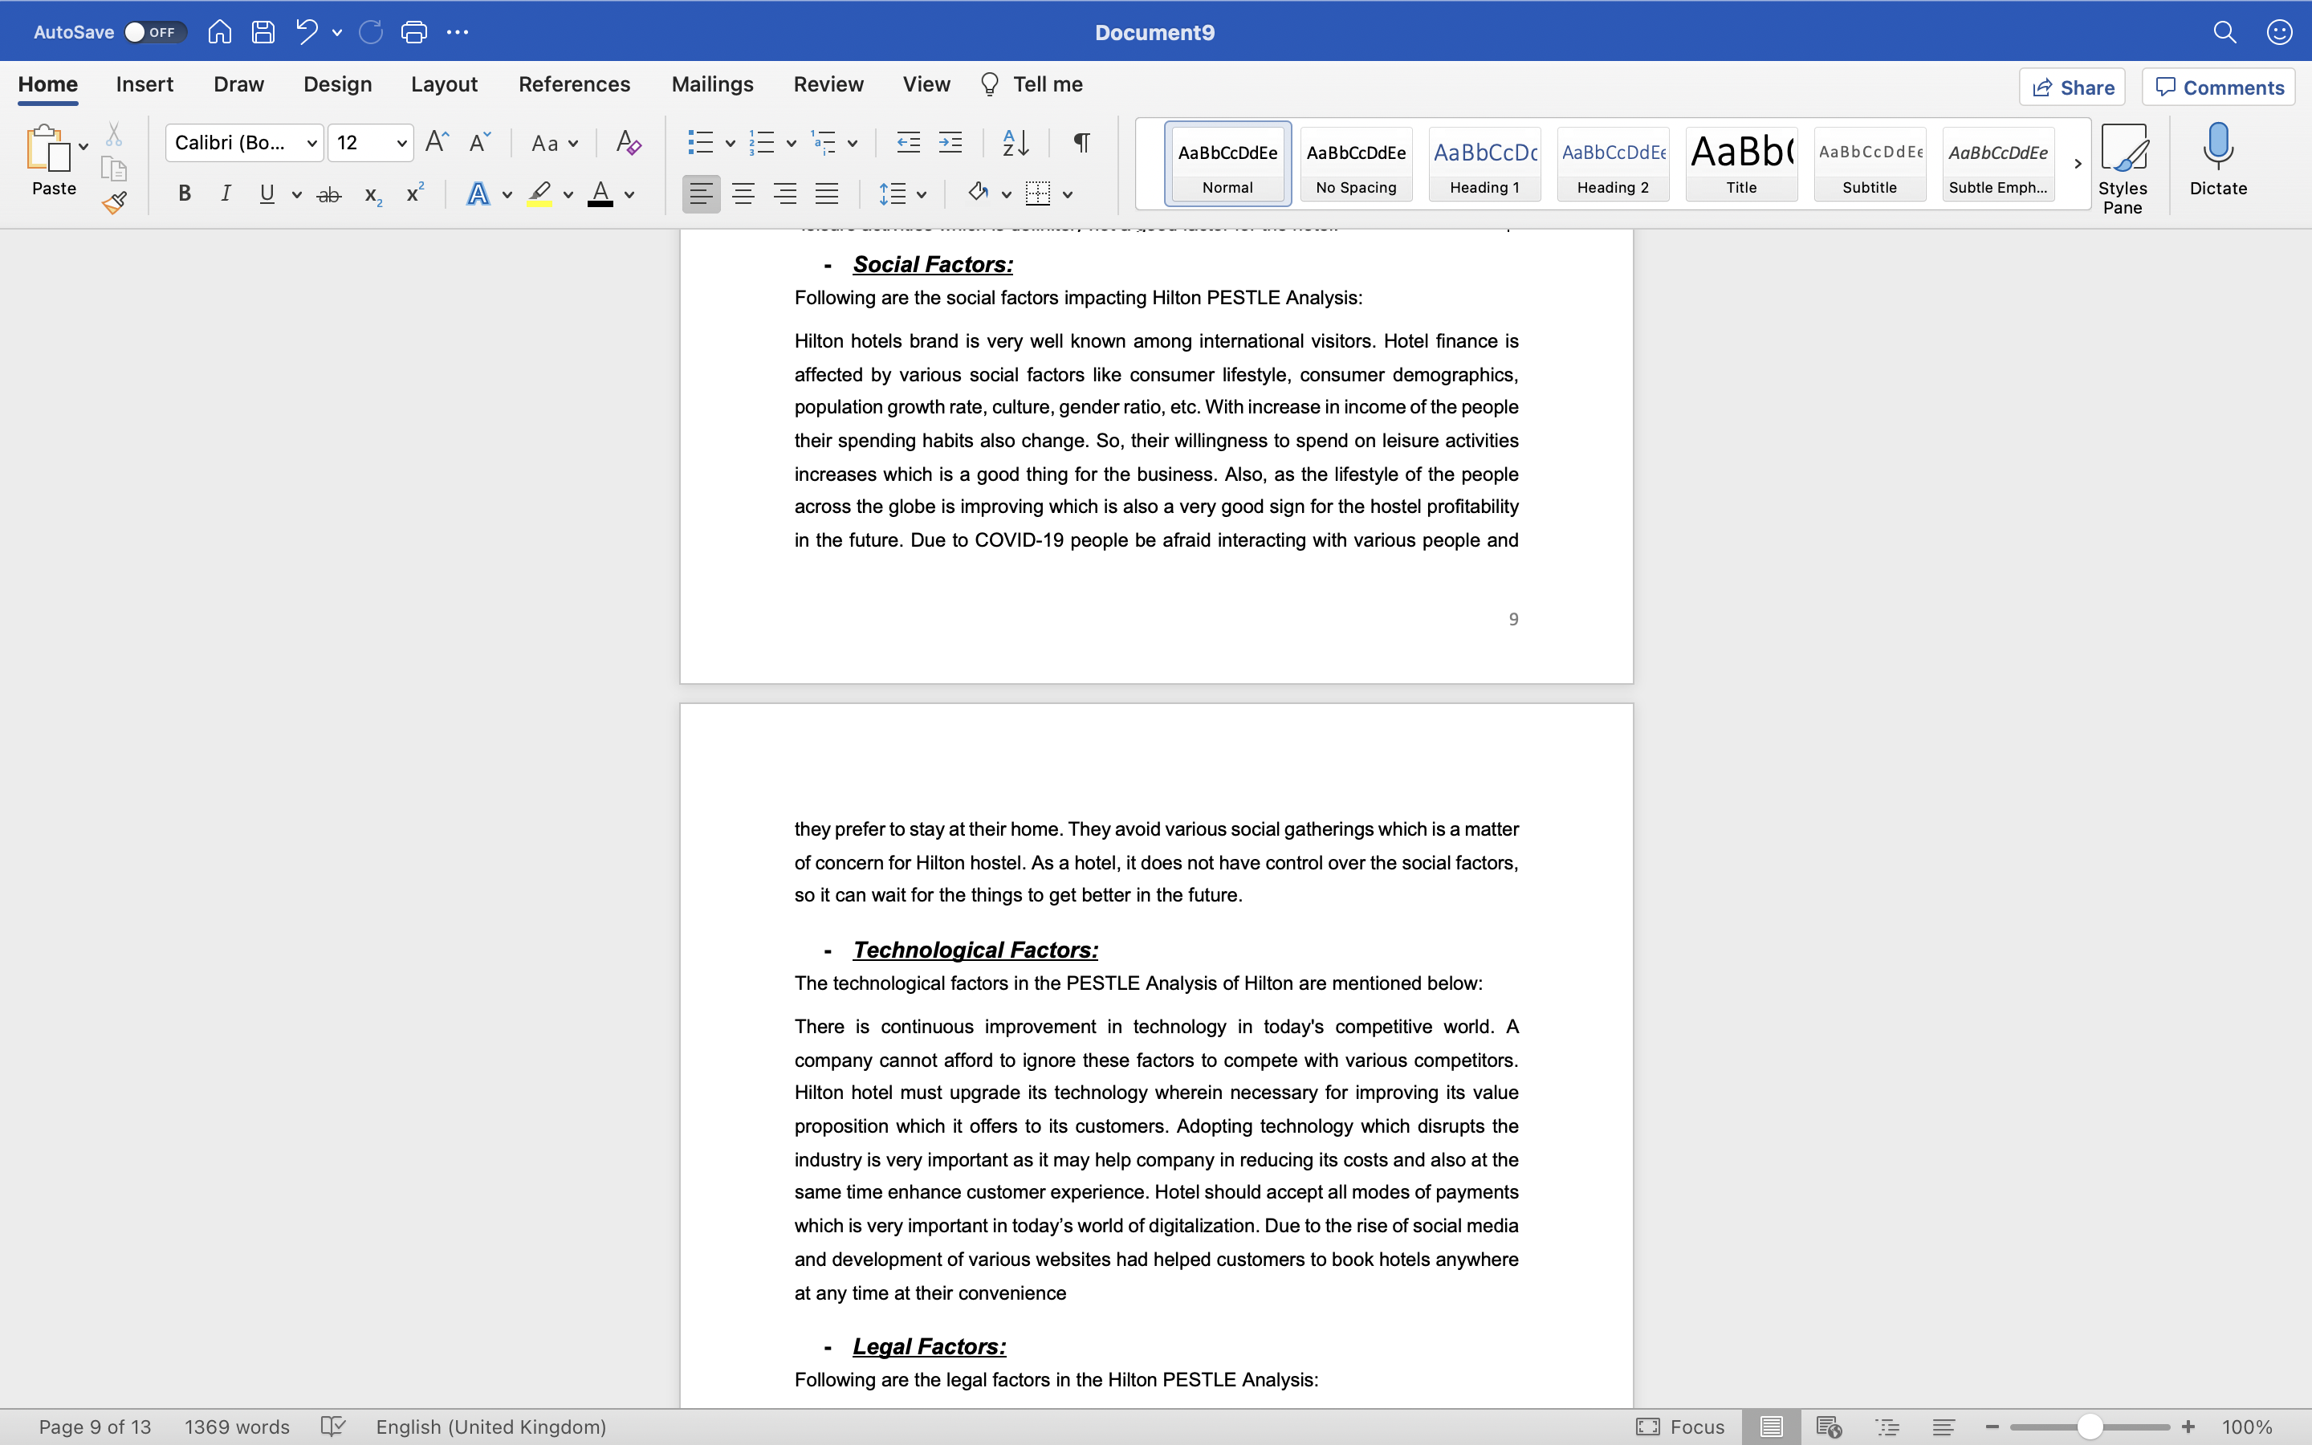

Technological Factors:
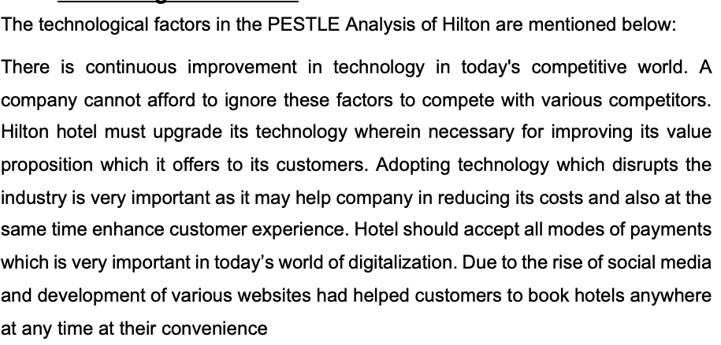

Legal Factors:

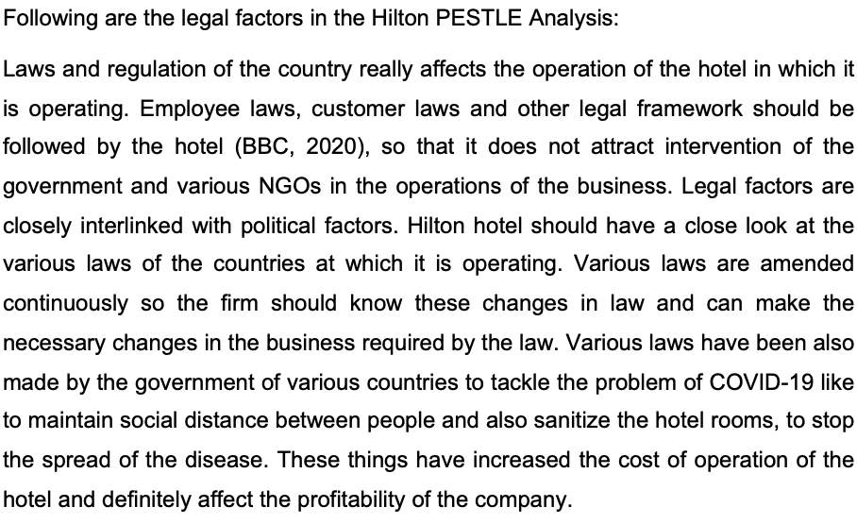

Environmental Factors:
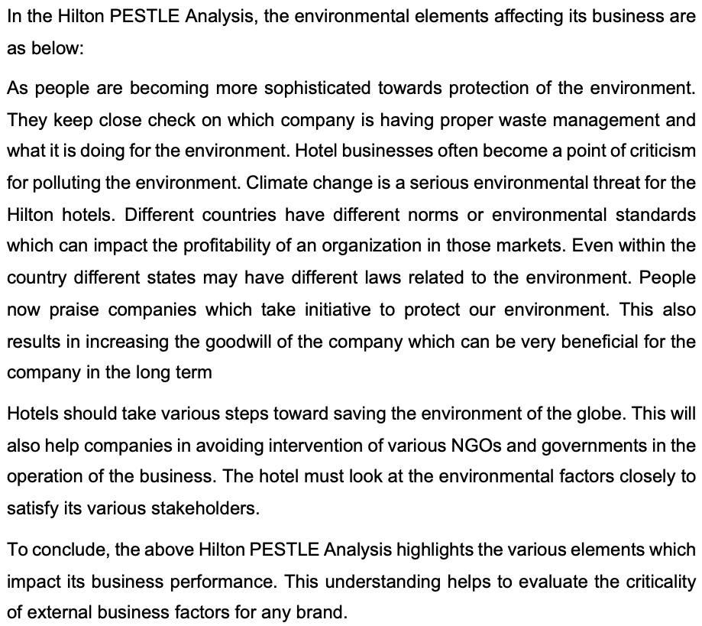

Findings and Recommendations
After looking clearly into the hotel operation, it is important to mention that there are a lot of poor reviews that are providing regarding the customer services that are offered in the hotel. For example, one review left on TripAdvisor has mentioned that:
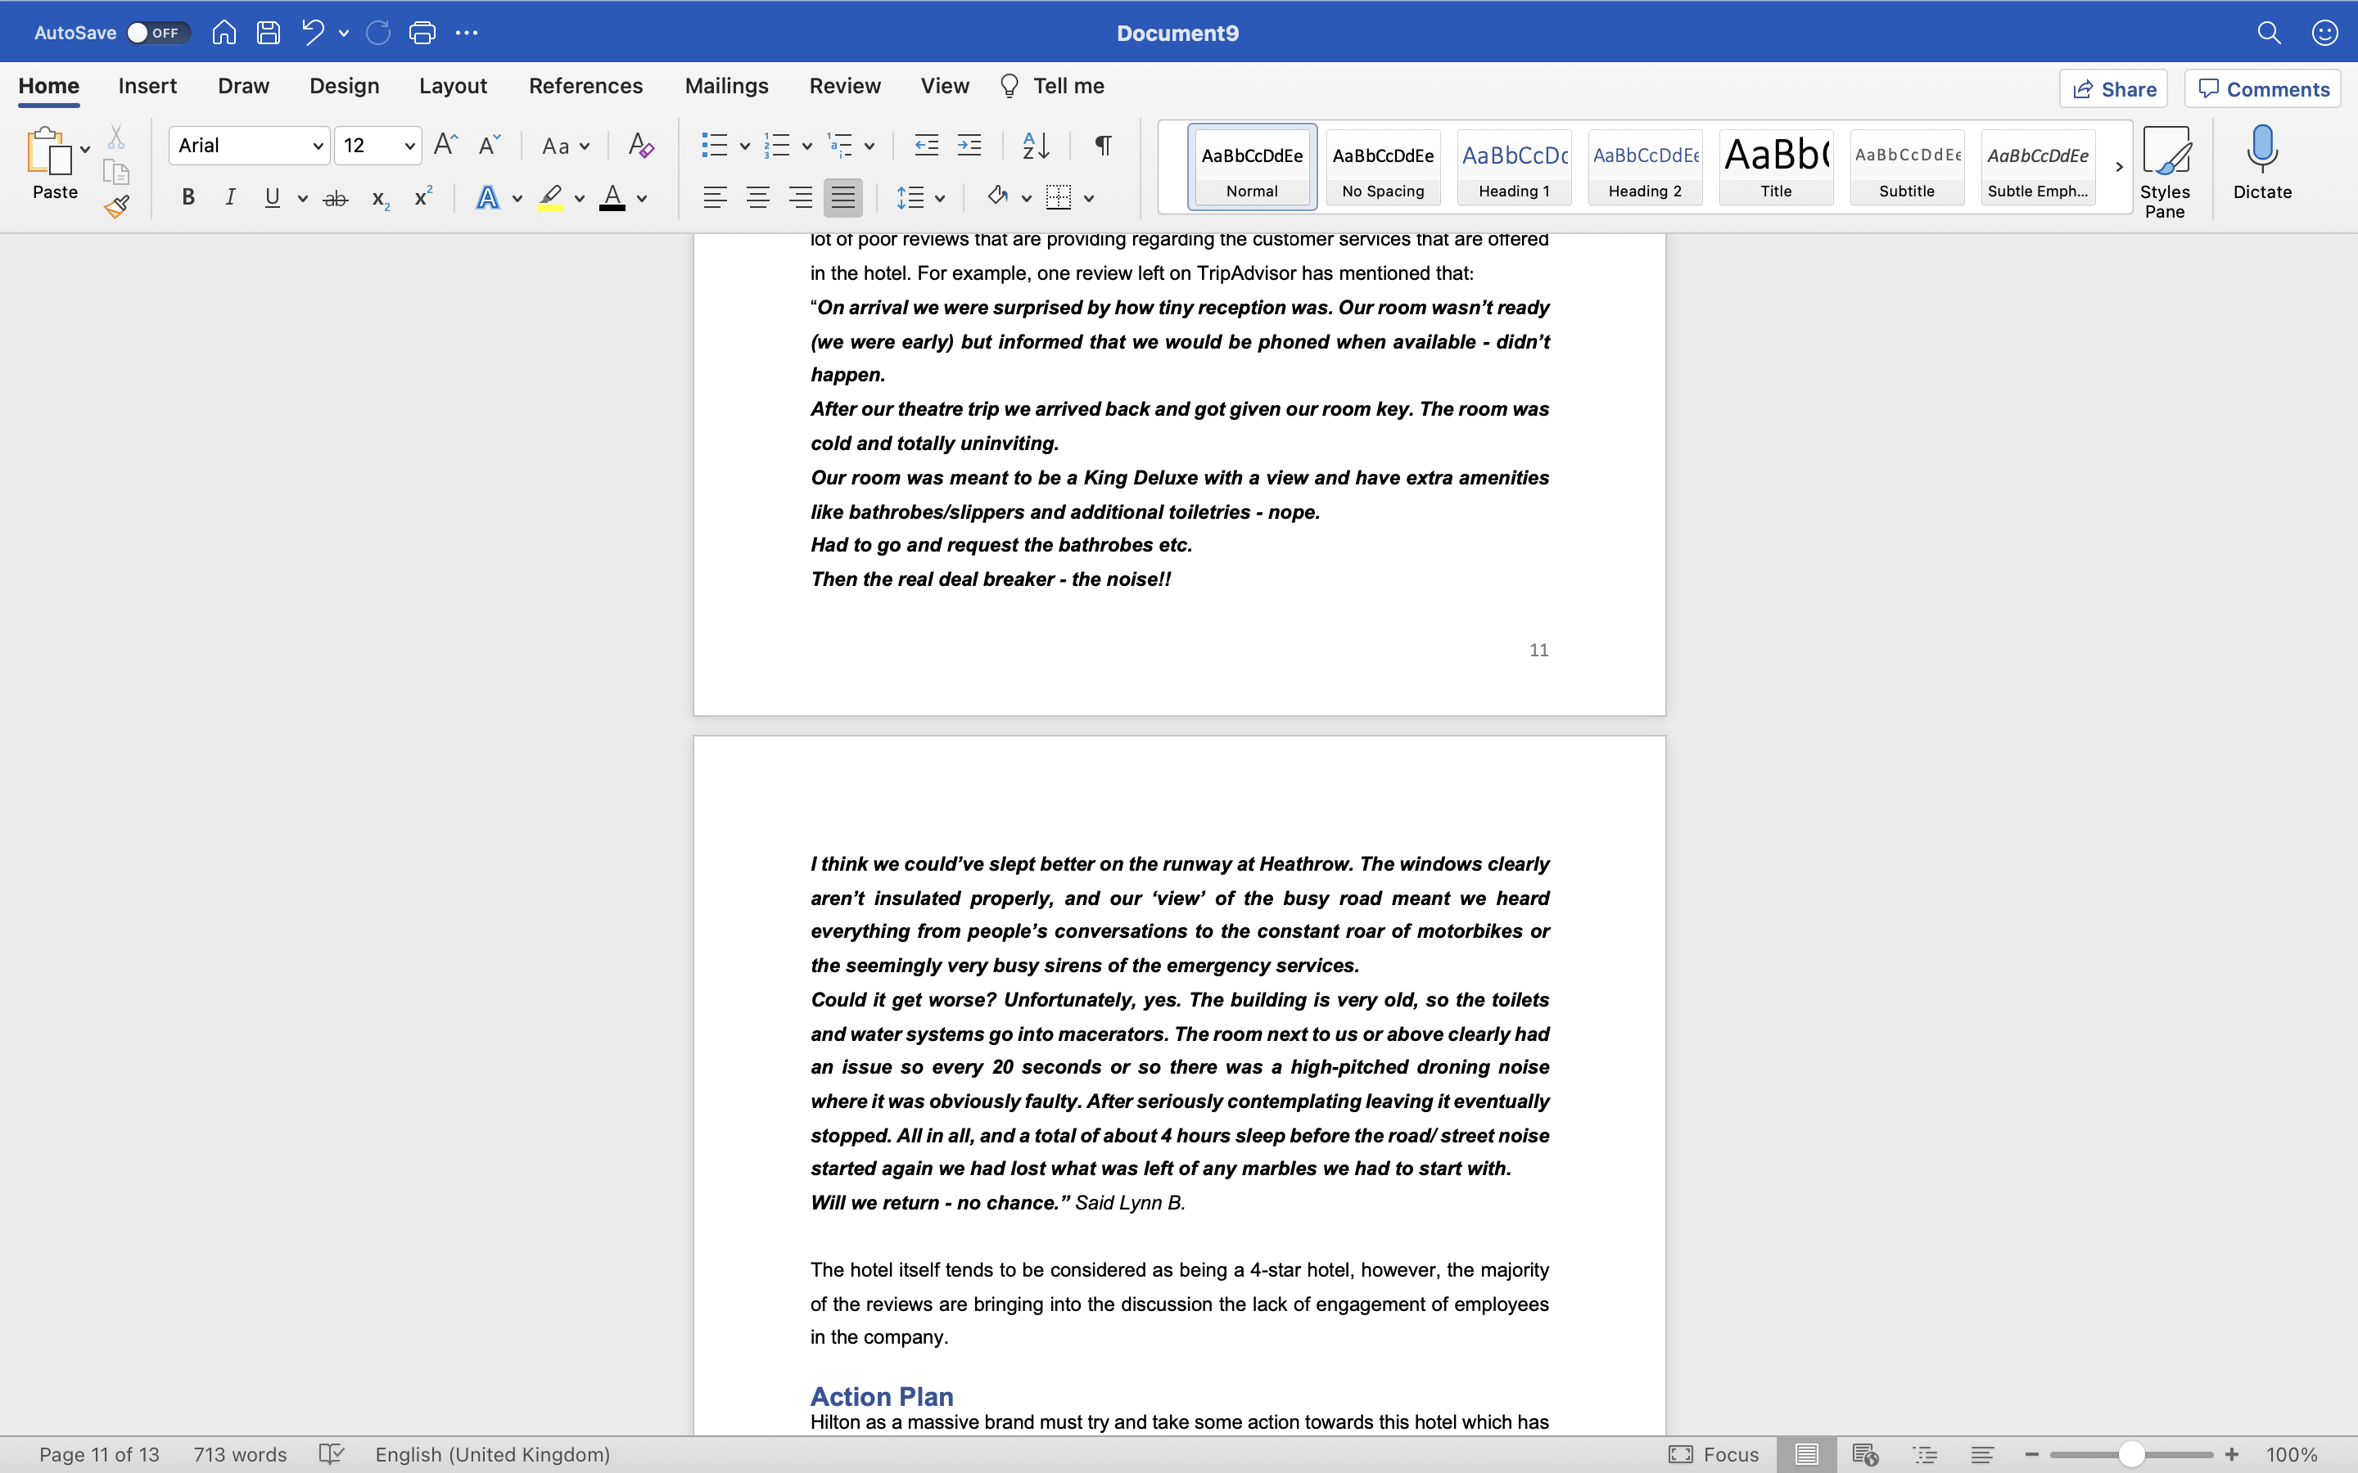
The hotel itself tends to be considered as being a 4-star hotel, however, the majority of the reviews are bringing into the discussion the lack of engagement of employees in the company.

Action Plan
Hilton as a massive brand must try and take some action towards this hotel which has not been checked for training and monitoring purposes for a very long period of time. Therefore, if the superior teams of Hilton are managing well the rehabilitation of the employees, they do have chances to bring the hotel back on track, however, this is not going to be the easiest thing. This process is going to take a long period of time and automatically a lot of effort to make each employee including the managers understand the role of the hotel in the industry and the actions that must be strictly undertaken to make sure that exactly this is happening.
x z x m n b h l k d s a e s d f r e w s a c v d s f g r w r t g f d b v c x k j l o r e w q a s d f
c v x z x m n b h l k d s a e s d f r e w s a c v d s f g r w r t g f d b v c x k j l o r e w q a s d f c v x z x m n b h l k d s a e s d f r e w s a c v d s f g r w r t g f d b v c x k j l o r e w q a s d f c v x z x m n b h l k d s a e s d f r e w s a c v d s f g r w r t g f d b v c x k j l o r e w q a s d f c v x z x m n b h l k d s a e s d f r e w s a c v d s f g r w r t g f d b v c x k j l o r e w q a s d f c v x z x m n b h l k d s a e s d f r e w s a c v d s f g r w r t g f d b v c x k j l o r e w q a s d f c v x z x m n b h l k d s a e s d f r e w s a c v d s f g r w r t g f d b v c x k j l o r e w q a s d f
c v x z x m n b h l k d s a e s d f r e w s a c v d s f g r w r t g f d b v c x k j l o r e w q a s d f c v x z x m n b h l k d s a e s d f r e w s a c v d s f g r w r t g f d b v c x k j l o r e w q a s d f c v x z x m n b h l k d s a e s d f r e w s a c v d s f g r w r t g f d b v c x k j l o r e w q a s d f c v x z x m n b h l k d s a e s d f r e w s a c v d s f g r w r t g f d b v c x k j l o r e w q a s d
x z x m n b h l k d s a e s d f r e w s a c v d s f g r w r t g f d b v c x k j l o r e w q a s d f
c v x z x m n b h l k d s a e s d f r e w s a c v d s f g r w r t g f d b v c x k j l o r e w q a s d f c v x z x m n b h l k d s a e s d f r e w s a c v d s f g r w r t g f d b v c x k j l o r e w q a s d f c v x z x m n b h l k d s a e s d f r e w s a c v d s f g r w r t g f d b v c x k j l o r e w q a s d f c v x z x m n b h l k d s a e s d f r e w s a c v d s f g r w r t g f d b v c x k j l o r e w q a s d f c v x z x m n b h l k d s a e s d f r e w s a c v d s f g r w r t g f d b v c x k j l o r e w q a s d f c v x z x m n b h l k d s a e s d f r e w s a c v d s f g r w r t g f d b v c x k j l o r e w q a s d f
c v x z x m n b h l k d s a e s d f r e w s a c v d s f g r w r t g f d b v c x k j l o r e w q a s d f c v x z x m n b h l k d s a e s d f r e w s a c v d s f g r w r t g f d b v c x k j l o r e w q a s d f c v x z x m n b h l k d s a e s d f r e w s a c v d s f g r w r t g f d b v c x k j l o r e w q a s d f c v x z x m n b h l k d s a e s d f r e w s a c v d s f g r w r t g f d b v c x k j l o r e w q a s d

Reference List

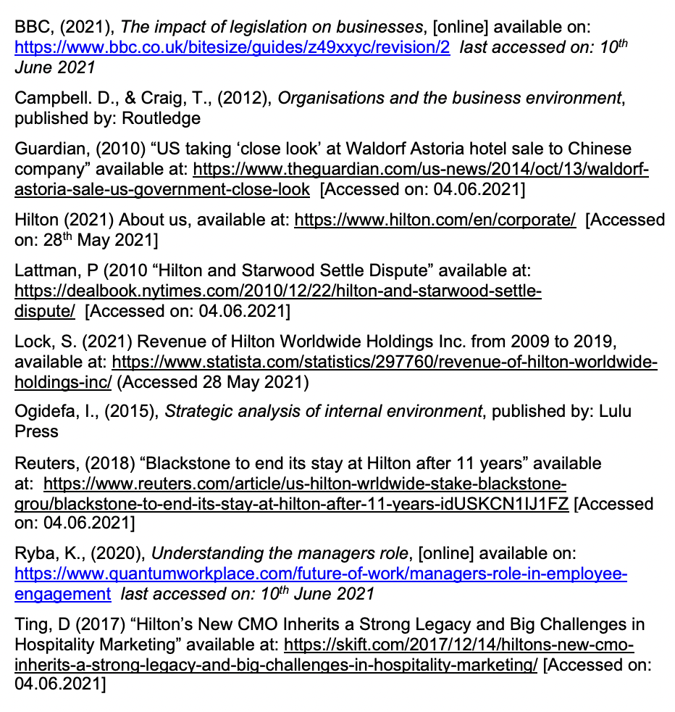
S c v x z x m n b h l k d s a e s d f r e w s a c v d s f g r w r t g f d b v c x k j l o r e w q a s d f c v x z x m n b h l k d s a e s d f r e w s a c v d s f g r w r t g f d b v c x k j l o r e w q a s d f c v x z x m n b h l k d s a e s d f r e w s a c v d s f g r w r t g f d b v c x k j l o r e w q a s d f c v x z x m n b h l k d s a e s d f r e w s a c v d s f g r w r t g f d b v c x k j l o r e w q a s d f c v x z x m n b h l k d s a e s d f r e w s a c v d s f g r w r t g f d b v c x k j l o r e w q a s d f c v x z x m n b h l k d s a e s d f r e w s a c v d s f g r w r t g f d b v c x k j l o r e w q a s d f
c v x z x m n b h l k d s a e s d f r e w s a c v d s f g r w r t g f d b v c x k j l o r e w q a s d f c v x z x m n b h l k d s a e s d f r e w s a c v d s f g r w r t g f d b v c x k j l o r e w q a s d f c v x z x m n b h l k d s a e s d f r e w s a c v d s f g r w r t g f d b v c x k j l o r e w q a s d f c v x z x m n b h l k d s a e s d f r e w s a c v d s f g r w r t g f d b v c x k j l o r e w q a s d f c v x z x m n b h l k d s a e s d f r e w s a c v d s f g r w r t g f d b v c x k j l o r e w q a s d f c v x z x m n b h l k d s a e s d f r e w s a c v d s f g r w r t g f d b v c x k j l o r e w q a s d f c v x z x m n b h l k d s a e s d f r e w s a c v d s f g r w r t g f d b v c x k j l o r e w q a s d f c v x z x m n b h l k d s a e s d f r e w s a c v d s f g r w r t g f d b v c x k j l o r e w q a s d f c v x z x m n b h l k d s a e s d f r e w s a c v d s f g r w r t g f d b v c x k j l o r e w q a s d f c v x z x m n b h l k d s a e s d f r e w s a c v d s f g r w r t g f d b v c x k j l o r e w q a s d f
c v x z x m n b h l k d s a e s d f r e w s a c v d s f g r w r t g f d b v c x k j l o r e w q a s d f c v x z x m n b h l k d s a e s d f r e w s a c v d s f g r w r t g f d b v c x k j l o r e w q a s d f c v x z x m n b h l k d s a e s d f r e w s a c v d s f g r w r t g f d b v c x k j l o r e w q a s d f c v x z x m n b h l k d s a e s d f r e w s a c v d s f g r w r t g f d b v c x k j l o r e w q a s d f
c v x z x m n b h l k d s a e s d f r e w s a c v d s f g r w r t g f d b v c x k j l o r e w q a s d f c v x z x m n b h l k d s a e s d f r e w s a c v d s f g r w r t g f d b v c x k j l o r e w q a s d f c v x z x m n b h l k d s a e s d f r e w s a c v d s f g r w r t g f d b v c x k j l o r e w q a s d f c v x z x m n b h l k d s a e s d f r e w s a c v d s f g r w r t g f d b v c x k j l o r e w q a s d f c v x z x m n b h l k d s a e s d f r e w s a c v d s f g r w r t g f d b v c x k j l o r e w q a s d f c v x z x m n b h l k d s a e s d f r e w s a c v d s f g r w r t g f d b v c x k j l o r e w q a s d f
c v x z x m n b h l k d s a e s d f r e w s a c v d s f g r w r t g f d b v c x k j l o r e w q a s d f c v x z x m n b h l k d s a e s d f r e w s a c v d s f g r w r t g f d b v c x k j l o r e w q a s d f c v x z x m n b h l k d s a e s d f r e w s a c v d s f g r w r t g f d b v c x k j l o r e w q a s d f c v x z x m n b h l k d s a e s d f r e w s a c v d s f g r w r t g f d b v c x k j l o r e w q a s d f
c v x z x m n b h l k d s a e s d f r e w s a c v d s f g r w r t g f d b v c x k j l o r e w q a s d f c v x z x m n b h l k d s a e s d f r e w s a c v d s f g r w r t g f d b v c x k j l o r e w q a s d f c v x z x m n b h l k d s a e s d f r e w s a c v d s f g r w r t g f d b v c x k j l o r e w q a s d f c v x z x m n b h l k d s a e s d f r e w s a c v d s f g r w r t g f d b v c x k j l o r e w q a s d f c v x z x m n b h l k d s a e s d f r e w s a c v d s f g r w r t g f d b v c x k j l o r e w q a s d f c v x z x m n b h l k d s a e s d f r e w s a c v d s f g r w r t g f d b v c x k j l o r e w q a s d f
c v x z x m n b h l k d s a e s d f r e w s a c v d s f g r w r t g f d b v c x k j l o r e w q a s d f c v x z x m n b h l k d s a e s d f r e w s a c v d s f g r w r t g f d b v c x k j l o r e w q a s d f c v x z x m n b h l k d s a e s d f r e w s a c v d s f g r w r t g f d b v c x k j l o r e w q a s d f c v x z x m n b h l k d s a e s d f r e w s a c v d s f g r w r t g f d b v c x k j l o r e w q a s d f x k j l o r e w q a s d f c v x z x m n b h l k d s a e s d f r e w s a c v d s f g r w r t g f d b v c x k j l o r e w q a s d f c v x z x m n b h l k d s a e s d f r e w s a c v d s f g r w r t g f d b v c x k j l o r e w q a s d f c v x z x m n b h l k d s a e s d f r e w s a c v d s f g r w r t g f d b v c x k j l o r e w q a s d f c v x z x m n b h l k d s a e s d f r e w s a c v d s f g r w r t g f d b v c x k j l o r e w q a s d f c v x z x m n b h l k d s a e s d f r e w s a c v d s f g r w r t g f d b v c x k j l o r e w q a s d f c v x z x m n b h l k d s a e s d f r e w s a c v d s f g r w r t g f d b v c x k j l o r e w q a s d f
c v x z x m n b h l k d s a e s d f r e w s a c v d s f g r w r t g f d b v c x k j l o r e w q a s d f c v x z x m n b h l k d s a e s d f r e w s a c v d s f g r w r t g f d b v c x k j l o r e w q a s d f c v x z x m n b h l k d s a e s d f r e w s a c v d s f g r w r t g f d b v c x k j l o r e w q a s d f c v x z x m n b h l k d s a e s d f r e w s a c v d s f g r w r t g f d b v c x k j l o r e w q a s d f
c v x z x m n b h l k d s a e s d f r e w s a c v d s f g r w r t g f d b v c x k j l o r e w q a s d f c v x z x m n b h l k d s a e s d f r e w s a c v d s f g r w r t g f d b v c x k j l o r e w q a s d f c v x z x m n b h l k d s a e s d f r e w s a c v d s f g r w r t g f d b v c x k j l o r e w q a s d f c v x z x m n b h l k d s a e s d f r e w s a c v d s f g r w r t g f d b v c x k j l o r e w q a s d f c v x z x m n b h l k d s a e s d f r e w s a c v d s f g r w r t g f d b v c x k j l o r e w q a s d f c v x z x m n b h l k d s a e s d f r e w s a c v d s f g r w r t g f d b v c x k j l o r e w q a s d f
c v x z x m n b h l k d s a e s d f r e w s a c v d s f g r w r t g f d b v c x k j l o r e w q a s d f c v x z x m n b h l k d s a e s d f r e w s a c v d s f g r w r t g f d b v c x k j l o r e w q a s d f c v x z x m n b h l k d s a e s d f r e w s a c v d s f g r w r t g f d b v c x k j l o r e w q a s d f c v x z x m n b h l k d s a e s d f r e w s a c v d s f g r w r t g f d b v c x k j l o r e w q a s d f
c v x z x m n b h l k d s a e s d f r e w s a c v d s f g r w r t g f d b v c x k j l o r e w q a s d f c v x z x m n b h l k d s a e s d f r e w s a c v d s f g r w r t g f d b v c x k j l o r e w q a s d f c v x z x m n b h l k d s a e s d f r e w s a c v d s f g r w r t g f d b v c x k j l o r e w q a s d f c v x z x m n b h l k d s a e s d f r e w s a c v d s f g r w r t g f d b v c x k j l o r e w q a s d f c v x z x m n b h l k d s a e s d f r e w s a c v d s f g r w r t g f d b v c x k j l o r e w q a s d f c v x z x m n b h l k d s a e s d f r e w s a c v d s f g r w r t g f d b v c x k j l o r e w q a s d f
c v x z x m n b h l k d s a e s d f r e w s a c v d s f g r w r t g f d b v c x k j l o r e w q a s d f c v x z x m n b h l k d s a e s d f r e w s a c v d s f g r w r t g f d b v c x k j l o r e w q a s d f c v x z x m n b h l k d s a e s d f r e w s a c v d s f g r w r t g f d b v c x k j l o r e w q a s d f c v x z x m n b h l k d s a e s d f r e w s a c v d s f g r w r t g f d b v c x k j l o r e w q a s d f
x k j l o r e w q a s d f c v x z x m n b h l k d s a e s d f r e w s a c v d s f g r w r t g f d b v c x k j l o r e w q a s d f c v x z x m n b h l k d s a e s d f r e w s a c v d s f g r w r t g f d b v c x k j l o r e w q a s d f c v x z x m n b h l k d s a e s d f r e w s a c v d s f g r w r t g f d b v c x k j l o r e w q a s d f c v x z x m n b h l k d s a e s d f r e w s a c v d s f g r w r t g f d b v c x k j l o r e w q a s d f c v x z x m n b h l k d s a e s d f r e w s a c v d s f g r w r t g f d b v c x k j l o r e w q a s d f c v x z x m n b h l k d s a e s d f r e w s a c v d s f g r w r t g f d b v c x k j l o r e w q a s d f
c v x z x m n b h l k d s a e s d f r e w s a c v d s f g r w r t g f d b v c x k j l o r e w q a s d f c v x z x m n b h l k d s a e s d f r e w s a c v d s f g r w r t g f d b v c x k j l o r e w q a s d f c v x z x m n b h l k d s a e s d f r e w s a c v d s f g r w r t g f d b v c x k j l o r e w q a s d f c v x z x m n b h l k d s a e s d f r e w s a c v d s f g r w r t g f d b v c x k j l o r e w q a s d f
c v x z x m n b h l k d s a e s d f r e w s a c v d s f g r w r t g f d b v c x k j l o r e w q a s d f c v x z x m n b h l k d s a e s d f r e w s a c v d s f g r w r t g f d b v c x k j l o r e w q a s d f c v x z x m n b h l k d s a e s d f r e w s a c v d s f g r w r t g f d b v c x k j l o r e w q a s d f c v x z x m n b h l k d s a e s d f r e w s a c v d s f g r w r t g f d b v c x k j l o r e w q a s d f c v x z x m n b h l k d s a e s d f r e w s a c v d s f g r w r t g f d b v c x k j l o r e w q a s d f c v x z x m n b h l k d s a e s d f r e w s a c v d s f g r w r t g f d b v c x k j l o r e w q a s d f
c v x z x m n b h l k d s a e s d f r e w s a c v d s f g r w r t g f d b v c x k j l o r e w q a s d f c v x z x m n b h l k d s a e s d f r e w s a c v d s f g r w r t g f d b v c x k j l o r e w q a s d f c v x z x m n b h l k d s a e s d f r e w s a c v d s f g r w r t g f d b v c x k j l o r e w q a s d f c v x z x m n b h l k d s a e s d f r e w s a c v d s f g r w r t g f d b v c x k j l o r e w q a s d f
c v x z x m n b h l k d s a e s d f r e w s a c v d s f g r w r t g f d b v c x k j l o r e w q a s d f c v x z x m n b h l k d s a e s d f r e w s a c v d s f g r w r t g f d b v c x k j l o r e w q a s d f c v x z x m n b h l k d s a e s d f r e w s a c v d s f g r w r t g f d b v c x k j l o r e w q a s d f c v x z x m n b h l k d s a e s d f r e w s a c v d s f g r w r t g f d b v c x k j l o r e w q a s d f c v x z x m n b h l k d s a e s d f r e w s a c v d s f g r w r t g f d b v c x k j l o r e w q a s d f c v x z x m n b h l k d s a e s d f r e w s a c v d s f g r w r t g f d b v c x k j l o r e w q a s d f
c v x z x m n b h l k d s a e s d f r e w s a c v d s f g r w r t g f d b v c x k j l o r e w q a s d f c v x z x m n b h l k d s a e s d f r e w s a c v d s f g r w r t g f d b v c x k j l o r e w q a s d f c v x z x m n b h l k d s a e s d f r e w s a c v d s f g r w r t g f d b v c x k j l o r e w q a s d f c v x z x m n b h l k d s a e s d f r e w s a c v d s f g r w r t g f d b v c x k j l o r e w q a s d

