Remediating Polluted Land
Student: Emma Bergson P148476
Module: Environmental Pollution Control
Module Code: M6X01198
Tutor: Andrew Thorn
Date: 11 April 2020

Executive Summary
As part of an environmental consultant team contracted by the local council, an environmental site survey of a former industrial site, has been completed. The site was supposed to be contaminated with heavy metals (HM) such as Cadmium, Chromium, Mercury and Zinc. In the first instance, the report discusses the different steps involved with carrying out a site survey going into detail regarding the preparation needed to achieve a thorough survey and how to collect the relevant data.
Available techniques that could be used for remediating the land have been evaluated. Both on-site and off-site techniques are discussed with on-site split into in-situ and ex-situ. In-situ includes surface capping and encapsulation, electrokinetics and vitrification, soil flushing and solidification, phytoremediation and bioremediation. Ex-situ includes landfilling, soil flushing and vitrification. Off site discusses similar techniques to on-site ex-situ techniques.
The financial, health and safety and ethical issues are deliberated; investigating the costs, some computer models to help with obtaining good data, Sustainable Remediation Forum in the UK and some of the health issues that may occur.
Finally, some recommendations are given. With the lack of detail in the brief a few suggestions for the remedial process are given. For high heavy metal content, landfill or vitrification and for mild to medium soil flushing and solidification have been proposed.

Contents
Executive Summary ii
Contents iii
List of Figures and Tables iv
1 Explain how you would carry out a site survey and what issues need to be considered in order for this to be comprehensively undertaken 1
1.1 Preparation/Desk Study 1
1.1.1 Define objectives 2
1.1.2 Available information/Documentary material 2
1.1.3 Geostatistical risk analysis 2
1.1.4 Visual inspection 2
1.1.5 Primary conceptual model 2
2 Evaluate what techniques could be used to remediate the land. 4
2.1 On-Site 4
2.1.1 In-situ 4
2.1.2 Ex-situ 6
2.2 Off-Site 7
3 A consideration of financial, health and safety and ethical issues 8
4 Recommendations 9
5 References 10

List of Figures
Figure 1. On site remediation techniques 7
Figure 2. Ex-situ soil flushing technique 10

Explain how you would carry out a site survey and what issues need to be considered in order for this to be comprehensively undertaken
The local authority has contracted out an environmental consultant team to undertake an environmental site assessment of a former industrial site supposed to be contaminated with HM such as Cadmium, Chromium, Mercury and Zinc. In the first instance, a site investigation strategy should be developed producing:
- A precise model of how this will be achieved
- An assessment of consequences
- Concise and relevant information (Cairney, 1998)

Table 1 displays an example of a site investigation strategy.
Table 1. Site investigation strategy (Cairney, 1998)
Stage | Activities
Preparation | Objectives defined
Preparation | All available information is checked
Preparation | Visual inspection
Preparation | A primary conceptual model is formed  Geostatistical Risk Assessment undertaken
Investigation Planning | What needs to be proved/ disproved for the model
 | Constraints identified (financial, access)
 | Techniques for the investigation are selected
 | Strategies for sampling and testing decided
Investigation | All exploratory sampling and tests carried out
 | Collect thorough records
 | As information arises revise the model
Reporting | Analyse results and refine the site model
 | Separate factual and interpretative accounts compiled
Risk Assessments | The contaminant implications for the planned re-use of the land Identified

Preparation/Desk Study
Following the British Standards (BS 10175:2011+A2:2017) guidance (British Standards Institution, 2017) a Preliminary Investigation is the first part of an investigation strategy and is split into two parts, firstly the documentary material is studied followed by a site investigation.

Define objectives
The objectives for the site in question is to determine the level of contamination of HM found within the soil and suggest ways for remediation.

Available information/Documentary material
There are many ways to obtain information about a site and deciding what information to gather is an important part of the strategy process. Initially, tracing the site back to ‘greenfield’ conditions needs to be established and can be done through investigating superseded maps available through contacting the local authority’s Pollution Control Team. Pembrokeshire County Council will do a full interrogation of their database (for a small fee) which includes information of historical landfill sites, industrial history dating back to 1865, Local Authority pollution incidents and more (Pembrokeshire County Council, 2020). Regulatory authorities such as National Resources Wales should also be contacted as should previous owners of the site.

Geostatistical risk analysis
Geostatistical risk analysis uses stochastic simulation to model uncertainties in the area of interest. Using a geostatistical simulation, possible realities can be quantified, and any contamination exceeding thresholds can be determined (Guastaldi & Alessandro Del Frate, 2012). Using the information and documentation obtained, this type of risk analysis would help evaluate the risk involved in remediation.

Visual inspection
Once all the information has been acquired, this needs to be accompanied with a visual inspection of the site. This will help to affirm or if needed, update current records discovered through the desk study. In this particular case certain areas could be emitted such as building structure and the visual impact of the site. The main points to be aware of:
- Any waste material deposited
- Any vegetation and the quality of it
- Bad odours (Thorn, 2020)

Primary conceptual model
When the site reconnaissance is complete a primary conceptual model can be finalised. Stipulating beforehand what information is required will ensure the correct data is compiled and the intended procedures are used. Clearly defined details into the exploration methods, how do to the observations, and the approach to sampling, will all aid in achieving this. With the sampling, details should be laid out defining protocols for the method, size, and testing strategy. The model should also give details on how the data is to be reported to ensure a good understanding and interpretation (Cairney, 1998).

Evaluate what techniques could be used to remediate the land.
Remediation of land can involve one or more techniques and involve being treated on-site or off-site. If treated on-site it can be dealt in-situ; relatively undisturbed soil, or ex-situ; excavated soil but remaining on-site. Off-site would involve excavating the soil and transporting it to landfill or to a treatment centre (Nathanail & Bardos, 2004).

On-Site
Figure 1 displays the different types of remediation techniques on-site for HM contamination which will be investigated further.
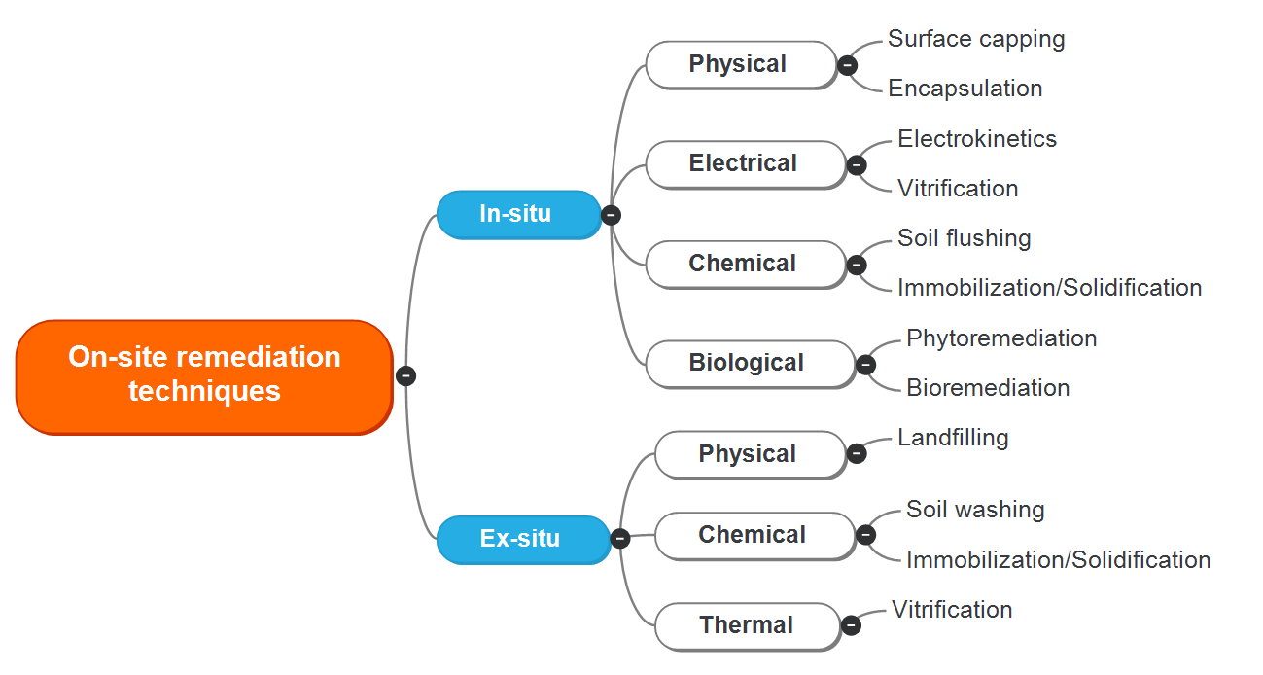
Figure 1. On site remediation techniques

In-situ
Excavation and off-site transportation are not a requirement when remediating contaminated soil in-situ. Because the soil disturbance is marginal, there is minimal exposure to the workers and nearby public. Treatment costs may be reduced, however, detailed field conditions such as depth of contamination, permeability of the soil, weather conditions and chemical leaching must be considered (Olexsey & Parker, 2006).

Surface capping and Encapsulation
Some specialists agree that surface capping and encapsulation have been very popular remediation techniques for HM contamination. The cost-effective measure is a quick way to deal with the problem of contamination. Surface capping would involve the land being capped, this would prevent the pathway for the contaminants and isolate the source from the receptor. Total encapsulation, the preferred method for HM contamination, would create a barrier surrounding the entire site, thus completely isolating the metals from the immediate environment (Meuser, 2010) (Industrial Environmental Management, 1997) (Liu, et al., 2018).

Electrokinetics and vitrification
Electrical adsorption can be used to eradicate HM using electrokinetic extraction. The process involves inserting electrodes into the ground and applying a low-density direct current. Several processes, such as solution pumping, (co-)precipitation and electroplating remove any metal contaminants concentrated at the polarized electrodes (Liu, et al., 2018). This technique is still in development stage therefore would be costly to implement.
If, after the analysis, the levels of HM are found to be very high, vitrification is a good solution. Contaminated soil is converted into a chemically inert product using a thermal treatment method. The produced glass and crystalline product are stable and easily removed (Fitzpatrick, et al., 1987).

Soil Flushing and Immobilization/Solidification
Soil flushing is used on soils with high permeability such as homogenous, coarse-textured soils. Wuana, et al.,2010, and Hou, et al., 2015, agree that for the removal of HM, an acidic aqueous solution would be used such as ethylene-diamine-tetra-acetic acid (EDTA). EDTA has been tested and known to be an effective chelating agent on HM (Wuana, et al., 2010) (Hou, et al., 2015). Although technically simple, the installation of subsurface drains or solution collection wells could be challenging and expensive (Liu, et al., 2018) however, it can be a permanent measure, and reusing the soil is socially and economically beneficial (Hou, et al., 2015).
Chemical immobilization uses chemical agents to trap pollutants in the soil by solidifying or converting, ‘the mobile pollutant fractions… into precipitates and/or strongly sorbed moiety’ (Liu, et al., 2018). The contaminants are not removed from the soil, rather, the concentration and solubility are extremely reduced, therefore, the probability of further contamination is minimised (Tajudin, et al., 2015).
Soil flushing and solidification are often used in conjunction with each other, with solidification complementing the soil flushing (Liu, et al., 2018).

Phytoremediation and bioremediation
Phytoremediation uses plants for the removal of soil contaminants. If time allows, phytoremediation is a very environmental and economical choice. The results can be enhanced using plants that grow quickly and have a strong arbuscular mycorrhizae (AM) relationship; using the AM to extend the root system increases the area of nutrient acquisition to the host plant (Khan, et al., 2000) (Dann, 2017). Zhang, et al., 2019, experimented with soil taken from a waste electrical and electronic equipment site which was heavily contaminated with HM (Cd, Cu, Pb, Cr, Zn, and Ni). They grew garlic chives, inoculated with AM fungi and intercropped with sunflower to encourage the growth of the chives and investigate the HM acquisition in them. The intercropping of the sunflower enabled growth in the chives, the HM acquisition was increased due to the AM fungus increasing the efficiency of phytoextraction and the quality of the chives was improved from the ‘root to shoot’ reduction of HM transfer (Zhang, et al., 2019).
Bioremediation utilises the fact that all organic materials will biodegrade at varying degrees using either aerobic or anaerobic degradation. Either the bacteria natural to the soil or an added bacterium would be used, and the environmental conditions should be optimized by ensuring the presence of the right temperature, humidity, available oxygen and basic nutrients. This is a slow process but economical if time allows (Kiely, 1997).

Ex-situ
Ex-situ on site would involve excavation of the contaminated area either to a designated landfill area, a soil flushing set up or vitrification zone.

Landfilling
Landfilling uses a process of excavating the contaminated land and transporting it to a secure engineered structure with impermeable lining, drains for leachate and dikes (Liu, et al., 2018). The void space should be filled with non-contaminated fill material. An advantage for on-site landfill is the reduction of waste materials leaving the site (Nathanail & Bardos, 2004).

Soil flushing
The excavated soil would be transported to an onsite soil flushing set up where the contaminants are extracted using water or other solutions of an aqueous nature. Solubilizing the contaminants encourages the movement of metals to be extracted (EPA, 1991). Figure 2 shows the typical process.

Vitrification
A similar process to in-situ accept the soil is extracted and treated thermally in a designated place on site.

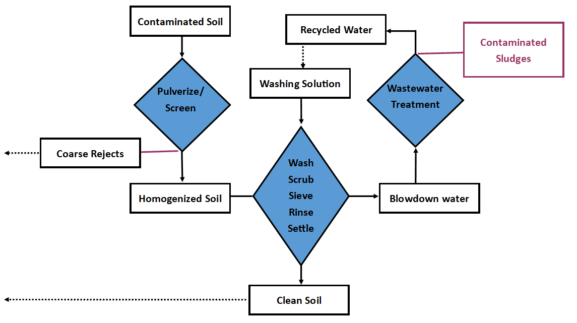
Figure 2. Ex-situ soil flushing technique

Off-Site
All off-site treatment would start with excavation of the contaminated soil. This excavated soil is transported to treatment centres or landfill and the void would be filled with non-contaminated material. In the past it has been seen as the preferred way to remediate contaminated soil due to the remediation almost guaranteed to be complete. However, the disruption to site and the transporting of contaminants has made it a less sustainable method (Cairney, 1998).

A consideration of financial, health and safety and ethical issues
The remediation of contaminated land will involve many specialists and the choice of treatment will make a big difference in the final cost. Off-site transportation will incur the most and may be the only option if the soil is highly contaminated with heavy metals (Cairney, 1998).
Cost benefit analysis should not only include the economics of the situation, but to take into consideration human health and safety, environmental and social sustainability. An excel tool, Sustainable Choice Of REmediation (SCORE), has been developed to assist with this, using Monte Carlo Simulation for uncertainties a detailed cost benefit analysis can be developed (Söderqvista, et al., 2015). Modern remediation has to take a more sustainable approach, always considering how the process will affect the environment. To provide a more sustainable remediation practice, a Sustainable Remediation Forum in the UK (SuRF-UK) was established in 2007. Used to select optimal remediation activities, it gives direction on sustainable remediation (Ridsdale & Noble, 2016). It aims to minimise the complexity and costs that can be found by supporting a tiered approach. Consistent assessment is supported by utilising a framing process, (Bardos, et al., 2016) (Ridsdale & Noble, 2016).
According to Landrigan et al., 2018, ‘Pollution is the largest environmental cause of disease and premature death in the world today’. The health issues surrounding contaminated land are mostly invisible. Contaminated soil can expose humans to toxins via ingestion, inhalation, or dermal absorption (Landrigan, et al., 2018). Thus, when remediating contaminated land, it is vital to include risk analysis to cover human health and safety.

Recommendations
With limited information it is hard to recommend anything definitive. Assuming the timeframe for remediation will be short the following options have been suggested.
If the soil is heavily contaminated with the metals in question then excavation in-situ is a good option. The landfill technique would be used, on site would avoid further contamination, in a designated area and the void would be filled with fresh uncontaminated soil.
Another option for heavy contamination is in-situ vitrification. This thermal treatment would create inert waste.
For mild to medium contamination on site and if the soil is homogenous with a coarse texture then a combination of soil flushing and solidification would be preferable. This would be a sustainable remediation as the soil could be reused.

References
Bardos, R. P. et al., 2016. The rationale for simple approaches for sustainability assessment and management in contaminated land practice. Science of The Total Environment, Volume 563-564, pp. 755-768.
British Standards Institution, 2017. BS 10175:2011+2017. In: s.l.:BSI Standrads Ltd .
Cairney, T., 1998. Rational Site Investigations. In: T. Cairney, ed. Contaminated Land: Problems and Solutions. 2nd ed. s.l.:CRC Press.
Dann, G., 2017. Edible Mushrooms. 1st ed. Cambridge: Green Books.
EPA, 1991. In situ soil flushing. Engineering Bulletin , Volume 021, pp. 2-91.
Fitzpatrick, V. F., Timmerman, C. L. & Buelt, J. L., 1987. In situ vitrification: A new process for waste remediation.. s.l., Office of Science and Technical Information.
Guastaldi, E. & Alessandro Del Frate, A., 2012. Risk analysis for remediation of contaminated sites: the geostatistical approach. Environmental Earth Science, pp. 897-916.
Hou, D., Al-Tabbaa, A. & Hellings, J., 2015. Sustainable site clean-up from megaprojects: lessons from London 2012. Proceedings of the Institution of Civil Engineers - Engineering Sustainability, 168(2), pp. 61-70.
Industrial Environmental Management, 1997. Practical contaminated land management: methods of remediation. [Online]
Available at: https://www.edie.net/library/Practical-contaminated-land-management-methods-of-remediation/1108
[Accessed 29 March 2020].
Khan, A. G. et al., 2000. Role of plants, mycorrhizae and phytochelators in heavy metal contaminated land remediation. Chemosphere, 41(1-2), pp. 197-207.
Kiely, G., 1997. Environmental Engineering. 1st ed. Maidenhead: McGraw-Hill Publishing Company.
Landrigan, P. J. et al., 2018. The Lancet Commission on pollution and health. The Lancet, Volume 391, pp. 462-512.
Liu, L., Li, W., Song, W. & Guo, M., 2018. Remediation techniques for heavy metal-contaminated soils: Principles and applicability. Science of The Total Environment, Volume 633, pp. 206-219.
Meuser, H., 2010. Soil Remediation and Rehabilitation: Treatment of Contaminated and Disturbed Land. s.l.:Springer.
Nathanail, C. P. & Bardos, R. P., 2004. Reclamation of Contaminated Land. Chichetser: John Wiley & Sons Ltd.
Olexsey, R. A. & Parker, R. A., 2006. Current and Future In Situ Treatment Techniques For The Remediation Of Hazardous Substances In Soil, Sediments, and Groundwater. Soil and Water Pollution Monitoring, Protection and Remediation, Volume 69, pp. 211-219.
Pembrokeshire County Council, 2020. Contaminated Land. [Online]
Available at: https://www.pembrokeshire.gov.uk/contaminated-land/how-can-i-find-out-if-land-may-be-contaminated
[Accessed 27 March 2020].
Ridsdale, D. R. & Noble, B. F., 2016. Assessing sustainable remediation frameworks using sustainability principles. Journal of Environmental Management, Volume 184, Part 1, pp. 36-44.
Söderqvista, T. et al., 2015. Cost-benefit analysis as a part of sustainability assessment of remediation alternatives for contaminated land. Journal of Environmental Management, Volume 157, pp. 267-278.
Tajudin, S. A. A., Azmi, M. A. M. & A, N. A. T., 2015. Stabilization/Solidification Remediation Method for Contaminated Soil: A Review. Langawki, IOP Publishing Ltd.
Thorn, A., 2020. Contaminated Land. Swansea: Universit of Wales Trinity St David.
Wuana, R. A., Okieimen, F. E. & Imborvungu, J. A., 2010. Removal of heavy metals from a contaminated soil using organic chelating acids. International Journal of Environmental Science & Technology, Volume 7, pp. 485-496.
Zhang, Y. et al., 2019. Intercropping with sunflower and inoculation with arbuscular mycorrhizal fungi promotes growth of garlic chive in metal-contaminated soil at a WEEE-recycling site. Ecotoxicology and Environmental Safety, Volume 167, pp. 376-384.

