Ana Carden-Coyne, David Morris and Tim Wilcox, eds., The Sensory War, 1914–2014(Manchester Art Gallery: Manchester, 2014)
Images from section entitled ‘Pain and Succour’

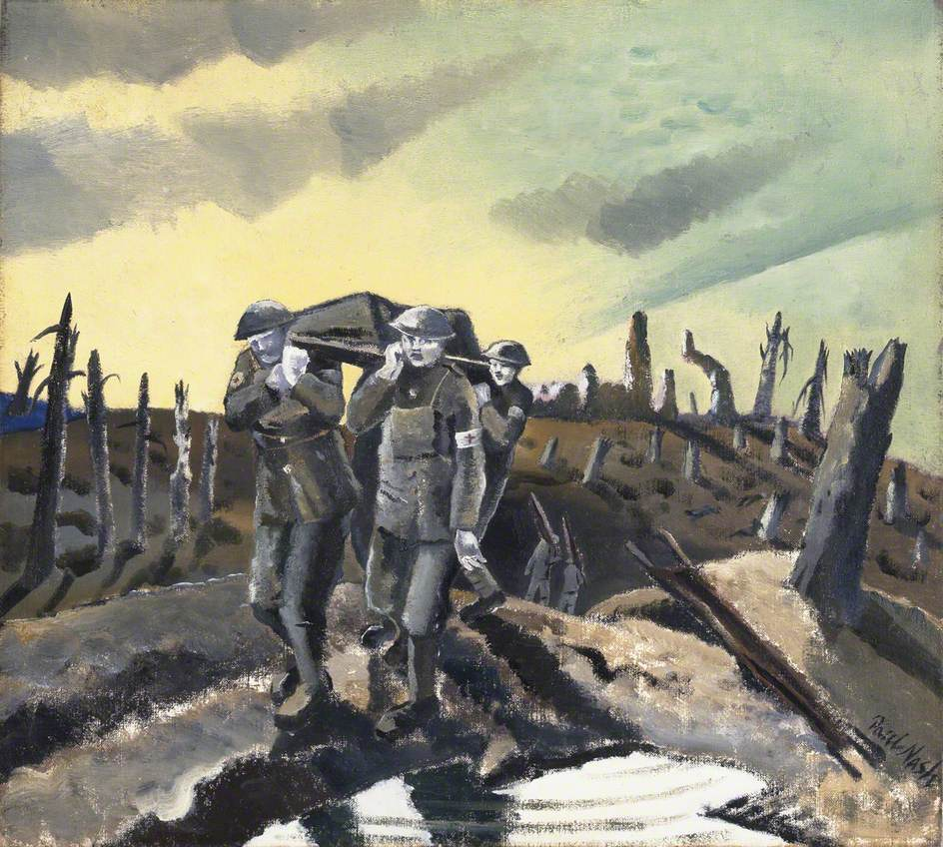
Paul Nash, Wounded, Passchendaele, 1918
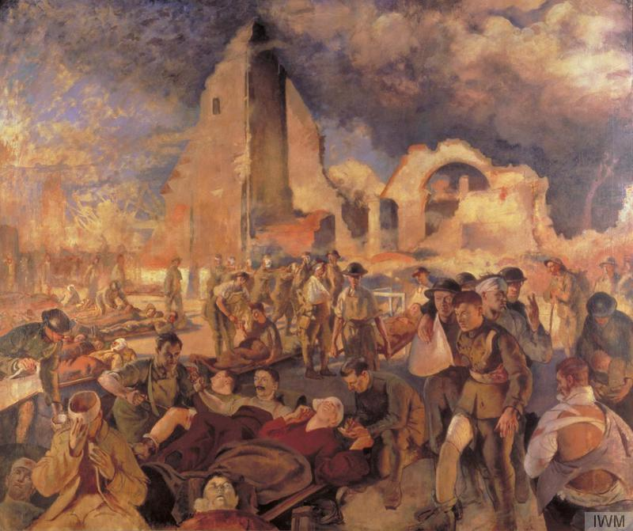
Henry Tonks, An Advanced Dressing Station in France, 1918

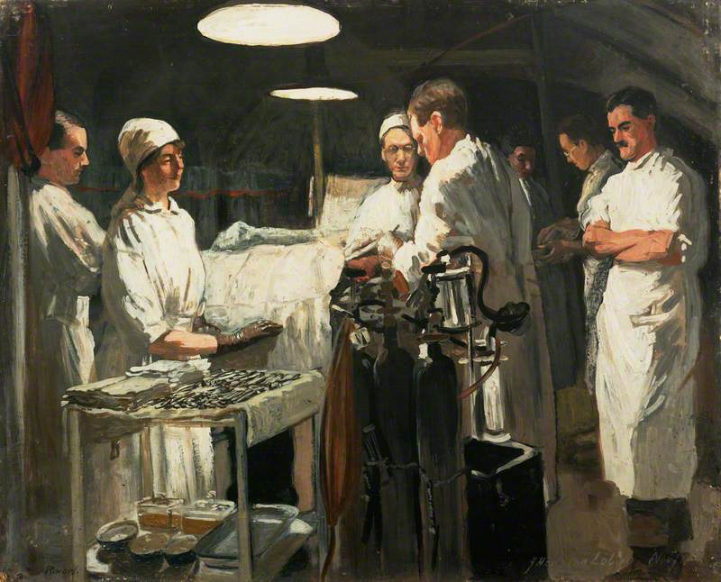
John Hodgson Lobley, The Operating Theatre, First Casualty Clearing Station, 1918.

