MARIA NITA
2128458

COACHING AND MENTORING

Table of Contents
Introduction 3
1. The Importance of Coaching in Post-COVID Workplaces 3
Coaching vs. Traditional Learning and Mentoring 3
The Role of Coaching in Addressing Post-COVID Challenges 4
Practical Applications of Coaching 5
Why My Workplace Needs Coaching 5
2. The Skills Required to Be an Effective Coach 6
3. How the Model Used Compared with Other Well-Known Models of Coaching 8
The GROW Model (Goals, Reality, Options, Will) 8
The CLEAR Model (Contracting, Listening, Exploring, Action, Review) 9
Cognitive Behavioral Coaching (CBC) 9
Similarities and Differences of the Approach 9
Conclusion 10
References 11

Introduction
Coaching has now become one of the most powerful learning solutions in post-COVID working environments as it focuses on specific needs in individual and organisational contexts. While training can be delivered in a one-size-fits-all, or the mastering of a certain behaviour can occur through mentorship, coaching allows for a streamlined approach to developing skills and psychological strength needed to thrive in today’s work setting (Vlados, 2021). In a post-pandemic working environment, where people shifted to work from home, everyone has adapted technologies, and employees are increasingly experiencing burnout, coaching provides change readiness, self-assurance, and advancement. All those organisations that make use of coaching successfully, ensure that their employees are able to rise up to those challenges and transform into better liked thriving organisations. This paper aims to explicate the concept of coaching and differentiate it from other related interventions such as mentoring, with relevance to its application in the workforce.

1. The Importance of Coaching in Post-COVID Workplaces
With the onset of COVID-19, the culture of work was shifting dramatically, changing expectations and providing new concerns for workers and employers. Being physically present at work has made employees more stressed due to the shift to the new hybrid working models, and constant training has required the use of unique learning solutions for each employee through the use of coaching (Palmucci and Santoro, 2024). Coaching is another form of learning intervention that is sensitive, learner-centred and medicinal in that it endeavours to fix psychological and emotional ills that affect an individual’s performance in a given job.

Coaching vs. Traditional Learning and Mentoring
Methods of training delivery like workshops or e-learning modules have the tendency to apply a generic approach in training. These methods are useful for knowledge sharing, but they do not provide the targeted approach that is needed to address the problems which employees may encounter (Tanıs and Barker, 2017). For instance, in my organization (or other large organizations such as Google and Deloitte) general training programs are common to provide employees with technical training, but they invariably lack the soft skills that are relevant to employees, such as how to manage emotions and control public speaking anxiety.
Mentoring, which is another frequently used practice, consists of having an experienced staff member help a less experienced one. Mentoring offers a wealth and experience, career guidance and support but is restricted by the viewpoint of the mentor and their accessibility. While consulting is about providing specific solutions to the challenges within the organization, coaching is more about enhancing the performance of an individual by concentrating on their problems and helping them to solve them with the help of improved awareness (Grant, 2017). For example, as mentioned in the conversation, Luciana had learned how to address her fear of speaking in front of an audience—an issue that could be better addressed by some guidance to help her deal with the emotions involved rather than a simple suggestion.
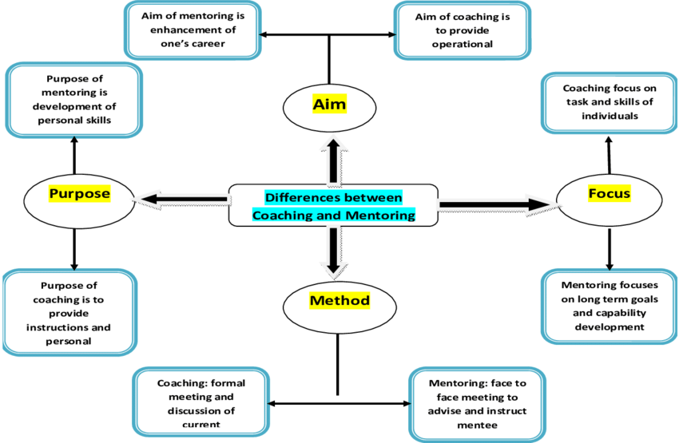
Figure: Difference between Coaching and Mentoring
(Source: Khakwani et al., 2012)

The Role of Coaching in Addressing Post-COVID Challenges
COVID-19 has impacted workplaces in many ways with workers experiencing burnout, disengagement and demands for an ability to cope with stress. Coaching is a much more efficient approach as it tackles these problems at an individual level (Buheji and Buheji, 2020). While, it is important to mention that mentoring is generally career-oriented while coaching aims at all aspects of an employee’s life including the emotional state, flexibility, and confidence levels.
For example, in my workplace (or an SME organization), coaching is employed to assist employees who are promotion-bound in new roles. This may include individual coaching sessions to enhance decision-making/conflict-solving skills, and emotional intelligence skills which are indispensable in the post-COVID ever political change world (Kaushik, 2020).

Practical Applications of Coaching
Leadership Development:
Coaching is useful in that it facilitates the acquisition of all these competencies necessary in the management of virtual teams. Some of them are; how to ensure that remote and in-office workers work in harmony, to include both the remote and the in-office workers and how to manage their output when working in the supper-connectivity age (Van Wyk, R., Odendaal and Maseko, 2019). For instance, at Deloitte, leadership coaching programs have helped managers prepare for leading teams in a hybrid working model.
Building Resilience and Adaptability:
Coaching removes other social factors like fear and anxiety and enables the employee to become strong. In Luciana’s case, he supports a learner through exploring feelings and one can cope with barriers, for instance, talking to an audience or pressure on the stage (Bozer and Jones, 2018). This emotional support is very important when the nature of the work as is in post-Covid workplaces ever-changing and full of uncertainties.
Improving Performance and Engagement:
Coaching involves offering feedback and setting specific goals in order to improve the employees’ performance and commitment to their work (Cannon-Bowers et al., 2023). For example in Microsoft, coaching is considered in appraisal, which assists workers in evaluating their targets and goals in relation to the firm’s goals.
Career Transition and Upskilling:
In light of automation and digitalization, the employees sometimes require training and development or other remunerative employment. Coaching is a form of help, which offers a specific method of coping with the changes: Clients get personal support according to their skills and personal development goals (Passmore, 2019).

Why My Workplace Needs Coaching
In my organization (or an imaginary organization), conventional approaches to training are seen as the Norm in workforce development. However, those methods do not cater for individual difficulties like how to communicate or how to deal with stress. This might be more accurately addressed by launching coaching programs which could help employees manage personal and career challenges (Faithfull-Byrne et al., 2017). For instance, workers who are too shy to speak in public can attend learning sessions that enable them to become more confident and clear just like Luciana.
Further, for hybrid work arrangements, the roles of coaching could help leaders navigate these issues as well as develop means of communication and team engagement (Kotte and Bozer, 2022). Coaching is therefore a valuable tool that we can use to create a culture that positively influences our organisational culture by creating a more resilient, adaptable, and engaged workforce.

2. The Skills Required to Be an Effective Coach
Coaching skills are a set of methods, personal qualities and interpersonal competencies that define the effectiveness of a coach as a facilitator of change. They also allow the coach to set up a positive environment conducive to the work and task execution of the coachee.
Active Listening:
A good coach listens in order to comprehend the concerns the coachee has, and the feelings, and vision this individual has. The object content of the communication between coaches and clients can give a clue about what needs to be changed (Digirolamo and Tkach, 2019). For example, when Luciana declared she had the flu she shouldn’t be speaking in public, the coach listened with the purpose of identifying the main causes of anxiety and insufficient practice.
Empathy and Emotional Intelligence:
Empathy enables coaches to get familiar with coachees and shows that the coaches are concerned about the coachees. Coaches can control their own emotions and assist the coachee in dealing with problematic emotions such as fear and anxiety due to emotional intelligence (Fillery‐Travis and Lane, 2020).
Questioning and Reflection:
Questioning makes the coachee develop an understanding of themself. Open-ended questions allow people to think about their ideas, the causes, and the ways to solve them (Romão et al., 2022). For instance, when asking Luciana how her fear is costing her professionally to become a better presenter helped her realize the implications of avoiding such speeches.
Adaptability and Flexibility:
It is important for coaches to therefore approach how they will be addressing their respective coachee in the remote management way (Ellinger et al., 2023). This means that the techniques must be varied and form a generalized framework to suit all sorts of learners.
Goal Setting and Accountability:
Coaches assist coachees to do the right thing, ensure that they complete this right thing to the best of their abilities and make certain that they complete this right thing at the right time, every time. Integration of large goals into daily goals and continuous working towards those goals allows for constant progress including what Luciana said about the gradual practice of public speaking.
Feedback and Encouragement:
Reinforcing as well as encouragement strengthens the coachee and helps them follow the coaching process. Introducing positive reinforcement gives confidence and strength to the subject to put so much effort towards achieving goals (McCarthy and Milner, 2020).
These skills combined enable one to mobilise coachees to overcome challenges, foster confidence and realise their potential.
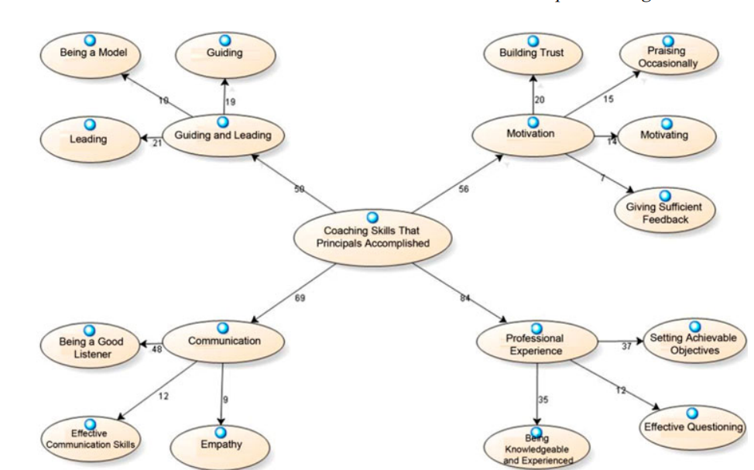
Figure: Skills Required to Be an Effective Coach
(Source: Yirci et al., 2014)

3. How the Model Used Compared with Other Well-Known Models of Coaching
To work with Luciana the organized yet versatile design of a coaching session was applied. In this model, the focus was made on feelings recognition, including the obstacles to be faced, and the strategies to be implemented. To compare it to other popular models of coaching, similarities and differences appear when comparing it with this model.

The GROW Model (Goals, Reality, Options, Will)
The GROW model is one of the primary tools and easily the most popular framework in the coaching domain (Osatuke et al., 2017). A goal example is the decision made by Luciana who wants to feel confident with speaking in public, the current state being lack of experience as well as fear of public speaking, options include taking classes in public speaking as well as gradual practice being the will to act. This session best fits into this model especially where emphasis is placed on forming practical goals and identifying resources for support. However, the session involved such feelings’ analysis beyond what the GROW model requires less compared to other areas.
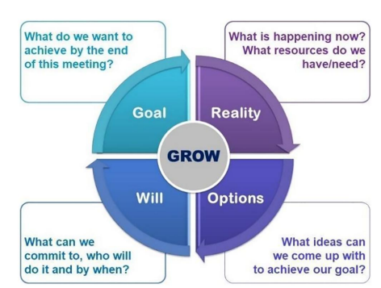
Figure: The GROW Model
(Source: Jelodari et al., 2023)

The CLEAR Model (Contracting, Listening, Exploring, Action, Review)
The CLEAR model covers contract or agreement, listening, analysis of options, action, and review. The model used in the session looks somewhat like CLEAR since there is an equal focus on listening and brainstorming solutions (Myers and Bachkirova, 2018). However, there was no contracting or review stage in the session and therefore it was less prescriptive than CLEAR. This more flexible approach also enabled a higher level of emotional appeal thereby enabling the needed correction of the phobia of speaking in public by Luciana.
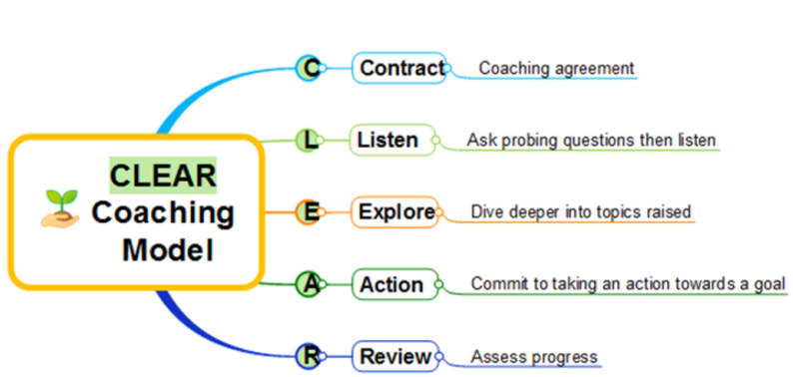
Figure: The CLEAR Model
(Source: LinkedIn, 2023)

Cognitive Behavioral Coaching (CBC)
CBC is concerned with changing negative cognitions to effect behavioural change (Mihăescu, 2023). For instance, in the case of Luciana, this would help in dealing with her concern about making a mistake and the agitation brought on by interruptions from the audience. Although it is arguable that the session on emotional regulation could be akin to the process of Cognitive Behavioural Coaching, it should be noted that, unlike CBC, the session did not include the process of cognitive restructuring as structured in the protocol. However, it was more inclined to build confidence with the practice of certain skills one can use in a given situation.

Similarities and Differences of the Approach
During the coaching session with Luciana, I had the liberty to mix the ideas from the different models. It incorporated GROW’s goal setting, and discovering options, some aspects of the CLEAR model including active listening and a bit of the CBC model that involves emotional limiting factors (Lungu et al., 2021). However, one of the key concerns remained in focusing on relations and empathy, which distinguished it from those models. The approach of one-to-one intervention was beneficial particularly for Luciana, because she had emotional issues that influenced her learning rather than a lack of skills.
Formal models such as GROW or CLEAR can offer more framework but cannot guide the coaching process as intensively focusing on the coachee’s emotions as Person Centred Coaching (Friedel, 2024). The practical appraisal and emotional orientation of the model employed with Luciana render it particularly suitable to her and guarantee both functional adaptation and personality development.

Conclusion
Finally, it can be concluded that coaching is a way to promote human development in individual and team contexts and can be effectively used in the contemporary world of work. It enables individuals to effectively face and possibly overcome obstacles through the development of abilities, demeanour, and strength. Coaching therefore involves the use of empathy, listening and flexibility which is evident in the case of Luciana. As much as formats such as GROW and CLEAR have been developed to guide the coaching process, a more liberal approach with more emphasis on the client usually has higher returns. Coaching embedded within organisational development initiatives is the key to helping the vast potential of the workforce deliver for the business.

References
Bozer, G. and Jones, R.J., 2018. Understanding the factors that determine workplace coaching effectiveness: A systematic literature review. European Journal of Work and Organizational Psychology, 27(3), pp.342-361.
Buheji, M. and Buheji, A., 2020. Characteristics of ‘problem-based learning’in post-COVID-19 workplace. Human Resource Management Research, 10(2), pp.33-39.
Cannon-Bowers, J.A., Bowers, C.A., Carlson, C.E., Doherty, S.L., Evans, J. and Hall, J., 2023. Workplace coaching: a meta-analysis and recommendations for advancing the science of coaching. Frontiers in psychology, 14, p.1204166.
Digirolamo, J.A. and Tkach, J.T., 2019. An exploration of managers and leaders using coaching skills. Consulting Psychology Journal: Practice and Research, 71(3), p.195.
Ellinger, A.D., Jones, J., Hamlin, R.G. and Beattie, R.S., 2023. The manager as coach. The complete handbook of coaching, pp.263-280.
Faithfull-Byrne, A., Thompson, L., Schafer, K.W., Elks, M., Jaspers, J., Welch, A., Williamson, M., Cross, W. and Moss, C., 2017. Clinical coaches in nursing and midwifery practice: facilitating point of care workplace learning and development. Collegian, 24(4), pp.403-410.
Fillery‐Travis, A. and Lane, D.A., 2020. Does coaching work or are we asking the wrong question?. Coaching Researched: A Coaching Psychology Reader, pp.47-63.
Friedel, C., 2024. Evaluation of a Cognitive Behavioural Coaching Programme for Secondary School Students, pp.34-78.
Grant, A.M., 2017. The third ‘generation’of workplace coaching: creating a culture of quality conversations. Coaching: An International Journal of Theory, Research and Practice, 10(1), pp.37-53.
Jelodari, M., Amirhosseini, M.H. and Giraldez‐Hayes, A., 2023. An AI powered system to enhance self‐reflection practice in coaching. Cognitive Computation and Systems, 5(4), pp.243-254.
Kaushik, M., 2020. Post COVID-19 world-A paradigm shift at workplace. Test Eng. Manag, 83, pp.1-13.
Khakwani, S., Aslam, H.D., Azhar, M.S. and Mateen, M.M., 2012. Coaching and mentoring for enhanced learning of human resources in organizations:(Rapid multiplication of workplace learning to improve individual performance). Journal of Educational and Social Research, 2(1), pp.257-266.
Kotte, S. and Bozer, G., 2022. Workplace coaching research: Charted and uncharted territories. In International handbook of evidence-based coaching, pp. 971-982.
LinkedIn, 2023. Unleash Limitless Potential: How the CLEAR Coaching Model Can Transform Your Practice, LinkedIn. Available at: https://www.linkedin.com/pulse/unleash-limitless-potential-how-clear-coaching-model-reba (Accessed: 5 December 2024).
Lungu, A., Boone, M.S., Chen, S.Y., Chen, C.E. and Walser, R.D., 2021. Effectiveness of a cognitive behavioral coaching program delivered via video in real world settings. Telemedicine and e-Health, 27(1), pp.47-54.
McCarthy, G. and Milner, J., 2020. Ability, motivation and opportunity: managerial coaching in practice. Asia Pacific Journal of Human Resources, 58(1), pp.149-170.
Mihăescu, D., 2023. The impact of cognitive-behavioral managerial coaching on human resource performance and efficiency in enterprises. In Competitivitatea şi inovarea în economia cunoaşterii, pp. 87-96.
Myers, A.C. and Bachkirova, T., 2018. Towards a process-based typology of workplace coaching: An empirical investigation. Consulting Psychology Journal: Practice and Research, 70(4), p.297.
Osatuke, K., Yanovsky, B. and Ramsel, D., 2017. Executive coaching: New framework for evaluation. Consulting Psychology Journal: Practice and Research, 69(3), p.172.
Palmucci, D.N. and Santoro, G., 2024. Managing employees' needs and well-being in the post-COVID-19 era. Management Decision, pp.1-10.
Passmore, J., 2019. Mindfulness in organizations (Part 2): a practitioners’ guide to applying mindfulness-based approaches in leadership development, workplace wellbeing and coaching. Industrial and commercial training, 51(3), pp.165-173.
Romão, S., Ribeiro, N., Gomes, D.R. and Singh, S., 2022. The impact of leaders’ coaching skills on employees’ happiness and turnover intention. Administrative Sciences, 12(3), p.84.
Tanıs, H. and Barker, I., 2017. E-mentoring at a distance: An approach to support professional development in workplaces. Turkish Online Journal of Distance Education, 18(3), pp.135-155.
Van Wyk, R., Odendaal, A. and Maseko, B.M., 2019. Team coaching in the workplace: Critical success factors for implementation. SA Journal of Human Resource Management, 17(1), pp.1-11.
Vlados, C., 2021. Designing integrated business training programs focused on the unemployed in the post-COVID-19 era. TEM Journal, 10(2), pp.645-655.
Yirci, R., Özdemir, T.Y., Kartal, S.E. and Kocabaş, İ., 2014. Teachers' perceptions regarding school principals' coaching skills. School Leadership & Management, 34(5), pp.454-469.

