Student Name: Adriana Trifu
Student ID: 1812538
Module code: BMSK4003
Lecturer: Gulnar Ali

certificate of higher education in skills for the workplace
Module name: Effective team working and Communication

Table of Contents
Introduction 2
What communication means? 2
Effective communication 2
Methods of communication 3
Relevant theories 4
Shannon Weaver’s Model 4
Schramm’s Model 5
Communication within the workplace 6
Improving workplace communication 7
Conclusion 8
References 9

Introduction
The following essay will show the importance of effective communication in a business organization, and how communication within the workplace and performance of employers can be improved, based on my personal experience and from what I know from theory. The purpose of this essay is also to identify possible potential reasons for successful and unsuccessful organizational communication.

What communication means?
The term “communication”, it refers simply to the act of sending information from one person, place or group to another.
“Communication is the exchange of thoughts, information, or ideas that results in mutual understanding between two or more people.” (Maund, Michaela and Tinkler, 2017)
For this procedure to take place, is necessary one sender at least, one to receive the message, and the message sent within a communication medium. The sender has a concept in mind, encodes that idea in the form of words, images, or gesticulation, then choose a medium to transmit those symbols in order to be accessed by the. A face-to-face discussion may be a medium, or any piece of art from an art gallery, any electronic transmission media or even a text message. After the receiver gets the message, he or she has to comprehend it, in order to understand the message and the sender’s intention.

Effective communication
Effective communication happens if the receiver gets and understands the message transmitted by the sender in an accurate form. Meaningful communication is an important factor for the success of any organization, but, frequently, the process may face a multitude of problems that obstructs the procedure and impede understanding. This process is a must for the easy running of a business and several methods of communication are used in the environment of a business, in order to achieve this.
If the communication takes place in a proper way, both the sender and the receiver get the same information correctly.
For the communication process to be effective, it requires certain skills, such as:
• Listening Skills – it refers to how we listen
• Non Verbal skills – means body language
• Para Verbal skills – how we say the words we use
• Verbal skills – what words we use
• Written skills – how we write

Methods of communication
There are different ways to communicate effectively in the workplace:
- Verbal Communication
- Written Communication
It is impossible to avoid written communication in the workplace. Letters, traditional paper and pen or letters, emails, text messages, reports, or any other documents of the day to day business life, for example:
- Nonverbal methods of communication
To be able to hear what is not being said, is vital in communicating effectively.
Wordless messages are part of any communication, usually used to reinforce verbal communication.
- Physical Nonverbal Communication, known as body language, is a face-to-face conversation, and that is why you need to maintain a proper body posture, eye contact, facial expressions, gestures like a pointed finger, touch, tone of voice, and others. “The body language during the interpersonal communication needs to be friendly to ensure the effectiveness of the communication” (Robles, 2012).

You also have to be aware of your movements or gestures, and eye contact. When communicating, the way you sit and stand, help in transferring the intended message. For example, you should use your gestures in an appropriate form, the hands should be left at your sides and is better to avoid fidgeting, because is distracting. If you cross your arms you will send the signal of being angry. It is totally inappropriate to stare or to roll your eyes when someone is talking to you, and also not to look in the eyes of the person you are talking to.

- The facial expressions are the most common form of nonverbal communication, and some emotions are hard to express using verbal communication, and you can use a frown or a smile to manifest them.

- Paralanguage
Another important element of nonverbal communication is the way things are being said instead of what it is said. The difference within a conversation, is made by the style of speaking, the tone, emotions, stress, voice quality and intonation.
In order to be effective communicators, we have to be careful with the tone we use, our appearance and body language, with the words we are trying to express. From my experience, when individuals lie, they use to blink more often. Tone is another nonverbal element of communication. Another example could be the tone we use, because it is possible to alter the message’s perceived meaning.

Relevant theories

Shannon Weaver’s Model

Fig. 1
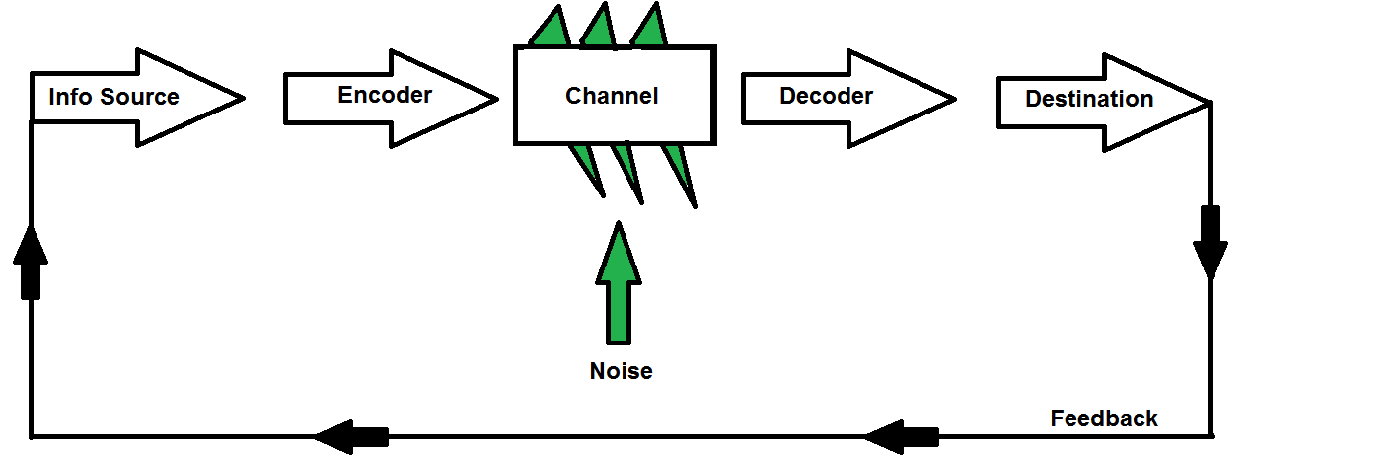

This model was created in 1948, and it is known as “mother of all models.”
Through a technological channel, such as telephone and telegraph, the sender encodes the message, and then sends that message to its receiver. Then, the sender changed the message into codes understandable to the machine.
The receiver needs to decode the message, and then to understand and interpret it. In some cases, the decoder can be the receptor machine. The communication process can also face problems; the channel can have noise, and because of that, the receiver might not have the capacity to decode that message.
The first purpose of the model was to improve technical communication for telephonic communication. It was made to increase as much as possible the telephone capacity with lowest level of noise. Later, it has been applied for all methods of communications, with the purpose of developing effective communication.

Schramm’s Model
Fig. 2
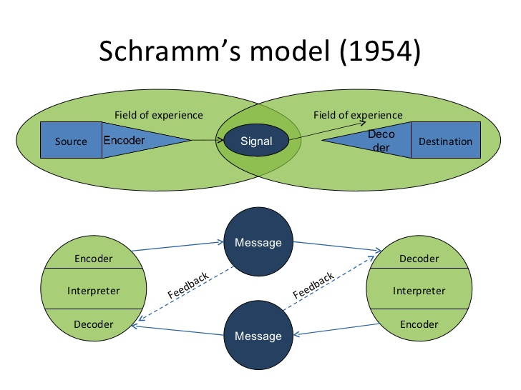

This model of communication was proposed in 1954, and has its roots from the Shannon Weaver’s model itself.
The process consists in putting the effective information into words and then conveying that information to others. The role of encoding is to initiate the process of communication by converting the thought into content. After the information reaches the recipient, its main responsibility is to understand the speaker intention. The message is useless if the second party cannot decode what the sender wants to communicate. Without the two most important factors: encoding and decoding, information can never progress between two individuals. According to the Schramm’s model, the two essential processes of an effective communication are coding and decoding. He also highlights that without a feedback from the recipient, communication is incomplete, because communication is in fact a two-way process between the first party and the second party.

Communication within the workplace
Effective communication between colleagues reduces misinterpretation and maximizes work efficiency. Ineffective communication undercuts our capacity to execute. If you cannot connect and communicate with your co-workers in an effective way, will be difficult for you to finish your work successfully. Now, I would like to shortly present you how I concluded that communication between co-workers is the key to a productive workforce. I will give you one example from my own experience at the last job, in order to sustain my conclusion. I have been through different situations and I realise how hard is to communicate within the workplace and also being part of a team.
One day at work I went through a situation where ineffective communication ended up with an angry customer. I was communicating by phone, with one of our loyal customers. He wanted to change the delivery address for the order he placed on Just Eat, which is a home delivery app, and because of the noise made by my other colleagues, I was distracted and I did not understand what the client wanted to communicate. I heard that our customer request was to cancel the order and so I did. After one hour, the client called us again, unsatisfied and angry. His tone made me realise how mad he was at that time. I apologized, but it was too late to fix the mistake I have made. Because of our ineffective communication and unprofessionalism within the workplace, the customer made a complain to the head office.

Improving workplace communication

- Do not bury the lead.
This means writing the most important thing first; each successive paragraph can flesh out the main idea for those who are interested in reading further.
If you need something, you have to ask for it clearly, and always start with the main point.
- Be a good listener
Effective communication is a two-way street. It is important to hear the message other people are trying to deliver to you. Multi-tasking while someone is trying to have a conversation with you, will make the conversation ineffective. You also have to stop thinking about the way in which you are going to respond.
- Listen actively
“One of the sincerest forms of respect is actually listening to what another has to say” (Bryant H. McGill).
Listen actively to your colleagues, will show them your respect and your interest about what they are saying. You have to pay attention when other people are talking to you, trying to orientate your body towards them, and look them in the eyes, during the conversation. If when they are talking, you interrupt them, you will not be able to understand what they are trying to say, and you will also show respect if will not try to reply before they finish talking. In case you have any questions, then you can ask them to clarify any issues you may have. One important thing is to not email or text while someone is talking to you.
- Understand your owncommunication style
There are different communication preferences regarding the words and media we use, depending on each person. It is possible to communicate nonverbal information through the tone or body language, such as eye-rolling, or including emoji in every thread.
- Show Respect
You have to treat others the way you would like to be treated. The language you use and also your non-verbal communication shows people your lack of respect. I know from my own experience that if you do not respect the person you are talking to, you will not be able to communicate effectively. I went through a situation like this, at my last job, with one of my co-workers. In order to do your job efficiently and safely, you have to communicate effectively with your colleagues, acting like a team, no matter the personal feelings you have about them. Me and a colleague of mine, we were arguing from personal reasons, before work. Later, when we started our shift at the coffee shop and we were supposed to work together, as a team in order to do our job in an effective way, my colleague offended me and raised the tone of his voice, right in front of a client. We started arguing again and as a result of our inappropriate form of communication and disrespect, our client made a complain about us to the head office.

Conclusion
The process of communication and its effectiveness help to develop an effective team. In order to meet the objectives of the organisation, an effective teamwork, with effective communication skills, is needed. This paper has discussed the effective strategies and the importance of forming an effective team, based on relevant theory, but also from my own experience within the workplace.

References
Maund A., Schriek M., Tinkler P. K. (2017), Certificate in Higher Education: Skills for the Workplace Student Yearbook, SAGE Publication Ltd, London
Morgan P. (2017), The business student’s guide to study and employability, SAGE Publication Ltd, London
Robles, M.M., (2012). Executive perceptions of the top 10 soft skills needed in today’s workplace. Business Communication Quarterly, 75(4), pp.453-465.

Ruck, K. and Welch, M., (2012). Valuing internal communication; management and employee perspectives. Public Relations Review, 38(2), pp.294-302.

West, M.A., (2012). Effective teamwork: Practical lessons from organizational research. John Wiley & Sons.

Links:
Fig. 1
https://www.google.ro/search?q=shannon+weaver+model&client=opera&source=lnms&tbm=isch&sa=X&ved=0ahUKEwj8uorb9ZPiAhXmSxUIHX8ZCJAQ_AUIDigB&biw=1647&bih=862&dpr=1.13#imgrc=Tlxxa9tzjUZoAM [accessed on 08.05.2019]
Fig. 2
https://www.google.ro/search?q=schramm+model+of+communication&client=opera&hs=KCY&source=lnms&tbm=isch&sa=X&ved=0ahUKEwjWjLWZ9pPiAhXNShUIHSbOAR0Q_AUIDigB&biw=1647&bih=862&dpr=1.13#imgrc=Fln8yr23iW_fSM [accessed on 08.05.2019]

