University of Wales Trinity Saint David

Dishant moradiya
Student id : 2213506
Subject: H.R.M ( LCMB7000 )
Professor : M.rehman

Table of Contents
Introduction 3
Discussion 3
Current state of the UK’s labour market 3
Emerging changes in Human Resourcing Strategies during a post-Covid, post-Brexit external environment 8
Conclusion 10
Reference list 12

Introduction
Human resource management is one of the strategic approaches that is used for supporting and nurturing employees for enhancing a positive environment in the workplace. The functions of HRM varies based on different industries and business. It includes th typical functions of recruitment, benefits, compensation, employee relations, as well as training and development. HRM is originally called people or personnel management, which is the fundamental part of any organisation. Moreover, to make maximum use of the organisation's human resources, HRM focuses on developing, planning and administering programs and policies. The study is to evaluate the latest situation in the labour market of the UK. Furthermore, the coming changes in the strategies of human resourcing in the Post-Covid, Post-Brexit external environment is to be also evaluated by the study. Tackling the initial economic shock from Covid-19 and Brexit remained to be the most significant issue that impacted changing the strategies of HRM.

Discussion

Current state of the UK’s labour market
The UK is having the chance of stepping into the downturn soon, and at this point, the country results in estimating the balance of net employment to fall, which may turn it negative. After the downturn hit, employers started to change and present a new set of rules and policies. It has been noticed that about 46% of recruiting employers have faced harder challenges in filling vacancies.
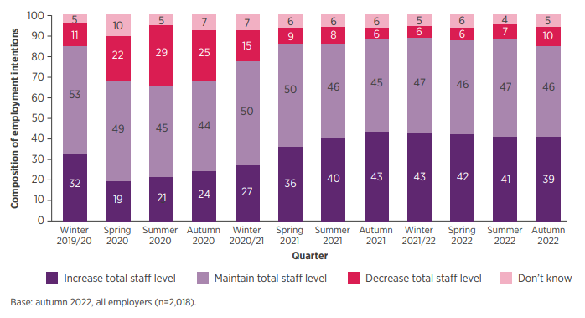
Figure 1: Composition of Employment intentions
(Source: Cipd.co.uk., 2022)
Some of the highest responses related to "hard-to-fill" vacancies were due to the upskilling of already existing staff, which is about 47% which is followed by raising pay which amounted to 44%, which is up in the previous quarter by 29%. On the other hand, in order to overcome this situation associated with "hard-to-fill" vacancies which are 24%, only fewer employers resulted in enhancing appropriate planning related to increasing wages in the near future (Andrew Powell., 2022).
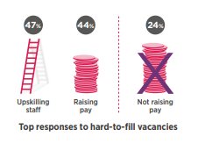
Figure 2: Responses to fill vacancies
(Source: Cipd.co.uk., 2022)
However, the redundancy intentions remained at a lower level which is currently increasing. In 3 months to December 2022, about 16% of employers are creating plans for making redundancies which is up from 13% last quarter. In total, the median of predicted basic pay raised, and it stands to about 4%; the predicted pay awards for the private sector have increased to a median of 5%, which is the most inflated of any sector.
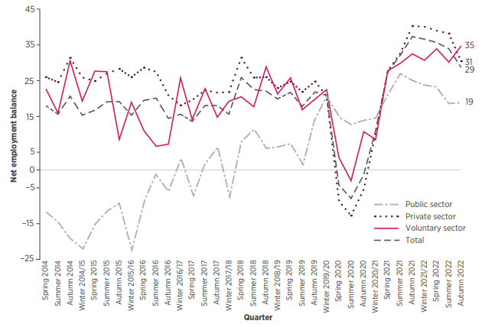
Figure 3: Net employment balance
(Source: Cipd.co.uk., 2022)
In 2022, from June to August, the employment rate in the UK was about 75.5% which is about 0.3 points lower in comparison to the previous quarter, which is March to May 2022, which results in offering a relatively higher rate of employment as compared to other periods. Self-employed workers decreased while the employee number lowered in the quarter. This rate of employment is considered to be 1.0% lower compared to before the pandemic situation. September 2022 displayed a monthly increase for the most timely estimation associated with payrolled employees, which is about 69,000, increased on August 2022, which set a record of about 29.7 million. However, on the other hand, the rate of unemployment for June to August 2022 reduced by about 0.3% points for the quarter to 3.5%, which is targeted to be the lowest rate from December to February in 1974 (Ons.gov.uk., 2022). Even though there was an increase in the employed number of people in the quarter, there has been a decrease in the short-term, which is up to 6 months and long terms which is more than 12 months. It has been discovered that the employee people number per vacancy fell to a low record of about 0.9% from June to August 2022.
As compared to the previous quarter, which is from March to May 2022, the rate of economic inactivity also raised by about 0.6% points to around 21.7% during the period of June to August 2022. The labours who belong to the age group of 50 to 64 and 16 to 24 years remained responsible for driving an increase in this latest quarter.
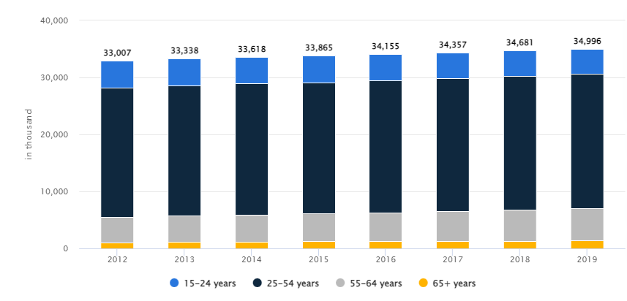
Figure 4: Labour force by Age
(Source: Statista.com., 2022)
The prior reason behind the economic inactivity is due to the quarterly increase that has been driven by the people as they were students or maybe on long-term leave. A high record has been built under the number of economically inactive due to long-term sick. On the other hand, the predicted vacancies number reduced by 46,000 in the quarter, that is, from the period July to September 2022 to about 1,246,000, which is considered to be the greatest fall in this quarter since 2020 June to August. It has been noticed that the vacancies number stayed at a historically higher level instead of the quarterly falls in 3 consecutive time.
However, from June to August 2022, the growth in daily pay, excluding bonuses, amounted to about 5.4% among the employees, and the growth in the average total pay, including bonuses, amounted to about 6.0%. This rate determines the growth most strongly in the daily pay that is seen out of the Covid-19 period. For the private sector, the average growth of the daily pay amounted to 6.25 and for the public sector amounted to 2.2% (Ons.gov.uk., 2022). This is regarded to be the largest growth experienced by the private sector out of the height of the pandemic period and is also said to be the largest difference between the public and private sectors. In context to real terms, that is, after adjusting the inflation of the entire year, the total pa amount was reduced by 2.4%, and the regular payment amount was reduced by 2.9%. This amount is relatively slightly lower as compared to that of the largest growth fall over the comparable records, which started in 2001.
The intentions of recruitment are above the pre-pandemic levels, which means 7 out of 10, that is about 69% of employers, are further planning to start their recruitment process in the next 3 months. The intention of recruitment in the public sector is given the highest priority, which amounted to 80% is then followed by the Voluntary sector, which is about 74%, whereas the private sector amounted to about 66%.
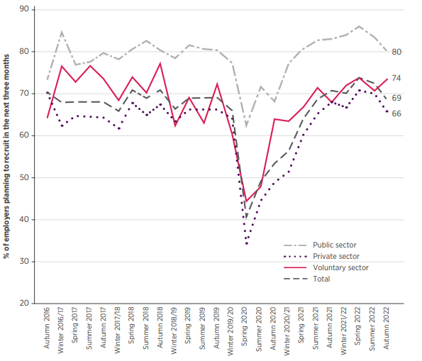
Figure 5: Recruitment intentions by broad sector
(Source: Cipd.co.uk., 2022)
In the industry sector, about 4,869k male employees worked in 2019. In the same year, the 25 to 54 years old labour force amounted to about 23,562K and the rate of unemployment is estimated to be about 4.3% for this country in 2025 (Statista.com., 2022).
Recommendations
Based on the above outlook of the current labour market of the UK, certain recommendations are being provided below:
Focusing on the existing workforce is the most important recommendation that could be adopted by the employers of the different sectors in order to balance the income level. In order to fill the skill gaps, training could be offered by the employers to reskill or upskill staffs which could further lead to retention and engagement of employees. Internal secondments are required to be taken into consideration which could be used in both processes that are for the offering of development opportunities as well as a path of redeploying the workforce to the significant areas of needs.
Supporting alleviating cost-of-living strainsassociated with the workforce through granting financial well-being in order to ensure support to employees. Moreover, in order to support them, the approaches of reward are required to be reviewed for the identification of the best results. It is also to be looked upon by the employers that the financial well-being and reward approaches are able to ensure support to the staff. Furthermore, the impact of any changes is to be regularly assessed to enhance that the work is intended.
Considering all optionsbefore making staff redundant if an organisation is passing through any hard times. Organisations must take into consideration of redundancies as the last option. Being an employer, it must be the priority to explore some of the other cost-cutting measures firsts, which include the reduction of working hours or redeploying of staff. Adopting these measures will favour the organisations in avoiding the chances of any unfair dismissal claims.
Pay outlook is to be improved by the employers based on the situations in order to cut additional costs along with grabbing the interests of the staff. Employers are required to ensure proper planning of pay review. Similarly, it may be said that an increase in pay for employees is the most common and well-known option that could be utilised for obtaining positive results in this case. It has been noticed that only 1% of staff expects a decrease, and about 6% of staff expects a pay freeze; however, about 37% of staff feel it is hard to tell the employers about the pay outlook.

Emerging changes in Human Resourcing Strategies during a post-Covid, post-Brexit external environment
Brexit remained the centre of attention in 2019, and therefore, the firms of the UK remained engaged in the development of Contingency plans for their business following the Exit of the EU. On the other hand, Covid-19 took hold in 2020, which diverted the attention of employers (Deloitte.com., 2022). In order to deal with the immediate and pervasive impact of the pandemic, many of those working in Brexit has been deployed for dealing with this. On 31st December 2020, the transition period with the EU of the UK experienced an end. Hence, as the pandemic has completely transformed the economic context related to Brexit, the leaders of business are required to interplay among this two. As compared to Brexit, the uncertain hit to growth and demand from Covid-19 is unquestionably significant. Some of the important areas taken into consideration for tackling the impact of both Covid-19 and Brexit are as follows:
Supply chain is the primary area that displayed the largest interplay between Covid-19 and Brexit, and automotive is regarded to be a clear example in this case as the sector had experienced a hard hit as a result of the combined challenge (Spieske and Birkel 2021). Automotive had remained to be a bellwether for the largest drop in consumer demand. On the other hand, the plunged due to the advent of Covid-19 has increased along with registration of new cars reduced by 40% during the phase of January to August.
People are the other prominent area that is to be also focused on for adapting to the latest changes. Both Covid-19 and Brexit have resulted in changing the labour market (Mayhew and Anand, 2020). Due to the pandemic, the staff themselves is not willing to move from the UK to the EU due to the Covid-19 lockdown measures. As a result, unemployment is further expected to increase, which could result in the creation of service gaps.
Resources are another important areas that have been affected due to the advent of the pandemic as well as Brexit (Tetlow and Pope, 2020). The leaders of business are further required to deal with the financial shocks associated with both Brexit and Covid-19. A larger impact has been determined by the pandemic, which created a heavy blow to the cash flow and balance sheet, along with a decrease in profitability along with a sharp rise in Corporate debt.
Some of the emerging changes in the strategies of human resourcing include
Flexibility: the New Normal
Due to the emergence of the global pandemic, staff are being offered the option of Working from home or a hybrid set which is likely to continue in the near future. Brexit has resulted in the creation of volatility economically, which is further creating indirect consequences for certain things such as pensions, financial incentives and bonuses. About 20% of all available positives accounted for remote jobs, which received more than 50% of all applications (McCabe, 2021). Tops performers are recruited by those employers who offer opportunities for staff to work in a hybrid set or remotely. As a result, in place of the traditional 9 to 5 in-office or full-time schedule, an increasing number of employers continue to offer staff the option of virtual office options. Nowadays, location is not the foremost consideration of the candidates, whereas they are mostly concerned with debating the cons and pros of remote vs in-office work (Babapour et al. 2021). This emerging change is required to be adopted by HR for recruiting the top performer along with maintaining mutual trust as well as employee motivation in the near future.
Prioritising Employee Wellness
The emergence of the pandemic has raised the necessity for the wellness and health of employees. The stress level of individuals has increased due to the imminent threat of Brexit and the pandemic. As a result, the health of the families is their major concern, along with determining whether the market's volatility will jeopardise their jobs. HR is required to develop initiatives related to wellness as well as programmes of employee assistance to address the mental and physical health of staff (Tuzovic and Kabadayi, 2020). A study conducted by Gartner proved that about 21% of commitment and motivation are increased due to the offering of a comprehensive well-being program. Working styles and managing process of new talents is to be applied by organisations due to the impact of Brexit and the pandemic. In order to recognise the mental health-related concerns of staff, HR professionals must make use of techniques. Moreover, HR must also empower the staff to exercise routines and participate in fitness-related programs as well as other healthy habits (Azzouzi et al. 2022). Overall an all-encompassing plan for the well-being of the employees is to be created, which must prioritise the physiological, psychological and fiscal health of the staff.
Reskilling and Upskilling
Rather than annual activities, in today's competitive environment, employee training and development are important. For boosting their morale and productivity, companies are maintaining a premium on skill development and training. Researchers have discovered that over 94% of workers results in staying in the same company for a longer period of time. The development of skills is a crucial part that is to be facilitated for driving positive results. Brexit and Covid-19 are not so easy to manage as they had anticipated negative impacts on the daily process of the companies (Qamar et al. 2022). Employee shortage is being faced by companies due to a lack of appropriate skills among the staff. Brexit has empowered a positive outlook across companies for continuing working.

Conclusion
It can be concluded that the companies operating in the UK have faced severe issues due to the joint impact of Covid-19 and Brexit. In order to tackle the change, most employers had resulted on focusing in the pay outlook to grab the attention of the top performers. Employers have also proposed flexible working environments as well as increased the wages of the employees for reducing the cost-of-living crisis. A positive outlook is to be encouraged by the companies for balancing the practical aspects of Brexit and the pandemic. It has been identified that staff requires opportunities for hybrid and remote working facilities during the post-pandemic situation. However, HR must prioritise the initiation of new well-associated policies.

Reference list
Andrew Powell., 2022. House of Commons Library. UK labour market statistics. Available at https://researchbriefings.files.parliament.uk/documents/CBP-9366/CBP-9366.pdf [Accesed on 19/12/22].
Azzouzi, S., Stratton, C., Muñoz-Velasco, L.P., Wang, K., Fourtassi, M., Hong, B.Y., Cooper, R., Balikuddembe, J.K., Palomba, A., Peterson, M. and Pandiyan, U., 2022. The impact of the COVID-19 pandemic on healthy lifestyle behaviors and perceived mental and physical health of people living with non-communicable diseases: An international cross-sectional survey. International Journal of Environmental Research and Public Health, 19(13), p.8023.
Babapour Chafi, M., Hultberg, A. and Bozic Yams, N., 2021. Post-pandemic office work: Perceived challenges and opportunities for a sustainable work environment. Sustainability, 14(1), p.294.
Cipd.co.uk., 2022. CIPD. LABOUR MARKET. OUTLOOK Autumn 2022 VIEWS FROM EMPLOYERS. Available at https://www.cipd.co.uk/Images/labour-market-outlook-autumn-2022_tcm18-112526.pdf Accesed on 18/12/22].
Deloitte.com., 2022. Deloitte. Tackling Brexit and COVID-19 together. Available at https://www2.deloitte.com/content/dam/Deloitte/uk/Documents/international-markets/deloitte-uk-tackling-brexit-and-covid-19-together.pdf Accesed on 20/12/22].
Mayhew, K. and Anand, P., 2020. COVID-19 and the UK labour market. Oxford Review of Economic Policy, 36(Supplement_1), pp.S215-S224.
McCabe, S., 2021. Will the new ‘normal’be that different?.
Ons.gov.uk., 2022. Office for National Statistics. Data and analysis from Census 2021. Home. Labour market overview, UK: October 2022. Available at https://www.ons.gov.uk/employmentandlabourmarket/peopleinwork/employmentandemployeetypes/bulletins/uklabourmarket/october2022#:~:text=The%20employment%20rate%20is%201.0,to%20a%20record%2029.7%20million Accesed on 21/12/22].
Qamar, A., Collinson, S. and Green, A., 2022. Covid-19 disruption, resilience and industrial policy: the automotive sector in the West Midlands. Regional Studies, pp.1-15.
Spieske, A. and Birkel, H., 2021. Improving supply chain resilience through industry 4.0: A systematic literature review under the impressions of the COVID-19 pandemic. Computers & Industrial Engineering, 158, p.107452.
Statista.com., 2022. Statista. Labor Force - United Kingdom. Available at https://www.statista.com/outlook/co/labor-force/united-kingdom Accesed on 19/12/22].
Tetlow, G. and Pope, T., 2020. Brexit and coronavirus: economic impacts and policy response.
Tuzovic, S. and Kabadayi, S., 2020. The influence of social distancing on employee well-being: a conceptual framework and research agenda. Journal of Service Management, 32(2), pp.145-160.

