ECIE4012
The Principles of Learning and Teaching

Portfolio

Student Number:2317370

Blog 1
Understanding Skinner’s Theory of Learning
B.F. Skinner, an influential American psychologist, is best known for his groundbreaking studies in behaviourism and the concept of operant conditioning. Skinner's theory of learning, in contrast to earlier psychological theories that relied on introspection, focusses on how consequences shape behaviour. This blog delves into the fundamentals of Skinner's theory, including how it applies to education and behaviour modification, as well as its relevance in the modern world.
The Basics of operant conditioning
The key concept of Skinner's theory is operant conditioning, which holds that behaviour is influenced by its consequences. Unlike classical conditioning, which involves associating an involuntary response with a stimulus, operant conditioning focusses on voluntary behaviours and the consequences that result from them (Skinner, 1953). Skinner proposed that behaviours followed by positive outcomes are more likely to be repeated, whereas those followed by negative outcomes are less likely to reoccur.
This process is accomplished through reinforcement and punishment. Reinforcement may be positive or negative. Positive reinforcement occurs when a behaviour is followed by a rewarding stimulus, increasing the likelihood that the behaviour will be repeated. For example, when a student is praised for completing their homework, they are more likely to do so again.
On the other hand, punishment is used to reduce a behaviour. It can be either positive (adding an unpleasant outcome) or negative (removing a desirable outcome). For instance, if a child is scolded for throwing a tantrum, they may be less likely to indulge in similar behaviour in the future.
Positive reinforcement
Positive reinforcement occurs when a desirable outcome follows a behaviour. A bonus for good work, for example, motivates employees to work harder. It is used in a variety of settings, including the workplace, to promote innovative ideas and actions.
Negative reinforcement
Negative reinforcement occurs when a bad thing disappears after you do something good. For example, if you work hard, you may not have to complete a difficult task. It motivates people to do things because they do not want to face a negative outcome.
The theories of B.F. Skinner are essential to education, particularly when it comes to student motivation and classroom management. According to his idea, students behave better in situations that are structured. Additionally, it uses rewards to make learning enjoyable.

Classroom management techniques
A strong learning environment requires effective classroom management. Skinner's theories offer a few strategies for effective classroom management. These consist of:
- Positive Reinforcement: Rewarding excellent behaviour and motivating pupils to behave well.
- Behaviour contracts: Clearly defining objectives and incentives to let pupils know what is expected of them.
- Token Economy: By rewarding excellent behaviour with tokens that they may exchange for incentives, students are encouraged to maintain their course.
To support students' learning, teachers might also employ prompting and shaping. Teachers can transform challenges into opportunities for learning by being aware of the consequences of their actions.
The role of reward systems
A significant component of Skinner's work on reinforcement is reward systems. They play a crucial role in promoting appropriate conduct in classrooms. Students can become more responsible and motivated to learn with the help of an effective reward system.
Negative reinforcement is most effective when applied quickly, frequently, and consistently. This increases the effectiveness of rewards. It fosters a motivated learning atmosphere and aids teachers in better classroom management.
Skinner’s influence on psychology
Many aspects of psychology, particularly behavioural therapy, have evolved because of B.F. Skinner's work. He demonstrated how incentives and penalties impact human behaviour. This information aids therapists in methodically altering negative behaviours.
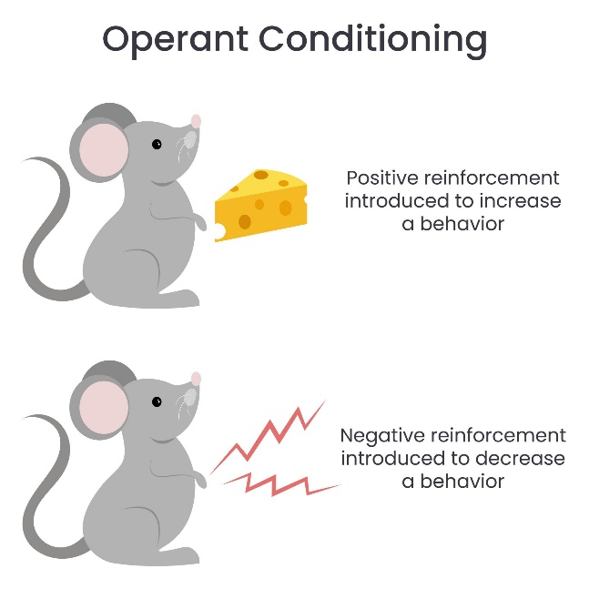
(Simplypsychology.org, 2023)

Blog 1: Reference list
Logan, D.W. (2024). Exploring Skinner Theory: Insights You Should Know. Studying HQ. https://studyinghq.com/how-to/skinner-theory/.
Simplypsychology.org. (2023). https://www.simplypsychology.org/wp-content/uploads/Operant-Conditioning-Reinforcement-1-1024x1024.jpeg.
Skinner, B.F. (1953). Science and human behaviour Bfskinner.org. https://www.bfskinner.org/newtestsite/wp-content/uploads/2014/02/ScienceHumanBehavior.pdf.

Blog 2
Understanding Vygotsky Theory of Learning
The Russian psychologist Lev Vygotsky is most recognised for his developmental psychology theories. He wrote about many different subjects. As time went on, his opinions evolved. In addition to the significance of language and culture in cognitive development, he was a pioneer in the idea of the zone of proximal development. Vygotsky wanted “to create a new and comprehensive approach to human psychological processes” (Kurt, 2022).
Alexei Leontiev, Boris Varshava, Leonid Zankov, and Alexander Luria were among the students who Vygotsky brought together between 1926 and 1930 to begin studying the development of higher cognitive functions such as language comprehension, logical memory, selective attention, and decision-making. Three distinct perspectives were used to study this phenomenon:
- The cultural-historical approach examined how patterns of social and cultural interaction alter forms of mediation and developmental processes.
- The developmental approach examined how children develop more complex cognitive abilities.
- The instrumental method investigates how people utilise things to help with memory and thinking mediation.
What is his theory?
According to Vygotsky's social development theory, social interactions can direct and mediate a child's cognitive growth and learning ability. His idea (also known as Vygotsky's Sociocultural theory) asserts that learning is a fundamentally social activity rather than an autonomous voyage of discovery. He goes on to say that having a more informed community member, such as a parent or teacher, facilitate a child's learning is extremely beneficial.
Vygotsky's sociocultural theory also proposed that children internalise and learn from the beliefs and attitudes they observe around them. He felt that culture played a significant part in determining cognitive development, which differed among civilisations. Vygotsky also emphasised the importance of language as the foundation for all learning.

Three Key Elements of Vygotsky's Theory
Vygotsky's social development theory consists of three major components:
- The Zone of Proximal Development (ZPD) This concept emphasises the gap between a learner's existing abilities and potential, which can be bridged with the assistance of more educated peers or scaffolding.
- Scaffolding is the assistance provided by teachers, classmates, or more skilled individuals to help students bridge the gap between their current ability level and the level required to complete a task independently.
- Cultural artefacts, language, symbols, and social interactions all play an important part in cognitive development, influencing people's comprehension of the world and problem-solving skills. (Psychology, 2024)
(Brodie, 2024)

(Timetoast, 2025)

Blog 2: Reference list

Brodie, K. (2024). Lev Vygotsky’s Sociocultural Theory of Cognitive Development. https://www.earlyyears.tv/vygotsky-sociocultural-cognitive-development-zpd/.
Gowrie (2024). Lev Vygotsky’s theory of child development.
https://www.gowriensw.com.au/thought-leadership/vygotsky-theory.
Kurt, S. (2022). Lev Vygotsky: Who He Was and What He Has Done. https://educationaltechnology.net/lev-vygotsky-who-he-was-and-what-he-has-done/.
Psychology, E. (2024). Vygotsky’s Social Development Theory - Explore Psychology. https://www.explorepsychology.com/vygotsky-social-development-theory/.
Timetoast.
https://www.timetoast.com/timelines/historia-de-la-pedagogia-y-sus-maximos-exponentes.

Blog 3
The theoretical approaches to learning portray a range of ways that shape how we understand, perceive, and retain information. Within my workplace I identify positive behaviour one example of this can be seen in rewarding systems in my first blog. We also portray classroom management techniques, which linking to my first blog Skinner advocated for several teaching practices that modern "progressive" educational reformers support, including scaffold instruction, small units, instruction repetition and review, and instant feedback.
Linking to skinner’s theory the positive impacts of portraying rewarding systems is encouraging learners within schools to work and study harder towards their work. Another positive impact would improve learners' academic performances. Skinner’s reward systems would create a more positive classroom atmosphere. It would also enhance self-esteem and confidence in students. (NeuroLaunch editorial team, 2024)
Skinner’s theory of classroom management techniques has a positive impact towards students because students would benefit from no major distractions in the classroom. Another positive impact of classroom management techniques is students building relationships with peers and educators to strengthen their social and emotional skills. Educators creating a fun and interesting way for students to learn would have a positive impact on classroom management. (Augusta University, 2024)
Linking back to skinner’s theory the negative impacts of portraying rewarding systems is learners may lose interest in their learning as they would think if they do not work hard enough, they will not be rewarded. Another negative impact would be causing unhealthy competition amongst learners or even emotional damage, students would see it as the learner with the most reward system points is the smartest in the class. Skinner’s theory was to see the positive side of reward systems so they should be implemented correctly.
Skinner’s theory of classroom management has a negative impact towards learners because with substandard classroom management the classroom would have increased disruptions. Another negative impact would be a negative classroom climate which means the classroom and students would be chaotic and “out of control.” Negative classroom management would leave an impact on the educators' well-being. (News, 2024)
The theoretical approaches to learning portray a range of ways that shape how we understand, perceive, and retain information. Within my workplace I identify positive behaviour one way of portraying this is through the example of social development and child's cognitive growth and learning ability in my second blog.
Linking to Vygotsky's theory, the positive impact of social development is it can help their academic performance. Another positive impact is involvement in extracurricular activities to where learners can socialise with peers and make friends. Vygotsky’s Social development theory has a positive impact on students when it comes to their family as it would encourage them to socialise with their families.
Vygotsky’s theory of child’s cognative growth and learning ability has a positive impact because it improves a child's motivation towards their learning. Another positive impact is improving learns physical development and physical fitness. Educators can create a positive impact by supporting a learner's academic progress.
Linking back to Vygotsky’s theory the negative impact of portraying social development is parenting practices that impede children’s intellectual and behavioural development, would leave them less prepared for “critical thinking” situations.
Vygotsky’s theory of child’s cognative growth and learning ability has a negative impact towards learners' motivation towards their work, they would affect a child's academic performance. Another negative impact is a learner not getting the correct support from their educator.
To summarise, both Skinner's and Vygotsky's theories provide valuable insights into the learning process, highlighting distinct but complementary aspects of how students interact with and absorb information. Skinner's emphasis on rewarding systems and classroom management highlights the value of positive reinforcement, which, when used correctly, can foster a productive and supportive learning environment. Positive outcomes, such as improved academic performance, increased self-esteem, and a positive classroom environment, demonstrate the effectiveness of Skinner's methods. However, potential negative outcomes, such as unhealthy competition or a sense of reward dependency, highlight the importance of applying his theories carefully to avoid unintended consequences.
Similarly, Vygotsky's theories of social development and cognitive growth emphasise the significance of social interactions, familial support, and collaborative learning. These elements can greatly improve academic performance, motivation, and physical development. However, difficulties may arise if children are not given adequate guidance or support, or if external factors, such as harmful parenting practices, impede their development.
Finally, both Skinner and Vygotsky provide frameworks that educators can use to create a balanced and supportive learning environment, but these approaches must be carefully considered and tailored to the needs of individual students. Understanding the positive and negative implications of these theories allows educators to better guide students towards success while minimising potential drawbacks.

Blog 3: Reference list
Augusta University (2024). Why Is Classroom Management Important?
https://www.augusta.edu/online/blog/why-is-classroom-management-important.
Crittenden, J. and Gray, J. (2024). The importance of play-based learning beyond EYFS: https://my.chartered.college/research-hub/the-importance-of-play-based-learning-beyond-eyfs/.
Educationtask.com. (2023). Understanding The Negative Effects of Reward Systems in Classrooms
https://www.educationtask.com/negative-effects-of-reward-systems-in-classrooms.html.
NeuroLaunch editorial team (2024). Rewards for Good Behaviour at School: Effective Strategies for Motivating Students.
https://neurolaunch.com/rewards-for-good-behavior-at-school/.
News, eSchool (2024). Advantages and Disadvantages of Classroom Management. https://www.eschoolnews.com/innovative-teaching/2024/04/05/advantages-and-disadvantages-of-classroom-management/.
PsychologyWriting.com. (2022). Cognitive Theory: History, Strength, and Weaknesses | https://psychologywriting.com/cognitive-theory-history-strength-and-weaknesses/ .
Thomson, S. (2021). Disadvantage hindering social and emotional development. https://www.teachermagazine.com/au_en/articles/disadvantage-hindering-social-and-emotional-development .

Blog 4
Draw on experiences from your own setting to identify resources and strategies used to support effective teaching and learning, linking back to your chosen theories in Blogs 1 & 2

In my setting linking to skinner

Blog 4: Reference list

