

MARKETING ESSENTIALS

BMIH4005

  - SUPPORTING MARKETING PLAN

Student name: Mihaita Ionut Manda

Student ID number: 2232074

Lecturer: Scott James

Word Count: 1359

Table of Contents
Introduction 3
Situation Analysis 3
Company 3
Customers 3
Competitors 4
Collaborators 4
Climate 5
Marketing Mix 5
Objectives 5
Strategy 6
Tactics 7
Actions 8
Control 8
Conclusion 8
References 10
Appendices 12
Appendix 1 – SWOT analysis 12
Appendix 2 – Customer segmentation 13
Appendix 3 – Perceptual Positioning Map 14
Appendix 4 - Bowman’s Strategy Clock 15
Appendix 5 – PESTLE analysis 16
Appendix 6 – Marketing mix 17
Appendix 7 – Gantt Chart 18
Appendix 8 – PowerPoint Presentation Slides 19

Introduction
The management of any venture has to be aware enough of the marketing strategies, objectives and performance level to encapsulate betterment in marketing eventually (Ferrell, Hartline and Hochstein, 2021). The chosen organisation for the marketing plan is the UK-based hotel chain Holiday Inn which is a part of the Intercontinental Hotel Group Plc. Recovering from the atrocious impact of Covid-19 the group has improved eventually and in 2022, has generated a net revenue of 20.75 billion GBP (Statista, 2023 a). Here in this marketing plan, different frameworks will be used encompassing the strategic approaches of the company. These will include SWOT analysis, PESTLE, Marketing mix, SMART Targeting, Ansoff Matrix and others.

Situation Analysis

Company
Considering the UK-based hospitality organisation Holiday Inn, the strengths and weaknesses can be evaluated with the help of a SWOT analysis. Within the strengths, it has to be mentioned that all the hotels under the intercontinental hotel group are seriously following the local and governmental laws fostering a productive reputation (ihg, 2023). The weakness, and lacking of technological upliftment can be mentioned as decreasing the efficacy of the hotel in the contemporary world of business. The stronghold areas are both optimistic and opportunistic as it is correlated with brand loyalty and reputation to maintain customer success. While on the other hand, due to a lack of technical expertise Holiday in was encountered a cyber-attack in 2022 (Boyd, 2022).
[Refer to Appendix 1]

Customers
Segmentation: Based on the performance level and regarding statistics, the millennials with the age span of 25-34 must be the primary focus targeting both genders to consider the demographic segmentation. After the covid pandemic, the main issue in hospitality is hygiene maintenance where awareness is major in Generation Y.
[Refer to Appendix 2]

Targeting: The market is hugely opportunistic as the Hotel industry in the UK has a market size of 16.42 billion GBP in 2022 (Statista, 2023 b).

Competitors
Perceptual position map
In order to elucidate the position of Holiday Inn in the competitive market of the UK hospitality sector, it has to be justified by certain means. To be more clarified with the positioning based on the Perceptual map Holiday Inn is best suited to be fit in “High quality- Low Price” considering its closest competitors and their positionings such as Premier Inn and Travelodge. These two are the most performing hotel chain in the UK context, and following these Holiday Inn can improve their potential to generate more efficiency.
[Refer to Appendix 3]
Bowman’s Strategy Clock
Bowman’s strategic clock can be mentioned as one of the strategic tools to encounter the competitive edges of different companies to choose the appropriate one among eight definite factors (Mihajlović and Miletić, 2022). Furthermore, considering Bowman’s Strategy Clock the best-suited strategic position for Holiday Inn is the Focused differentiation where the competitive advantages of the company can outperform others offering more productive service that can be perceived by the consumers.
Company | Strategy | Bowman’s Clock position
Premier Inn | Hybrid | Upper left of the clock
Travelodge | Low Price | Bottom left of the clock
Hilton | Focused differentiation | The upper right of the clock
Holiday Inn | Focused differentiation | The upper right of the clock

[Refer to Appendix 4]

Collaborators
To acquire more advanced collaborative relationships with the external environment and the operators such as other business ventures to foster B2B connections, Partners and franchises an awareness programme must be considered. Brand recall can be the first, where the relationship can be generated between brand proposition and customers which can be called as top of mind awareness.

Climate
Through the PESTLE analysis, the Hotel, named Holiday Inn can encounter a lot of benefits and a certain range of threatening attributes considering the contemporary UK context. The political stability index is the first one considering the political scenario where Holiday Inn can reinforce effectively its new service in a less uncertain and politically violent landscape. The current decrease in inflation to 8.7% in the UK is another opportunistic thing in order to set the price range of the service. Setting the pricing, Holiday Inn also need to envisage the future of per capita disposable income as it is still decreasing in the UK context. Next, to mention the marketing essentials, digital marketing, especially social media marketing can be opportunistic as the social media penetration in the UK remained at 90% (Statista, 2023 c). Organisational Sustainability and employee benefits Furthermore, the environmental protection and employment rights act, 1996 persuasion are certainly beneficial considering the organisational context.
[Refer to Appendix 5]

Marketing Mix
The latest service, reinforcing the monitoring service to satisfy the customers in the post-pandemic scenario to foster better health and hygiene maintenance encompassed the whole of the new service. Holiday Inn can consider a competitive pricing strategy in order to balance its position in the highly competitive hospitality sector in the UK context. In the marketing mix, the most suitable place to foster the new service is the local market of the UK where people are more intrigued by the hotel’s reputation along with considering social media marketing as the promotional strategy.
[Refer to Appendix 6]

Objectives
Objectives | Measurable | Attainable | Relevance | Time-bound
Advanced promotion | The reflection can be measured through customer engagement by one social media posting | Customer success can be attained through the digital customer feedback | It is relevant because of the success rate and engagement of the social media promotion | 6 Weeks
Increment in customer count | Per day footfall can be measured | An increment in the revenue margin can be attained | The reachability of the brand can be relevant | 4 Weeks
Customer retention | Post-purchase count should have been measured | Customer feedback and trustworthiness can be attained. | Customer buying-decision can be controlled through the new service and regarding relevance of the customer satisfaction. | 6 weeks

KPI
Input | Output
Advertisement | The response rate can be increased to 10% more
Social media penetration | 100 posts minimum to project acquisition of 10,000 followers
Direct Marketing | The response rate will be increased to 20% more
Website engagement | 20% increase month-on-month up to one year

Strategy
New value proposition
Value proposition |  |  | Customer profile
Gain creators | Pain relievers |  | Gains | Pains
Health and Hygiene cautions are certainly a motivating factor nowadays | The fear of cross-contamination in a public area can be reduced |  | More brand loyalty and effectiveness | Lack of awareness among the people
Products and Services |  |  | Customer jobs
The new service is the critical monitoring service regarding customers’ health and hygiene. |  |  | Verbal promotion of the new services which can be beneficial for Holiday Inn in customer acquisition.

- To reinforce the new service and market it for wider value along with profound customer acquisition power, Product development will be the appropriate strategic approach considering the strategies of Ansoff Matrix. Based on this, it can be mentioned that through definite research, competitiveness must be considered and with the help of distribution channels products or services can be promoted for better branding (Clarissia, 2020).
- Furthermore, it can also be mentioned that alter the strategic approach for service maintenance and engage all stakeholders with a new approach for the enhancement of the hygiene maintenance service. The Promotion should be refurbished. in this case for rapid customer acquisition, social media advertising should be changed to influencer marketing. the main rationale behind this is the UK’s social media handling person count which is remaining at 57.1 million according to the statistics of 2023 (Statista, 2023 d).

Tactics
From a certain aspect, social media penetration is the main strategy within the whole communication mix. The RACE framework can be mentioned as the pivotal approach after conceiving the most appropriate plan.
Reach: In the digital marketing strategy, the reach is a vital thing which is the enhanced engagement encapsulated by positive interaction between the brand and social media handling people on different social media pages (Chaffey, 2022).
Act: Generation of leads through engagement and the interaction made by the company is the main action after the reachability, the company will be gaining in due time.
Convert: Holiday Inn should be focused on this stage most precisely as it encircles the actual conversion from the social media advertisement to communicate with people more intrinsically.
Engage: Relationship building is the prior focus where post-purchasing decisions can be assured to balance customer retention.
Through this strategic approach regarding communication tactics, the hotel brand can be improved eventually over time. The regrading issue, as aforementioned which is related to the current customer’s fear about hygiene maintenance in hotel chains can be mitigated. The new services on more advanced regular monitoring can be reinforced to the larger community which further can generate awareness for them. The result will gain the brand reputation and loyalty to come up with a more penetrating performance level. Based on the above analysis of RACE framework the most important stage is the Act and Engage as Holiday Inn is currently trying to alter its poor social media performance.

Actions
A one-year timespan has been taken to encompass the whole marketing action by using different channels. November 2023 to November 2024 is the time when promotional channels can be active by a certain means.
[Refer to Appendix 7]

Control
To measure success, the key performance indicator will be an increased number of followers on social media platforms. Other than this, the revenue margin increment can also be mentioned to evaluate the contribution of the new customers. The main reason is the rapid enforcement and generation of awareness through the influencers, leveraging more brand reputation and beneficial aspects for the UK people.

Conclusion
From the above discussion, it can be concluded that to get rid of the ongoing fear of hygiene perseverance, the new service, encapsulated by Holiday Inn can be beneficial and opportunistic in the long run. Through the SOSTAC analysis, all the strategic approaches have been illuminated in this marketing plan along with considering the current market standards and growth factors. Recommending further, technological improvement can also be mentioned where the most beneficial thing will be artificial intelligence to acquire insight into customer preferences and feedback by a certain means.

References
Boyd, M. (2022). Holiday Inn hotels hit by cyber attack affecting bookings and reservations. Available at: https://www.mirror.co.uk/travel/news/holiday-inn-hotels-hit-cyber-27928458 (Accessed 5 June 2023)
Chaffey, D. (2022). Introducing The RACE Growth System and RACE Planning Framework: practical tools to improve your digital marketing. Available at: https://www.smartinsights.com/digital-marketing-strategy/race-a-practical-framework-to-improve-your-digital-marketing/ (Accessed 5 June 2023)
Clarissia, S.M.S. (2020). A study on Ansoff Matrix Technique: As a growth strategy and an adaptive learning technique adopted in the leading brand of products. BIMS Journal of Management, p.18.
Ferrell, O.C., Hartline, M. and Hochstein, B.W. (2021). Marketing strategy. Cengage Learning.
ihg (2023). Holiday Inn. Available at: https://www.ihg.com/holidayinn/hotels/us/en/reservation (Accessed 5 June 2023)
Mihajlović, V. and Miletić, V. (2022). Limiting factors of strategic positioning within established businesses. Ekonomski signali: poslovni magazin, 17(1), pp.107-119.
netlawman.co.uk (2022). Employment Rights Act 1996. Available at: https://www.netlawman.co.uk/ia/era-1996 (Accessed 5 June 2023)
ons.gov.uk (2023). Average household income, UK: financial year ending 2022. Available at: https://www.ons.gov.uk/peoplepopulationandcommunity/personalandhouseholdfinances/incomeandwealth/bulletins/householddisposableincomeandinequality/financialyearending2022#:~:text=Main%20points,(ONS)%20Household%20Finances%20Survey (Accessed 5 June 2023)
similarweb, (2023). Competitive Research. Available at: https://pro.similarweb.com/#/digitalsuite/websiteanalysis/audience-demographics/*/999/2023.02-2023.04?webSource=Total&key=holidayinn.com (Accessed 5 June 2023)
Statista (2023 a). Gross revenue of the InterContinental Hotels Group worldwide 2007-2022. Available at: https://www.statista.com/statistics/223353/intercontinental-hotels-group-revenue/ (Accessed 5 June 2023)
Statista (2023 b). Hotel industry in the United Kingdom - statistics & facts. Available at: https://www.statista.com/topics/3146/hotel-industry-in-the-united-kingdom-uk/#topicOverview (Accessed 5 June 2023)
Statista (2023 c). UK: social media penetration 2018-2027. Available at: https://www.statista.com/statistics/553582/predicted-social-network-user-penetration-rate-in-the-united-kingdom-uk/#:~:text=UK%3A%20social%20media%20penetration%202018%2D2027&text=In%202022%2C%20the%20social%20media,is%20expected%20to%20reach%2093.48%25 (Accessed 5 June 2023)
Statista (2023 d). Active social media users in the United Kingdom (UK) 2023. Available at: https://www.statista.com/statistics/507405/uk-active-social-media-and-mobile-social-media-users/#:~:text=The%20United%20Kingdom%20(UK)%20was,the%20population%20of%20the%20UK (Accessed 5 June 2023)
theglobaleconomy (2023). United Kingdom: Political stability. Available at: https://www.theglobaleconomy.com/United-Kingdom/wb_political_stability/#:~:text=Political%20stability%20index%20(%2D2.5%20weak%3B%202.5%20strong)&text=The%20latest%20value%20from%202021,to%20compare%20trends%20over%20time (Accessed 5 June 2023)
tradingeconomics (2023). United Kingdom Inflation Rate. Available at: https://tradingeconomics.com/united-kingdom/inflation-cpi (Accessed 5 June 2023)

Appendices

Appendix 1 – SWOT analysis
Strengths | Weaknesses
All the hotels are governed by local laws and chiefly focused on customer health and safety gaining trustworthiness (ihg, 2023). | Technological upliftment is to some extent slow in this organisation which needs more emphasis.
Opportunities | Threats
Brand reputation and sustainable management are evident to acquire more customer acquisition through the new marketing plan for service enhancement. | In 2022, the hotel chain has been attacked with a good round of cyber-attacks (Boyd, 2022). Lack of encryption and security can be the rationale behind the technical distortion

Appendix 2 – Customer segmentation
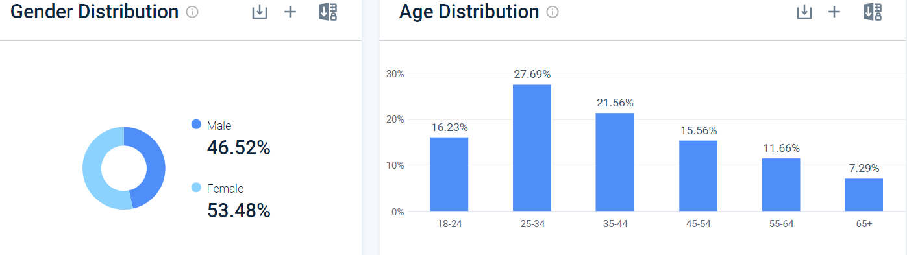
(Source: similarweb, 2023)

Appendix 3 – Perceptual Positioning Map
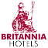
High quality
High Price
Low quality
Low Price

Appendix 4 - Bowman’s Strategy Clock
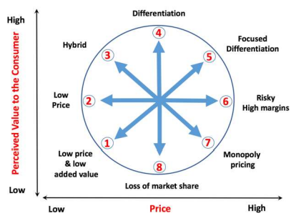
(Source: Motivated by Mihajlović and Miletić, 2022)

Appendix 5 – PESTLE analysis
Elements | Factors and influences
Political | Political stability Index in the UK: 0.54 (2021) (theglobaleconomy, 2023)  This is highly opportunistic for Holiday Inn to reinforce business within a stable environment.
Economic | Inflation rate in the UK: 8.7% according to April 2023 (tradingeconomics, 2023)  Inflation is showing a gradual decrease nowadays which is beneficial for the company to balance its pricing strategy
Social | Per capita disposable income in the UK: In 2022 ending it was at £32,300 (ons.gov.uk, 2023)  the new services have to compromise its profitability initially to gather poor and average incomed people also.
Technological | Social media penetration rate in the UK: In 2022 it was at 90% (Statista, 2023 c)  Social media marketing will be most beneficial to gain the most powerful customer acquisition in one go.
Legal | Employment Rights Act 1996 will be effective to offer equal rights to the employees against any unethical movements regarding dismissal and redundancies (netlawman.co.uk, 2022).
Environmental | Environmental Act 2021 is more intrigued by the company’s sustainability goals, reducing environmental impacts.

Appendix 6 – Marketing mix
Product/Service | Price
The new service from the company’s end will focus more on hygiene maintenance and regular monitoring of customer safety. | The UK market is highly competitive with a lot of business ventures; thus, enforcement of a competitive pricing strategy will be most beneficial in primary diversification.
Place | Promotion
The local market is the primary target market before going global evaluating the popularity of the services at first. | Social media marketing especially through advertisement will be the most productive strategy.

Appendix 7 – Gantt Chart
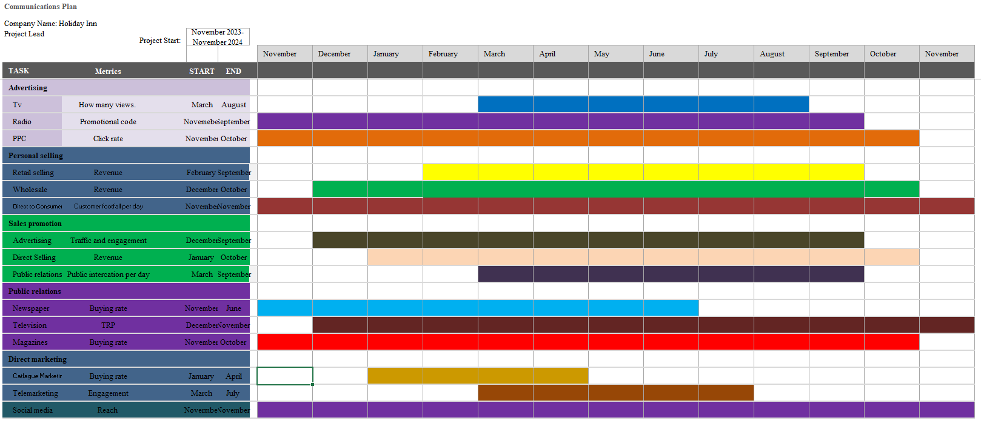

Appendix 8 – PowerPoint Presentation Slides


