MARKETING ANALYSIS OF HIUT DENIM

Student Name: Zilai Wang

Student Number: 1903231

TABLE OF CONTENTS
EXECUTIVE SUMMARY 1
1: INTRODUCTION 2
2: SITUATIONAL ANALYSIS 2
2.1: SWOT Analysis 2
2.1.1: Strengths 3
2.1.2: Weaknesses 3
2.1.3: Opportunities 4
2.1.4: Threats 4
2.2: PEST Analysis 4
2.2.1: Political Factors 5
2.2.2: Economic Factors 5
2.2.3: Social Factors 6
2.2.4: Technological Factors 6
2.3: Consumer Insights 6
2.3.1: Product Development 6
2.3.2: GAP Analysis 8
2.3.3: Channel Strategy 8
3: OBJECTIVES 9
3.1: Sell – Customer Acquisition 9
3.2: Serve – Customer Satisfaction 9
3.3: Sizzle – The WOW Factor 9
3.4: Speak – Engaging Customers 9
3.5: Save – Cost Effective 10
4: STOP STRATEGY 10
4.1: Segmentation 10
4.2: Target Market 10

4.3: Objectives 10
4.3.1: Ansoff matrix 10
4.3.2: SMART objectives 11
4.4: Positioning 12
5: TACTICS 14
5.1: Marketing Mix 14
5.2: Content/Contact Plan 15
6: ACTIONS 16
6.1: Responsibilities and Structures 16
6.2: Processes and Systems 17
6.3: Internal Resources and Skills 17
6.4: External Agencies 18
7: KEY PERFORMANCE INDICATORS (KPIs) 19
8: RECOMMENDATIONS 19
9: CONCLUSION 20
REFERENCES 21

EXECUTIVE SUMMARY
The marketing plan of Hiut Denim Co. fulfils the purpose of launching a marketing program to create more brand awareness and increase sales by the next year. SOSTAC method has been used for creating the marketing plan. For carrying out the external environment analysis, PEST framework is chosen and for the internal analysis SWOT and VRIO has been conducted. The three marketing objectives established are smart by nature which includes corporate, marketing/business and marketing communication goals. In the customer insights product life cycle, gap analysis and channel strategy have been described along with the demand of customers for jeans in the UK.
The brand portfolio of Hiut Denim is observed to be at the growth stage and in the quadrant of cash cows of BCG matrix. Based on the operations of Hiut Denim, it is said to follow the product development strategy of the Ansoff matrix. Also, according to the market mix, direct selling Promotional strategy, social media advertisement strategy, selective distribution strategy and medium level pricing strategy must be incorporated within Hiut Denim for creating brand awareness. Some recommendations have been mentioned at last related to implementation of the balanced scorecard framework to improve strategic actions, minimum cost strategy for dealing with retailers and market penetration strategy to enter into a new market.

1: INTRODUCTION
Hiut Denim, the Welsh company which was founded by David Hieatt and Clare Hieatt in the year 2011 (Hiutdenim, 2020).Formally the company was located in cardigan which is to be a huge supplier of denim jeans to one of the biggest retailers in UK marks and Spencer’s. They used to prepare 35,000 pairs of jeans every week which was a bulk supply. After cutting down the supplier and entrepreneur relationship by Marks and Spencer’s in 2002 the company had to shutdown. This resulted in a loss of almost 400 jobs of skilled and talented people (Hiutdenim, 2020).Themission of Hiut Denim is to provide the low-impact design jeans to customers in the UK at an affordable price (Velasquez, 2020). However, the vision of the company lies in helping the talented employees to gain their jobs back which will be a huge community development.
SOSTAC is the planning tool which was founded in 1996 for helping the companies to prepare a marketing plan. The model was developed by PR Smith who is also the co-author of e-marketing excellence. SOSTAC times for situation, objectives, strategy, tactics, action and control. The situation describes the current position of the company in the market, objectives imply the goals of a company, strategy denotes the way to pursue their objectives, tactics help in understanding how to execute the strategies, actions derive the entire plan and control indicates failure or success of the plan. SOSTAC is used in this marketing plan to identify the marketing program for Hiut Denim to be held in the upcoming year.

2: SITUATIONAL ANALYSIS

2.1: SWOT Analysis
The tool of SWOT Analysis is used to analyse the internal environment of the organisation. It mainly focuses on the strengths and weaknesses of the organisation along with the opportunities and threats the company faces.

Figure 1: SWOT Analysis
(Source: Phadermrod, Crowder and Wills, 2019)

2.1.1: Strengths
The company has hired experienced and extremely talented employees who could produce bulk pairs of jeans in a short time. Customer preferences are another huge strength of the company where their primary goal is to satisfy customers by any means (Hiut Denim, 2020). In fact, every year they find more than a hundred people to inspire them to achieve their individual goals, which is a new strategy for community development that is rare for other supplier organisations. They also partnered with the Candiani Jeans Mill where a sustainable manufacturing process is followed for producing jeans (Hiut Denim Co, 2019).

2.1.2: Weaknesses
The capability of Manpower is shortened in Hiut Denim because previously they used to manufacture 35,000 pairs of jeans per week but now it is only hundred jeans per week which is very low compared to other big manufacturers in the UK (Halls, 2017). It is a private limited company funded by share capital from the financial firm Tenzing (Tenzing, 2020).Therefore it accounts for lower revenue and profit which is a major weakness for the company. A strong brick and mortar presence is missing for the company to develop more.

2.1.3: Opportunities
Since, David and Clare are planning to bring back the lost talent therefore a huge range of opportunities are in line with Hiut Denim (LinkedIn, 2020). This includes greater production and hence high revenue, expansion to other market regions and therefore sustainability of the business, providing customers with the most superior quality available in the market (GÜREL, 2017). Bringing back the manufacturers from the past who had been excellently delivering their expertise in the organisation can also restore the firm reputation which was harmed in the past (Halls, 2017).

2.1.4: Threats
Hiut Denim has an extremely high level of threat from the new entrants and substitutes because of their low quantity production and time consuming processes. Each pair of jeans takes almost 1 hour and 11 minutes of time to be prepared which is quite low compared to other manufacturing giants like Dawson Denim, Kapital, 45R, 3sixteen and Raleigh denim (Halls, 2017).

2.2: PEST Analysis
In order to understand and analyse the external environment of the organisation in which it exists, PEST Analysis is conducted. It primarily focuses on the Political, Economic, Social and Technological factors that influence the company directly or indirectly.
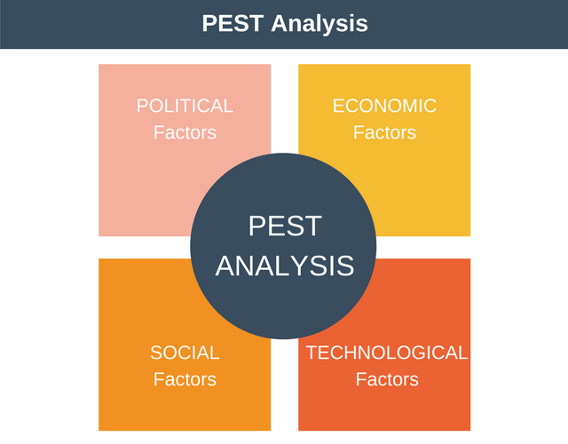
Figure 2: PEST Analysis
(Source: Barbara et al., 2017)

2.2.1: Political Factors
Cardigan is a small town of 4000 inhabitants out of which 10% have a rooted history of Denim craftsmanship (Halls, 2017). Regulations related to supplier of machinery, health and safety, electrical equipment, product safety and use of hazardous substances must be followed by Hiut Denim in order to manufacture in the UK (Barbara et al., 2017). For example, section 6 of Health and safety at work addresses any kind of safety from machinery and equipment used in the firm. The post-Brexit incidents have also resulted in increased cost of manufacturing due to currency devaluation which has a negative impact on the operation cost of Hiut Denim (AMADEO and BERRY-JOHNSON, 2020).

2.2.2: Economic Factors
According to statistics, the inflation rate of the UK is 1.5 % which is less than 2% and is standard to sell commodities at an affordable rate (ONS, 2020). The per capita income of UK residents as recorded in 2018 is 45,350 USD which implies the purchasing power of customers even if the prices of jeans is set higher (Tradingeconomics, 2020).Again, corporate tax of UK is only 19 % which is less than any other developing and developed economies like India and US(GOV.UK, 2020). On an average, the economic factors have a positive impact on the operations of Hiut Denim. However, the global recession due to Covid-19 pandemic will cause a great loss to sale of Hiut Denim.

2.2.3: Social Factors
The inclined shift of consumer preferences towards packaged cropped and distressed jeans can be regarded as one of the key trends in all over the world. Therefore, employees of Hiut Denim may feel a little stress to meet up the expectations of customers. Throughout the world people are looking for trending Denim like cropped hems, two-tone jeans as well as skinny jeans (Psmarketresearch, 2020). Therefore, meeting customer demand with less number of employees will be difficult for Hiut Denim in the post Covid-19 pandemic. However, the Denim market internationally valued at 56.1 billion USD as recorded in 2017 which projects a 5.8% compound annual growth rate (Psmarketresearch, 2020). This can mark a huge opportunity for Hiut Denim to grow outside their origin.

2.2.4: Technological Factors
Almost 91% of the adults in the UK use the internet for which Hiut Denim will be having a great opportunity to promote their products online and concentrate on website marketing as well(Johnson, 2020).Mainly, the age group of 16 to 44 years are highly available on social media sites like Facebook, LinkedIn, Instagram and Pinterest (Johnson, 2020). Therefore, Hiut Denim can use social media marketing to enhance the brand awareness. High quality Sewing Machines are available in the UK which can be utilised by Hiut Denim for faster and convenient work.

2.3: Consumer Insights

2.3.1: Product Development
Skinny jeans are continuing to dominate the market of women's jeans in the UK. Along with that high waist Denim is another increasing trend which is observable since the last two years. Straight legs and slim fit are other different styles of jeans for women. There is a rapid change of demand for cropped hem jeans for women in the UK which has resulted in an increased volume by 175% from 2016 till 2017(Agarwal, 2018).
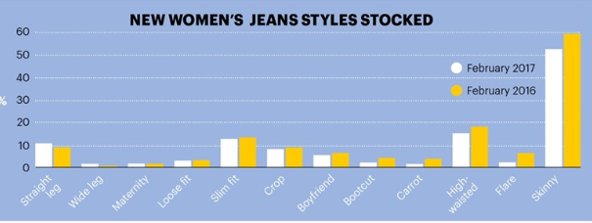
Figure 3: Customer demand for Women Jeans
(Source: Agarwal, 2018)
On the other hand, the stonewash style of jeans for men has been an increasing demand for which the volume has increased by 627.3% in the similar year (Agarwal, 2018).However it is observed that the jeans which are priced below 60 GBP have a greater demand specifically for the local brands like Topman and River Island (Agarwal, 2018).
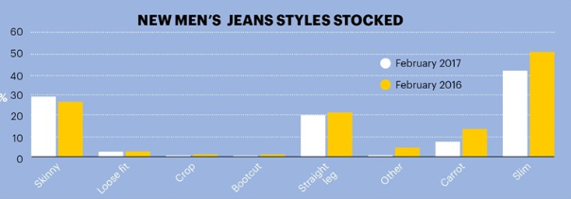
Figure 4: Customer demand for Men Jeans
(Source: Agarwal, 2018)
Hence, by applying the product life cycle theory, Hiut Denim is said to be at the growth stage for developing its product in a unique way to gain a competitive benefit (Jian, Cai and Chen, 2017). Hiut Denim focuses on selling skinny fit and slim fit Jeans starting from 150 GBP onwards which can impact on the lower consumer demand (Agarwal, 2018). Therefore, Hiut Denim should focus on producing more affordable priced jeans yet trendy ones.
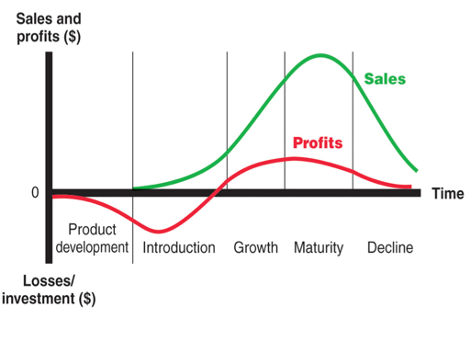
Figure 5: Product life cycle theory
(Source: Jian, Cai and Chen, 2017)

2.3.2: GAP Analysis
This particular analysis will help in identifying the exact position ofHiut Denim at the present time and where they want to be in future. Hiut Denim produces only hundred pairs per week however it aims at manufacturing more than 35000 years which it used to be until 2002 (Walker, 2012). It wants to be the market leader of the jeans manufacturing industry in the UK.

2.3.3: Channel Strategy
This includes selection of different channel types by evaluating a desired intensity of product distribution designing of channel configuration as well as managing of channels (Jian, Cai and Chen, 2017). It is highly essential for distributing a product or service to the potential customers and target markets. The best suitable channel strategy for Hiut Denim is direct selling. This is mainly done through website marketing by Hiut Denim. They directly connect to customers through their websites. However, it has been involved in the indirect selling strategy being a supplier of marks and Spencer’s.

3: OBJECTIVES

3.1: Sell – Customer Acquisition
Hiut Denim has recently introduced the Limited release of first ever biodegradable and micro plastic free stretchable jeans (Velasquez, 2020).Like Candiani Denim, Hiut Denim Co. is planning to replace the pixel-based and common synthetic elastomers with the custom engineered element formed with natural rubber and organic cotton core. Hiut Denim, therefore, plans on selling biodegradable jeans at market-friendly prices across the world as an innovative creation compared to other brands (Velasquez, 2020).

3.2: Serve – Customer Satisfaction
Hiut Denim promises customers about delivering the most superior quality of jeans in the market at affordable prices. In order to satisfy customers, they plan on being available for maximum time to the customers for resolving queries and issues. Online deliveries mainly required 48 hours to reach customers which are quite fast. Whereas within the UK, the deliveries can be made even in 24 hours. To attract customers they already manufacture trendy jeans for both men and women. For example for men, they have slim tapered, skinny, slim and V-fit collections of jeans. For women, Hiut Denim produces relaxed tapered, relaxed fit, slim, skinny and high waist styles.

3.3: Sizzle – The WOW Factor
The cut to order pairs of biodegradable eco-friendly jeans will be sold for around 210-225 USD (Velasquez, 2020). The prices of jeans by Diesel, Wrangler or Calvin Klein are higher as compared to these prices and therefore customers can opt for buying Hiut Denim based on the reputation. The wow factor is that only hundred pairs shall be available across the world which is something new as compared to other brands. Each of the pairs shall come with a vegan label and Hiut Denim tote bag of limited edition.

3.4: Speak – Engaging Customers
The only effective marketing channel to connect to customers worldwide is involvement in social media. A large number of tables are available on social media platforms like Facebook, Twitter, Instagram and Pinterest, where Instagram is highly used for photography and fashion advertisement. Already Meghan Markel has been observed to endorse Hiut Denim however after reopening sufficient funds should be accumulated for celebrity endorsement.

3.5: Save – Cost Effective
In order to reduce the operating cost of producing eco-friendly jeans, Hiut Denim has partnered with Candiani Denim. It has thereby used the plant based patented forever stretch technology of Candiani Denim to manufacture micro-plastic free jeans all over the world. Impact, Hiut Denim has recycled plastic waste for reducing environmental pollution and contribution to the well-being of society.

4: STOP STRATEGY

4.1: Segmentation
Segmentation strategy is used for organising the business or customer base along the Geographic demographic psychographic and behavioural lines or by combining all of them. Demographic segmentation is already followed by Hiut Denim Co. because the jeans they manufacture are mainly based on customer preferences, trends and styles. In fact, a middle income group is targeted based on which they have applied the price skimming strategy. The age group of 12-38 years is being targeted who follow trendy fashionable lifestyles. However, to expand its outlets and supplies all over UK and overseas, it is suggested to Geographic segmentation.

4.2: Target Market
It is the particular group which is aimed by an organisation to introduce new products and services. Hiut Denim has targeted the middle income society and mainly the youth ageing between 12 and 32 years. It is this mass marketing in terms of targeting customers because the customer segment receives a single generic product and there is no product differentiation.

4.3: Objectives

4.3.1: Ansoff matrix
This matrix is used for showcasing different objectives to be set by Hiut Denim for creating the marketing program or strategy (Schawel and Billing, 2017). Four quadrants are shown in the matrix, each of which shows one single strategy. The strategies are market development, diversification, market penetration and product development. Based on the Ansoff matrix, it already uses product development strategy.
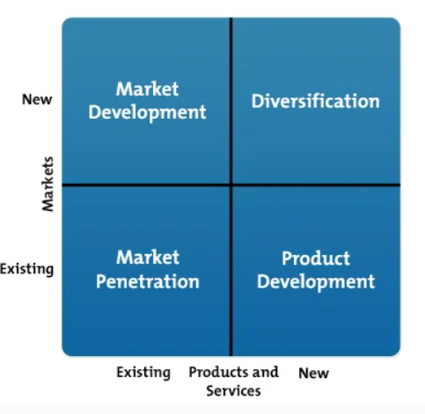
Figure 6: Ansoff Matrix
(Source: Schawel and Billing, 2017)
However, to expand into a broad market and offering a tough competition to its rival firms, market penetration strategy will be appropriate (Schawel and Billing, 2017). While entering into a new market, in the long run Hiut Denim can apply Cost leadership strategy by supplying in the retail firms of the UK.

4.3.2: SMART objectives
 | Specific | Measurable | Achievable | Realistic | Timely
Corporate: To increase sales volume by 25% in the next year | Yes | It can be measured by increasing profit margin and becoming a market leader | Yes | Yes | 8-12 months
Marketing: To gain a market share of about 20% by the upcoming year | Yes | customer loyalty and brand awareness can measure rate | Yes | Yes | 6-12 months
Marketing communication: To increase brand awareness by 50-70% among the 18-34 year olds | Yes | Measurable via customer demand and responses | Yes | Yes | 7-9 months
Table 1: SMART objectives
(Source: Made by self)

4.4: Positioning
For understanding the position of Hiut Denim and its brand portfolio, the BCG matrix is suitable to elaborate (Torquati et al., 2018). This is a corporate planning framework which is widely utilised for to train the brand portfolio of an organisation on a particular quadrant along the market share and market growth axes (Torquati et al., 2018).The four quadrants are- dogs, cash cows, stars and question marks.
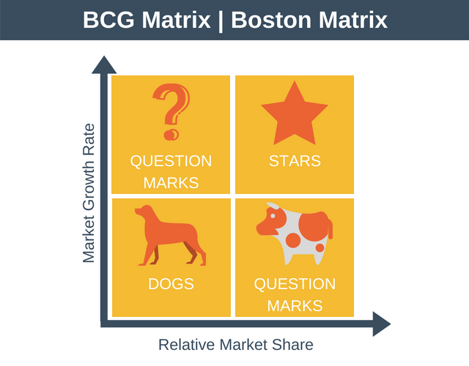
Figure 7: BCG Matrix
(Source: Torquati et al., 2018)
- Dogs usually hold a lower share of the market as compared to its competitors and operate in the slow growth economy.
- Cash cows are regarded as the most profit generating brands on which sufficient investments must be made.
- Stars are considered to maintain hair market share and operate in the heavy growth industries.
- Question marks refer to the brands which require a closer consideration because they enjoy a relatively lower market share in the accelerating markets which consume huge cash and incur heavy losses.
Previously, Hiut Denim could be put in the quadrant of question marks due to the losses it encountered for a lower share of the market (Walker, 2012). However, presently, the brand portfolio it invented can be regarded as cash cows because it is rare and unique. Hiut Denim should therefore present itself for being the stars in the long run.

5: TACTICS

5.1: Marketing Mix
- Product: In order to meet the demand of UK customers and even worldwide, Hiut Denim should concentrate on the styles and trends of fashion related to jeans. Hems of jeans are stitched with chains and pockets are specifically designed to carry iPhones (Madgwick, 2013).For example, it should focus more on raw hem, ripped, stonewash, frayed, distressed and mid wash jeans for men. While for women, it should produce more cropped hem, skinny, ripped and high waist jeans (Madgwick, 2013).
- Price: Medium value pricing will be the best strategy to be followed by Hiut Denim, because it is the technique where the initial price setup is high at first then the prices are lowered over the time (Hu and Xu, 2019). Since Hiut Denim already had an impression on the market of the UK about their quality and as they are more focused on eco-friendly quality now, therefore a medium value price would not matter because the demand is not elastic. The range of prices between 200 to 250 dollars in the first 100 pairs of jeans throughout the world is appropriate (Velasquez, 2020).With the time, it should follow an economic pricing without compromising quality for greater customer attraction.
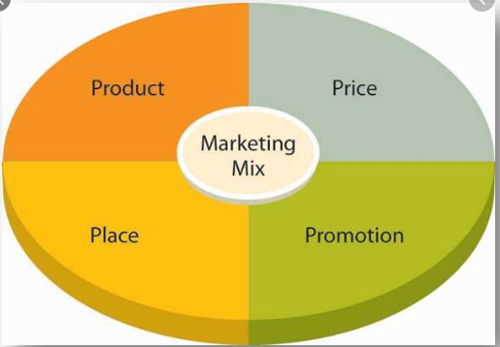
Figure 7: Marketing mix
(Source: SAM, 2017)
- Promotion: Around 45 million of people are active social in users in all over the UK which is 66% of the entire population as recorded in January 2020 (Statista, 2020). Since the very beginning of the Year 2017, total users of social media in the UK have crossed 39 million specifically by using Facebook (Statista, 2020).Therefore, following direct marketing, the social media advertisements shall be the most suitable promotional strategy for initial marketing of Hiut Denim products. This will be the most cost effective and fast promotional technique for attracting higher customer base (Hu and Xu, 2019). Opening a page on Facebook and LinkedIn and displaying some images of jeans and mentioning the offers and discounts sites will be beneficial.
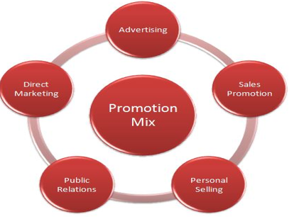
Figure 8: Promotion mix
(Source: Hu and Xu, 2019)
- Place: Initially, Cardigan is the best place to start up with retailing services. Slowly with time, Hiut Denim can expand its outlets all over the UK with the help of market penetration and low cost strategy (Hu and Xu, 2019). Supplying to big retailers like Marks and Spencer’s, TESCO and ASDA will set up the perfect indirect selling distribution channel. A selective distribution strategy appropriate for Hiut Denim.

5.2: Content/Contact Plan
SAFS framework stands for Suitability, feasibility, acceptability and sustainability. Suitability allows a company to address the strategic position and the chief different objectives for long run. Feasibility talks about possibility to choose a particular strategy considering competencies and resources available in the company. Acceptability is the strategy to help different stakeholders for achieving their long term and short term objectives. Sustainability will meet all of the above mentioned criteria. According to the processes it follows for manufacturing jeans sustainability is the suitable strategy followed by Hiut Denim (Velasquez, 2020).

6: ACTIONS

6.1: Responsibilities and Structures
A line organisational structure will be perfect one to be followed by Hiut Denim. This is because it is the simplest of all other organisational structures and the operative source from the top level to the bottom level management (Horch, 2018). An effective communication can be followed throughout this structure which brings organisational stability.
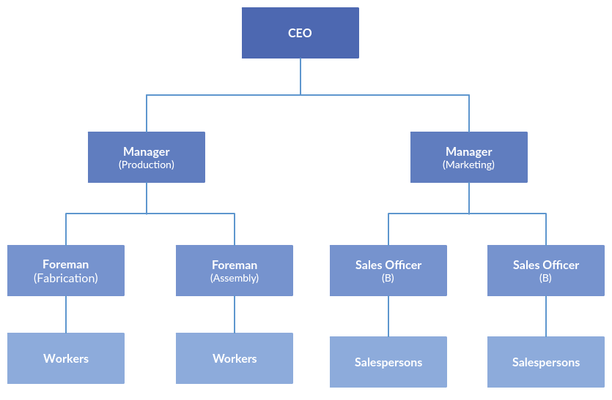
Figure 9: Line organisational structure of Hiut Denim
(Source: Horch, 2018)

6.2: Processes and Systems
The different systems and processes to be improved at Hiut Denim should include the timing and speed of production which is highly slow relative to its competitors in the market. It must aim at hiring more employees so that it can produce more than a hundred pairs of jeans every week. However, Hiut Denim does not comply with the Employment Act of 1996 of the UK and follow the code of ethics (Hiutdenim, 2020).It also lacks proper privacy policies and therefore adherence to prepare employment legislation is highly required (Hiutdenim, 2020).

6.3: Internal Resources and Skills
VRIO Analysis is appropriate to determine internal skills and resources which can be used to enjoy competitive benefits (Ariyani and Daryanto, 2018).
 | Valuable | Rare | Costly to imitate | Organised | Competitive advantage
Innovation | Yes | Yes | Yes | Yes | Sustainable benefit
Product design and Quality | Yes | No | Yes | Yes | Competitive parity
Skilled Human resource | Yes | Yes | Yes | Yes | Sustainable advantage
Customer service | Yes | No | No | Yes | Temporary
Table 2: VRIO Analysis
(Source: Made by self)
From the VRIO analysis, the innovative idea of biodegradable materials for use in preparing jeans and the skilled manpower generate sustainable competitive benefit because they are valuable, rare, organised and costly to imitate (Velasquez, 2020).On the contrary, product design/quality which is guaranteed by Hiut Denim is valuable, organised and non-imitable but it is not rare. Any rival company accessible to advanced technology can manufacture eco-friendly jeans. Therefore, it generates competitive parity. Lastly the customer service of Hiut Denim which include timely responses to customers, free repairs and on-time shipping are neither there nor costly to imitate. Therefore, it provides temporary competitive benefits. Hiut Denim should focus more on utilising resources which are non-substitutable.

6.4: External Agencies
The primary role of external agencies of advertisement is to develop the marketing campaigns of a company like Hiut Denim. External Agencies already have staff members who are experts in their respective fields- advertising, sales, promotion, media buying and research. For Hiut Denim, a digital/interactive agency should be appointed for the upcoming marketing program but at an affordable budget (Horch, 2018).
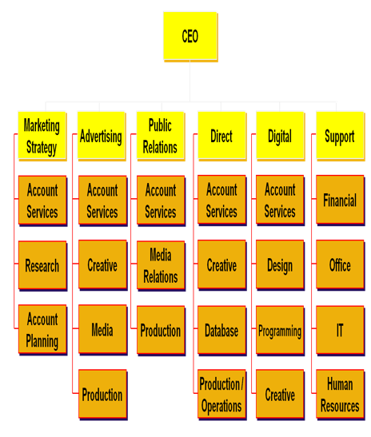
Figure 10: External agencies
(Source: Horch, 2018)

7: KEY PERFORMANCE INDICATORS (KPIs)
KPS are the factors which are usually tracked by companies for analysing their systems and processes. These are also used for measuring success in the context of predetermined objectives or goals. For Hiut Denim, the key performance indicators are-
- Capacity utilisation: Hiut Denim perfectly utilizes the skills and know-how of their workers and thereby manufacturers hundred pairs of jeans every week which will be increased when they shall hire 10% of the total Cardigan town for manufacturing of Hiut Denim jeans. To use upgraded technology they have also but not width Candiani Denim Co.
- Customer satisfaction: In order to satisfy customers, Hiut Denim promises to deliver the best quality of the name across the market at a price which is neither very cheap nor unaffordable. Refund and exchange options are available for online purchases. Again, a free repairing policy is available at the website of Hiut Denim.
- Process capability: Hiut Denim holds a narrow objective to produce only jeans and not any other apparel. Therefore, they are specialised in a technology for manufacturing only jeans which shall be biodegradable in nature (Velasquez, 2020).
- On-time shipping: Hiut Denim ships to almost every region of the world through the international Royal mail tracking service. For long distance shipping, it may take 7 to 10 days of time for reaching customers. However across the UK, the orders will maximum take 48 hours to be delivered. In fact, there is also next day delivery service for UK customers.

8: RECOMMENDATIONS
- Sales promotion could be used as a promotional strategy for Hiut Denim through different events, coupons premiums product samples freebies or rebates. All of these can be profitable when brand awareness is developed for Hiut Denim. These sales promotion strategies can be either directed at customers and sales staff or the retailers.
- The minimum cost strategy should be applied in the long run. This implies quantity to be sold to the retailers will be in bulk but at the least possible market price. It will increase the sales volume of different retailers and eventually raise the demand from other markets as well.
- The company should soon hire more than 400 workers and they should be provided with a target level every week for increasing the revenue and business objectives. A balanced scorecard can be used by the company as the performance metric to improve, control and identify strategies. Later on, market penetration strategy will be effective instead of product development because it will help in expanding the market.
- With the development of a company, marketing to new places should be done using the 7p marketing mix instead of 4P, which will also concentrate on the process. Physical evidence and people. Process shall indicate innovative delivery system; physical evidence may imply more brick and mortar presence as well as people shall be related to hiring of skilled employees in accounts and production departments.

9: CONCLUSION
The primary objective of the marketing plan is to create brand awareness for Hiut Denim throughout the world. The mission and vision of the company lies in delivering extraordinary quality jeans compared to its rivals. From the marketing plan, it is therefore suggested to use price skimming strategy along with demographic and geographic segmentation. Customised targeting will be appropriate for selecting the target market initially. A social marketing strategy and channel will be appropriate for reaching out to a large number of customers. Full utilisation of capacity, on-time shipping, capability of processes and customer satisfaction services are some key performance indicators for Hiut Denim.

REFERENCES
Agarwal, S. (2018). Denim Styles Which Are Cool For UK Consumers. [online] Denim Jeans | Trends, News and Reports | Worldwide. Available at: https://www.denimsandjeans.com/latest-denim-reports/denim-styles-cool-uk-consumers/26036 [Accessed 28 April 2020].
AMADEO, K. and BERRY-JOHNSON, J. (2020). Brexit Consequences For The U.K., The EU, And The United States. [online] The Balance. Available at: https://www.thebalance.com/brexit-consequences-4062999 [Accessed 28 April 2020].
Ariyani, W. and Daryanto, A. (2018). Operationalization of Internal Analysis Using the VRIO Framework: Development of Scale for Resource and Capabilities Organization (Case Study: XYZ Company Animal Feed Business Unit). Asian Business Research Journal, [online] 3(1), pp.9-14. Available at: http://ecsenet.com/index.php/2576-6759/article/view/6 [Accessed 28 April 2020].
Barbara, C., Cortis, D., Perotti, R., Sammut, C. and Vella, A. (2017). The European Insurance Industry: A PEST Analysis. International Journal of Financial Studies, [online] 5(2), p.14. Available at: https://www.mdpi.com/2227-7072/5/2/14 [Accessed 28 April 2020].
GOV.UK (2020). Rates And Allowances For Corporation Tax. [online] GOV.UK. Available at: https://www.gov.uk/government/publications/rates-and-allowances-corporation-tax/rates-and-allowances-corporation-tax [Accessed 28 April 2020].
GÜREL, E. (2017). SWOT ANALYSIS: A THEORETICAL REVIEW. [online] http://sosyalarastirmalar.com/. Available at: http://sosyalarastirmalar.com/cilt10/sayi51_pdf/6iksisat_kamu_isletme/gurel_emet.pdf [Accessed 28 April 2020].
Halls, E. (2017). Your New Favourite Pair Of Jeans Come From A Tiny, Rural Town In Wales. [online] British GQ. Available at: https://www.gq-magazine.co.uk/article/best-jeans-for-men-hiut-denim [Accessed 28 April 2020].
Hiut Denim (2020). Customer Service – Hiut Denim Co.. [online] Hiutdenim.co.uk. Available at: https://hiutdenim.co.uk/pages/customer-service [Accessed 28 April 2020].
Hiut Denim Co. (2019). 100+ MAKERS AND MAVERICKS — 2019. [online] Medium. Available at: https://medium.com/@hiutdenim/100-makers-and-mavericks-2019-2f9a6be1c0b2 [Accessed 28 April 2020].
Hiutdenim (2020). Our Way – Hiut Denim Co.. [online] Hiutdenim.co.uk. Available at: https://hiutdenim.co.uk/blogs/story/101830593-our-way [Accessed 28 April 2020].
Horch, H. (2018). The intermediary organisational structure of voluntary associations. Voluntary Sector Review, [online] 9(1), pp.55-72. Available at: https://www.ingentaconnect.com/content/tpp/vsr/2018/00000009/00000001/art00004 [Accessed 28 April 2020].
Hu, Y. and Xu, B. (2019). The Research of the Each Other Support between Online Sales and Offline Store based on the Marketing Mix. Proceedings of the 1st International Conference on Business, Economics, Management Science (BEMS 2019), [online] Available at: https://www.atlantis-press.com/proceedings/bems-19/125907388 [Accessed 28 April 2020].
Jian, X., Cai, S. and Chen, Q. (2017). A study on the evaluation of product maintainability based on the life cycle theory. Journal of Cleaner Production, [online] 141, pp.481-491. Available at: https://www.sciencedirect.com/science/article/pii/S0959652616314147 [Accessed 28 April 2020].
Johnson, J. (2020). Topic: Social Media Usage In The UK. [online] www.statista.com. Available at: https://www.statista.com/topics/3236/social-media-usage-in-the-uk/ [Accessed 28 April 2020].
LinkedIn (2020). David Hieatt. [online] https://uk.linkedin.com/. Available at: https://uk.linkedin.com/in/davidhieatt [Accessed 28 April 2020].
Madgwick, H. (2013). Hiut Denim Co. Jeans. [online] FashionBeans. Available at: https://www.fashionbeans.com/2013/hiut-denim-co-2/ [Accessed 28 April 2020].
ONS, (2020). Inflation And Price Indices - Office For National Statistics. [online] Ons.gov.uk. Available at: https://www.ons.gov.uk/economy/inflationandpriceindices [Accessed 28 April 2020].
Phadermrod, B., Crowder, R. and Wills, G. (2019). Importance-Performance Analysis based SWOT analysis. International Journal of Information Management, [online] 44, pp.194-203. Available at: https://www.sciencedirect.com/science/article/abs/pii/S0268401216301694 [Accessed 28 April 2020].
Psmarketresearch (2020). Denim Market Size, Trends | Industry Growth Forecast Till 2023. [online] Psmarketresearch.com. Available at: https://www.psmarketresearch.com/market-analysis/denim-jeans-market [Accessed 28 April 2020].
SAM, A. (2017). The Effects of Marketing Mix (4P) on Companies’ Profitability: A Case Study of Automotive Industry in France. Journal of Research in Marketing, [online] 8(1), p.636. Available at: http://www.jormonline.com/index.php/jorm/article/view/207 [Accessed 28 April 2020].
Schawel, C. and Billing, F. (2017). Ansoff-Matrix. Top 100 Management Tools, [online] pp.31-33. Available at: https://link.springer.com/chapter/10.1007/978-3-658-18917-4_8 [Accessed 28 April 2020].
Statista (2020). Topic: Social Media Usage In The UK. [online] www.statista.com. Available at: https://www.statista.com/topics/3236/social-media-usage-in-the-uk/ [Accessed 28 April 2020].
Tenzing, (2020). The Hiut Denim Company - Tenzing Private Equity. [online] Tenzing Private Equity. Available at: https://tenzing.pe/design/the-hiut-denim-company/ [Accessed 28 April 2020].
Torquati, B., Scarpa, R., Petrosillo, I., Ligonzo, M. and Paffarini, C. (2018). How Can Consumer Science Help Firms Transform Their Dog (BCG Matrix) Products Into Profitable Products?. Case Studies in the Traditional Food Sector, [online] pp.255-279. Available at: https://www.sciencedirect.com/science/article/pii/B9780081010075000129 [Accessed 28 April 2020].
Tradingeconomics (2020). United Kingdom GDP Per Capita | 1960-2018 Data | 2019-2020 Forecast | Historical. [online] Tradingeconomics.com. Available at: https://tradingeconomics.com/united-kingdom/gdp-per-capita [Accessed 28 April 2020].
Velasquez, A. (2020). Hiut Denim Bows Limited Collection Of Biodegradable Stretch Jeans. [online] Sourcing Journal. Available at: https://sourcingjournal.com/denim/denim-brands/hiut-denim-biodegradable-stretch-jeans-candiani-coreva-200777/ [Accessed 28 April 2020].
Walker, T. (2012). Hiut: Made In Britain And Made To Last. [online] The Independent. Available at: https://www.independent.co.uk/life-style/fashion/features/hiut-made-in-britain-and-made-to-last-7576601.html [Accessed 28 April 2020].

