Assignment Title: Effective Team Work and Communication (Assessment 1)

Students Name: Suraiya Amin
Student ID: 2028701
Module Name: Effective Team Work and Communication
Module Code: BMSW4002-LON
Module Teacher: Joy Botu
Module Leader: Lloyd Beharry

Table of Contents
Introduction 3
Understanding of the models of communication and communication skills 3
Understanding Communication 3
Effective team communication 4
Different Communication Models 4
Communication Skills for Effective Communication 7
Examples of poor communication in workplace 8
Suggestions to improve communication in the workplace 9
Conclusion 10
References 11

Introduction
An effective team work and communication are interrelated with each other very tightly. For ensuring effective team work, there is needed successful communication among the team members. In this report, a brief discussion about the effective team work and communication skills will be written. For better understanding, I will also show some examples of poor communication that I face at my workplace. Besides some recommendations for effective team working and developing communication skills will also be included in this report.

Understanding of the models of communication and communication skills

Understanding Communication
Communication is the process of sharing information for one person or group to another person or group successfully. For successful communication requires a sender, and a receiver. Communication can be done directly or through any media. Communication is mainly two types such as oral communication, written communication and non-verbal communication.

Written communication: This type of communication is done through emails, letters or any other documents.

Oral Communication: This type of communication is done through face to face or over the audio / video conference or etc.

No-Verbal communication: Non-verbal communication is done through using various type of signals such as body language, codes, gestures etc. There any not used any clear voice speech.

Communication is done following a basic flow or channel that is shown in the following diagram. This flow looks like as:
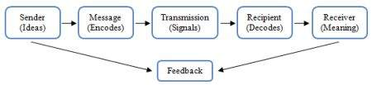
Figure: Basic Flow of Communication Diagram
From the diagram of flow of communication shows the process of communication. We can see that firstly the sender sends messages and the receiver receives the message and gives feedback to the sender (Juneja, 2015).

Effective team communication
To manage a team, there is no alternative of effective communication among the team members. Generally, when communicating, we focus only what the speaker says. But effective communication emphasizes more on listening than talking. Effective communication is more than just normal communication. It includes the internal meaning too. It defines the emotions and intentions behind the exact information that the sender sends. To convey a message, he/she needs to understand the full meaning of the information. The listener needs to focus on non-verbal signals (Crick, 2014).

and requires some communication skills. These skills help to manage a team effectively.

Different Communication Models
The methods of communication depend on the types of transaction. To understand the methods of communication and communicate effectively, firstly it is needed to understand the different types of communication models. Three important communication models are described below.

- Shannon and Weaver Model of Communication
Shannon and Weaver Model of Communication is the most popular model to understand the effective communication. It is accepted overall the world by most of the scholars. Shannon and weaver both described this model in their article named “A mathematical Theory of Communication” in 1980. Though this communication model was designed to improve the technical communication, but now it is used overall the world. This model finds the factors that affects the communication named it as “Noise”. The model contains some components such as Sender (Information Source), Encoder (Transmitter), Channel, Noise, Decoder, Receiver and Feedback (Bhatt, 2013).
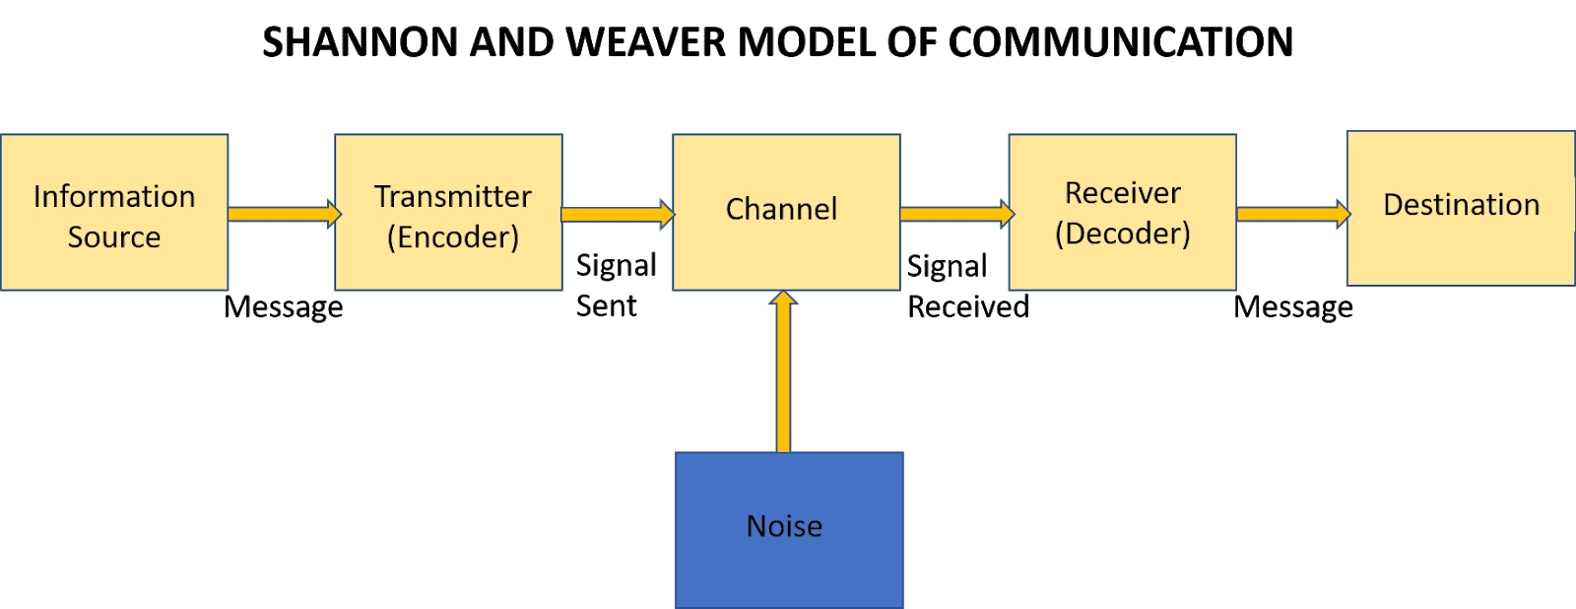
Figure: Shannon and Weaver Model of Communication

Sender (Information Source): From this information source the communication process is started. A sender can send a message through different ways such as in writing, oral or body language. For example, the person who read newscast. They decide what they will say before starting the newscast.

Encoder (Transmitter): This is the step where the idea is converted to signals. For example, the telephone and computers.

Channel: This is the step where the information is accepted from the sender and sent to the decoder and receiver. World wide web (internet) is an example of channel when sending an email.

Noise: It is the barrier of exact idea transmission. This barrier is known as “noise”. Noise interrupts the message and our understandings. Noise are two types such as external and internal noise. External noise can be wrong encoding or letter lose, failing internet connection etc. And internal noise can be that they have not concentration, speaking with heavy accent etc.

Decoder: The next step is decoder. It is the opposite of the encoder. Decoder converts the signals to meaningful idea readable or listenable so that the receiver can understand.

Receiver: At this step a person receives the information from the media. This person is known as the receiver.

Feedback: After receiving the information, the receiver sends feedback to the sender that he/she has got the information’s to stop the communication loop (Dundon and Wilkinson, 2012). It is the last step of Shannon and Weaver’s communication model.

- Berol’s Communication Model
Berol’s communication model is another famous model for understanding the effective communication. According to this model, effective communication depends on the relationship of the sender and the receiver who receives the information. Berol says that for effective communication, both the sender and the receiver needs to acquire the best communication skills. Only the skilled person can ensure the effective communication among the team.
Berol’s model has some components and all components have some sub-components. The following diagram is showing the Berol’s communication process.
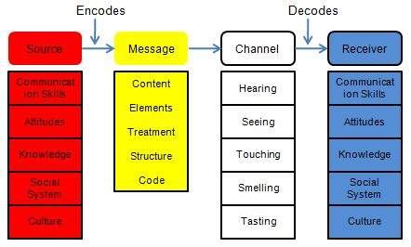
Figure: Berol’s communication Model (Kobiruzzaman, 2021).

- Schramm's Model
This model is also known as the Osgood-Schramm model too. It is a continuously cyclical communication model between the sender and the recover. It defines that effective communication is a two-way path with the message between the sender and the receiver continuously.
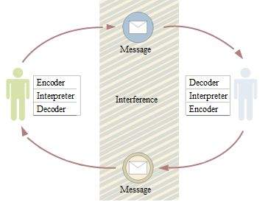
Figure: Schramm's Model’s Diagram

Communication Skills for Effective Communication
Communication skills means the skills those are needed to share information with the other person successfully and effectively. For effective communication, one needs to acquire some important skills. In class, there have discussed some communications skills that are elaborated below.
- Public Speaking: To manage a team effectively one needs to have public speaking skill to share information with others. Before starting this module, I was not good at public speaking. But after starting this module, when I have worked in my team, I needed to speak publicly about my task among my team members (Whitcomb and Whitcomb, 2013). I tried and tried to do good. And then I have a good result and gained public speaking skill.
- Active listening: Active listening is a very important skill for effective communication and information sharing. A person needs to acquire this skill at first to accept the right information. Active listening skill helped me to understand the topics that were discussed in my class by my class teacher.
- Conciseness: The sender must be able to make the message in the minimum words and maximum meaning. He or she needs to be able to avoid the excessive words in the message (Koski and Launonen, 2012). While writing this module, I have managed a lot of information about the task, but to prepare this module I have managed it carefully with exact words.
- Friendliness: For receiving the best output from the communication, both the sender and the receiver should make the environment friendly. To share information or assist each other my team members was very friendly to help each other’s that helped me to better understand the task.
- Confidence: The sender must be confident what he/she will send to the receiver. It makes the communication easy. While starting, I was very nervous as I have not enough idea what I should do. But gradually I got help from my friends and became confident in task that helped me complete the module (Koski and Launonen, 2012).
- Open-mindness: The sender and the receiver must be open-minded what they say and what they will accept. It is important to hypothesize with their point of view.
- Clarity: Others will fail if the information is not clear. It may create opposite result of the expected result. So, it is very important to gain the skill to send the clear information that contains the exact meaning.
- Feedback: It is another important skill for the receiver for effective communication. The receiver must be able to receive and provide the appropriate feedback to the sender so that the sender can be ensured that the receiver had got the information. When I got any information from my class teacher or my team leader, I tried to give feedback to them so that they can ensure that I got understanding about the topics (Hargie, 2019).

Examples of poor communication in workplace
Poor communication is occurred when there is happened in-coordination, discrepancy or imbalance in the workplace. For example, the team members sometimes can’t understand what the team members says. It creates poor communication in the workplace. During working in the workplace as a member of a team, I also faced this type of problems. Here I have discussed some examples of poor communication in my workplace.
- Poor leadership: Leadership is the activity of managing others to do a specific task. But when the leader become failure to manage the team members, it is poor leadership. During this module writing, sometimes my team leaders couldn’t be able to manage workplace properly lack of proper skill. Because he was also new as a team leader. And so sometimes we didn’t get much help from the team leaders (Dundon and Wilkinson, 2012).
- Unclear objectives: To gain success, we need clear goals and objectives. Clear objectives provide appropriate direction. But sometimes our goal was not so clear to understand better.
- Limited feedback: While doing task in my team, I asked some questions to my team members to understand my duty but I didn’t get appropriate feedback from them that made some problems in my workplace to complete the task.
- Demoralized Employees: My team was made consisting some team members. The team members were unique at their skill and knowledge. Sometimes they have thought that they are not enough capable to do the task. And so, they lost interest in their work. In this way they became demoralized. They felt unvalued, unappreciated according to their capacities and talents.
- Cultural diversity: My team members came from different cultural background. So sometimes we have faced problem to communicate with others with proper ways (Tiwary et al., 2019).

Suggestions to improve communication in the workplace
To improve the communication in the workplace and develop the team effectively, there is needed to follow some rules and regulations. Here I recommended some suggestions for effective communication using my findings.
- To deliberate the duties among the team members, the goals and objectives should be clear and concise. Weberian theory helps to define clear roles and responsibilities. It indicates the hierarchical, structured and clear communication.
- To exercise the powers, the team leaders need to have controlled capability. Temkin’s and Cheney’s organizational control theory says that there are four types of control that helps to exercise powers. These four types of control are simple, technical, bureaucratic and concretive (Tinker, 1996).
- To manage a team effectively, the team should be democratic. Everyone has the right to give their opinions in the decision-making period. Deetz’s Managerialism theory defines how a manage a democratic team effectively.
- The team leader should be informal to the team mambas to share the information, so that workplace becomes friendly.
- For developing the skill of the team members, the team leader can train the team members.
- To complete the task before deadline, a date should fix and defined before starting any task that will help to finish the task before deadline (Yang, 2019).

Conclusion
Effective communication is more than just normal communication. It includes the internal meaning too. It defines the emotions and intentions behind the exact information that the sender sends. To convey a message, he/she needs to understand the full meaning of the information. For developing communication skill, Shannon and Weaver’s model, Berol’s model and Schramm’s model can be followed. To get the best output from the workplace weber’s model, Temkin’s and Cheney’s organizational control theory, and Deetz’s Managerialism theory should be followed.

References
Bhatt, R., 2013. Tips for Effective Communication Skills. Indian Journal of Applied Research, 3(1), pp.83-84.
Crick, J., 2014. Effective team communication. In Practice, 36(2), pp.96-98.
Dundon, T. and Wilkinson, A., 2012. Case studies in global management. Australia: Tilde Publishing and Distribution.
Hargie, O., 2019. The handbook of communication skills. Abingdon, Oxon: Routledge.
Juneja, P., 2015. Aristotle Model of Communication. [online] Managementstudyguide.com. Available at: <https://www.managementstudyguide.com/aristotle-model-of-communication.htm> [Accessed 22 November 2021].
Kobiruzzaman, M., 2021. Models of Communication, 3 Types of Communication Models Linear. [online] Newsmoor.com. Available at: <https://newsmoor.com/3-types-of-communication-models-linear-interactive-transactional/> [Accessed 22 November 2021].
Koski, K. and Launonen, K., 2012. Assessing the communication skills of carers working with multiple learning disabilities: a case study. International Journal of Language & Communication Disorders, 47(6), pp.685-695.
Tinker, T., 1996. Recommendations to Improve Health Risk Communication: Lessons Learned from the U.S. Public Health Service. Journal of Health Communication, 1(2), pp.197-217.
Tiwary, A., Rimal, A., Paudyal, B., Sigdel, K. and Basnyat, B., 2019. Poor communication by health care professionals may lead to life-threatening complications: examples from two case reports. Wellcome Open Research, 4, p.7.
Whitcomb, C. and Whitcomb, L., 2013. Effective interpersonal and team communication skills for engineers. Piscataway, NJ: IEEE Press.
Yang, H., 2019. A critical reflection on improving effective team communication. Frontiers of Nursing, 6(1), pp.13-18.

