

Cover Page

Student Name: Sehrish Bibi
Student Number : 2322746
Module Code :BMHP5015
Module Title: Changemakers: Building Your Personal Brand For Sustainable Employment
Assignment Title: Component 1: Assignment Report

Task 1 – Personal Brand
Write about your own person brand and how you could develop this to enable you to reach your employment goals (200 words- 2 referenced sources)
Personal brand is important in health and social care jobs. It demonstrates what you are professionally, what you care about and how people view you. (Mohajer, 2021). My brand is built around being caring, trustworthy, and committed to taking care of people. Having been employed in schools and care homes, I acquired that I can be a good communicator, collaborator, and sympathiser. These are the skills that are central to my presentation. To achieve my ideal engineer of becoming a health and social care practitioner, I must also fine-tune my online presence and leadership confidence. According to Henrickson et al., 2022), a good brand must consider continuous self-reflection, honesty, and receptiveness to adapt to new professional requirements. I shall promote my brand on LinkedIn, integrating CPD programmes, and receiving mentors’ reviews. I will also develop a clear narrative of my strengths, successes, and values to become more visible and trusted. By maintaining a close care of my brand, I will gain trust of the employers and demonstrate that I really am willing to provide high-quality and person-centred care.

Task 2 - Network Map and Rationale
Create a map of your own network considering career, support, social and community dimensions. Additionally, you should provide a supporting rationale explaining and critically assessing this (200 words- 2 referenced sources).
Network Map Structure (MAKE A NETWORK MAP)
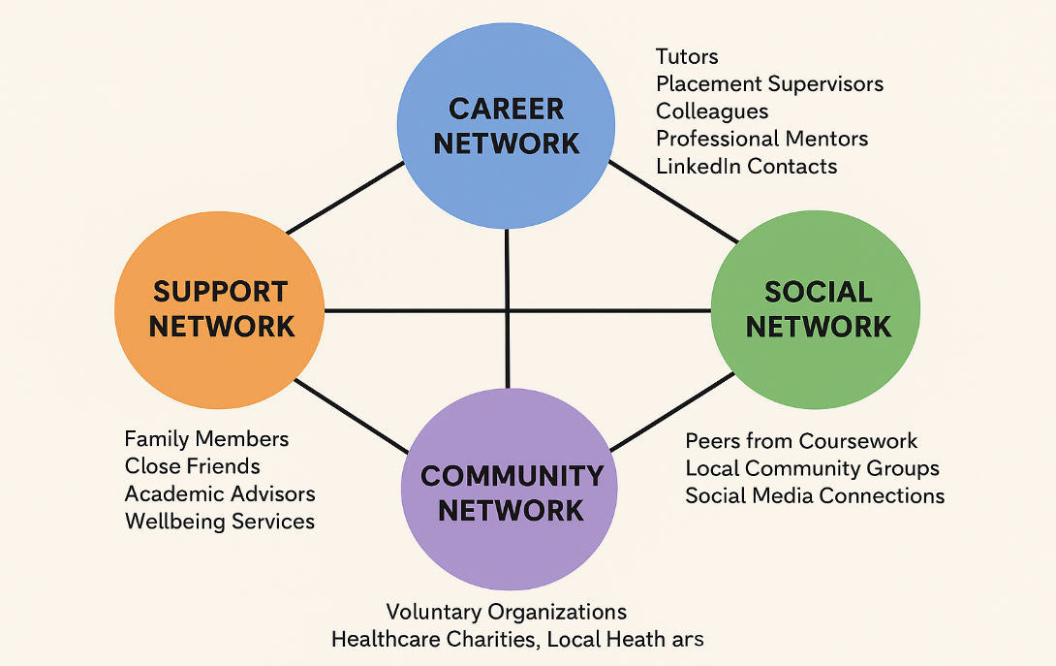
Figure 1 Network Map
The professional network enables my career development, exchange of knowledge and emotional resilience. According to Granovetter theory, weak ties (acquaintances) are the ones that result in new jobs and information. My mentors, bosses, and online communities need mentors to make choices and learn. Communities that support also enhance emotional wellbeing and work life balance which is highly essential in caring occupations (Volk et al., 2024). Participation in volunteer and professional organisations allows us to learn collectively. I will attend health forums and networking events in order to make my network stronger. It will assist me in job hunting, creating my identity, and remaining resilient.

Task 3- Blog
Write a blog exploring a current topic or issue of your choice within the health and social care sector in the UK. The purpose of this is to inform a specific target audience of your choosing (300 words)
Digital health technology is transforming the UK health industry, altering the manner in which care is provided, accessed and administered. The blog targets students and novice employees and demonstrates that digital tools can be used to make care more rapid, simpler, and patient-centred. According to the NHS Long Term Plan (England, 2023), the way we should treat ourselves and, in particular, those with long-term conditions, such as diabetes or heart disease, is by employing mobile apps, telehealth, and wearables. COVID-19 increased the number of remote appointments through NHS apps like NHS App and AccuRx. They maintained the work of services and aided patients who were unable to move or travel (Mittal et al., 2025).
However, there is still a large issue of digital inequality. Elder and low-income populations are usually excluded as they are not familiar with how to work with digital tools or do not have access to it. This should be corrected to ensure digital change is equitable and universal. Workers and patients could be assisted by teaching staff and investing in easy-to-use platforms. New employees have to learn the digital world in order to find work and work properly. Futuristic practitioners will be able to support care through all digital tools, and in a person-centred manner by learning digital skills: as NHS plans to make the future a digital-first place.

Task 4- NHS Equality, Diversity and Inclusion Quiz (250 words equivalent)
- What is the primary goal of the NHS Equality, Diversity, and Inclusion Improvement Plan?
The NHS Equality, Diversity, and Inclusion (EDI) Improvement Plan aims to help create an inclusive, caring, and fair workplace that makes all employees feel appreciated, respected, and encouraged to do their best, which enhances patient care (Hemmings et al., 2021).
- How does the NHS EDI Improvement Plan propose to tackle the gender pay gap?
The gender pay gap in the plan is addressed by ensuring that people can view hiring process transparently and all are given equal opportunity to hold leadership and pay is checked periodically to identify and rectify disparities among employees.
- What is meant by the term ‘intersectionality’ as used in the NHS EDI Improvement Plan?
Intersectionality refers to the fact that various social identities such as gender, race, age and disability interact to impose special experiences of unfair treatment in the workplace.
- Why is it important for the NHS to create a psychologically safe work environment?
The psychologically safe workplace allows individuals to communicate concerns or ideas without being accused of it. It improves the teamwork, training, and patient safety.
- How does the NHS EDI Improvement Plan suggest improving the experience of internationally recruited staff?
The strategy proposes enhanced induction, mentorship, and career management of foreign employees to enable them feel part of the organisation and stay.
- What role does leadership play in advancing EDI objectives according to the NHS Improvement Plan?
Leadership plays a major role in the promotion of EDI objectives through demonstration of inclusion, accountability, and cultural transformation within NHS Trusts.
- Identify one way the NHS EDI Improvement Plan aims to reduce health inequalities within the workforce.
Special development programmes on senior and clinical leadership position run for under-repreresented groups is one mechanism to reduce workforce inequalities.
- Why does the NHS EDI Improvement Plan emphasise the importance of collecting and analysing data on protected characteristics?
Examining and obtaining information on safeguarded characteristics enables us to take evidence-based choices and hold us responsible in combating inequality.
- Explain how flexible working policies can contribute to equality and inclusion in the NHS workforce.
Flexible work contributes to inclusion by accommodating various needs such as taking care of others, disabilities, and religion, that translates to improved work-life balance.
- What is one strategy mentioned in the NHS EDI Improvement Plan to combat bullying and harassment in the workplace?
The plan combats bullying and harassment through more powerful reporting, zero tolerance policies and training to promote respect and politeness.

Task 5- A Letter to Yourself
Think of a time in the past when you may have been experiencing issues or difficulties, and after considering what you have learned in this module about emotional intelligence and resilience write a letter to your younger self explaining how these attributes were important at that time and perhaps how developing these areas could have been useful (250 words)
Dear Younger Me,
I understand that you are feeling overwhelmed with studies, work, and domestic tasks. You tend to question whether you are strong enough to cope with it all. In retrospect, I would have learned more about emotional intelligence and resilience skills, which determine personal and professional development. Emotional intelligence, according to Goleman (Singh et al., 2022) is having an awareness of your feelings, being able to control them as you learn about other people. When you had to hold back at that time, you believed that being weak meant being vulnerable. The acceptance of emotions would render you to be free-spoken and to maintain healthier bonds with other children and role models. Resilience, also, would have helped. It is not only a question of toughing it out but of knowing how to adjust and overcome disappointments (Rachmad, 2022). You might have perceived challenges as an opportunity to be strengthened and become more self-cognizant instead of failure. Had you practised self-compassion, sought support and concentrated on what was within your control, you would have felt less nervous and more confident. I have learned today that the cultivation of these qualities would bring a sense of balance and optimism even in times of uncertainty. Because in my time travel, I would say to you that you should believe in yourself further and follow your feelings and also that being resilient does not mean that you are an unbreakable person, it means that you can learn to bend but not to break.
With compassion,
Your Future Self

Task 6- GANTT Chart (200 words equivalent)
Compile a Gantt chart which illustrates the tasks you have to complete to achieve your future employment goals
Tasks  Month | 1 | 2 | 3 | 4 | 5 | 6 | 7 | 8 | 9 | 10 | 11 | 12
Identify preferred health and social care career path
Research job requirements and person specifications
Enrol in relevant CPD or training programmes
Gain voluntary or part-time experience
Develop and update CV and LinkedIn profile
Network with professionals and attend career events
Apply for graduate or care roles
Attend interviews and refine professional presentation skills
Secure employment and begin induction or training

The development of an effective Gantt chart will provide a clear and achievable roadmap towards securing employment in health care and social care. According to Wadhwa (2024), such tools as Gantt charts can be used to manage time, hold people responsible, and track goals by visualising important milestones. In the initial six months, my plan includes the self-assessment, training, and networking to develop skills and confidence. The CPD courses and voluntary placements suggested by Health Education England (John-Matthews et al., 2021) will enhance my employability and practical perspectives on person-centred care. The second part of the year will be about job applications, interviews and preparation onto a career, ensuring that I am fit to work. It is an organisation-based model that enhances proactive career development and sustainability through the management of long-term objectives into managable steps. I will look at the chart and make necessary changes to ensure that I am on track with professional standards and emerging opportunities in the evolving UK health and social care environment.

Task 7- Making Changes- Report
You are the manager of a care home and want to make changes your workplace. Identify one specific change that you want to implement and write a brief report on how this is going to be achieved considering the necessary skills needed and addressing possible barriers to success. Relevant change models can be highlighted (250 words- 2 referenced sources).
Being the manager of a care home, I would recommend the use of a digital care record system, as opposed to paper records. This shift will enhance the speed, accuracy, continuity of care and retain CQC standards. Effective change requires leaders, effective communication, and digital capabilities of all the individuals. According to Change Management Model by Lewin, we are supposed to pass through three stages unfreezing, changing and refreezing (Amina et al., 2022). During the unfreezing phase, I would hold a meeting with the staff and train them about the advantages of digital records, such as reduced errors, real-time data, and improved handovers. At the change phase, pilot test is done to create mutual confidence and correct the mistakes. Lastly, by receiving feedback and refresh in-service training in the refreezing phase to integrate the new system into the day-to-day business.
Some personnel could however be resistant to change, particularly those who are not tech savvy. According to Kotters eight step model, urgency to be created and early wins to sustain momentum should be an important consideration (Mancini, 2023). To mitigate opposition, I would employ peer mentoring, provide step-to-step instructions, and ensure that the staff is thanked to motivate them to respond positively. Moreover, good IT services and data protection is crucial to employee confidence and compliance. This change can result in improved documentation, communication, and person-centred care in the home by the amount of a supportive, shared approach.

Task 8- Self-Reflection
Using one of the highlighted models of reflection, reflect on what you have learned about yourself during this module, as well as the knowledge you have gained, and explain how this has developed your skills and informed your future practice (250 words- you must reference the model you use)
What?
In this module, I have gained further insights into my professional identity, personal brand and ability to work in health and social care. I found out about the positive contribution of skills such as communication, resilience, and emotional intelligence to professional development. Initially, I did not realise the significance of self-promotion and networking until now when I realise how they influence job opportunities and confidence.

So What?
The model by Rolfe and Tei, (2025) allowed me to assess my strengths and areas of improvement. I found out that I am an empathetic and organised person, but at times I am reluctant to take the initiative in a team. The readings of leadership theories and emotional intelligence demonstrated to me that effective teamwork and service provision rely on self-awareness and the skill of relationship. The module has also developed my digital competencies and allowed me to understand that the NHS itself believes in equality, diversity, and inclusion, which will inform my ethical and culturally competent practise.
Now What?
Moving forward, I will continue to strengthen my leadership, communication, and reflection capabilities via CPD workshops and mentorship as well as networking. I will apply the reflection regularly to make decisions and on-going improvement in practise. This self-awareness will enhance me to provide compassionate and person-focused services in accordance with the evolving demands of the health and social care setting.

Reference List
Amina, A., Kassem, A. and Sleem, W. (2022). Applying Lewin's change management theory to improve patient's discharge plan. Mansoura Nursing Journal, 9(2), pp.335–348.
England, N.H.S. (2023). NHS long term workforce plan [online].
Hemmings, N., Buckingham, H. and Palmer, W. (2021). Attracting, supporting and retaining a diverse NHS workforce. London: Nuffield Trust.
Henrickson, L., Jephcote, W. and Comissiong, R. (2022). Soft skills, stories, and self-reflection: Applied digital storytelling for self-branding. Convergence, 28(6), pp.1577–1597.
John-Matthews, J.S., Hobbs, C., Chapman, P., Marsden, D., Allarton, R., Booth, A., Martin, F., Woodley, J. and Harden, B. (2021). Ensuring an essential supply of Allied Health professions (AHP) placements: using crowdsourcing to develop a national call to action. International Journal of Practice-Based Learning in Health and Social Care, 9(2), pp.49–62.
Mancini, L.A. (2023). The role of change management in corporate digitalization: The relevance of Kotter’s eight-step change model within IT/digitalization projects (Master's thesis, ISCTE–Instituto Universitario de Lisboa (Portugal)).
Mittal, R., Kannan, A.K., Mohindroo, R., Movva, C., Zhang, L., Reehana, S. and Srinivasan, S. (2025). Implementing Accurx for Total Triage Enhancing Care Navigation and Patient Experience. Cureus, 17(2).
Mohajer, S.M. (2021). Personal branding for doctors, necessities and importance. Brandafarin Journal, 2(13).
Rachmad, Y.E. (2022). Resilience to Change Theory.
Rolfe, V. and Teig, N. (2025). Opportunity to learn: A comparison of analytical approaches and relations to student achievement. International Journal of Educational Research, 134, p.102819.
Singh, A., Prabhakar, R. and Kiran, J.S. (2022). Emotional intelligence: A literature review of its concept, models, and measures. Journal of Positive School Psychology, 6(10).
Volk, J.O., Schimmack, U., Strand, E.B., Reinhard, A., Hahn, J., Andrews, J., Probyn-Smith, K. and Jones, R. (2024). Work-life balance is essential to reducing burnout, improving well-being. Journal of the American Veterinary Medical Association, 262(7), pp.950–957.
Wadhwa, K. (2024). The role of Gantt chart in project management.

