Background research
……….looking at walkie talkies and small low frequency and power radios
EM spectrum overview
- Please find the ethics approval form filled out in the one note are
Transmission policy in the uk ofcom
In the uk the EMR spectrum is managed by a UK licensing body called OFCOM they are responsible for authorising and managing the spectrum to stop interference between use of spectrum and users. The spectrum is broken down into different bands
Prototyping of rf systems and how to tests them
- Vero board
- Strip board
- Breadboard / solderless breadboard (good for protyping although will cause problems with reactance and inductance and capacitance
- X microwave – circuit block design (too expensive)
Walkies talkies
https://www.albany.edu/~gc227838/ist523/How%20WiFi%20Works.pdf (page two)
Simple walkie-talkies like this transmit at a signal strength of about 0.25 watts, and they can transmit about 500 to 1,000 feet.
The biggest problem with using walkie talkies is there limited range and signal interference. The signal
Difference between repeartors and amplifiers - https://www.javatpoint.com/repeaters-vs-amplifier#:~:text=The%20primary%20difference%20between%20them,is%20unimportant%20to%20an%20amplifier.
We chose to go for a amp rather than a repeater as we weren’t fussed about the signal within the noise and so didn’t need to both with the modulation that a repeater would.
Types of amps
and there class systems ie A,B,AB,C,D,E,F etc
push-pull amplifiers - One use of phase splitters is to provide input signals to a single-stage amplifier that uses two transistors. These transistors are configured in such a way that the two outputs, 180º out of phase with each other, combine. This allows more gain than one transistor could supply by itself.
A endless frequency amp ?
If you ignore the amplifying device (transistor, electron tube, etc.), and if the amplifier circuit is made up of resistors only, there should be no limits to the frequency response. In other words, a totally resistive circuit would have no frequency limits. However, there is no such thing as a totally resistive circuit because circuit components almost always have some reactance.

audio amps
Audio amplifiers are described as amplifiers between 15 Hz to 20KHz {https://ohioelectronicstextbook.org/ide-electronics-31-audio_and_radio_frequency_amplifiers.html }
The main difference between an audio amplifier and a rf amp is the frequency response
- Bandwidth
- Frequency
- Nominal level power level in dB
- Voltage
- Noise
- Impedance
- Frequency response
- Gain
- Noise
- Distortion
Audio amps and how they work
Rf amps
Rf amps and how they work
“Now that you have seen the way in which a broadband, or video, amplifier can be constructed, you may be wondering about radio-frequency (rf) amplifiers. Do they use the same techniques? Are they just another type of broadband amplifier?
The answer to both questions is "no." Radio-frequency amplifiers use different techniques than video amplifiers and are very different from them.”
“rf amplifier should have maximum impedance at the desired frequency.”

Paragraph for report
To understand the project we have chosen to undertake you firstly need to understand the domain in which it sits in. The project we have chosen looks at the audio environment typically between 20 Hz to 20,000 Hz and the radio frequency portion of the EM spectrum which sits between 30 Hz to 300 GHz. The EM spectrum as a whole is managed careful by different government organisations across the world who monitor spectrum use in there respective countries. In the UK the spectrum is manged by OFCOM they
Cross over distortion
Report plan to organise the team
Contents
- page 1 - contents
- page 2 – introduction
- etc
Introduction
What is the project about ?
Aim – What is the overall research question you’re trying to answer?
Objectives – What are the actions you’re going to take to try to satisfy the aim?
A brief description of what is coming up in the following chapters

Background research and lit review
Intro to research
- Write an introductory paragraph at the start of the chapter that briefly describes the sections
Cerys
- Introduction to the field
- Explanation of challenges of the field
- What other research has been done in your field?
- Who did this research?
- What were their results?
- How do these results relate to other researchers' work in the field?

James
- What other research has been done in your field?
- Who did this research?
- What were their results?
- How do these results relate to other researchers' work in the field?
- What are the crucial differences between the different aspects in the field?

Ethan
- What other circuits exist in the field?
- What other techniques have been used to achieve similar results?
- How does part of the circuit work?
Conclusion of review
What did you learn from the research and the key points you are taking with you.

Research and or development methodology
Here you explain in detail what, why and how of the procedures you used in order to generate the solution to the idea.
- For your chosen development methodology explain:
  - Why you have chosen that method – mix of ethan and james research to justify why that amp and then why that circuit
  - What are the advantages of that method to your project – mix of all research to avoid the problems we have found in each of those areas.
  - If there are any disadvantages to the method then how you will work around them.
- What hardware are you going to use, and why is it appropriate for the project?
- What software are you going to use, and why is it appropriate for the project? - james as simulated this bit
- Materials and Tools. eg why are you using a particular package or language to design and develop your software? – ethan as describes the circuit
- How are you going to evaluate success? What methods of testing are you going to use? – cerys as describes usecase
Implementation
- Software screen shots
- Photos of the bread boarding and then the vero board work
- How did the software function? – Flowcharts, code segments (NOT entire listings), did you use any internal peripherals?
- What difficulties did you encounter, and how did you overcome them?
- What we did and why
Results and analysis
Once it works can look ay this
  - What were the results?
  - Were they what was expected? – If not, why not?
  - How does this link to your literature review?
  - Do the results fit against the project requirements?
Evaluation
- Evaluation usually comes in one of two forms: either you compare what you did with your objectives, or you can compare what you did with what someone else did.
- What conclusions can be drawn from your data?
- Did your data back up the research in your literature review or disagree with it?
- Did you meet your objectives? If not, why not?
- Did you meet your aim? If not, why not?
- Overall, are the answers what you would expect? If not then why not?
- If you were to do it again, what would you do differently?
Conclusion and recommendations
- Summary of everything and the most key points or ideas
- Things gained from this project none technical
Reflection
The key question here is:
- What did you learn while doing the project? How did it change you as a person?
It will help you to:
  - make connections between the documented theory and what you did in practice.
  - make sense of what you did and help yourself to do a better job next time.
Put simply - could you have done it better and, if so, how?
References
The usual

Bibliography
of background reading
This will include all material you have read but not necessarily directly quoted in the text.
Appendices
Appendices to a report contain information that, while not important or interesting enough to be included in the body of the report, is nevertheless relevant.

Cerys report sections
introduction
The following report aims to review, deliberate and ultimately answer the question of can basic audio power amplifiers be used in other high frequency areas within the EM spectrum such as low-end HF (High Frequency 3MHz – 30MHz) ​[1]​. Initially giving the reader an overview of the EM spectrum, Amplifier classification, impedance matching and other notable key topics. The report will then move onto the design, implementation and testing of the chosen Amplifier circuit. This will cover key principles such as software implementation, testing and refinement as well as the need for real world prototyping. Whilst discussing test plans, safety considerations and a note on ethics. The report will then go onto the analysis of results such as ideal operating frequencies, power levels and notable output characteristics. Overall hoping to give the reader an answer to the question but also the required background understanding, knowledge and test principles to apply within other areas of the field.
Background research and lit review
Introduction to research
The following section is designed to highlight key research points and literature that were considered by the group in the process of identification and realisation of the project. It is intended to give the reader the wider context to understand the domain the project sits in as well as highlight the key issues that could affect the project. Starting at a high-level overview before moving on to the bespoke challenges of amplifier class systems and impedance matching.
Cerys
The group project chosen focuses on amplification of audio and RF signals which sit within the EM spectrum, the electromagnetic spectrum is the categorisation of all signals that are made of EM radiation organised according to wavelength or frequency ​[2], [3]​. In practice this includes everything from radio waves that are used for communication systems to gamma rays which can be used for sterilisation. The following report will focus on the audio (20 Hz to 20,000 Hz) ​[4], [5]​ and High frequency radio signals (3 and 30 MHz) ​[1]​. Audio frequencies ranges are based off of the human hearing range. Whereas HF frequencies signals are classified by the ITU (International Telecommunication Union).
It is important to understand the regulations that govern how the spectrum is managed and can be used. In the UK the spectrum is manged by OFCOM who are responsible for authorising and managing spectrum usage ​[6]​. This will be covered in greater depth in the test plan and ethics section of this report.
There are many key features that affect both audio and rf signals such as attenuation, amplification, impedance matching, reactance and more. Impedance matching and amplification will be explained below in further detail as they are particularly relevant to amplifiers.
To understand amplification, impedance matching and attenuation you firstly need to understand the key features of signals such as amplitude, fundamental frequencies, harmonics, ripple and cross over distortion and the effect they have.
The amplitude of a signal is simply the max power present in the signal usually measured in volts or dBm[?]. The amplitude of a signal can be a really useful tool to spot the fundamental frequency and the following harmonics from above the noise floor present in the signal as can be seen below.
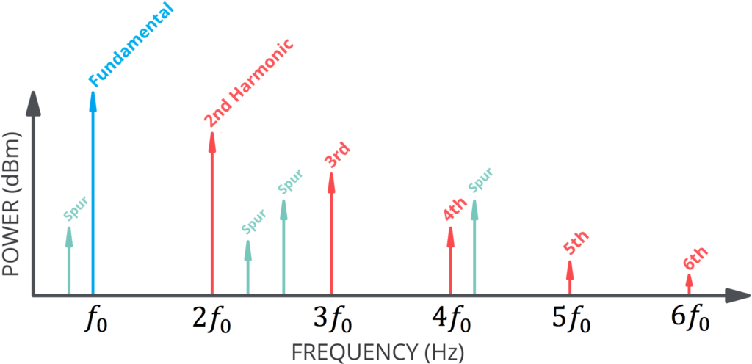
Figure 1 - Strength of Harmonic Frequencies
Cross over distortion can cause attenuation and signal degradation with can affect the amplitude of a signal as seen below.
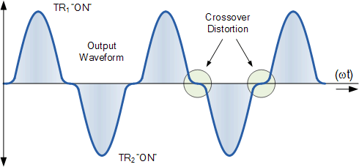
Figure 2 - Crossover Distortion ​[7]​
Cross over distortion will be covered in greater depth further on in the report. However, it is important that the reader understands the degradation affect that cross over distortion can cause due to the either a mismatch in transistors or the biasing current on the base is set incorrectly ​[7]–[9]​.
Ripple can also cause a drop in the voltage output as well as the quality of the signal, and can cause overall attenuation of a signal ​[10]​.

Conclusion of review
As seen from the above literature review there are many key elements that going into amplification of a signal and what defines the frequencies that will and will not work with that amplifier. Class systems can be a great way of understanding amplifier outputs without having to analyse the specifics affects they will have on each signal. Impedance matching can help reduce attenuation of the overall signal. oscillations can cause increased attenuation. With oscillations reducing the power of the overall signal.
Research and development methodology
Once the literature review was conducted and the key topics and focal points were identified, the research turned to focus on how we could develop such a system.
The initial development research began with looking into amplifiers and the key features of them. Amplifiers have class systems associated with them defining how that type of amplifier would work this helped identify what kind of output we could expect from various designs. “A practical introduction to electronics” by M.Hartley Jones ​[11]​ was key in this process and helped to solidify not only the key elements of amplifier circuit design but also the key components and techniques that would need to be employed. The design that was chosen to be taken forward was a complementary Darlington class AB emitter follower. This was due to its simplistic design which then can be built upon if required to explore how amplifiers behaviour is affected as the input signal frequency is increased.
(Why you have chosen that method – mix of ethan and james research to justify why that amp and then why that circuit)
To implement the above circuit a mix of hardware and software were chosen. Proteus ​[12]​] then DIY Layout Creator​[13]​ were chosen for software implementation. Breadboard and Vero board were chosen for physical implementation. proteus was chosen for the circuit design as it is easy and simple to use with inbuilt test features such as oscilloscopes, amp-meter and volt-meter to supply an accurate way the circuit might work. DIY Layout creator was used to design the Breadboard and Veroboard as it had a greater array of available components and allowed you to add flying wires in, rescale, rotate and manipulate the breadboard with ease. This also had the advantage of allowing the design to be peer reviewed. Breadboard was chosen for the initial physical implementation for its ease, adaptability and simplicity of test. However, vero board was later chosen as a more stable, long-term option for the circuit creation as it is more physically robust but can also handle high frequencies. ​[14]​
To evaluate success accurately a mix of qualitative and quantitative parameters were chosen to make sure the system was working as expected.
Parameter | Qualitative | Quantitively | Pass or fail
Current increase | Is it higher than input | Is it up to 1A
Frequency | Can the circuit be used above audio frequency | Can the circuit be used between 3 and 30 MHz
Solder joints | Are all connected and not dry
Cross over distortion | Is there cross over distortion | What percentage of the signal experiences cross over distortion
How much noise is present on the signal ? | Is there noise on the signal | What is the SNR
Once the success criteria and design were confirmed equipment was identified that would allow for quantitative and qualitative testing.
To complete the above tests :
- Spectrum analyser
- Oscilloscope
- Signal generator /function generator
- Multi-meter (Volt and ampere meter)
- Probe leads
- Flying wires for input and output of amp
- Dual power supply for +- 24 volt supply
The spectrum analyser is used to check across a large span to see the signal across a larger bandwidth and to look for any harmonics which was out of the capacity of the oscilloscope.
The function generator was the initial source for the signal in but it was found to be unreliable and hard to adapt. The function generator was replaced by a signal generator as a more adaptable and reliable source.
The multi-meter allows the user to monitor the current or voltage in a circuit, for the above tests the multi-meter must be placed in series to measure the current.

Here you explain in detail what, why and how of the procedures you used in order to generate the solution to the idea.
- For your chosen development methodology explain:
- What are the advantages of that method to your project – mix of all research to avoid the problems we have found in each of those areas. - ethan descirbe circuit stuff
- If there are any disadvantages to the method then how you will work around them.
- What hardware are you going to use, and why is it appropriate for the project?
- What software are you going to use, and why is it appropriate for the project? - james as simulated this bit
- Materials and Tools. eg why are you using a particular package or language to design and develop your software? – cerys
- How are you going to evaluate success? What methods of testing are you going to use? – cerys as describes usecase -
Implementation
Implementation introduction
For the implementation of the circuit we chose a multi- step process to allow for constant review and refinement. Starting with the recreation of the circuit design in proteus, then moving on to create a physical version on breadboard with a final build on vero board also known as strip board. we used online software to design both the vero board and breadboard design to keep them neat and organised but also easier to peer review.
Physical implementation
Breadboard
To implement the circuit on breadboard it was firstly required to order the components that were used in the simulation of the design.
However, after some research it was found that some of the required components had been discontinued, therefore suitable replacements would be required. This was achieved primarily with the aid of CPC similar components feature, which helped guide us to a set of components which we could short list, check their respective data sheets to compare key details and then order. This can also be done through the use of a towers transistor book.
One example of this is the transistors, in the original design used ZTX450 but these were unable to be sourced, so the ZTX451 variant was used.

Once all the components had been confirmed, the next stage was breadboarding the circuit. Breadboard is a solderless board that allows connections to components with ease. The initial design for the breadboard was done through a software called Pebble. Pebble is a software that allows you to virtually put components onto a breadboard and organise the connections between components. However due to the limitation of the Pebble software a replacement software DIY Layout Creator ​[13]​ was sourced. Using this software helps keep the breadboard design in a logical order whilst saving space, it also allows for easy rearranging, rather than having to constantly remove and replace components in the real-world version. However, the initial design that was created had a few problems such as 2 pins going to the same location and the components being larger that the program suggested. These were easily overcome by re-sizing the components and peer reviewing the layout.
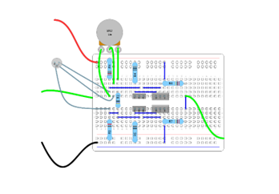
Figure 5 - Final Breadboard layout
Once the design was finalised it was then recreated on breadboard. However, when beginning to test the breadboard it became clear it would be difficult to test the system. Some components such as the large power amplifiers and 1k trimmer were physically too big to fit in the breadboard meaning further jumper cables were needed to connect the system introducing more possible loose connections. As well as some components not sitting in the correct hole causing potential shorts.
Breadboard also isn't recommended due to its low current capabilities. Breadboard isn't recommended for high frequencies due to it parasitic internal inductance and capacitance and are generally rated for 10 kHz and below. This is due to the parasitic elements which can change the resonance and impedance of the circuit, changing its behaviours at high and low frequencies. ​[15]​
Following the issues experienced with the breadboard, it became clear that trying to achieve reliable results would not be possible. Therefore, testing was stopped on the breadboard and the move to a better soldered connection was required. Again, the DIY Layout Creator ​[13]​ was used to make the plan before beginning to assemble.

Vero board
The vero board implementation followed the same process as breadboard designing with an online tool, once again allowing for simple peer review before moving onto the physical implementation . Initally the smaller components were placed into the board for spacing before the larger holes and breakes were drilled before moving onto soldering them in. Once all the components were soldered in place and all the solder joins were visually inspected it was found a few were dry so to avoid this all of the joints were fluxed and reheated before being reviewed one last time.

Test plan and Ethics
The above project doesn’t require many of the traditional ethics questions to be asked that would be see in biology, psychology or other forms of research. But does require the creators to think about regulations and IP. IP or intellectual property is the law that protects intangible creations such as patterns, research, art, inventions, images etc. As the basis of the project surrounds a complementary Darlington class AB emitter follower from the book “a practical guide to electronics "it was important to reference the text accurately as well as all other IP from other sources that is used in other parts of the project.
As previously discussed, when using signals that fall on the EM spectrum it is important to understand the underpinning regulations such as OFCOM spectrum licensing. Which states what frequencies and power levels you can and can’t emit at. The above project doesn't need to consider the OFCOM regulations as there is no over the air testing or high-power levels involved. If the project was to involve the above it would require permissions from OFCOM as the project looks between 20 Hz - 30 MHz which crosses bands such as maritime mobile communication (20.05-59.75 kHz), Radio navigation (70 – 72 kHz), broadcasting (14.8-255 kHz), mobile except aeronautical (5.06-5.25 MHz). ​[6]​
TEST PLAN
The initial plan is to confirm the setup of the signal generator and the spectrum analyser by directly plugging the signal generators output into the spectrum analyser. To check the signal that is coming from the signal generator is accurate. The following tests focus on the amplification effect of a signal using the amplifier from audio to low HF frequencies.
To power the amplifier a positive and negative 24 volts supply will be connected this will be created using a dual power supply. This will be connected to the respective rails as seen below.
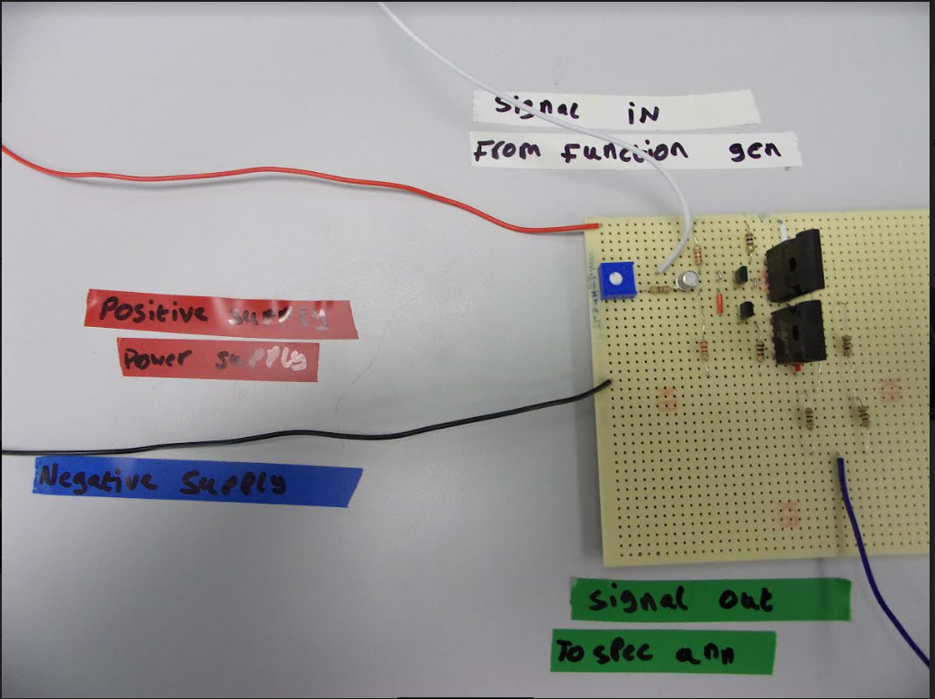
Figure 7 - Photo of Vero Board test setup

A signal generator will be connected to the Input of the amplifier to supply a signal for amplification. With a spectrum analyser / oscilloscope attached to the output of the amplifier to view the noise, power and frequency of the signal. An ammeter will be placed in series on the output so it can be compared to the input current to see if there is any increase. The frequency will then be systematically stepped up and the DBm and frequency will be recorded for later analysis.

reflection
During this process the team has learnt a number of key skills such as report writing and circuit analysis whilst discovering how to research relevant literature within a sea of information and extraction of key details such as circuit design principles and key rf principles such as amplification, resonance and cross over distortion. The team was able to work together effectively to prototype and test the amplifier in RF frequencies whilst considering key safety principles within the lab environment and the wider policy surrounding over air testing. the team was able to solve problems dynamically solving problems such as procurement and discontinued parts issues to build an equivalent circuit.
Whilst using our research to guide us we were able to reproduce the circuit from “the practical guide of electronics”, using the smaller transistors as switches for the larger power transistors. If we were to do this again the team would focus more on impedance matching and wouldn't protype using breadboard due to the problems breadboard can use due to its capacitive and inductive features. The team would also try and create more amplifier options to test the best options of arrangement and would also introduce an RF amplifier as a control to compare the non rf amplifiers to.
References (see next page)

