Gobbet – BBC: What is Orientalism?

“When will we stop stereotyping?” is a video produced by the BBC in collaboration with Professor Evelyn Alsultany explaining the term Orientalism and the consequences it has within our society (particularly “Western” societies). To place this piece within context, Alsultany is a professor on the representation of Arab and Muslim people particularly within the US media and the specific forms of racism that these groups face. Her background in this field leads to her part in this piece as she is focussed on those whom Orientalism has real world effects.
Unlike the other options of pieces for this gobbet, “When will we stop stereotyping?” is a video posted on the BBC’s own website. It features animations to illustrate Alsultany’s points as well as subtitles. I think that these are important to not as these components of the piece make for it to be much more widely accessible for a number of different audiences. This piece is part of a series of short films all found under the “ideas” section of the BBC’s website. This collection of short films includes various topics such as history, economics and psychology, meaning that this film can be discovered by people who would not otherwise be looking for it. It allows for Alsultany and her analysis of Said’s work and the term orientalism to reach audiences which would otherwise not encounter such information. The use of a video rather than an essay or article is also notable. The video, with brightly coloured animations, makes the information easier to be consumed by these wider audiences. Rather than alienating those who would simply skip over a written piece on the subject, the video format allows for it to capture this audience and require less intent observation than a written piece. The video also contains subtitles, allowing it to be accessed by those with hearing difficulties.
The video begins with introducing Said and the term orientalism. They explain that Said argues that orientalism is the way in which the “East” or “Orient” is seen as the opposite or a juxtaposition of he “West”. They very early in the video simplify the term orient, explaining that it means the east and the roots of the word and its opposition to the west. However, the video fails to delve deeper into the issues that arise from simply using the terms east and west, and does not further explain the difficulties with these terms, the problems that arise with their use, or even what either Said or Alsultany define the east and the west as. As is often discussed in contemporary anthropology these term are hard to accurately define. There is no totally agreed upon definition of east and west and no clear border between the two. Rather, they fall prey to the assumptions and personal viewpoints of the writer. It can be inferred from Alsultany’s presence in the video and the later examples of orientalism given that she at least, definitely includes Arab and majority Muslim countries in her own definition of the east.
The video then goes on to use visual imagery in order to further explain how orientalism works. Using the example of a pair of glasses they explain the orientalism distorts a persons view of the world by adding layers of stereotypes and creating an image of those in the “east” as something different to those in the “west”. This provides the viewer with a easily understandable metaphor without becoming patronising, allowing viewers to more easily accept it. With a more patronising explanation, one in which the viewer is told that they are actively engaging with these orientalist views would alienate said viewers. By explaining orientalism as an outside force that the viewer is able to simply “take off the glasses” and see the world more clearly, viewers are less likely t feel as though they are being blamed for the influence of orientalism in their day to day lives.
The next point made by Alsultany is about the extremes at which those in the “east” are represented particularly in the media. Alsultany describes the two very juxtaposing views of Asian women as either “as exotic – a belly dancer- or oppressed – a “veiled woman” with no nuances in between.” This is also seen in Asian men, however, instead of oppressed, men are viewed as violent and dangerous. It is important to note that these perceptions are much more recent and a result of the post-9/11 world in which we live, where the media has created a fear in much of the public of Asian people in general, not only Muslims.
Finally, the video end with reiterating the point from Said which they explained at the beginning of the video. Not only is orientalism about views of the east but about its juxtaposition to the west. Orientalism therefor, is just as defining of the west as it is the east. As explained in the video, this contributes to the prevalence of orientalism in todays society as it is as much about how the west views themselves as hot the view the east. As a result, orientalism has become more stubborn than some of the views developed at the same time during the 18th and 19th century. Rather than becoming an antiquated view, it has simply morphed into something different. Whilst the east was once portrayed as an exotic and otherworldly place, there has been a shift towards it becoming a dangerous place. In todays portrays of the east vs the west the east is a dangerous place with a dangerous religion, as opposed to the west with its supposedly more progressive ideas, where women are not oppressed and society is supposedly more free.

Blog Post – The Use of “Meme Culture” in the Welsh Independence Movement

With the latest generation of young Welsh people, the sense of alienation from the UK government and its policies has become not simply more widely felt, but more intensely felt. AS a result, there has been a surge within Welsh youth to regain a Welsh State independent of Westminster. And unlike our pre – worldwide web predecessors todays Welsh youth have access to the internet in order to find others like them, with dreams of a better, more independent Welsh state. The Facebook community page “Welsh Independence Memes for Angry Welsh Teens” (which I will from here refer to as simply Welsh independence memes) has almost ten thousand followers, and posts daily content relating to the injustices done to the welsh people in todays government, in the past with attempts to wipe out welsh culture, and hopeful looks toward an independent future for Wales.
The Worship of the “Real Prince of Wales”
Despite the currents British monarch’s title as the Prince of Wales, many followers of Welsh Independence Memes would argue that there has not in fact been a “true” Prince of Wales for hundreds of years, since the last one was hung, drawn and quartered by the English.

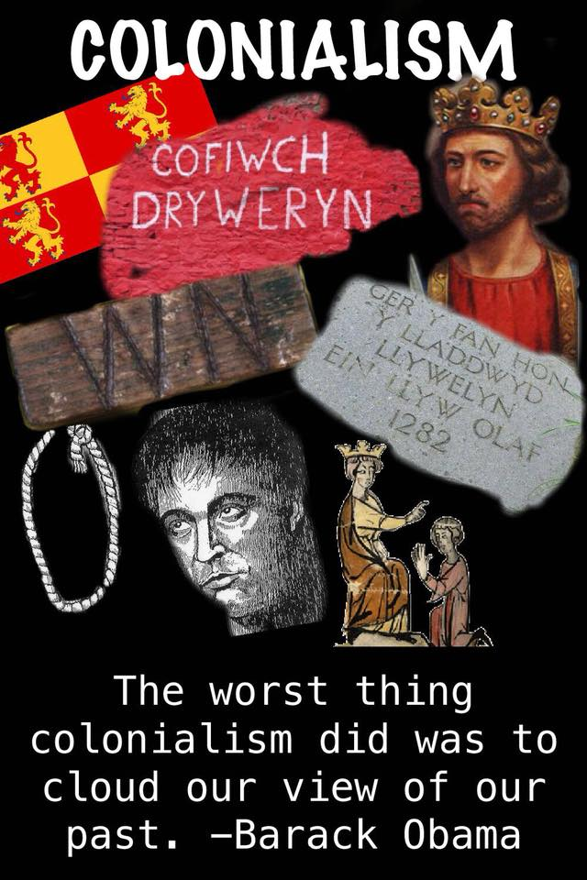 https://www.facebook.com/indy4us/photos/a.2002643086439519/2076270975743396/?type=3&theater (last accessed 8.3.19)
The above photo posted to the page draws parallels between what may be considered modern colonialism (that of the past 200-300 years) to the invasion and annexation of wales by the English in the middle ages. It also highlights the continued attempts at drowning out Welsh culture, in the case of Cofiwch Dryweryn, quite literally. The site of the Tryweryn graffiti, a memorial of a welsh town flooded to provide the English city of Liverpool with water holds a particularly bitter sentiment as not only was it a literal example of this drowning out of welsh culture, but in the weeks before the posting of the above picture was vandalised, leading to public outcry. The picture also features the “Welsh Not” which was used in the 19th and early 20th century to punish welsh children who spoke their native language, Welsh, at school.
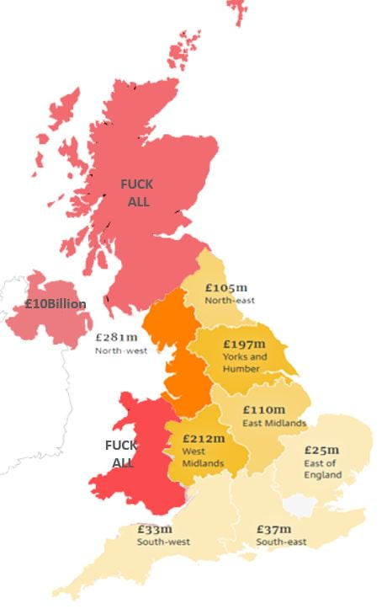 https://www.facebook.com/photo.php?fbid=10216775687237275&set=a.1105753796805&type=3&theater (last accessed 8.3.19)
This diagram was also featured on the page, illustrating the inequalities between money allocated to different areas of the UK regarding funds after Brexit. IT highlights the lack of funds allocated for both Wales and Scotland, both of which were annexed by the English government, and whose current governments do not support much of what goes on in Westminster – unlike the DUP of northern Ireland.
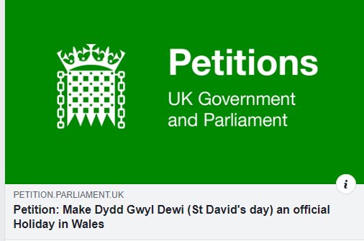 https://www.facebook.com/welshindependencememes/ last accessed 8.3.19
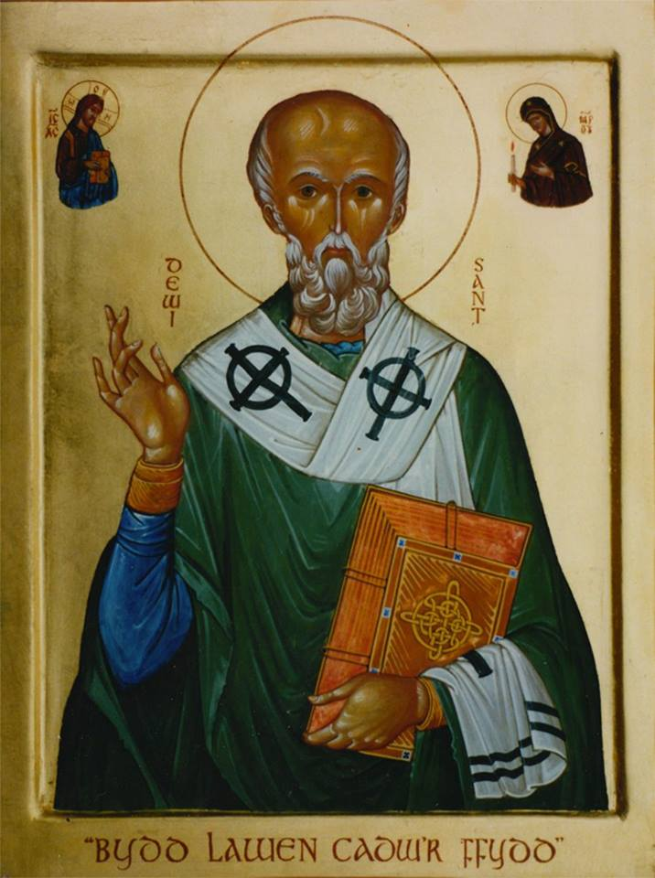 https://www.facebook.com/welshindependencememes/photos/a.1201826023228190/2118087874935329/?type=3&theater
The above image is from a post, sharing a petition for parliament to make St David’s Day an official holiday in wales. St David’s Day, the patron saint of wales, is not officially recognised. Whilst this seems to many to be a trivial, to those that follow this page, this is symptomatic of wider issue of forgetting Welsh heritage and welsh traditions within Westminster. The second above image is a portrait of saint David, or in welsh Dewi Sant. This image was posted to celebrate the patron saints day on march 1st and unlike most content on this page, was not making a joke. But instead the image of the patron saint was posted with respect, whilst not from a religious standpoint but instead from one that celebrates and respects the heritage of the welsh people that has survived hundreds of years of attempts to be wiped out by the English government.

It is pages like these, where young people from across the country can communicate with each other about matter that directly affect them, but in light hearted ways, that allow these kinds of new nationalist movements to develop. With the use of memes and joke, not only does the page and its followers make fun of their English oppressors and the government that they believe treats them unfairly, but allows for a space to celebrate their own heritage. IT is not a small feat that the welsh culture, language and traditions have managed to last through years of English oppression, and whilst not always using the advances of the internet, the spirit of the welsh that can be seen here is directly responsible for this survival. The welsh independence movement could have died with the mines, the language, our “real” prince of wales. But instead, the welsh people have consistently fought back. Except now, rather than through the use of violence and bloodshed, it is derogatory names for the English, such as Saes, and laughter that they fight back, and continue to fight for the right of welsh representation/

Somethin’ Else. 2018. “When will we stop stereotyping?” BBC [online] Available at https://www.bbc.com/ideas/videos/when-will-we-stop-stereotyping-people/p06p97cr?playlist=the-a-z-of-isms Accessed 7.3.19

