Freedom Farmers

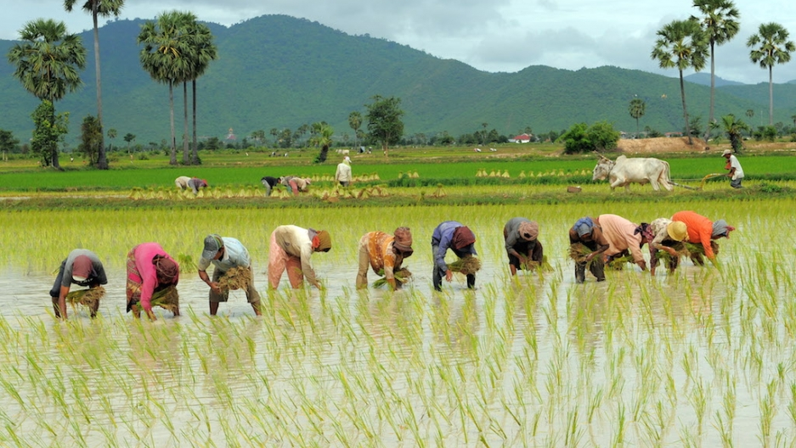

By Sam Reseigh
Abstract
I have been set the task to produce on implications and development of farming technology in Cambodia. The goal is to help aid the disabled farmers to become involved within the farming community which in turn will supply food and income. Cambodia is mainly a rural area as estimated to be 80% of Cambodia’s 16.25 million citizens live within rural areas working on farmlands as a community. Cambodia was a country involved in civil war between 1967-1975 which resulted in the army placing landmines around the rural areas as battle was based there and along the borders, an majority of the Cambodian people are physically disabled due to injuries from landmines, this majority struggle to support their families or themselves with an income causing poverty ,starvation and crime. The project goal is to help these people to get involved with the farming community which in turn will allow them to live better lives.

Contents Table
- Introduction
- Research
- Aims of the project
- Design ergonomics
- Technologies
- Design concept
- Final design explained
- Design meets ISO901 quality standards
- Evaluations and future development
- Conclusion
- Reference page

Introduction

This will be a report will explain/show the stages of development of farming and quality of life improvement programme. The project will be based on the rural farming communities of Phnom Pehng, Cambodia. the project design will be based upon an idea of giving the Physically disabled the opportunity to get involved with the community. The design will be based upon the ability to survey the lands and enable the person to communicate with farmers on the fields which allows them to communicate back and forth, the design will allow the person to assist with their community farm. A large percentage of people in Cambodia are physically disabled due to the landmines placed in the rural areas during the civil war so the project will give the opportunity to involve themselves into the working world and gain responsibilities and funds for their daily life’s.

The device will allow the farmers in the community to communicate, transport small tools, survey the lands and spread seeds in a large area in a shorter time frame. The main customers this product will be aimed at are the physically disabled and based on persons that have lost limbs below the waist and can’t travel far without difficulty as the lands are uneven. The design inspiration is based off the drone which is a flying system, this will benefit my design to lower costs as there are so many designs in scale and materials used so I can gather research, I will design it from the best functionality for the persons using and not compromise the quality and durability so the overall design will be based around quality but usability and its performance for farming work.

The aim of Cambodia project
The aim of the project is to research and provide the people of Cambodia with aid in getting the vulnerable and disabled back into employment within their communities which will in turn provide them and their families with a better living, with the products provided we can help them to be involved with the farming culture. The project is based upon helping the most vulnerable due to the civil war in Cambodia many vulnerable people are the result of the war due to landmines being placed around the rural areas and not removed as they were never tracked on the map.

The main aim is to provide a product that will benefit them in the farming industry as Cambodia has a vast rural area full of farmlands, I will be involving the design of a drone with communication capabilities and surveying capabilities, by implementing these ideas I feel the person will benefit and the community. As a group we are developing different products such as apps which will be compatible with the drone ,ai systems that will allow the persons to ask for weather conditions for present and future, these will all be compatible with each other to ensure maximum resources for the person in use.
Topographical Research

Research on Phnom Penh shows that majority of land is surrounded by rivers that flow through the farmlands, the land is measured 11.8 meters above the rivers but Cambodia has two seasons, hot and monsoon season. The hot season will have temperatures from 21 degrees to 40 degrees, the hot weather season spans from January to June but as there are rivers flowing through Phnom Penh meaning the lands are rich with nutrients and water which makes the land very suitable from farming on hence the massive faring communities in rural areas. The system will have to be designed to withstand high temperatures so it doesn’t over heat casing damage to components within. The drone can be used to inspect the river beds that aren’t accessible by foot to ensure there is no damage or can be reinforced when the season changes to monsoon. This can benefit the farmers as to save keeping their land and crops which will keep the income to the farmers and their families, the economy will benefit from keeping the crops safe and lands as it will keep a steady flow of produce to the markets/stores which will keep the price on certain foods at a steady level which is good for the economy.

During the monsoon season the drone can be used to survey the lands for points on the river which as said before are weak and need reinforcing, the drone can supply a plan to implement paths for the water to flow to calm the water and flow it away from the farmlands. The monsoon season happens from end of June til November, the rain happens 20 days of each month and the rain is known to be predictable, the
drone can be used to survey the damage caused by the monsoon.

During the season changes the farming communities of Phnom Penh are vital to keeping the food supplies to market and stores so having the opportunity to survey their land and set in place defences for the crops is important for the food income and the economy is protected.

Design Ergonomics

The audience the product which will be designed around is very important as it will be aimed to give the physically disabled the opportunity to be a part of their community and have responsibilities. The aim is to help those who are physically disabled as of the result of landmines and other factors such as poverty so not getting access to medical attention which stops the person from having an income to supply for his/her family.

It is very important the product is designed around those who are no longer able to walk. The product has to be designed around ease of use. The product will be first launched into the Cambodian market with the appropriate design factors of the ergonomics of Asian people, but specific to the Cambodian people until further expansion of the market. Asian people tend to have smaller hands so the drones design will be taking into account the size and design on the controller for the drone to allow ease of use. The design should always imply he ease of use and the comfort of the user so it will be easy to use.

Funding Possibilities

With developing a design with the project come the costs of manufacturing, transporting the product to these rural areas and further development for the future. The individual parts for the drone are reasonably priced but making enough units will add up to a much bigger cost so will need to exhaust other funding options such as:

- Charity shop- we could open a charity shop like existing charities to allow customers to purchase products that have been donated which then can be sold as second hand products which can supply a fund to the manufacturing of the product.
- Charity online funding- with setting up an online page we can advertise our charity using social media pages such as Facebook to involve the world with our charity, donating online, sponsoring people of Cambodia, social media is an amazing tool for advertising as there over a billion users worldwide and the ability for people to share and set up funds toward the page.
- Government grants- the local government of Cambodia can open a grant fund which would give up a lump sum of money to fund the charity, this is a good thing for the government to get involved as well to show good motive for the people it serves.

Technical Specifications

This list is the key specifications required to base my design upon and how its to be implemented onto the final design:

- Physical design- the components on the drone have to be able to withstand high temperatures, (ABS) plastic is a good suit to this as it doesn’t have a true melting point and is regularly available and can be shaped easily.

- Protection- as I will be focused in rural farming areas It will need to be well sealed from dust, water, I have found IP67 which has a rating of 6 for dust penetration and 7 from water penetration, this is ideal as both these will be a daily of the product.

- Being that the product will be flying in forest areas it is important to be bale to withstand a knock, the edges of the body will be supported with rubber on the support legs and the body around the removable lid, protection will be needed for the rotors.

- Focusing on rural areas suggests they won’t have a recycling system implemented as much so the packaging will come with bio-degradable cardboard to allow it break down over time.

- The product should be able to last for 6 years with maintenance to components and repair components sent out if needed for repairs.

- The product will be designed to be portable.

- The functionality s key so will be designed around its performance and can be used to support farmers and user.

- The amount produced will be minimal to test/improve design in needed be, with 300 units produced firstly. The product production should be small taking one to two hours to produce complete unit.

- The product design must not be offensive to the culture or any religions.

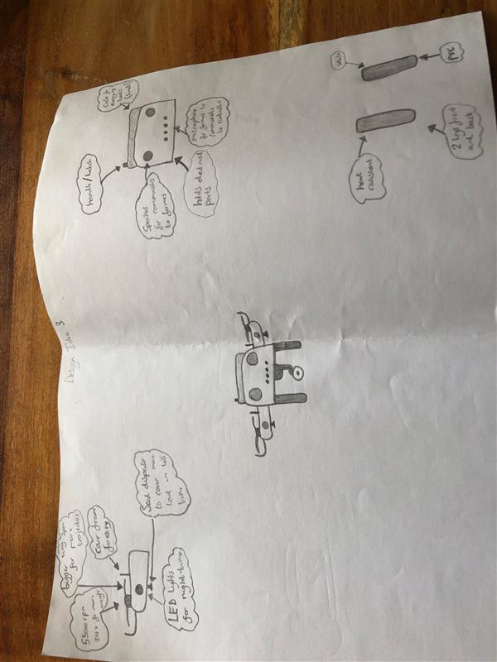

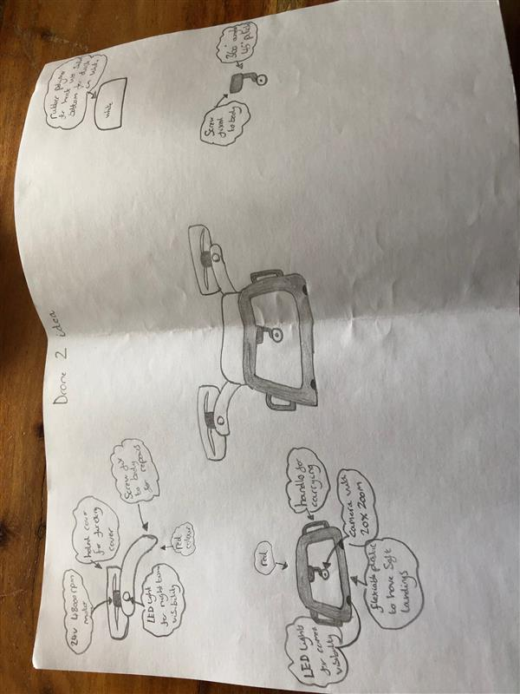

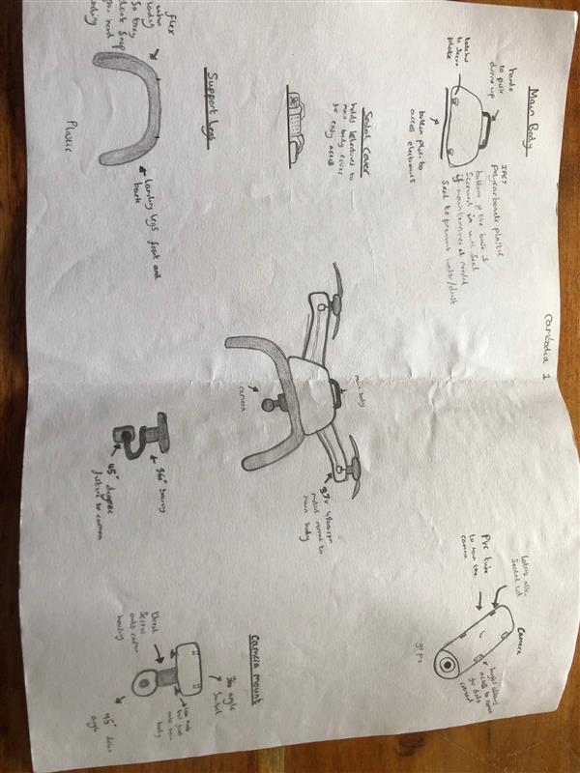
Drawing designs
The drawings I have produced were in an effort to produce sketches on what I believe the product should represent, I have improved on my design as I go through, involving the specification list to ensure the designs meet the standards required to make a good product. The drawings represent what the appearance should look to be, with research I have developed them to be user friendly and serve more of a purpose than surveying but used as a carrying tool or seeder, the drones were designed to navigate through dense areas and the material choice to suit the harsh ever changing environment’s. The rural areas of Cambodia have a dense forestry area surrounding so that was taken into account with damaging the propeller’s or having the drone become stuck with branches. The design has taken into account the weight by using the least amount of body component’s so its easy to handle and pick up. I have chosen drawing three as my design I wish to go off as I think it sits the needs of the person in use with helping to provide a role within the community.

Technologies

The following will list the technology integrated into the design:

- The product will have a 1080P camera fitted to the underside, this will project back to the hand controller with a 5.8inch screen, allowing the operator to see what the camera is viewing.

- The controller has a built-in mic and so does the drone to allow communication from the farmers and operator.

- The drone will be fitted with lights to be able for use in the night with the camera.

- LED flight lights on the body to be able to track in motion.

- Controller has alerts to tell user if battery is low, temperature and wind speed for better usability.

- If the battery becomes low it alerts user and if not able to fly back to user it will and the drone at a safe speed for damage prevention.

- 360-degree gyro fitted to camera on the underside and a 45-degree tilt angle.

Development of design

After research I have been able to source suitable designs for my drone which will meet the criteria of what I want to design and in the best possible way to benefit the farmers of Cambodia and others to come with development.

Software
Software is an important part of the whole project as it interlinks all the designs and products involved with this product such as the drone design, an app is being developed to allow the user to access many products to help with farming such as accessing the drones functions via applications on phone or tablet/iPad allowing the app to see what the drones sees, communicate from the app through the drones communication device installed and receive through the drone to the application. The major goal of the app that is being developed is to connect any device that can install and use applications. The application will allow the user to store detailed logs of evets, footage and any key information. The application will be compatible with products designed around the amazon echo dot which is in development. The app will have built weather reports as a standard function to allow users the use of local weather stations reports to predict and prepare.

Hardware

Hardware is very important as well as software to work with each other giving the most usage out of the device:

Communications/informational devices

Siri -this is a system installed software that comes standard with any apple device allowing the user to speak to its devices and ask questions such as the weather for today and future.

Amazon echo dot- this device allows the user to communicate to the device giving information using operator questions which the information is gathered from the internet such as temperature, farming tips and weather reports.

Google assist- this is a software installed onto android phones but can be found on the internet upon google search but using it allows again the use of asking a question and getting the answer from researching it from the internet.

Farmer hardware

Drones- drones will assist in helping the venerable farmers use to scout the lands and bring small tools to the field, it will be compatible with the software to gain optimum compatibility, will have a communication device fitted to speak from farmer to farmer, a camera which is relayed back to the controller or through mobile, tablet, computer devices.

Final Design
After researching best designs with sketches and details drawing of the product adding different parts to benefit with the farmers through research, the research gathered on the environment of Cambodia and the ergonomics I have concluded my best design and have chosen upon my findings suited to my research:
- Function- the product can be used to communicate to the farmers in the field, this can be used to call for help, the product can be used to transport small tools to the fields as the farming fields are large areas, the product and be a source of light in the night.
- Weight-the weight is important to its transport for the user to be able to pick it up and put outside for launch
- Portability-the weight is a key factor but it has been designed to safely be transported with handles attached to body.
- Camera-the camera has been attached to a 360 gyro to allow maximum view.
- Controller- the controller is fitted with a small screen the projects the cameras feed and a mic to communicate to and from the drone.
- Compatibility with apps on phones/tablets
The final design was important as to not copy any other designs on the market, the product was designed to optimise the functionality for the user, the product will be easy to operate and the accessibility to the components is important to be maintained or repair parts, the product controller will be basic but still have good functionality for what its required to do. The controller functions include a microphone to communicate to the farmers and the farmers to do the same for asking for supplies or when the user surveys the land. The product will be listed as a surveyor tool but will have extras to benefit all.
The device has been designed to set it apart from other designs and benefit the user I the farming community, the device main part is the camera but the extra such as a mic and speaker to communicate to the farmers on the field allows them to be involved from their homes in a safe environment. The product will have the ability to be easily maintained given access to the main components making maintenance and repairs easier to keep the product at its maximum performance. The design will also have the specification in mind and the quality assurance when using recycled material.

Material
The drone will be used as an outdoor device so will need to bare the hot/cold and humid so the material used will have to be able to withstand different conditions all through the seasons. The material selection is key to making sure the drone is able to be used 24/7 if needed.
Plastic
The project spec states we wish to use recycled materials to prevent polluting the environment and can be a cheaper option, the drones parts will be best suited to be made using plastic moulding which involves a mould specifically made to the design of the parts/components such as the body, propeller support arms, legs. Injection moulding is a good option to mass produce but the tooling itself has to be designed on CAD and tested before final design can be made which is costly but once perfected can be used constantly and the design can be implemented to different lines making production smooth and easy.
The cost of setting up a production line using injection moulds is costly but in the long run you have moulds which can be used to mass produce so you will make your money back on the amount produced.
The whole body will be plastic to save weigh on shipping, usage ease and transportation for the farmers using.
ABS plastics are the best suit as they can withstand high temperature, have a good durability and can be easily moulded which is what the spec involves for mass production.

Components used
Propeller motors
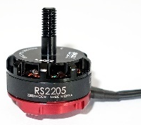
Emax RS2205 2300KV motor (£9.55)

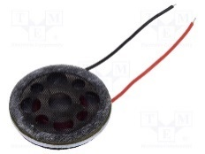
Speaker
0.5W,50ohms, miniature loudspeaker (£4.28)

Microphone
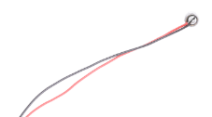
3mm hole microphone, 50-16000 hz -44DB (£1.88)

LED lights
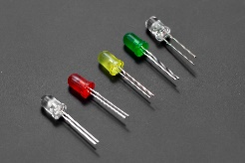
5mm LED pack (50 pcs) (£3.40)

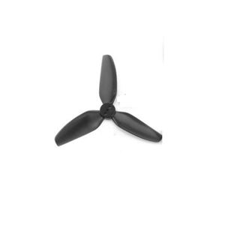
Propeller
HQ prop t3x3x3 PC tri-blade propeller’s (£1.95)

With these components we can build a prototype that can be developed and used to base our own design of components so that we can make manufacturing cheaper in the long run but is a good base to go off. We can develop more ideas with size, weight and performance with our final product.

specification | Weightings | Design 1 | Design 2 | Design 3
production | 5 | 3 | 2 | 4
Recycled material | 8 | 4 | 4 | 6
Rain/dust effectiveness | 5 | 4 | 3 | 4
Weather resistance | 10 | 7 | 8 | 8
cost | 10 | 6 | 5 | 6
appearance | 5 | 3 | 2 | 5
weight | 5 | 3 | 3 | 4
total |  | 30 | 27 | 37

Quality assurance
The drone will have to meet with all safety checks and ISO ratings so that the drone is functional but safe to use, the drone will be using recyclable materials to reduce pollution. Plastics are somewhat hard to recycle due to the life span of the material and the process involved with recycling means pollution to the air/environment so using recyclable materials benefits the reduce of pollution as seen with plastic bottles in the streets and in the sea waters.
The drone needs to be made out of the best possible plastics to make it meet specifications for the build but also the cost effectiveness. Testing that the material used are at the best standard means a time and expense quality check but will be necessary to meet the project standards. All the checks are important to providing the customer the best possible product but keeping the environment safe as well.
The drone/project needs to have high quality from the plastics used so it’s important for consistent quality and recyclability applications of recycled plastics has changed with research and development with use in medical and high-performance parts and in the food, industry using high quality plastics for specific purposes.
Quality insurance is looked at strongly with recycling plants for the means of reducing the use of dumping sites and instead recycling them, the plastics are tested intensely to ensure the best quality outcome so that customers can receive with the quality assurance verification on the material.

Project Expectations
The project specifications will need to be aesthetically appealing and performance guarantee on the design of the product. These will be strongly taken into account to prevent damage or complaint from the customer. The research and development or recycled plastics has been greatly widened to reduce pollution and for re-use with the highest of quality. The project needs to meet quality criteria so the recycled plastic will need to be tested for purpose such as the chemicals used within the plastic.so that when it comes to recycling the product, we can ensure the reduction of pollution and the reuse of the plastic.
Quality Measures
The project specification needs the plastic/product to meet high standards so the source of the material being the recycling plants need to be meeting our order amounts and the standard we require the material to be at with the testing involved. This involves the use of quality testing, the testing equipment in the labs are high end testing facilities such as:
Blenders- blenders are used for use on new plastics and recycled plastics to test the quality and tensile testing of the plastic, recycled plastics have to meet standards, by using blending small amounts of off spec plastics into on spec plastics makes the off spec plastics but has to be checked again for contaminates of prohibited or additives.
Ovens- ash is found within plastics so with manufacturing it is important to be tested, contents of ash are measured/tested by taking samples from plastics and placing into the oven which is heated the extreme temperatures to separate the ash from the plastics.
Melt indexer-this is the measurement of the weight of plastic, this provides the tester the indication of performance for different applications. Measurement of viscosity for plastic is performed by using a capillary rheometer.
x-ray fluorescence- testing materials can be done by x-ray to see what materials are prohibited from being used in manufacturing, the failed plastics are sent back into the recycling process.

Quality Control
Using quality testing methods ensure that the plastics used in manufacturing are to the best standard as these materials are used in all sorts of manufacturing aspects such as food industry, electrical equipment, car parts etc. the plastics are formed by layering different materials together to form a stronger material. Using recycled materials encourages recycling but is also a cost saver so is test vigorously to ensure the customer receives quality goods, even after the processes are complete it is tested again to ensure all the correct properties are within the material by using an analysing machine which is a quick and reliable test check that makes sure the correct composition is performed.

Conclusion
The group was set a task to produce a combined report that we selected as a group, the aim of the group to provide different products that we thought would benefit our individual sectors and make them compatible with each other product ensuring maximum usage out of them for the vulnerable people of Cambodia, we decided to base our ideas for the farming community as Cambodia has over 16.25 million people in is population and 80% are living in the rural/farmlands of Cambodia. with majority of persons working on farms and the landmines placed during the civil war we decided to help with the farming culture, the vulnerable people were our main target to helping make their lives better for themselves and their families such as providing them with our products which in turn provides them with a roles in the farming community and sources them with money for their family. The group was then asked to provide an individual report of their specific product and come up with a design that would benefit but also meet standards to manufacture such product.
I feel my drone will benefit the farming community as to heling survey lands for possible farmlands, areas where security is need for their crops or farm animals and the advice each other for weather conditions coming with the aid of the camera they can see where a river bank may become loose and break free so can source a solution instead of venturing out to dangerous areas.
The products were designed upon performance to the person operating and the goal of recycling and using recycled material to reduce our carbon foot but with the quality assurance that our products would meet a high standard but benefit all that uses them.

References for information
https://www.hobbyrc.co.uk/emax-rs2205-2300kv-red-bottom-racespec-motor?gclid=CjwKCAjwte71BRBCEiwAU_V9h8R758MuiYFIjnQyoQpeQwRi6fjAGDzR-FMfCnnvb7LTRw8NQEsGmBoC5ZIQAvD_BwE
https://www.tme.eu/gb/details/vs-k16-50/speakers/visaton/2816/?brutto=1&gclid=CjwKCAjwte71BRBCEiwAU_V9hzvPH7VMf_pBEsI-p21yV3bsvO222gUMYZWwvgPyLFaJUeLvVd3GEBoCuisQAvD_BwE
https://uk.rs-online.com/web/p/condenser-microphone-components/7800734?cm_mmc=UK-PLA-DS3A-_-google-_-PLA_UK_EN_Passive_Components_Whoop-_-Condenser+Microphone+Components_Whoop-_-PRODUCT_GROUP&matchtype=&aud-827186183686:pla-478072688335&s_kwcid=AL!7457!3!428942734035!!!g!478072688335!&gclid=CjwKCAjwte71BRBCEiwAU_V9h66R68c6SmmmhrSvILHj32l5FqKjcB64kgVWLwfbe2yMwGMjTAKYRhoCexQQAvD_BwE&gclsrc=aw.ds
https://www.dfrobot.com/product-877.html?gclid=CjwKCAjwte71BRBCEiwAU_V9h6HhAmOFqnK4oFsBCIVGEU5qkFTm6zAZsCHyTd8Re8d02sA_JywRlBoCojcQAvD_BwE
https://www.hobbyrc.co.uk/hq-prop-3x3x3-pc-tri-blade-propellers-black?gclid=CjwKCAjwte71BRBCEiwAU_V9hyDJghaPChtcfK25hJrdbVhxqwMVCZQzbwzvOkcEgeYGxX8v5-TnERoCaBcQAvD_BwE
https://en.wikipedia.org/wiki/Cambodian_Civil_War
https://www.divecambodia.com/visit-cambodia/weather-seasons
https://www.google.com/search?q=cambodia+population&rlz=1C1CHWA_enGB643GB643&oq=cambodia+population&aqs=chrome..69i57j0l7.15796j0j7&sourceid=chrome&ie=UTF-8
google.com/search?q=cambodia+population&rlz=1C1CHWA_enGB643GB643&oq=cambodia+population&aqs=chrome..69i57j0l7.15796j0j7&sourceid=chrome&ie=UTF-8
https://en.wikipedia.org/wiki/Land_mines_in_Cambodia
https://www.britannica.com/place/Cambodia

