University of Wales Trinity Saint David (UWTSD)


Assignment Title: “ Marketing Environmental Analysis for Pioneers and Followers”

Programme: Master of Business Administration (MBA)
Module: Marketing Management
Module Code: LCMB7024
Lecturer:
Student Name: Marzana Hasan Mita
Student ID: 2504068
Word Count: 2400
Submission Date: 21st November, 2025

Table of Contents
1. Introduction 3
2. Theoretical Foundations of Marketing Environment 3
2.1 Concept of Marketing Environment 3
2.2 Pioneering vs Following Strategy 3
3. Critical Analysis of Macro Marketing Actors 4
3.1 Technological Environment 4
3.2 Socio-Cultural Environment 6
4. Strategic Responses to Macro Factors 7
4.1 Responses to Technological Factors 7
4.2 Responses to Socio-Cultural Factors 9
5. Discussion: Comparative Evaluation 11
6. Conclusion and Recommendations 12
References 13

Figure 1 Global Technology Trends in Smartphones (Source: Teece, 2018). 5
Figure 2 Strategic Responses of Pioneers and Followers to Macro Factors (Source: Author) 9

1. Introduction
The marketing environment can be defined as all external and internal elements that influence the way a firm creates, markets, and sells its products (Kotler and Keller, 2022). It consists of economic, social, technological, and competitive forces that influence business decisions. It is significant to understand this environment so that firms can embrace change and develop strong strategies to achieve long-term success. In business strategy, companies are categorised as either pioneers or followers. First movers are the earliest achievers who introduce new products or innovations into the market that have early brand awareness and customer loyalty (Grant, 2021). Instead, followers enter later and learn through pioneers, who frequently enhance their products and supply them at a cheaper price (Chen et al., 2021). In this report, the global smartphone industry will be discussed in terms of Apple Inc. being a pioneer and Samsung Electronics being a follower. It will examine the way the two companies react to the factors of a marketing environment and stay competitive.

2. Theoretical Foundations of Marketing Environment

2.1 Concept of Marketing Environment
The marketing environment is a set of factors that influence the way a business operates and makes marketing choices (Kotler and Armstrong, 2020). It is divided into two parts: the micro environment and the macro environment. The micro environment encompasses individuals and organisations near the business, which includes the customers, competition, suppliers, distributors, etc. These are the factors that have a direct effect on the day-to-day operations of a company. Macro environment encompasses broader external resources that range between political, economic, social and technological as well as environmental and legal perceptions. These influence long-term plans and direction of a company (Day, 2011). In order to comprehend such changes, companies practice environmental scanning, which implies gathering and analysing data regarding the market and market trends. This assists managers to make more well-informed choices, minimise risks and discover new opportunities. Having knowledge of the environment enables companies to remain strong and competitive in the dynamic global market.

2.2 Pioneering vs Following Strategy
A pioneer is a firm that launches a new product or idea earlier than others. This assists it in the acquisition of early benefits like good brand image and customer loyalty (Grant, 2021). A follower will come to the market later when the pioneer has shown success and will learn the lessons of the pioneer (Chen et al., 2021). The followers tend to enhance products, make them cheaper, and reach more customers. Pioneers are extremely creative, and followers seek to learn and enhance. The two have significant roles towards competition and innovation in industries like smartphones.

3. Critical Analysis of Macro Marketing Actors
Macro marketing environment encompasses all external pressure that influences the way firms compete and achieve success. Kotler and Keller (2022) observe that knowledge of these forces enables companies to plan in the long term. This section examines two critical variables, which include technological changes and socio-cultural trends. It contrasts the response of pioneers such as Apple and followers such as Samsung.

3.1 Technological Environment
The technological environment refers to new technologies, systems, and innovations that define the way smartphone companies compete. Such technological changes may present opportunities and threats. According to Kotler and Keller (2022), businesses should be mindful of these changes to remain competitive.
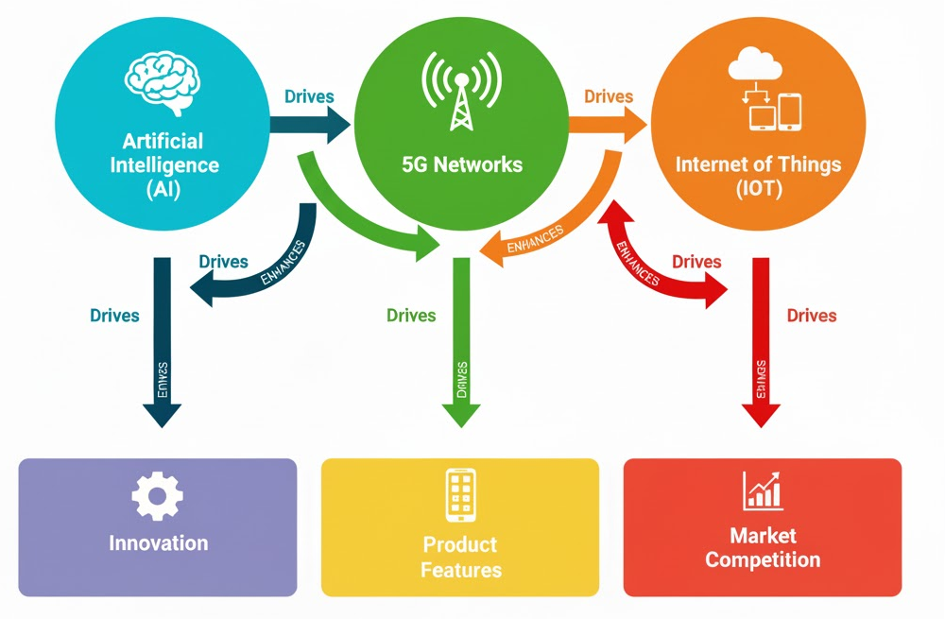
Figure 1 Global Technology Trends in Smartphones (Source: Teece, 2018).
Current Trends
The main trends in the smartphone market are artificial intelligence (AI), 5G networks, and the Internet of Things (IoT). AI enhances voice-assistants, web cameras and prediction software. To illustrate, Apple applies AI to improve the quality of photos and introduce smarter personal assistants. 5G enables quicker, faster internet, as well as cloud-based services, and makes applications, such as gaming and virtual reality, possible (Teece, 2018). The IoT connects smartphones to other smart gadgets like smart watches, speakers, and home appliances, and makes the experience seamless.
Opportunities for Pioneers
Innovation and industry standards can be led by pioneers such as Apple. Being an early adopter of AI, 5G, and IoT also enables Apple to provide some distinct features that cannot be easily duplicated by its rivals. An example is the Apple ecosystem, which connects the devices and makes the user more loyal and purchase more products (Prahalad and Ramaswamy, 2004). The strategies enable Apple to continue with the premium image and sell at a higher price.
Threats for Followers
Competitors such as Samsung struggle with imitation and rapid technology transfer. To be competitive, they have to embrace new technologies within a short period of time. It involves the followers making a variety of devices at varying prices to come to the wider market. Nevertheless, they cannot be regarded as leaders in innovation (Chen et al., 2021).
Pioneers are able to achieve loyalty, increased margins and leadership of the brand at the expense of high research costs and threats of imitation. Followers minimise risk and increase market reach, although they might seem less innovative. Both of them manage to succeed when they are efficient by utilising technology and are responsive to trends in the market. Success is determined by strategic timing, appropriate investment and knowledge of the customer needs.
Table 1 – Key technological trends and impacts
Trend | Impact on pioneers (Apple) | Impact on followers (Samsung)
Artificial Intelligence | Fast, private AI; premium experience | Cloud-based or delayed AI; cost focus
5G Networks | New services; premium appeal | Affordable 5G phones; broader market
IoT / Ecosystem | Strong ecosystem loyalty | Compatibility across devices; value focus

3.2 Socio-Cultural Environment
Socio-cultural environment comprises the social values, lifestyles and cultural trends, which influence customer behaviour. The variation in these factors affects the manner in which smartphone companies promote their products. According to Kotler and Keller (2022), strategic marketing requires knowledge of social trends.
Changing Consumer Values
Sustainability, ethical and social responsibility are becoming significant concerns among consumers. Consumers like brands that are less impactful on the environment and ethically treat workers (Lee and Kotler, 2019). Apple, as an innovator, recycles its materials and lowers carbon emissions. Its premium image is reinforced by its ethical practices and transparent chain of supply, and its long-term customer loyalty is established.
Brand Loyalty Vs Price Sensitivity
Brand loyalty is strong among pioneers such as Apple. Quality, innovation, and ethical standards enable customers to pay more (Chen et al., 2021). The follower companies, such as Samsung, target price-conscious consumers who desire economical products with the same features. The followers have to find the balance between quality and cost to remain competitive and attractive to various markets.
Marketing Implications
Apple employs brand storytelling and CSR marketing to engage with customers emotionally (Holisoh et al., 2024).. This brings a feeling of belonging and identity. Samsung employs the localisation techniques and the concept of influencer marketing to appeal to the younger generation in various markets. Samsung can achieve greater relevance and brand awareness by working to localise campaigns with local cultures and values.
Opportunities and Threats
To social pioneers, social trends present a chance to build more loyalty and to defend high prices. The risk is that followers can copy ethical practices or sustainability assertions in order to appeal to customers (Tu et al., 2018). To followers, the social trends enable them to grow market share by being affordable and locally relevant. The danger is a loss of prestige and the perception of being a follower instead of a leader.
Early adopters get high loyalty and a premium image but have to remain innovative and communicate effectively. Follower gains are rapid adaptations and value provision at the expense of desired premium sales. Both categories of firms are obliged to keep track of social changes to keep up with the competition.
Table 2 – Key socio-cultural trends and impacts
Trend | Impact on pioneers (Apple) | Impact on followers (Samsung) | Evidence
Sustainability | Builds loyalty; premium image | Reaches price-sensitive, eco-conscious buyers | Tu et al., 2018.
Ethical consumption | Strengthens trust through supply chain transparency | Gradual adoption; risk of criticism | Sheth, 2021
Social media and lifestyle | Supports premium brand identity | Influencer campaigns appeal to young consumers | Holisoh et al., 2024

4. Strategic Responses to Macro Factors

4.1 Responses to Technological Factors
Smartphone companies are faced with opportunities and challenges due to technological changes. In order to remain competitive, pioneers and followers react differently.
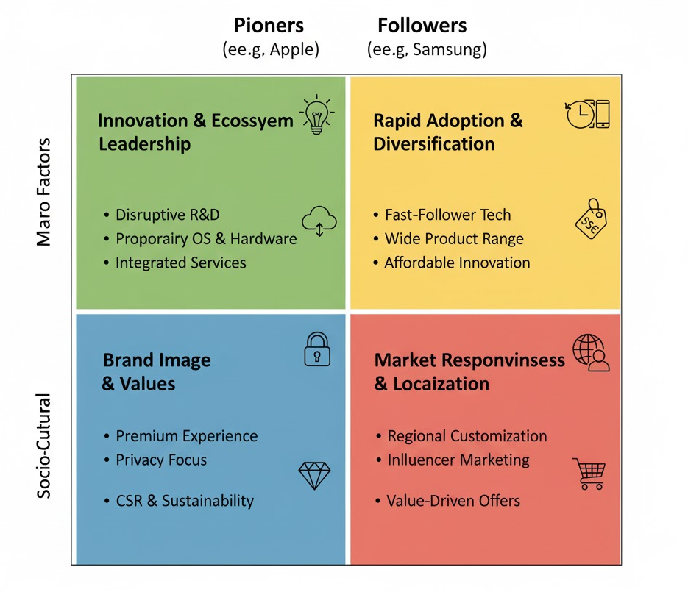
Figure 2 Strategic Responses of Pioneers and Followers to Macro Factors (Source: Author)
Apple (Pioneer) Response
Apple is innovative and differentiated with ecosystem integration. Teece (2018) argues that market leaders are innovators who can establish new technologies. Apple also has extensive research and development investments in an effort to inject AI, 5G and IoT capabilities into its devices. As an example, its camera with AI and Siri assistant gives smarter, quicker, and confidential user experiences.
The Apple ecosystem strategy connects Apple Watches, MacBooks, iPhones, and iPads. This provides a smooth user experience, fosters loyalty, and minimises the probability of customers moving to other competitors (Prahalad and Ramaswamy, 2004). Apple concentrates on product development (adding new technology features) and market penetration (offering innovative devices to current markets) with the help of the Ansoff Matrix. Using the Differentiation Strategy by Porter, Apple has a premium status, which explains the high prices.
Samsung (Follower) Response
Samsung can rapidly respond to market trends and emphasises cost leadership and differentiation. The successes and mistakes of pioneers are studied by followers (Chen, Ishida and Mukherjee, 2021). Samsung releases 5G-enabled and AI-powered models even faster than Apple, with numerous models at varying costs targeting broader markets.
The Ansoff Matrix applied by Samsung is also a combination of product development (addition of new features) and market development (expansion to new customer groups). It focuses on speed-to-market and low cost with quality as a strategy to compete with high-end innovators.
Apple is benefiting in terms of loyalty, high margins, and brand leadership, but at the cost of high costs and imitation threats. Samsung minimises risks and accesses more customers, but seems less innovative. They both have the ability to succeed because they employ technology effectively, release at the right time, and fulfil customer demands.
Table 3 – Strategic responses to technological trends
Trend | Pioneer Response (Apple) | Marketing Strategy | Follower Response (Samsung) | Marketing Strategy
AI | Fast, private AI on device | Differentiation, product development | Cloud AI or adapted features | Cost leadership, fast adaptation
5G Networks | Early adoption; new services | Market penetration, differentiation | Affordable 5G phones for a wide market | Product development, market development
IoT / Ecosystem | Strong integration across devices | Ecosystem strategy, differentiation | Multi-brand compatibility; value focus | Compatibility strategy, affordability

4.2 Responses to Socio-Cultural Factors
The socio-cultural trends determine the ways in which firms can communicate with consumers and position their products.
Apple (Pioneer) Response
Apple is centred on brand storytelling, sustainability, and corporate social responsibility (CSR). Lee and Kotler (2019) have recommended that any company that demonstrates ethical actions and environmental friendliness establish greater trust. Apple is recycling, cutting down the carbon emissions, and making its supply chain transparent. These efforts are emphasised by its marketing, which links customers to the values of the brand. The narrative of Apple fosters emotional attachment and loyalty over time.
Samsung (Follower) Response
Samsung reacts to it through the localisation of marketing, influencer campaigns, and the provision of cheap, environmentally friendly devices. As pointed out by Holisoh, Setyawati and Lestari (2024), localisation is used to target customers in other regions by modifying messages to local cultures and languages. Samsung can use influencer marketing to reach younger audiences that are active on social media. Providing low-cost devices and some eco-friendly characteristics, Samsung also targets price-sensitive buyers who value social responsibility but are unable to buy high-quality products.
Strong brand loyalty and a perceived ethical leadership benefit pioneers in the long term, although it is essential to continue active communication and prevent complacency. By keeping up with the social trends and delivering value, followers experience a short-term gain in market share but risk losing direction in the prestige and premium perception. The two methods involve keeping a close track of the socio-cultural developments to maintain competitiveness and relevance (Barney, 1991).
Table 4 – Strategic responses to socio-cultural trends
Trend | Pioneer Response (Apple) | Follower Response (Samsung)
Sustainability | Promotes recycled materials and carbon reduction | Affordable eco-friendly devices
Ethical consumption | Highlights supply chain transparency and fair labour practices | Gradual adoption; localised ethical campaigns
Social media and lifestyle | Storytelling and brand image campaigns | Influencer partnerships and regional campaigns

5. Discussion: Comparative Evaluation
The technological and socio-cultural analysis reveals evident disparities between leaders and followers in the smartphone market. Innovation, high-quality features and construction of a strong brand image are the focus of pioneers such as Apple. In this way, they are able to dominate the market and make loyal customers. The combination of early adoption of AI, 5G, and IoT can put Apple at a competitive advantage. Its ethical and environmental practices are also very strong, which enhances its customer confidence and augments its high-end image.
Followers such as Samsung react differently. They follow trends fast, provide cheaper devices and localised marketing to make themselves available to more consumers. The followers might not be at the forefront of innovation, but they mitigate the risk by following the strategies of the pioneers. The impact of influencer marketing and the regional campaign of Samsung makes it appeal to young consumers who are price-sensitive.
There is a greater competitive edge in loyalty and brand leadership of pioneers. The followers are more flexible and quicker to adapt. Both tactics will work, yet the key to long-term success will involve the equilibrium between innovation, social trends, and timing. Companies that track the external dynamics and react tactically have a higher likelihood of surviving competitively within the smartphone market worldwide.
Conclusions and Recommendations.

6. Conclusion and Recommendations
Smartphone companies are highly influenced by technological and socio-cultural forces. Early innovation, high-quality features, ecosystem integration, and good moral conduct are some of the areas that help pioneers achieve a competitive advantage. Such strategies create loyalty among customers and enable firms to establish industry standards.
The followers can gain by fast adaptation, affordable products, and localisation of the marketing campaign to fit the local area. This aids them in getting in touch with more consumers and minimising the risk of innovation failure.
Recommendations:
- To remain a leader, pioneers need to invest further in technology, sustainability, and communication.
- Followers should quickly adopt useful innovations, focus on value, and tailor marketing to local markets.
The two should also keep a check on the trends in technology and social trends in order to maintain competition and deliver customer satisfaction.

References
Armstrong G, Kotler P, Harker M and Brennan R (2020). Principles of Marketing. 8th ed. Pearson.
Barney JB (1991). Firm Resources and Sustained Competitive Advantage. Journal of Management 17(1), pp. 99–120.
Chen J, Ishida T and Mukherjee S (2021). Technology Adoption and Follower Strategies in Consumer Electronics. Journal of Marketing Theory and Practice 29(3), pp. 45–59.
Day GS (2011). Closing the Marketing Capabilities Gap. Journal of Marketing 75(4), pp. 183–195.
Grant RM (2021). Contemporary Strategy Analysis. 11th ed. Wiley.
Holisoh R, Setyawati D and Lestari A (2024). Localisation and Social Media Marketing in the Smartphone Industry. International Journal of Business and Marketing 12(1), pp. 15–28.
Kotler, P. and Keller, K.L. (2022). Marketing Management. 16th ed. Pearson.
Lee K and Kotler P (2019). Social Marketing: Changing Behaviours for Good. 6th ed. SAGE.
Narver, JC and Slater, SF (1990). The Effect of a Market Orientation on Business Profitability. Journal of Marketing 54(4), pp. 20–35.
Prahalad CK and Ramaswamy V (2004). Co-creation Experiences: The Next Practice in Value Creation. Journal of Interactive Marketing 18(3), pp. 5–14.
Sheth JN (2021). New Frontiers of Relationship Marketing. Journal of Marketing Theory and Practice 29(1), pp. 1–15.
Teece DJ (2018). Business Models and Dynamic Capabilities. Long Range Planning 51(1), pp. 40–49.
Tu Y, Zhang X and Huang H (2018). Consumer Attitudes Towards Ethical and Sustainable Products in Technology Markets. Journal of Business Ethics 152(4), pp. 1011–1025.

