4/9/2026

Module NaMe: Changemakers, Creativity and Value creation
Module Code: ACCA 5033
Student NAME: DUMITRU DANILOV
Student ID: 2430681
Lecturer: Fahad Ahmed Redhwan Al Amiri

Trinity saint david University of Wales
(London Campus)

Assessment 2
Practical and Professional Development of the Proposed Project
Table of Contents
Introduction 2
Task 1. Orbital Data Center 3
Project Management & Planning 3
Practical Prototype Development 3
Implementation plan: 3
Prototype Development 3
Process and Key Features 4
Feedback: 5
Task 2. Enterprise & Innovation 6
PEST & SWOT Analysis 6
PEST Analysis 6
SWOT Analysis 7
Legal and Ethical Considerations 8
Start-up Concept Based on Project Idea 9
Start-up Name and Logo 9
Business Type (Legal Classification) 10
Business Strategy 10
Funding and Business Initiatives 10
Conclusion 11
Task 3. Project Reflection 12
Development of New Skills 12
Impact on Society 12
Risks and Challenges 13
Risk Reduction Strategies 13
Conclusion 14
Reference 15
Appendices 16
Project Progress Form 16

Introduction
Global need for data processing and storage has dramatically expanded due to the quick development of digital technologies like cloud computing, artificial intelligence, and satellite systems. Conventional data centers have high operating costs and a negative impact on the environment since they need a lot of electricity and intricate cooling systems [1], [4].

Orbital data centers, which place computer hardware in Earth orbit, offer a creative alternative approach, as was covered in Assignment 1. In addition to providing immediate processing of satellite data without the need for significant data transfers to Earth, this approach permits the utilization of continuous solar energy and natural cooling in space [1], [2].

By concentrating on the project management and design elements of an orbiting data center, this assignment expands on earlier studies. It provides an organized blueprint for how such an idea could be put into practice by outlining the project scope, necessary technologies, development methodology, and system design.

Task 1. Orbital Data Center

Project Management & Planning

Practical Prototype Development

Implementation plan:

The idea of an orbital data center created in Assignment 1 serves as the foundation for this project's execution. The primary objective is to develop a conceptual prototype that shows how data can be handled while in orbit and sent back to Earth.
The study focuses on a simulation-based prototype because it is impossible to construct a true orbital system in an academic setting. Diagrams, system models, and simple data flow representation fall under this category.

The following actions are part of the implementation plan:

- Determine system needs by conducting research.
- Create the system architecture (ground station and satellite).
- Make a data flow model.
- Create a basic prototype (simulation or diagram-based).
- Test the idea and get input.

Prototype Development
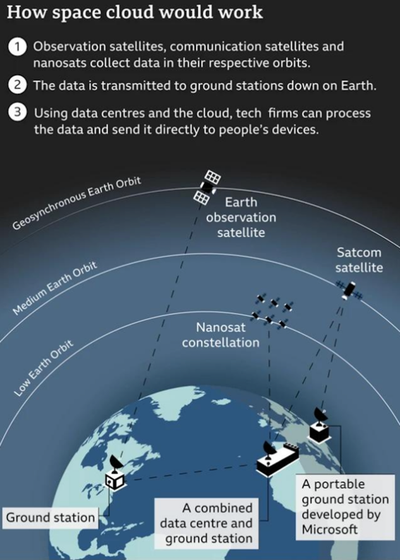
A basic form of an orbiting data center system is represented by the prototype. It shows how the system might function in practice but lacks actual hardware.
The prototype consists of:
- Satellite data gathering
- Data transfer to the orbiting data center
- Processing data in orbit
- Data processing and transmission to Earth
This model demonstrates how unprocessed satellite data can be reduced in size and increased in efficiency before being transmitted to ground stations [1], [2].
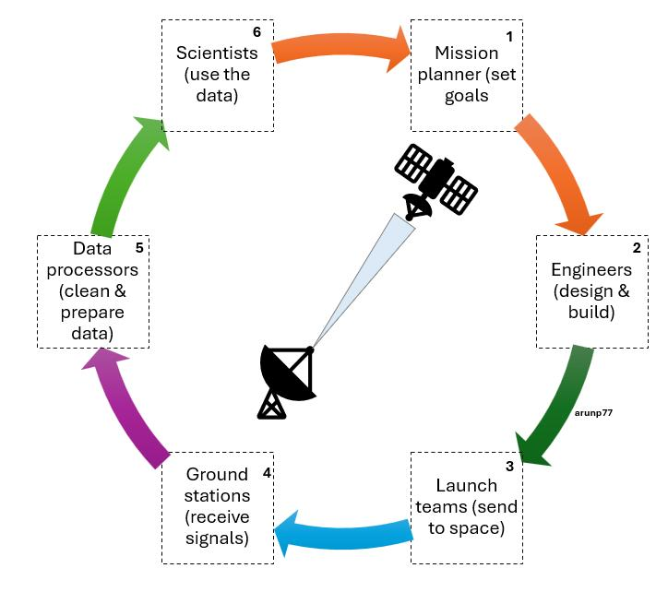

Process and Key Features
The main process of the system is:
- Satellite collects raw data
- Data is sent to orbital data center
- Processing is completed in orbit
- Processed data is sent to Earth
- Users access final data

Key features of the prototype:
- Use of solar energy (concept level) [1]
- Natural cooling in space
- Reduced data transmission load
- Improved efficiency of satellite systems

Survey:
Method of Data Collection
Participant input was gathered using a straightforward questionnaire survey. Both multiple-choice and open-ended questions were included in the poll.
Four individuals with rudimentary engineering or technology skills were given the questionnaire.
Sample inquiries:
- Do you comprehend the system's concept?
- Is the prototype straightforward to understand and follow?
- What is the idea's primary strength?
- What changes would you recommend?

Summary of Survey

According to the response, the majority of participants thought the prototype was straightforward and grasped the idea of the orbital data center.

Important conclusions:

- 3 out of 4 participants said the idea is innovative
- 2 participants mentioned that the concept is complex
- 3 participants highlighted energy efficiency as the main advantage
- 2 participants identified high cost as the main challenge

Improvements Based on Survey
Based on the feedback, the following improvements could be made:
Simplify the system explanation using clearer diagrams
Provide more details about communication systems
Include cost estimation for better understanding
Improve visual presentation of the prototype
These changes would make the project easier to understand and more realistic.

Task 2. Innovation

PEST & SWOT Analysis
For this analysis, a relevant example is SpaceX, as it is one of the leading companies in space technology and satellite infrastructure. Its activities are closely related to the concept of orbital data centers.

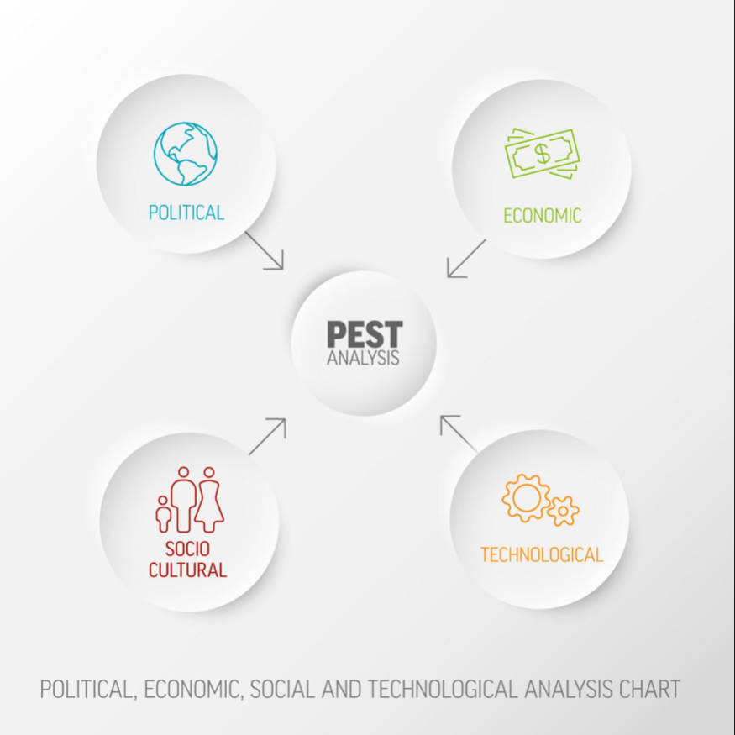
PEST Analysis

Political factors:
Space activities are highly regulated by governments and international organisations. Companies like SpaceX must follow strict laws related to satellite launches, orbital safety, and communication systems. Government support and contracts (for example, cooperation with NASA) can also strongly influence company growth.
Economic factors:
The space industry requires very high investment. Launch costs, research, and development are expensive. However, the market for satellite services and data processing is growing fast, which creates strong business opportunities. [4]
Social factors:
Public interest in space technology is increasing. People and businesses rely more on internet services, cloud computing, and satellite data. At the same time, there are concerns about space sustainability and environmental impact.
Technological factors:
Advanced technologies such as reusable rockets, satellite networks, and space communication systems are key drivers. Continuous innovation is required to stay competitive and reduce costs. [4]

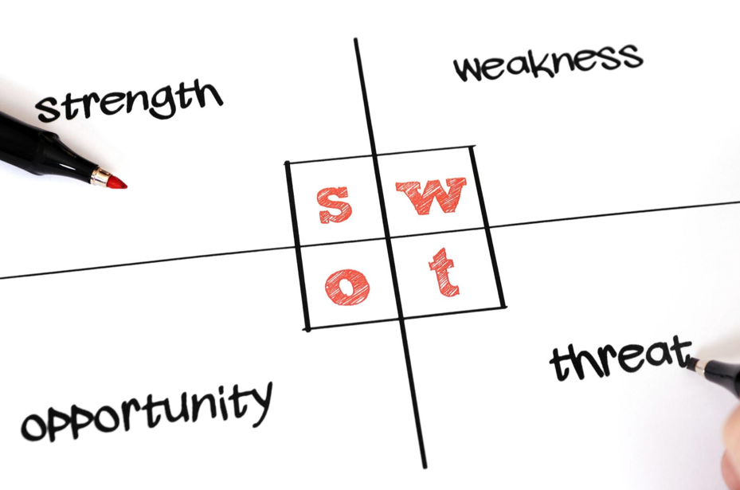
SWOT Analysis
Strengths:
- Strong innovation in space technology
- Reusable rocket systems reduce costs
- High demand for satellite-based services
Weaknesss:
- Very high development and operational costs
- Dependence on successful launches
- Complex technology and high risks
Opportunities:
- Growing demand for global internet and data services [4]
- Expansion of space-based infrastructure
- New markets such as orbital computing [1], [2]
Threats:
- Strong competition from other companies
- Space debris and safety risks [3]
- Legal restrictions and regulations

Legal and Ethical Considerations
Legal considerations include international space law, satellite communication regulations, and safety standards. Companies must ensure that their operations do not create space debris or interfere with other satellites. [3]
Ethical considerations include sustainability and responsible use of space. Increasing numbers of satellites can lead to overcrowding in orbit, which may create long-term risks for future space missions.

Start-up Concept Based on Project Idea

Start-up Name and Logo

Company Name: OrbitCreative Ltd.

Company Logo:



Business Type (Legal Classification)
The business would be registered as a Private Limited Company (Ltd) in the UK.
This structure is suitable because:
- It limits financial risk for owners
- It allows easier investment and funding
- It is commonly used for tech start-ups

Business Strategy
The main strategy is to develop and provide space-based data processing services. [1], [2]
Key strategic points:
- Focus on innovation and research
- Partner with space companies and agencies
- Target industries that use satellite data (weather, defence, environmental monitoring)
- Start with a small-scale prototype and expand gradually
The company would first offer data processing services for satellite operators, helping them reduce data transmission costs and improve efficiency.

Funding and Business Initiatives
To support the start-up, several funding options can be used:
- Government grants (for innovation and space research) [4]
- Private investors and venture capital
- Partnerships with organisations like European Space Agency
- Research funding from universities and innovation programs
Additional initiatives:
- Collaboration with tech companies
- Participation in innovation competitions
- Development of pilot projects

Conclusion
This task demonstrates how the concept of an orbital data center can be supported by real business and enterprise strategies. The analysis of SpaceX shows how external factors affect space technology companies, while the proposed start-up OrbitCreative Ltd. provides a realistic example of how such an idea could be developed into a business.
Despite challenges such as high costs and technical risks, the growing demand for data and satellite services creates strong opportunities for future development. [1]-[4]

Task 3. Project Reflection

This project focused on the concept of an orbital data center, which is a new and innovative idea in the field of data processing and space technology. Through this project, I developed a better understanding of how future technologies could improve efficiency and reduce environmental impact.

Development of New Skills
One of the main benefits of this project is the development of new skills. During the research and planning stages, I improved my ability to analyse technical information and work with academic sources such as reports from the European Space Agency and IEEE publications [1], [2].
I also developed skills in critical thinking, as I had to evaluate both advantages and disadvantages of orbital data centers, including technical challenges such as radiation and space debris [3], [5].
In addition, I improved my project management skills, including planning, organising tasks, and managing time effectively. Creating diagrams and system models also helped me develop basic design and visual communication skills.
These skills are important for future work in technology and engineering fields.

Impact on Society
The concept of orbital data centers has the potential to create a positive impact on society. One of the main benefits is reduced energy consumption, as space-based systems can use solar energy and natural cooling [1], [4]. This could help reduce the environmental impact of traditional data centers.
Another important benefit is improved data processing efficiency, especially for satellite data. Processing data in orbit can reduce the need for large data transfers to Earth, which can improve communication systems and reduce costs [2].
In addition, orbital data centers could support industries such as environmental monitoring, disaster management, and global communication. This means that the project could contribute to both economic and social development.
Overall, the project shows how technology can be used to solve real-world problems.

Risks and Challenges
Despite the potential benefits, the project also faces several risks and challenges.
One major challenge is high cost, especially related to launching equipment into space [4]. This makes the project difficult to implement in the early stages.
Another challenge is space environment risks, such as radiation and space debris. These factors can damage equipment and reduce system reliability [3], [5].
There are also technical challenges, including communication latency and system maintenance. Repairing equipment in orbit is complex and expensive.
Finally, there are legal and regulatory challenges, as space activities must follow international laws and safety standards.

Risk Reduction Strategies
To reduce these risks, several strategies can be used.
First, costs can be reduced by using reusable launch systems and developing the project in stages instead of full deployment at once [4].
Second, radiation-resistant materials and technologies can be used to protect equipment [5].
Third, better satellite tracking systems can help reduce the risk of collision with space debris [3].
In addition, strong collaboration with organisations such as European Space Agency can help ensure compliance with regulations and improve project reliability.
These strategies can make the project more realistic and achievable.

Conclusion
In conclusion, this project has provided valuable insights into the future of data processing and space technology. It has helped develop important skills such as research, analysis, and project planning.
The concept of orbital data centers offers strong potential benefits, including improved efficiency and reduced environmental impact. However, it also presents significant challenges, particularly in terms of cost and technical complexity.
With further development, innovation, and collaboration, this idea could become a realistic solution in the future and contribute positively to society.

Reference
[1] European Space Agency, “Space-Based Cloud Computing,” 2023.
[2] A. Rinaldi, “Orbital Data Centers: A New Frontier for Cloud Computing,” IEEE Spectrum, 2023.
[3] NASA, “Orbital Debris Quarterly News,” 2023.
[4] McKinsey & Company, “The Future of Space Infrastructure and Services,” 2022.
[5] S. K. Sharma et al., “Radiation Effects on Space Electronics,” IEEE Aerospace Conference, 2020.
[6] T. Davenport and R. Bean, “Data Centers and the Energy Challenge,” MIT Sloan, 2022.
[7] IEEE, “Satellite Communication Systems Overview,” IEEE Xplore.
[8] J. Wertz et al., Space Mission Engineering, Microcosm Press.
[9] ITU, “Satellite Communication Regulations,” International Telecommunication Union.
[10] OECD, “The Space Economy in Figures,” OECD Publishing.
[11] UK Government, “Space Industry Regulations,” gov.uk.
[12] ESA, “Orbital Systems and Space Safety,” ESA Reports.

Appendices

Project Progress Form

Project Idea: Orbital Data Center

Name: Dumitru Danilov
ID: 2430681
Course Title: Changemakers, Creativity and Value creation Assessment 2

Log 1
Day & date: 01/04/2026
Progress:
Initial research completed based on Assignment 1. Reviewed key concepts such as space-based computing, satellite data processing, and energy efficiency. Defined project aim and objectives.
Actions:
- Start detailed literature review
- Identify key technologies and system components
- Collect supporting academic sources
Next review date: 04/04/2026

Log 2
Day & date: 04/04/2026
Progress:
Completed literature review using sources such as ESA, IEEE, and NASA. Identified key benefits and challenges including energy efficiency, radiation risks, and space debris.
Actions:
- Begin system design (architecture and structure)
- Define system components (satellite, ground station)
- Start drafting Task 1
Next review date: 07/04/2026

Log 3
Day & date: 07/04/2026
Progress:
Developed system architecture and initial diagrams. Defined data flow process from satellite to Earth. Started writing Task 1 (Project Management).
Actions:
- Complete Task 1 writing
- Create Gantt chart
- Improve diagrams and visuals
Next review date: 10/04/2026

Log 4
Day & date: 10/04/2026
Progress:
Completed Task 1 including planning, methodology, and system design. Added diagrams and improved structure.
Actions:
- Start Task 2 (Enterprise analysis)
- Prepare PEST and SWOT analysis
- Define start-up concept
Next review date: 13/04/2026

Log 5
Day & date: 13/04/2026
Progress:
Completed Task 2 including PEST and SWOT analysis, business idea, and funding strategy. Added diagrams and citations.
Actions:
- Start Task 3 (Reflection)
- Analyse skills development and impact
- Identify risks and mitigation strategies
Next review date: 16/04/2026

Log 6
Day & date: 16/04/2026
Progress:
Completed Task 3 including reflection, risks, and impact on society. Finalised references and improved overall structure.
Actions:
- Review all tasks
- Check grammar and formatting
- Prepare final document
Next review date: 19/04/2026
Log 7
Day & date: 19/04/2026
Progress:
Final review completed. All tasks checked, formatted, and ready for submission. Ensured consistency with Assignment 1 and proper referencing.
Actions:
- Submit final assignment
- Backup all files
- Reflect on feedback (after submission)
Next review date: N/A

