Module code
M6X01910

Module name
Sustainable Architectural Developments

Assignment Title
Case Study for building sustainability upgrade

Submission Date
9th March 2018

Glossary
L/p/d Litres per person per day
SuDS Sustainable urban Drainage Systems
CAMS Catchment Abstraction Management Strategy
SWM Surface Water Management
Interception The prevention of any rainfall event <5mm from entering a water body
Urban Heat Island An area which is significantly warmer, due to human activities, than its surrounding rural areas
1:100 A rainfall event which, statistically, occurs once in 100 years
OS Ordinance Survey
PRE Public Rescue Equipment

Figures
Figure 1 – Conceptual Design of a Pumped RWH System.
Figure 2 – Partial Infiltration Pervious Paving Structure.
Figure 3 – A Conceptual Dry Swale Design.
Figure 4 – Example Pond Plan and Profile Views.
Figure 5 – Conceptual Planted Pond Edge Detail.

Contents
- Site Description 5
- Strategic SWM and SuDS Objectives 5
  - Water Quantity 5
  - Water Quality 5
  - Amenity 5
  - Biodiversity 5
  - Climate Change Resilience 5
- Site Characteristics 6
  - Topography 6
  - Existing Flow Routes and Flood risk 6
  - Potential for Infiltration and Water Quantity 6
  - Potential for Surface Water Discharge and Water Quality 6
  - Existing Site Land Use and Amenity 7
  - Existing Site Infrastructure 7
  - Existing Soils 7
  - Local Habitats and Biodiversity 7
  - Local Landscape and Townscape 7
- Refurbishment Characteristics 7
  - Proposed Topography, Land Use and Landscape Characteristics 7
  - Proposed flood risk management strategy 8
  - Proposed site infrastructure 8
  - Proposed building use, style and form 8
  - Proposed adoption and maintenance and standards 8
  - Proposed Climate Change Resilience 8
- SuDS design criteria 9
- Conceptual SuDS design 13
  - Internal Terminal Water Component Specification 13
  - Rainwater harvesting 14
  - Pervious paving 16
  - Swales 17
  - Bioretention pond 18
- Maintenance 19
- Health and safety 19
- References 21
- Bibliography 21
- Appendices 23
  - OS map of site 23
  - River flood plain map 24
  - Surface water flood plain map 25
  - Site plan with proposed SuDS 26
  - BREEAM Domestic Refurbishment Wat01 Table 24 27
  - BREEAM calculator results for original components 28
  - BREEAM Domestic Refurbishment Wat01 Table 23 29
  - BREEAM calculator results with new components 30
  - BREEAM New Construction Wat01 Table 24 31
  - BREEAM calculator with RWH contribution 32
  - SuDS maintenance schedules 33
    - RWH system 33
    - Swale 34
    - Pervious pavements 35
    - Bioretention and pond 36
    - SuDS risk assessment matrix 38

- Site Description
The Saint David's Building is a large solid stone walled building on the Lampeter campus of The University of Wales Trinity Saint David. The building is due to be refurbished and the University would like to include new sustainable water measures within this. Runoff management is one issues that the University would like improved and therefore SuDS are being considered. Within the campus there are several other buildings and open amenity space, including what was previously a playing field and is now open amenity land, running along the western edge of the Dulas, a tributary to the Afon Teifi.

- Strategic SWM and SuDS Objectives
Following this report, further stakeholder, university, community and local planning authority involvement should be gained to inform the process further and improve the overall outcome of the SuDS scheme. However, this report outlines the preliminary objectives for this site.
  - Water Quantity
To mitigate the damage surface water runoff causes to downstream water bodies by controlling the peak runoff rate and the runoff volume.
  - Water Quality
To manage the diffuse pollution, from urban runoff, discharged into groundwater and surface waters, as required by the EU Water Framework Directive (European Commission, 2016).
  - Amenity
To design and deliver urban environments which reinforce and improve local communities.
  - Biodiversity
To fulfill the UK Government objective to connect people to nature (Defra, 2011) and contribute to local communities and enhancing habitats and ecosystems.
  - Climate Change Resilience
To delivers solutions which enable the adaptation of sites to urban creep and climate change.

- Site Characteristics
  - Topography
The site lies in a valley between two peaks, sloping towards the south-western corner of the campus (see Appendix 11.1).
  - Existing Flow Routes and Flood risk
The building in question sits outside the river flood plain (Appendix 11.2), however, the Architectural Technologist responsible for the refurbishment has reported the current runoff management as poor and there has been some water damage seen within the building. Appendix 11.3 shows that the amenity land is prone to surface water flooding, potentially reducing its amenity. The natural flow would follow the topography of the site. However, Appendix 11.3 shows that the buildings on site are disrupting the natural flow. It is likely that, other than discharge to the river, any SuDS solutions will not be approved if sited within the high river flooding area and surface water flooding area.
  - Potential for Infiltration and Water Quantity
Previous bore holes taken on site (\W.J. & Sons, 1992a, 1992b, 1992c) show that from less than 1m from the surface to 20m there is sandy, silty clay soil. This type of soil tends to have a low hydraulic conductivity and therefore may not infiltrate water well.
In 2013 the Government classified Welsh Water as a moderately stressed 'Water Company Area'. However, Lampeter is in a 'Low Stress' area. Due to the surface water flood risk on the campus, RWH could still be a viable option, along with other SuDS, for surface water management and water consumption reduction (Environment Agency and Natural Resources Wales, 2013).
  - Potential for Surface Water Discharge and Water Quality
95% of Welsh Waters water resource is from reservoirs or abstraction from rivers (Dŵr Cymru Cfy, 2018). There is a CAMS assessment point just outside of Lampeter which falls within the Teifi & North Ceredigion CAMS area for abstraction licenses. The Lampeter CAMS has 65 licenses for surface water abstraction; been found to have water available for abstraction 70-90% of the time; and new abstraction licenses will be considered. Therefore, surface water discharges into the Dulas will need to be appropriately treated for diffuse pollution (Natural Resources Wales, 2014).
  - Existing Site Land Use and Amenity
The site is currently a university campus with both teaching and accommodation buildings, hard landscaping and open amenity spaces.
  - Existing Site Infrastructure
There are existing services and other buried infrastructure which will need to be located before further site investigation or construction begins.
  - Existing Soils
As the soil on site is likely to have a low hydraulic conductivity, infiltration SuDS components may not be appropriate. Other SuDS components should not have the same issues.
  - Local Habitats and Biodiversity
A suitability qualified ecologist will be hired to complete an ecological assessment report before outline and detailed design stages. The ecologist should also be consulted during these processes.
  - Local Landscape and Townscape
The site is a university campus on the western edge of Lampeter town. Urbanisation reduces downstream. The town is mainly traditional buildings, but the campus has a mixed character.

- Refurbishment Characteristics
  - Proposed Topography, Land Use and Landscape Characteristics
There are to be external changes to the St. David’s Building limited to the siting and connection of the RWH system. The current paving will be replaced by pervious paving. Vegetative swales are proposed to transport surface water to a bioretention pond sited on the current open amenity space. The university, local schools, and the local community can all benefit from ecological and biodiversity education opportunities. Health and safety measures will be put in place around the swales and pond. SuDS are also usually more environmentally friendly; reducing embodied energy and the energy used in water treatment.

  - Proposed flood risk management strategy
SuDS can lie within the low flood risk areas shown in Appendix 11.2. However, the effect on functionality from the flood risk will need to be checked. Components coming from the pond to discharge to the water course can lie in the high flood risk areas.
  - Proposed site infrastructure
The RWH system and any below surface SuDS components will need to be integrated into the current infrastructure around the St. David’s Building and the rest of the site.
  - Proposed building use, style and form
The St. David’s Building currently houses the St. David’s Chapel, The Founder’s Library, and student accommodation (Wikipedia, 2018). The accommodation areas are those to be refurbished. The current open amenity space is to stay as that with the addition of the surface level, vegetative SuDS components.
  - Proposed adoption and maintenance and standards
The local planning authority should be consulted to be sure the SuDS scheme adheres to any local required standards. The Suds scheme should comply with the Welsh Governments 'Recommended non-statutory standards for sustainable drainage (SuDS) in Wales – designing, constructing, operating and maintaining water drainage systems' (Crown, 2017) and the SuDS Manual, published by CIRIA (2015).
The local sewerage undertaker should be contacted about the adoption and maintenance of any below ground components but it is also recommended that the maintenance of the surface level SuDS become and community activity in conjuncture with the University.
  - Proposed Climate Change Resilience
Due to the rural location of the campus, Lampeter isn't an urban heat island and therefore would not benefit from urban cooling due to the introduction of SuDS. However, the improvements to water quantity, quality, flood risk, and biodiversity will all increase the campus' ability to adapt to climate change.

- SuDS design criteria
These design criteria have been taken from the SuDS Manual (2015), included are the opportunities and challenges to fulfilling them on the site in question.
Drivers | Design Criteria | Opportunities | Challenges
Water Quantity | Use surface water runoff as a resource | A portion of the runoff from the roof of the building will be collected and stored for use within the building for toilet flushing and clothes washing. | Siting of the RWH system storage sympathetically within a historic area of the campus.
Water Quantity | Support effective management of flood risk in the receiving catchment | Discharge through infiltration and to surface waters will be prioritised over discharge to sewers, as set out in the EU Water Framework Directive. | Low hydraulic conductivity soils and flood risk may affect the functionality of the SuDS.
Water Quantity | Preserve morphology and ecology of receiving surface waters | Rates of discharge for high volume events will be managed in accordance with the water quantity standards. Low return events (<5mm) will be controlled without discharge to surface waters and high return events (1:100) will have controlled discharge to prevent downstream flooding. | SuDS maintenance issues adversely affecting the functionality of the SuDS. Climate change effecting the frequency of 1:100 rainfall events.
Water Quantity | Preserve and protect existing hydrological systems on the site | The natural drainage systems on site will be preserved where appropriate and new systems introduced where necessary. | Many of the natural hydrological systems have already been disturbed and will need to be recreated around the existing development.
Water Quantity | Drain the site effectively | Runoff from the site will be infiltrated, stored. or discharge within a suitable time, not disturbing performance of the SuDS for further rainfall events. | Low hydraulic conductivity causing slow infiltration rates. Siting of emergent water storage for high return events.
Water Quantity | Manage on-site flood risk | Runoff which exceeds the capacity of the SuDS will be stored until infiltration or discharge is safe for the downriver hydrology. | Siting of emergent storage systems sympathetically. Functionality of SuDS during flood periods.
Water Quantity | Design in system flexibility and adaptability | Any further development on the campus will include further introduction of SuDS. Subsequent hard landscaping will be of a permeable nature. | Should the introduction of SuDS be more expensive, they may be excluded from future development plans. Anticipation of urban creep for an education development and the effect or urban creep from the town affecting the University site.
Water Quality | Support the management of water quality in receiving surface waters and groundwaters | SuDS will be designed to prevent diffuse pollution reaching receiving waters through retention, sedimentation, and treatment. | Maintenance, or lack of, causing issues with the effectiveness of the SuDS. Further development increasing the levels of diffuse pollution to be treated.
Water Quality | Design system resilience to cope with future changes | SuDS designed to account for urban creep and added to the university development policy. | Difficulties in anticipating urban creep levels. Funding for SuDS in further developments.
Amenity | Maximise multi-functionality | The SuDS will provide safe pathways and new recreational and educational spaces. Effective drainage of open amenity space even in flood period increasing amenity. | Health and safety issues and funding for educational programs including the SuDS.
Amenity | Enhance visual character | Diversifying the landscape and use of vegetation and open water spaces to enhance the open amenity space. | Maintenance of vegetation and water needed to maintain visual enhancement.
Amenity | Deliver safe surface water management system | The SuDS will be designed with health and safety of the community in mind. | Community education has been proven to significantly increase the acceptance and mitigate perceived danger of SuDS systems.
Amenity | Support development resilience/adaptability to future change | The SuDS will be designed to accommodate urban creep and climate change or have funding in place for their adaptation. | Issues in estimating urban creep and ringfencing funding for further SuDS development.
Amenity | Maximise legibility | At least half of the SuDS will be visible. | Perceive dangers and the maintenance of these spaces.
Amenity | Support community environmental learning | The SuDS will contribute to the education of the entire local community; university, schools, and adult education programs. | Education to mitigate the perceived dangers of the SuDS systems. Funding to run these educational programs.
Biodiversity | Support and protect natural local habitat and species | The SuDS will be designed to create a new habitat for local, native species. | Maintenance of these spaces causing threats to the inhabitants of the SuDS. Litter and urban uses of the space causing pollution of the water.
Biodiversity | Contribute to the delivery of local biodiversity objectives | The SuDS will be designed in accordance with the objectives of any local biodiversity strategies. | A more extensive SuDS development may be needed to fulfill these strategies.
Biodiversity | Contribute to habitat connectivity | An ecologists report will be commissioned to further the understanding of the site and preserve and connect habitats. | A more extensive SuDS development may be needed to effectively fulfill these criteria.
Biodiversity | Create diverse, self-sustaining and resilient ecosystems | An ecologist will be consulted to ensure diverse naïve habitats are created. | Maintenance of the SuDS components may interrupt the natural systems in the habitats.

- Conceptual SuDS design
A conceptual design of the site with placement of the SuDS systems can be found in Appendix 11.4.
  - Internal Terminal Water Component Specification
The age of the current water consuming components is unknown. For the purposes of estimating the current water consumption for the St. David's Building, default values from Table 24 of the water category from BREEAM Refurbishment Domestic Buildings Technical Manual (SC5072-2010-2.0) will be used along with the water efficiency calculator associated with this category. The table and a copy of the results of the calculator can be seen in Appendix 11.5 and 11.6. Currently there is a maximum occupancy of 53, most bedrooms have their own sink and there are 16 shower rooms/water closets and five kitchens. Each component type is assumed to be of the same style throughout the building and therefore have the same consumption. The BREEAM water efficiency calculator has estimated the current consumption at 128.9 L/p/d, less that the average, stated by the Energy Saving Trust (2013), at approximately 140 L per day.
The proposal for the building is to adjust the maximum occupation to 58; 32 shower rooms/water closets and one bathroom; two kitchens; and one laundry room. It is specified that the new water consuming products are to comply with the excellent standard found in Table 23 'Equivalent terminal fitting consumption standards'. The building's water consumption has been reevaluated using Table 23 and the BREEAM water efficiency calculator, as shown in Appendix 11.7 and 11.8. The calculator has estimated that the new water consumption could be as little as 90.3 L/p/d with the new water consuming products. In comparison with the draft manual for BREEAM New Construction (SA5078: BREEAM UK New Construction 2018), the values found in Table 23 are efficient enough to achieve 3 credits. Where possible the values in Table 24 of the New Construction manual should be used to increase water efficiency further (Appendix 11.9). However, this could be greater improved using non-potable water for uses such as flushing toilets. According to The Energy Saving Trust (2013), 22% of domestic water consumption is used for flushing toilets. Non-potable water can also be used for washing clothes, irrigation of outdoor areas, and activities such as washing cars.

  - Rainwater harvesting
One source of non-potable water is the harvesting of rainwater. This involves the collection and storage of runoff water from the rooves of building for use by water consuming components. According to the SuDS manual (2015), the intermediate method calculation for the potential rainwater harvest from a roof is as follows:
$$Y_{R}=A*e*AAR*n$$
Where Y_{R} is the annual runoff yield (L); A is the collecting runoff area (m²); e is the runoff coefficient; AAR is the average annual rainfall (mm); and n is the hydraulic filter efficiency. According to the AutoCAD drawings of the building in question, the roof area is approximately 1010m²; the runoff coefficient, according to the SuDS manual and BS 8515:2009+2013, for a pitched roof with tiles is 0.9; the annual rainfall at the closest climate station (Trawsgoed) is 1216.7mm (Met Office, 2018); the hydraulic filter efficiency should be received from the manufacturer, however the SuDS manual states that 0.9 is a relevant default.
$$1010*0.9*1216.7*0.9=995,382.27L$$
Therefore, the daily yield is 2,727L and, with a maximum occupation capacity of 58, 47L per person per day; approximately half the potential water consumption calculated previously. When added to the proposed BREEAM water efficiency calculation, these figures showed that 100% of the toilet flushing and washing machine demand (34.26 L/p/d) could be met and the potable water demand was reduced further to 59.2 L/p/d (Appendix 11.10).
RWH systems are specified for the storage of 5% of a year, or roughly 18 days. The St. David’s Building 18-day non-potable water demand, with the new water components, would be the daily non-potable water demand multiplied by the occupancy, the days of the year and 0.05.
$$34.26*58*365*0.05=36,264.21L$$
The RWH storage system should therefore be designed (in accordance with BS 8515:2009+A1:2013) to hold this volume of water. Primary screening wire meshed should be installed to prevent large debris, such as leaves, from entering the rainwater drainage pipes and the storage tank. First flush devices should also be installed to prevent the first 5mm of runoff (and generally the most polluted) from entering the storage tank and contaminating the water held there. Water from the first flush devices and the excess water are to be discharged into the downstream swales for conveyance tot eh pond and surface water. When specifying the storage tank, the potential of corrosion, flotation and maintenance should be considered. It is proposed that a plastic storage tank would be most appropriate for this site. The water on site should be tested to determine the level of post or pre-storage treatment requires. This can range from disinfection to biological treatment.
Figure 1 - Conceptual Design of a Pumped RWH System (SuDS Manual, 2015).
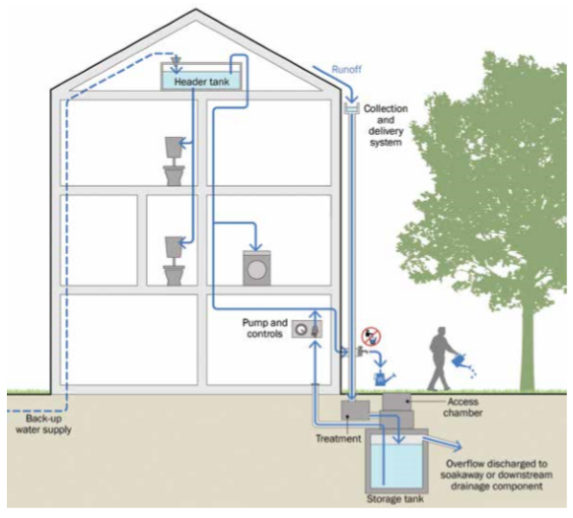

  - Pervious paving
Pervious pavements are separated into porous (infiltration across the entire surface area) and permeable (infiltration only between areas of impermeable material). They are an interception method, therefore reducing the runoff volume, and its substructure can aid in the treatment of the water runoff through sedimentation, biodegradation, absorption, and filtration. They required to capture high return rainfall events and allow infiltration or discharge to another drainage system, and be structurally sound enough to withstand the loads placed upon them. Pervious paving is recommended to replace the current hard landscaping within the courtyard of the St. David’s Building and surrounding it. Pervious paving is also recommended for any hard landscaping put in place for access to the other SuDS components and any future hard landscaping on the campus. There are three different substructure solutions for pervious paving: total infiltration; partial infiltration; no infiltration. The permeability of the soil below the St. David’s building is unknown, but can be assumed to be similar to that of the amenity land. Therefore, due to the low hydraulic conductivity of this soil, a partial infiltration substructure is recommended. This will allow for as much infiltration as possible of the intercepted rainfall from these areas and convey the minimum amount to the subsequent SuDS components.

Figure 2 - Partial Infiltration Pervious Paving Structure (SuDS Manual, 2015)
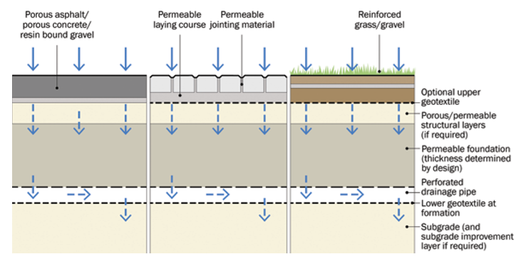

  - Swales
There are three types of swale; a simple conveyancing swale, a dry swale, and a wet swale. A dry swale is proposed for the Lampeter site due to the increase water retention potential.
Figure 3 - A Conceptual Dry Swale Design (SuDS Manual, 2015)
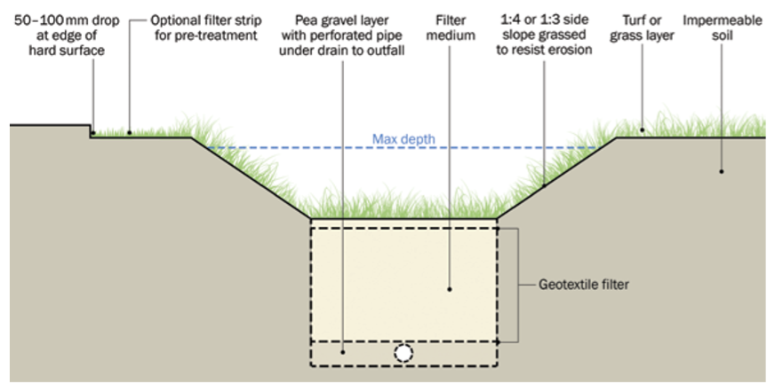
The dry swale, with its filter strip and filter medium starts the treatment of runoff as it is conveyed to the bioretention pond. The swales will be designed to allow as much infiltration as possible, with excess water being conveyed by the under drain to the downstream bioretention system. During flood periods, excess water will attenuate within the swales, keeping the surface level amenity space from flooding. The bottom of the swale will be between 0.5-2.0m with the slope gradient being between 1:3 and 1:4 to allow for easy maintenance of the grass, and to mitigate health and safety issues. The under drain is to have a flow capacity of at least 2 l/s/ha.

  - Bioretention pond
A bioretention pond is suggested for the site to continue the treatment of runoff from the site and to attenuate water for the larger return rainfall events (1:100). The pool is to include wetland areas to facilitate water treatment and contamination sedimentation. Feeding of the pond from swales prevents the stagnation of the water, preserving its amenity. Controlled outlets allow for the pond to fill during high return events, reducing the risk of downstream flooding and allowing for the water to have time to be treated. There will be a permanent pool all year round with additional attenuation space of around 0.5m above the permanent pond. The pond will need to conform to the Reservoir Act 1975 (amended by the Flood and Water Management Act, 2010). The pond will be suitable for siting on the open amenity land due to the low hydraulic conductivity soils allowing the water levels to be maintained. However, a liner may be required because of the proximity of the pond to the ground water level; due to potential polluting of the ground water.
Figure 4 - Example Pond Plan and Profile Views (SuDS Manual, 2015).
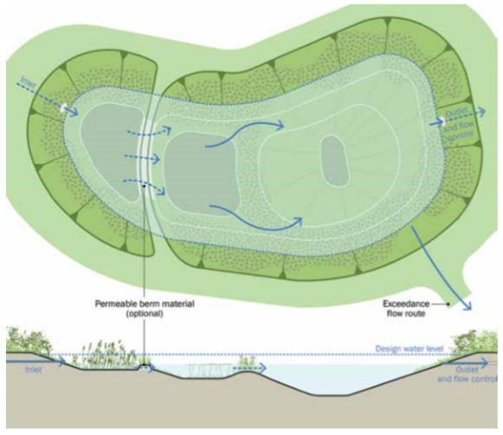
Figure 5 - Conceptual Planted Pond Edge Detail (SuDS Manual, 2015).
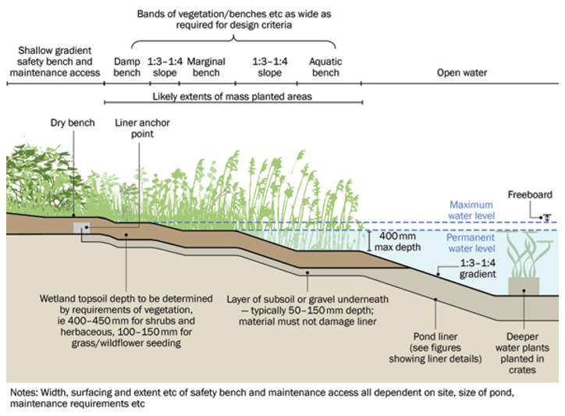
- Maintenance
The maintenance of each SuDS is slightly different, maintenance schedules for each of the SuDS proposed for the Lampeter site can be found in Appendix 11.11. There are some SuDS components which will need to be maintained by professionals, however, there are maintenance jobs which could be fulfilled by the university staff, students and the local authority. Maintenance such as the removal of litter and the care and replanting or reseeding of the vegetation.
- Health and safety
HR Wallingford (2003) undertook a survey of residents living with SuDS in their area and found that SuDS education was an important factor in their perception of any risk associated with them. The greatest perceived threat is likely to be the risk of drowning in the permanent body of water situated in the pond. A full risk assessment should be commissioned before finalising of the pond design. However, some design options are available at the conceptual design stage. Gradients leading to the SuDS components should be no greater that 1:4 and bands of wetland and reeds can be used to deter paddling and swimming. Water velocities should be kept to a maximum of 2.0 m/s at a depth of <0.3m, and should decrease as the depth increases; this mill mitigates the risk to those who are unstable on their feet (the elderly and very young). The siting of safety signs at the entrances to the open amenity space may be the only way to educate users as to the dangers of the SuDS components. These signs should include:
- the site name;
- the location and postcode (incase they’re needed by the emergency services)
- Contact detail for the emergency services and site supervision services;
- Site maps depicting the location of safety equipment, and first aid.
PRE should be sited near to the pond and surface water edge but has been shown to give a false sense of security to those intending to use the water, and have a high risk of being vandalised. Further risks, such as pollution, algae, litter and safe working practices can be mitigated by proper maintenance. Should some of the maintenance be given over to the local community, as suggested, proper training from qualified persons will be required. A SuDS risk assessment matrix can be found in Appendix 11.12.

- References

Ballard, W. B., Wilson, S., Udle-Clarke, H., Illman, S., Scott, T., Ashley, R., Kellagher, R., 2015. The SuDS Manual. London: ciria.
BREEAM UK, 2013. BREEAM Refurbishment Domestic Buildings Technical Manual (SD5072 – 2012 – 2.0). Watford: BRE Global Ltd.
BREEAM UK, 2018. BREEAM UK New Construction Non-domestic Building (United Kingdom) Technical Manual (SD5078: BREEAM UK New Construction 2018). Watford: BRE Global Ltd.
British Standards Institution, 2013. Rainwater harvesting systems – Code of practice. London: BSI Standards Limited [online] Available through IHS http://www.ihsti.com.ezproxy.uwtsd.ac.uk/tempimg/C6074C-CIS888614800305513.pdf [Accessed: 20/02/2018].
Crown, 2017. Recommended non-statutory standards for sustainable drainage (SuDS) in Wales – designing, constructing operating and maintaining surface water drainage systems. [pdf] Available at: http://gov.wales/topics/environmentcountryside/epq/flooding/drainage/?lang=en [Accessed: 08/03/2018].
DEFRA, 2011. The Natural Choice: securing the value of nature. (CM 8082). London: Department for Environment Food and Rural Affairs.
Dŵr Cymru Cfy, 2018. Water Resources. [online] Available at: http://www.dwrcymru.com/en/My-Water/Water-Resources.aspx [Accessed: 08/03/2018].
Energy Saving Trust, 2013. At home with water. London: Energy Saving Trust.
Environment Agency and Natural Resources Wales, 2013. Water stressed areas – final classification. Bristol: Environment Agency. Cardiff: Natural Resources Wales.
European Commission, 2016. The EU Water Framework Directive – integrated river basin management for Europe. [online] Available at: http://ec.europa.eu/environment/water/water-framework/index_en.html [Accesses: 05/03/02018].
HR Wallingford, 2003. An assessment of the social impacts of sustainable drainage systems in the UK. (Report SR622). London: Department for Trade and Industry.
Met Office, 2018. Lampeter climate. [online] Available at: https://www.metoffice.gov.uk/public/weather/climate/gcm07nrwu#averagesTable [Accessed: 20/02/2018].
Natural Resources Wales, 2014. The Teifi and North Ceredigion Abstraction Licensing Strategy. Cardiff: Natural Resources Wales.
Natural Resources Wales, 2018a. Lampeter campus river flood map. Natural Resources Wales [online] Available at: https://maps.cyfoethnaturiolcymru.gov.uk/Html5Viewer/Index.html?configBase=https://maps.cyfoethnaturiolcymru.gov.uk/Geocortex/Essentials/REST/sites/Flood_Risk/viewers/Flood_Risk/virtualdirectory/Resources/Config/Default [Accessed: 20/02/2018].
Natural Resources Wales, 2018b. Lampeter campus surface water flood map. Natural Resources Wales [online] Available at: https://maps.cyfoethnaturiolcymru.gov.uk/Html5Viewer/Index.html?configBase=https://maps.cyfoethnaturiolcymru.gov.uk/Geocortex/Essentials/REST/sites/Flood_Risk/viewers/Flood_Risk/virtualdirectory/Resources/Config/Default [Accessed: 20/02/2018].
Ordinance Survey, 2018. University of Wales Trinity Saint David: Lampeter Campus. OSMaps [online] Available at: https://osmaps.ordnancesurvey.co.uk/52.11376,-4.07574,18 [Accessed: 08/03/2018].
Wikipedia, 2018. University of Wales Trinity Saint David. [online] Available at: https://en.wikipedia.org/wiki/University_of_Wales_Trinity_Saint_David [Accessed: 05/03/2018].
W.J. & Sons, 1992a. Applied Geology SN54NE6. [online] British Geological Survey. Available at: http://scans.bgs.ac.uk/sobi_scans/boreholes/255891/images/10509387.html [Accessed 20/02/2017].
W.J. & Sons, 1992b. Applied Geology SN54NE5. [online] British Geological Survey. Available at: http://scans.bgs.ac.uk/sobi_scans/boreholes/255890/images/10509384.html [Accessed 20/02/2017].
W.J. & Sons, 1992c. Applied Geology SN54NE7. [online] British Geological Survey. Available at: http://scans.bgs.ac.uk/sobi_scans/boreholes/255892/images/10509390.html [Accessed 20/02/2017].
- Bibliography
Ballard, W. B., Wilson, S., Udle-Clarke, H., Illman, S., Scott, T., Ashley, R., Kellagher, R., 2015. The SuDS Manual. London: ciria.

- Appendices
  - OS map of site (Ordinance Survey, 2018)
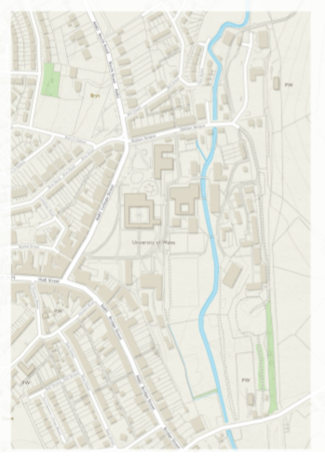

  - River flood plain map (Natural Resources Wales, 2018a)
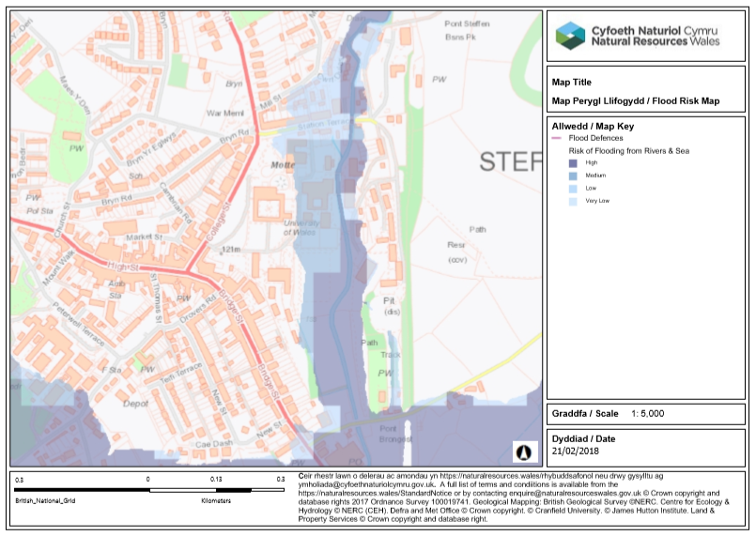
  - Surface water flood plain map (Natural Resources Wales, 2018b)
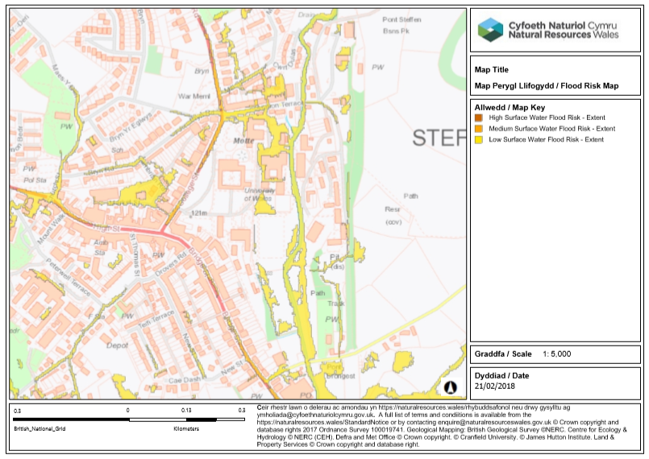
  - Site plan with proposed SuDS
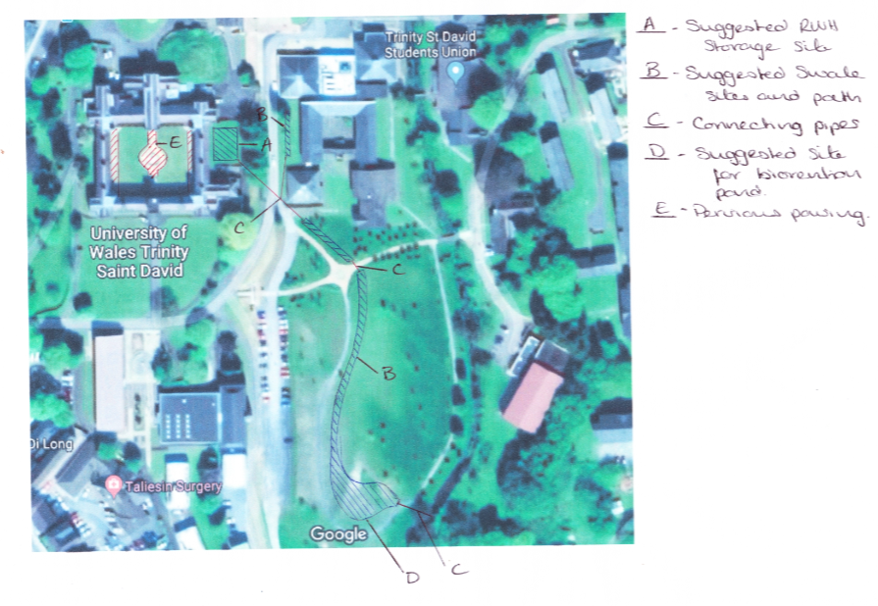

  - BREEAM Domestic Refurbishment Wat01 Table 24 (BREEAM UK, 2013)
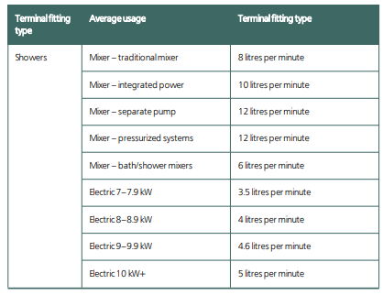
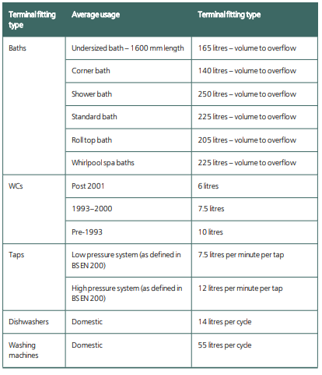

  - BREEAM calculator results for original components
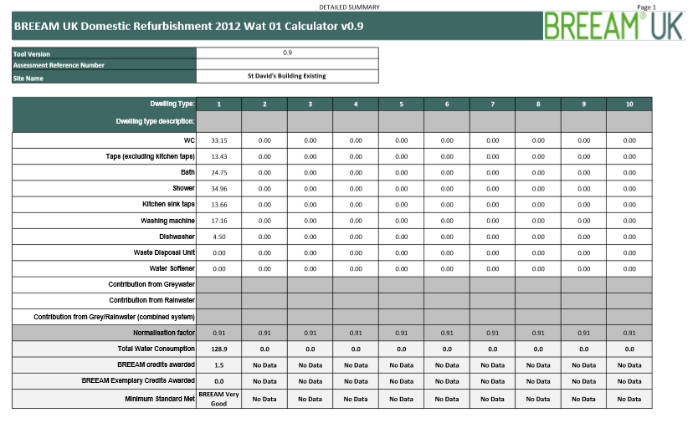

  - BREEAM Domestic Refurbishment Wat01 Table 23 (BREEAM UK, 2013)
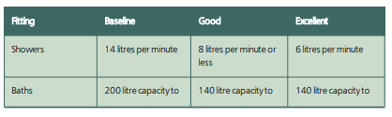
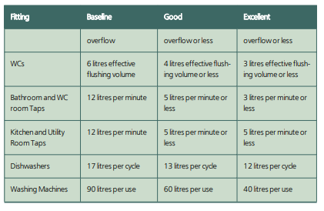

  - BREEAM calculator results with new components
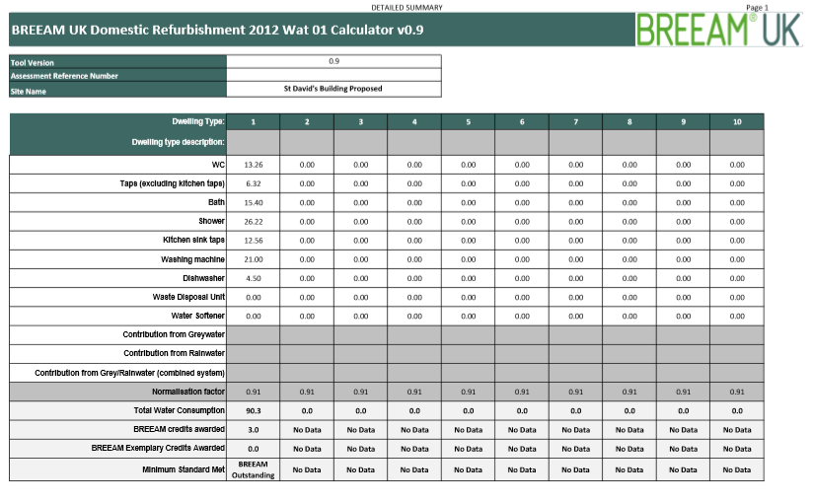

  - BREEAM New Construction Wat01 Table 24 (BREEAM UK, 2018)

  - BREEAM calculator with RWH contribution
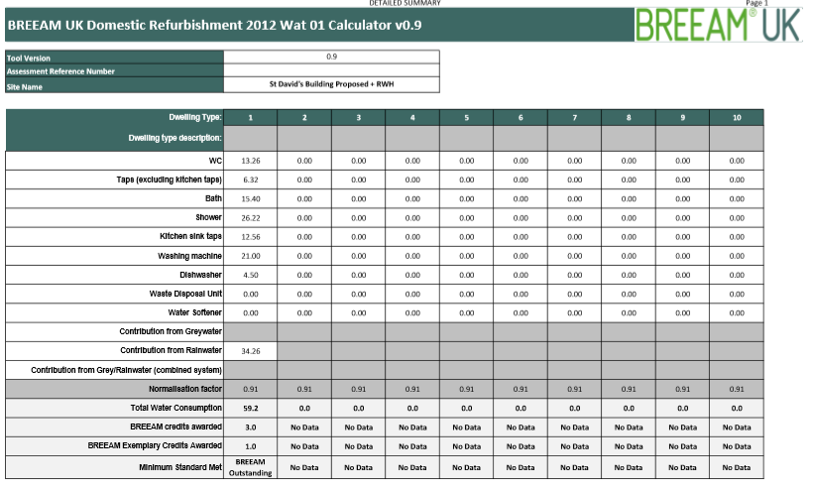

  - SuDS maintenance schedules (SuDS Manual, 2015)
    - RWH system
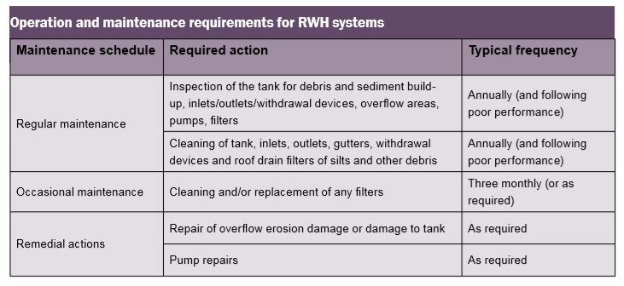

    - Swale
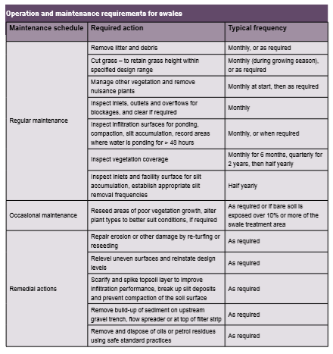

    - Pervious pavements
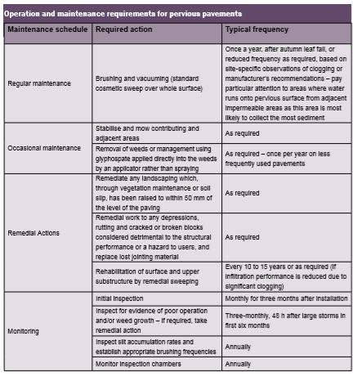

    - Bioretention and pond
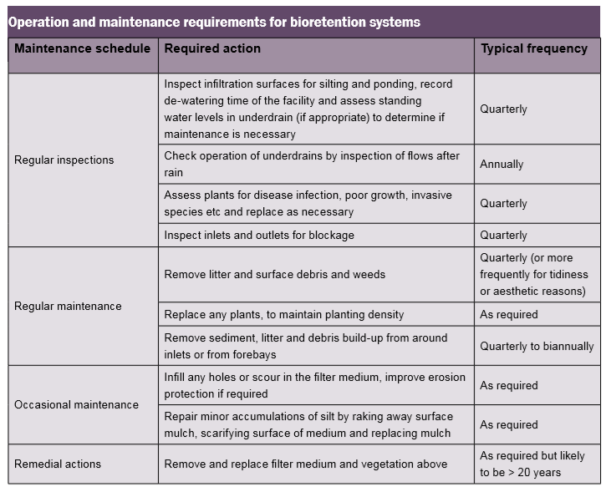
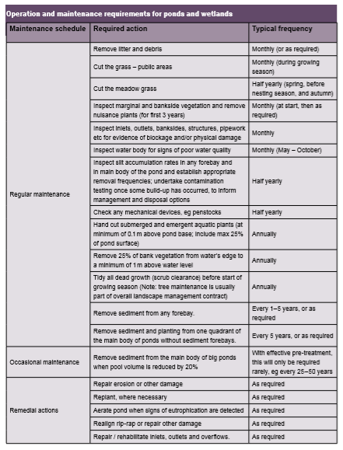
  - SuDS risk assessment matrix (SuDS Manual, 2015)


