

BA (Hons) Leadership and Management Skills for the Workplace
Module: Leading and Implementing Change (LCLM6003)
Assignment Title:
A Strategic Change Plan
Student Name: Leila Zougui
Student ID: 2321811
Lecturer : Dr Eric Osei
Submission Date: 20/07/2026
Word Count: 3896

Abstract
The purpose of this report is to critically investigate the performance of Jaguar Land Rover (JLR) and the strategic environment currently operates in, as well as proposing a detailed change-management plan to enable them to adapt to rapid digitalisation within the automotive industry. By using PESTLE, Porter’s Five Forces, SWOT, McKinsey 7S and RBV frameworks, we can observe the pressures, including sustainability demands and changes in regulation, as well as potential gaps in ability within the workforce. Through this, a strategic plan can be formulated where stakeholder communication, financial planning, risk mitigation, AI-enabled manufacturing and other aspects of productive change are taken into account. The critical reflection towards the end of this report will also analyse the strengths, weaknesses and ethical considerations associated with the recommendations presented.

Executive Summary
JLR perform within an industry shaped by rapid innovation, creative destruction, electrification and intensifying global competition alongside pressures to adhere to regulations, ethical standards and sustainability initiatives. As a result, clear goals should be outlined to speed up the process of transformation, therefore, this report aims to provide a detailed environmental and organisational analysis to be able to conceptualise the drivers of change for a firm.
External analysis (e.g. PESTLE) exposes the rising pressure to decarbonise operations and manufacturing as well as changes within consumer behaviour and expectations. Shifts in trend and increasing competition further complicates activities within this environment, meaning it is essential to consider the contexts in which JLR operate in to give a holistic strategy that will be entirely successful and long-term. Internal analysis (e.g. SWOT) can identify strengths in the current strategies JLR use as well as the holes in certain aspects of the company - for example in organisational culture and digital capability.
The proposed strategic plan looks at three interconnected aspects:
1. Experimenting with digital and AI-enabled manufacturing to aid quality control and increase operational efficiency through expanding on workplace skills (by investing in training).
2. Investing into research into new electric-vehicle models and improving battery circularity to continue to thrive and compete within the rapidly innovating automotive industry.
3. Balancing the need to integrate AI into operations with the requirement to meet sustainability regulations
This report concludes that JLR’s transformation aided by AI is necessary for prospective growth and their success depends on sustained leadership commitment and investment into education and capability expansion.

Table of Contents
Abstract 2
Executive Summary 2
Table of Figures 5
1. Introduction 6
1.1 Overview of Jaguar Land Rover 6
2. Environmental and Organisational Analysis 8
2.1 External Environment analysis: PESTLE analysis 8
2.2 External Environment analysis: Porter’s Five Forces 9
2.3 Internal Environment analysis: SWOT analysis 10
2.3 Internal Environment analysis: McKinsey 7S Framework 10
2.4 Triggers for Change 11
3. Review and Evaluation of Change Management Models 12
3.1 Lewin’s Change Model 12
3.2 Comparison to ADKAR Model 13
4. Leadership and Organisational Culture in Change 13
4.1 Transformational Leadership 13
4.2 Situational Leadership 14
4.3 Transactional Leadership 14
4.4 Organisational Culture 14
5. Proposed Strategic Change Management Plan 16
5.1 Proposed Strategic Change Management Plan 16
5.2 Stakeholder Analysis 16
5.3 Implementation Framework 17
5.4 Communication Plan 17
5.5 Financial and Resource Plan 18
5.6 Risk Assessment and Mitigation 18
5.6.1 Risk Likelihood Impact Matrix 19
5.7 Evaluation and KPIs 20
6. Discussion and Critical Reflection 21
7. Conclusion 22
8. References 23

Table of Figures

Figure 1, PESTLE analysis of JLR 7
Figure 2, JLR Porter's Five Forces 8
Figure 3, SWOT of JLR 9
Figure 4, Hofstedes cultural dimensions (theculturefactor.com, 2026) 14
Figure 5, Risk matrix table for JLR 18

1. Introduction
Innovation is pivotal in enabling organisations to adapt to changing business environments, however, the traditional theoretical models often simplify its complexities. Although it being widely defined as the introduction of new products or organisational methods, contemporary literature argues that it is ineffective as a method of growth if it is not aligned with organisational capabilities and objectives.
In industries undergoing disruptive change and creative destruction, innovation can be useful in identifying capability gaps and cultural resistance, for example within the automotive industry. In this industry, innovation can be directly associated with electrification, digitalisation, Artificial Intelligence and circular-economy practices, although, the idea that this form of innovation automatically adds value to a company’s product line and enables them to be more competitive is too surface-level. The success of innovation as an objective for firms can only be achieved through the integration of new technologies into already put in place systems of operations as well as developing their workforce’s digital competence
This report looks to examine Jaguar Land Rover’s external and internal business environment, supported through the application of different frameworks including PESTLE, Porters Five Forces, SWOT and McKinsey 7S Framework.

1.1 Overview of Jaguar Land Rover
Jaguar Land Rover (JLR) is a major UK manufacturer and producer of cars, and expanded through inorganic integration (merger of two distinct brands). Its acquisition by Tata Motors in 2008 paved the way for significant expansion into emerging markets, and investment in electrification to create vehicles achieving ‘modern luxury’ further added value to their products. During the 2023 financial year, a reported £29 billion in revenue was obtained, indicating a strategic emphasis on high-profit margin models such as the widely revered Range Rover. It is also reported that JLR is “the most profitable division across the group’s segments directly involved in the sale of vehicles” (Blahak, 2023).
To continue to thrive and establish themselves as a primary competitor in the automotive industry, it is essential that JLR undergo transformation through digitalisation and sustainable practices since the firms are subject to ‘volatile, uncertain, complex and ambiguous environments’ (Sjodin et al., 2022). Rising demand for electric vehicles and use of AI has further encouraged firms to engage in risk-taking to drive growth (Bohnsack & Pinkse, 2022). An example of JLR planning transformative change is through their Reimagine Strategy launched in 2021, aiming to deliver ‘modern luxury by design’ by centring customer focussed innovation above all (JLR, 2023). By achieving net-zero carbon emissions by 2039 and becoming a fully electrified luxury manufacturer by 2030, JLR can also align itself with global sustainability initiatives and regulations such as the UK’s Zero Emission Vehicle mandate.

2. Environmental and Organisational Analysis
Understanding the external and internal environment in which JLR operates in is essential as organisations globally function within dynamic environments, with in turn creates uncertainty and influence strategic choices and long-term survival. Analysing both external and internal factors is vital as it allows for the identification of threats and opportunities, and resources can be aligned with environmental demands. This is known to enhance organisational adaptation, particularly in volatile markets such as in automotive manufacturing (Mikalef et al., 2021).

2.1 External Environment analysis: PESTLE analysis
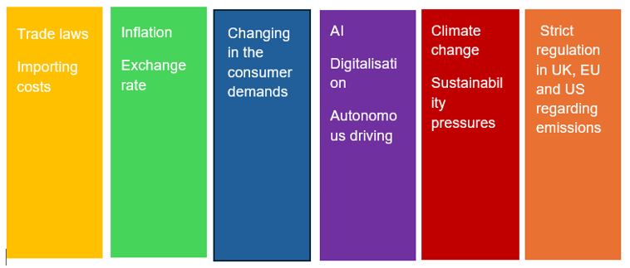

Analysing the external environment is an integral part in understanding how factors outside the organisation can have an effect on business operations, and can provide companies with knowledge on the ways to identify potential opportunities and threats, which in turn would allow them to respond effectively to those changes. The PESTLE framework is used for the “analysis and monitoring of external environmental factors with an impact on the organization” (Christodoulou and Cullinane, 2019, as cited in Matovic, 2020), and stands for Political, Economic, Social, Technological, Legal and Environmental.
Figure 1, PESTLE analysis of JLR

Following on from the technological aspect of the PESTLE analysis, it is evident that companies not utilising technological advancements such as Honda fall short in certain markets such as the Chinese market, where ‘foreign brands that once dominated the Chinese market’ are ‘struggling to keep up’ with Chinese rivals operating with highly automated factories (BBC News, 2026). These competitive pressures are a clear indicator of a need to invest even more into electric models, otherwise existing rivals may force them out of certain geographic market or the automotive industry completely.

2.2 External Environment analysis: Porter’s Five Forces
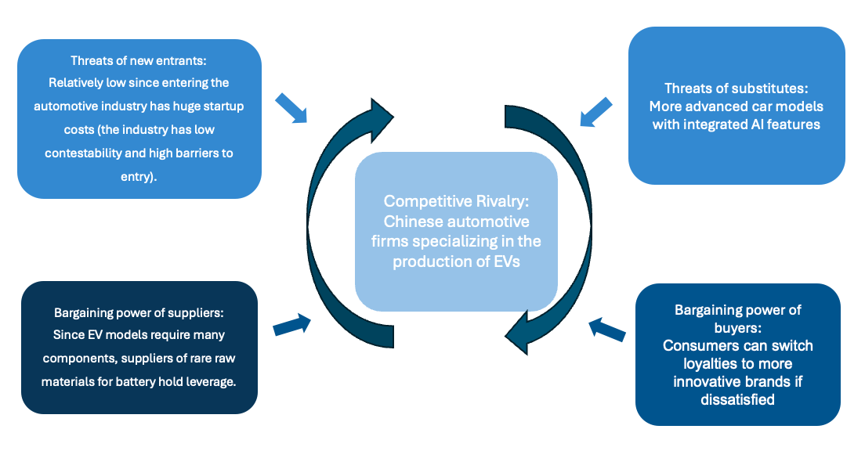
Porter’s Five Forces, developed in 1979 by Michael Porter, is seen as a framework which “complements” the PESTEL analysis through examining competitive dynamics within the automotive industry (Sogra et al., 2026). This framework allows for a better understanding of industry profitability through the analysis of competitive rivalry, the threats of new entrants into the automotive industry, bargaining power of suppliers and buyers, along with the threat of substitutes.
Figure 2, JLR Porter's Five Forces
In JLRs case, given their positioning within the industry, they benefit from being an already established firm with sufficient financial backing from their parent company Tata Motors. JLR remain as key competitors despite the existence of other rivals: ‘key capabilities that make JLR unique and offer it a competitive advantage in the market include great design for cars that are safe and fast, environmental innovation in their design, unique engineering knowledge, and automotive manufacturing technologies’ (Economics & Management Review, 2024).

2.3 Internal Environment analysis: SWOT analysis
The SWOT analysis looks to evaluate conditions internally by identifying the organisations Strengths and weaknesses, along with assessing potential opportunities and threats from external factors. Similar to PESTLE analysis, SWOT looks to “serve as a foundational tool in strategic planning” to provide companies with an understanding of the business environment to make better informed decisions (Ghaleb, 2024).
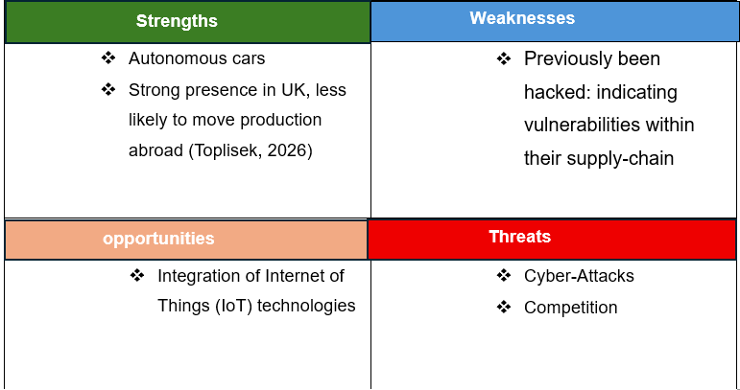
Figure 3, SWOT of JLR
As companies continue to integrate and develop Internet of Things (IoT) technologies within their vehicles, exposure to cyber security threats increases and poses a critical risk to customer safety and data privacy. The risk was exemplified after the JLR cyberattack in August 2025, which resulted in a £196M profit loss and production stoppages, causing a 24% revenue drop for the quarter (Legett, 2025). A statement released by JLR reported that there was “no evidence any customer data has been stolen but our retail and production activities have been severely disrupted” (JLR, 2025). The incident demonstrated that although customer data remained unaffected, there were significant operational and financial consequences as appropriate safety measurements weren’t implemented.

2.3 Internal Environment analysis: McKinsey 7S Framework
This model analyses organisational alignment across the 7 S categories: Strategy, Structure, Systems, Shared values, Skills, Style and Staff. Internal coherence of these seven elements guarantees organisational effectiveness and enables a firm to thrive.

For JLR, the 7S model is a necessary framework to provide a structured lens to see how internal factors can slow down strategic transformation. Strategy reflects JLR’s Reimagine programme which focuses on electrification and modern luxury to satisfy evolving consumer expectations. Structure continues to be a matrix configuration that coordinates global functions. Systems include digital manufacturing, ERP platforms and supply chain processes. Shared values are imperative to create a positive and driven culture that encourages motivation through shared purpose, placing an emphasis on sustainability, innovation and craftmanship. Skills indicate the high level of expertise and education associated with mechanical engineering capabilities, but there still remain gaps in software expertise, such as in AI and data analytics. Style looks at the cohesion of transformational leadership at senior levels and traditional hierarchical leadership. Staff goes hand in hand with skill and emphasises on the workforce required for digital upskilling.

2.4 Triggers for Change
AI has been a key player for innovation in the automotive industry. Practical applications of AI include improved safety using AI-powered systems e.g. advanced driver-assistance systems to reduce accidents due to human error as well as improved navigation with the provision of real-time traffic updates. Other than within the vehicle itself, AI can be incredibly useful within the manufacturing process and helping it to become more streamlined and efficient: for example, AI can automate processes to cut down on production time and may be able to monitor more accurately than human-led investigations. Finn and Downie (2025) had mentioned that “AI helps forecast supply chain needs, spot potential disruptions in production lines and optimize inventory levels”, which in turn also helps with quality control. Integrating AI within operations will allow JLR to embody the technological transformation that the automotive industry is undergoing, since digitisation will become the new norm for thriving firms. By capitalising on AI within their new models, JLR can get ahead of the game early on and once again establish themselves as a stronger competitor amongst other companies such as BMW, Audi and Mercedes-Benz.
Although AI may prove to be beneficial for JLR in streamlining its operations, a more original approach needs to be taken due to competitors such as BMW already utilising generative AI as shown in academic literature; ‘generative AI enhances BMW’s efficiency in supply chain management by predicting market demands and refining production plans’ ‘forecast future demand for specific vehicle models and components, allowing BMW to adjust production schedules proactively, optimize inventory levels, and minimize inventory costs, thereby improving overall production efficiency.’ (Yijun Qiu, 2025). Despite this, JLR have a unique advantage where, ‘due to the various firms that had acquired it before Tata Motors’ their engineering knowledge ‘includes BMW’s build-to-order operations strategy that it has perfected, and Ford’s engineering fingerprints, which it has combined with those from Jaguar, Land rover and Tata, to produce unique inimitable designs ‘ (Vincent, 2014; Petter, 2013; Ludwig, 2012 as cited by Li, Le, et al .,2024).
The automotive industry has seen a significant transformation globally, driven by technological advancements in artificial intelligence (AI) and digitalisation, and to be able to maximise the use of AI, it is imperative that JLR invest into training schemes to familiarise their employees with the advancing technology required to keep up with technological transformation within the automotive industry.

3. Review and Evaluation of Change Management Models
Change management is described as “the process of continually renewing an organization's direction, structure, and capabilities to serve the ever-changing needs of external and internal customers” (Moran and Brightman, 2001, as cited in Hussain et al, 2016). Effective implementation of change management enables companies to achieve their goals by increasing employee productivity, reducing conflicts within the workplace and minimising errors, which overall improves organisational performance (Chatterjee et al., 2023; Latifah et al., 2024, as cited in Hasan, Aparisi-Torrijo and Gonzalez-Ladron-de-Guevara, 2025).

3.1 Lewin’s Change Model
Lewin’s three-stage model (Unfreeze, Change, Refreeze) is one of the earliest and most influential frameworks for looking at organisational transformations. This looks at destabilising existing behaviours and implementing new, more effective practices and later institutionalising them. Research implies that this model remains useful to understand behavioural and cultural aspects of change (Burnes & Cooke, 2023).
Strengths: This model emphasises the psychological part of change and is relevant for firms such as JLR that must change their deeply entrenched engineering and manufacturing mindsets towards electrification.
Limitations: Critics argue that this model is too linear for today’s rapidly changing and dynamic environments (Cumming’s et al., 2016). The automotive industry is noted for its constant technological disruption, meaning refreezing may not be a viable method of maintaining its position.
Therefore, whilst this model provides a foundation for cultural change, it must be used alongside other models to provide a well-rounded framework for improvement.

3.2 Comparison to ADKAR Model
The ADKAR model takes a more individualistic approach and can be beneficial in addressing personal difficulties. These act as actionable steps towards change and success as well as making the transformation of a firm more personal, therefore inciting motivation and purpose within employees who can now invest in not only the vision of the company but their own self-development as a worker.

4. Leadership and Organisational Culture in Change
Ample planning and investment in AI and other forms of digitalisation can be instrumental in the path towards adaptation for JLR, however, for this to be effectively implemented we need proper leadership. For JLR, who are undergoing major electrification, digitalisation and restructuring, leadership and culture are large components for success.
Organisational culture is described as “the shared values, beliefs, and practices that shape the behavior and attitudes of its members” and can be divided into three subcategories: Transformational leadership, Situational Leadership and Transactional Leadership.
JLR have maintained strong organisational culture through abiding by their Creator’s Code, consisting of customer love, unity, integrity, growth and impact. To impose these expectations, it is important that there are leaders to help guide the workforce and ensure the code remains effective. This can be done by experimenting with the three types of leadership systems.

4.1 Transformational Leadership
Transformational leaders motivate and inspire followers by creating visions and offering intellectual stimulation. It has been found that transformational leadership increases innovation, adoption of digital technology and organisational learning (Aga et al., 2016). This type of leadership style will prove to be beneficial for JLR as the Reimagine strategy calls for employees to adopt innovative technologies and gain skills and transform from traditional engineering to software-driven mobility.

4.2 Situational Leadership
According to situational leadership theory, the leader should adjust their style based on the readiness of the followers and nature of the task. Situational leadership style plays an important role in changeable settings such as digital transformation. Recent literature highlights the positive effect of situational leadership on acceptance of change (Thompson & Glasø, 2018).

4.3 Transactional Leadership
Transactional leadership is all about performance management, organisational structure and reward systems. Although this type of leadership has been criticised for being inflexible, it proves useful when there is a need for discipline. Transactional leadership helps in automotive manufacturing when it comes to ensuring quality, safety and operational excellence. There is also research that transactional leadership works well alongside transformational leadership and provides stability during transition period (Breevaart et al., 2014).

4.4 Organisational Culture
With the company the UK’s largest employer in the automotive industry (UK Government, 2025, as cited in Toplisek, 2026), it is important to evaluate the values, beliefs and behaviours within the organisation which may influence employee performance and their willingness to accept change. Through the use of various frameworks such a Scheins Model of Organisational Culture and Hofstede’s Cultural dimensions, we will be able to evaluate the cultural factors which may affect JLRs performance.
Hofstede’s cultural dimensions model (1991) introduces cultural dimensions to understand how national culture can influence workplace behaviour, with the dimensions being power distance, individualism vs collectivism, masculinity vs femininity uncertainty avoidance, long-term vs short-term orientation and indulgence vs restraint (Ghaleb, 2024). Given that JLR is a British born country, it is influenced by UK cultural values, however as the company was acquired by an Indian automotive manufacturer, aspects of Indian culture may influence certain practices and leadership styles.

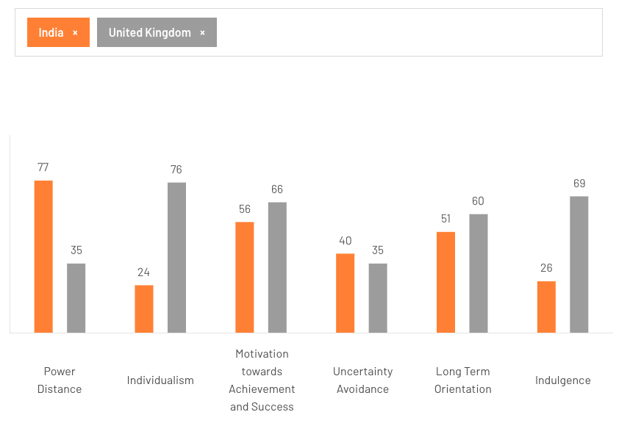
Figure 4, Hofstede’s cultural dimensions (theculturefactor.com, 2026)
As shown in Figure 4, there is a clear difference between certain dimensions such as individualism and power distance in the UK vs in India. For example, Individualism in the UK has a score of 76 compared to India’s score of 24. This means that workers in UK firms are defined by their own roles and prefer to have autonomy as opposed to constantly working as a collective. Whilst it is important to collaborate on certain projects and have effective communication, individualism allows employees to take responsibility for their performance and take pride in their achievements whilst learning from their personal feedback.
Since JLR operates in the UK, cultural dimensions such as a lower power distance score (35) will be important in planning the type of leadership style embodied by the firm. For example, having management teams with a large amount of power may create tension since individuals in the company would prefer to work collaboratively and hold significant weight within company decisions. This score also highlights the importance of communication when carrying out changes within the firm, implying that transparency about AI integration is key for JLR.

5. Proposed Strategic Change Management Plan
Once an idea is conceptualised, it is crucial that it is supported by a structured change management plan to ensure that the strategy aligns with the stakeholder expectations and organisational capabilities. In the case of JLR, a comprehensive plan is needed to drive digital innovations through the use of AI-driven technologies.

5.1 Proposed Strategic Change Management Plan
Change Vision:
To transform JLR into a fully electrified, digitally empowered and operationally agile luxury car manufacturer by 2030, through the strategic implementation of AI-driven technologies and digital innovation.
Strategic Objectives:
- Accelerate electrification across all brands.
- Strengthen digital capabilities (AI, automation and data analytics).
- Improve operational efficiency and supply chain resilience.
- Develop a culture of innovation, agility and continuous learning.
- Enhance customer experience through digital retail and connected services.

5.2 Stakeholder Analysis
The stakeholder analysis looks at individuals or groups who influence organisational decisions and hold varying levels of power. As a result, firms can anticipate resistance and adapt their communication strategies to yield the most effective results (Freeman, 1984; Mitchell et al., 1997).
Primary Stakeholders
- Employees: critical for capability development and cultural change.
- Customers: influence demand, brand perception and loyalty.
- Suppliers: essential for electronic vehicle components, batteries and semiconductors.
- Regulators: enforce emissions, safety and data protection standards.

Secondary Stakeholders
- Local communities: affected by employment and environmental impact.
- Unions: influence workforce relations and change acceptance.
- NGOs: shape sustainability expectations.
- Media and industry bodies: influence reputation and legitimacy.

5.3 Implementation Framework
A hybrid implementation strategy shall be used to ensure that all aspects of the transformation are aligned with JLR’s objectives.
1. Kotter’s Steps for structure and leadership alignment
- Encourage more rapid electronic vehicle development and respond more urgently to regulatory pressures
- Form strong teams of senior leaders across engineering, sustainability and other operations
- Communicate a clear and compelling vision centring modern luxury and electrification to increase motivation
2. ADKAR (Employee Capability Development)
- Make the workforce abundantly aware of digital and EV transformation
- Develop a higher level of desire through incentives and career progression
- Provide ample training within AI, EV systems and other digital tools
- Through performance metrics, analyse individual progression to reinforce new behaviours
3. Lewin (Cultural Unfreezing and Refreezing)
- Do not settle for legacy engineering assumptions
- Integrate digital-first behaviours into leadership practices and other organisational processes
This implementation framework combines the strengths of all frameworks, with Kotter’s leadership focus, ADKAR’s capability development and Lewins’s focus on cultural change.

5.4 Communication Plan
Effective communications allow for certainty and a formation of trust, subsequently leading to greater employee engagement (Appelbaum et al., 2018).
JLR should use:
- Town-hall meeting: leadership updates and Q&As
- Digital platforms (internet, dashboards and newsletters)
- Leadership briefings
- Training workshops
- Feedback loops: surveys, focus groups and suggestion platforms
- Communication Principles:
- Transparency
- Consistency
- Two-way dialogue
- Tailoring messages to stakeholder groups

Effective communication reduces uncertainty, builds trust and increases employee engagement.

5.5 Financial and Resource Plan
Strategic change signifies a need for investment in technology, consumers and infrastructure. The success of digital transformation such as JLR’s Reimagine strategy depends on resource allocation and long-term investment (Sjödin et al., 2022).
JLR should allocate resources to:
- EV R&D and battery technology
- Digital infrastructure (AI, automation, cloud systems, cybersecurity.)
- Workforce training and development ( digital skills, leadership training.)
- Supply chain diversification ( near-shoring, multi-sourcing.)
- Sustainability initiatives (renewable energy, circular economy practices.)
Investment should be phased to balance financial stability with strategic ambition.
Financial Strategy
- Phased investment to balance financial stability with strategic ambition.
- Cost optimisation through automation and lean processes.
- Strategic partnerships to reduce R&D costs.

5.6 Risk Assessment and Mitigation
A risk assessment is used to analyse any uncertainties that may affect progression of business objectives, and through identification and evaluation of potential risks, it enables organisations to implement effective mitigation strategies to minimise the impacts of such risks (Hussein et al., 2013)

5.6.1 Risk Likelihood Impact Matrix
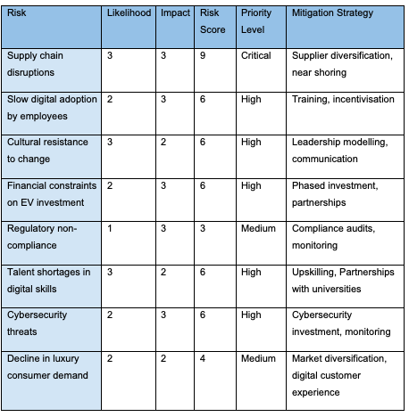
The key risks associated with the proposed changes are identified in the table shown below along, together with mitigation strategies to minimise their impacts.
Figure 5, Risk matrix table for JLR

5.7 Evaluation and KPIs
Key Performance Indicators (KPIs) monitor progress for firms to identify whether their strategies are effective and if they are likely to achieve their objective of transformational change. These must be specific, measurable, achievable, relevant and time-bound (SMART).
- Electrification: Percentage of EV models launched
- Digital Capability: Employee digital skills certification rate
- Operational Efficiency: Reduction in production downtime
- Sustainability: CO₂ emissions reduction across company operations (Net-zero by 2039 potentially)

These key performance indicators (KPIs) make sure that JLR’s transformation will be measured and focused on its strategic objectives. Electrification KPIs measure progress towards the target EV sales in 2030. Operational KPIs increase efficiency and reduce costs. Customer experience KPIs represent market competitiveness. Sustainability KPIs comply with the regulatory and societal requirements. Financial KPIs provide long-term viability.

6. Discussion and Critical Reflection
One of the important strengths in the analysis comes from its ability to incorporate frameworks related to both external and internal environments, such as PESTLE, Porter’s Five Forces, SWOT, McKinsey 7S, and RBV. Inclusion of recent open access peer reviewed literature enhances academic credibility and relevance to the current strategic management theories. The second strength is the hybrid change management framework that combines Kotter, ADKAR and Lewin approaches. Hybrid change management framework combines the aspects of structure (Kotter), behaviour (ADKAR) and culture (Lewin), thus becoming a relevant tool for managing changes in a large engineering oriented multinational company.
The proposed strategic plan itself is very well aligned with the JLR's Reimagine Strategy as it covers such issues as electrification, development of digital skills, efficiency and cultural transformation. The inclusion of KPIs, risk management, stakeholders' analysis and communication plan allows one to make the plan actionable and measurable. Finally, leadership and culture are important elements that are usually neglected in transformation projects of technical nature. Thus, incorporation of transformational, transactional, and situational leadership with cultural frameworks (Schein and Hofstede) shows the importance of human aspects of change management.

7. Conclusion
Currently, Jaguar Land Rover (JLR) finds itself at a critical point in terms of the company's organizational development. Due to the challenges related to the shift to electric cars, digitization, regulatory changes, and the unstable economy on a global scale, the company needs to undergo strategic transformation. The current external environment characterized by technological disruption, political uncertainty, and increasing competition requires proactive adjustments (Bohnsack & Pinkse, 2022; Sjödin et al., 2022). The presented hybrid change management approach combining Kotter, ADKAR, Pettigrew and Lewin will be helpful in guiding this transformation process.

During the environmental analysis, it was identified that the main factors in the external environment included geopolitical instability, fragility of the supply chain, and increasing competition due to the existing premium brands as well as new players in the market of EVs. In the internal environment, JLR has such strengths as brand equity, engineering capabilities, and strategic support provided by Tata Motors. However, the challenges were identified in terms of cultural rigidity, lack of digital literacy, and legacy system.

The strategic change plan that is provided in Section 5 outlines an actionable plan for the transformation of JLR, which includes the vision for change, stakeholder management, risk management and KPIs. Nevertheless, for its implementation, a consistent leadership commitment, proper communication and monitoring of the process are needed. The ethical and sustainability aspects have to be considered at all times, especially in relation to employees, supply chain and the environment.

8. References
Aga, D.A., Noorderhaven, N. and Vallejo, B., 2016. Transformational leadership and project success: The mediating role of team-building. International Journal of Project Management, 34(5), pp.806–818.
Appelbaum, S.H., Habashy, S., Malo, J.L. and Shafiq, H., 2018. Back to the future: Revisiting Kotter’s 1996 change model. Journal of Management Development, 37(7), pp.543–557.
Blahak, J.C., 2023. Accelerating into an Electric Future: How Electric Vehicle Investments Will Advance Revenue Growth (Master's thesis, Universidade NOVA de Lisboa (Portugal)).
Bohnsack, R. and Pinkse, J., 2022. Value creation and value capture in the automotive industry’s transition to electric vehicles. Technological Forecasting and Social Change, 176, 121452.
Breevaart, K., Bakker, A.B., Hetland, J., Demerouti, E., Olsen, O.K. and Espevik, R., 2014. Daily transactional and transformational leadership and daily employee engagement. Journal of Occupational and Organizational Psychology, 87(1), pp.138–157.
Burnes, B. and Cooke, B., 2023. The past, present and future of organization development: Taking the long view. Human Relations, 76(1), pp.3–28.
Cummings, S., Bridgman, T. and Brown, K.G., 2016. Unfreezing change as three steps: Rethinking Kurt Lewin’s legacy for change management. Human Relations, 69(1), pp.33–60.
Donaldson, T. and Preston, L.E., 1995. The stakeholder theory of the corporation: Concepts, evidence, and implications. Academy of Management Review, 20(1), pp.65–91.
Finn, T. and Downie, A. (2025) 'AI in automotive industry,' What is AI in the automotive industry?, 17 November. https://www.ibm.com/think/topics/ai-in-automotive-industry.
Freeman, R.E., 1984. Strategic Management: A Stakeholder Approach. Boston: Pitman.
Ghaleb, B.D.S. (2024) 'The importance of using SWOT analysis in business success,' International Journal of Asian Business and Management, 3(4), pp. 557–564. https://doi.org/10.55927/ijabm.v3i4.10857
Hasan, M.M., Aparisi-Torrijo, S. and González-Ladrón-De-Guevara, F. (2025) 'Change management and organizational performance: current key trends,' Cogent Business & Management, 12(1). https://doi.org/10.1080/23311975.2025.2478447.
Hiatt, J., 2006. ADKAR: A Model for Change in Business, Government and Our Community. Loveland, CO: Prosci Research.
Hussain, O.K. et al. (2012) 'Understanding risk and its importance in business activities,' in Studies in computational intelligence, pp. 1–29. https://doi.org/10.1007/978-3-642-28690-2_1.
Hussain, S.T. et al. (2016) 'Kurt Lewin’s change model: A critical review of the role of leadership and employee involvement in organizational change,' Journal of Innovation & Knowledge, 3(3), pp. 123–127. https://doi.org/10.1016/j.jik.2016.07.002.
Intel (no date) Artificial Intelligence (AI) in the Automotive Industry.
JLR (Jaguar Land Rover), 2023. Reimagine Strategy Overview. Available at: https://www.jaguarlandrover.com
JLR Careers (no date). https://careers.jaguarlandrover.com/who-we-are.
JLR Media Newsroom (2025) 'Statement on cyber incident,' JLR Media Newsroom, 5 September. https://media.jaguarlandrover.com/news/2025/09/statement-cyber-incident.
Leggett, T. (2025) Jaguar Land Rover posts heavy loss after cyber-attack. https://www.bbc.co.uk/news/articles/ckg1w255gy1o.
Li, Le, et al. "What Are JLR Trying To Achieve With Their Current Global Strategies? Using the Module Content, Wider Reading and Your Own Re-search, Critically Evaluate the JLR Global Strat-egy Potential and Advise JLR on Improvements." Economics & Management 5.3 (2024).
Matovic, I. M. (2020). PESTEL Analysis of External Environment as a Success Factor of Startup Business. Research Papers in Economics. https://doi.org/10.5281/zenodo.4058794
Mitchell, R.K., Agle, B.R. and Wood, D.J., 1997. Toward a theory of stakeholder identification and salience. Academy of Management Review, 22(4), pp.853–886.
Pollack, J. and Pollack, R., 2015. Using Kotter’s eight stage process to manage an organisational change program: Presentation and practice. Systemic Practice and Action Research, 28(1), pp.51–66.
Qiu, Yijun. "The Essence of Generative AI and Its Impact on Enterprise Digital Transformation: A Case of Generative AI in BMW." (2025).
Schein, E.H. and Schein, P., 2017. Organizational Culture and Leadership. 5th ed. Hoboken: Wiley.
Sjödin, D., Parida, V. and Kohtamäki, M., 2022. Digital servitization and business model innovation in manufacturing firms. Industrial Marketing Management, 102, pp.53–69.
Sogra, S.F. et al. (2026) 'Strategic Environmental analysis in the automobile industry: The role of external forces in shaping operations,' International Journal of Management and Business Development, 3(2), pp. 7–14. https://doi.org/10.55640/ijmbd-v03i02-02.
Taras, V., Steel, P. and Kirkman, B.L., 2020. Three decades of research on national culture in the workplace: Do the differences still make a difference? Organizational Dynamics, 49(1), 100709.
The world's carmakers are struggling to compete with China https://www.bbc.co.uk/news/articles/c4g8vg72z43o
Thompson, G. and Glasø, L., 2018. Situational leadership theory: A test from three perspectives. Leadership & Organization Development Journal, 39(5), pp.574–591.

