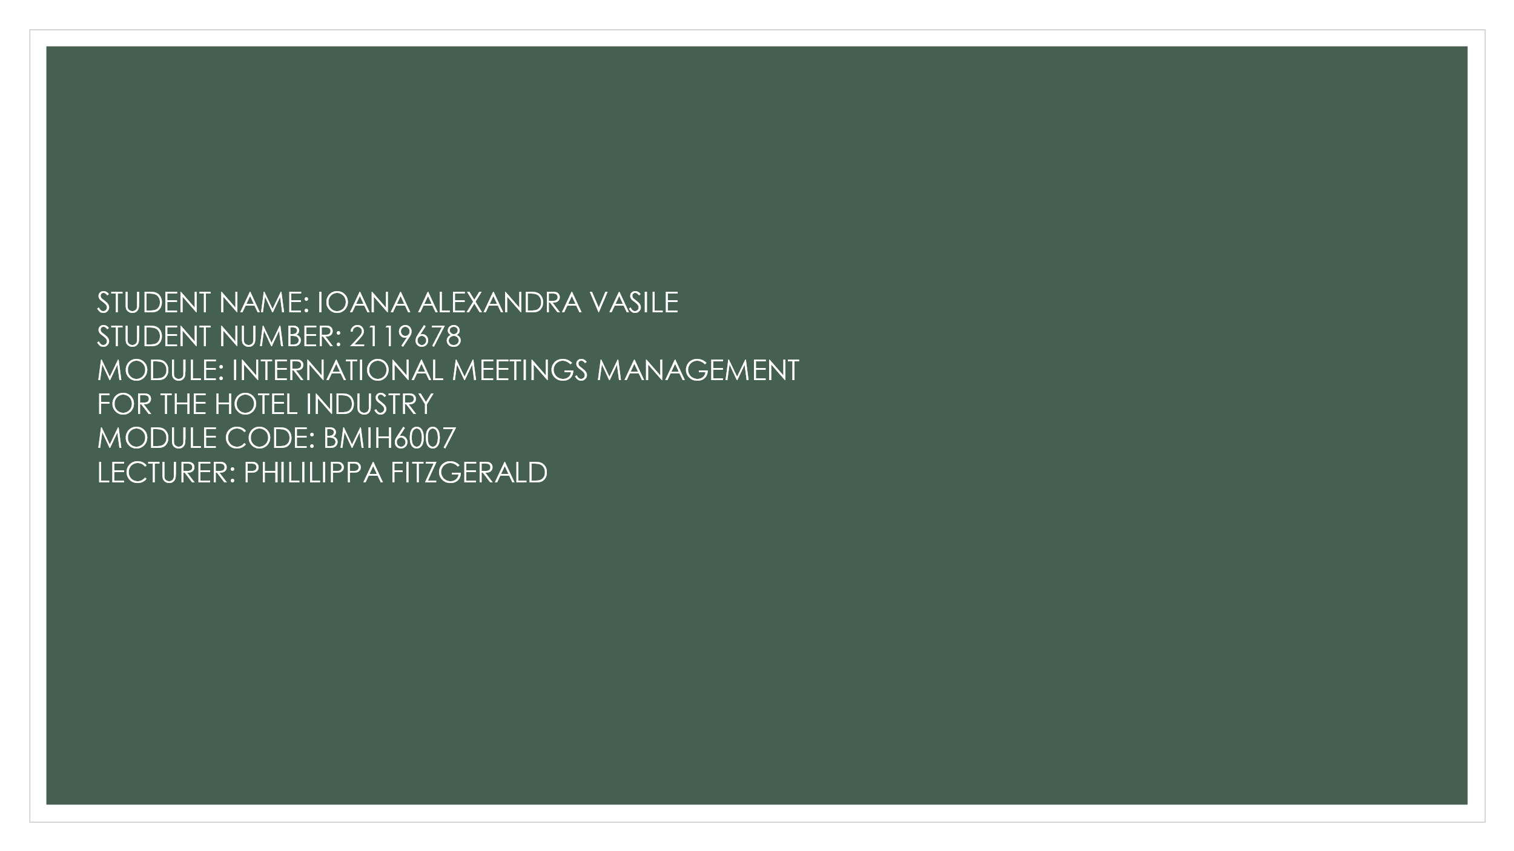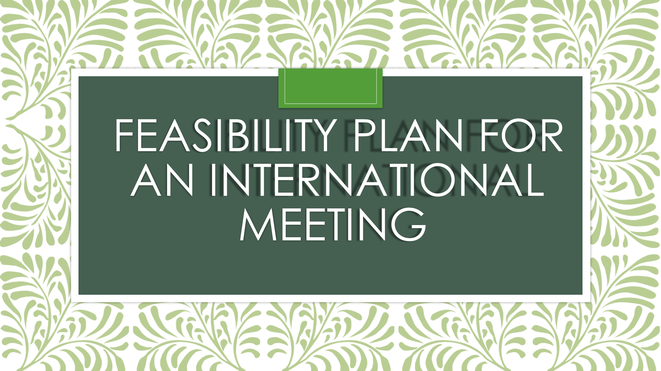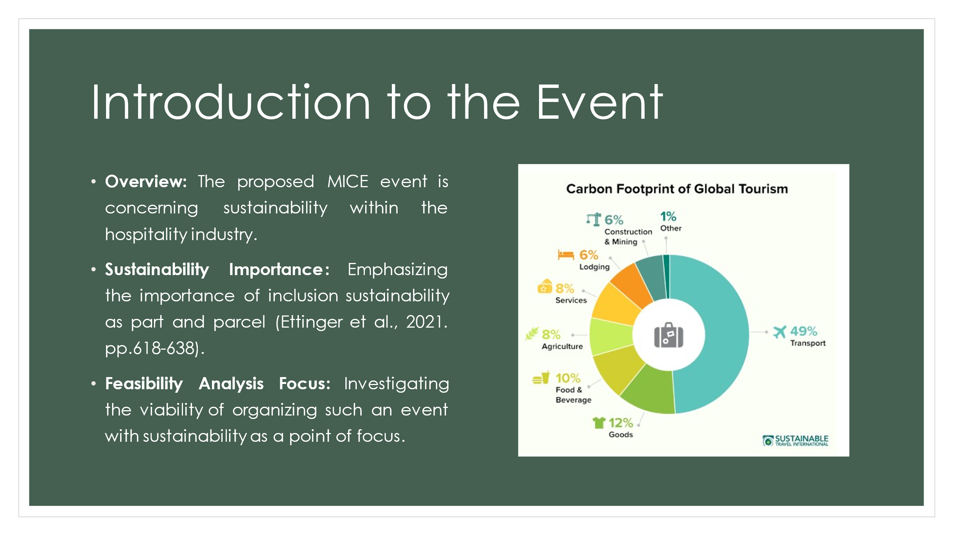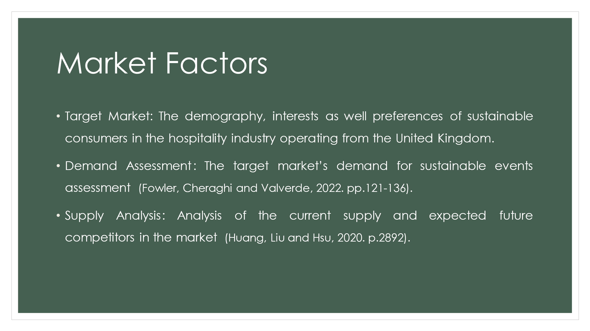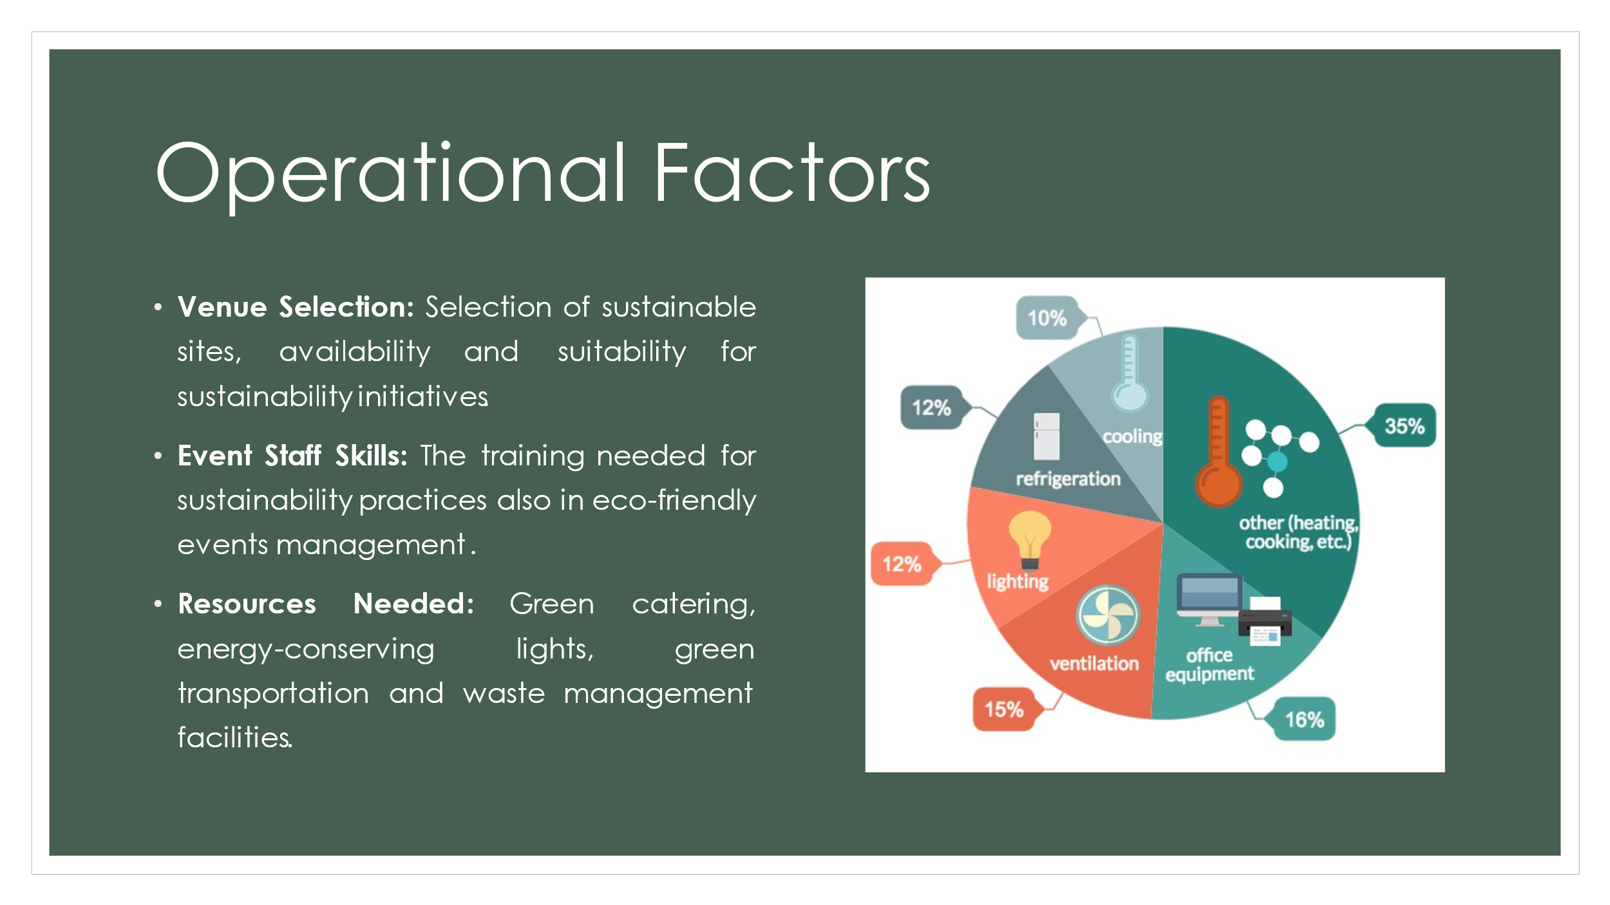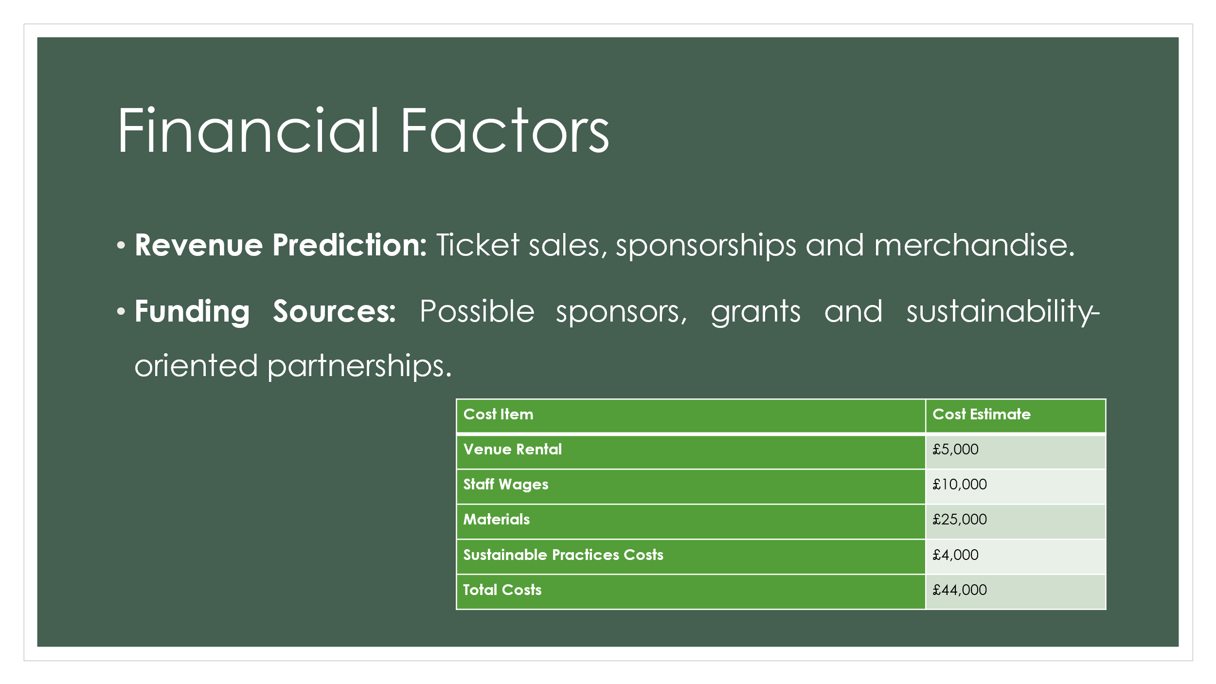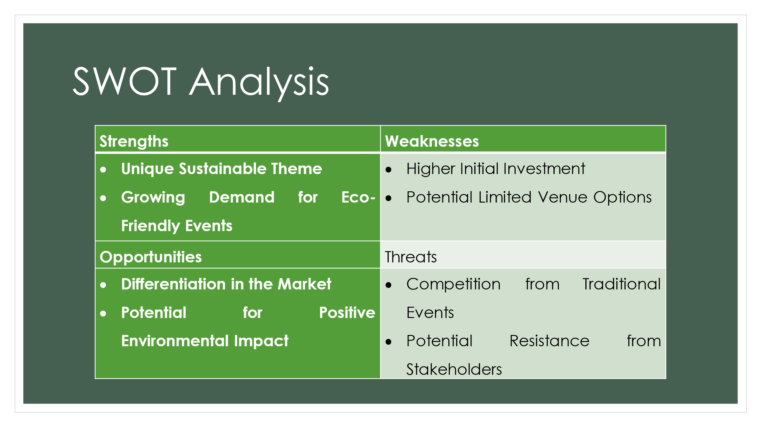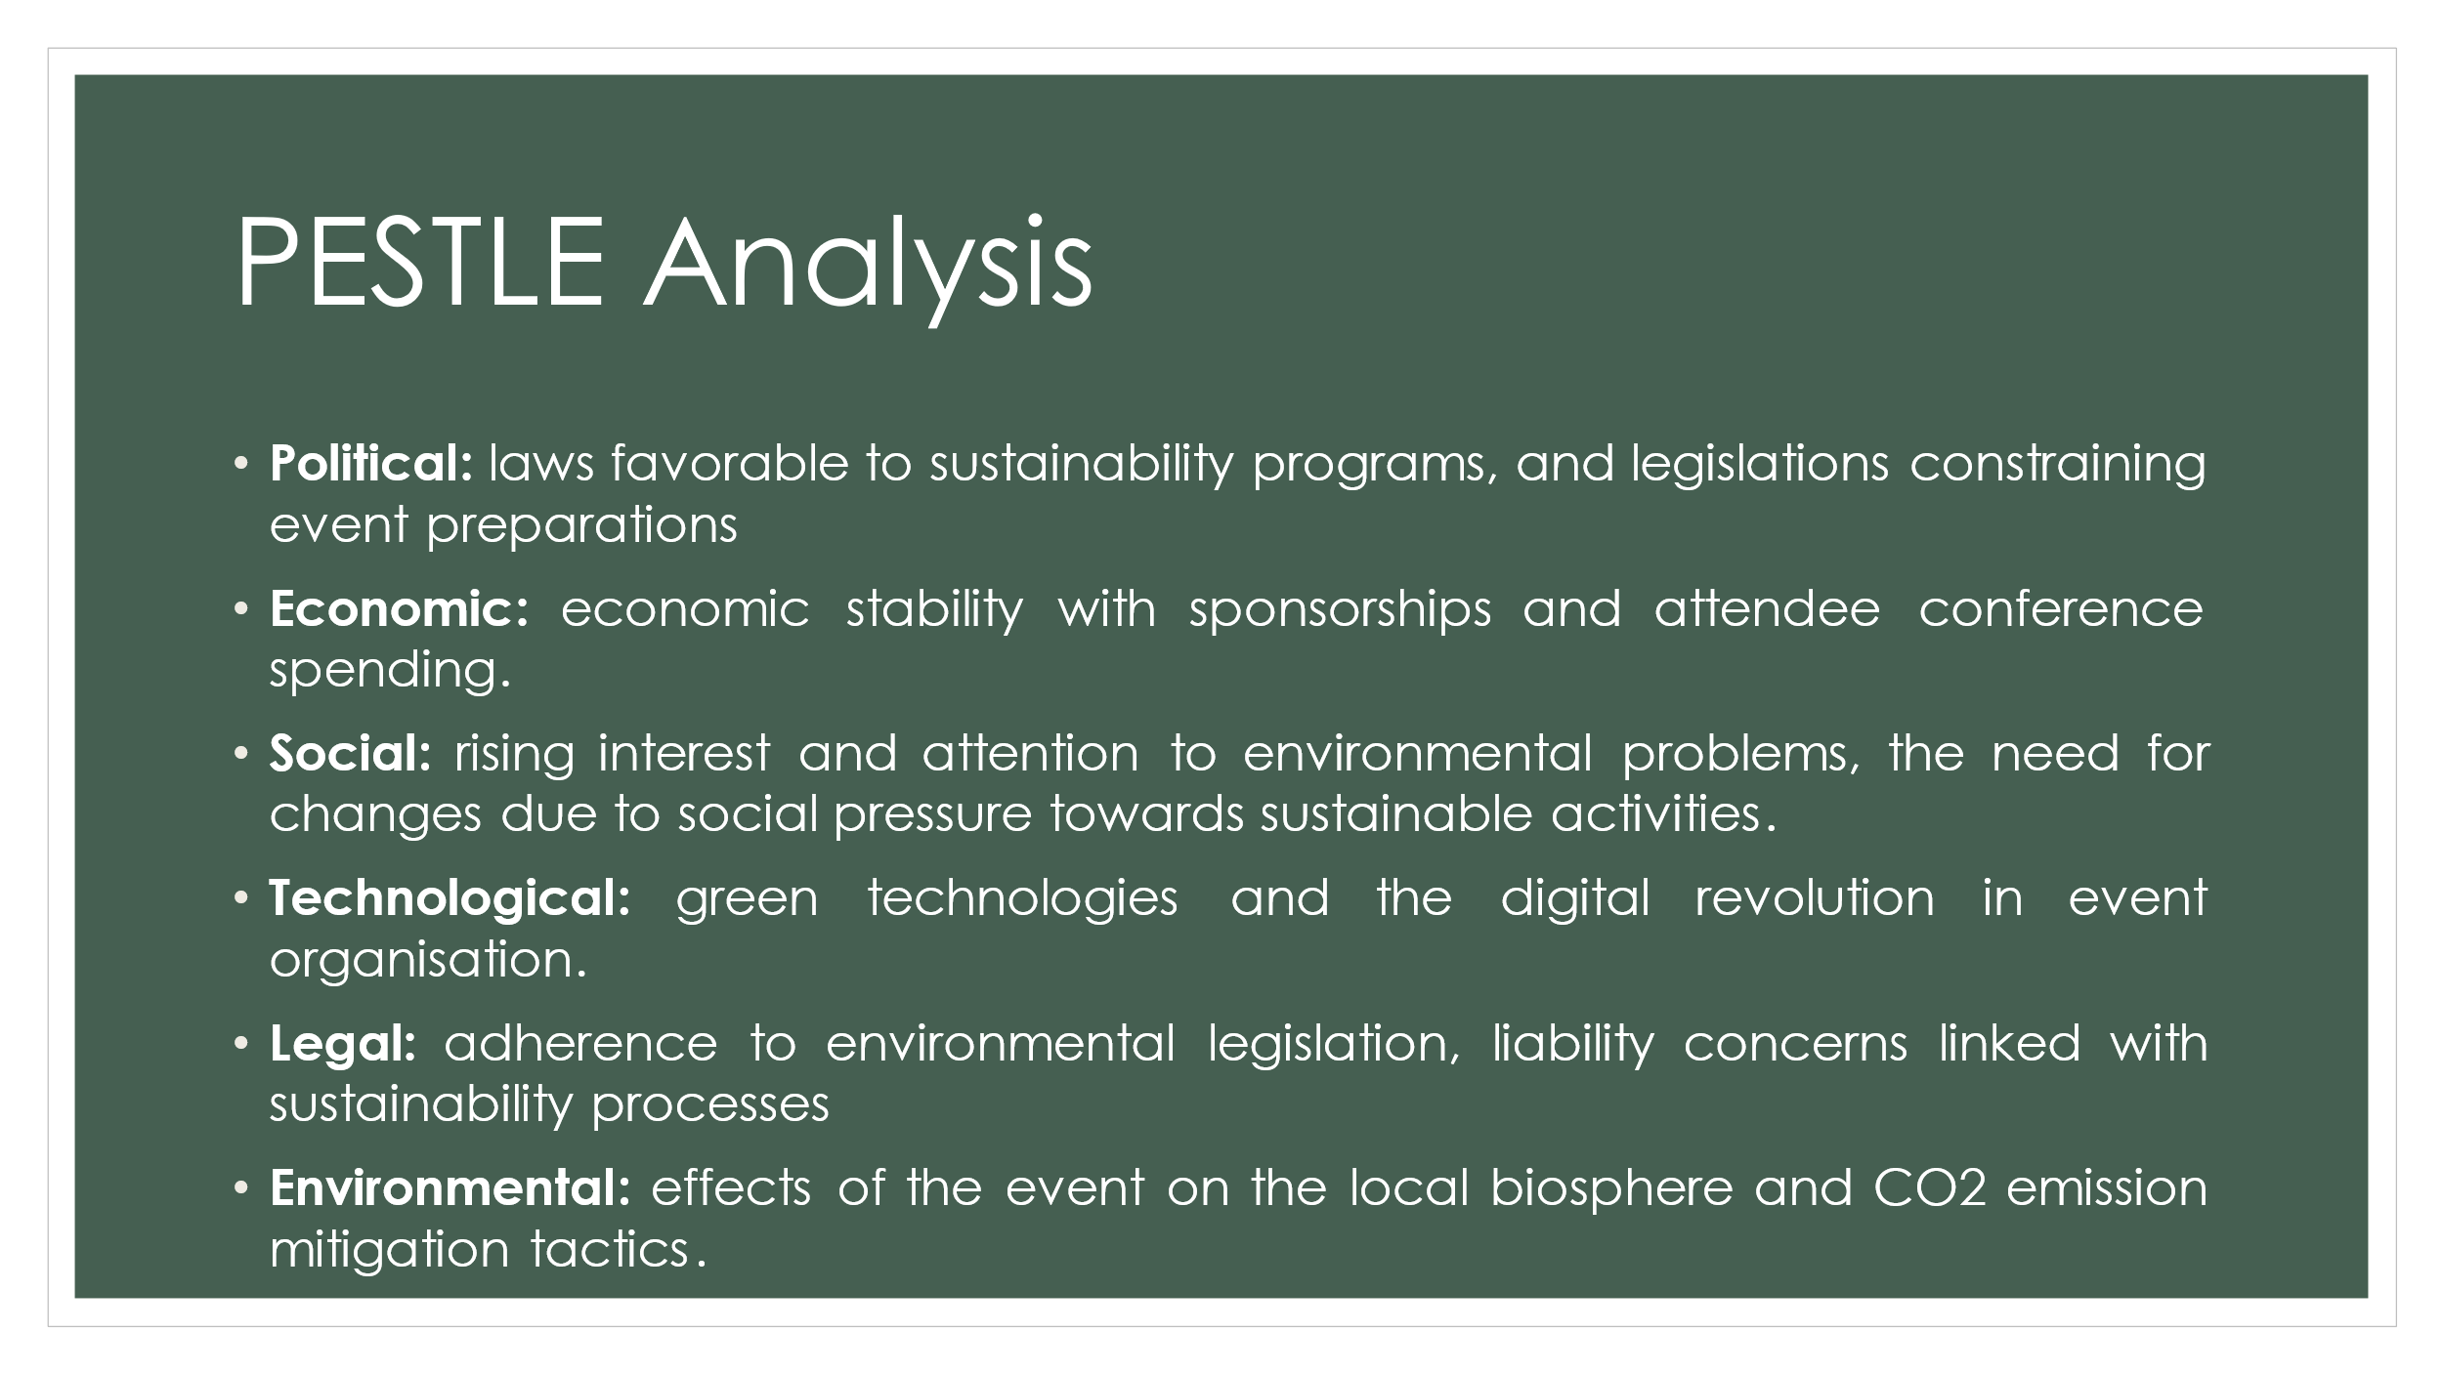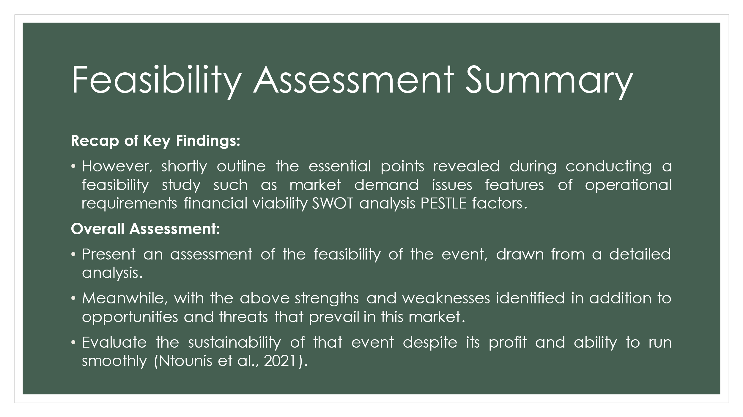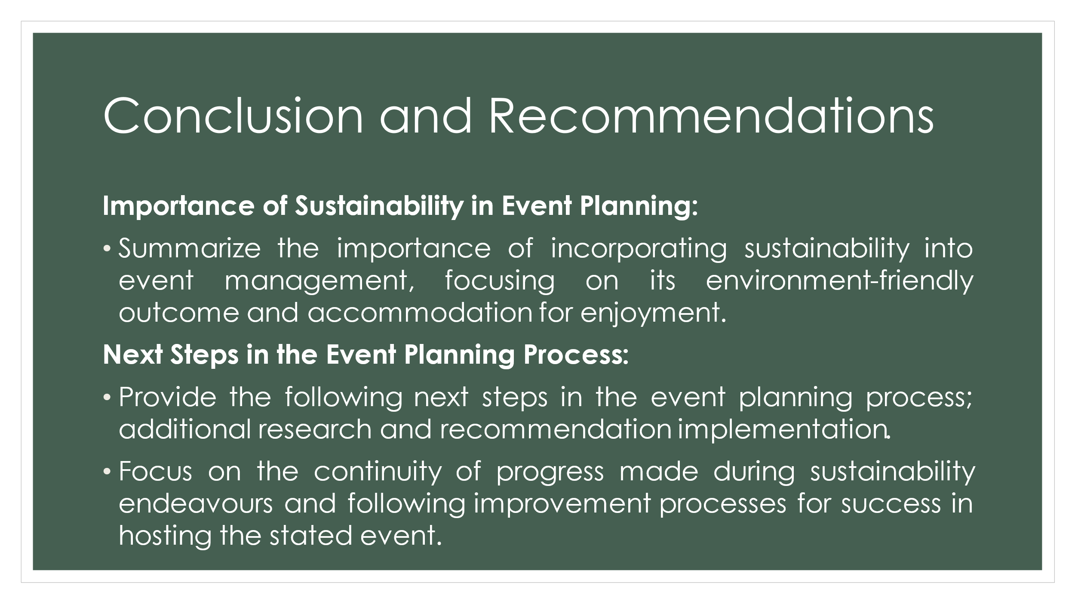
Reference List
Allen, J., Harris, R., Jago, L., Tantrai, A., Jonson, P. and D'Arcy, E., 2022. Festival and special event management. John Wiley & Sons.
Antchak, V., Lück, M. and Pernecky, T., 2021. Understanding the core elements of event portfolio strategy: lessons from Auckland and Dunedin. International Journal of Contemporary Hospitality Management, 33(7), pp.2447-2464.
Bladen, C., Kennell, J., Abson, E. and Wilde, N., 2022. Events management: An introduction. Taylor & Francis.
Chersulich Tomino, A., Perić, M. and Wise, N., 2020. Assessing and considering the wider impacts of sport-tourism events: A research agenda review of sustainability and strategic planning elements. Sustainability, 12(11), p.4473.
Claxton, S. and Kent, A., 2020. The management of sustainable fashion design strategies: An analysis of the designer’s role. Journal of Cleaner Production, 268, p.122112.
Elf, P., Werner, A. and Black, S., 2022. Advancing the circular economy through dynamic capabilities and extended customer engagement: Insights from small sustainable fashion enterprises in the UK. Business Strategy and the Environment, 31(6), pp.2682-2699.
González-Granadillo, G., González-Zarzosa, S. and Diaz, R., 2021. Security information and event management (SIEM): analysis, trends, and usage in critical infrastructures. Sensors, 21(14), p.4759.
Jallow, H., Renukappa, S. and Suresh, S., 2021. The impact of the COVID-19 outbreak on the United Kingdom infrastructure sector. Smart and Sustainable Built Environment, 10(4), pp.581-593.
Ludvigsen, J.A.L. and Hayton, J.W., 2022. Toward COVID-19 secure events: Considerations for organizing the safe resumption of major sporting events. Managing Sport and Leisure, 27(1-2), pp.135-145.
Miles, L. and Shipway, R., 2020. Exploring the COVID-19 pandemic as a catalyst for stimulating future research agendas for managing crises and disasters at international sports events. Event Management, 24(4), pp.537-552.
Mohanty, P. and Choudhury, R., 2022. Events tourism in the eye of the COVID-19 storm: Impacts and implications. In Event Tourism in Asian Countries (pp. 97-114). Apple Academic Press.
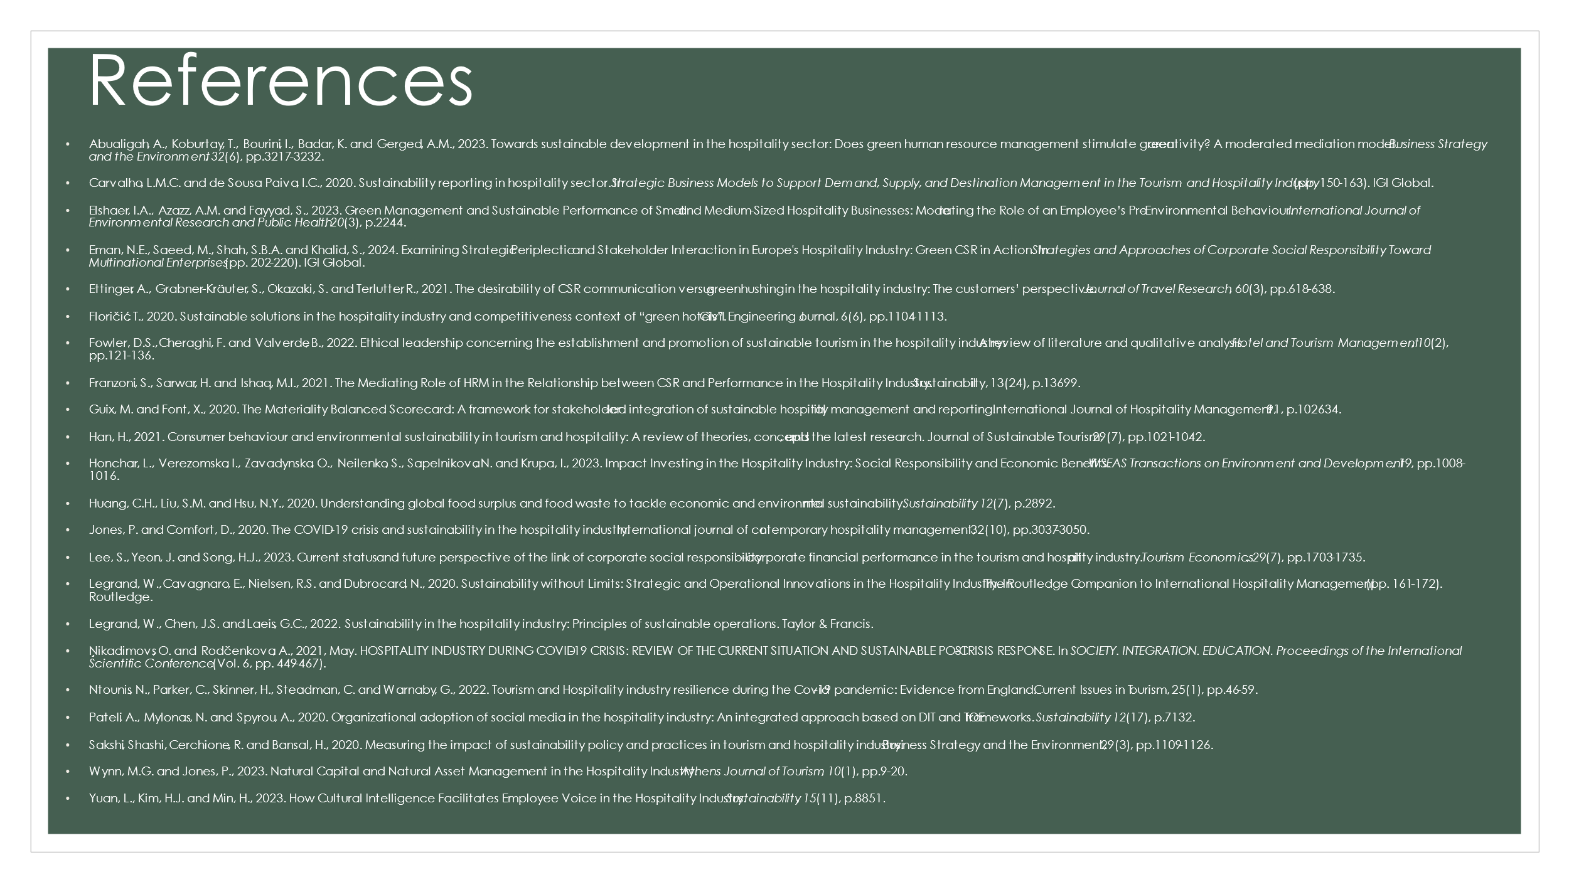

https://uowtsd-my.sharepoint.com/:v:/g/personal/2119678_student_uwtsd_ac_uk/EYQIVWs7q7JEuPMjxPa2Us8B6osWUKiZxVOqmEjh8UQRxA?referrer=Teams.TEAMS-ELECTRON&referrerScenario=MeetingChicletGetLink.view.view

