MODULE NAME AND CODE
PROBLEM SOLVING AND INNOVATION BMSW4014
ASSESSMENT TITLE
Presentation about Wilko

YOUR NAME HERE: Mihaela Elena Marin
UNIVERSITY OF WALES TRINITY SAINT DAVID
Student number here: 2240233

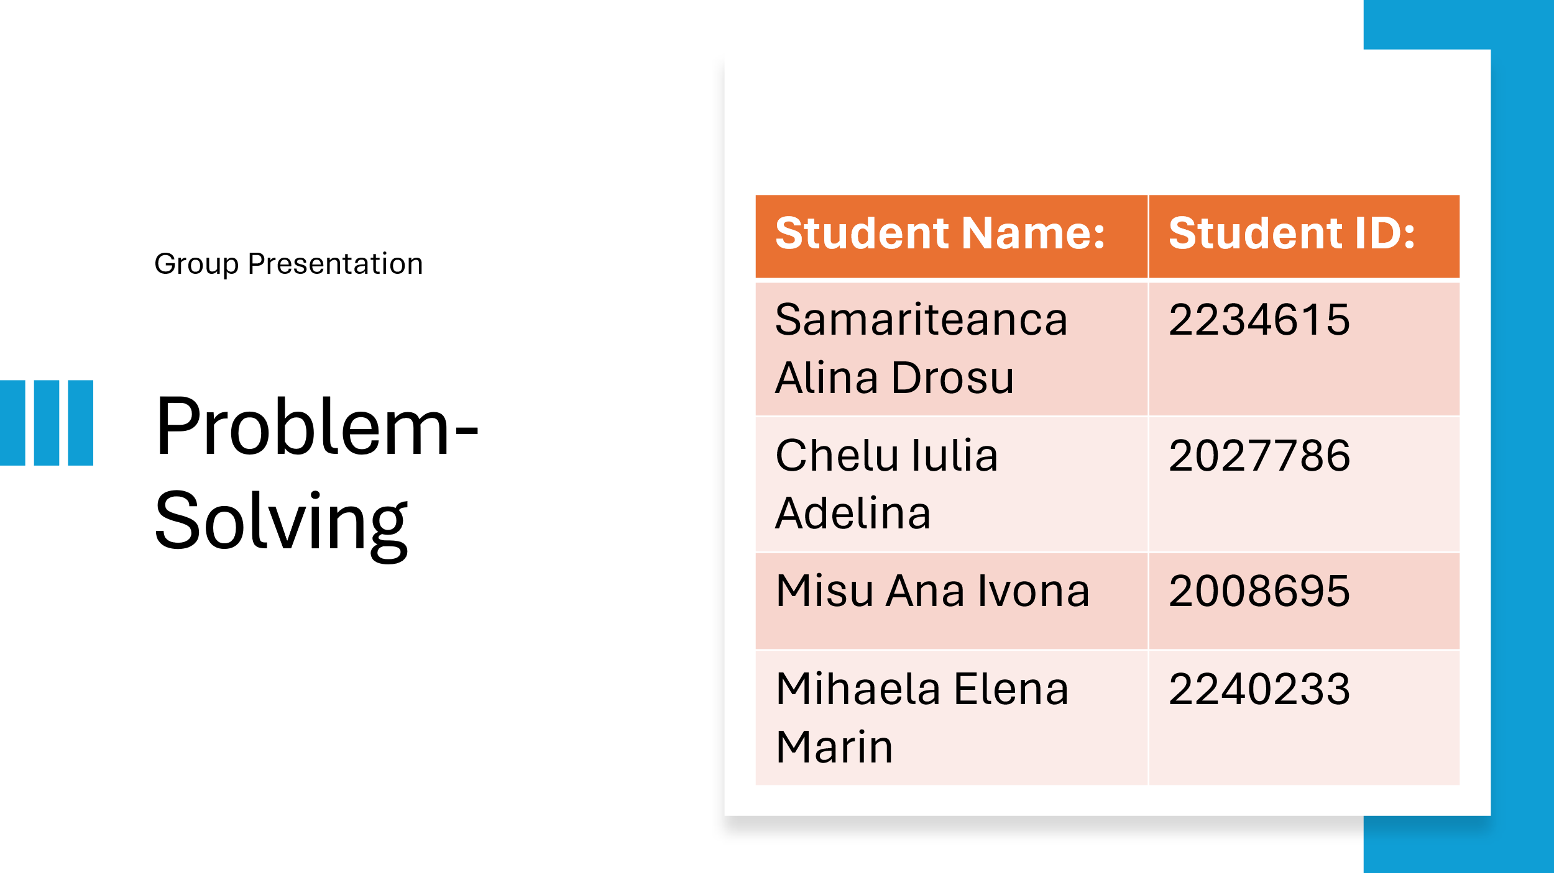
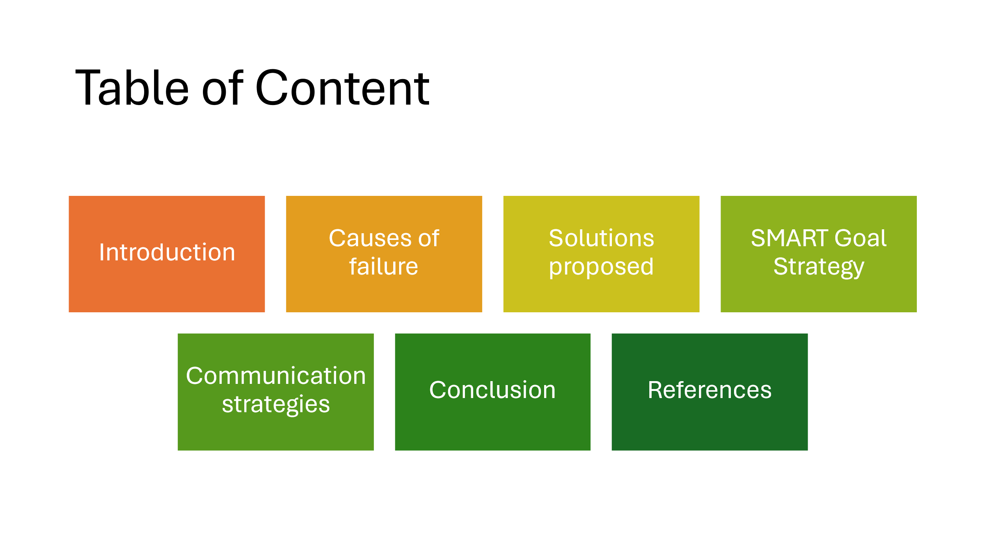
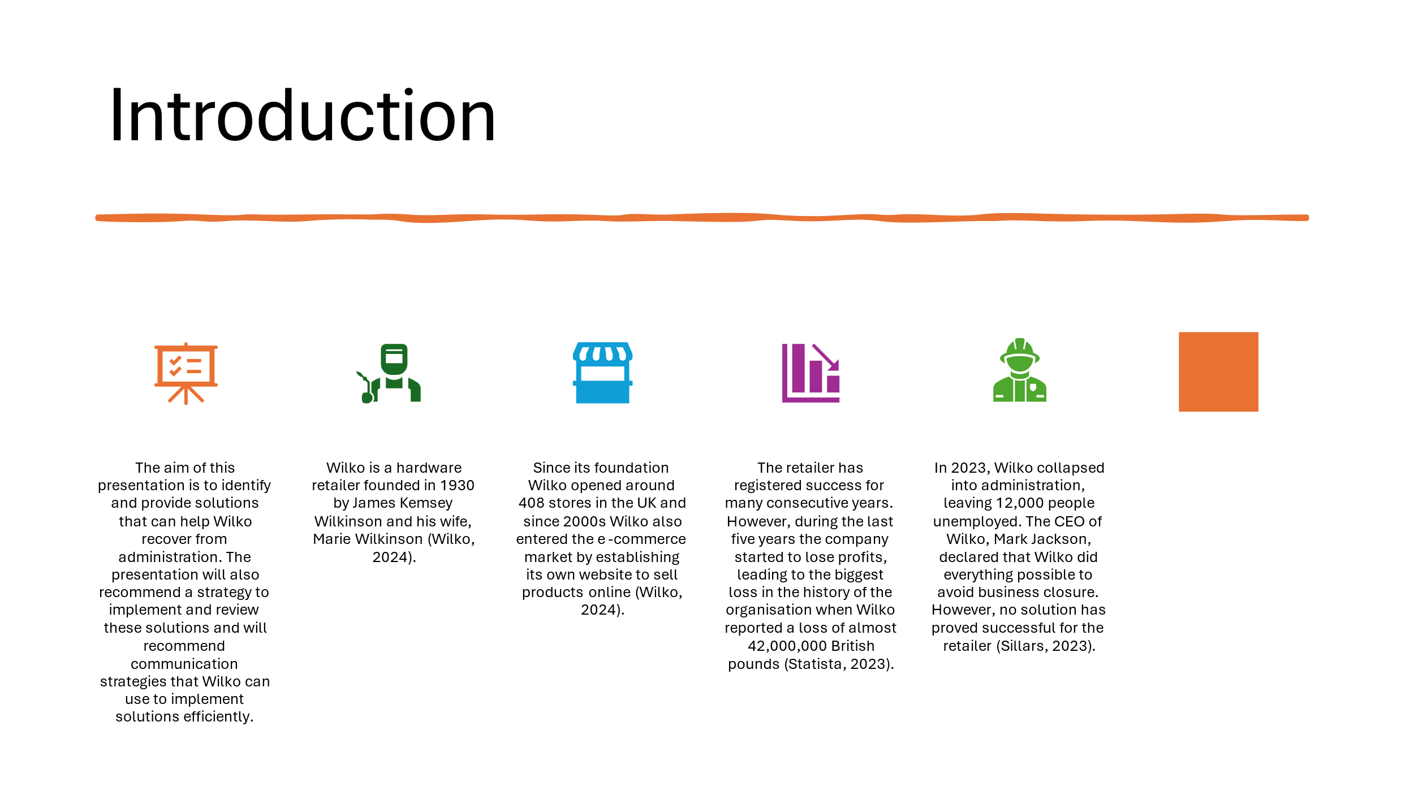
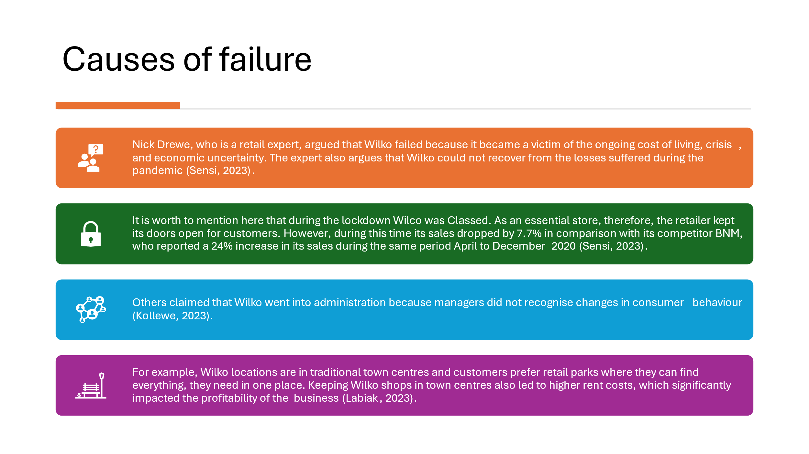
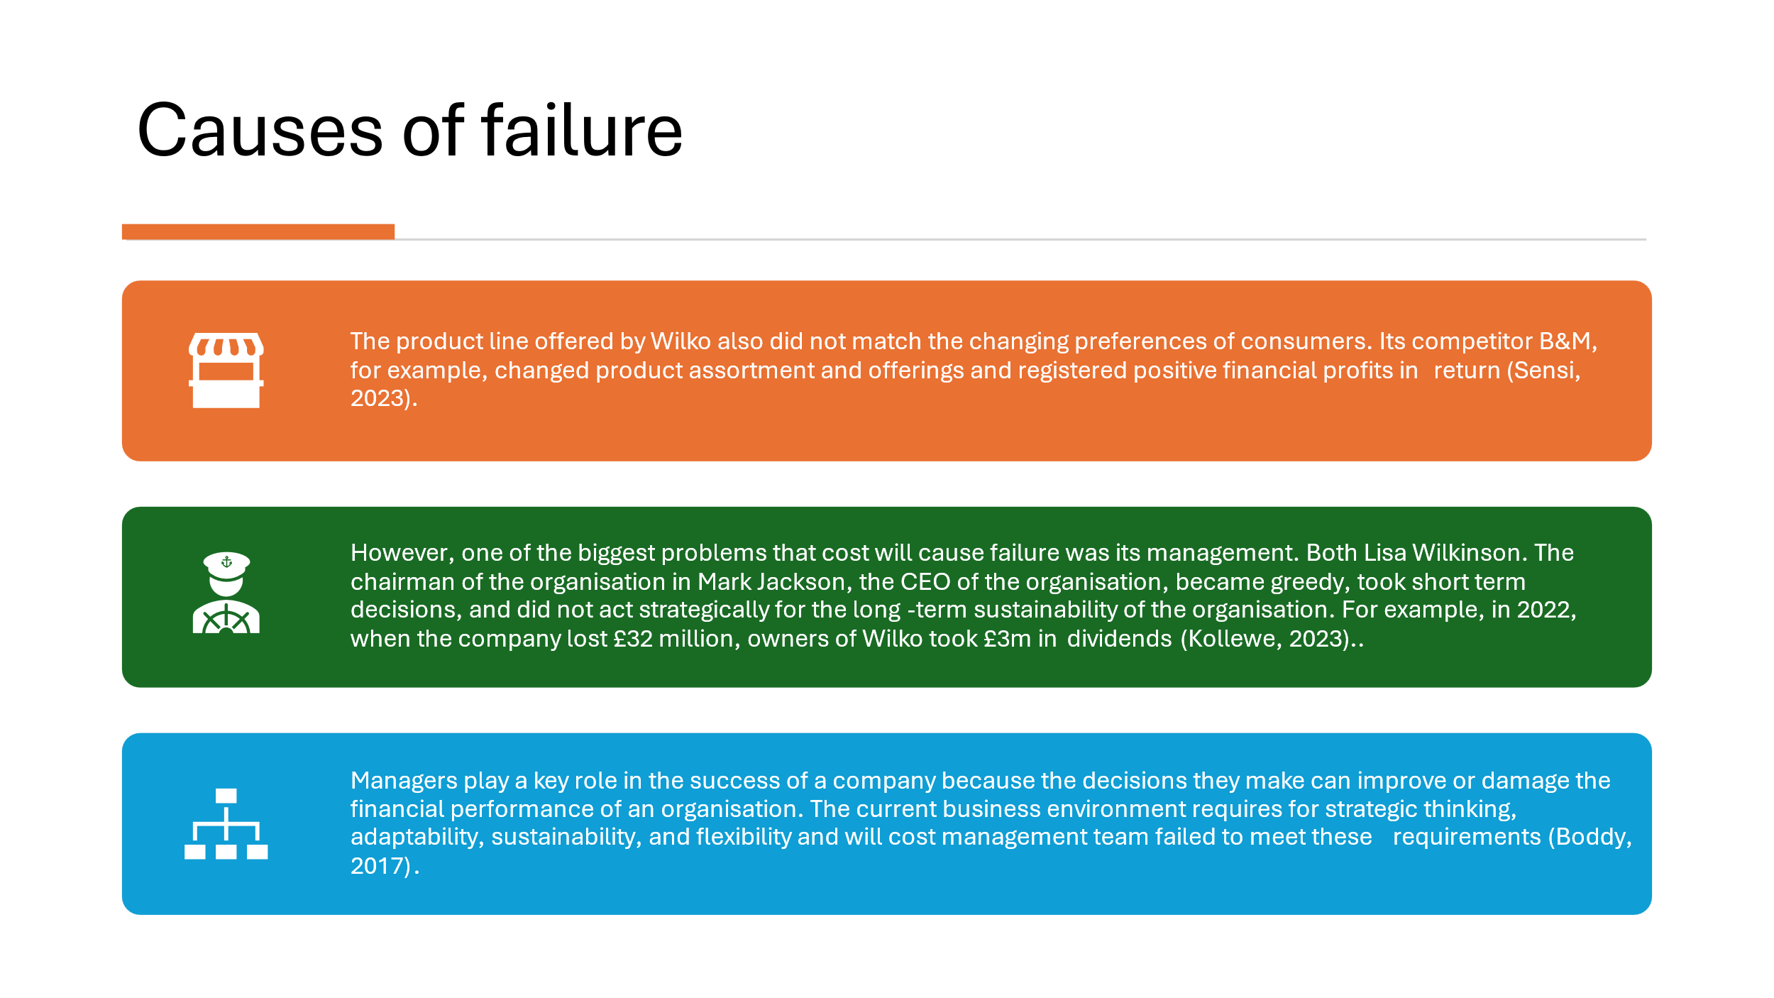
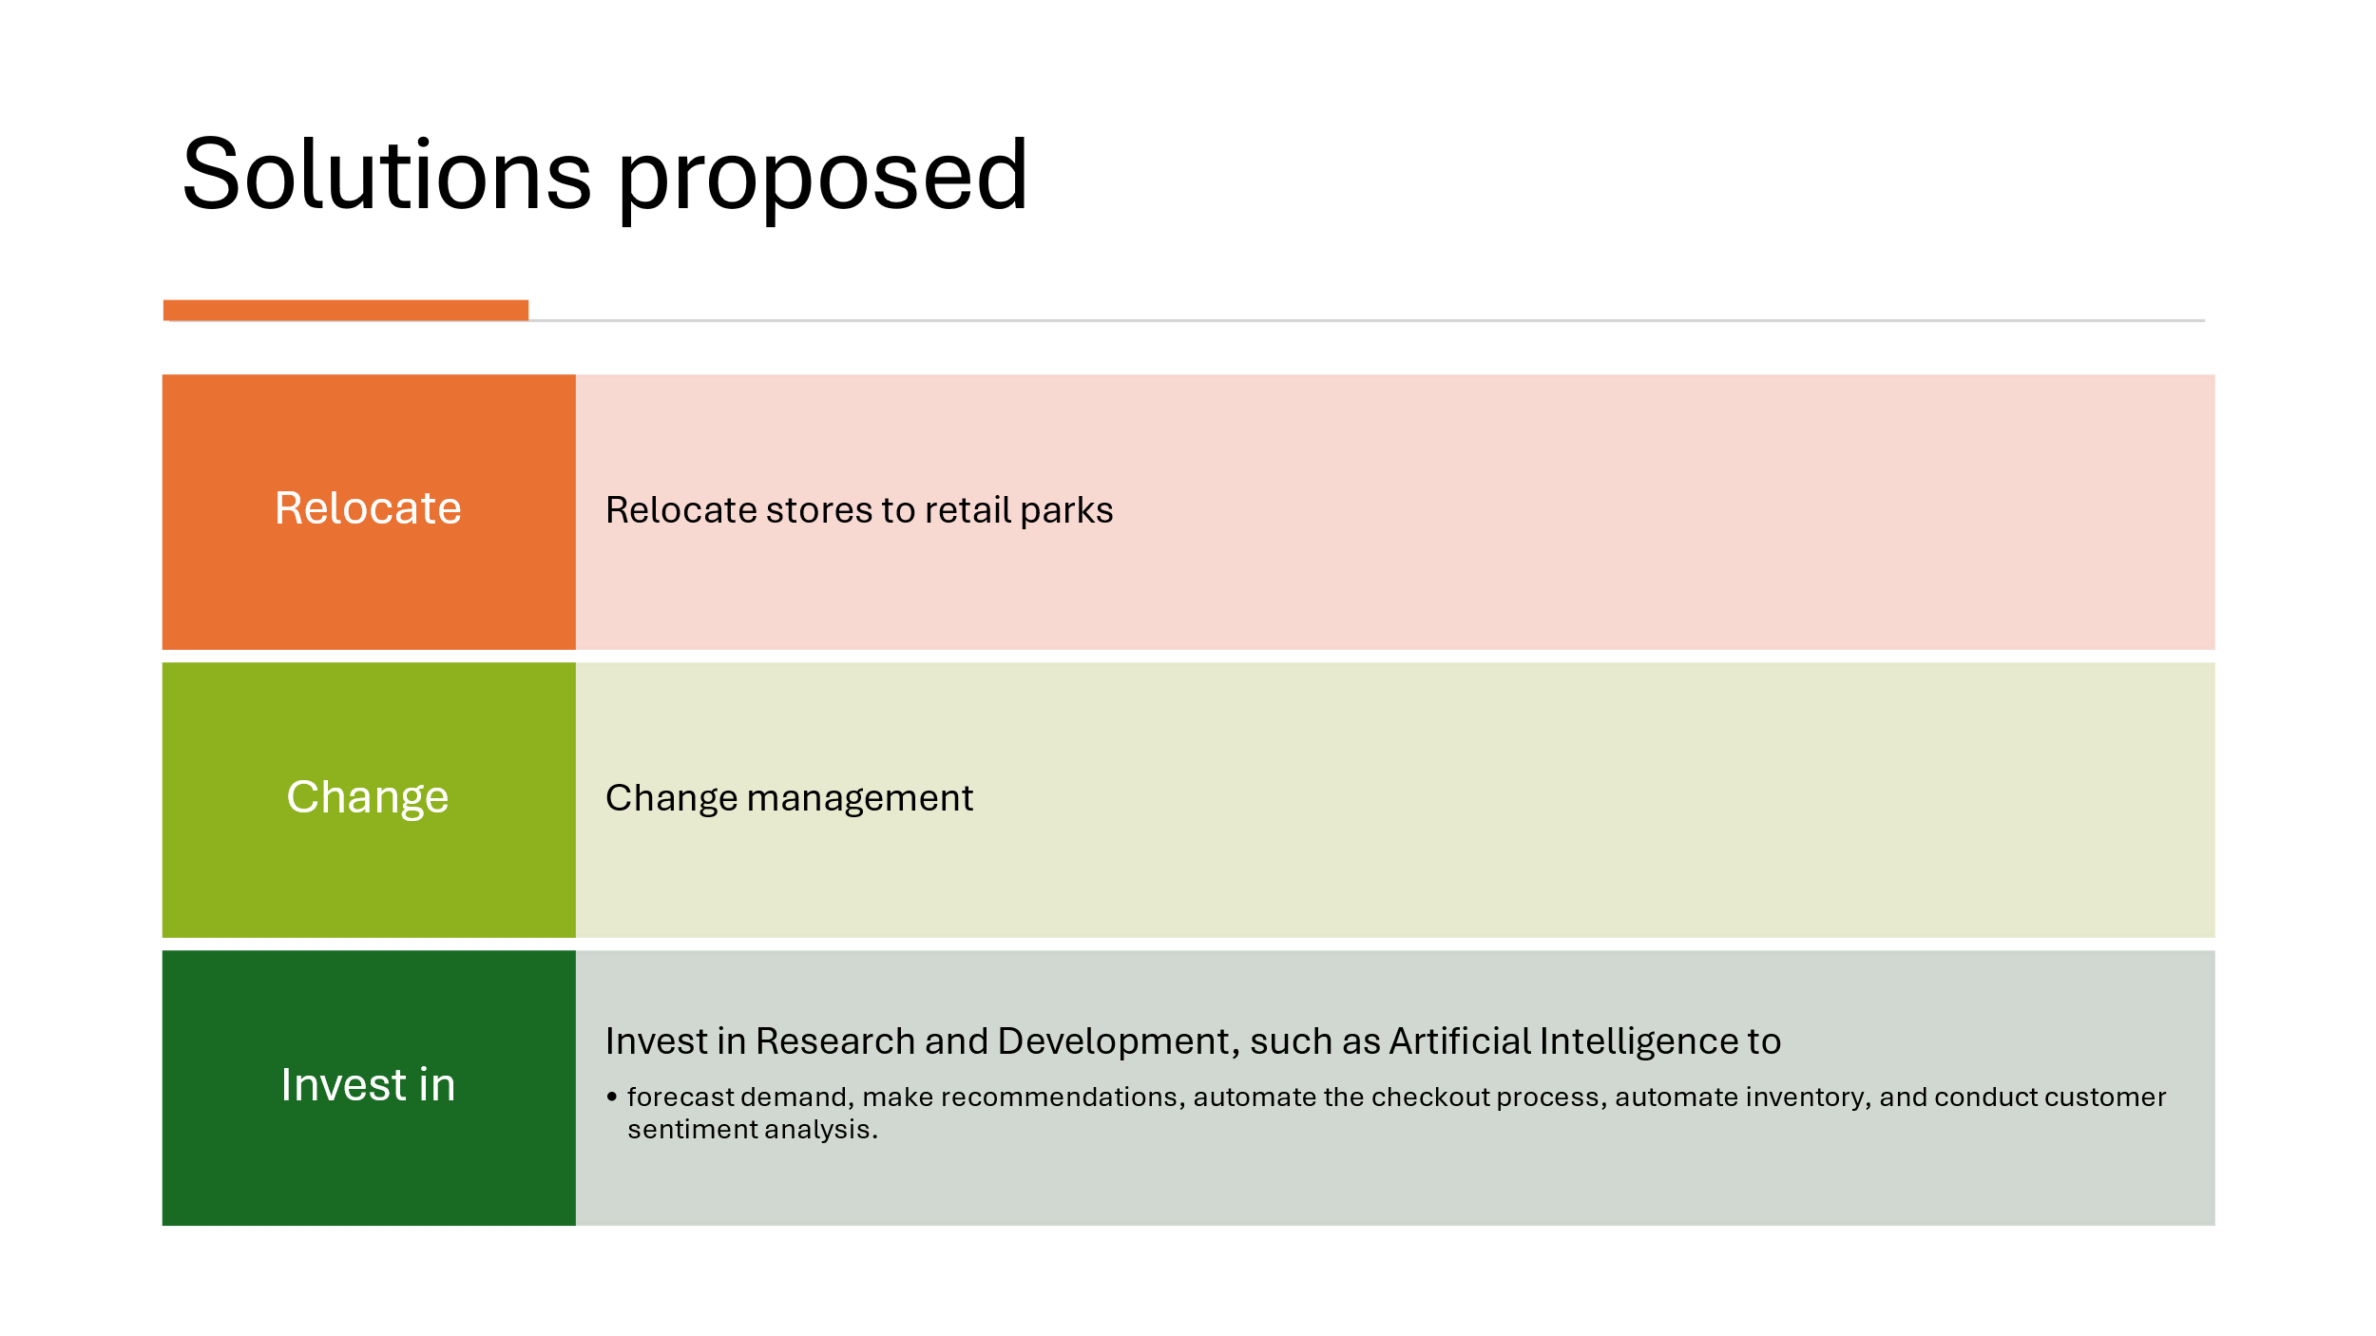
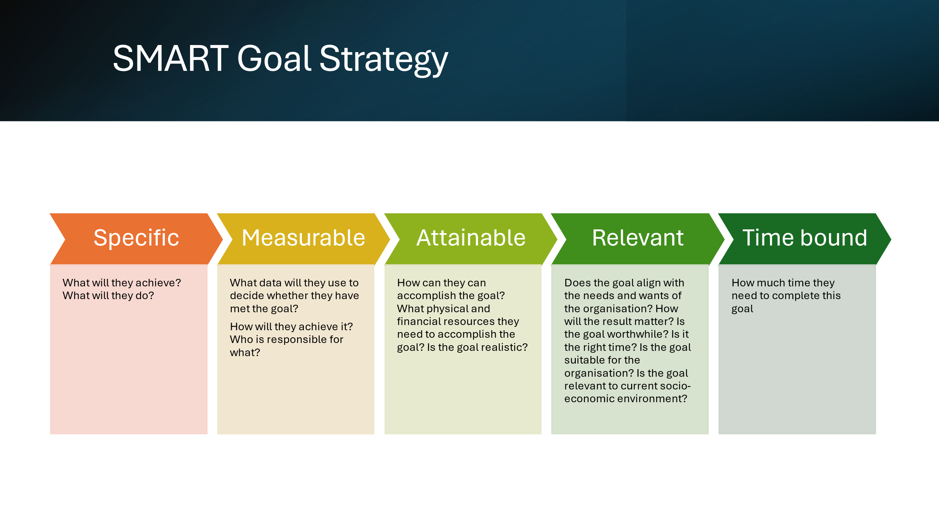
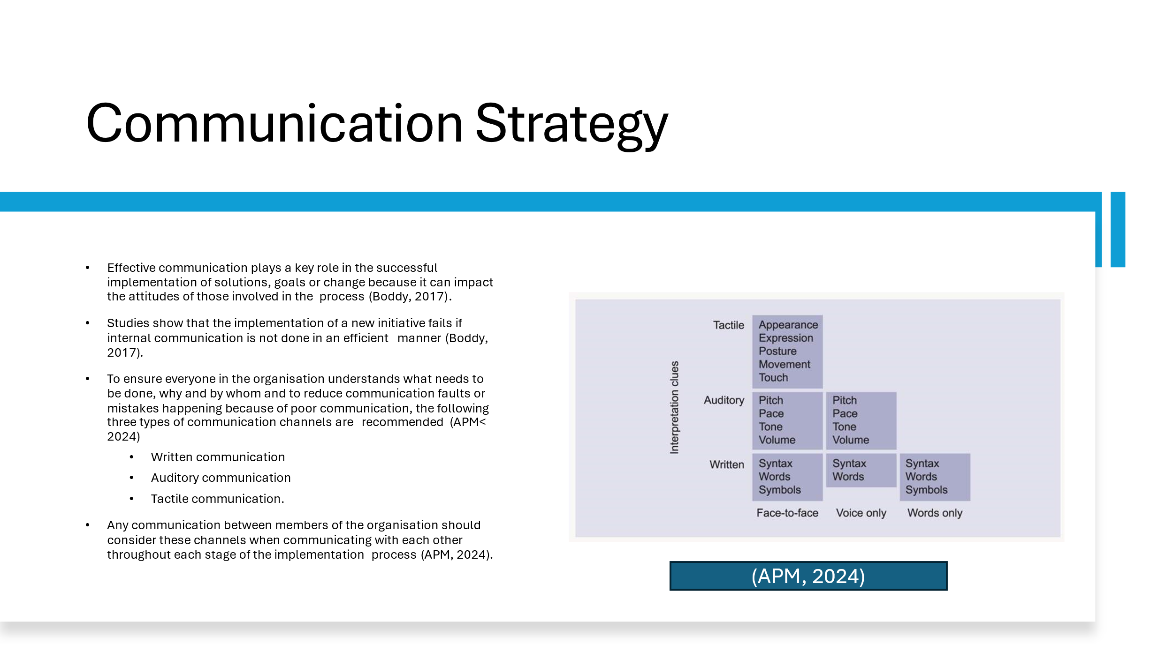
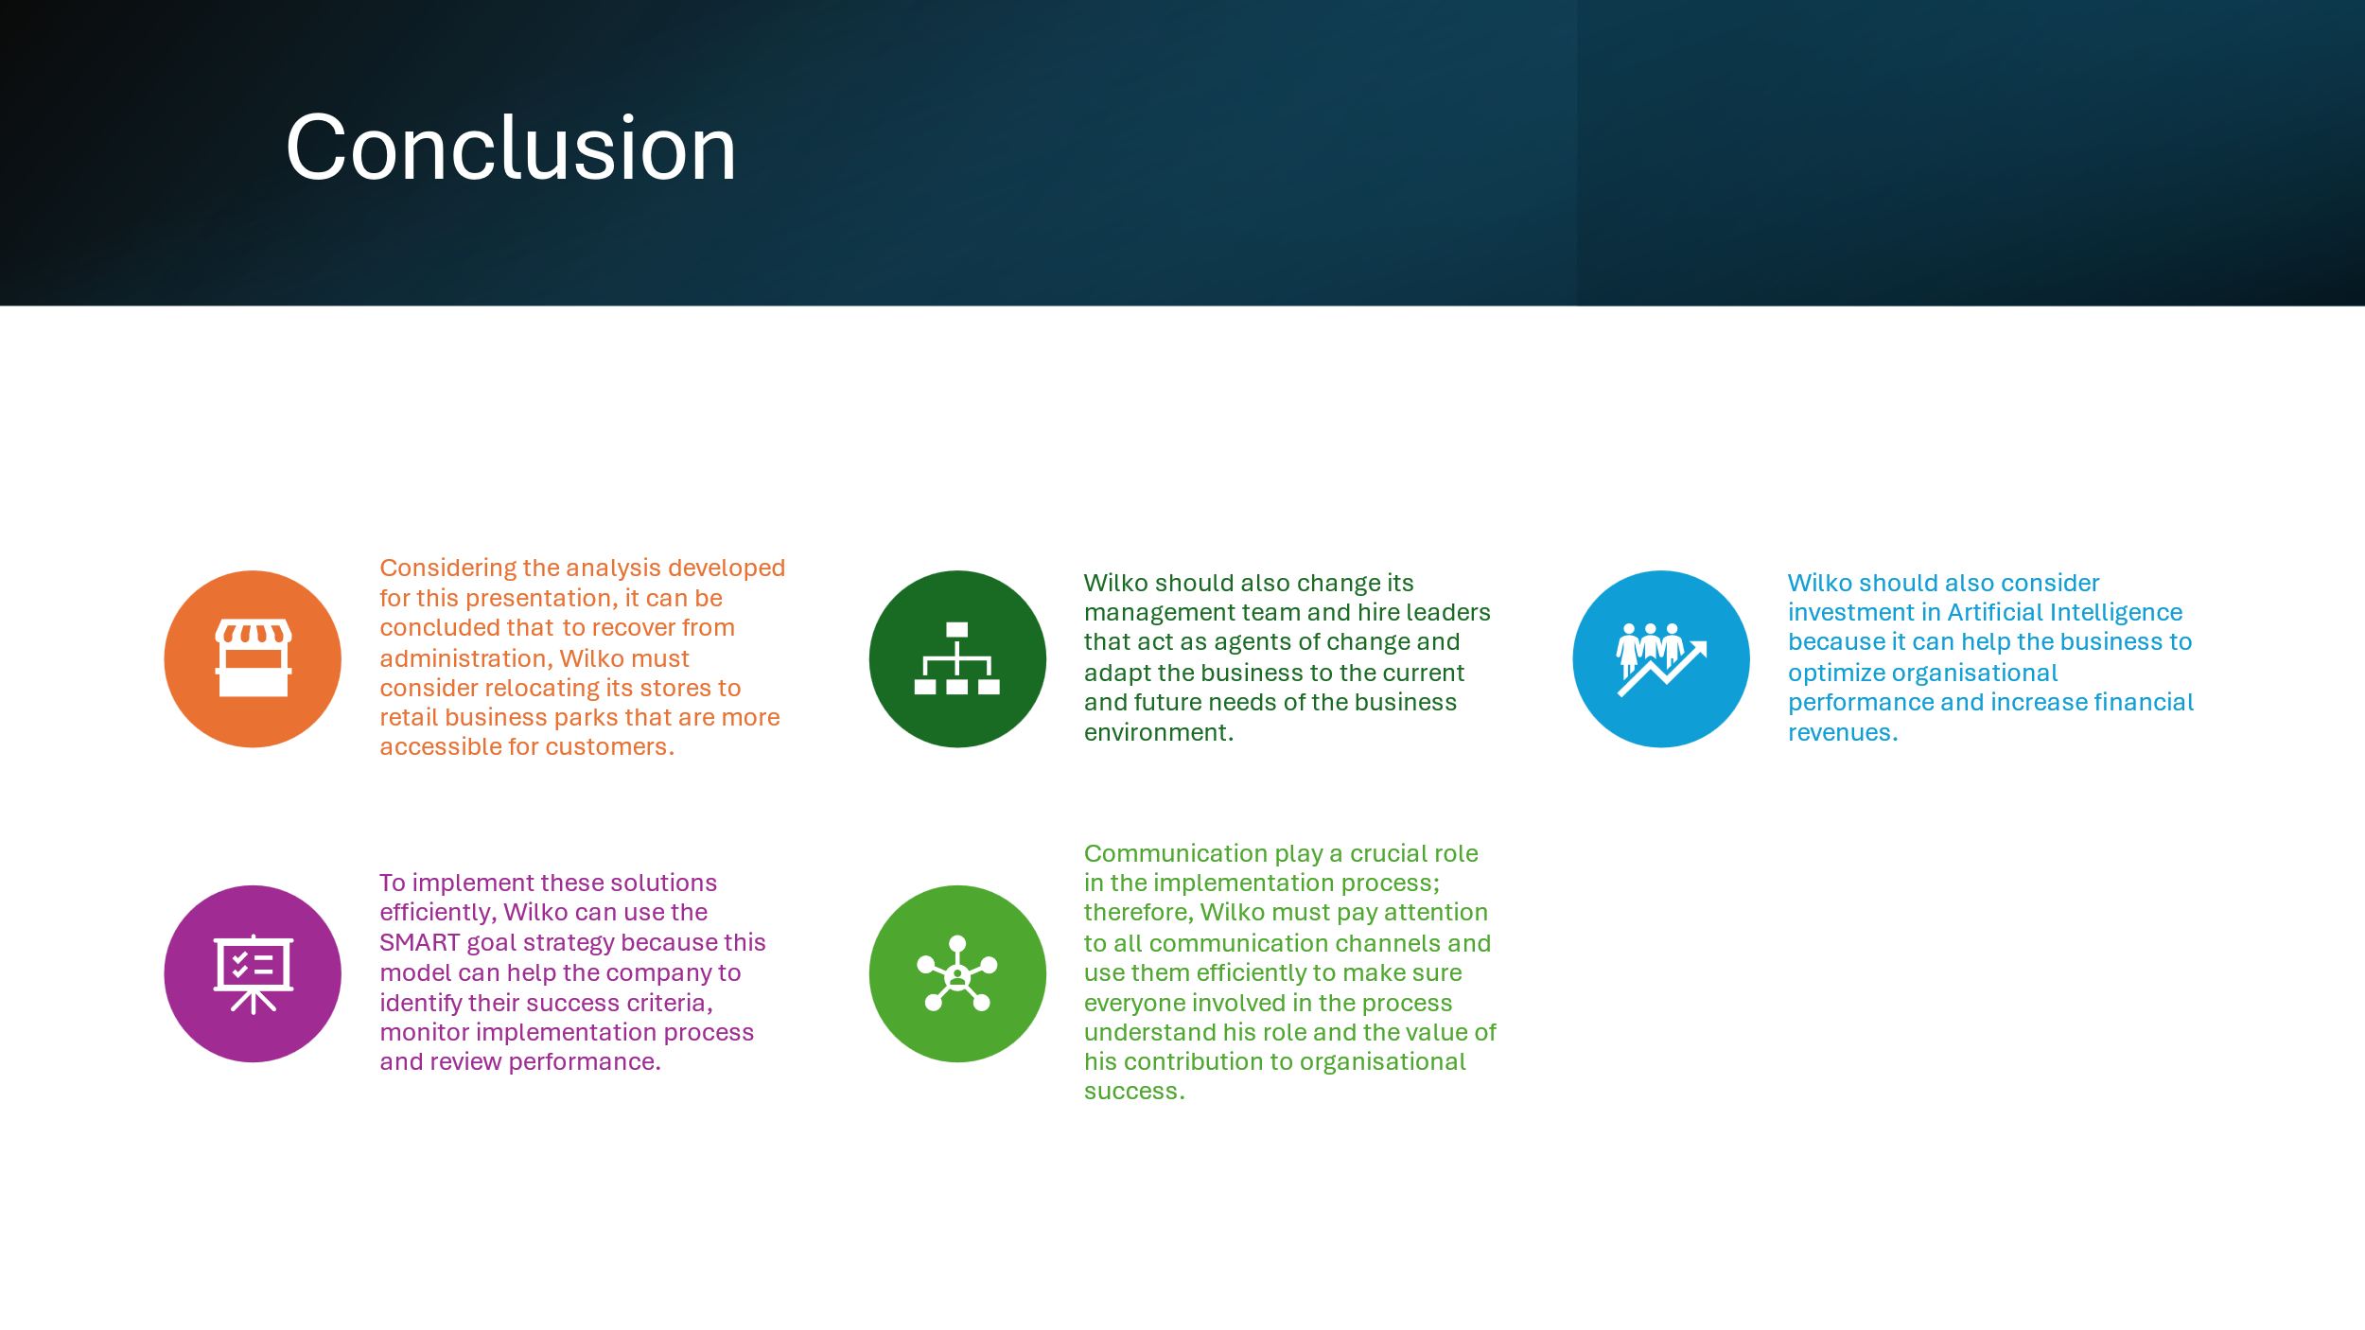
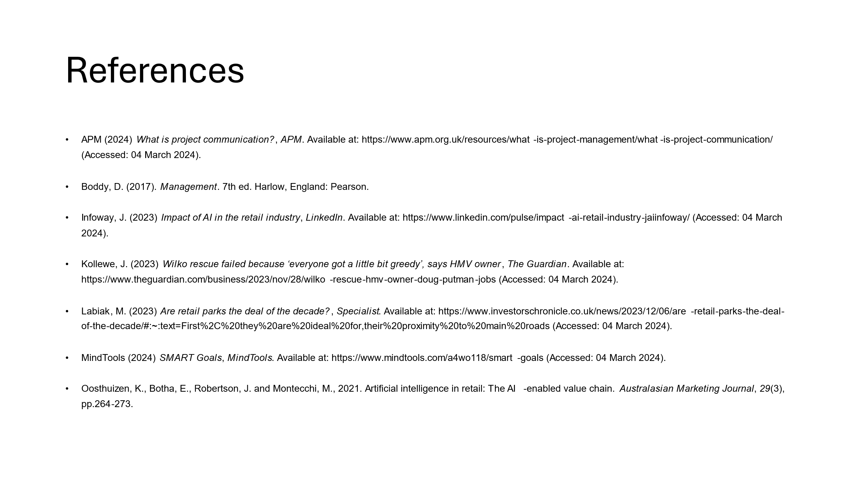
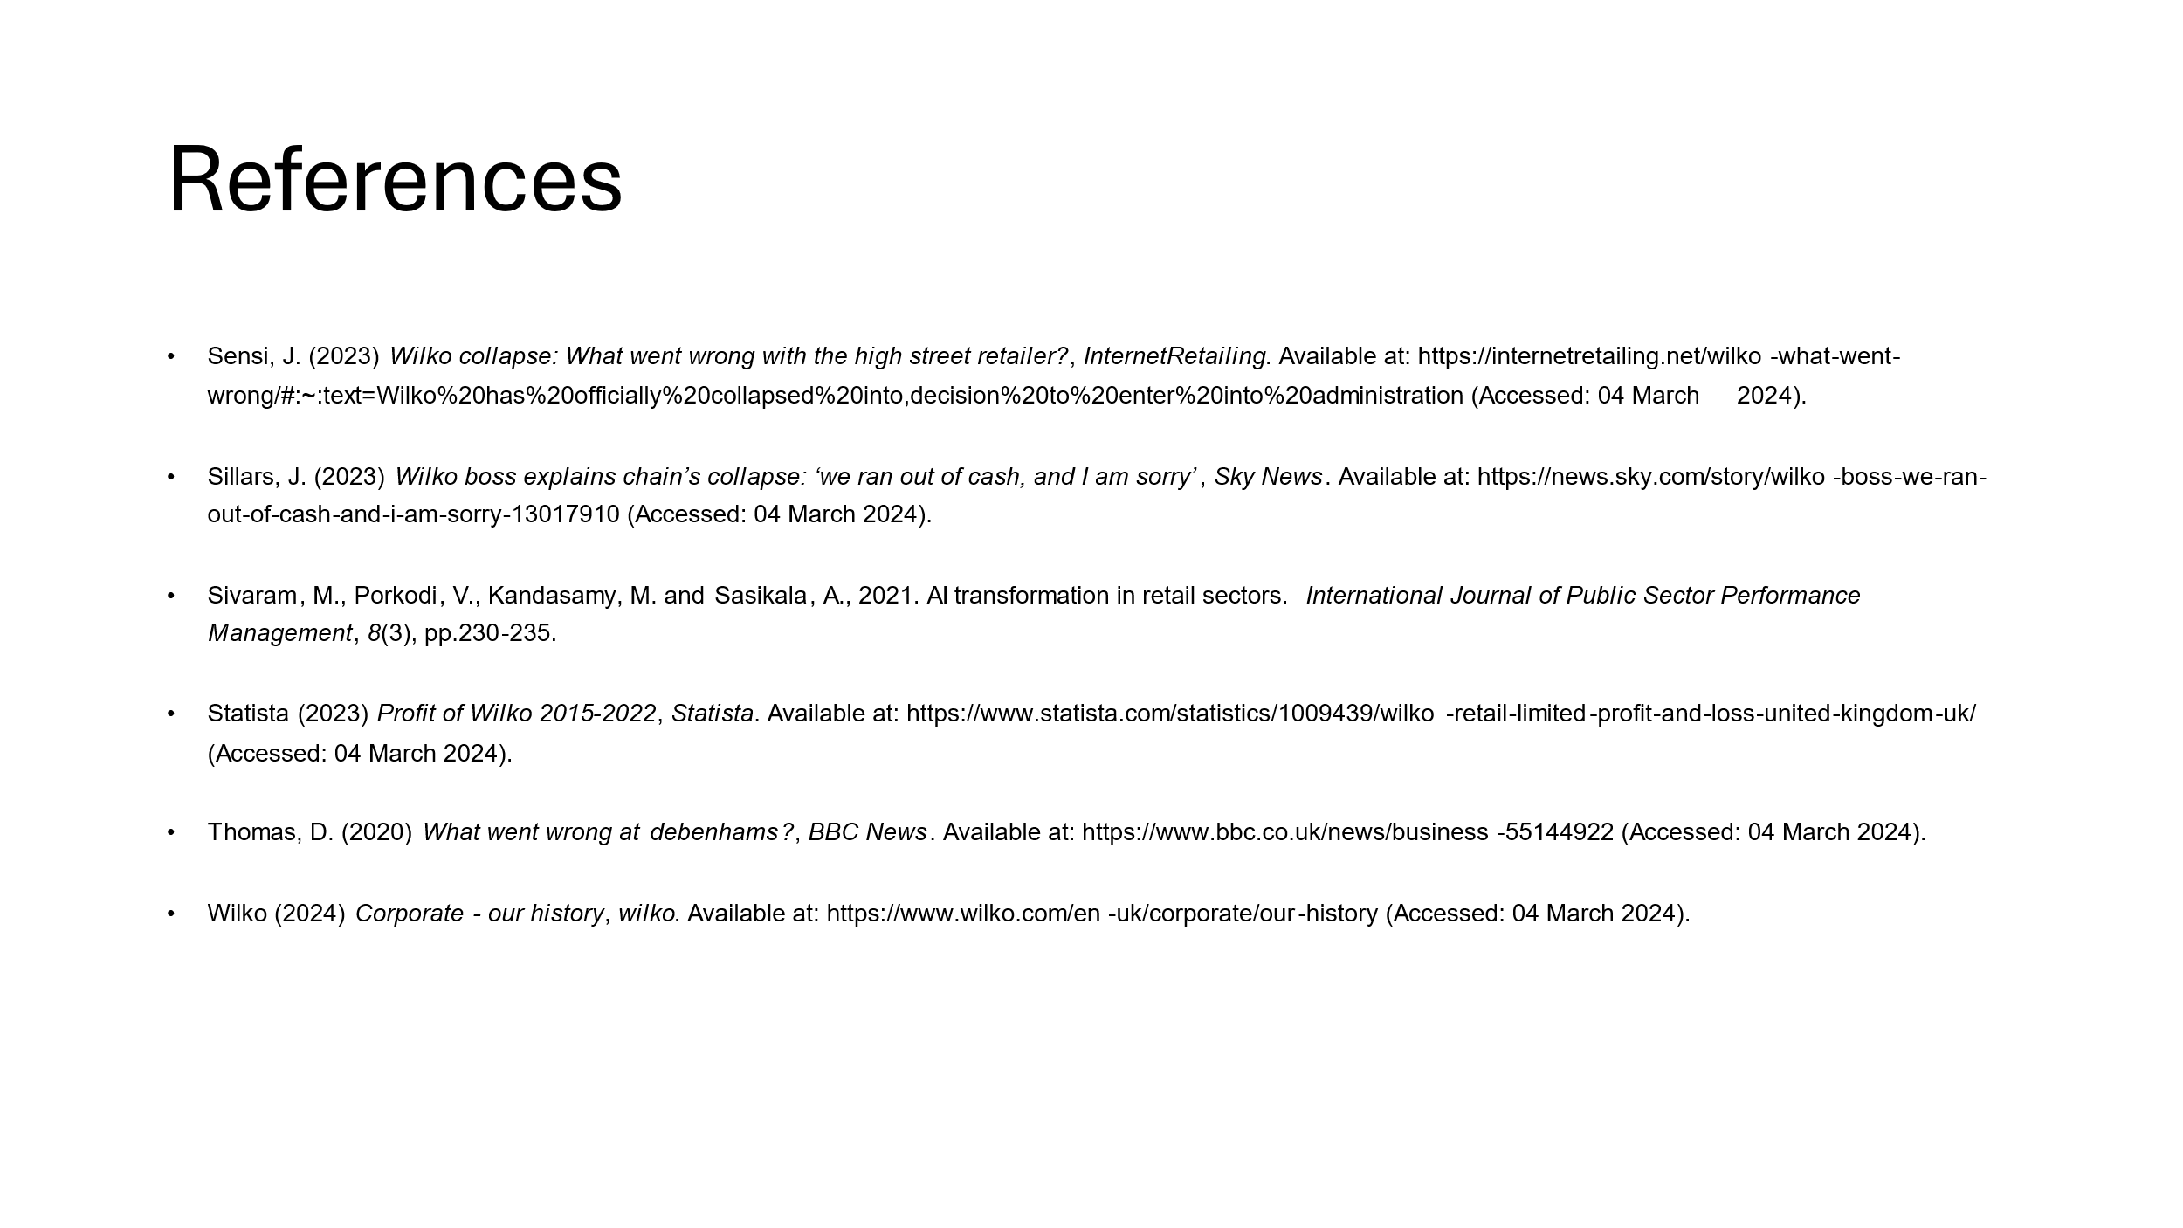

Side Notes
Wilko should consider moving its stores to retail parks because they attract a diverse range of customers, have plenty of car parking and are easy to access. Renting retail parks is also cheaper than in town centres which can allow Wilko to minimise costs.
Another solution for Wilko would be to change the management of the organisation and find managers who share the same organisational values that secured the success of the retailer for the last 90 years.
Wilko needs leaders that are not afraid of change and the only constant in the business environment is change. Therefore, hiring leaders who are also agents of change can help the company to adapt better to the future, adopt new technologies, change customer interactions, and engage employees to meet the goals and objectives of the organisation (Boddy, 2017).
Organisations that cannot adapt to change, cannot survive on the business market. Debenhams, for example, was one of the biggest retail chains in the UK and because the company did not adapt to the changing needs of consumers, the company failed. If Wilko does not consider change management, the company will follow the same path as Debenhams (Thomas, 2020).
The retail sector is constantly evolving in accordance with technology development and customer demand. Artificial intelligence is one the latest trends in the retail sector because it helps companies to forecast demand, make recommendations, automate the checkout process, automate inventory, and conduct customer sentiment analysis (Oosthuizen et al., 2021).
Artificial intelligence can help Wilko to better understand what customers want and when. This can help Wilko to prepare inventory in advance and avoid markdowns. Artificial intelligence is so efficient in forecasting demand that Nike for example invested $110 million in 2019 in an artificial intelligence programme to manage its inventory and please its customers more efficiently (Oosthuizen et al., 2021).
AI can help Wilko to enhance sales through recommendations. For example, artificial intelligence uses customer online profile such as google search history, order history or social media activity to make recommendations for further products. This can help Wilko to promote its products and attract more customers than with other traditional promotional methods (Sivaram et al., 2021).
Artificial intelligence can also help Wilko understand how Wilko as a brand is perceived by its customers and the company can use this data to improve customer experience both offline and online, improve customer relationships and enhance customer loyalty (Infoway, 2023).
In order to implement these solutions in an efficient manner, Wilko can consider the use of the SMART goal strategy.
This strategy will allow the company to define success criteria, identify resources needed, identify the people responsible to take actions, verify the success rate of the solution, the relevance of the solution and monitor closely the effectiveness of the solution (Boddy, 2017).
SMART is an acronym for Specific, measurable, attainable, relevant, and timed. The concept of SMART goal is commonly attributed to Peter Drucker's Management by Objectives concept. Later, Professor Robert S. Rubin at Saint Louis University added that evaluation and review should also be added to SMART acronym because it is importance to identify the strenghts and weaknesses of a solution to allow further improvement (MindTools, 2024).

