A COMPARISON OF THE MARKETING METHODS OF TWO MULTINATIONAL HOTEL BRANDS
MOXY and SIX SENSES

Student Name
Andreea Mariana Stoican
Student ID Number
2221000

Marketing Essentials BMIH4005

Lecturer
Chris Wilkin

WORDCOUNT: 1500

Table of Contents
1.0 Introduction 3
2.0 Situation analysis 4
3.0 Objectives 7
4.0 Strategy 7
5.0 Tactics 8
6.0 Action 10
7.0 Control 11
8.0 Conclusion 11
References 12

1.0 Introduction
A marketing plan refers to the advertising strategy that is being formulated for a given business for its future success. The marketing plan which will be prepared here will have an approach of increasing the market performance of the existing business organisation (Corporatefinanceinstitute, 2021). It will be about analysing the target market, advertising channels and other potential methods.
This marketing plan is being mainly prepared for the business Six Senses to help it improve its market share in the given marketplace of the UK.
The marketing place will focus on situation analysis, strategy, tactics, objective and requisite action plan of business. The different frameworks which would be used are Porter's five forces, SWOT, Pestle, the 4Ps of marketing and the Race matrix for the services.
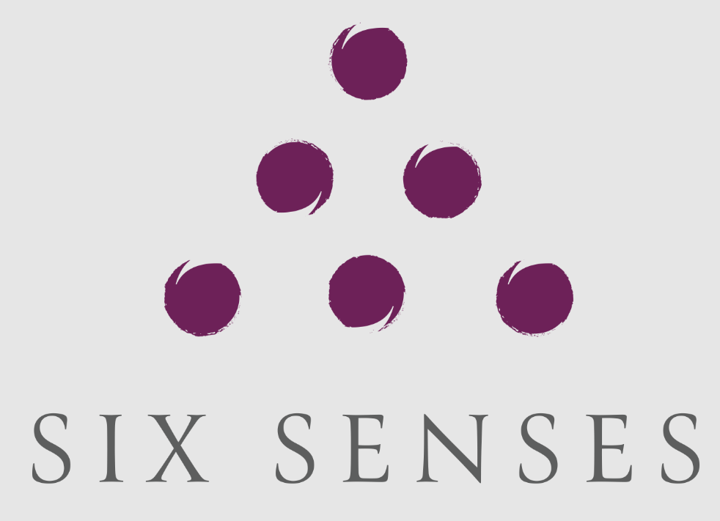
Figure 1: Six senses
(Source: Sixsenses, 2023)

2.0 Situation analysis
Company
Strength  - Availability of luxury resorts (Sixsenses, 2023)  - Long-term change is focussed on every property | Weakness  - High premium prices  - Limited available location of the business
Opportunity  - Elimination of single-use plastic favouring environment  - Future reforestation projects (Sixsenses, 2023) | Threat  - High competition in the hospitality industry
Table 1: Swot analysis
Customers
Market segmentation includes the identification of potential customers for the business (Corporatefinanceinstitute, 2020). In this case, potential customers will be travellers who prefer to travel leisurely either alone or with their families.
The business will aim towards the segment of customers preferring premium pricing hotel rooms under the specific mode of targeting. It will selectively reduce the intensity of competition in the market in the available range.
Competitors
Porters force component | Impact | Description
Bargaining power of suppliers | Low | There are numerous suppliers present in the hotel industry that can be selected by the business.
Bargaining power of customers | High | Customers are the ones responsible for driving the business and guests will be given the top priority (Cheng et al., 2020)
Competition rivalry | High | The UK has several hotel businesses present that would compete with each to provide hospitality services to the clients
The threat of new entrants | Moderate | The UK has certain capital requirements and trade policies that would it a little difficult for a business to enter this market (Cgma, 2019)
Threat of substitute | Moderate | The risk is present in terms of technology providing innovative services but there is much to be accomplished
Table 2: Porter’s five forces analysis
Collaborators
The given organisation is aware of business-to-business relationships as it partners with travel websites such as TripAdvisor to display business service information and promotion (Tripadvisor, 2023).
Climate
Pestle component | Description
Political | - The UK has a political index of 0.54 which represents the overall political stability of the county is adequate (Theglobaleconomy, (2022)
Economical | - Interest rates have been raised by a percentage point to about 4% (Bankofengland, 2023)  - Inflation rates in the UK are very high about 10% (Bankofengland, 2023)
Social | - The employment rate in the UK is at present 75.6% (Statista, (2023)  - Unemployment rates in the UK have been recorded at 3.7% which is quite good (Statista, (2023)
Technological | - UK technological sector has a market value of 1 trillion dollars with number 1 spot in Europe (Gov, 2023)
Legal | - The UK has "Employment Rights Act (1996)" for all businesses  - The "Agency workers regulation (2010)" bars discrimination of a part-time working employee
Environmental | - "Environmental protection act (1974)" is present in the UK which holds valid for hotel industries and other businesses (Field, 2021)
Table 3: Pestle analysis

3.0 Objectives
Brand awareness is a major attribute for a business in these modern times given the number of businesses that are available online (Stevenstate, 2020). It is therefore necessary for businesses operating in any given sector to increase their overall business availability. The objective of this marketing plan will be the same for increasing the number of customers.
SMART target
This marketing plan will aim to increase its new customer review by over 30% with greater business visibility in the market.

4.0 Strategy
The value proposition of Six Senses is that it focuses on the transformative mode of travel where the business is continuously upgrading its services (Sixsenses, 2023). Their product offering helps add experience to the travel journey of both convenience and safety. Their service offering differentiates the business from the others and these values will be communicated through their detailed website page. Digital tools such as social media will also be relied on with appropriate use of stakeholders to deliver on the promise.
Based on the consideration of Bowman's strategy clock, the value proposition of the services will be utilised through a focussed differentiation approach (Bstrategy, 2021). This will ensure that the company will be providing premium servicing.
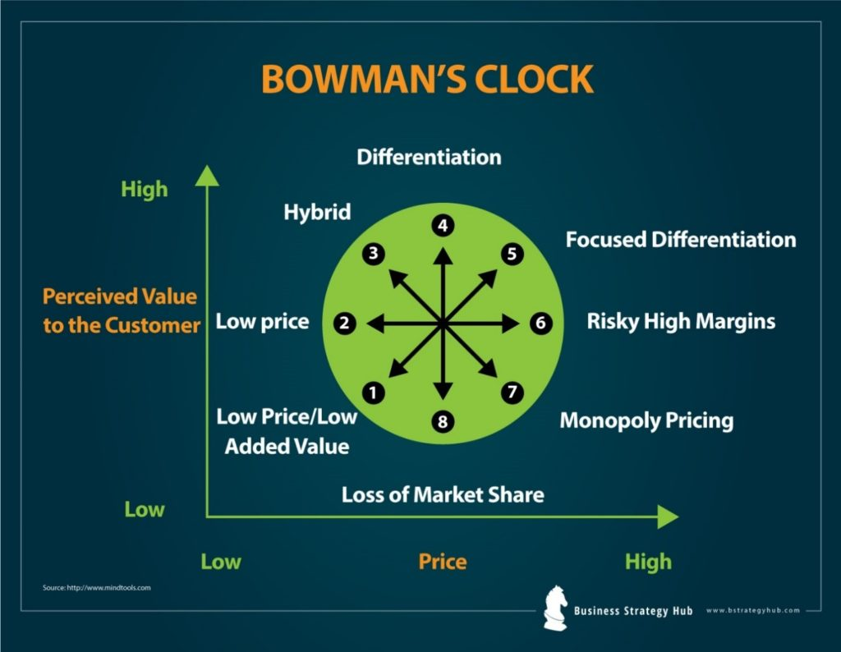
Figure 2: Bowman’s strategy clock
(Source: Bstrategy, 2021)

5.0 Tactics
Product
The destinations that are currently offered by the business include primarily Europe, China, India, Fiji, Italy, Spain, Switzerland and many other such countries (Sixsenses, 2023). It mostly includes Europe, Asia-Pacific and North America as its core places of services.
Place
The particular area of service will be located by the customers by directly visiting the website page of the business or checking out popular travel websites. The supply chain channels involving logistics and distribution present in the UK in terms of requisite supplies will be utilised for the services.
Price
Premium pricing has been utilised within the area of the UK as well as other parts of Europe (Qualtrics, 2020). It is important to highlight that the price point differs for the business depending on their location of service, particularly in Asia-Pacific. The price point difference seen for the business is guided by the availability of facilities such as spas, luxury resorts, five-star dining and others.
This is in consideration with the focussed differentiation approach of the business.
Promotion
The specific advertising media that will be utilised for the marketing shall involve digital channels mostly with some form of offline marketing in the form of pamphlets offered at the supermarkets. Promotional offers will involve discount coupons, extra benefits and others that will be communicated through appropriate media. The benefits are provided in the form of early bookings for interested customers for promoting prior planning (Sixsenses, (2023). The strategies have been described through the communication matrix.
Communication | Format | Frequency | Owner | Escalation
Weekly status update | Reports | Weekly | Hotel manager | CEO
Budget | Reports | Monthly | Finance officer (Communicationmatrix, 2020) | CFO
Risk review | Reports | Quarterly | Service Manager | CEO
Table 4: Communication matrix

6.0 Action
It will be required for the given market plan to utilise a proper course of action planning. This will involve the preparation and deployment of the market plan adequately. At first, it will be required to set the requisite goals as per the objective based on which market research will be performed (Techtarget, 2021). The required allocation of budget, developing market strategies and analysing results will require 2 months. Feedback on the strategy will be gathered and tracked through KPIs.
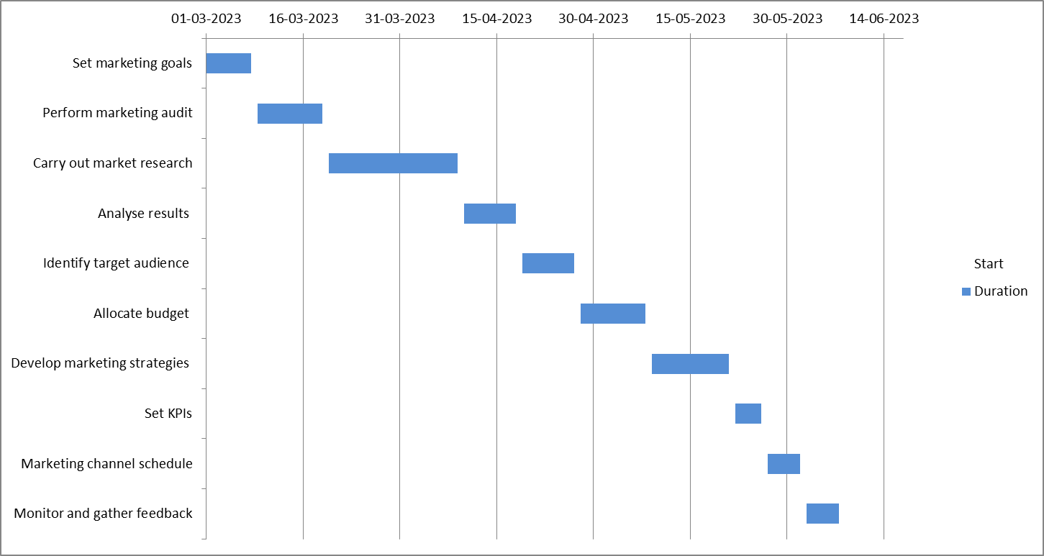
Figure 3: Market action plan

7.0 Control
The unique selling point for the business is the sleek hotel designs and premium pricing for the top-end customers. The features of the hotel include luxury rooms, deluxe suites, swimming pools, a personalised cafe, adjoined dining place and others. Customers also benefit from wellness programs and the sustainability approach of the business for positive impact (Sixsenses, 2023).
The success of the marketing plan will be tracked based on several customer reviews and pay-per-click measure results. The arrival of new customers will be analysed in this manner to keep track of market plan success. The attitude of the customers will be tracked by analysing the customer reviews provided by the clients.

8.0 Conclusion
The marketing plan was successfully developed for the business Six Senses and it was found that the company has serious potential to compete in the UK marketplace. The challenges of the marketing plan involve the identification of appropriate channels for the maximum efficiency of marketing efforts. In addition to this, it is also important to allocate a plausible budget for this approach to minimise expenses. A recommendation for the given marketing plan will be thorough research on any alternative digital marketing tools as well as a financial management strategy to help with the plan of increasing new customers for the business.

References
Bankofengland, (2023), Marketing plan. Available at: https://www.bankofengland.co.uk/explainers/why-are-interest-rates-in-the-uk-going-up [Accessed on: 07.02.2023]
Bstrategy, (2021), Bowman strategy clock . Available at: https://bstrategyhub.com/wp-content/uploads/2019/01/Strategic_Clock-1024x794 [Accessed on: 07.02.2023]
Cgma, (2019), Porter’s five forces. Available at: https://www.cgma.org/resources/tools/essential-tools/porters-five-forces.html [Accessed on: 07.02.2023]
Cheng, B., Guo, G., Tian, J. and Shaalan, A., (2020). Customer incivility and service sabotage in the hotel industry. International Journal of Contemporary Hospitality Management, 32(5), pp.1737-1754.
Communicationmatrix, (2020), Marketing plan. Available at: https://www.communicationmatrix.org/ [Accessed on: 07.02.2023]
Corporatefinanceinstitute, (2020), Targeting and segmentation. Available at: https://corporatefinanceinstitute.com/resources/management/market-segmentation-and-targeting/ [Accessed on: 07.02.2023]
Corporatefinanceinstitute, (2021), Marketing plan. Available at: https://corporatefinanceinstitute.com/resources/management/marketing-plan/ [Accessed on: 07.02.2023]
Croner, (2020), Labour regulations. Available at: https://croner.co.uk/resources/employment-law/legislation-list/ [Accessed on: 07.02.2023]
Field, (2021), Environmental laws. Available at: http://www.field.org.uk/list-of-environmental-laws/ [Accessed on: 07.02.2023]
Gov, (2023), UK technological spending. Available at: https://www.gov.uk/government/news/uk-tech-sector-retains-1-spot-in-europe-and-3-in-world-as-sector-resilience-brings-continued-growth [Accessed on: 07.02.2023]
Qualtrics, (2020), Pricing models. Available at: https://www.qualtrics.com/au/experience-management/product/pricing-strategies/ [Accessed on: 07.02.2023]
Sixsenses, (2023), Dedicated wellness retreat. Available at: https://www.sixsenses.com/en/corporate/news/our-first-dedicated-wellness-retreat [Accessed on: 07.02.2023]
Sixsenses, (2023), Early booking discount. Available at: https://www.sixsenses.com/en/offers/early-booking [Accessed on: 07.02.2023]
Sixsenses, (2023), Experiences. Available at: https://www.sixsenses.com/en/experiences [Accessed on: 07.02.2023]
Sixsenses, (2023), Resorts. Available at: https://www.sixsenses.com/en/resorts [Accessed on: 07.02.2023]
Statista, (2023), Employment rate. Available at: https://www.statista.com/statistics/281992/employment-rate-in-the-united-kingdom/ [Accessed on: 07.02.2023]
Statista, (2023), Unemployment rate. Available at: https://www.statista.com/statistics/279990/unemployment-rate-in-the-uk-by-country/ [Accessed on: 07.02.2023]
Stevenstate, (2020), SMART goals. Available at: https://stevens-tate.com/articles/5-smart-goal-examples/ [Accessed on: 07.02.2023]
Techtarget, (2021), Action planning. Available at: https://www.techtarget.com/whatis/definition/action-plan [Accessed on: 07.02.2023]
Theglobaleconomy, (2022), UK political index. Available at: https://www.theglobaleconomy.com/United-Kingdom/wb_political_stability/ [Accessed on: 07.02.2023]
Tripadvisor, (2023), Traveller’s choice. Available at: https://www.tripadvisor.com/TravelersChoice [Accessed on: 07.02.2023]

