RESEARCH PRACTICES

  - Ruairi Evans

Contextual Practices
Research Practices
M5X01571
P149760
Research Practices

Dissertation Proposal

This document is a proposal for a dissertation. The proposed dissertation will be approximately 5,000 words and the subject covered will be animation.
There are going to be a few elements that need to be covered in animation as it’s going to be a big topic to cover.
There are going to be some steps and research to go through and they are 3 Keywords that are part of the subject, 3 images that relate to the subject and along with that comes a maximum of 3 artists or thinkers and there will be a question that will be developed for the dissertation

3 Key Images
There are 3 Key Images to explain, what is the explanation behind them?
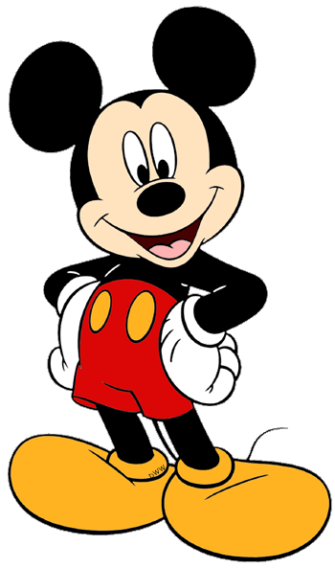

The first image displays Micky Mouse (Disneyclips, 2018) Micky Mouse is a very important figure in Animation History, this will be explained further in this essay. The point being made in this key image is that there are many iconic Animated Characters that have made a big impact in Animation.

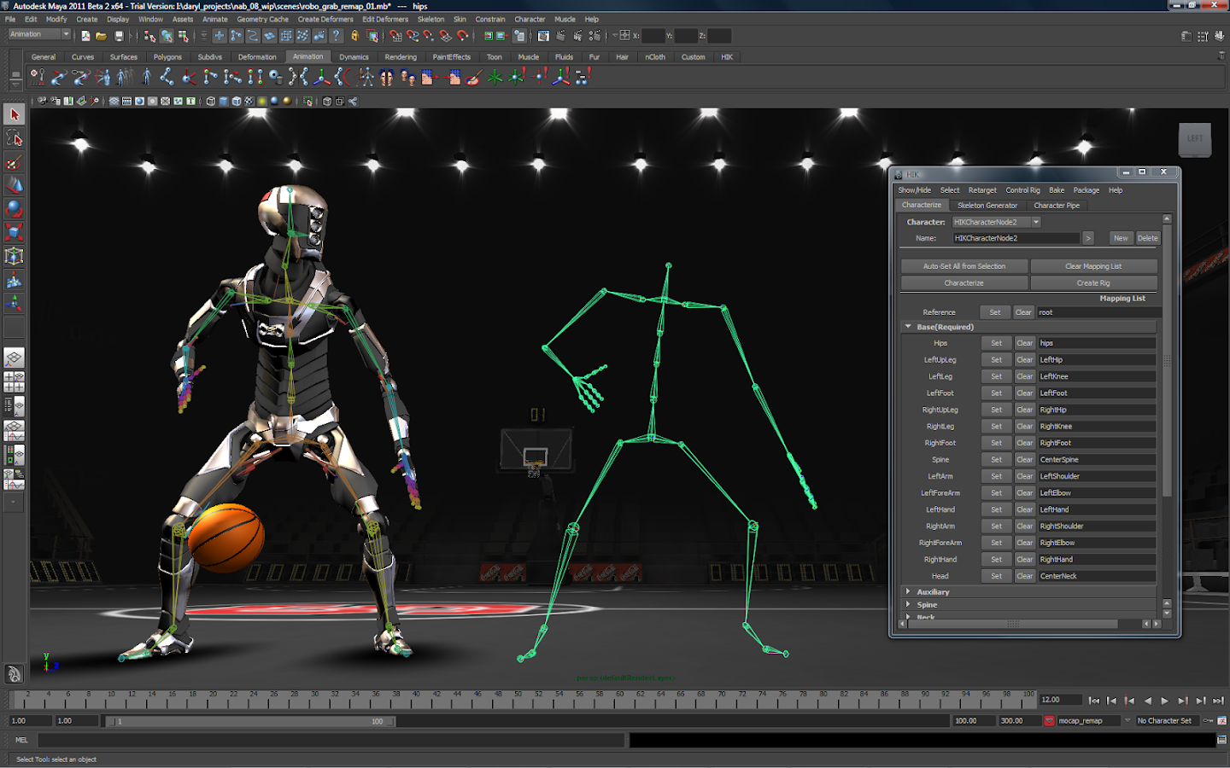

The second key image displays a 3D Model (Google Play, 2018) (Google Play, 2018). 3D Animation is a very complex and modern form of animation and as you can see This shows the progress and evolution of animation as well as the many different processes there are in animation and the fact that it can be made on computers.
What is also being shown in this Key Image is that the 3D Model has some joints. The joints are to help with making the 3D Model move in a more realistic pattern.

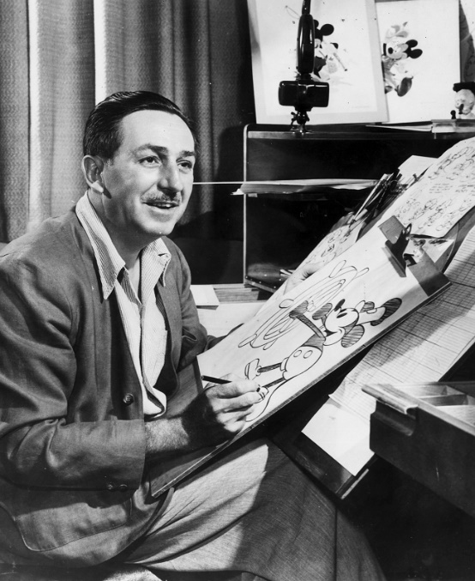

This is the third key image shows and it shows a picture of Walt Disney (Walt Disney's Life Through Pictures , 2018) (Diz Avenue, 2018). In this picture, Walt Disney appears to be working on his designs for Micky Mouse It also displays that in Animation’s history, there has been some important artists and thinkers that helped animation to evolve.
Information on Animation
This is the first keyword proposed for the proposed dissertation, Information is Animation?
This keyword will be looking in this book known as The World History of Animation (Cavalier, 2011). This book, will be looking for some important facts and briefly explain about them and how I will talk about them in the dissertation.
The World History of Animation talks about the history of animation but in different countries and has many different timelines. It also mentions some key figures in the history of animatio (Cavalier, 2011).
What is worth looking at in this book? This book has many pictures and it talks about many different animated pieces, techniques and the people behind it.
One fact it talks about is that Emile Cohl’s Fantasmagorie (Fantasmagorie, 1908) is said to be one of first fully animated videos of all time. Another thing that it talks about is the many different types of animation that there are from the beginning to now. Examples are
1. Stop Motion
2. Drawn-on film animation
3. Motion Photographs
4. Cut Out Animation
5. Multiplane Camera
6. Anime
7. CGI
8. Claymation
It also mentions different Disney and Pixar films along with other small animated shows along with other companies like DreamWorks and lots of other historical animators (Cavalier, 2011).
Another thing that the book looks at is other different types of animation that is very interesting like Motion Capture, Lo-Fi Animation, Cut-out and Paint-on-glass. The other things the glossary also talks about is Panning, Pixels, Keyframes and Compositing and they all play a very important part in the information on Animation (Cavalier, 2011). Why are they important things to know? They are very important because there are lots of different animation methods and key words that are needed for when someone is working on a piece of animation. If the animator knows the different types of animation then he/she has a good understanding of what is needed for making an animated piece for somebody like a client.
So what has this keyword looked at? This keyword has looked at some information about Animation. What is Animation? Animation is giving life to a drawing or an object and it comes with all different kinds of techniques and abilities. How can this information be used in the dissertation? There are lots of different types of animation and there have been lots of different methods that have been introduced to animation over the course of history.
A timeline is a good idea to have in the dissertation and it could as a way of explaining the different stages that animation has gone through. How else could What is Animation be presented in the dissertation? Different flags and countries can be shown as a way of saying that many different people from around the world have contributed to animation which is a good way of showing that animation exists all over the world.
This is very helpful because it contains a lot of information and history about animation so when it comes to writing the dissertation, this will use this book and reference it for when it comes to writing up the dissertation.

Process of Animation
Process of Animation is the second keyword and it will be one of my focusses in the dissertation. What is there to look at in this keyword? There are a few things to look at for this part of this keyword because
One book to look at is The Encyclopaedia of Animation Techniques. What is this book all about? This book talks about how an animated show is created but what it shows is that the process is different depending on what type of animation somebody is working on (Taylor, 1996)
One of the first things that it talks about is Drawn Animation Process. What is in that process? It starts from the idea to storyboard, recording and analysing the sound, layout of the scene, movement drawings test, colour is added, the scene and sounds are edited together and then then final animated piece is complete (Taylor, 1996).
Computer Animation Process is another different type of process from the drawing process. It doesn’t mention the CGI Animation but it does mention and compare how computer animation works in a similar fashion to Drawn Animation (Taylor, 1996).
There is also the Model Animation process, what is this process? It is a very practical process which involves using a puppet and that is also produced by hand and a camera is used for to help with the animating (Taylor, 1996) .
Those are the three processes mentioned in this book, what does this explain about the Process of Animation? It explains that when it comes to animating, there is a long process of creating the animated scene starting from the idea to the final film. How can this be explained in the proposed dissertation? (Taylor, 1996) It can be explained to the reader of the dissertation that animation is a long and difficult process to go through and there are lots of equipment, techniques

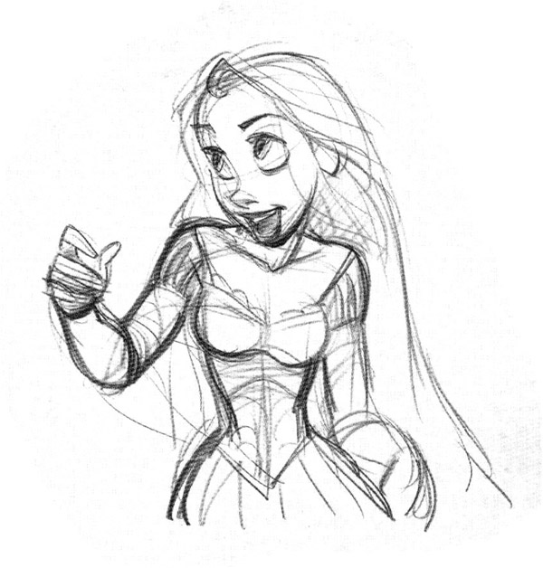
Glen Keane
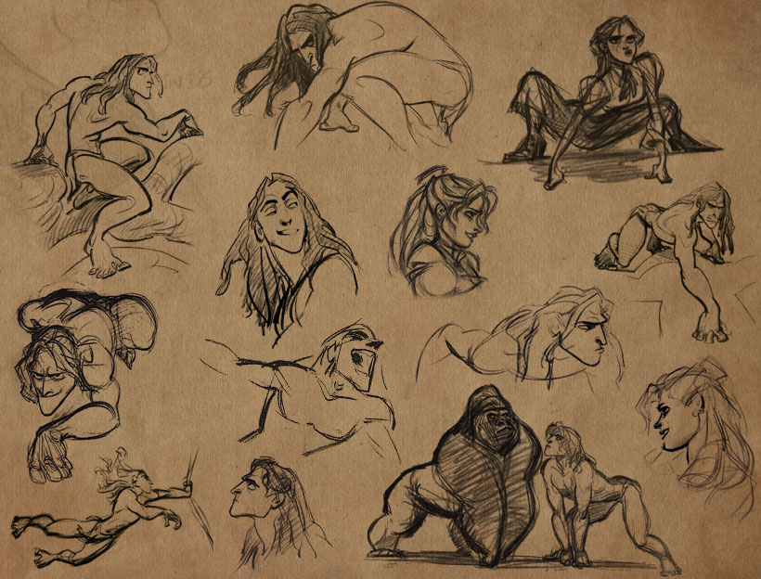
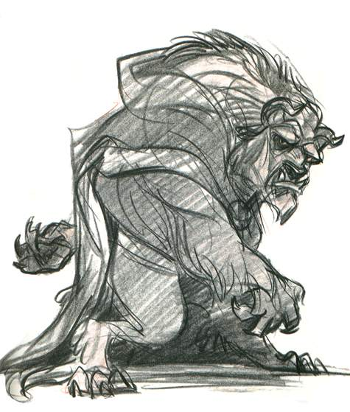

Artwork by Glen Keane

Glen Keane was the creator and animator for Disney characters The Little Mermaid, Tarzan, Pocahontas and Beast. Glen has a quote to say about designing and animating a character and that is
“Any time you design a character for a Disney picture, especially a fairy tale, it's going to become the definitive design for that character, so you don't want to hack something out. You need to put in the kind of care it warrants if it's going to live in history. (good reads, 2018)”
― Glen Keane
He also says to write and animate the character with sincerity (good reads, 2018).
What does this explain about Glen Keane? By the look of this research so far, it looks as if Keane is talking about how important it is when you create your character from writing it to animating it and considering on what is important to help make the character have an impact on its intended audience.
How is this helpful for the dissertation? This is going to be very helpful when it comes too actually including research in the dissertation as quotations and criticisms from thinkers and artists will help with analysing a subject in the write up and getting a clear understanding and new knowledge of animation.

Psychology of Animation
Psychology is something interesting to discuss in Animation. It is an interesting keyword to discuss because it is good way to interpret how people view an animated scene or character in their minds.
There are some thinkers and books to look at for this subject so lets take a look.
One good book to look at is the Audiovisual Contract. What is it? The Audiovisual Contract is a book by Michel Chion and it talks about the different types of sounds and how the sound and moving image (so technically the animation) work together to give some impact and feelings to the audience (Chion, 1994).
Part 1 of the book is about the Audiovisual Contract and it talks about a film called Persona (Persona, 1966). It mentions the scene of when the nail impales the hand, it book mentions that without the sound, it looks completely different but when the sound of the hand being impaled comes on, and it sounds terrifyingly real.
The book also looks at the different types of listening from the audience for when it comes to watching a scene and listening at the sounds (Chion, 1994).
The types of listening are Casual Listening, Sematic Listening and Reduced Listening.
The book also mentions valuable types of music and terminology for both the sound and moving image.
There is also the Audio-visual Analysis and the it aims to look at how the sound and the moving image work together. The audio-visual analysis that Chion proposes is an exercise with some respect for the type of moving image that the audience is watching and the questions asked are “What do we see?” and “What do we hear? (Chion, 1994)”
Now to look at Walt Disney and what he has to say about Animation and how it works.
Walt Disney
Walt Disney was a Motion Picture Television Producer, Motion Picture and Showman and was the co-founder of Walt Disney Production along with his brother Roy (Anon., 2018).
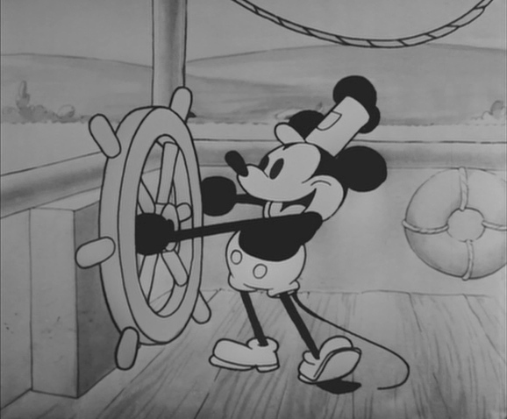

One of Disney’s first projects was an animated cartoon called Steamboat Willie (pictured above (Steamboat Willie, 1928)) in 1928 (MoMA, 2018). It is an animated clip in Black and White which features the iconic Disney character Mickey Mouse. Micky Mouse gained a lot of public attention so to make Steamboat Willie an even bigger success, Walt Disney decided to add soundtrack to the clip to create more tension and emotion to the scene. This made Steamboat Willie the first animated scene to feature sound and here is a quote by Walt Disney regarding the soundtrack
“The effect on our little audience was nothing less than electric. They responded almost instinctively to this union of sound and motion.”
By reading this quote from Walt Disney, it suggests that Animation can really work if you add sound and emotion to the scene, it can help create emotion for the audience when they watch the scene and listen to the audio as well.
The proposed dissertation will be analysing an animated scene and I will be looking at an animated scene and I will look more in depth of Walt Disney’s views on animation to help with analysing a scene.
So what has this Keyword covered? It has covered some facts on how animation can make an impact on the audience’s emotions by the usage of sound incorporated into the moving image. The keyword has also looked at what Michel Chion has had to say about mixing sound and image with his Audiovisual Analysis.

Proposed Question
Following all of this research comes a final question for the proposed dissertation

What is Animation all about?
Along with it comes some sub questions and they are
What is needed in Animation?
How much does Animation make an impact on the world?
What types of Animation are out there?

Now to work on the 5,000 dissertation with this question

Bibliography
Anon., 2018. Walt Disney. [Online]
Available at: https://www.biography.com/people/walt-disney-9275533 .
Cavalier, S., 2011. The World History of Animation. Oakland: University of California Press.
Chion, M., 1994. Audio-Vision. New York: Colombia University Press.
Disneyclips, 2018. Disneyclips. [Online]
Available at: https://www.disneyclips.com/imagesnewb/mickeymouse2.html
Diz Avenue, 2018. Diz Avenue. [Online]
Available at: https://www.dizavenue.com/2012/04/walt-disneys-life-through-pictures.html
Fantasmagorie. 1908. [Film] Directed by Emile Cohl. s.l.: s.n.
good reads, 2018. good reads. [Online]
Available at: https://www.goodreads.com/author/quotes/211671.Glen_Keane
Google Play, 2018. Apps. [Online]
Available at: https://play.google.com/store/apps/details?id=com.lmdgfvdl.pltfjhgh.fbdrtnpd
MoMA, 2018. MoMA. [Online]
Available at: https://www.moma.org/collection/works/89284
Persona. 1966. [Film] Directed by Ingmar Bergman. s.l.: s.n.
Steamboat Willie. 1928. [Film] Directed by Ub Iwerks, Walt Disney. s.l.: s.n.
Taylor, R., 1996. Animation Techniques. London: Quarto Publishing Act.

