EFFECTIVE TEAM WORKING & COMMUNICATION
STUDENT NAME - ANNA KIRVEJOVA
STUDENT ID - 1921532

Table of Contents
Introduction 3
Application of theories related to group dynamics, teamwork and communication in the workplace 4
Aristotle Model of communication 4
Berlo’s SMCR Model of Communication 5
Tuckman’s Model of Communication 7
Significance of theories and concepts in the workplace 9
Conclusion 11
Reference List 12

Introduction
The report is an in-depth analysis of effective strategies and techniques to establish proper communication. It takes the assistance of various popular strategies like Berol’s SMCR theory of communication and Aristotle’s model of communication. The report highlights the various elements that influence content or message that is being sent.
On the other hand, Aristotle's theory has great pragmatic use in real life in the context of public speaking. The Tuckman’stheory of Group development has also been well-defined. It helps to understand the basic transformational changes that a group encounters in the course of its development. All these theories and their practical application or benefits have been thoroughly illumined. The impact of communication in an individual's life and as a driving force of growth has been properly defined in the report.

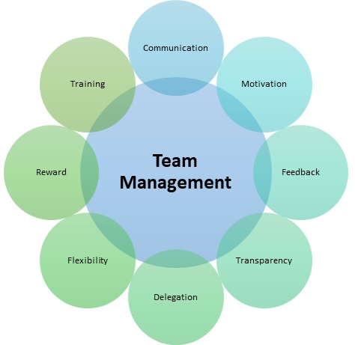
Figure 1: Effective Team Working
(Source: Thompson, 2018)

Application of theories related to group dynamics, teamwork and communication in the workplace
Communication can be seen to be playing a pivotal role in improving the various nuances of group dynamics as well as engaging in effective teamwork. There are various theories and concepts of communication that have a proper pragmatic approach in real-life scenarios.
These theories facilitate the establishment of effective and fluid communication within a group of people. Aristotle's model of communication is an immensely significant concept and has absolute relevancy in each and every working sector (Oetzel, 2017). The Tuckman’s Theory of communication, as well as Osgood Schramm’s model of communication, is also universally applicable that helps in understanding the group dynamics, teamwork and especially initiation of effective communication during any group activity.

Aristotle Model of communication
Aristotle was an eminent philosopher who initiated the very first or earliest model of communication that has absolute relevance even in recent times. Aristotle has proposed his theory of communication which has become one of the most popularly accepted models of communication (Thompson, 2018). The crux of his findings or theory traces its foundation from the importance of audience in communication.
The Aristotle Model of Communication consists of these five specific fundamental elements, namely, Speaker, Speech, Occasion, Audience and lastly Effect.
Aristotle Model of Communication entirely emphasises on the role of the speaker or even at public speaking instead of establishing interpersonal communication (Yap et al., 2017). According to the eminent philosopher, speakers must carry out their oratory in accordance with proper relevance with the audiences along with specific occasions with the sole aim of achieving the desired outcome through their speech.
The orator or the speaker should entirely focus on creating and phasing their speech with insightful, informative as well as crisp content by using persuasive techniques in order to obtain the desired outcome from their audiences (Son et al., 2019). This model serves as a guide for individuals to generate effective and impactful communication publicly, keeping in mind the type of audience and the occasion they are delivering the speech to.

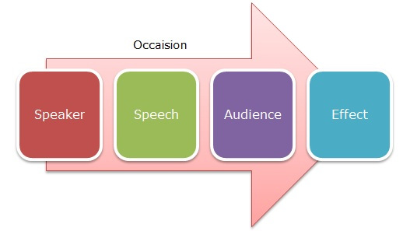
Figure 2: Aristotle Model of Communication
(Source: Son et al., 2019)
Giudici and Filimonau (2019), have opined that the speakers are supposed to create their speeches with impactful content in order to persuade their target audience that would eventually influence them to provide the responses accordingly. In this concept, the speaker provides the required message or information to its listeners.
Thus, Aristotle's Model of Communication provides absolute guidance to individuals that want to excel in public speaking along with enhancing their skills of teamwork and effective communications.

Berol’s SMCR Model of Communication
The SMCR Model of communication was introduced by David Berol in 1960, who was an American theorist of communications. The acronym of SMCR stands for Sender, Message, Channel and Receiver model of communication, which was inspired by Shannon Weaver's Model of Communication (1949) (Schiff et al., 2018). In his theory, he shed the light of the factors that affect the various individual components in the establishment of communication in a more efficient way.
The models emphasize on encoding and decoding that talks place before a sender sends any message before it is received by the receiver. The mode mainly has four components to describe the entire communicative process with namely- source, message, channel and receiver. Each of these components is influenced by several factors.
Source or sender, the first factor of this model can be influenced by several elements such as proper communication skills, correct attitude, knowledge and social structure. The sender is supposed to have a proper attitude, thorough knowledge of the message they are trying to convey and proper awareness of the social setting they are in.


Figure 3: Berol’s SMCR Model of Communication
(Source: Schiff et al., 2018)
The factor of the message is influenced by content or the backbone of communication, elements of various nuances of non-verbal communication like facial expressions, hand gestures and treatment (Gross et al., 2016). Treatment refers to the way the one treats the message he or she is willing to share. The next factor channel is influenced by the mediums of communication like seeing, hearing, smelling, touching or using the five senses as the channels of communicating. The last factor or the receiver which is also known as decoding depends on aspects like whether the receiver is on the same with the sender, whether they have got sound communicative skills or even have the positive attitude to receive the very essence of the message.

Tuckman’s Model of Communication
Bruce Tuckman, who was an American psychological researcher, attempted to carry out research on group communication. In 1965 his research was successful that gave birth to the theory that is popularly known as "Tuckman’s Stages of Group Development” (Reisinget al., 2017). According to the theory of “Group Development” or Tuckman’s theory, the major stages of group development can be categorised into Forming. Storming, Norming and Performing. The five elements can be explained briefly with other literary views. He later added the fifth stage that is known as Adjourning in 1970.

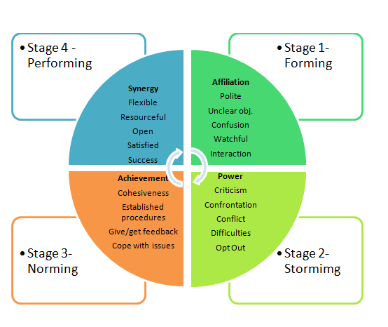
Figure 4: Tuckman’s Team Development Model
(Source: Reisinget al., 2017)
Forming: The first stage inthe process of development is mainly the stage of making evaluations.In this stage, a group is just getting formed and each of the members of the group attempt to get properly familiarized with each other whilst also exchanging their perspective, notions and expectations on the context of the group (Etheringtonet al., 2019). The stage can also be classified by a high dependence of the team members on the leader for proper guidance and direction. The individual roles and responsibilities have not been clearly defined. At this stage, everything is required to be carefully organized and not too much rushed as the stage provides the group members utmost transparency about the objective, norms and purpose of the group. This forms the very foundation of the growth and achievement that the group collectively is supposed to obtain in the later stages.
Storming: The second stage or Storming brings forth the most level of disagreements, group disputes as most of the members of the group attempt to strive for gaining leadership and authority even by challenging the basic objectives of the group. Shermanet al. (2020), have pointed out that the disputes concerning the leadership may or may not be followed by a positive outcome. If the disagreements and conflicts get tilted towards constructive criticisms, then this may result in systematic group undertakings and proper cohesiveness. If the contrary happens then contrast opinions, negative criticisms can take the form of ridicule and disrupt the whole harmony of the group.
Norming: Norming is the third stage in Tuckman’s Model that is characterized by conduction if similar opinions and homogeneous experiences within the group. In this stage, team members adopt their own identity, tasks and a sense of cohesion about the group.
Performing: This phase of development is marked by a sense of cohesiveness, responsibility towards the group and maturity within the team members. This developmental stage encounters various ongoing disputes to be resolved and members having a proper consensus on things. It is also characterized by a rational decision-making phase where the focus entirely lies on achieving the group objectives (Ledezma, 2020). This is the stage where most of the group development takes place.
Adjourning: The fifth stage that was later introduced by a Tuckman may or may not be encountered by a group. Adjourning stands for dissolution or dismantling of a group. Adjourning can take place generally due to two reasons. The first is the group has already achieved its goals or the increase in individual differences or the disruption of rhythm and harmony owing to the increase in disagreements within the group.

Significance of theories and concepts in the workplace
In the course of undertaking this report, I got the opportunity to understand and go through several theories and concepts of communication that also have their practical usage. It was clear in my head in order to succeed in my workplace or in life; a sound communicative skill is required. To ace in the workplace, one also needs to understand the basic concepts of teamwork.
Zaudkeet al. (2016), have indicated that the core essence of Berol’s Communication Theory is understanding the correct trajectory of sending and receiving a message that is thoroughly influenced by its surrounding elements. This concept has helped to focus on the various channels and modes of communication. The theory, along with providing insights about the channels of communication but also helped to learn the benefit of creating an enriching content or message.
Reisinget al. (2017), Have said the nature of content has absolute power in determining how it will be perceived by the receiver. This theory helped me in my workplace in making sure my content was worthy of sending as well as identifying the main barriers as well as appropriate channels of communication.

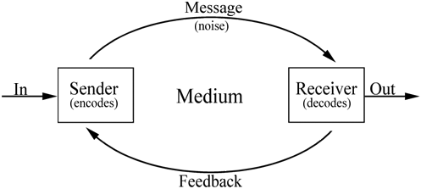
Figure 5: Channels of communication
(Source: Reisinget al., 2017)
According to Son et al.(2019), a properly phased, influential, persuasive and rich speech accounts for the very essence of effective communication. Aristotle's Model of communication has guided me to executive a tailor-made speech in accordance with an audience as well as the occasion (McDermott, 2020). It has acted as a catalyst and helped me in public speaking. It provides proper instruction on how to execute an impactful speech or various other nuances about oratory. However, I have said that effective oratory or speaking and non-effective or poor audience results in communication getting non-applicable or linear.
It can arguably be said that communication plays one of the most pivotal roles in the workplace scenario, irrespective of whether it is an individual or a whole group. Effective and fluid communication can be considered as the seed of success that shows its benefits in the long-term scenario.
Tuckman’s Theory of communication suggests that all the group members in a team can encounter various disputes as well as disagreements. However, the right approaches and way that the group undertakes in solving the issues reflect the ability of the same group to prosper and excel in the forthcoming future. A group in the process of its development goes through various drastic changes (Thompson, 2018). I entirely agree with the fact that each and every organization or association of a group of people is bound to go through drastic changes owing to the variety of people and their nature. However, it can also be said that if the correct approach or the demerits and merits are known to the team with the help of theoretical concepts, then it will be easy for them to succeed (Schiffet al., 2018). I have previously had experiences of working in a group that came to the stage of Storming or rapid disagreements or disputes within the team members.
The existing knowledge and innate communicative skills I had has helped me a lot in my teamwork. Thus, the theoretical guideline and concepts have helped my teammates and me a lot in warding off any unfortunate incident that could have disrupted the whole harmony. The completion of teamwork in a proper answer helped me and my teammates to gain a good reputation amongst people while also making me well-aware of my qualities.

Conclusion
The report highlights various significant nuances of communication and also its importance in the real world. The portfolio, with the help of specific communicative models and theories, have provided proper and effective strategies of communication. It also has with the help of Tuckman’s communication theory helps in understanding how to engage in effective group development. Ineffective communication within individuals can result in distortion of the message, futile disputes, unwanted confusion and, many more. Thus, I have understood that in order to succeed in the workplace, we all need to acquire certain communicative as well as interpersonal skills for which I have resorted to the established theories and communicative models by various researchers.

Reference List
Etherington, N., Wu, M., Cheng-Boivin, O., Larrigan, S. and Boet, S., 2019. Interprofessional communication in the operating room: a narrative review to advance research and practice. Canadian Journal of Anesthesia/Journal canadiend'anesthésie, 66(10), pp.1251-1260.
Giudici, M. and Filimonau, V., 2019. Exploring the linkages between managerial leadership, communication and teamwork in successful event delivery. Tourism Management Perspectives, 32, p.100558.
Gross, A.H., Leib, R.K., Tonachel, A., Tonachel, R., Bowers, D.M., Burnard, R.A., Rhinehart, C.A., Valentim, R. and Bunnell, C.A., 2016. Teamwork and electronic health record implementation: a case study of preserving effective communication and mutual trust in a changing environment. Journal of Oncology Practice, 12(11), pp.1075-1083.
Gross, A.H., Leib, R.K., Tonachel, A., Tonachel, R., Bowers, D.M., Burnard, R.A., Rhinehart, C.A., Valentim, R. and Bunnell, C.A., 2016. Teamwork and electronic health record implementation: a case study of preserving effective communication and mutual trust in a changing environment. Journal of Oncology Practice, 12(11), pp.1075-1083.
Hogan, T.M. and Malsch, A., 2018. Communication strategies for better care of older individuals in the emergency department. Clinics in geriatric medicine, 34(3), pp.387-397.
Ledezma, D., 2020. Teamwork: The Importance of Effective Communication.
McDermott, F., 2020. Inside group work: A guide to reflective practice. Routledge.
Oetzel, J.G., 2017. Effective intercultural workgroup communication theory. The International Encyclopedia of Intercultural Communication, pp.1-5.
Reising, D.L., Carr, D.E., Gindling, S., Barnes, R., Garletts, D. and Ozdogan, Z., 2017. An analysis of interprofessional communication and teamwork skill acquisition in simulation. Journal of Interprofessional Education & Practice, 8, pp.80-85.
Schiff, L., Miele, K., McCollum, M., Li, Q. and Connolly, A., 2018. Teaching and sustaining a shared mental model for intraoperative communication and teamwork. Obstetrics &Gynecology, 132, p.58S.
Sherman, J.M., Chang, T.P., Ziv, N. and Nager, A.L., 2020. Barriers to effective teamwork relating to pediatric resuscitations: perceptions of pediatric emergency medicine staff. Pediatric emergency care, 36(3), pp.e146-e150.
Son, J., Lee, H.K., Jin, S. and Lee, J., 2019. Content features of tweets for effective communication during disasters: A media synchronicity theory perspective. International Journal of Information Management, 45, pp.56-68.
Thompson, N., 2018. Effective communication: A guide for the people professions. Macmillan International Higher Education.
Yap, J.B.H., Abdul-Rahman, H. and Chen, W., 2017. Collaborative model: Managing design changes with reusable project experiences through project learning and effective communication. International Journal of Project Management, 35(7), pp.1253-1271.
Zaudke, J.K., Chestnut, C., Paolo, A. and Shrader, S., 2016. The impact of an interprofessional practice experience on student behaviors related to interprofessional communication and teamwork. Journal of Interprofessional Education & Practice, 4, pp.9-13.

