
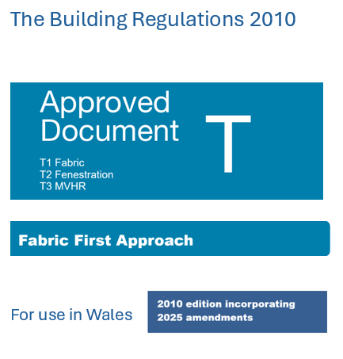 | Abstract  To achieve net zero “contractors need to learn how to construct buildings that achieve high levels of airtightness”  Patrick Furlong (0650804)  ACBA5028

Contents
Part T: Fabric First standard 1
Section 0 1
Introduction 1
The construction sector and carbon emissions 1
Importance of airtightness 2
Problems associated with poor fabric performance 2
T0.1 Fabric first approach 2
Air tightness and air pollution mitigation 3
Section T1 5
Airtightness provision 5
General 5
T 1.1 Understanding airtightness and infiltration 5
T 1.2 Continuous air and insulation barrier 6
T 1.3 How airtightness impacts other elements 8
T 1.4 Airtightness on site 9
Section T 2.0 Windows 14
T 2.1 Window orientation and size 14
T 2.1 Window requirements 14
Section T 3.0 MVHR 14
Bibliography 15
Glossary 18

Part T: Fabric First standard

Section 0

Introduction

The construction sector and carbon emissions
Construction is a major contributor to global greenhouse gas emissions and there is a need for urgent and coordinated action to reduce its carbon footprint Mohammadpourkarbasi et al (2023). Achieving net zero carbon homes is directly linked to Building Regulations Schweber et al (2015) however, Part L of the current building regulations is inadequate and unlikely to meet ambitions of net zero carbon emissions Mohammadpourkarbasi et al (2023). BREEAM and Passivhaus demonstrate what is achievable, but uptake remains limited without regulatory drivers Okonta et al (2024). Both the AECB and Passivhaus trust when consulted about changes to PART L AND PART F STANDARDS FOR NEW DWELLINGS IN 2025 highlighted a need to improve building fabric rather than relying on bolt-on technologies such as PV which is inherently risky AECB and Passivhaus Trust (2025).

Importance of airtightness
“Airtightness makes ventilation/heating systems work properly whilst improving insulation’s effectiveness. This helps with reducing our fuel bills and increases health & comfort through the elimination of mould and condensation.” AECB (2024)
To achieve net zero “contractors need to learn how to construct buildings that achieve high levels of airtightness” LETI (2020)
Table 1 Opportunities to reduce energy consumption in residential developments LETI (2020)
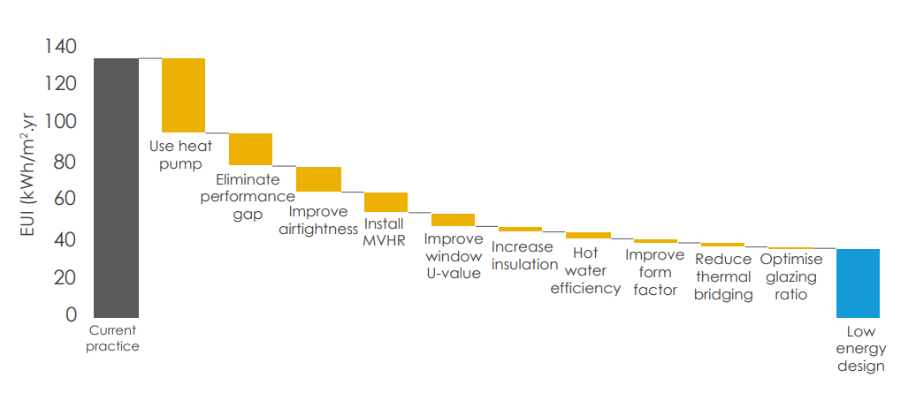

Problems associated with poor fabric performance
Although heat pumps are seen as a low carbon technology Table 1, they are not effective in draughty buildings with poor energy efficiency Lingard (2020). Design strategies should prioritise airtightness as it can reduce heating demand by 54% Pochampalli et al (2024). As 80% of our future building stock already exists it is vital that airtightness not only applies to new build but must include retrofit; the UK’s buildings are acknowledged as being among the least efficient in Europe with up to 70% of buildings not meeting current standards Bortone et al (2022).

T0.1 Fabric first approach
As part of a “fabric first” approach Okonta, E. and Rahimian, F. (2024) the comfort standard intends to improve build quality to eliminate draughts, condensation or mould, hot or cold radiant discomfort, fuel poverty, overheating in summer months, noise and poor indoor air quality. 72% of all energy consumption can be attributed to maintaining comfort Echarri-Iribarren et al (2024).

Requirement T1(1)
Table 2 Requirements for residential buildings Traynor (2019) and Corfield (2025).
 | New build | Refurbishment
Airtightness | <0.6 h⁻¹ @ 50 Pa (n50) | <1.0 h⁻¹ @ 50 Pa (n50)
Window surface temperature | >17 °C | >17 °C
Summer comfort | No more than 10% year > 25°C | No more than 10% year > 25°C
Ventilation | ~30 m³/hr. person | ~30 m³/hr. person
Space heating | Maximum heating demand < 15 kWh/m²yr @20°C or Peak heating load ,10 W/m² | Maximum heating demand 25 kWh/m²yr @20°C

Air tightness and air pollution mitigation
Improving airtightness can act as a mitigation strategy for areas with high outdoor pollution by preventing pollution entering homes and thus protecting people from disease caused by air pollution such as PM 2.5 and climate change Fu et al. (2025) Figure 1

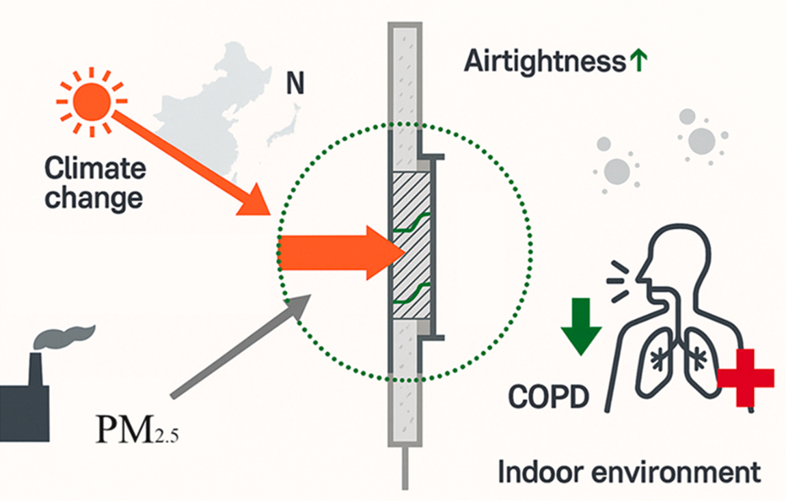
Figure 1 Improving indoor air quality through increased airtightness Fu et al. (2025)
However, airtightness does require a ventilation strategy as pollution peaks take longer to dissipate in highly airtight homes Mc Gill et al (2015)

T0.3 Interaction with Other Approved Documents
Approved Document T should not be used in isolation. The measures required to achieve the comfort standard interact directly with other functional requirements of the Building Regulations, and compliance must therefore be demonstrated across the full regulatory framework. The most relevant interactions are summarised below.

(a) Interaction with Approved Document L – Conservation of Fuel and Power
- Airtightness is a core input into calculations under Part L.
- Reduced infiltration rates directly affect heating demand, primary energy use and carbon emissions.
- Continuity of insulation, junction performance and avoidance of thermal bypass as addressed in Part T, supports compliance with Part L energy targets.
- Failure to achieve airtightness and or thermal continuity may result in a Part L compliance issue.

(b) Interaction with Approved Document F – Ventilation
- As airtightness improves, natural infiltration is reduced; therefore, mechanical ventilation systems (e.g., MVHR) become essential.
- Part F sets minimum ventilation rates and system performance criteria that must be met when airtightness values fall below 3 m³/h·m² or when whole-house MVHR is used.
- Commissioning, testing and user guidance as required by Part F, are integral to ensuring that improved airtightness under Part T does not compromise indoor air quality.
- Designers must ensure that the specified ventilation system is compatible with the anticipated airtightness level.

(c) Interaction with Approved Document O – Overheating
- Window size, shading design and orientation, addressed in Part T, influence the dynamic thermal modelling and overheating risk assessment required by Part O.
- Excessive glazing or poor shading strategies may lead to non-compliance with Part O even if thermal comfort targets under Part T are achieved.
- MVHR systems specified under Part T may also support summertime ventilation strategies required for O compliance.

(d) Interaction with Approved Document B – Fire Safety
- Airtightness membranes, tapes and service penetrations must not compromise fire-resistance performance required by Part B.
- Service voids introduced for airtightness must maintain fire-stopping and cavity barrier continuity.

(e) Interaction with Approved Document E – Resistance to Sound Transmission
- Many airtightness measures improve acoustic separation.
- However, care must be taken to ensure that penetrations sealed for airtightness also meet acoustic requirements under Part E.

Section T1

Airtightness provision

General

T 1.1 Understanding airtightness and infiltration
The aim of Requirement T1(1) is to protect the building from unwanted heat loss and moisture entering the structure from air movement caused by external forces (forced convection) due to differential wind pressure Figure 2 and internal forces (natural convection) Figure 3 caused by difference in air density. This uncontrolled ventilation is known as infiltration Price et al (2020).
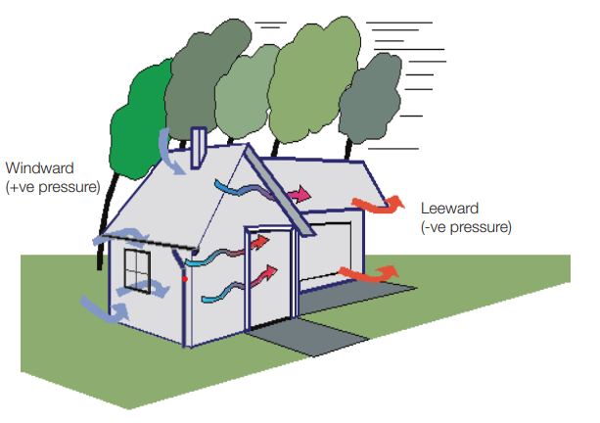
Figure 2 Forced convection due to differential wind pressure BRE
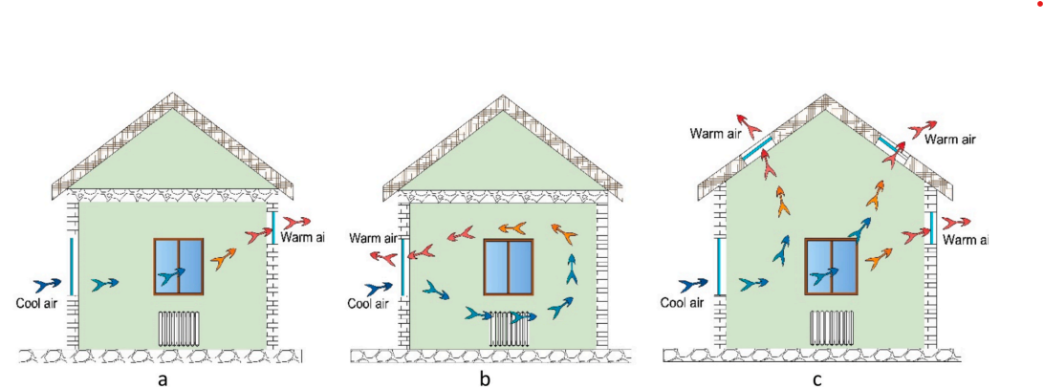
Figure 3 Natural convection caused by difference in air density: Stack Effect (a), One-Sided Ventilation (b), and Cross Ventilation (c). Myroniukn et al (2026).
A gap of 1mm x 1mm within a square metre area of airtight material, can reduce U-value of insulation by a factor of 4.8 Lewis, S. (2017).
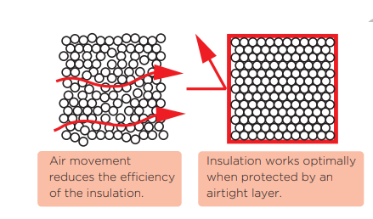
Figure 4 Heat loss due to thermal bypass of insulation due to a lack of airtightness Lewis, S. (2017)

T 1.2 Continuous air and insulation barrier
The envelope of a building should consist of 4 key parts an external weather (wind) barrier, insulation, structure and air barrier Figure 5 Typical construction build-up for thermal performance of the building envelope Dollard (2022).

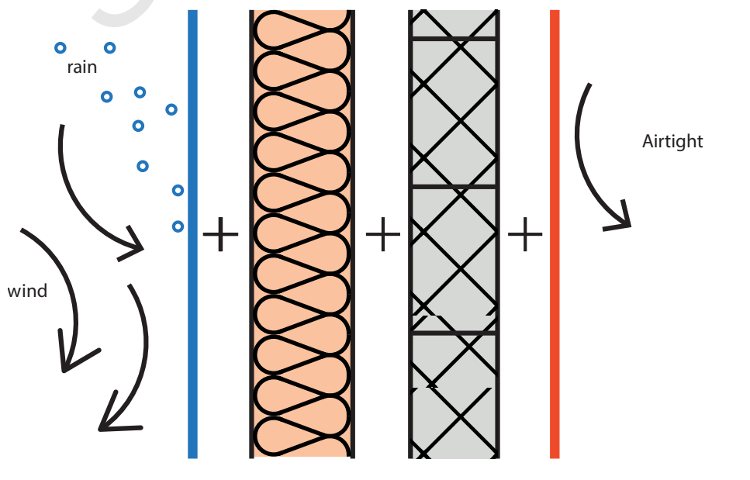
Figure 5 Typical construction build-up for thermal performance of the building envelope Dollard (2022).
The weather barrier is always on the outside of the insulation, and the air barrier is always on the inside of the insulation. It is difficult to achieve continuous insulation and airtightness with traditional cavity construction Dollard (2022) as the structure (cavity ties) should not cross the insulation layer and optimally is on the inside of the insulation Figure 6.
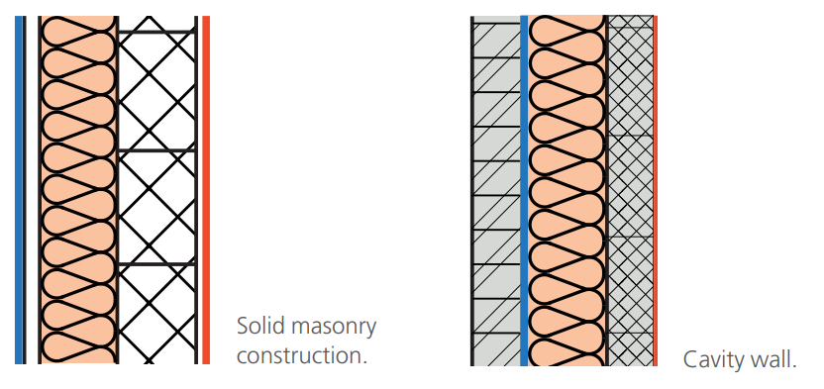
Figure 6 Key layers in a traditional masonry construction Dollard (2022).

Great care needs to be taken to understand how other components such as windows and their position are relative to the insulation Figure 7.
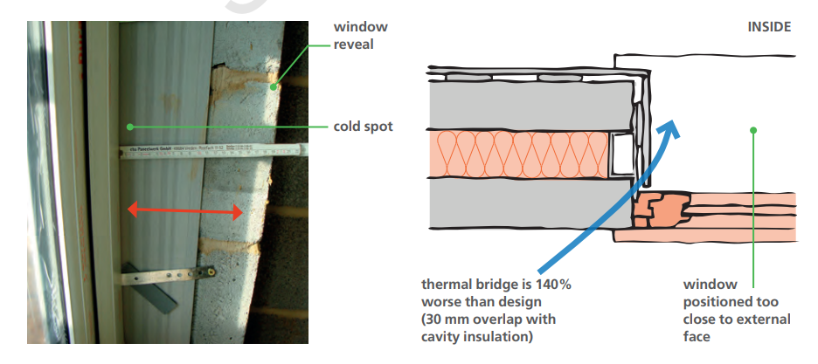
Figure 7 Installation of the window differed by 50 mm and reduced the performance of the junction by 140% Dollard (2022).

There can be no gaps in the insulation layer (continuous insulation) and no air cavities next to the insulation as to prevent thermal bypass Figure 8
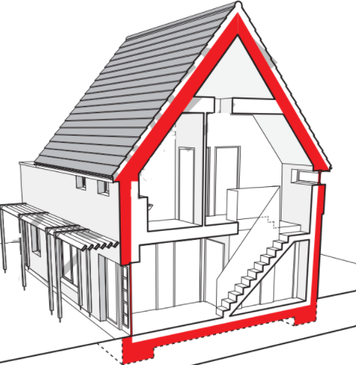
Figure 8 Continuous layer of insulation Lewis, S. (2017).

T 1.3 How airtightness impacts other elements
A 10mm wide crack between insulation batts can reduction insulation performance by 198% and even a 3mm crack can degrade insulation performance by 158% Siddall (2009). Service zones will be located on the inside of the air barrier layer Figure 9.

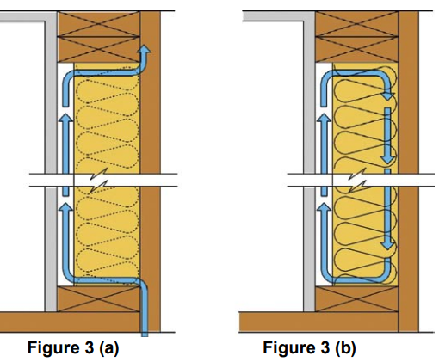
Figure 9 Gaps in insulation and the impact upon performance Siddal (2009)
A lack of airtightness will result in decreased insulation performance and the ingress of moisture Figure 10.
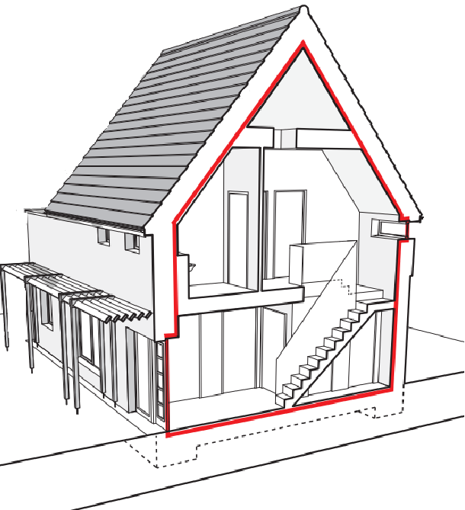
Figure 10 Continuous air barrier Lewis, S. (2017).

T 1.4 Airtightness on site
This is achieved through good knowledge, design, suitable materials, good planning & sequencing and attention to detail during application to comply with BS EN 12207 & BS EN 1026.
- Toolbox tools on airtightness should be given to anyone working on site regardless of if they work on the air tightness layer or not to ensure that inadvertent damage does not occur and if it does then a climate of no blame is established to encourage reporting as repairing the air barrier later can be significantly more costly.
- Materials selection to achieve airtightness can be seen in Table 3 and a more detailed selection can be found in APPENDIX B.

Table 3 Suitable and unsuitable airtightness products and construction materials
Unsuitable airtightness products | Suitable airtightness products | Suitable construction materials
Expanding foam | Airtight grommets and other specialist preformed pieces | Concrete cast in situ
Silicone caulking | Proprietary airtight board | Wet plaster > 5mm depth
Duct tape | Airtight membranes | Screed
Dot and dab plaster boarding | Airtight paints and sprays | Suitably protected Damp proof membranes
Foil tape | Airtightness tapes | Precast concrete with care at edges and joints

- Construction materials such as brick and block can be bonded onto and support the airtight layer through the application of suitable coatings such as parging, render, wet plaster (>5mm in thickness) or application of suitable coatings such as passive purple. It is important that where there is no service void any chasing into masonry by things such as sockets will require sealing behind with a parge coat or airtight paint Figure 11.
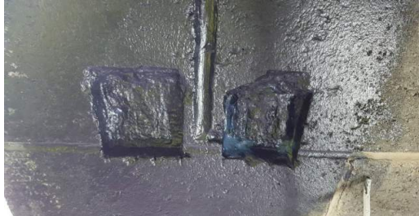
Figure 11 Chasing in blockwork for electrical switches and wiring, treated with an airtight paint that paints on blue and dries black when airtight Price et al (2020)
- Anyone working on the airtightness of a building should be suitably qualified and competent. On larger sites consideration should be made of appointing someone to the position of ATTIC (Air Tightness and Thermal Integrity Champion). ATTIC is recognised as best practice within BSRIA guidance on building performance and the ATTMA standards for airtightness testing.
- Care needs to be taken with junctions Figure 12 and selection of appropriate materials.
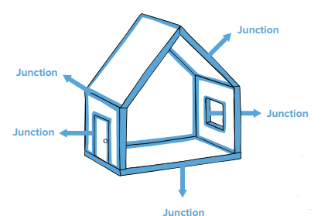
Figure 12 Heat loss from junctions Dollard (2022)
Wall to floor junctions require wet plaster to meet the floor behind the skirting which is not usual practice Figure 14. The plaster can then be joined to the screed which can be used as the air barrier in the floor, or the DPM can be extended up to the internal walls and the joint to plaster layer is behind skirting with a suitable tape and the surface must be appropriately prepared i.e. clean, dry and or primed. However, DPM as the air barrier is high risk since it is often covered prior to the first airtightness test Figure 13.
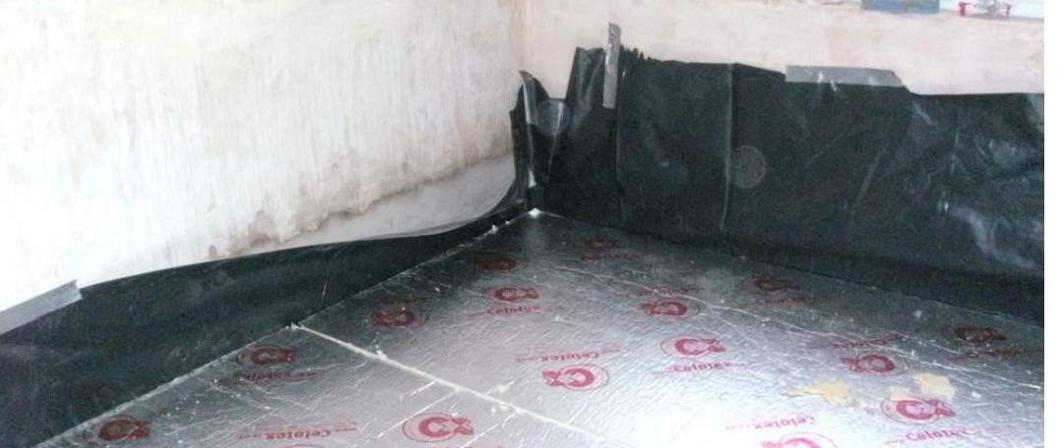
Figure 13 DPM used as the air barrier Price et al (2020)
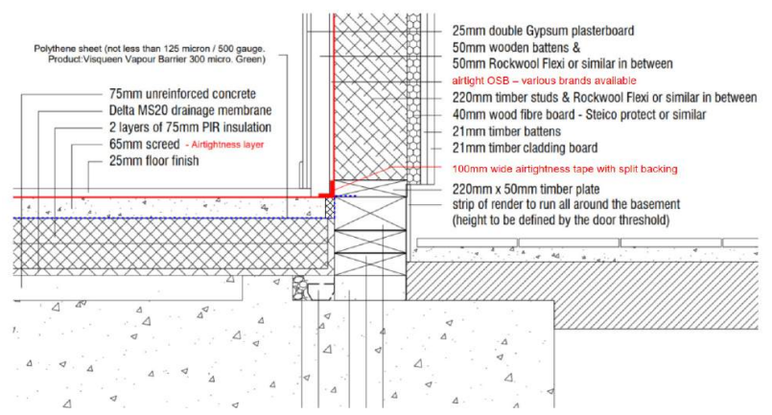
Figure 14 Case study basement wall to floor junction with air barrier Dollard (2022)
Windows Figure 15 and doors Figure 16 need to be robustly sealed to the air barrier at the head, jambs and threshold Price et al (2020). Poorly fitted windows and doors are a common point of failure for airtightness Corfield, A. (2025).

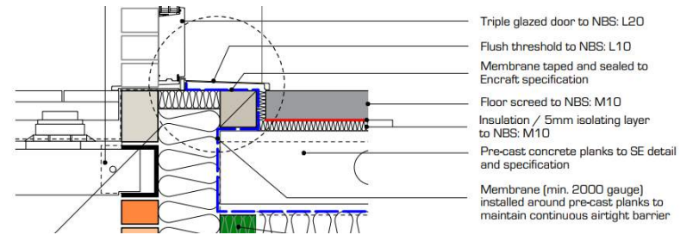
Figure 15 Case study window installation with air barrier Price et al (2020)
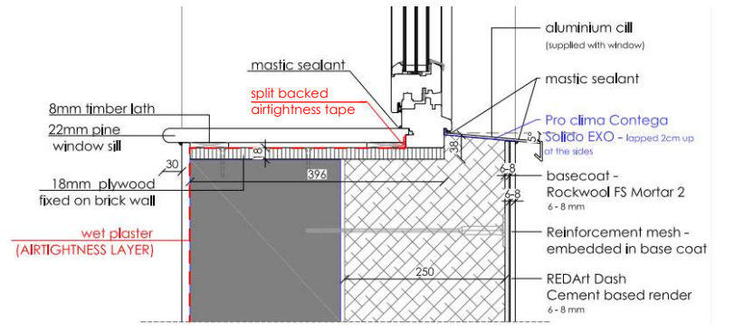
Figure 16 case study window cill installation with air barrier Price et al (2020)
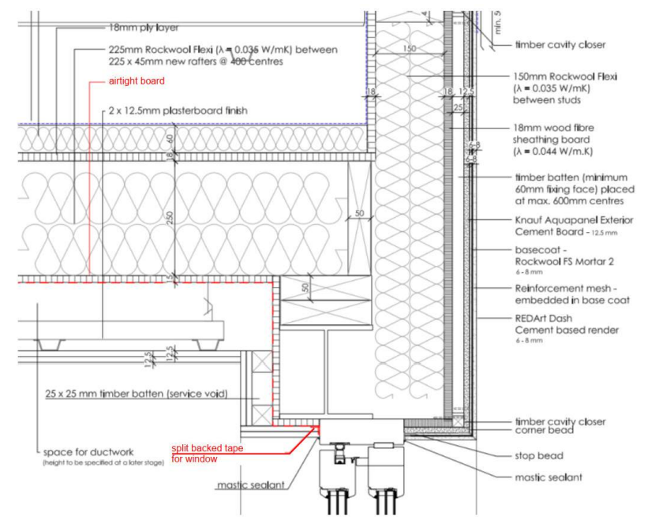
Figure 17 Case study wall to roof junction with window head Dollard (2022)
- Services should ideal be run in a service void that doesn’t pass through the air barrier. Any penetrations through the air barrier need to be suitably sealed and include the following:
1. Waste pipes & soil pipes
2. Ventilation ducts
3. Incoming water, gas, oil, electricity, data and district heating, as applicable
4. Chimneys and flues, including air supplies to wood burning stoves or similar
5. Connections to external services, such as entry phones, outside lights, external taps and sockets, security cameras, satellite dishes

Intermediate floor junctions that penetrate the wall can be problematic; joists require taping to all around and sealing to the air Figure 18.
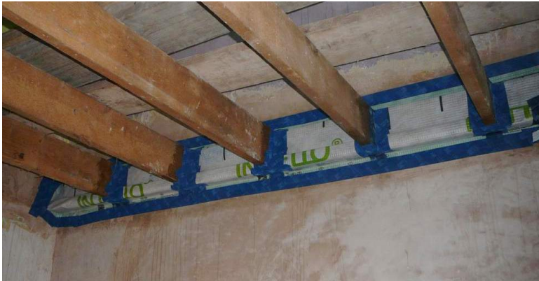
Figure 18 Intermediate floor to wall junction. Air barrier is wet plaster with membrane and airtightness tape around the joists Price et al (2020)
However, on a new build, avoid installing joists into the wall by fitting a perimeter beam, from which joist hangers support the intermediate floor, is a far more robust airtightness detail Price et al (2020).

T 1.5 Windows and doors form an integral part of the building envelope and the airtightness strategy. They should achieve a Class 4 or above rating according to classification BS EN 12207 as described in BS EN 1026 Price et al (2020).
T 1.6 It is essential that interim testing is carried out at stages where most of the air barrier is accessible so that remedial work can be conducted. Testing can be done by experienced airtightness tester using smoke pens or thermal camera, but it may be advisable on large site to train people up who can perform the testing dynamically Price et al (2020) Figure 19.
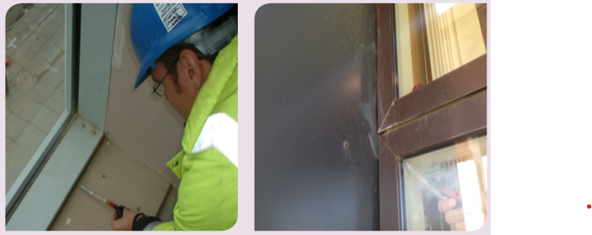
Figure 19 Smoke pen testing McLeod et al (2015)
T 1.7 It is important to keep detailed records and evidence for anything to do with airtightness which can then be used to resolve any disputes. This includes photos and detailed information of airtightness products including what they are, who checked them, when, how they were stored, where they were stored, how they were handled and by who along with their competence. All junction detail should be photographed and cross referenced with when and who carried out that work to demonstrate the correct product was used, surfaces were appropriately prepared i.e. what was used to clean the surface, whether a primer was used and what was the moisture content Price et al (2020).
T 1.8 Use of timber in the structure could lead to expansion due to water exposure and then shrinkage once the timber is no longer exposed to the elements and dries out, this can commonly compromise the airtightness layer especially in timber frame buildings. This can be mitigated by efforts on site to protect timber from moisture. When taping wood products (joists, OSB, SIPS, etc) tapes should not be taut to allow for movement and places such as the corners of openings which are particularly susceptible and require special attention.

Section T 2.0 Windows should meet BS EN 14351-1 & BS 8213-4

T 2.1 Window orientation and size
During the design phase it is important to consider fenestration and shading which can be optimised for comfort. Windows are thermally less efficient than a wall and cost more per m². East and west glazing is not optimal, risking overheating in the summer and poor solar gain in winter. In comparison south facing glazing can be easily shaded in summer using roof overhangs and reveals and offers maximum solar gain in the winter. Overuse of glazing on north elevations, particularly sky lights can also lead to overheating Butcher (2023).
Table 4 Glazing requirements Butcher (2023)
Total glazing maximum ~15-20% of floor area | Keep fenestration simple! Minimise transoms and mullions to reduce the proportion of frame, which will be more than you think
South glass area maximum ~20% of internal wall area | Limit areas of skylights to that required for daylight
Limit glazing on North, East and West elevations to daylight, views and ventilation | Glazing less than ~850 mm distance from floor does little to improve daylight, so should be avoided
Window heads close to ceiling maximise daylight penetration – but remember to leave room for curtain rails, blinds, and ventilation opening for tilting windows | Daylight factor: 2% is a good target for kitchens, 1.5% for living rooms and home office, 1% for bedrooms. Higher than 4% might indicate overheating risk for that room BS EN 17037 & BS EN ISO 52022-3

T 2.1 Window requirements
Table 5 Window requirements
U-value < 0.8 W/m2K.
minimum g-value of 50%.
air leakage (n50) be limited to < 0.6 ach @ 50 Pa
Window, thermal bridge free construction, insulated frame, Uω (W/ (m² K)) <0.8

Section T 3.0 MVHR
Research suggests that reduction of ventilation rates due to increased air tightness can negatively impact indoor air quality McGill et al (2015). A suitable ventilation strategy will be required to maintain indoor air quality. This should be achieved using mechanical ventilation and heat recovery system (MVHR). MVHRs work by extracting air from rooms such as utilities, kitchens and bathrooms. This air then enters a heat exchanger and used to heat fresh air from outside and this heated outside air is then depending on the system returned to the same room or other habitable rooms. Homes with high airtightness and MVHR have better air quality with lower concentration of indoor PM10, PM2.5, CO₂, and VOCs than standard homes Moreno-Rangel et al (2023) and installing (MVHR) leads to a decrease in asthma symptoms Eick et al (2011). MVHR ductwork and fans, and installation and commissioning are more complicated and expensive than traditional ventilation, but this is offset by reducing the demands on the heating system and is better suited to noisy or polluted sites Dollard (2022).
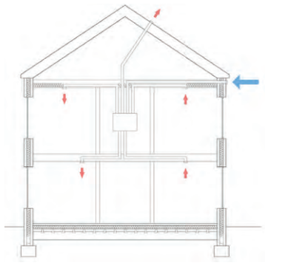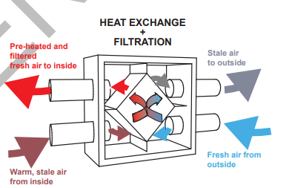
Figure 20 MVHR is a whole-house system that extracts damp air, draws in fresh air, and uses heat exchangers to recover heat, pre-warming fresh air Dollard (2022)
It is important that the inhabitants understand how to operate the MVHR via a suitable handover from suitable qualified person.
“AQ in homes with mechanical ventilation systems depends greatly on the commissioning and handover process”. Moreno-Rangel (2023)
When designing the MVHR system should meet BS EN 13141-6 BS 5918 with consideration of the location of the system as to minimise pipe duct lengths and requirement for insulation which can impact efficiency Lewis (2017).
Table 6 MVHR requirements
Heat recovery with Net efficiency, hHE (%) >75
Heat loss through casing <5 W/K
Internal and external leakages (%) <3
Electric energy demand for ventilation (including control), Ƥel (W/(m³/h)) <0.45

Bibliography
AECB. (2024). Airtightness Guidance - AECB. [online] Available at: https://aecb.net/airtightness-guidance/. [Accessed 1 Dec. 2025].
‌AECB and Passivhaus Trust (2025) Response to Welsh Government consultation - Building Regulations (Part L) 2025 Review. (n.d.). Available at: https://www.passivhaustrust.org.uk/UserFiles/File/2025/Welsh%20Building%20Regulations%20Consultation/2025%20Welsh%20Part%20L%20Consultation_PHTandAECB%20responses.pdf [Accessed 7 Dec. 2025].
Bortone, I., Sakar, H., & Soares, A. (2022). Gaps in Regulation and Policies on the Application of Green Technologies at Household Level in the United Kingdom. Sustainability, 14(7), 4030. https://doi.org/10.3390/su14074030 [Accessed 2 Dec. 2025].
Butcher, B. (2023) How to build a Passivhaus (second edition) Chapter 7. London: Passivhaus Trust. Available at: https://www.passivhaustrust.org.uk/UserFiles/File/Technical%20Papers/How%20to%20Build%202023/HowToBuild-Ch7.pdf [Accessed 7 Dec. 2025].
Coaction.org.uk. (2025). Contractor & Certified Passivhaus Tradesperson. [online] Available at: https://coaction.org.uk/courses/tradesperson [Accessed 7 Dec. 2025].
Corfield, A. (2025). How to design a Passivhaus. Homebuilding & Renovating, (227), pp. 66-67,69,71,73,75.
Dollard, T. (2022). Designed to Perform: An Illustrated Guide to Delivering Energy Efficient Homes (2nd ed.). RIBA Publishing.
Echarri-Iribarren, V., Gómez-Val, R. and Ugalde-Blázquez, I. (2024) ‘Energy Losses or Savings Due to Air Infiltration and Envelope Sealing Costs in the Passivhaus Standard: A Review on the Mediterranean Coast’, Buildings (Basel), 14(7), p. 2158. Available at: https://doi.org/10.3390/buildings14072158. [Accessed 3 Dec. 2025].
Eick, S.A. and Richardson, G. (2011) ‘Investigation of different approaches to reduce allergens in asthmatic children’s homes — The Breath of Fresh Air Project, Cornwall, United Kingdom’, The Science of the total environment, 409(19), pp. 3628–3633. Available at: https://doi.org/10.1016/j.scitotenv.2011.06.011. [Accessed 5 Dec. 2025].
LETI (2020). LETI Climate Emergency Design Guide How new buildings can meet UK climate change targets. [online] Available at: https://www.leti.uk/_files/ugd/252d09_3b0f2acf2bb24c019f5ed9173fc5d9f4.pdf. [Accessed 1 Dec. 2025].
LETI (2023) Low Embodied Carbon Specification and Procurement Guide. (n.d.). Available at: https://www.leti.uk/_files/ugd/252d09_25883cf6c33547b48b367ec3c7d0319b.pdf. [Accessed 6 Dec. 2025].
Lewis, S. (2017) PHPP illustrated: a designer’s companion to the Passive House Planning Package. 2nd edition. London: RIBA Publishing.
Lingard, J. (2021). Residential retrofit in the UK: The optimum retrofit measures necessary for effective heat pump use. Building Services Engineering Research & Technology, 42(3), 279–292. https://doi.org/10.1177/0143624420975707 [Accessed 7 Dec. 2025].
McGill, G., Oyedele, L.O. and McAllister, K. (2015) ‘Case study investigation of indoor air quality in mechanically ventilated and naturally ventilated UK social housing’, International journal of sustainable built environment, 4(1), pp. 58–77. Available at: https://doi.org/10.1016/j.ijsbe.2015.03.002. [Accessed 1 Dec. 2025].
McLeod, R. Jaggs, M. Cheeseman, B. Mead, K. (2015) Passivhaus primer: Airtightness Guide Airtightness and air pressure testing in accordance with the Passivhaus standard - A guide for the design team and contractors, Passivhaus BRE Available at: https://www.passivhaustrust.org.uk/UserFiles/File/Technical%20Papers/BRE_Passivhaus_Airtightness_Guide.pdf [Accessed 2 Dec. 2025].
Mohammadpourkarbasi, H., Riddle, B., Liu, C., & Sharples, S. (2023). Life cycle carbon assessment of decarbonising UK’s hard-to-treat homes: A comparative study of conventional retrofit vs EnerPHit, heat pump first vs fabric first and ecological vs petrochemical retrofit approaches. Energy and Buildings, 296, Article 113353. https://doi.org/10.1016/j.enbuild.2023.113353 [Accessed 3 Dec. 2025].
Moreno-Rangel, A., Sharpe, T., McGill, G., & Musau, F. (2023). Indoor Air Quality and Thermal Environment Assessment of Scottish Homes with Different Building Fabrics. Buildings (Basel), 13(6), 1518. https://doi.org/10.3390/buildings13061518 [Accessed 7 Dec. 2025].
Myroniuk, K., Zhelykh, V., Furdas, Y., Jesson, M., & Mitoulis, S.-A. (2026). Energy-saving of passive ventilation systems in thermally modernized residential buildings – a review. Energy and Buildings, 350, Article 116681. Available at: https://doi.org/10.1016/j.enbuild.2025.116681 [Accessed 5 Dec. 2025].
Okonta, E, D., & Rahimian, F. (2024). Examining approaches to investigating the United Kingdom’s existing building fabric in the pursuit of net zero targets. Urbanization, Sustainability and Society, 1(1), 78–114. https://doi.org/10.1108/USS-09-2023-0004 [Accessed 7 Dec. 2025].
Okonta, E. and Rahimian, F. (2024) ‘Examining approaches to investigating the United Kingdom’s existing building fabric in the pursuit of net zero targets’, Urbanization, Sustainability and Society, 1(1), pp. 78–114. Available at: https://doi.org/10.1108/USS-09-2023-0004. [Accessed 1 Dec. 2025].
Pochampalli, P., Tubelo, R., Rodrigues, L., Gillott, M., & Nash, R. (2024). Cost-Effectiveness Evaluation of Energy-Efficient Retrofit Strategies for Pre-1930s Mid-Terrace Houses in the UK. Buildings (Basel), 14(12), 3849. https://doi.org/10.3390/buildings14123849 [Accessed 2 Dec. 2025].
Price, S. Baines, A. Jennings, P. (2020) Good practice guide to airtightness (Version 10.4). London: Passivhaus Trust. Available at: https://passivhaustrust.org.uk/UserFiles/File/Technical%20Papers/Good%20Practice%20Guide%20to%20Airtightness%20v10.4-compressed.pdf [Accessed 7 Dec. 2025].
Schweber, L., Lees, T., & Torriti, J. (2015). Framing evidence: policy design for the zero-carbon home. Building Research and Information: The International Journal of Research, Development and Demonstration, 43(4), 420–434. https://doi.org/10.1080/09613218.2015.1004658 [Accessed 7 Dec. 2025].
Siddall, M. (2009) Green Building Magazine, Summer 2009 (Volume 19 No 1), Available at: https://aecb.net/wp-content/uploads/2024/11/Impact_of_thermal_bypass-2.pdf [Accessed 1 Dec. 2025].
Traynor, J. (2019). EnerPHit: A Step-by-Step Guide to Low Energy Retrofit (1st ed.). RIBA Publishing

APPENDIX A – British Standards
BS EN 12207 – Air Permeability Classification
BS EN 1026 – Air Permeability Test Method
BS EN 14351-1 – Windows and External Doors Product Standard
BS 8213-4 – Code of Practice for Installation of Windows and Doors
BS EN 17037 – Daylight in Buildings
BS EN ISO 52022-3 – Solar and Daylight Properties of Glazing
BS EN 13141-6 – Ventilation Testing for Mechanical Systems
BS 5918 – Domestic Ventilation Systems Code of Practice

APPENDIX B
Suitable airtight materials

Glossary
air barrier An air barrier comprises materials and/or components, which are air impervious or virtually so, separating conditioned spaces (heated), from unconditioned spaces (unheated).
air change rate The rate at which outside air enters a space divided by the volume of that space. This is expressed as ach (air changes per hour).
air exfiltration The uncontrolled outward leakage of indoor air through cracks, discontinuities and other unintentional openings in the building envelope.

air infiltration The uncontrolled inward leakage of outdoor air through cracks, discontinuities and other unintentional openings in the building envelope.
air leakage index The leakage of air (m3 .h-1) in or out of a building space, per unit area (m²⁾ of envelope (excluding ground floor area, except for non-ground supported lower floors) at a reference pressure of 50 Pa between inside and outside the building.
air permeability the leakage of air (m³ .h⁻¹) in or out of a building space, per unit area (m²⁾ of envelope (including ground floor area) at a reference pressure of 50 Pa between inside and outside the building.
air leakage rate The leakage of air (m³ .h⁻¹) in or out of a building space, per unit volume (m³⁾ at a reference pressure of 50 Pa between inside and outside the building.
air leakage path A route by which air enters or leaves a building or flows through a component.
airtightness A term describing the tightness of a building. The smaller the air leakage for a given pressure difference across a building, the tighter the building envelope. airtightness layer A layer built into the external envelope to minimise air infiltration/exfiltration. It may consist of a wide range of materials (eg, sealants, gaskets, glazing or membranes) and should be continuous to be effective.
ATTMA Air Tightness Testing & Measurement Association
breather membrane A water-resistant sheet which allows transmission of water vapour, but which provides resistance to airflow.
BSRIA Building Services Research and Intelligence Association
conditioned zone The occupied zone in a building requiring heating or cooling and normally bounded by an airtightness layer.
draught Excessive air movement within the conditioned zone, which may cause discomfort.
draughtproofing Filling gaps between opening parts of components and their frames. envelope area The boundary or barrier (m²⁾ separating the interior volume of the building from the outside environment. This includes the area of the external walls, roof and, depending upon the air leakage parameter specified, the area of the ground supported floor.
Fan pressurisation test A method of testing air leakage of a building. It allows airflow and pressure difference across the envelope to be measured and an estimate of leakage to be obtained.
infiltration rate The rate at which outside air infiltrates a building or a room under natural meteorological conditions (normally expressed in air changes per hour (ach) or litres per second).
infrared camera A camera sensitive to the infrared part of the spectrum, which can be used to ”see” locally cooled areas on the internal surfaces or heated areas on internal and external surfaces of the envelope of a building.
minimum ventilation requirement The minimum quantity of outdoor or conditioned air which must enter a building to maintain an acceptable indoor air environment for occupants.
natural ventilation The movement (caused by wind and outside temperature) of outdoor air into a room or space through intentionally provided openings, such as windows and doors and nonpowered ventilators.
smoke test A building (or parts of it) is filled with smoke using smoke machines and then pressurised to force the smoke through gaps in the building envelope.
smoke tube/pencil These are hand-held devices, which produce smoke in small quantities for more specific identification of leakage paths within a building under pressurisation or depressurisation, or under natural infiltration.
stack effect Air movement through a building caused by differences in the density of air due to temperature differences between the air inside and outside of the building. thermography The use of cameras sensitive to infrared radiation to identify thermal weak spots in the envelope of the building and to help identify air leakage paths through gaps and cracks in the building.
Vapour control layer A layer impervious to water vapour and usually enclosing an occupied space.
Ventilation Supplying or removing air, by natural or mechanical means, to or from a space.

