BMIH6003
Student: Semra Ismail
Nr:2207104
Hotel Placement – Managing Guest Service Operations
LEVEL 6
Table of Contents
Introduction 3
Section 1: Reflection on Experience and Personal Development 3
Section 2: Critical Analysis of Work-Based Skills and Technical Knowledge 5
Section 3: Reflection on Organisational Issues 7
Conclusion and Action Plan 8
References 9
Appendix: Workbook placement log 11

Introduction
Lakes Hotel & Spa is a luxury hotel in Bowness-on-Windermere famed for its panoramic views of lakes, luxury standards of rooms and amenities (Lakes Hotel, 2025). The facilities in the hotel, including a spa and multiple dining options as well as well-maintained guest rooms, provide premium services for its visitors. The housekeeping department is very important to the maintenance of cleanliness, room readiness and guest satisfaction (Casado, 2012), for which guest service operations are very important to uphold the hotel’s reputation. Housekeeping Management is effective and directly affects hotel guest experience as it minimises guest complaints regarding housekeeping, smoothens hotel operations, and avoids any guest concerns together (Rughubalan, 2009). Since the beginning of January, I have been in a 10-week hotel placement, which I completed on Mondays and Tuesdays from 27th Jan - 24th Mar 2025. An elevator malfunction (and the guests carrying their heavy luggage upstairs) was a recurring problem as it impacted their experience. As guest service, problem-solving, teamwork, and task management skills, I wanted to learn.
Objectives
- To enhance guest service skills by handling guest complaints and assisting with luggage in challenging situations.
- To develop problem-solving abilities by identifying and implementing solutions to operational challenges.
- To improve teamwork and communication by coordinating with housekeeping, front desk, and maintenance teams.
- To strengthen task management skills by balancing room preparation responsibilities with guest assistance.

Section 1: Reflection on Experience and Personal Development
Using Kolb's (1984) Experiential Learning Cycle, I was able to take part in housekeeping duties and guest issues ranging from the malfunction of an elevator. This experience helped in the personal and vocational development of a person.
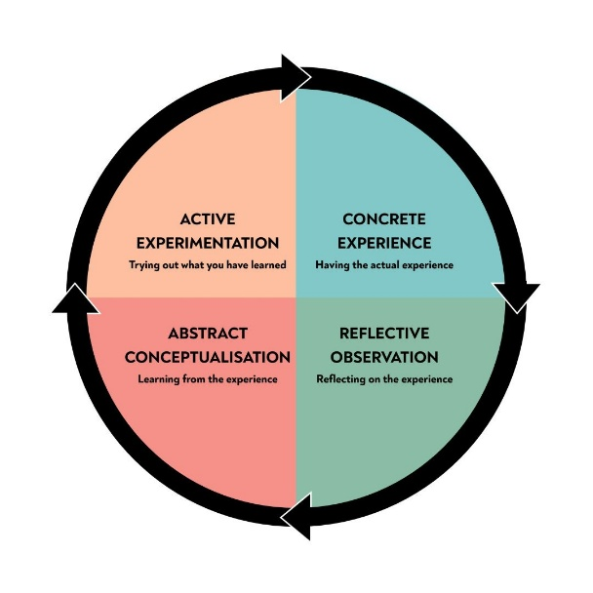
Figure: Kolb’s Experiential Learning Cycle (Kolb’s, 1984)
Concrete Experience:
I shadowed the housekeeping supervisor, during which time I helped with room setup daily, linen management, chemical usage, operating the washing machine and dryer, etc. During this time they experienced a recurring elevator malfunction that caused several guests to be upset as they had to lift heavy luggage up. However, assisting guests with their bags turned out to be suboptimal when it came to a guest’s arrival experience, which is a key “moment of truth” in hospitality (Sarpong, 2016).
Reflective Observation:
At peak check-in times, guests would come and come throughout the day, causing me to have pressure on rooms to be prepared quickly. I was also stressed when guests were dissatisfied with carrying their bags upstairs because there was nothing I could do about the elevator issue. For this reason, this situation gave essential exposure to the direct correlation between housekeeping operations and guest experience. At a time when you have no control over the problem, I learned to keep calm and be a guest-oriented individual during a response.
Abstract Conceptualisation:
This experience was in agreement with Grönroos’s (1988) service quality model, emphasising the importance of functional quality or how services are delivered. Cleanliness is not just about how clean a space is but also how the guests look at cleaning. In the elevator issue, the two dimensions, that is, reliability and responsiveness, found in Parasuraman et al.’s (1988) SERVQUAL model were also tested. They experienced delays when assisting guests and there was little proactive communication with guests on service.
Active Experimentation:
After this experience, I came up with the idea of providing luggage assistance during peak hours and alerting guests to the elevator malfunction if they checked in. Additionally, I enhanced communication with the front desk and maintenance teams, to ensure that the issue was being communicated across all the departments and staff could better support each other. In terms of guest service operations, this approach was supposed to mitigate inconvenience to guests with a forward, service-oriented approach that is critical to guest service operations (Johnston et al., 2012).

Section 2: Critical Analysis of Work-Based Skills and Technical Knowledge
From Lakes Hotel & Spa, I developed a number of work-based skills and technical skills that were essential in making sure that client service was of an excellent standard. Particularly, a malfunctioning elevator displayed how critical it is to manage the tasks, communicate, work collectively, and provide customer service.
Task Management:
Due to the faulty elevator, I was a part of the housekeeping team which meant prioritising room preparation and cleanliness while at the same time helping guests with their luggage. This dual responsibility sometimes resulted in delays in room readiness, and I was forced to quickly adapt and manage time (Casado, 2012). The service of the room was balanced with guest assistance, which deepened the importance of flexibility in daily operations (Rughubalan, 2009).
Communication and Teamwork:
This situation constantly required constant coordination with the reception team that had to alert the guests about the elevator issue because he or she was expected to arrive. I also joined hands with colleagues from housekeeping and maintenance, working to aid the guests with prompt assistance. Communication, in another way, was effective in reducing confusion and making sure that guests were aware of the support available so that few complaints arose (Johnston et al., 2012).
Customer Service Skills:
There was a lot of patience and empathy needed to assist guests with luggage and attend to their concerns. It was actually a proactive offer of help that helped me prevent complaints and created a better guest experience. This also aligned with Sarpong's 2016 “Moments of Truth”, as each encounter with the guest changes their perception of the hotel.
Supervisor's Role and Observed Strategies
My supervisor played a crucial role in handling guest concerns by:
- Staff should express active communication at the time of guest check-in to convey the apology while providing support.
- The hotel executed a guest recovery plan that provided free refreshments to guests whose service was negatively affected.
- Staff members should keep their composure while engaging in active listening to provide reassurance to annoyed guests.
- Staff rotation through responsible delegation allowed employees to provide luggage assistance while maintaining their daily housekeeping responsibilities.
I learned that transparent communication and planned guest service recovery strategies used together alongside proactive approaches help decrease guest dissatisfaction.
Theoretical Application:
According to Hart et al. (1990), the “Service Recovery Paradox” states that the guests’ loyalty will be enhanced by successfully resolving the complaints. I also found out from my experience that once you’ve reached prompt luggage assistance and some sincere apologies from the latter guest, you’d get a chance to turn a dissatisfied guest into an appreciative one.

Section 3: Reflection on Organisational Issues
Concrete Experience:
A persisting problem during my placement at Lakes Hotel & Spa was the elevator failing and subsequently receiving an abundance of guest complaints. The heavy luggage that the guests had to carry upstairs was visible, demonstrating obvious frustration. I was a member of the housekeeping team where I was often forced to abandon a room that I had to hand over to a guest. As a result, room readiness was delayed, and pressure increased at peak check-in times. Such operational challenges showed the importance of guest satisfaction depending on the synchronous work of the back of the house and the front of the house (Vallen and Vallen 2014).
Impact Analysis:
The elevator issue had a large effect on guest experience and operations. Since guests had long journeys, it was important for convenience and having to carry luggage up to rooms led to disappointment or indeed dissatisfaction and some guests were concerned about the hotel’s standards. This is consistent with research that shows that depressing first impressions have a major effect on guest retention (Dixon et al., 2009). Operationally, staff productivity was disturbed, particularly when guests could not be assisted from the time diverted away from important housekeeping duties. Adding to guest dissatisfaction was the delay in-room preparation, which forwarded ripples to departments (Johnston and Clark, 2018). Furthermore, any poor online reviews would reflect poorly on the hotel’s reputation in an area like Windermere, which is in the tourism business (Wirtz and Lovelock, 2021).
Abstract Conceptualisation:
Though the updated SERVQUAL model by Parasuraman et al. (1988) still holds true, it suggests that reliability and responsiveness play an important part in service expectations. Services that actually fail are good, as they would define a service quality gap, an area in which service recovery should be critical. Furthermore, it is argued that in luxury settings, where guest expectations are not met, dissatisfaction follows, and this is highly sensitive (Brady and Cronin, 2011).
Suggested Solutions:
- Short-Term: Assign a luggage assistance team during peak hours.
- Mid-Term: Install temporary luggage ramps or strengthen porter services.
- Long-Term: Implement proactive maintenance schedules and establish contingency procedures.

Conclusion and Action Plan
The problem here is that they are highlighting that placement at Lakes Hotel & Spa is the key problem-solving and team cooperation that is necessary for running those smooth guest service operations. The guest satisfaction in human problem resolution, though not just focusing on avoiding problems, depends on how such problems are resolved (Michel et al., 2009). In operational disruptions, assistance to guests emphasised the importance of the effectiveness of communication, flexibility and teamwork among all departments (Johnston and Clark, 2018).
Future Development Plan:
- Provide real-time decision-making practice to enhance problem-solving under pressure.
- To which areas of guest complaint-handling techniques should they proceed to be trained (Wirtz and Lovelock, 2021)
- Shadows reception and front desk team to develop cross-department knowledge about the all-inclusive guest journey.

References
Brady, M.K. and Cronin, J.J. (2011) Some new thoughts on conceptualising perceived service quality: A hierarchical approach. Journal of Marketing, 65(3), pp.34-49.
Casado, M. (2012) Housekeeping Management. 2nd ed. London: Wiley.
Dixon, M., Kimes, S.E. and Verma, R., 2009. Customer preferences for restaurant technology innovations.
Gronroos, C., 1988. Service quality: The six criteria of good perceived service. Review of business, 9(3), p.10.
Hart, C.W., Heskett, J.L. and Sasser Jr, W.E., 1990. The profitable art of service recovery. Harvard Business Review, 68(4), pp.148-156.
Johnston, R. and Clark, G. (2018) Service Operations Management: Improving Service Delivery. 5th ed. London: Pearson.
Johnston, R., Clark, G. and Shulver, M. (2012) Service Operations Management. London: Pearson.
Lakes Hotel (2025) Lakes Hotel & Spa. Available at: https://lakeshotel.co.uk/ (Accessed: 21 February 2025).
Michel, S., Bowen, D. and Johnston, R., 2009. Why service recovery fails: Tensions among customer, employee, and process perspectives. Journal of Service Management, 20(3), pp.253-273.
Parasuraman, A., Zeithaml, V.A. and Berry, L.L. (1988) ‘SERVQUAL: A Multiple-Item Scale for Measuring Consumer Perceptions of Service Quality’, Journal of Retailing, 64(1), pp. 12–40.
Rughubalan, G. (2009) Hotel Housekeeping: Operations and Management. Oxford: Higher Education Press.
Sarpong, S., 2016. The Service Industry and the" Moment of Truth": The Quest for the Holy Grail. Athens Journal of Tourism, 3(1), pp.25-40.
Vallen, G.K. and Vallen, J.J. (2014) Check-in Check-out: Managing Hotel Operations. 9th ed. Harlow: Pearson Education Limited.
Wirtz, J. and Lovelock, C., 2021. Services marketing: People, technology, strategy. World Scientific.

Appendix: Workbook placement log


