
Evaluation of blended learning and classroom learning on student attainment (Report)
Stanciu Radu Mihai
Module coordinator: Giridhar Katti | Student ID: 2111825 | Module Code: BMSW4001

Table of Content

Introduction Page 02
Blending Learning Page 02
Traditional Learning, HE Page 03
Evaluation Page 04
Recommendation Page 04
Conclusion Page 05
References Page 06

Introduction:

Since 19th Century the higher education become more and more demanded because of economic, politic, and social changes, and now the world moving toward to increase the independence in terms of trade, culture, and communication. According with Philip G. Altbach the university remains the main source to accumulate wisdom but over the past couple of years technology advance to fast and Higher Education could not to keep updates further. In Further to develop, the university need to look at Blended learning and traditional classroom learning and find which is more suitable to go further. So, in this report I am going to compare Blended learning and Traditional classroom learning in HE. (Altbach, 1998)

Blended Learning:
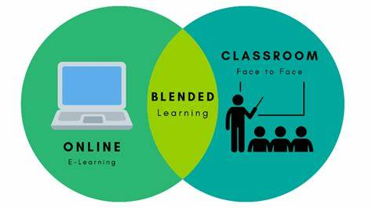
As we arrive at this point the first question is what exactly is blended learning? While there are a wide variety of responses to this question, according with Jared Stain and Charles R. Graham, blended learning doesn’t have a single definition in order to explain what blended learning is, but still been quite a bit of ambiguity it can be defined by been an educational strategy resulted by the combination, or better say the blend between online learning and face to face learning in order to produce effective, efficient and flexible learning (Graham, 2014). In 2003 a study by The American Society for Training and Development show that blended learning become one of the top 10 learning trends to emerge in the knowledge delivery industry. Forward, blended learning same as any other strategy can have advantages and disadvantages. Regarding that, the advantages of blended learning can be:
The reduce costs:
By company the cost of Blended learning is reduced by “cut costs”. That mean It requires less classrooms or training centres, fewer instructors, less commuting time. And for the student, less money spend on transport as part of it is online; less money spends on books and prints been everything you need in an online format, less money to spend on lunch because the student can eat in their own house which also can benefit by students having what they want to eat.
Improve skills and feedback:
Not been in class and the student start to improve his self-learning skills; problem solving; communication skills by using formal writing, time management and self-motivation as is no one to ‘push’ the student. Another important advantage is that blended learning makes traditional training more valuable and help in receiving better feedback. When people can complete assignments independently, they can come to class with the same knowledge level. There is more time for useful discussions and to practice what they have learned.
Flexibility:
Blended Learning been the blend between online and face to face the student become more flexible allowing more time by saving from another part. for example by saving time on transport, the student have more time to prepare himself for the online class or can also allocate that time to sleep more and wake up much fresh.
But as usual nothing can be perfect, and the Blended learning have also some disadvantages
Plagiarism and credibility problem
Plagiarism is a well-known issue in the e-learning world. It might be hard for online learners to resist the temptation of looking up things on the web while learning from a computer or smartphone. To prevent Plagiarism, you can use plagiarism checkers. Timers, randomized questions (so all participants get a different selection of questions for their test), and secure browsers that block web navigation help prevent participants from looking up answers during online tests or courses.
Lack of motivation
Another disadvantage is that, depending on how you set up blended learning, it might diminish the motivation of your participants. Not every blended learning model is suited to every person, task, subject, or organization. In the way you consider children’s’ reading levels when choosing books for them, you should consider which approach will work best for your employees or customers.
Employees who are used to working with their hands might also dislike sitting in front of a screen for too long. As you can imagine, it's essential to consider these things when you prepare your learning methods and materials. (Voughan, 1945) (Catlin R. Tuker, 2017)

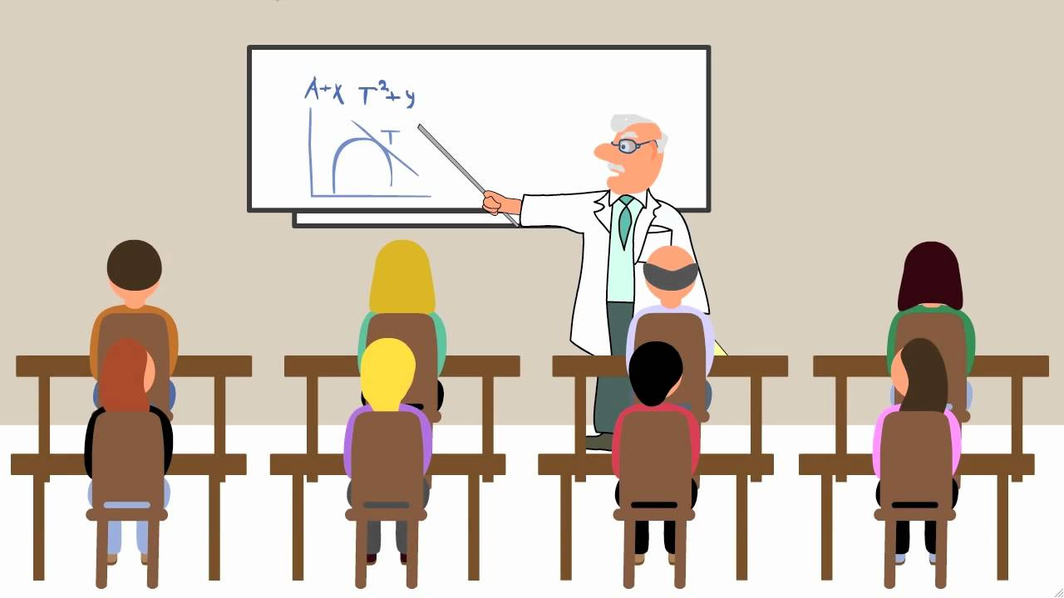
Traditional Learning, HE
Traditional learning is the face-to-face learning happen in university classes; the knowledge and information is given by the lecturer to students only in the classroom environment. According with Joyce A. Castronova, this type of learning is becoming less effective in achiveving the expectation of employer’s search in now days. Joyce A. Castronova is referring that the ‘old fashon’ methods do not seem to be able to create the employee businesses look for today. And that is because the technology is develop faster then ever. The students now day need more IT practice, for example the students need to achieve more experience in online for video conference and be able to play with multiple programmes and needed to learn to work without been always assisted and strong problem solving skills. And for all that first is needed to be lay down the pro and cons of traditional learning:
Gain confidence in public speech :
Traditional learning can have the advantage of experience achieved by students to speak in public as they need to present in class they work to everyone and by that they also become more confidents by every presentation. Students need to create presentation and present in front of the class in order to achieve marks, experience that pressure of an live action ; ‘face to face’ public interaction will make the students to use to public speech and presentation.

Gain Interpersonal Skills:
Learning in class students achieve strong interpersonal skills by interacting with each other , working in group and support when it need, this skill is very demand by employers now days in all types of businesses.
No Flexibility:
There’s can’t be always good, and for students, learning in classrooms means there’s an set schedule to follow which give the students no flexibility by needed to follow the module scheduler and not absent to be able to have all the knowledge and information up to date. (Castronova, n.d.) (Hannay, 2006)

Evaluation
Blended learning and traditional learning has been a controversial subject between students; teachers; even employers as some prefer classroom learning and other blended learning as both having advantages and disadvantages which also make Aaron M. Rozeboom to do some research and write an article about Blended learning versus Traditional learning. The results of Aaron M. Rozeboom article is a research to determine if the blended learning is more approach to provide students with advantages then the students in a direct instruction classroom. The examination showed that the graduated understudies in a mixed homeroom performed higher than graduated understudies from conventional study hall learning. The examination likewise uncovered that the graduated understudies from mixed learning had been more ready to use their assets, work together with associates and others, and accomplish a greater amount of a proprietorship from their realizing which had accordingly more grounded abilities. The understudies been more drawn in with the modules, information and information got on the grounds that they expected to figure out how to be more free and effectives then, at that point, assuming they been in a customary study hall . They couldn't manage the cost of the choice to unwind toward the back and tune out the educator, rather they had been posed developmental inquiries about the recordings of teacher to assist themselves with checking their agreement. Yet additionally the understudies with higher requirements could profited from the mixed study hall also, and that is on the grounds that they could work one-on-one or in little gatherings with the educator. This exercises permit them to get the assistance required and responded to for their inquiries. Furthermore the people who had a more significant level of information additionally benefits since they could work , and review forward in 'their own speed' investigating forward level ideas by their own rather than customary gaining where all from the class should be in total agreement. Mixed learning give to all understudies a positive learning encounter and draw in higher understudy accomplishment then Traditional learning by setting up the understudies to be all the more wide.. (Rozeboom, 2017)

Recommendation
In order of the purpose of this report the recommended learning method between blended learning and traditional classroom learning for students in the Higher Education is Blended learning. Blended Learning can help to improve the higher education methodology and increase its flexibility which students in now day need it the most as students now day are not only study, they also working to afford they life style. Also It can mean better Higher education provision for people residing in remote and rural areas, for those who are part of Traveller communities, and those engaged in high-performance training. All environments and tools should be equally accessible to minority groups, students with disabilities, or students from socio-economically disadvantaged backgrounds, and should not lead to discrimination or segregation. Also The Commission should have as proposes shorter-term or long-term measures to address about COVID-19 pandemic. This includes, for example, additional support for students learning difficulties, and a renewed focus on the well-being of learners and their families, and on their digital competences. forward for blending learning environments can be improved by letting students to choose how they want to be they own scheduler which will also will increase students well being by been able to sort out they own time. (khan, 2015) ( School Education Gateway, 2021) (Paul Harris, 2009)
andupfrontcommunicationsregardingthisarelikelytofacilitatebuy‐infromallinvolved.A
standardofcontinuousimprovementshouldbemaintainedwhichassuresminimalpossible
disruptiontothelearningdelivery.
Aswithanynewapproachtodeliveringlearning,comprehensivesupportforallstakeholdersshould
beavailableasandwhenrequired.Thisshouldbecomprisedofanappropriately‐skilledteam.Clear
andupfrontcommunicationsregardingthisarelikelytofacilitatebuy‐infromallinvolved.A
standardofcontinuousimprovementshouldbemaintainedwhichassuresminimalpossible
disruptionAlso the teachers and students should be comprised of an appropriately‐skilled training by a trained team. A standard of continuous improvement should be maintained which assures minimal possible disruption to the learning delivery and weekly feedback should be implemented for students and teachers during the beginning of the implementation of blended learning .
interventionsshouldbeappropriatelyandthoroughlymeasured,evaluatedby
participants,andanalysedbytheteachingandproductionteam.Ideally,evaluationshouldtake
accountof:
• Learningoutcomes.
• Participants’learningstyles/preferences.
• Motivation.
• Clarityofgoals,content.
• Interaction.
• Perceivedvalueandsatisfaction.
• Effectiveness.
• Appropriatesupport,workload,andassessment.
• Accesstoresources,usabilityanddesign.
• Howthe‘blend’oflearningworked.
• Confidencelogsifpossible.
• Evidenceofmeta‐cognition.

Wherepossible,standardized,reliableandvalidmeasuresshouldbeemployedtofacilitate
replicationandappropriatecomparison
interventionsshouldbeappropriatelyandthoroughlymeasured,evaluatedby
participants,andanalysedbytheteachingandproductionteam.Ideally,evaluationshouldtake
accountof:
• Learningoutcomes.
• Participants’learningstyles/preferences.
• Motivation.
• Clarityofgoals,content.
• Interaction.
• Perceivedvalueandsatisfaction.
• Effectiveness.
• Appropriatesupport,workload,andassessment.
• Accesstoresources,usabilityanddesign.
• Howthe‘blend’oflearningworked.
• Confidencelogsifpossible.
• Evidenceofmeta‐cognition.

Wherepossible,standardized,reliableandvalidmeasuresshouldbeemployedtofacilitate
replicationandappropriatecomparison
interventionsshouldbeappropriatelyandthoroughlymeasured,evaluatedby
participants,andanalysedbytheteachingandproductionteam.Ideally,evaluationshouldtake
accountof:
• Learningoutcomes.
• Participants’learningstyles/preferences.
• Motivation.
• Clarityofgoals,content.
• Interaction.
• Perceivedvalueandsatisfaction.
• Effectiveness.
• Appropriatesupport,workload,andassessment.
• Accesstoresources,usabilityanddesign.
• Howthe‘blend’oflearningworked.
• Confidencelogsifpossible.
• Evidenceofmeta‐cognition.

Wherepossible,standardized,reliableandvalidmeasuresshouldbeemployedtofacilitate
replicationandappropriatecomparison
interventionsshouldbeappropriatelyandthoroughlymeasured,evaluatedby
participants,andanalysedbytheteachingandproductionteam.Ideally,evaluationshouldtake
accountof:
• Learningoutcomes.
• Participants’learningstyles/preferences.
• Motivation.
• Clarityofgoals,content.
• Interaction.
• Perceivedvalueandsatisfaction.
• Effectiveness.
• Appropriatesupport,workload,andassessment.
• Accesstoresources,usabilityanddesign.
• Howthe‘blend’oflearningworked.
• Confidencelogsifpossible.
• Evidenceofmeta‐cognition.

Wherepossible,standardized,reliableandvalidmeasuresshouldbeemployedtofacilitate
replicationandappropriatecomparisoBlended learning can help to improve the inclusiveness of education, particularly due to its flexibility. It can mean better education provision for people residing in remote and rural areas or hospitals and care centres, for those who are part of Traveller communities, and those engaged in high-performance training. All environments and tools should be equally accessible to minority groups, children with disabilities, or children from socio-economically disadvantaged backgrounds, and should not lead to discrimination or segregation.
Conclusion
In conclusion blending learning is from my opinion most suitable for now days . Additionally as of late, the advanced education benefit of giving blended learning openings had been gotten critical consideration from understudies and educators and more liked and a superior choice during the last long periods of Covid 19 pandemic. Likewise blended learning had more extravagant arrangement of learning approaches and conditions. Likewise now days the mixed learning can move toward any blend of various strategies for learning, with various learning conditions and distinctive learning styles which is more appropriate. How I notice before Blended learning can give adaptability in figuring out how to the two understudies and educators and can Integrate virtual and actual scenes empowers the two instructors and understudies to be arranged better for future, however this is best when there is institutional help through the arrangement of expert learning and the chance for overhauling courses for the most fitting mix. The customary homeroom learning isn't reasonable any longer for the time being days and it not arranged enough the understudies for additional businesses inquiries. Innovation is running quicker and understudies should have the option to deal with now days challenges.

References
School Education Gateway, 2021. New Council Recommendation on blended learning. [Online]
Available at: https://www.schooleducationgateway.eu/en/pub/latest/news/council-recommendation-blended.htm
[Accessed 14 11 2021].
Altbach, P. G., 1998. Comparative Higher Education. Boston College ed. London: Ablex Publishing.
Castronova, J. A., n.d. Discovery Learning for the 21st Century: What is it and how does it compare. JOURNAL OF EDUCATIONAL AND INSTRUCTIONAL COGNITIVE LEARNING THEORIES WITH EMPHASIS ON LATENT LEARNING, GESTALT AND INFORMATION PROCESSING THEORIES, 1(1), p. 13.
Catlin R. Tuker, T. W. a. J. T. G., 2017. Blended Learning in Action. 1 ed. California: Crowin a SAGE Company.
Graham, J. S. a. C. R., 2014. Essentials for blended learning A Standards-Based guide. 1 ed. New York: Routledge.
Hannay, T. N. a. M., 2006. PERCEPTIONS OF DISTANCE LEARNING:. MERLOT Journal of Online Learning and Teaching, 2(1), p. 11.
khan, M. S., 2015. Blended Learning vs Traditional Classroom Settings. International Journal of Nursing, 2(1), pp. 158-161.
Paul Harris, J. C. L. F., 2009. Blended learning: overview and recommendations for successful implementation. Industrial and Commercial Training, 41(3), pp. 155-163.
Rozeboom, A. M., 2017. Blended Learning Versus the Traditional. Education at NWCommons, p. 17.
Voughan, D. R. G. a. N. D., 1945. Blended Learning in higher education. 1 ed. San Francisco : Jossey Bass A Wiley Inprind.



