

University of Wales Trinity Saint David (UWTSD)

Module code and Name: LCHS7003 Community Care and Management of Longer-term Conditions

Assessment Title: Chronic kidney disease (CKD)
Student Name: Mohammed Amaan

Student ID: 2612142

Contents
1. Introduction 3
2. Understanding chronic kidney disease 3
3. Why CKD matters: the scale of the problem 4
4. Causes and risk factors 5
5. Detecting CKD 6
6. Treating and slowing CKD 7
7. Chronic disease models applied to CKD 8
8. Living with CKD: self-management and health literacy 10
9. Advanced CKD and kidney failure 11
10. Policy and system perspectives 11
11. Conclusions and recommendations 12
12. Where to find support 12
References 13

1. Introduction
Chronic kidney disease (CKD) is a long-term condition in which the kidneys gradually lose their ability to filter waste and excess fluid from the blood. It is common, usually causes no symptoms in its early stages, and is closely linked with heart disease, so many people discover it late [1], [2]. This booklet is written for adults in the UK who are at risk of CKD, who have recently been diagnosed, or who support someone living with the condition.
It has three aims: to explain CKD in plain language, to summarise the strongest current evidence on detection and treatment, and to examine critically where evidence and health policy still leave gaps. Because health information only helps when people can understand and act on it [3], technical terms are explained when first used, key messages are boxed, and tables and figures appear where they clarify more than text. The evidence combines national guidelines [4], [5], large randomised trials, systematic reviews and UK policy reports. This booklet is for education and does not replace advice from your GP, pharmacist or kidney team.

2. Understanding chronic kidney disease

2.1 What the kidneys do
Most people have two kidneys, each about the size of a fist. Every day they filter the blood, remove waste, balance water and salts, help control blood pressure, and produce hormones that support red blood cell production and bone health [6], [7]. Because the kidneys have large spare capacity, a person can lose a substantial amount of function before feeling unwell, which is why CKD is often called a silent condition [8].

2.2 How CKD is defined and staged
CKD is diagnosed when kidney function is reduced, or kidney damage is evident, for more than three months [5], [4]. Two simple tests are central. The estimated glomerular filtration rate (eGFR) is calculated from a blood creatinine level and estimates how well the kidneys are filtering. The albumin-to-creatinine ratio (ACR) is a urine test that detects protein leaking through damaged kidney filters. Both matter because the risks of kidney failure, heart disease and death rise as eGFR falls and as ACR rises [9], [10]. Table 1 combines the two measures into the risk categories used in UK and international guidelines.
Table 1. CKD risk categories by eGFR and ACR. Adapted from KDIGO CKD Work Group [5].
eGFR category | A1: ACR below 3 mg/mmol | A2: ACR 3–30 mg/mmol | A3: ACR above 30 mg/mmol
G1 ≥90 (normal or high) | Low risk | Moderate | High
G2 60–89 (mildly reduced) | Low risk | Moderate | High
G3a 45–59 (mild to moderate) | Moderate | High | Very high
G3b 30–44 (moderate to severe) | High | Very high | Very high
G4 15–29 (severely reduced) | Very high | Very high | Very high
G5 <15 (kidney failure) | Very high | Very high | Very high
eGFR is measured in mL/min/1.73 m². Stages G1 and G2 count as CKD only when other signs of kidney damage, such as a raised ACR, are present.
Numbers need context, however. eGFR naturally declines with age, so a modestly reduced value in an otherwise healthy older adult may reflect ageing rather than disease, and critics argue that labelling such people risks anxiety and unnecessary treatment [11]. Supporters of earlier identification reply that albuminuria and falling eGFR reveal genuine risk that would otherwise be missed [12]. A practical resolution is to look beyond a single number. The Kidney Failure Risk Equation uses age, sex, eGFR and ACR to estimate the five-year chance of needing dialysis or a transplant [13], and NICE advises using it to guide referral and monitoring [4].

Key points
- CKD means reduced kidney function or kidney damage lasting more than three months.
- Two tests define it: eGFR (blood) and ACR (urine).
- Risk depends on both results together, not on either alone.

3. Why CKD matters: the scale of the problem
CKD is a major global cause of illness and death. The Global Burden of Disease study estimated that about 697.5 million people worldwide, roughly 9.1% of the population, were living with CKD in 2017, and that it caused 1.2 million deaths [14]. CKD is projected to become the fifth leading cause of years of life lost globally by 2040 [15], and the burden falls heavily on low- and middle-income countries, where treatment for kidney failure is least accessible [16], [17]. Prevalence estimates vary with definitions and populations: one meta-analysis placed global prevalence at 13.4% [18].
In the UK, Kidney Research UK [1] estimate that 7.2 million people have CKD, including about 3.25 million at stages 3–5 and a further 3.9 million at stages 1–2, many of whom are undiagnosed. The report estimates that kidney disease costs the UK economy £7 billion a year, of which £6.4 billion is direct NHS spending (about 3.2% of NHS expenditure), and projects that total costs could reach £13.9 billion by 2033 without action (Figure 1). Dialysis alone is estimated to cost the economy £372 million annually in lost working time [1]. These figures come from a charity-commissioned economic model that relies on assumptions about prevalence and growth, so they are best treated as informed estimates, although their direction agrees with independent epidemiological reviews [2], [19].
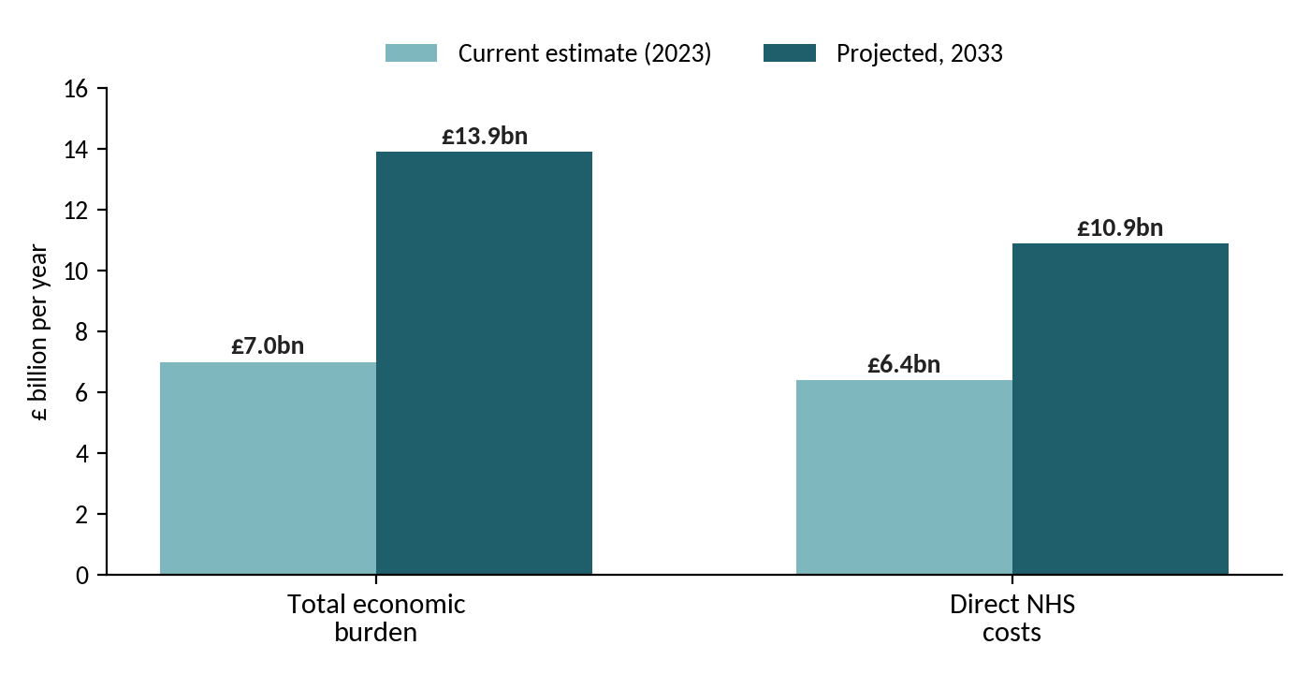
Figure 1. Estimated annual cost of kidney disease in the UK, 2023 and projected 2033. Data from Kidney Research UK [1].
For most people with CKD, the greatest threat is not kidney failure but cardiovascular disease. Reduced kidney function substantially increases the risk of heart attack, stroke and heart failure, and many people die of cardiovascular causes before they would ever need dialysis [9], [20]. Good CKD care is therefore largely cardiovascular risk management, a point that shapes the treatments described in Section 6.

4. Causes and risk factors
The most common causes of CKD are type 2 diabetes and high blood pressure. Glomerulonephritis (inflammation of the kidney filters), polycystic kidney disease, long-term urinary obstruction, recurrent infection, previous acute kidney injury and some medicines, including regular non-steroidal anti-inflammatory drugs (NSAIDs) such as ibuprofen, also contribute [6], [21]. Rising rates of diabetes, obesity and heart disease mean that more people are at risk [1]. NICE advises testing people with diabetes, hypertension, cardiovascular disease, a family history of kidney failure or previous acute kidney injury, and its 2021 update added people with gout [4].
Lifestyle plays a part. Kelly et al. [22] found in a systematic review and meta-analysis that a healthy diet, regular physical activity, not smoking and a healthy body weight were each associated with a lower risk of developing CKD, although most included studies were observational, so cause and effect cannot be assumed.
Risk is also unequally distributed. Living in more socioeconomically deprived circumstances is associated with higher CKD risk [23], and people from ethnic minority groups appear more likely to progress to kidney failure [24]. These patterns most plausibly reflect an interaction of biology, the prevalence of diabetes and hypertension, and unequal access to early care, rather than ethnicity itself as a cause [25], [26].
The role of ethnicity in measuring kidney function has also been contested. Older eGFR equations applied a multiplier for Black patients, which could delay diagnosis; newer equations omit race [27], and UK guidance has reconsidered ethnicity-based adjustment [4]. The example shows how clinical tools can embed assumptions that affect fairness of care.

5. Detecting CKD
Early CKD rarely causes symptoms. When they appear they may include tiredness, swollen ankles, breathlessness, itching, foamy urine and needing to pass urine more often at night [8], and by then the disease may be advanced. Detection therefore depends on testing people at risk. In practice, a blood test for eGFR and a urine ACR test are done during routine reviews for diabetes and hypertension, and abnormal results are repeated to confirm that they persist [4]. Primary care studies suggest that CKD is under-recognised and inconsistently coded, which limits both treatment and monitoring [28].
Whether to go further and screen the whole population is debated, as Table 2 shows.
Table 2. Wider testing for CKD: arguments for and against
Arguments for earlier, wider testing | Arguments for caution
Effective treatments that slow progression now exist, including blood pressure control and SGLT2 inhibitors [4], [29]. | Population-wide screening has not been shown to improve outcomes, so targeted testing of high-risk groups is favoured [12].
Tests are inexpensive, and earlier treatment may avoid costly dialysis [1]. | Age-related decline in eGFR may cause overdiagnosis, anxiety and unnecessary medicines in people unlikely to progress [11].
Many people at risk are unaware that they have CKD [1]. | Extra testing adds primary care workload and could widen inequalities if uptake is uneven [26].

On balance, the evidence supports systematic, targeted testing of high-risk groups combined with risk prediction, so that people likely to progress are identified without labelling large numbers of people who are not [12], [11].
Interpreting results also takes care. A single abnormal result does not confirm CKD: kidney function can fall temporarily during infection, dehydration or acute illness, so a reduced eGFR is normally repeated, and a raised ACR is confirmed on a further early-morning urine sample before a diagnosis is made [4]. Once CKD is confirmed, the pattern over time matters more than any single value. A stable eGFR in the mildly reduced range carries a very different outlook from one that falls quickly, which is why regular monitoring, and not one-off testing, is the core of good care [5], [13].

6. Treating and slowing CKD
There is no cure for established CKD, but progression can often be slowed and cardiovascular risk reduced. Table 3 summarises the main approaches, and the text that follows examines the evidence critically.
Table 3. Main approaches to slowing CKD and reducing risk
Approach | What the evidence shows | Points to consider
Blood pressure control | NICE sets a target below 140/90 mmHg, or below 130/80 mmHg when ACR is 70 mg/mmol or more [4]. Intensive control reduced cardiovascular events in SPRINT [30]. | SPRINT excluded people with diabetes, so targets should be individualised [31].
ACE inhibitors or ARBs | Losartan reduced a composite of kidney failure, doubled creatinine or death by 16% in diabetic kidney disease [32]. | Blood tests are needed after starting, and doses may need pausing during illness [5].
SGLT2 inhibitors | Reduced kidney failure and serious decline in kidney function in several large trials (Figure 2). | Eligibility is restricted, and genital infections and dehydration are risks [5].
Finerenone | Reduced a composite kidney outcome by 18% in type 2 diabetes with CKD [33]. | Potassium levels need monitoring.
Statins | Recommended to reduce cardiovascular risk in CKD [4]. | Offered alongside, not instead of, lifestyle change.
Diet and activity | Less than 5 g salt a day and about 150 minutes of moderate activity a week if able [5]. Dietitian advice should be individualised [34]. | Avoid unsupervised restrictive diets, which risk malnutrition.

The most important recent advance is the use of sodium-glucose co-transporter 2 (SGLT2) inhibitors, originally diabetes drugs. Randomised trials showed that canagliflozin reduced kidney failure and serious kidney decline in people with type 2 diabetes [35], and the later DAPA-CKD and EMPA-KIDNEY trials showed benefit in people with CKD whether or not they had diabetes [36], [37]. NICE has recommended dapagliflozin and empagliflozin for defined groups of adults with CKD [29], [38]. Even so, trial participants were closely supervised, so benefits in older, frailer people in routine care are less certain, and the drugs usually need to be paused temporarily during illness with vomiting or diarrhoea [5]. Kidney Research UK [1] argue that wider use of existing treatments is a major opportunity, with modelling suggesting that four interventions could save around 10,000 lives by 2033.
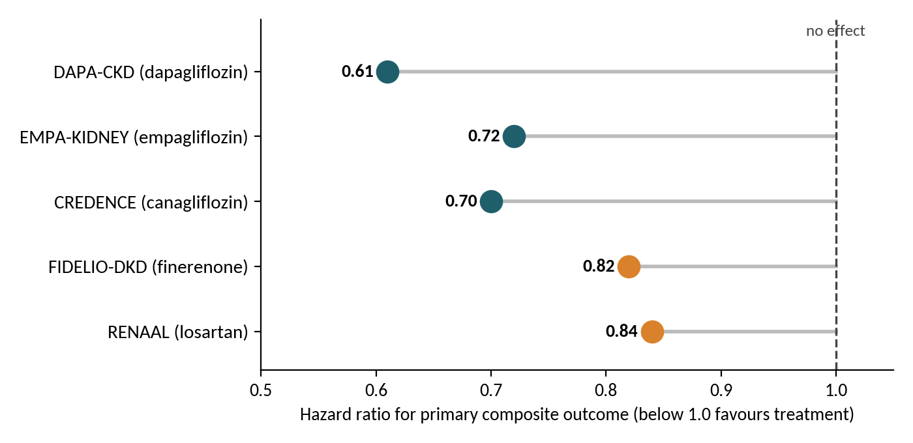
Figure 2. Hazard ratios for primary composite outcomes in landmark CKD trials. Sources: [32], [33], [35], [36], [37]. Outcome definitions differ between trials, so comparisons are indicative only.
Everyday habits add to what medicines achieve. Reducing salt helps blood pressure control and may enhance the effect of some kidney-protective drugs, while regular moderate activity improves cardiovascular fitness [5]. Dietary advice changes with the stage of disease. In earlier stages the emphasis is on a balanced, largely plant-based pattern and a healthy weight, whereas in advanced CKD limits on potassium, phosphate or protein may be needed, but these should be set by a renal dietitian after blood tests rather than adopted unsupervised, because over-restriction risks malnutrition [34], [5]. Stopping smoking and maintaining a healthy weight are associated with a lower risk of developing and worsening CKD, although, as noted earlier, the supporting evidence is largely observational [22].
Practical safety points
- Avoid regular NSAIDs such as ibuprofen unless a clinician advises otherwise.
- Ask a pharmacist before starting any new medicine, supplement or herbal remedy.
- If you have vomiting, diarrhoea or fever, ask your GP or pharmacist whether some medicines should be paused temporarily.
- Stop smoking, and keep blood pressure and blood sugar well controlled [5], [4].

7. Chronic disease models applied to CKD
CKD is lifelong, driven by several interacting risk factors and managed mostly outside hospital, so frameworks designed for chronic disease offer a useful structure for organising care. Two are especially relevant: the Chronic Care Model, which works at the level of the practice and patient, and the World Health Organization’s Innovative Care for Chronic Conditions (ICCC) framework, which extends to communities and policy.

7.1 The Chronic Care Model
Wagner [39] proposed that outcomes improve when an informed, activated patient interacts with a prepared, proactive practice team. Bodenheimer, Wagner and Grumbach [40] describe six elements, which Table 4 applies to CKD. The model suits CKD because good care depends on registers to find people at risk, agreed protocols and patients who manage medicines and diet. Evidence across chronic conditions suggests that these elements improve care processes and outcomes [40], but CKD-specific trials are limited, and models of care for early CKD remain inconsistently implemented [11].

Table 4. Elements of the Chronic Care Model applied to CKD
Model element | Application to CKD
Self-management support | Teaching people their eGFR and ACR, sick-day medicine rules and salt reduction, with attention to health literacy [41].
Delivery system design | Defined roles for GPs, pharmacists, dietitians and kidney teams, with referral triggered by risk of kidney failure [4], [13].
Decision support | Guidelines and risk equations built into everyday primary care workflows [5], [13].
Clinical information systems | Registers and consistent coding to find undiagnosed CKD and monitor treatment [28].
Health care organisation | Leadership and funding that treat kidney care as seriously as diabetes and cardiovascular care [42], [1].
Community resources | Charities, peer groups and culturally tailored information [43], [44], [26].

7.2 The WHO ICCC framework
The ICCC framework [45] organises care across three levels: micro (patients and families), meso (health organisations and communities) and macro (policy and financing). It argues that results depend on informed patients, prepared health teams and supportive communities working together within enabling policy. Figure 3 applies this to CKD. Its strength is that it names policy and resource constraints explicitly, which matters given the global burden of CKD [16], [19]. Its weakness is that it is broad, gives little operational detail and is hard to evaluate.
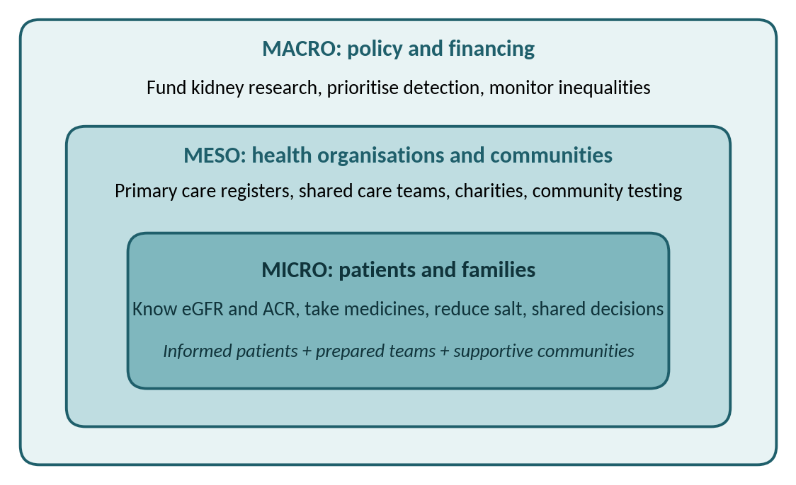
Figure 3. The WHO ICCC framework applied to CKD (adapted from World Health Organization [45])
The two models are complementary. The Chronic Care Model gives practices a practical checklist, while the ICCC framework explains why practice-level change stalls without policy support. Both, however, assume that people can act on information and services, and say little about deprivation or discrimination, so they must be paired with deliberate attention to inequalities [26], [23].

8. Living with CKD: self-management and health literacy
Most CKD care happens at home, so a person’s knowledge and confidence matter as much as prescriptions. Limited health literacy is common among people with CKD and is associated with poorer knowledge and outcomes [41]. Nutbeam [3] describes health literacy as including not only reading skills but also the ability to appraise information critically and use it to act. Bandura’s [46] concept of self-efficacy explains why confidence matters: people are more likely to sustain behaviours such as taking medicines or reducing salt when they believe they can succeed. The Behaviour Change Wheel adds that behaviour depends on capability, opportunity and motivation together, so information alone rarely suffices [47].
Practical steps follow from this. Know your latest eGFR, ACR and blood pressure; keep an up-to-date list of medicines; ask for information in a format you can use, including interpreters or easy-read leaflets; repeat the plan back in your own words to check understanding; and use kidney charities and peer groups for support [43], [44].
A critical caution is that self-management can shift responsibility onto people whose circumstances limit their choices. Healthy food, safe places to exercise, secure work and time off for appointments are not equally available, and the widening of health inequalities in England [26] means that services must support people rather than simply instruct them. Information should also be tailored to language, literacy and culture.
Questions to ask at your next appointment
- What are my eGFR and ACR, and what do they mean for me?
- Is my kidney function stable, improving or falling?
- What is my blood pressure target?
- Which medicines should I avoid or pause when I am ill?
- What is my risk of kidney failure over the next five years?

9. Advanced CKD and kidney failure
A small proportion of people progress to kidney failure (stage G5), where kidney function is too low to sustain health. The options are dialysis, kidney transplantation or conservative management without dialysis. Transplantation generally offers the best survival and quality of life for suitable people, whereas dialysis replaces filtering but demands considerable time, typically several sessions each week for haemodialysis, and carries wider personal and economic costs [6], [7].
For some people, especially older adults with frailty or several other conditions, conservative management that focuses on symptoms and quality of life may be a reasonable choice. NICE [48] recommends shared decision-making, in which options, likely benefits and burdens are discussed openly and nobody is steered towards a particular route. Planning early, ideally years before kidney failure, leaves time to consider transplantation, choose a dialysis type and prepare for treatment.

10. Policy and system perspectives
Individual action sits within a health system. The NHS Long Term Plan [42] prioritises prevention and early detection of cardiovascular disease and diabetes, which share risk factors with CKD, yet Kidney Research UK [1] argue that kidney disease remains under-prioritised, reporting that it received only 1.4% of relevant government research funding in 2021/22. Gaps include inconsistent early detection, uneven access to newer drugs and limited integration of kidney care with diabetes and cardiovascular services. Francis et al. [19] similarly call for CKD to be placed on the global public health agenda alongside other major non-communicable diseases.
Addressing inequality requires targeted outreach. Evidence that deprivation and ethnicity shape both risk and outcomes [23], [24], [25] argues for community-based testing, culturally appropriate information and monitoring of treatment uptake by group. Doing this well needs good-quality data on who is tested, diagnosed and treated, which is difficult while coding remains incomplete [28].
This booklet has limitations. It is a narrative review rather than a systematic one, so studies were selected for relevance and credibility, not through an exhaustive search, and it relies heavily on guidelines and large trials whose participants may differ from people in everyday practice. UK economic figures are modelled estimates [1], and recommendations on newer drugs are changing quickly [29], [38]. Readers should therefore treat the conclusions as a current synthesis, to be checked against the latest national guidance.

11. Conclusions and recommendations
CKD is common, costly and frequently undetected, but it is also one of the few chronic conditions for which several effective treatments now exist. The evidence reviewed here supports three sets of recommendations.
- For individuals: if you have diabetes, high blood pressure, heart disease or a family history of kidney failure, ask for eGFR and ACR tests, learn your results, avoid regular NSAIDs unless advised, stay active, stop smoking and take prescribed medicines consistently [5], [4].
- For clinicians and services: use eGFR and ACR together with risk prediction, offer eligible patients guideline-recommended treatments including SGLT2 inhibitors, and provide plain-language, culturally tailored information and shared decision-making [4], [13], [48].
- For policymakers: prioritise targeted detection in high-risk and deprived communities, fund kidney research in proportion to its burden, and monitor access to treatment by ethnicity and deprivation [1], [26].
Future work should test whether targeted detection programmes improve outcomes and cost-effectiveness in UK populations, and should evaluate self-management support designed with people from under-served communities. Evidence gaps remain, notably for older adults and for long-term outcomes of newer drugs in routine care, and readers should expect guidance to keep evolving.

12. Where to find support
Reliable information and peer support are available from the NHS website [8], Kidney Care UK [43] and the National Kidney Federation [44]. If you have severe symptoms, such as passing very little urine, marked swelling or breathlessness, seek urgent medical help.

References
[1] Kidney Research UK, “Kidney disease: A UK public health emergency,” Kidney Research UK, Peterborough, U.K., 2023. [Online]. Available: https://www.kidneyresearchuk.org/about-us/policy/health-economics-report/
[2] C. P. Kovesdy, “Epidemiology of chronic kidney disease: An update 2022,” Kidney Int. Suppl., vol. 12, no. 1, pp. 7–11, 2022.
[3] D. Nutbeam, “Health literacy as a public health goal: A challenge for contemporary health education and communication strategies into the 21st century,” Health Promot. Int., vol. 15, no. 3, pp. 259–267, 2000.
[4] National Institute for Health and Care Excellence, “Chronic kidney disease: Assessment and management,” NICE, London, U.K., NICE Guideline NG203, 2021. [Online]. Available: https://www.nice.org.uk/guidance/ng203
[5] KDIGO CKD Work Group, “KDIGO 2024 clinical practice guideline for the evaluation and management of chronic kidney disease,” Kidney Int., vol. 105, no. 4S, pp. S117–S314, 2024.
[6] A. C. Webster et al., “Chronic kidney disease,” Lancet, vol. 389, no. 10075, pp. 1238–1252, 2017.
[7] K. Kalantar-Zadeh et al., “Chronic kidney disease,” Lancet, vol. 398, no. 10302, pp. 786–802, 2021.
[8] NHS, “Chronic kidney disease.” https://www.nhs.uk/conditions/kidney-disease/ (accessed Oct. 20, 2026).
[9] A. S. Go et al., “Chronic kidney disease and the risks of death, cardiovascular events, and hospitalization,” N. Engl. J. Med., vol. 351, no. 13, pp. 1296–1305, 2004.
[10] K. Matsushita et al., “Association of estimated glomerular filtration rate and albuminuria with all-cause and cardiovascular mortality in general population cohorts: A collaborative meta-analysis,” Lancet, vol. 375, no. 9731, pp. 2073–2081, 2010.
[11] O. J. Wouters et al., “Early chronic kidney disease: Diagnosis, management and models of care,” Nat. Rev. Nephrol., vol. 11, no. 8, pp. 491–502, 2015.
[12] M. G. Shlipak et al., “The case for early identification and intervention of chronic kidney disease: Conclusions from a Kidney Disease: Improving Global Outcomes (KDIGO) Controversies Conference,” Kidney Int., vol. 99, no. 1, pp. 34–47, 2021.
[13] N. Tangri et al., “A predictive model for progression of chronic kidney disease to kidney failure,” JAMA, vol. 305, no. 15, pp. 1553–1559, 2011.
[14] GBD Chronic Kidney Disease Collaboration, “Global, regional, and national burden of chronic kidney disease, 1990–2017: A systematic analysis for the Global Burden of Disease Study 2017,” Lancet, vol. 395, no. 10225, pp. 709–733, 2020.
[15] K. J. Foreman et al., “Forecasting life expectancy, years of life lost, and all-cause and cause-specific mortality for 250 causes of death: Reference and alternative scenarios for 2016–40 for 195 countries and territories,” Lancet, vol. 392, no. 10159, pp. 2052–2090, 2018.
[16] V. Jha et al., “Chronic kidney disease: Global dimension and perspectives,” Lancet, vol. 382, no. 9888, pp. 260–272, 2013.
[17] P. Cockwell and L.-A. Fisher, “The global burden of chronic kidney disease,” Lancet, vol. 395, no. 10225, pp. 662–664, 2020.
[18] N. R. Hill et al., “Global prevalence of chronic kidney disease – A systematic review and meta-analysis,” PLoS ONE, vol. 11, no. 7, Art. no. e0158765, 2016.
[19] A. Francis et al., “Chronic kidney disease and the global public health agenda: An international consensus,” Nat. Rev. Nephrol., vol. 20, no. 7, pp. 473–485, 2024.
[20] R. T. Gansevoort et al., “Chronic kidney disease and cardiovascular risk: Epidemiology, mechanisms, and prevention,” Lancet, vol. 382, no. 9889, pp. 339–352, 2013.
[21] T. K. Chen, D. H. Knicely, and M. E. Grams, “Chronic kidney disease diagnosis and management: A review,” JAMA, vol. 322, no. 13, pp. 1294–1304, 2019.
[22] J. T. Kelly et al., “Modifiable lifestyle factors for primary prevention of CKD: A systematic review and meta-analysis,” J. Am. Soc. Nephrol., vol. 32, no. 1, pp. 239–253, 2021.
[23] P. Vart et al., “Socioeconomic disparities in chronic kidney disease: A systematic review and meta-analysis,” Am. J. Prev. Med., vol. 48, no. 5, pp. 580–592, 2015.
[24] H. O. Hounkpatin et al., “Ethnic minority disparities in progression and mortality of pre-dialysis chronic kidney disease: A systematic scoping review,” BMC Nephrol., vol. 21, Art. no. 217, 2020.
[25] D. C. Crews, A. K. Bello, and G. Saadi, “Burden, access, and disparities in kidney disease,” Kidney Int., vol. 95, no. 2, pp. 242–248, 2019.
[26] M. Marmot et al., Health Equity in England: The Marmot Review 10 Years On. London, U.K.: Institute of Health Equity, 2020.
[27] L. A. Inker et al., “New creatinine- and cystatin C–based equations to estimate GFR without race,” N. Engl. J. Med., vol. 385, no. 19, pp. 1737–1749, 2021.
[28] S. D. S. Fraser and T. Blakeman, “Chronic kidney disease: Identification and management in primary care,” Pragmatic Obs. Res., vol. 7, pp. 21–32, 2016.
[29] National Institute for Health and Care Excellence, “Empagliflozin for treating chronic kidney disease,” NICE, London, U.K., Technology Appraisal TA942, 2023. [Online]. Available: https://www.nice.org.uk/guidance/ta942
[30] SPRINT Research Group, “A randomized trial of intensive versus standard blood-pressure control,” N. Engl. J. Med., vol. 373, no. 22, pp. 2103–2116, 2015.
[31] D. Pugh, P. J. Gallacher, and N. Dhaun, “Management of hypertension in chronic kidney disease,” Drugs, vol. 79, no. 4, pp. 365–379, 2019.
[32] B. M. Brenner et al., “Effects of losartan on renal and cardiovascular outcomes in patients with type 2 diabetes and nephropathy,” N. Engl. J. Med., vol. 345, no. 12, pp. 861–869, 2001.
[33] G. L. Bakris et al., “Effect of finerenone on chronic kidney disease outcomes in type 2 diabetes,” N. Engl. J. Med., vol. 383, no. 23, pp. 2219–2229, 2020.
[34] T. A. Ikizler et al., “KDOQI clinical practice guideline for nutrition in CKD: 2020 update,” Am. J. Kidney Dis., vol. 76, no. 3, suppl. 1, pp. S1–S107, 2020.
[35] V. Perkovic et al., “Canagliflozin and renal outcomes in type 2 diabetes and nephropathy,” N. Engl. J. Med., vol. 380, no. 24, pp. 2295–2306, 2019.
[36] H. J. L. Heerspink et al., “Dapagliflozin in patients with chronic kidney disease,” N. Engl. J. Med., vol. 383, no. 15, pp. 1436–1446, 2020.
[37] EMPA-KIDNEY Collaborative Group, “Empagliflozin in patients with chronic kidney disease,” N. Engl. J. Med., vol. 388, no. 2, pp. 117–127, 2023.
[38] National Institute for Health and Care Excellence, “Dapagliflozin for treating chronic kidney disease,” NICE, London, U.K., Technology Appraisal TA1075, 2025. [Online]. Available: https://www.nice.org.uk/guidance/ta1075
[39] E. H. Wagner, “Chronic disease management: What will it take to improve care for chronic illness?,” Eff. Clin. Pract., vol. 1, no. 1, pp. 2–4, 1998.
[40] T. Bodenheimer, E. H. Wagner, and K. Grumbach, “Improving primary care for patients with chronic illness,” JAMA, vol. 288, no. 14, pp. 1775–1779, 2002.
[41] D. M. Taylor et al., “A systematic review of the prevalence and associations of limited health literacy in CKD,” Clin. J. Am. Soc. Nephrol., vol. 12, no. 7, pp. 1070–1084, 2017.
[42] NHS England, The NHS Long Term Plan. London, U.K.: NHS England, 2019.
[43] Kidney Care UK, “Kidney Care UK.” https://www.kidneycareuk.org (accessed Oct. 20, 2026).
[44] National Kidney Federation, “National Kidney Federation.” https://www.kidney.org.uk (accessed Oct. 20, 2026).
[45] World Health Organization, Innovative Care for Chronic Conditions: Building Blocks for Action: Global Report. Geneva, Switzerland: WHO, 2002.
[46] A. Bandura, “Self-efficacy: Toward a unifying theory of behavioral change,” Psychol. Rev., vol. 84, no. 2, pp. 191–215, 1977.
[47] S. Michie, M. M. van Stralen, and R. West, “The behaviour change wheel: A new method for characterising and designing behaviour change interventions,” Implement. Sci., vol. 6, Art. no. 42, 2011.
[48] National Institute for Health and Care Excellence, “Renal replacement therapy and conservative management,” NICE, London, U.K., NICE Guideline NG107, 2018. [Online]. Available: https://www.nice.org.uk/guidance/ng107

