Destination Management : Costa Rica

Student name : Cristina Cornea
Student ID : 2117591
Lecturer : Kathryn Roberts
Module : Sustainable Hospitality & Tourism Management

THE FUTURE OF HOSPITALITY AND IS IT PROFITABLE TO BE GREEN?
Introduction
Green hospitality is a concept that emphasises sustainable business operations within the hospitality industry. Its commitment to reducing waste, water use, energy consumption, and carbon emissions sets it apart from other practices within the hospitality sector (Claar, 2021). This entails investing in environmentally friendly technology, implementing sustainable practices, and creating public awareness about environmental issues. This paper provides a report on the future of green hospitality and whether it is profitable for Costa Rica to embrace it based on Milton Friedman's statement that "the social responsibility of an organisation is to increase profits". Moreover, the report will review Costa Rica's tourism industry and include research on Elkington's Triple Bottom Line, focusing on Doxey's Irridex model and Butler's life cycle model.

Relevance of Green Hospitality Relevant Today
Green hospitality is a concept that is more significant today than ever, especially in the context of Costa Rica's tourism and hospitality industry. As environmental issues such as pollution, deforestation, and climate change persist, Costa Rica's hospitality sector contributes to their mitigation. Globally, the eco-tourism industry occupies a market size of 172.4 billion USD, according to Statista Research Department (2023). Costa Rica remains a prime destination for sustainable tourism, serving as a model for other nations to emulate. The industry is dedicated to environmentally friendly hospitality and sustainable methodologies, paramount in safeguarding its abundant biodiversity and advancing the cause of sustainable development. Since consumers are even willing to forego brands that fail to reflect their values and spend more on brands that align with their sustainability values, as Tsukanova (2023) highlighted, Costa Rica has established many eco-friendly hotels. These hotels have played a crucial role in the nation's endeavours to promote sustainable tourism by supporting local employment and encouraging environmentally conscious behaviours, including recycling, efficient water and waste management, and solar energy utilisation.

Importance of Finance
In Costa Rica, the balance between financial priorities and sustainable practices in the hospitality industry is a crucial aspect of the country's approach to tourism. Many stakeholders acknowledge that sustainable practices are critical to the industry's long-term success. Brende and Sternfels (2022) suggest that integrating sustainable practices into the revenue management strategy is critical for attaining profitability and sustainability. For instance, the minister of the Central American country acknowledges that tourism now accounts for 8.1% of GDP and that this growth is accompanied by social and economic progress in regions where traditional industry has yet to reach. According to Rodriguez, the sustainability movement in Costa Rica prioritises ecological, social, and economic considerations. The long-term viability of the hospitality sector relies upon striking a balance between sustainability and profitability, notwithstanding the significance of financial factors. Embracing sustainable practices despite financial constraints necessitates a steadfast commitment to this objective and a sensible approach to sustainability.

Responsibility of Businesses for Being Environmentally Conscious
Both businesses and consumers play crucial roles in driving environmental sustainability for Costa Rica's hospitality and tourism industry. Businesses operating in Costa Rica are increasingly assuming a responsibility to maintain environmental sustainability, driven by ethical standards and market dynamics considerations. This is evidence of the nation's dedication to sustainability and its achievement in promoting sustainable tourism and hospitality. According to Cottam (2022), using this business model has enabled Costa Rica to attract eco-conscious tourists who appreciate the nation's unique qualities and experiences. Additionally, the growing trend among consumers to modify their behaviour to contribute to sustainable hospitality practices has influenced sustainability in the Costa Rican hospitality sector. According to recent research, consumers purchase ecological products and brands out of concern for the environment (Neuenburg and Kowalewski, 2022). For instance, the pandemic impacted the perspectives of 93% of respondents on sustainability, according to a study conducted by the IBM Institute for Business Value (IBV) last year. A majority of respondents (51%) in a survey of 16,000 global consumers conducted in February 2022 indicated that their level of concern regarding environmental sustainability has increased over the past year compared to the previous year (Ecobnb, 2023). Additionally, in 2021, 50% of consumers were willing to pay a premium for sustainable brands or products. Furthermore, in the past 12 months, 49% of consumers reported paying 59% more for sustainability products. These statistics show that businesses and customers play a significant role in promoting sustainable hospitality practices.

Relevance of Green Hospitality Today
The Costa Rican hospitality sector possesses considerable potential for absolute sustainability but has its share of obstacles. Green practices such as waste management, reducing energy consumption, and procuring locally produced food have already begun to be implemented by a significant number of hotels and restaurants (Oseguera, 2023). However, achieving full environmental sustainability necessitates a holistic strategy incorporating operational efficiency and visitor experiences. Resistance to change, high initial investment requirements, limited knowledge and comprehension regarding sustainability, and the intricacy of integrating and sustaining sustainable practices constitute the obstacles to genuinely green hospitality. The hospitality sector should be ready to face these challenges to attain complete green practices within the industry.

Financial Resiliency as a Key to Sustainability
Financial resilience is critical in ensuring long-term sustainability in Costa Rica's hospitality sector. Sustainability investments can bolster organisations' financial resilience, fostering long-term success and stability (Gleißner et al., 2022). Focusing on sustainability, for instance, can result in innovations, risk management, and enhanced operational efficiency, all of which have positive financial implications (Times, 2023). Allocating resources towards cloud-based technology investments can result in cost savings. Furthermore, empirical evidence indicates that an investment approach that exclusively allocates capital to companies with robust financial sustainability yields a return surpassing the market return. This illustrates the potential for sustainable practices to enhance long-term profitability and financial resilience in Costa Rica's hospitality sector.

Future Recommendations
The report provides several recommendations which can be implemented to improve the hospitality endeavours of organisations within Costa Rica's hospitality sector. The hospitality sector in Costa Rica should incorporate energy-saving measures into their daily routines, such as installing solar panels, utilising energy-efficient appliances and implementing LED illumination (Cheung et al., 2022). Waste management should embrace recycling initiatives such as reducing non-recyclable material usage. Additionally, composting organic waste can be advantageous in reducing waste. The hospitality sector can promote water conservation by using water-saving appliances and harnessing precipitation for landscaping. Organisations should aim for sustainable procurement practices by procuring organic, fair and locally produced goods (Jauhari, 2021). Staff should be trained in sustainable practices, and visitors should be informed about the initiatives to cultivate a culture of sustainability and improve guests' experiences.
To promote cooperation among industry stakeholders, organisations should foster collaborations with other businesses and local communities to pursue sustainable objectives collectively. Moreover, active involvement in green certification programmes, which frequently necessitate cooperation with certifying agencies and other enterprises, is highly recommended. The hospitality industry should foster community involvement by organising events, providing sponsorships, and initiatives advocating local environmental and social issues (Batabyal, 2018). Furthermore, the sector should collaborate with governmental entities to gain insights into incentive programmes, comprehend regulatory obligations, and influence forthcoming legislation.

Elkington's Triple Bottom Line
The Triple Bottom Line (TBL), which was proposed by John Elkington in 19941, is a framework that incorporates three components: Profit, People, and Planet. It promotes the inclusivity of social and environmental considerations into the profit motives of businesses (de Jager and Nicolau, 2020). The TBL framework can be applied in Costa Rica's hospitality industry in many ways. For instance, businesses can enhance social responsibility by implementing ethical supply chain practices, equitable treatment of employees, and investment in the local community. Moreover, establishing sustainable practices, such as waste management, energy efficiency, and water conservation, enables the industry to exhibit its commitment to planet conservation. Enterprises should prioritise the economic well-being of the communities they operate in, in addition to profit, to ensure economic sustainability. Moreover, additional revenue and market share may result from an emphasis on sustainability. Long-term success in the industry requires that the three dimensions be in equilibrium. Striving for this equilibrium will enable Costa Rica's hospitality sector to be more sustainable and resilient, enhancing its capacity to confront future challenges (Korstanje et al., 2020).

Doxey's Irridex Model and Environmental Sustainability
Developed by George Doxey in 1975, the Irridex model examines the evolution of residents' perceptions of visitors and the progression of tourism through the various phases of a location's life cycle. The model comprises four distinct stages: euphoria, apathy, irritation, and hostility. During the Euphoria phase, there is a limited number of travelers, and the residents warmly embrace the tourism industry and are willing to contribute towards the industry (David and Edgell, 2020). The apathy phase is characterised by a surge in tourist arrivals and a formalisation of the relationship between tourists and residents. Residents develop apprehension regarding tourism during the irritation phase due to the substantial influx of visitors and the intensifying competition for resources. The residents experience a gradual shift in their attitudes from positive to negative. During the final phase, travelers assume accountabilities for all negative occurrences within the host community as the residents develop a contemptuous attitude.
The Irridex model is significant within green hospitality because it can evaluate tourism's ecological consequences. This framework can be used to comprehend how tourism has affected the environment and locals' attitudes in Costa Rica, a nation well-known for its dedication to eco-tourism. Costa Ricans' favorable views about travel are critical in promoting eco-friendly travel strategies. This is consistent with the tenets of the Irridex Model, which holds that well-managed and sustainable tourism is frequently linked to favorable resident views. Moreover, the integration of the Irridex Model into sustainability policies can be observed in the operations of prominent hotel chains, including Accor and Marriott. They monitor critical environmental indicators, including electricity and water consumption, and incorporate visitor feedback to adjust their practices under sustainable development principles. Furthermore, polls conducted in locations such as Iceland, Bali, and Costa Rica indicate that environmentally conscientious hospitality practices have increased local acceptability and decreased hostility (Tsukanova, 2023).

Butler's Life Cycle Model
Butler's Tourism Area Life Cycle (TALC) model is a conceptual framework that outlines the phases of tourism development. The x and y axes represent time and visitor number growth, respectively (Stantation, 2023). The model illustrates six phases of tourism development: exploration, involvement, development, consolidation, stagnation, and decline or rejuvenation. Below is a graph showing the six phases of development according to Butler's Life Cycle Model.
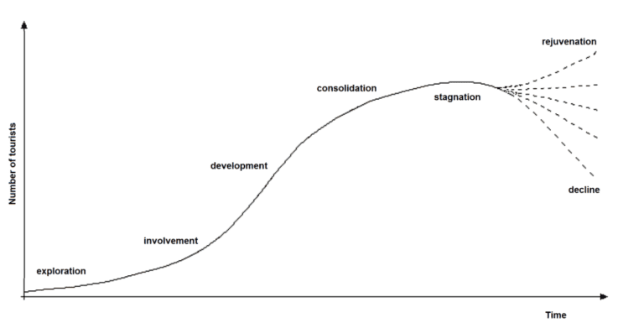
Figure 1 Graphical presentation of the TCL Model (Stantation, 2023)
During the exploration phase, a limited number of travellers initially discover a particular destination. The destination experiences a progressive surge in tourism-related enterprises and infrastructure as an increasing number of visitors commence their visits during the involvement phase (Statista Research Department, 2023). The tourism industry's explosive growth spurs significant investments in accommodations, services, and infrastructure during the development phase. At the consolidation stage, the number of visitors and the state of tourism facilities are at their maximum capacity. However, due to saturation, the destination encounters stability or a minor decline in tourism during the stagnation phase. Inadequate management may lead to a decrease in tourism to the destination as visitors opt for alternative locations.
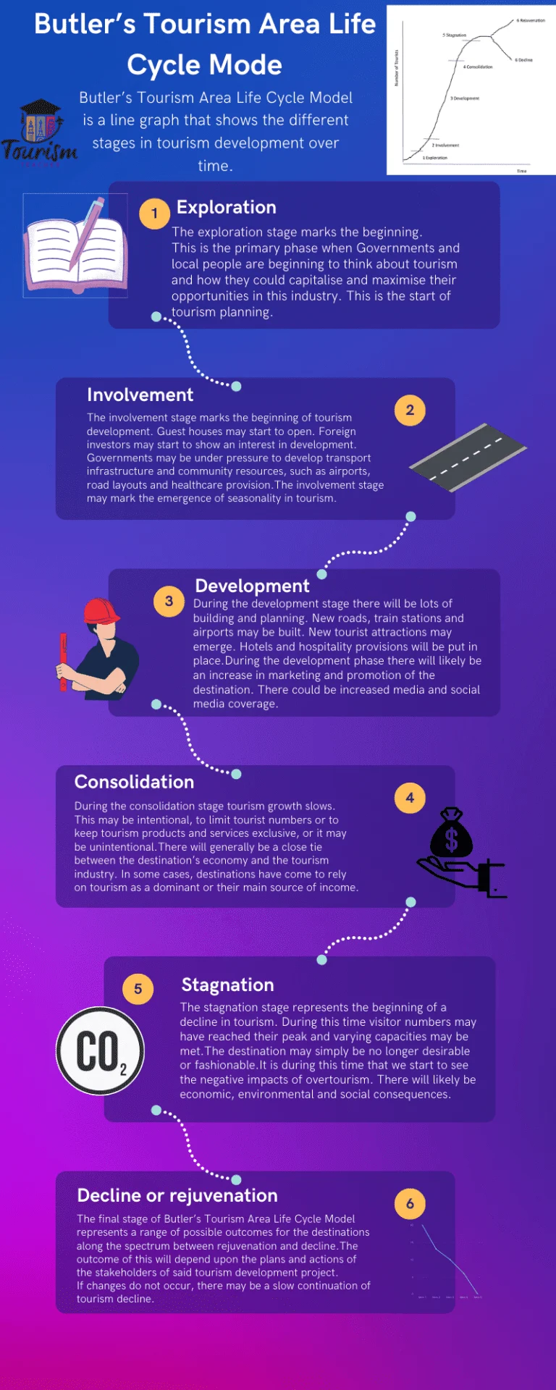
Figure 2 Stages in Tourism Development (Stantation, 2023)
The TALC model can be used to examine sustainability opportunities and challenges at various life cycle phases in the context of green hospitality. Costa Rica's tourism sector employs a perfect application of the TALC model. Early eco-tourists discovered the country's natural beauty during the exploration phase. Involvement resulted in a steady rise in infrastructure and visitor numbers, and during the construction stage, substantial expenditure was made on environmentally friendly lodging. Currently, Costa Rica must deal with consolidation and possible stagnation brought on by worries about over tourism. The nation has retained its allure by implementing green hospitality practices at every level. It supports environmental sustainability by providing eco-lodges, eco-tourism experiences, and wildlife conservation programs (Tsukanova, 2023).

Conclusion
In conclusion, the report has addressed the future of hospitality and whether it is profitable for Costa Rica's hospitality sector. From the findings based on research from various sources, the future of hospitality is green since most of the stakeholders are embracing sustainability initiatives. The financial implications to be incurred through implementing sustainability initiatives are low compared to the long-term benefits organisations that embrace the practice are set to gain. The Irridex model provides a roadmap for the sector to embrace profitability and sustainability. Moreover, by implementing the TALC model in the context of green hospitality, locations and enterprises can proactively strategies for sustainability, modifying their operations at each phase to mitigate the challenges while conserving their ecological and cultural principles.

References

Batabyal, D. (2018). Managing sustainable tourism resources. IGI Global.
Brende, B., and Sternfels, B. (2022, June 7). Resilience for sustainable, inclusive growth. McKinsey and Company. https://www.mckinsey.com/capabilities/risk-and-resilience/our-insights/resilience-for-sustainable-inclusive-growth
Chen, M.H., Wei, H., Wei, M., Huang, H. and Su, C.H.J., 2021. Modeling a green supply chain in the hotel industry: An evolutionary game theory approach. International Journal of Hospitality Management, 92, p.102716. https://www.sciencedirect.com/science/article/pii/S0278431920302681
Cheung, J., Nowak,, C., Fillare,, C., Gonzalez-Wertz,, C., Orrell,, G., and Peterson,, S. (2022, April 7). 2022 sustainability consumer research: Sustainability and profitability. IBM. https://www.ibm.com/thought-leadership/institute-business-value/en-us/report/2022-sustainability-consumer-research
Claar, S. K. (2021, October 6). Sustainability in the hospitality industry: Challenges and opportunities. Cornell SC Johnson. https://business.cornell.edu/hub/2021/10/06/sustainability-in-the-hospitality-industry-challenges-and-opportunities/
Costa, V., & Costa, C. (2022). Sustainability and competitiveness in the hospitality industry. IGI Global.
Cottam, S. (2022, August 15). Sustainability in hospitality: The key challenges and opportunities. Les Roches. https://lesroches.edu/blog/sustainability-in-hospitality-the-key-challenges-and-opportunities/
David L., and Edgell, S. (2020). Managing sustainable tourism: A legacy for the future.
de Jager, A.E. and Nicolau, M.D. (2020). Opening the Door for Wider Application of the Tourism Area Life Cycle Model with Application to the Rietvlei Nature Reserve, Tshwane, South Africa . African Journal of Hospitality, Tourism and Leisure, 9(6):912-929. DOI: https://doi.org/10.46222/ajhtl.19770720-59
Ecobnb. (2023, May 8). Green hospitality: Sustainable practices for hotels. https://ecobnb.com/blog/2023/05/green-hospitality-sustainable-practices-hotels-resorts/
Floričić, T., 2020. Sustainable solutions in the hospitality industry and competitiveness context of "green hotels". Civil Engineering Journal, 6(6), pp.1104-1113. https://scholar.archive.org/work/7hl237oyurevnk4zlcm7w7ctfa/access/wayback/https://www.civilejournal.org/index.php/cej/article/download/2171/pdf
Gleißner, W., Günther, T., and Walkshäusl, C. (2022, February 21). Financial sustainability: Measurement and empirical evidence. SpringerLink. https://link.springer.com/article/10.1007/s11573-022-01081-0
Jauhari, V. (2021). Managing sustainability in the hospitality and tourism industry: Paradigms and directions for the future (9th ed.). Oakville: Apple Academic Press. Inc
Korstanje, M., George, B., & Nedelea, A. (2020). Strategies for promoting sustainable hospitality and tourism services. IGI Global.
Maryville University. (2021, May 5). Going green: Benefits of sustainability in business. Maryville Online. https://online.maryville.edu/blog/importance-of-environmental-awareness-when-running-a-business/
Neuenburg, J., and Kowalewski, D. (2022, February 18). Sustainable growth in hospitality. Accenture. https://www.accenture.com/us-en/insights/travel/sustainability-hospitality
Oseguera, J.A. (Oso) (2023) How Costa Rica is leading the way in Sustainable Tourism, TravelPulse. Available at: https://www.travelpulse.com/news/destinations/how-costa-rica-is-leading-the-way-in-sustainable-tourism (Accessed: 12 November 2023).
Pavlić, V., and Portolan, A. (2016, January 1). Irritation index. SpringerLink. https://link.springer.com/referenceworkentry/10.1007/978-3-319-01384-8_564
Stantation, H. (2023, October 2). Butler's Tourism Area Life Cycle Model: A simple explanation. Tourism Teacher. https://tourismteacher.com/butlers-tourism-area-life-cycle-model/
Statista Research Department. (2023, January 3). Topic: Sustainable tourism worldwide. Statista. https://www.statista.com/topics/1916/green-tourism/#topicOverview
Times, T. (2023) Costa Rica sets example for sustainable tourism practices, The Tico Times | Costa Rica News | Travel | Real Estate. Available at: https://ticotimes.net/2023/08/07/costa-rica-sets-example-for-sustainable-tourism-practices (Accessed: 12 November 2023).
Tsukanova, T. (2023). Hospitality trends 2023: The future ahead. Hospitality News and Business Insights by EHL. https://hospitalityinsights.ehl.edu/hospitality-trends-2023-future

