

Applied Leadership and Management in the Workplace
Module Assignment Submission
Student Name: | Michael Jones
Student Number: | 2515577
Module No: | BMSK4014
Module Title: | Problem Solving and Decision Making

Statement of Confirmation of Authenticity
By the act of making this submission, the student declares that this is the work of the student named above. The work has not, in whole or in part, been knowingly presented elsewhere for assessment, or where assessment has been built on a previous assessment, this has been identified. Where materials have been used from other sources it has been properly acknowledged. If this statement is untrue, the student acknowledges that an assessment offence has been committed.
Attention is drawn to the plagiarism and unfair practice policies of both the University and of ILM.

Acknowledgement of Generative AI Use I acknowledge the use of co-pilot to support the development of this assignment. I used the tool specifically to check spelling, place references in alphabetical order.
I did not use the tool to produce the work, replace evidence, analysis, calculations or final conclusions presented in this assignment. I checked and edited any suggested content and remain responsible for the accuracy, originality and final submission.

Contents
1. Introduction: A complex workplace problem 3
1.1. Scope 3
1.2. Impact 3
2. Identifying and analysing information to make informed decisions 4
2.1 Brainstorming 4
2.2 Mind Mapping 5
2.3 Fishbone/Ishikawa Analysis 6
2.4. Five Whys 6
3. Potential solutions to the problem 7
4. Utilising decision-making techniques to evaluate solutions and evidence the most appropriate solutions 8
4.1. Weighted Grid Analysis 8
4.2. Proposed Solution 8
5. Implementation Plan/Turning solutions into plans to solve the problem 11
6. Overview of solution for stakeholders 12
7. Monitoring and review 12
8. Conclusion 13
9. References 14
10. Appendices 16
A. Potential Solutions to the Problem Table 16
B. Weighted Grid Analysis 17
C. Cost Benefit Analysis Table 17
D. Overview of Decisions for Stakeholders 18
E. Monitoring Table 19
F. Review Trigger Table 20

Introduction: A complex workplace problem
‘Towy Water’, a major provider of potable and wastewater services across the Gwynfe catchment and surrounding areas, is experiencing repeated bursts on a rising main that would not ordinarily be expected to fail at this stage of its lifecycle. The asset has suffered seven bursts within the past twelve months, occurring approximately twenty years earlier than build-modelling predicts for a ductile iron main of this specification. The pipe, installed in 1996, is a 150mm ductile iron rising main with an anticipated operational lifespan of fifty years. External factors such as ground movement during dry periods and accidental strikes by other utilities have been ruled out as contributing causes. This pattern of premature failure therefore represents a significant anomaly, requiring a structured, evidence-based problem-solving approach to identify the root cause and determine an appropriate solution.

1.1. Scope
Gwynfe main is a 150mm ductile iron pipe, that is 4 kilometres in length and has an operating pressure of 6.3bar. The main runs predominantly through agricultural land, access for repairs has proven challenging. This has been compounded during winter bursts due to wet ground conditions and the depth of the main, the main is 1.2m-5.3m deep. A particularly challenging repair has been carried out underneath the River Gwynfe, at a depth of 5.3m. Utilising directional drilling the team replaced, 30m of 150mm ductile iron, below the River Gwynfe, it was noted during the repair that the crown of the pipework has perished, finding a good end to make the new connections proved challenging due to the poor condition of the crown.

1.2. Impact
The bursts have the potential to cause pollution incidents to the River Gwynfe and a tributary known as the River Sawdde, a 1.2km section of the main passes under a site of special scientific interest (SSSI). Access to the majority of the main is via 6 separate farms and each repair has caused repairable damage to agricultural land and crops, this has led to substantial compensation claims and customer dissatisfaction. Leakage inspector burnout, repair contractor pressure and cost caused by this main is having an impact on business-as-usual service. Overtime, repair and maintenance cost pressures have been considerable and have taken us over budget on both measures, 7 months into the financial year.

Identifying and analysing information to make informed decisions
Significant resource and effort have been applied to gather information related to this problem. To ensure the information is assessed appropriately, and the best chance of the correct solution is applied I will apply four problem-solving models to lead in finding potential solutions.

2.1 Brainstorming
This model aids in finding potential causes and effects (Osborn .A.F. 1953). What evidence is needed to prove the theory or idea before they are judged.

Potential Causes | Evidence Needed | Potential Solutions
Pressure variations inside the main. | Internal pipe pressure measurements, for a period of no less than 7 days | Soft start pumps (variable speed drives). Proof that the air valves on the rising main are operating as designed.
Air valves not operating as designed. | Air valve inspections to prove operation, air valve maintenance evidence. | Repair/carry out maintenance/replace if found not to be operating as designed.
Incorrect pipe bedding material used. | Trial holes to be dug at specific location to check pipe bedding materials. | Replace pipe bedding.
Pipe material manufacturing fault. | Remove a section of existing pipework and send to a laboratory for analysis. | Replace pipework.

Brainstorming proved valuable because it enabled open, collaborative idea generation across operational, repair and asset teams. However, the method also demonstrated its limitations, as unstructured contributions can lead participants away from the problem statement unless the facilitator actively redirects discussion toward evidence-based reasoning. The strongest finding from this tool is the air valves not operating as designed.
Pressure readings are available and have been interrogated, they are within expected tolerances as confirmed by the operational team.
The correct pipe bedding material has been seen on all 7 previous burst repairs, as confirmed by the repair contractor team.
The same batch of pipework was used on a main, 16 miles from the Gwynfe main, records found by the asset team prove this. There have been 0, premature failures on this main, compared to the 7 at Gwynfe.
No maintenance cards have been found showing the 9 air valves located on this main have been maintained. The failure of the pipes crown indicates that air trapped at the top of the pipe mixed with H2s found in all pipes carrying this material, is likely contributing/causing the premature failures.

2.2 Mind Mapping
The mind map provided a clear visual structure for organising the problem, enabling relationships between causes, evidence and potential solutions to be identified more readily than through linear text. Although not a tool I typically employ, its effectiveness in supporting visual reasoning suggests it may be beneficial for future problem-solving tasks.
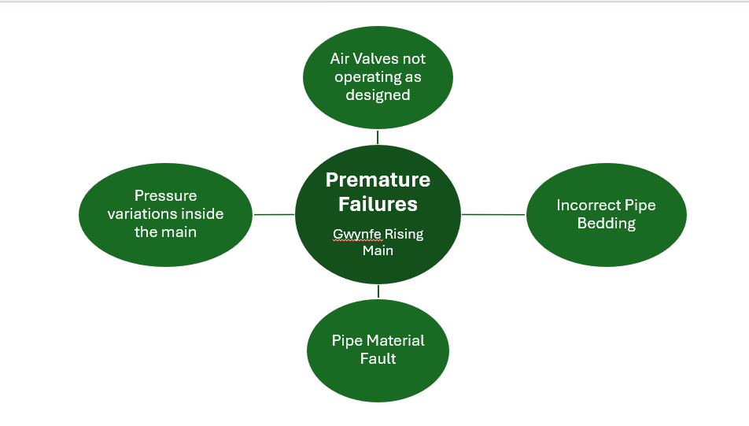
A mind map is valuable because it allows complex information to be organised visually, helping you see relationships between causes, evidence and solutions in a way that linear text often hides (Buzan & Buzan, 1993). This structure supports clearer thinking, reduces cognitive load, and makes it easier to identify the most influential factors driving the problem you are trying to solve.

2.3 Fishbone/Ishikawa Analysis

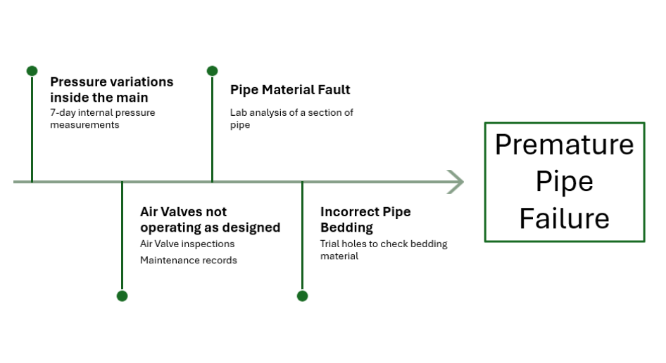
The fishbone analysis offered a systematic framework for categorising potential causes of premature failure across operational, maintenance, installation and material domains. Its structured format supported comparative evaluation of each branch, although the method’s reliance on subjective interpretation reinforces the need for corroborating evidence from field data and maintenance records (Ishikawa, K. 1985).

The fishbone method provides a clear visual structure that helps organise complex operational, installation and material-related factors, making it easier to compare categories such as pressure behaviour, valve performance, bedding quality and pipe material integrity in a single analytical frame. However, its reliance on subjective brainstorming means it cannot confirm causation without supporting evidence, a limitation widely recognised in high-quality reliability literature such as Doggett’s review of root-cause tools in Journal of Quality Technology (2005).

2.4. Five Whys

The ‘five whys’ is a tool I utilise often, it allows a team to constructively challenge one another, when seeking to find the answer to a problem. Once you have gathered and interrogated all the evidence, the five why’s, is in my experience a sober way to answer a question and truly find the problem (Ohno, 1988). The example below shows how implementation of this tool enabled the team and I to dive deeper into the root cause of the air valves failing.

Link | Why question… | Because answer | Supporting evidence…
Why 1 | Why has the main failed several times prematurely? | Due to air valves not operating as designed | On-site investigations prove air valves are not working
Why 2 | Why aren’t the air valves operating as designed? | They have not been maintained | Data search shows maintenance plans removed in 2016
Why 3 | Why have they not been maintained? | Prioritisation of asset maintenance deemed the maintenance low risk | Internal documents
Why 4 | Why was it deemed low risk? | Lack of knowledge/training by the decision maker | Risk matrix document used did not identify the long-term risk
Why 5 | Why is the lack of knowledge/training pertinent in this decision? | Poorly maintained air valves can lead to H2s accumulation in the crown of sections of a main, leading to oxidisation of cast iron main pipes and premature failure of the crown of the pipe. | Manufacturing and industry standards
Root Cause | Failed air valves causing H2s accumulation at the crown of several sections of the Gwynfe main due to a lack of proactive monitoring and maintenance.

After completing the five why’s, our root cause for the main failing is found to be an issue with valves that release air to the atmosphere from within the pipe. Without these air valves operating correctly, oxidisation can occur at the top (crown) of the pipe, leading to rust and eventually pitting at the top of the pipe (Treatment Plant Operator Magazine, 2025).

Potential solutions to the problem
After analysing the problem, reviewing all the evidence and speaking to stakeholders, I am at the point of proposing solutions. I will do this in a table format to allow for easy comparison (Proctor, T. 2005). See Appendix A for Table.

The three solutions all deal with the root-cause, each have different strengths and weaknesses it will require further tools to make an evidence-based decision on the correct solution for this problem, in the next section I will use a weighted grid analysis to make my decision on the correct solution.

Utilising decision-making techniques to evaluate solutions and evidence the most appropriate solutions

Weighted Grid Analysis
A weighted grid analysis is a structured decision tool that scores options against criteria, giving each criterion a deliberate weighting to reflect its real-world importance. It forces clear, evidence-based comparison rather than gut instinct, making the strongest option stand out through transparent scoring. It’s particularly effective when multiple stakeholders need to agree on a justified, defensible choice. Turning solutions into plans to solve the problem (Farmani et al., 2017). The table is included in Appendix B.
Re-writing and activating a lighter maintenance plan have scored the highest, it has a very similar effect on the root cause as re-activating the existing, intrusive maintenance plans at a lower on-going cost. Replacing the whole pipe has scored the lowest, this is due to the high cost and lack of control over its approval. It is also by far the most complex way to solve this problem and could potentially lead to funding being taken away from other high-priority asset replacement work that has been scoped and budgeted for, in this Asset Maintenance plan cycle.

Proposed Solution
After thorough and reasoned problem-solving tools have been applied to the problem, a solution has been chosen, this solution is to re-write and activate, periodic air valve maintenance. To further analyse this solution a cost benefit analysis will be completed for a 3-year period, (Boardman et al., 2018), this is to ensure the solution is affordable and saves money when compared to the current state. There will also be non-monetary costs associated with this solution, staff morale has been impacted by the repeated bursts, repair contractor availability has been severely depleted due to the time and complexity of repairing the bursts, this has raised the risks on other jobs and caused a backlog of planned preventative work, which has again raised the risk on known problem assets. The team has gone over budget on repair and maintenance budget seven months into the financial year, the overspend is directly attributable to the repeated bursts at Gwynfe. See Appendix C, for cost benefit analysis table.
After gathering these figures, I can work out the 3-year cost of the solution and any cost benefits associated, the next table shows the 3-year expenditure of the solution.
Costs £ | Year 1 | Year 2 | Year 3 | Total
Re-writing maintenance plans | 6,000.00 | -- | -- | 6,000.00
Re-activating maintenance plans | 3,000.00 | -- | -- | 3,000.00
Contractor Labour costs | 12,000.00 | 12,000.00 | 12,000.00 | 36,000.00
Broken air valves | 9,000.00 | -- | -- | 9,000.00
Total costs | 30,000.00 | 12,000.00 | 12,000.00 | 54,000.00

The total cost of the solution over a three-year period is £54,000.00. With a year 1 cost of £30,000.00 dropping to £12,000.00 for year 2 and year 3. In the next table the current state costs are calculated in preparation to complete a cost benefit analysis.

Current cost | Amount £ |  | Source of costs |  | One off/Annually recurring
Mains repair (contractor cost) | 30,000.00 |  | Previous repairs |  | Annually Recurring
Mains repair (internal cost) | 10,000.00 |  | Previous repairs |  | Annually Recurring
Regulatory fines | 100,000.00 |  | Previous repairs |  | Annually Recurring
Compensation payments to customers | 3,000.00 |  | Previous repairs |  | Annually Recurring
Total |  | 143,000.00

The annual cost of repair, fines and compensation payments of the Gwynfe main is £143,000.00, each cost calculated is annually recurring, giving a 3-year cost of £429,000.00. Further non-monetary costs can be assumed from this chart such as the reputational damage that is being done. The regulator and customers are not being well served by this pipe repeatedly bursting and it can be assumed that this is having a detrimental effect on the company’s reputation.
With the costs and benefits now calculated, it is possible to produce the net annual benefit of the solution.
Year | Yearly benefits | Yearly costs | Net annual benefit
Year 1 | 143,000.00 | 30,000.00 | 113,000.00
Year 2 | 143,000.00 | 12,000.00 | 131,000.00
Year 3 | 143,000.00 | 12,000.00 | 131,000.00
Total | 429,000.00 | 54,000.00 | 375,000.00

Even with higher costs in the first year of £30,000.00 the solution begins to pay itself back in the second financial quarter of year 1. The higher year 1 cost is down to the initial set up and re-writing of the maintenance plans and expected repairs to the existing air valves. This smooths out to a cost of £12,000.00 per annum for the following 2 years. Leading to a net annual benefit in year’s 2 and 3 of £131,000.00.
Over the 3-year period calculated the solution returns an average of £125,000.00 per annum (£429,000.00 - £54,000.00 / 3 = £125,000.00 per annum).
As a return on investment or a benefit to cost ratio the solution returns 694% on the investment (£429,000.00 – £54,000.00) / £54,000.00 * 100 = 694%).
The initial investment is demonstrated to be robust, delivering a rapid financial return and achieving £6.94 for every £1 spent. While also generating significant non-monetary value through enhanced staff morale, reduced operational risk in planned work, and strengthened customer and regulatory confidence.
A sensitivity analysis of the initial return was completed to assess how the solution performs under less favourable financial assumptions and is demonstrated in this table.
 | Calculation | Adjusted Value (£) | Calculation | New Ratio (£ per £1 spent)
Test A: Initial Benefits Reduced by 30% | 429,00 x 0.7 | 300,300 | 300,300/54,000 | 5.56
Test B: Initial Costs Increased by 20% | 54,000 x 1.2 | 64,800 | 300,300/64,800 | 4.60

When total predicted benefits were reduced by 30%, the adjusted benefit fell to £300,300, producing a return of £5.56 for every £1 spent. Increasing total costs by 20% raised expenditure to £64,800, and when combined with the reduced benefit figure, the return remained positive at £4.60 per £1 invested. As both ratios exceed 1, the solution continues to generate net financial value, even under adverse scenarios, demonstrating strong resilience and confirming the robustness of the proposed approach.

Implementation Plan/Turning solutions into plans to solve the problem
Now the solution has been found and costed a detailed plan is needed to execute the delivery.
A GANTT chart will be the document that will under pin delivery.
Progress meetings will be held daily on week 1, to focus the team on achieving the early milestones, then will be held once a week in weeks 2,3 and 4 moving to monthly for the remainder of the year.
The programme allows for some task slippage, engaging the contractor in week 1 is a pivotal step in the programme, any slippage in this step may cause the programme to run over. Land entry notices completed by the contractor require a 21-day notice period.
The Operational Delivery Team (OPS) and the SAP delivery team are internal teams and will be involved from day 1, meeting number 1. The Contractor delivery team (CON) will be involved from the Thursday of week 1 and will attend all subsequent meetings.
Activity | W1 | W2 | W3 | W4 | W5-52
Progress meetings | DAILY |  |  |  | Monthly
Re-write maintenance plans (OPS)
Re-activate maintenance plans (SAP)
Employ Contactor services (OPS)
Order materials (CON)
Train contractors (OPS)
Contact affected land owners (CON)
Regulator updates (OPS)
Work on site commences (CON)

The GANTT chart will serve as a point of reference for all teams involved, to guide the solution to a successful and timely delivery. The battle rhythm of daily, weekly, monthly meetings will allow for accountability for each part of the solution that has been given to a team, it will highlight if any part of the plan is failing and show its effect on the other parties involved in the delivery.

Overview of solution for stakeholders
The burst pipe in Gwynfe has affected several stakeholders, this has the potential to affect the businesses reputation, incur regulatory fines and customer claims (Sinaei, A. et.al 2025). It also adds to the workload of internal teams. Communicating the solution to all stakeholders and understanding the power or influence they have against their interest will be fundamental in achieving a successful outcome (Mitchell et al.,1997). See Appendix D for table.

Clear stakeholder communication is essential because it aligns expectations, reduces resistance, and ensures each group understands how the programme of works affects their interests and responsibilities. When power and interest are mapped effectively, engagement can be targeted to prevent reputational harm, regulatory challenge, and operational disruption. Strong, structured communication also supports project success by maintaining trust and reducing ambiguity across all parties involved (Dolana et,al 2025).

Monitoring and review
Monitoring and reviewing a solution is vital because it ensures the intervention is delivering the intended outcomes. It allows for early identification of deviations and provides evidence for timely corrective action. It also strengthens decision-making by linking real-world performance data to future planning (Ateş, B & Eirgash, M. A.2025). Preventing repeat failures and supporting continuous improvement. This reflective cycle is essential for demonstrating control, accountability, and sustained operational effectiveness. Please find the monitoring table in Appendix E.

Utilising SMART goals to monitor delivery will give the teams a strong chance of completing on time and the ability to identify any slippage in the delivery programme (Doran, G. T. 1981). In conjunction with the monitoring points utilising a set of review points into the programme gives further incite and control over the project (Farhad et al., 2026). Please find the review trigger table in Appendix F.

With a short initial delivery time and the challenges of resource constraints and changing priorities that affect frontline operational teams, utilising SMART goals that prioritise outputs, a robust, evidence-based monitoring and review structure provides the tools for a successful outcome (Proctor T., 2005).

Conclusion

The problem investigated was the repeated premature bursts on the Gwynfe rising main, which structured analysis demonstrated, were primarily driven by air valves not operating as designed. After applying several decision-making tools, the most appropriate solution identified was to re-write and activate a periodic air-valve maintenance plan, supported by transparent costings and a strong return on investment. The intended improvement is a sustained reduction in bursts, pollution incidents and operational pressure, delivered through a controlled, SMART-aligned monitoring and review process that enhances reliability, protects the environment and strengthens confidence among stakeholders.

References

Ateş, B., & Eirgash, M. A. (2025). Proactive and Data-Driven Decision-Making Using Earned Value Analysis in Infrastructure Projects. Buildings, 15(14), 2388. https://doi.org/10.3390/buildings15142388

Boardman, A. E., Greenberg, D. H., Vining, A. R., & Weimer, D. L. (2018). Cost–benefit analysis: Concepts and practice (5th ed.). Cambridge University Press.

Buzan, T., & Buzan, B. (1993). The mind map book. BBC Books.
Dolan, K. J., James, A., & Smith, A. (2025, July 28). Stakeholder engagement in large infrastructure projects. Australian Journal of Multi-Disciplinary Engineering; Taylor & Francis. https://www.tandfonline.com/doi/full/10.1080/14488388.2025.2538901

Doggett, A. M. (2005). Root cause analysis: A framework for tool selection. Journal of Quality Technology, 37(1), 14–26.

Doran, G. T. (1981). There’s a S.M.A.R.T. way to write management’s goals and objectives. Management Review, 70(11), 35–36.
Farmani, R., Kakoudakis, K., Behzadian, K., & Butler, D. (2017). Pipe Failure Prediction in Water Distribution Systems Considering Static and Dynamic Factors. Procedia Engineering, 186, 117–126. https://doi.org/10.1016/j.proeng.2017.03.217

Farhad, V. P. K. M. H. Q., Pantea Kazemi, V., Hamid, M., & Farhad, Q. (2026). Spatial Vulnerability of Surface Water: A Sensitivity Analysis Approach. Water Resources Management: An International Journal, Published for the European Water Resources Association (EWRA), 40(3), 1–19. https://econpapers.repec.org/article/sprwaterr/v_3a40_3ay_3a2026_3ai_3a3_3ad_3a10.1007_5fs11269-025-04392-3.htm
Ishikawa, K. (1985). What is total quality control? The Japanese way. Prentice Hall.

Mitchell, R. K., Agle, B. R., & Wood, D. J. (1997). Toward a theory of stakeholder identification and salience: Defining the principle of who and what really counts. Academy of Management Review, 22(4), 853–886.
Ohno, T. (1988). Toyota production system: Beyond large-scale production. Productivity Press.

Osborn, A. F. (1953). Applied imagination: Principles and procedures of creative problem-solving. Charles Scribner’s Sons.
Project metrics, S. (2025). SMART Objectives and Goals: Predictive Strategy| TrueProject. Trueprojectinsight.Com. https://www.trueprojectinsight.com/blog/project-office/smart-objectives-and-goals

Proctor, T. (2005). Creative problem solving for managers: Developing skills for decision making and innovation (2nd ed.). Routledge.
Sinaei, A., Dziedzic, R., & Creaco, E. (2025). Holistic Assessment of Social, Environmental and Economic Impacts of Pipe Breaks: The Case Study of Vancouver. Water, 17(2), 252. https://doi.org/10.3390/w17020252

Appendices

Potential Solutions to the Problem Table
 | Options | Description | Effect on root cause | Costs | Risks and barriers
1 | Re-activate air valve maintenance plans. | A simple admin process. | Regular site visits to maintain/replace any faulty air valves, allowing the release of air from the pipework and stopping further corrosion and bursts. | Minimal admin cost to re-activate the plans.  Significant resource cost in the initial stages for onsite teams and materials.  On-going costs will be high. | No defined budget code to allocate costs  Resource needed is not in place; contractors would be needed and training for the maintenance teams (skilled work).
2 | Re-write the maintenance plans, with a less intrusive maintenance plan. | A simple admin process. | Regular site visits to check operation of the air valves and report any faults, allowing the release of air from the pipework and stopping further corrosion and bursts. | Minimal admin cost to re-activate the plans  Significant resource cost in the initial stages for onsite teams and materials.  On-going costs will be affordable. | No defined budget code to allocate costs  Resource needed is not in place; contractors would be needed and training for the maintenance teams (unskilled work).
3 | Replace the main and the air valves. | Secure capital funding to replace the 6km of pipework and the 9 air valves. | Replacement of the whole pipe, including the air valves, removes any risk of pipe bursts. | Multi-million pound solution. | Multi-stakeholder buy in needed.  Would have a significant impact on the AMP budget profile and affect the completion of other vital projects.

B. Weighted Grid Analysis
Option | Affect | Cost | Control | Time | Unweighted total | Weighted total
Weight | X 5 | X 5 | X 3 | X 3
Re-activate maintenance plan | 3 (15) | 5 (25) | 3 (9) | 5 (15) | 16 | 64
Re-write and activate maintenance plan | 3 (15) | 5 (25) | 4 (12) | 5 (15) | 17 | 67
Replace pipework and air valves | 5 (25) | 1 (5) | 0 (0) | 1 (3) | 7 | 33

C. Cost Benefit Analysis Table
Costs | Amount in £ | Source of Cost | Direct/Indirect/Hidden/  Recurring cost
Re-writing maintenance plans | 6,000.00 | OPS team costs (internal budget transfer) | Direct
Activating maintenance plans | 3,000.00 | SAP team costs (internal budget transfer) | Direct
Contractor labour costs | 12,000.00 | Schedule of contractor rates | Recurring
Broken air valves | 9,000.00 | Direct contractor quotation | Hidden

D. Overview of Decisions for Stakeholders
Stakeholder | Power | Interest | Expected Outcome | Method, Frequency
Regulator | High | High | Reduction in Pipe Burst and pollution events | Formal, weekly until week 5 of the programme, ad-hoc once programme has been delivered
Landowners | High | High | Reduction in Pipe Burst and entry onto land | Formal (land entry notices), informal face to face explanation of the plan and expected outcome.
Local Community | Low | High | Reduction in Pipe Burst and consistent water supply | Informal, signage in the local area and social media interaction prior and during work.
Internal Teams | High | Low | Reduction in Pipe Burst, on time and on budget delivery | Formal and informal, weekly updates until week 5 of the programme, ad-hoc once the programme has been delivered

E. Monitoring Table
Measure | Current State | Desired State | Frequency | Task Owner | Supporting Data | Action if task deviates
Reduction in pipe bursts | 7 bursts per annum | 0 bursts per annum | Monthly updates | OPS | Repair work orders | Carry out a full review of what caused the burst
Reduction in Pollution incidents | 7 per annum | 0 per annum | Monthly Updates | OPS | Pollution Storyboards | Carry out a full review of what caused the pollution.
Redudtion in costs | £143,000.00 | £12,000.00 | Year 2 Contractor bill | OPS/CON | Contractor invoice | Review invoice to understand extra costs.
On time delivery | Five week initial delivery plan, followed by monthly planned inspections. | Programme delivered on time | Daily meetings week 1, weekly meetings week 2-5, monthly meetings thereafter | OPS/CON/SAP | GANTT chart compliance | Alter GANTT chart, challenge delivery failure with responsible team

F. Review Trigger Table
Review Trigger | Period | Decision | Partcipants
First stage GANTT implementation | Weeks 1-2 of programme | Can on site work commence on week 5 of the programme | OPS/SAP/CON
Midpoint stage GANTT implementation | Weeks 3-4 of programme | Will materials arrive for week 5 of the programme | OPS/CON
Final stage GANTT chart implementation | Week 5-52 | Is training adequate, are we seeing a reduction in bursts | OPS/CON
Post GANTT chart implementation | Week 52 | Full review of current position, successes, challenges of the current programme | OPS/CON

