August 18, 2025
Judit Konecsny-Varga (2411527)
2411527
School of Applied Computing
Creativity and Changemakers
Assignment 2: Project management and innovation

Table of Contents
Introduction 2
Project management 3
Project Management & Planning 3
Project Design 5
Enterprise and Innovation 7
Enterprise 7
Project reflection 10
Conclusion 11
References 12

Introduction

This report outlines a project plan for evaluating existing library applications to inform the development of an innovative, user-centred digital library platform for Swansea City Council. The project focuses on assessing 3–5 popular library apps such as Libby and OverDrive, using structured usability and performance evaluation methods to identify strengths, weaknesses, and key areas for improvement. The goal is to propose a digital solution that enhances library access, supports community literacy, and aligns with Swansea’s digital inclusion objectives.
The Project Management and Planning section details the structured timeline, resource requirements, and the methodologies of Design Thinking and heuristic analysis used to guide the app evaluation. Tools like Nielsen’s heuristics, the SUS scale, and Lighthouse will be employed for a rigorous assessment, while a Gantt chart created in Monday.com provides visual clarity of project stages.
The Enterprise and Innovation section explores the business case for the proposed app, E-LibrarySwansea. This includes a PEST and SWOT analysis of the current market, legal and ethical considerations, and a sustainable funding model involving public grants, council partnerships, and community support.
Finally, the Project Reflection addresses the challenges encountered during planning of time constraints, device variability, and data reliability, and reflects on how the structured approach enables effective decision-making.

Project management

Project Management & Planning

Aiming to assess 3–5 library apps (e.g., Libby, OverDrive) and identify factors influencing usability, efficacy, and performance. [4] [5]

Proposed Solution:
Conduct a literature review, select apps, develop evaluation criteria using heuristics (e.g., Nielsen’s), test usability and performance, analyse data, and compile a report with recommendations.[1] [4]

Required Technologies/Resources:
Android/iOS devices, emulators, UXCam, Appium, Firebase, Lighthouse, Nielsen’s heuristics, SUS scale, Google Scholar, Trello, Excel, and MS Word. [12]

Project Timeline (8 Weeks):

Weeks 1–2: Literature review & framework design

Week 3: App selection & setup

Weeks 4–5: Testing (usability & performance)

Week 6: Data analysis

Week 7: Report writing

Week 8: Final editing & submission [2]

Constraints:

Limited time, device differences, app access issues, data reliability, and scope creep must be managed effectively.

Project scope — definition, examples, and templates

I used Monday.com to create a Gantt chart to document my project stages:
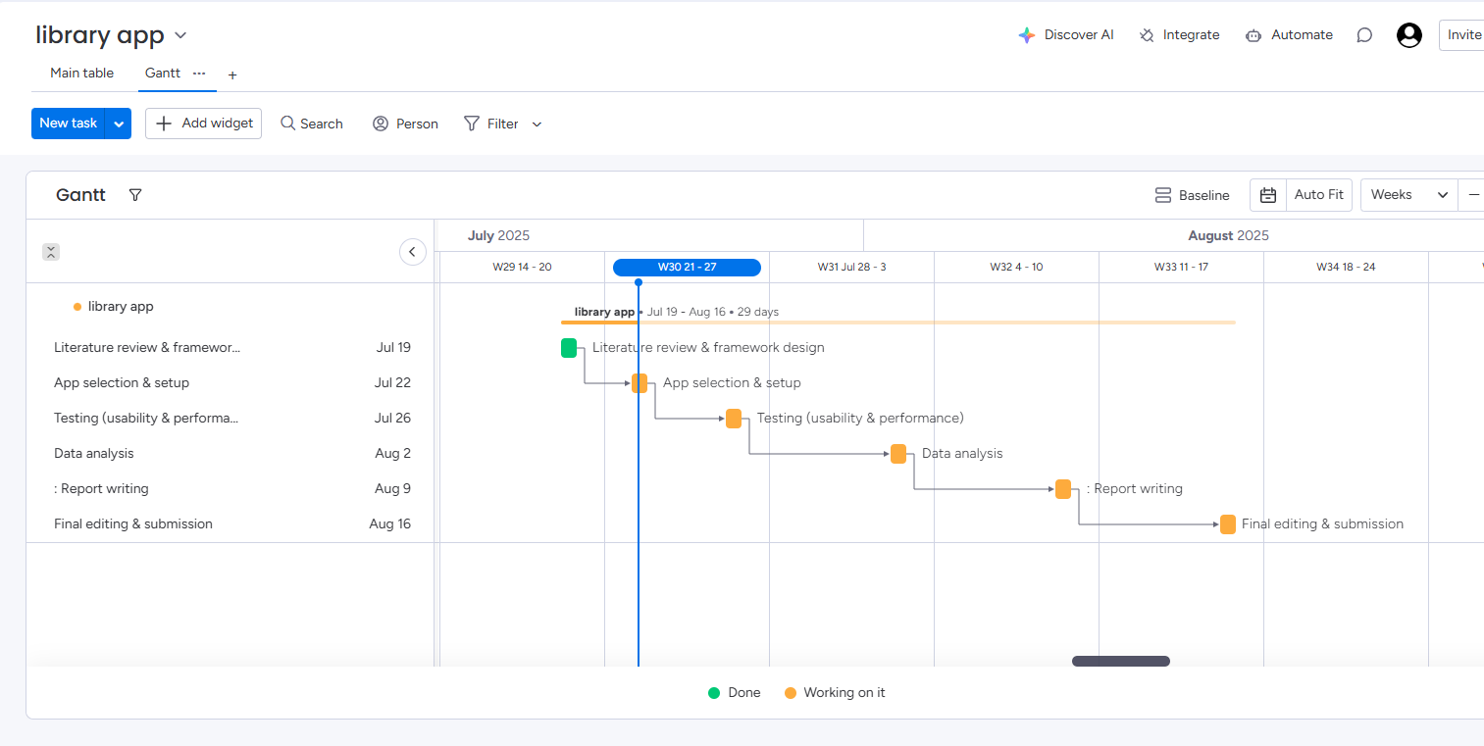
Figure 1. Gantt chart created in Monday.com

A suitable development method for this project is Design Thinking, as it emphasizes user-centred evaluation. The process begins by empathizing with users through surveys and research to understand how library apps are used. Next, the problem is defined by identifying key factors like usability, efficacy, and performance. In the ideation phase, evaluation criteria are developed. [3] This is followed by prototyping, where selected apps are prepared for review. In the testing phase, each app is assessed using the established criteria. Finally, findings are analysed and presented. Design Thinking enables structured, empathetic, and practical assessment of library app effectiveness.[17]

Project Design
Storyboard: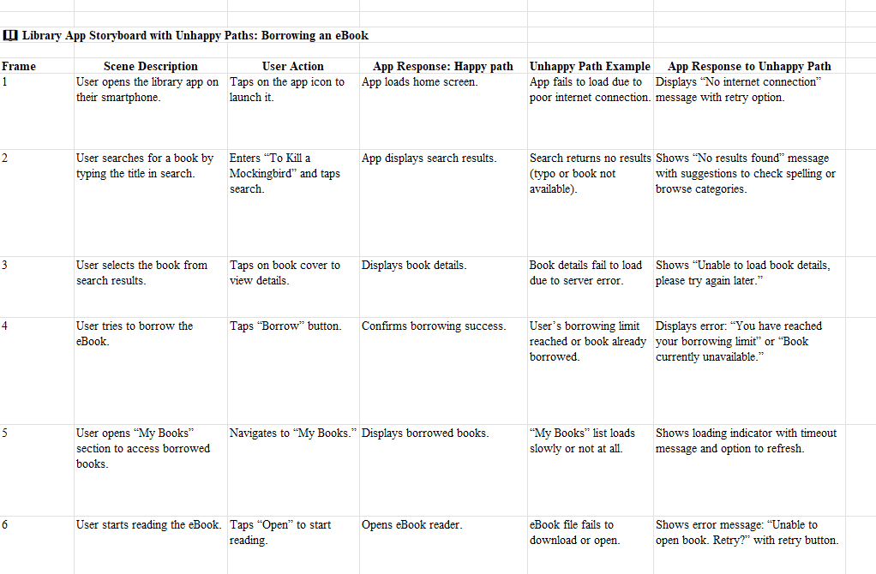

Figure 2. Storyboard showing User borrowing an eBook path [5]

Network structure diagram [7]: 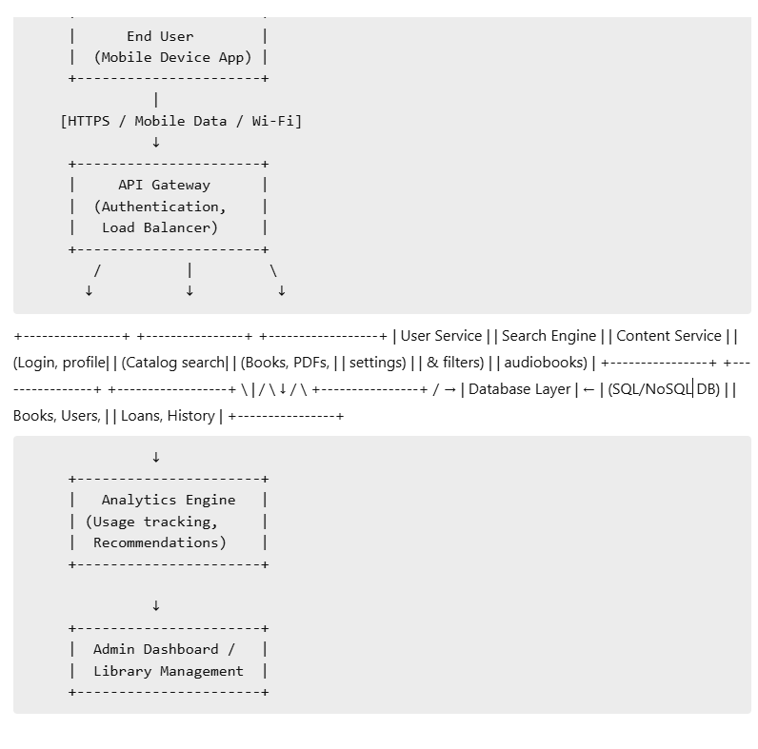
Figure 3. Network structure diagram

Explanation of network structure diagram:

Component | Description
Mobile App | Used by library patrons to search, borrow, and read/listen to content.
API Gateway | Manages traffic, authentication, and routes requests to the correct service.
User Service | Handles user login, account details, and session management.
Search Engine | Indexes and retrieves books based on queries. Supports filters, tags, etc.
Content Service | Delivers eBooks, audiobooks, or PDFs (streaming/download).[7]
Database Layer | Central repository for book metadata, user data, loan records, etc.
Analytics Engine | Collects usage data, generates reading stats, and personalizes recommendations.[8]
Admin Dashboard | Used by librarians/staff to manage content, monitor usage, and run reports.[7] [8]

Enterprise and Innovation

Enterprise
A PEST analysis considers the Libby app’s operational environment from a political, economic, social, and technological point of view. [11] Politically, government support for public libraries and data privacy regulations like GDPR and CCPA shape Libby’s compliance. Educational policies promoting digital learning further enhance its relevance. [12] Economically, fluctuations in public library funding and rising licensing costs may affect content availability, while competition from subscription-based alternatives (e.g., Audible) poses a financial threat.

Social trends highlight increasing demand for mobile reading, though the digital divide remains a concern. Demographic shifts suggest younger users may prefer multimedia formats. [11] Technologically, Libby must ensure compatibility across devices, deliver robust cybersecurity, and enhance app accessibility with features like screen readers and offline access.[12]

A SWOT analysis reveals Libby’s strengths, including free access via libraries, a user-friendly interface, and a wide content catalogue Weaknesses include content availability restrictions due to licensing, dependency on library partnerships, and limited offline functionality. Opportunities lie in expanding globally, improving accessibility, and introducing features like personalized recommendations. [9] Threats include legal disputes over digital lending, strong competition, and the risk of technological obsolescence.[10]

Legal considerations include compliance with copyright laws and DRM, data protection regulations, and digital accessibility mandates like the ADA. Ethically, Libby must address equity in access, particularly for users lacking digital infrastructure. Responsible data practices are essential to avoid misuse of user information. Additionally, maintaining a balance between content availability and censorship concerns is critical to uphold intellectual freedom. [11]

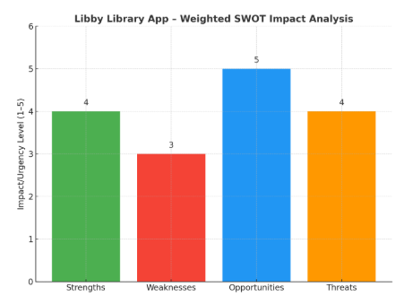Here’s the updated Figure 4. Weighted SWOT analysis graph for the Libby app [10]

Each bar reflects the impact or urgency level of a category:
- Opportunities (5/5): Highest impact—suggests strong potential for growth through accessibility and personalization.
- Strengths (4/5): Key assets like free access and usability are highly beneficial.
- Threats (4/5): Legal risks and tech competition pose serious concerns.
- Weaknesses (3/5): Still important but slightly less urgent than external threats or missed opportunities.
Start-up Name: E-LibrarySwansea
Logo:
A minimalist open book icon with Wi-Fi signal above it, symbolizing digital connectivity and knowledge access.
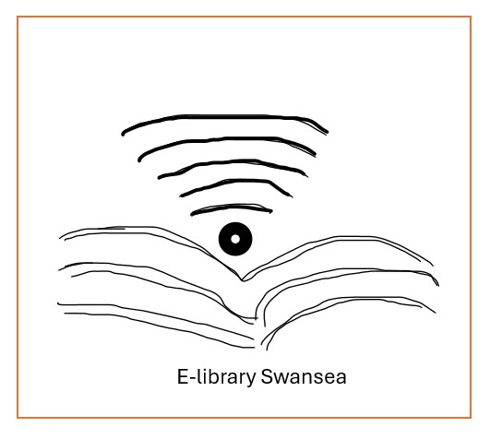
Figure XXX E-LibrarySwansea logo draft idea
Business Type (Legal Classification):
Community Interest Company (CIC) – This structure suits E-LibrarySwansea’s social aim to enhance public library access and literacy in Swansea, while enabling grant eligibility and limited profit distribution to reinvest in community services. [5]
Business Strategy:
E-LibrarySwansea will develop a mobile-first digital library platform in collaboration with Swansea City Council. The app will provide seamless access to library services—eBooks, audiobooks, events, reservations, and educational resources—while integrating smart notifications and AI-powered book recommendations. The focus will be on digital inclusion, targeting underserved communities with offline access and accessibility features for all users. [6]
Funding Initiatives:
Public Sector Funding:
Apply for Welsh Government digital innovation grants, Arts Council Wales.
Council Partnership Model:
Offer E-LibrarySwansea as a subscription SaaS (Software as a Service) to Swansea Council, with pricing based on population and usage metrics.
Corporate Sponsorship & CSR Partnerships:
Engage local businesses and national retailers in Swansea through sponsorships that fund literacy drives and digital access campaigns.
Community Crowdfunding:
Launch a community Kickstarter to generate public support and early user feedback.
Educational Institution Support:
Collaborate with Swansea University and local colleges for joint initiatives and research funding.[7]

Project reflection

Developing a mobile app for Swansea City Library would present an excellent opportunity to enhance my technical and professional skill set while contributing meaningfully to the community. This project is not just a technical task but also a gateway to developing new competencies, understanding user needs, and solving real-world problems through digital innovation.
One of the key ways I would plan to use this opportunity is by expanding my technical skills in mobile app development. While I have some experience with front-end design and web development, building a mobile app from the ground up will require me to learn and apply new tools and technologies such as Koha or Evergreen, Firebase for backend integration, and possibly APIs for digital library systems. [16]I would also aim to strengthen my skills in UX/UI design, ensuring the app is user-friendly, accessible, and inclusive for people of all ages and digital literacy levels. Beyond technical abilities, I hope to improve my project management, problem-solving, and collaboration skills, especially if the project involves liaising with library staff or receiving feedback from real users.
From a societal perspective, this app could have a significant positive impact. Public libraries are vital community resources, but many people are unaware of the full range of services they offer. By creating a mobile app, we can improve accessibility and convenience—allowing users to browse the catalogue, reserve books, receive event updates, and even access digital resources like eBooks or audiobooks. This can be particularly beneficial for users who face mobility issues, are visually impaired, or have limited time to visit the library in person. Moreover, by encouraging digital engagement with the library, the app could help promote literacy, learning, and a stronger sense of community, especially among younger generations who are more accustomed to using mobile devices.
Aside from these benefits, the project will likely encounter several risks and challenges. One significant challenge is ensuring data security and privacy. Since the app may handle user accounts and sensitive information, it will be important to comply with the data protection regulations of GDPR. To mitigate this, I would prioritise secure coding practices, encrypt user data, and consult legal or institutional guidelines on data handling.[17]
Another challenge is ensuring that the app is accessible and inclusive. This includes designing for users with disabilities and accommodating different languages where necessary. To address this, I will follow the accessibility guidelines of Web Content Accessibility Guidelines (WCAG) standards during the design phase and conduct user testing with a diverse range of participants to gather feedback and improve usability.[18]
A third potential challenge is integration with the existing library system. Public libraries often use specific management software for inventory and user accounts, and these systems may not have open APIs or might be complex to work with. To reduce this risk, I plan to engage early with library IT staff, understand their current systems, and explore workarounds such as scheduled data syncs or read-only features if full integration proves too complex within the project timeline.

The project might not only be a personal technical challenge, but it is also a meaningful opportunity to create something that benefits the community. By learning new technologies, working on a real-world problem, and considering both user needs and technical constraints, this project would play a significant role in my development as a software developer.

Conclusion
This report has presented a structured approach to evaluating existing library applications to support the proposed development of E-LibrarySwansea, a digital library platform for Swansea City Council. The project outlined plans for the assessment of 3–5 established apps through literature review, heuristic evaluation, and usability testing to identify usability factors and performance gaps relevant to future app development.
Design Thinking is applied to guide the app evaluation process, ensuring a user-centred methodology. Standardized tools such as Nielsen’s heuristics, the SUS scale, and Lighthouse are utilized to establish consistent evaluation criteria. The 8-week timeline was presented in the planning section, along with a network structure diagram.
The enterprise component has addressed market positioning through PEST and SWOT analyses, and the report has proposed the Community Interest Company (CIC) structure and a diverse funding model to support the app’s long-term viability. Constraints of time limitations and device variability have been acknowledged and followed by mitigation strategies incorporated into the project plan.

References
[1]
M. Derghan, “Management of Best Practices in Multinational Companies: Starbuck’s Best Practices in The Lebanese Market,” Technium Business and Management, vol. 2, no. 3, pp. 116–123, Nov. 2022, doi: https://doi.org/10.47577/business.v2i3.7901.
[2]
Muhardi Saputra, Devi Pratami, and A. Muhammad, “Expediting Multiple Projects Timelines with State-of-the-Art Dashboard Management Systems to Improving Efficiency and Minimizing Delays,” pp. 209–214, Nov. 2024, doi: https://doi.org/10.1109/incit63192.2024.10810524.
[3]
Interaction Design Foundation, “What is Design Thinking?” The Interaction Design Foundation, 2019. https://www.interaction-design.org/literature/topics/design-thinking
[4]
R. Purohit, “Building an App Like Libby: The Complete Guide to Creating a Digital Library Platform,” Dhiwise.com, Jun. 16, 2025. https://www.dhiwise.com/post/how-to-build-a-digital-library-app-like-libby (accessed Aug. 05, 2025).
[5]
“How to Create a Story Board? | Figma,” Figma, 2023. https://www.figma.com/resource-library/how-to-create-a-ux-storyboard/
[6]
A. Kumar, “Software Requirements Specification LIBRARY MANAGEMENT SYSTEM Slot-C1 Library Management System SRS Document,” Academia.edu, Nov. 09, 2017. https://www.academia.edu/35100170/Software_Requirements_Specification_LIBRARY_MANAGEMENT_SYSTEM_Slot_C1_Library_Management_System_SRS_Document#outer_page_3 (accessed Aug. 05, 2025).
[7]
Intellectsoft Team, “Basics: Mobile App Architecture & How to Start Building One,” Intellectsoft Blog, Apr. 17, 2019. https://www.intellectsoft.net/blog/mobile-app-architecture/
[8]
“Mobile App Architecture: Types & Best Practices In 2024,” inkbotdesign.com, Feb. 02, 2024. https://inkbotdesign.com/mobile-app-architecture/
[9]
“The SWOT analysis of a mobile app (with examples),” BusinessDojo, Nov. 21, 2023. https://dojobusiness.com/blogs/news/mobile-app-swot
[10]
A. C. Dantas et al., “Strengths, weaknesses, opportunities and threats of mobile applications in undergraduate nursing: a scoping review protocol,” PLOS ONE, vol. 20, no. 4, p. e0314757, Apr. 2025, doi: https://doi.org/10.1371/journal.pone.0314757.
[11]
W. Kenton, “What Is PEST Analysis? Its Applications and Uses in Business,” Investopedia, Feb. 26, 2025. https://www.investopedia.com/terms/p/pest-analysis.asp
[12]
A. Wood, “PESTLE Analysis Examples | OnStrategy,” OnStrategy, Dec. 09, 2022. https://onstrategyhq.com/resources/pestle-analysis-examples/
[13]
“Community and society - GOV.UK,” Www.gov.uk, Nov. 04, 2014. https://www.gov.uk/society-and-culture/community-and-society (accessed Aug. 05, 2025).
[14]
C. Cote, “How to Develop a Business Strategy: 6 Steps | HBS Online,” Business Insights Blog, Oct. 25, 2022. https://online.hbs.edu/blog/post/how-to-develop-a-business-strategy
[15]
“Community Interest Company - Businesslegal Ltd,” Businesslegal Ltd, 2023. https://www.businesslegal.ltd.uk/community-interest-company?msclkid=b07b71002d4c1d0438f61991dfe507fd (accessed Aug. 05, 2025).
[16]
Md. Ashikuzzaman, “Open Source Tools and Platforms for Digital Libraries Development,” Library & Information Science Education Network, Jan. 26, 2025. https://www.lisedunetwork.com/open-source-tools-and-platforms-for-digital-libraries-development/
[17]
Md. Ashikuzzaman, “Challenges and Opportunities in Building Digital Libraries,” Library & Information Science Education Network, Jan. 26, 2025. https://www.lisedunetwork.com/challenges-and-opportunities-in-building-digital-libraries/
[18]
W3C, “Web Content Accessibility Guidelines (WCAG) Overview,” Web Accessibility Initiative (WAI), Dec. 12, 2024. https://www.w3.org/WAI/standards-guidelines/wcag/
[19]
Vinish.dev, 2025. https://vinish.dev/srs-for-library-management-system

