

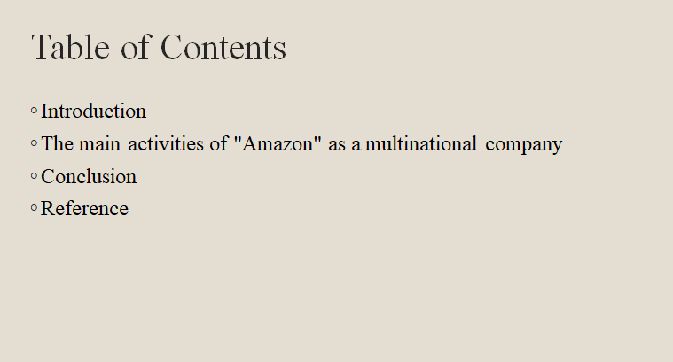
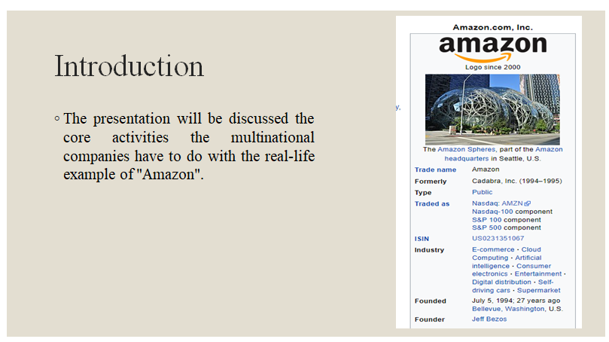
Every business establishes intending to become a multinational company operating in other counties with its large product portfolio. The presentation will be discussed the core activities the multinational companies have to do with the real-life example of "Amazon". (Narula, 2018).

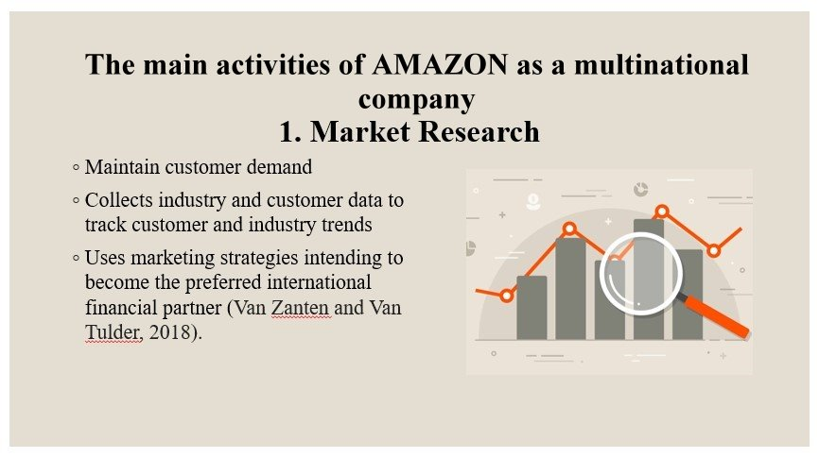

The main activities of “AMAZON” as a multinational company
“Amazon” as a multinational company has to do many operations and responsibilities to sustain itself in the market and to expand its growth continuously. The core activities of the company are described below-

1. Market Research
The company has done market research operations to maintain customer demand with the help of its market research team. The team collects industry and customer data to track customer and industry trends for the future. The company uses marketing strategies intending to become the preferred international financial partner to their targeted audiences. For further research of the market, the company analyses the competitors’ strategies in their operations so that “Amazon” can be aware of what others in the market doing (Van Zanten and Van Tulder, 2018).

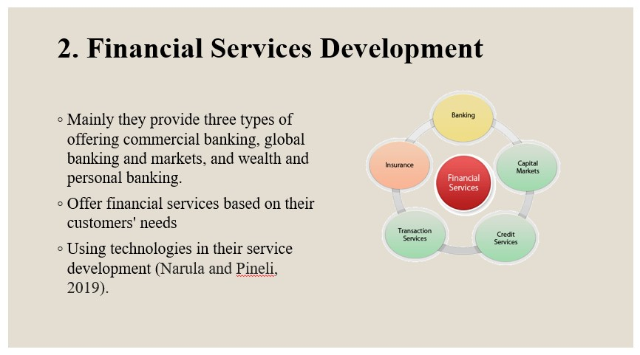

2. Financial Services Development
The multinational investment company “Amazon” provides many financial products and services but mainly “Amazon” provide three types of offering commercial banking, global banking and markets, and wealth and personal banking. The company’s target customers range from individual depositors and investors to large commercial and government organizations. “Amazon” offer financial services based on their customers' needs. “Amazon” develop financial schemes based on customer trends and economic factors. “Amazon” have their process of developing financial services and promoting them. “Amazon” are using technologies in their service development to cope with technological advancement (Narula and Pineli, 2019).
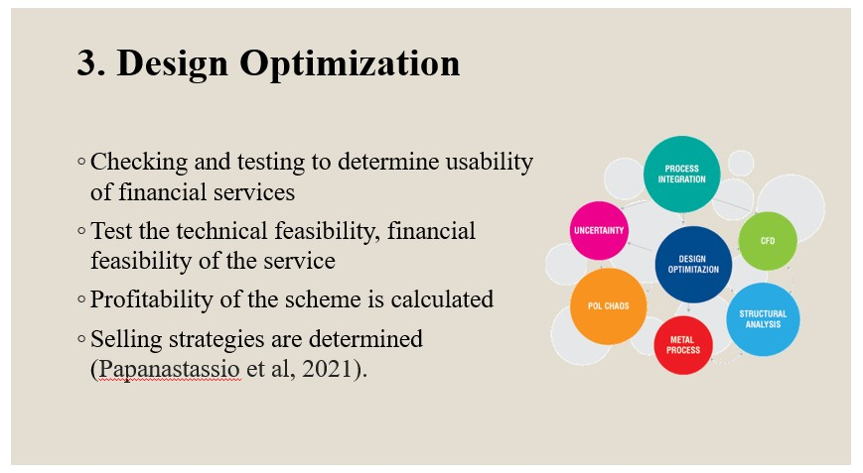

3. Design Optimization
In the design optimization operation, the developed financial service is going to do some checking and testing to determine its usability. Here, the company test the technical feasibility, financial feasibility of the service. The profitability of the scheme is calculated to determine whether the customers will continue to the maturity period or not and what can be the results. The promotional activities are also fixed and the selling strategies are determined. The scheme's profitability is analysed to see whether consumers would stick with it to the end of the term and what the outcomes may be. Also, the challenges of selling the financial service are identified with proper ways to overcome those (Papanastassio et al, 2021).


4. Infrastructure Management
The company has developed its infrastructures and now “Amazon” are upgrading its management system continuously as the company is expanding and operations are diversifying. “Amazon” is taking the help of technological tools to create and manage its virtual infrastructure. The company uses a database system to store each client’s financial history and a cloud storage facility to store them virtually. The company uses a virtual payment gateway system to effectively manage the currency exchange in national and international markets. For security purposes, the company has the most secure network and virtual storage system (Fuller and Phelps, 2018).
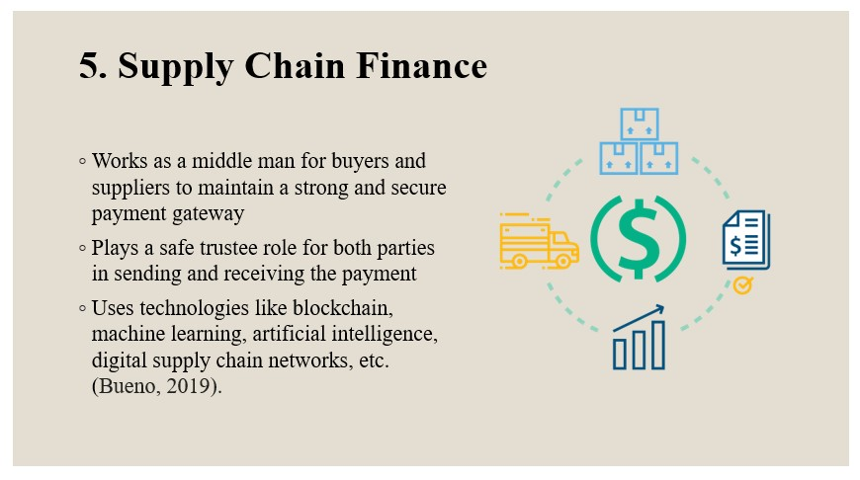

5. Supply Chain Finance
The company has a large distribution network of proving financial services effectively and efficiently without any delay or shortages. The company works as a middle man for buyers and suppliers to maintain a strong and secure payment gateway. As a result, the presentation was designed to focus on the basic functions of multinational corporations by examining the operations of the international investment bank "“AMAZON”." The company plays a safe trustee role for both parties in sending and receiving the payment. To do supply chain finance operations the company uses technologies like block chain, machine learning, artificial intelligence, digital supply chain networks, etc. (Bueno, 2019).
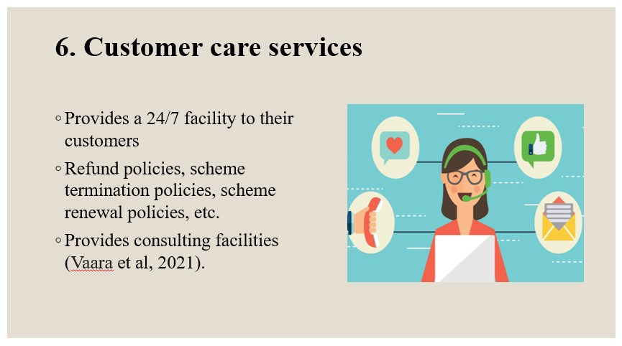

6. Customer care services
To provide customer service after the post-selling of their schemes or before selling them, the company maintains an efficient customer care service. The customer care service provides a 24/7 facility to their customers via customer care number and online help desk. The company has policies that attract customers such as refund policies, scheme termination policies, scheme renewal policies, etc. The multinational corporations reflect their achievement in becoming market leaders, and their operations are of interest to small firms that want to acquire the finest advice and learn from them. The company provides consulting facilities using customer care services. To improve the service offering, the company often collects information and recommendations from their clients through customer care service (Vaara et al, 2021).
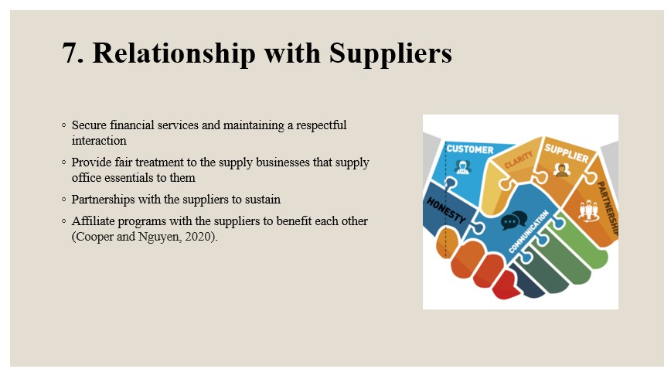

7. Relationship with Suppliers
“Amazon” maintains a good relationship with the worldwide supplier businesses through secure financial services and maintaining a respectful interaction. The company is aimed to provide fair treatment to the supply businesses that supply office essentials to them. The company maintains a smooth understanding of old and new suppliers. The firm acts as a secure trustee for both the sender and the receiver of the money. The company based on the region “Amazon” serve gets into partnerships with the suppliers to sustain itself in that market strongly. The company also does affiliate programs with the suppliers to benefit each other (Cooper and Nguyen, 2020).
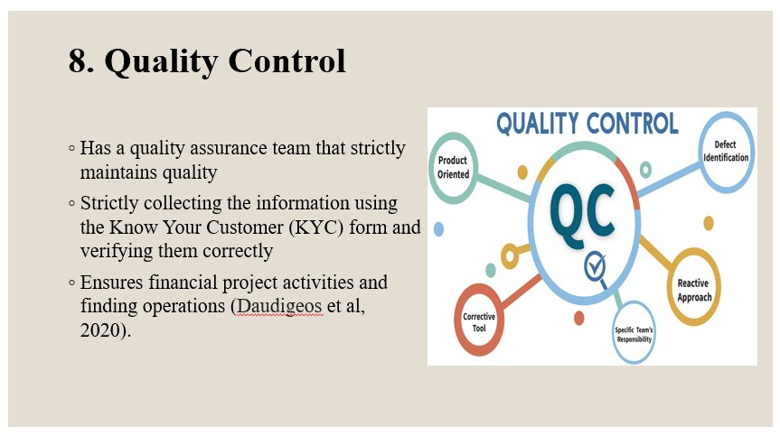

8. Quality Control
The company is strict in maintaining service quality. The company has a quality assurance team that strictly maintains quality in operations. The team is creating a new bank account by strictly collecting the information using the Know Your Customer (KYC) form and verifying them correctly to determine the accountability of the client.
To successfully handle currency exchange in national and international marketplaces, the organisation employs a virtual payment gateway technology. To maintain a solid and secure payment gateway, the organisation acts as a middleman between customers and providers. The team also determines the credit limit of any client based on their financial abilities to bear the credit amount. The company also ensures financial project activities and finding operations (Daudigeos et al, 2020).
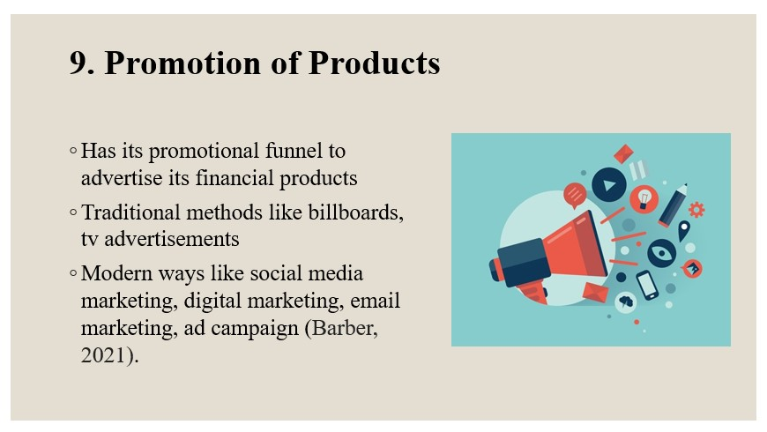

9. Promotion of Products
The company has its promotional funnel to advertise its financial products to attract customers. The company uses traditional methods like billboards, TV advertisements, and door to door direct promotion, etc. In addition, the difficulties of marketing financial services are recognised, along with appropriate solutions. The organisation has the most secure network and virtual storage system for security reasons. Moreover, the company also uses modern ways of promotion due to technological advancement which is social media marketing, digital marketing, email marketing, ad campaign, lead generation, etc. The company also boosts methods to promote specific regions (Barber, 2021).
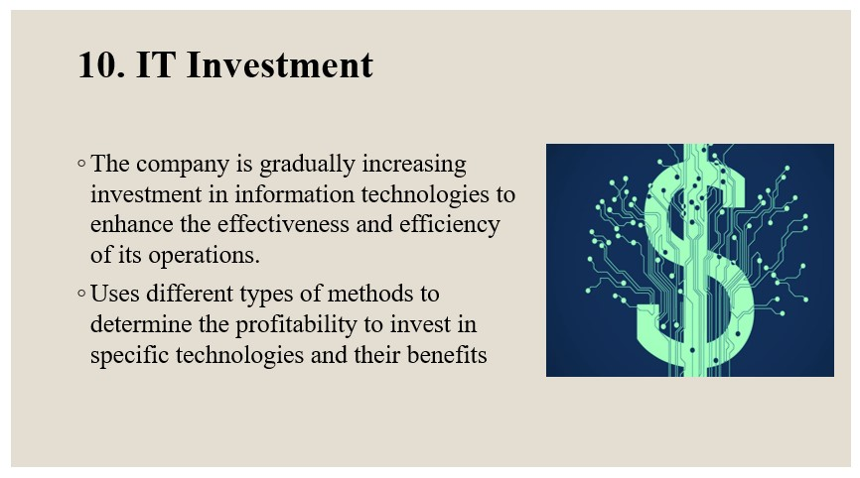

10. IT Investment
Due to technological advancement, in every sector, the use of technologies is becoming essential and beneficial and so for a multinational company investing in information systems is important to maintain competitiveness in the market. The company is gradually increasing investment in information technologies to enhance the effectiveness and efficiency of its operations.
“Amazon” have a system in place for creating and marketing financial services. To keep up with technological advancements, “Amazon” are using technology into their service development. The company uses different types of methods to determine the profitability to invest in specific technologies and their benefits for the company’s performance in the future (Christofi et al, 2021).
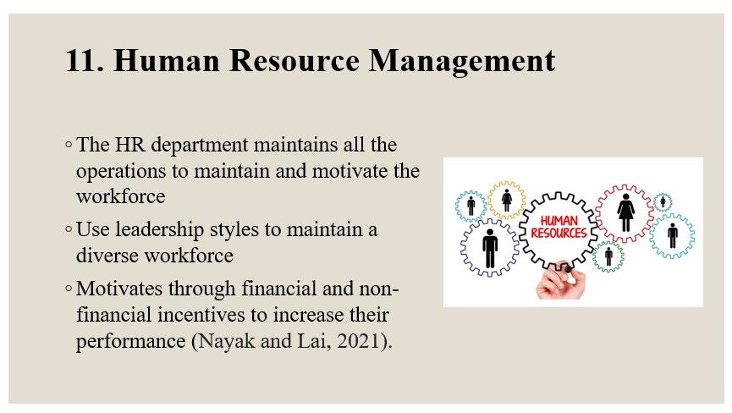

11. Human Resource Management
The company maintains its large workforce worldwide depending on its human resource department. The company is operating in many countries with a large workforce in every region and so it is important to form them to maintain the workforce effectively. With the real-life example of the multinational bank "“AMAZON”," the lecture will explore the key functions of multinational firms. For additional market research, the firm examines the tactics used by rivals in their operations so that “Amazon” may be aware of what others are doing.
The HR department maintains all the operations to maintain and motivate the workforce to do their work. The department undertakes many leadership styles to maintain a diverse workforce. The HR department also motivates through financial and non-financial incentives to increase their performance (Nayak and Lai, 2021).
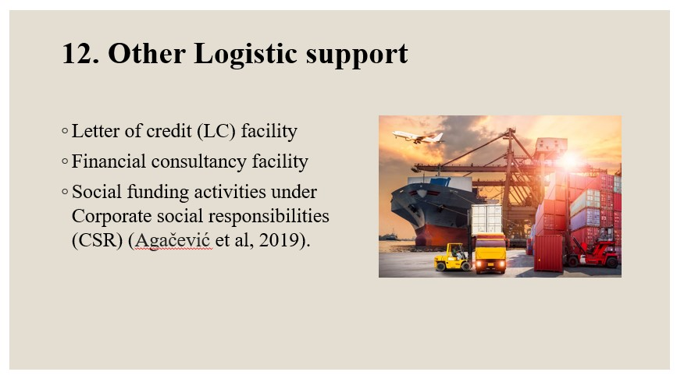

12. Other Logistic support
The company apart from financial services provide other logistic supports to their clients. The support includes a letter of credit (LC) facility for importer companies to exporter companies to provide financial trust. Every firm starts out with the goal of becoming an international corporation with a diverse product portfolio that can operate in different countries. The organisation employs marketing methods with the goal of becoming its target consumers' preferred worldwide banking partner. “Amazon” come up with financial plans based on client preferences and economic facts. The company also provide financial consultancy facility to their clients. The company also does social funding activities under Corporate Social Responsibility (CSR) (Agačević et al, 2019).
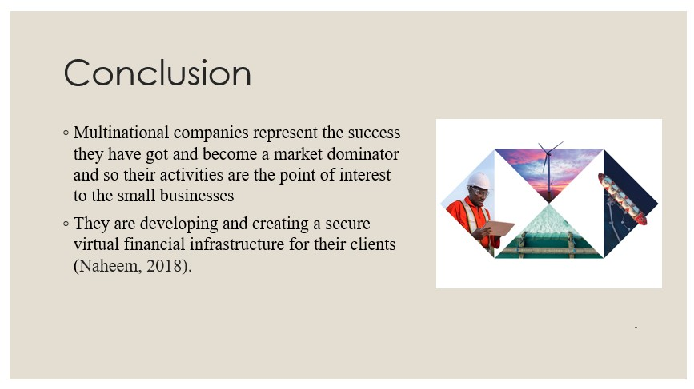

Conclusion
The multinational companies represent the success “Amazon” have got and become market dominators and so their activities are the point of interest to the small businesses as “Amazon” want to get the best advice and learn from them. Representing that, the presentation was set to discuss the core activities the multinational companies do by shedding light on the operations of the multinational investment company “Amazon”. The presentation on this company analysis recommends that the company should more focus on developing and creating a secure virtual financial infrastructure for their clients (Naheem, 2018).
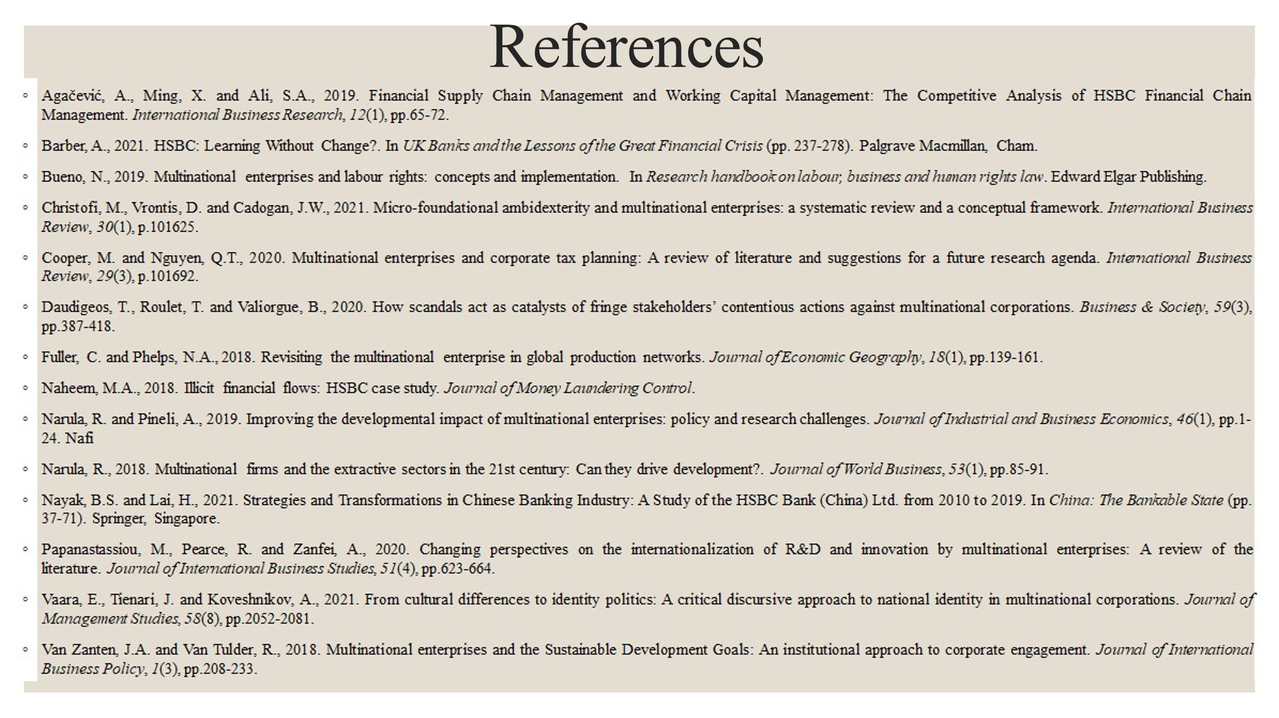

References
Agačević, A., Ming, X. and Ali, S.A., 2019. Financial Supply Chain Management and Working Capital Management: The Competitive Analysis of “AMAZON” Financial Chain Management. International Business Research, 12(1), pp.65-72.
Barber, A., 2021. “AMAZON”: Learning Without Change?. In UK Banks and the Lessons of the Great Financial Crisis (pp. 237-278). Palgrave Macmillan, Cham.
Bueno, N., 2019. Multinational enterprises and labour rights: concepts and implementation. In Research handbook on labour, business and human rights law. Edward Elgar Publishing.
Christofi, M., Vrontis, D. and Cadogan, J.W., 2021. Micro-foundational ambidexterity and multinational enterprises: a systematic review and a conceptual framework. International Business Review, 30(1), p.101625.
Cooper, M. and Nguyen, Q.T., 2020. Multinational enterprises and corporate tax planning: A review of literature and suggestions for a future research agenda. International Business Review, 29(3), p.101692.
Daudigeos, T., Roulet, T. and Valiorgue, B., 2020. How scandals act as catalysts of fringe stakeholders’ contentious actions against multinational corporations. Business & Society, 59(3), pp.387-418.
Fuller, C. and Phelps, N.A., 2018. Revisiting the multinational enterprise in global production networks. Journal of Economic Geography, 18(1), pp.139-161.
Naheem, M.A., 2018. Illicit financial flows: “AMAZON” case study. Journal of Money Laundering Control.
Narula, R. and Pineli, A., 2019. Improving the developmental impact of multinational enterprises: policy and research challenges. Journal of Industrial and Business Economics, 46(1), pp.1-24. Nafi
Narula, R., 2018. Multinational firms and the extractive sectors in the 21st century: Can “Amazon” drive development?. Journal of World Business, 53(1), pp.85-91.
Nayak, B.S. and Lai, H., 2021. Strategies and Transformations in Chinese Banking Industry: A Study of the “AMAZON” Bank (China) Ltd. from 2010 to 2019. In China: The Bankable State (pp. 37-71). Springer, Singapore.
Papanastassiou, M., Pearce, R. and Zanfei, A., 2020. Changing perspectives on the internationalization of R&D and innovation by multinational enterprises: A review of the literature. Journal of International Business Studies, 51(4), pp.623-664.
Vaara, E., Tienari, J. and Koveshnikov, A., 2021. From cultural differences to identity politics: A critical discursive approach to national identity in multinational corporations. Journal of Management Studies, 58(8), pp.2052-2081.
Van Zanten, J.A. and Van Tulder, R., 2018. Multinational enterprises and the Sustainable Development Goals: An institutional approach to corporate engagement. Journal of International Business Policy, 1(3), pp.208-233.

