University of Wales Trinity Saint David School of Engineering


Quality Tools & Root Cause Analysis
ACMA 4004

Christopher Davey
Student Number 2108666
07/03/2022

Contents
1 Introduction 1
2 Data Collection 2
3 Check sheets 3
4 Histograms 4
5 Cause & Effect / Ishikawa / Fishbone Diagrams. 6
6 Process Flow Charts 7
7 Pareto Analysis 8
8 Scatter Diagrams 10
9 Control Charts 11
10 Conclusion. 13
11 References 14

Figure 1 Data collection check sheet / Table 3
Figure 2 Site February wrench time performance 4
Figure 3 Wrench Time Performance Split into Categories 4
Figure 4 Industry Wrench Time Standards 5
Figure 5 Cause & Effect Diagram 6
Figure 6 Example of Flow Chart 7
Figure 7 Pareto Bar Chart Wrench Time Waste 9
Figure 8 Example of Scatter Diagram 10
Figure 9 Example of Process Control Chart 12

Introduction

In this report I will be conducting wrench time analysis using some of the 7 basic quality tools available to analyse wrench time performance. This will allow further identification and verification of waste that impacts the performance and productivity of the process.
We are currently running at 56.5% wrench time with the aim of reaching 60% or more to achieve a best-in-class standard which is on average around the top 3% - 5% in industry. The results from the analysis will identify key areas for development to increase the site wrench time to or beyond the required target.
Improvement within wrench time will also create a positive impact upon the site PSR (Product supply reliability), that also creates a knock-on effect to the site CSI (Customer satisfaction index), which hopefully keeps all our customers happy / supplied and reliable in turn.

Data Collection

Over 700 data points have been collected within 1 month of maintenance which equates to 10880 minutes of maintenance activities observed for wrench time performance.

Wrench time was analysed using ‘In the day-in-the-life-of approach with a dedicated observer who has been working at the site for many years.

Productivity Category | Reason | Time (min) | Percentage
Wrench Time | On Tools | 6163 | 56.5%
Incidentals | Transportation Time | 2377 | 21.9%
Incidentals | Reviewing Job Package | 703 | 6.5%
Incidentals | Gathering Tools & Materials | 487 | 4.5%
Waste | Waiting for Permit to work | 561 | 5.1%
Waste | Equipment Not Prepared | 230 | 2.1%
Waste | Job Cancelled Due to Scope Change | 286 | 2.7%
Waste | Waiting For Support Trade | 73 | 0.7%
 |  | 10880 min | 100%

Wrench time is categorised and measured into 3 main areas: -
- Wrench Time – This is actual time on tools executing the job / task in hand for the trade’s person or technician.
- Incidentals – This is time generally spent obtaining permits to work, obtaining tools and materials, and moving / traveling to the workface for execution. (This measurement is progressing the job for the required execution but not actual execution at the workface).
- Waste – This time is actual waste, for example: - waiting for plant operator to issue permit to work, Equipment not prepared in time for on time issue of permit to work, job scope change for job that was originally planned, and waiting for support trade (E.G, waiting for rigging support to assist lifting equipment from or back to the production plant).

Check sheets

Data is collected using a check sheet / table as identified below.

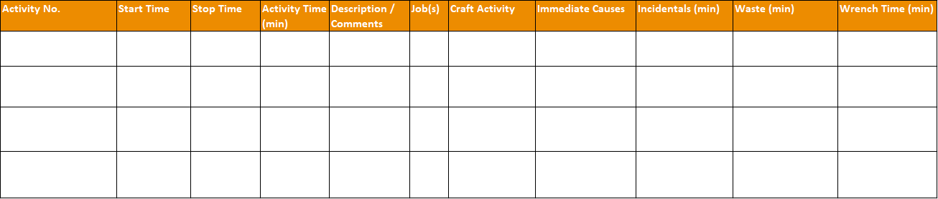
Figure 1 Data collection check sheet / Table
The purpose of a check sheet is to capture important data / metrics and occurrence to help understand defects patterns, progress, and cause of defects. The data is usually collected by using the same person and process to ensure continuity and consistency of information collected.
The data collected is then subjected to further analysis for trends or patterns in identifying waste within in a process or wrench time analysis which I am looking to reduce waste and increase hands on tools time.

Histograms

The data collected from February’s wrench time analysis shows the site is currently operating at 56.6 wrench time percentage which is currently 3.4% from best-in-class bracket.
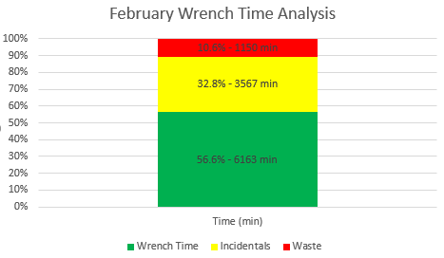
Figure 2 Site February wrench time performance
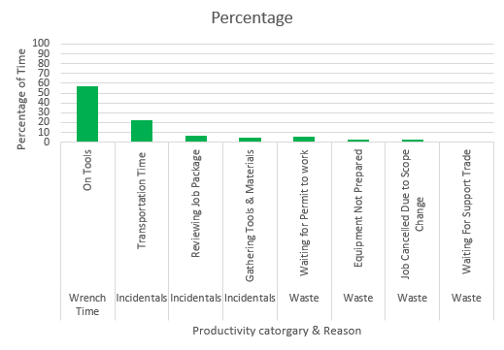
Figure 3 Wrench Time Performance Split into Categories

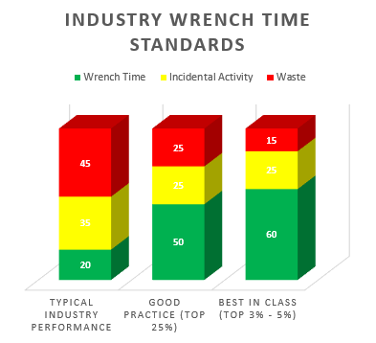
Figure 4 Industry Wrench Time Standards
From the data collected, there are 3 main areas of waste and 1 incidental that could improve the sites wrench time performance with further analysis and improvement.
Productivity Category | Reason | Percentage
Waste | Waiting for Permit to work | 5.1
Waste | Equipment Not Prepared | 2.1
Waste | Job Cancelled Due to Scope Change | 2.7
Incidentals | Transportation Time | 21.9

The very purpose of Histogram is to study the density of data in any given distribution and understand the factors or data that repeat more often.
Histogram helps in prioritizing factors and identify which are the areas that needs utmost attention immediately.
(whatissixsigma, n.d.)

Cause & Effect / Ishikawa / Fishbone Diagrams.

The Cause-and-effect diagram – also known as an Ishikawa, fishbone or Fishikawa diagram, is used to identify the potential causes of a specific event, known as ‘the effect’. Based on brainstorming, the technique provides a way of rationally determining and organising the factors that are suspected of contributing to the effect. These must then be tested and verified. Corrective and preventive actions can then be applied to mitigate or eliminate relevant factors.
Cause-and-effect diagrams are commonly used in product design and quality defect prevention, but they can also be used in any situation where an understanding of the root cause of a problem is required. The analysis is best conducted between groups of individuals with a shared understanding of the nature of the issue under examination. Each group should then be able to add their own perspective to the analysis.
(Green, 2021)

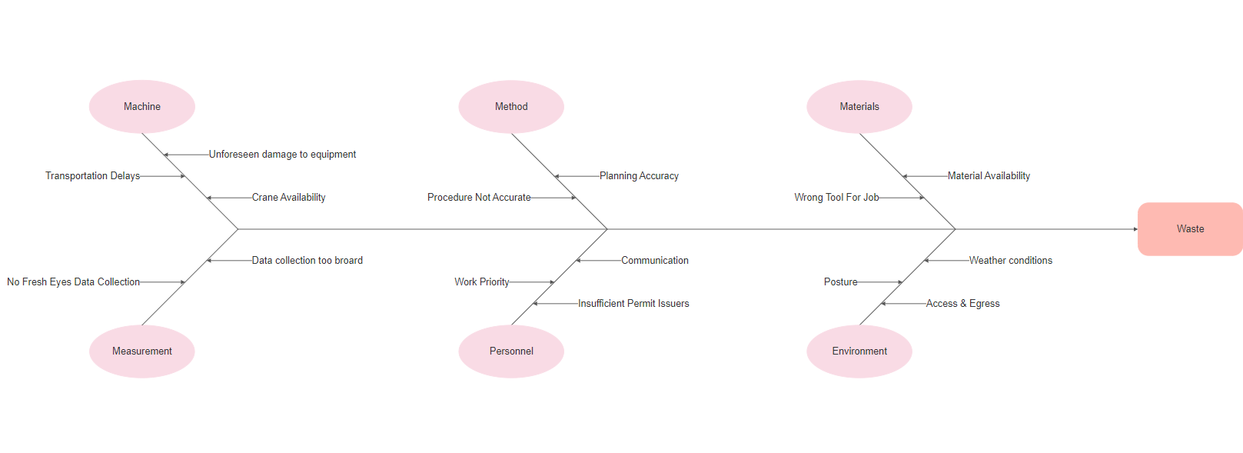
Figure 5 Cause & Effect Diagram
The Cause & Effect analysis looks further into the details around the outcome of the below wrench time losses.
Productivity Category | Reason | Percentage
Waste | Waiting for Permit to work | 5.1
Waste | Equipment Not Prepared | 2.1
Waste | Job Cancelled Due to Scope Change | 2.7
Incidentals | Transportation Time | 21.9

Process Flow Charts

Process flow charts are tools used to visualise the sequence of activities and decisions; they are used to streamline the flow of activities by applying logic whilst they enable an insight into how to perform activities effectively.
Flow charts display the sequential steps involved in converting a specific input into the required output. Process flow charts have not been a tool used as part of my analysis.
(Jenkins, 2022)
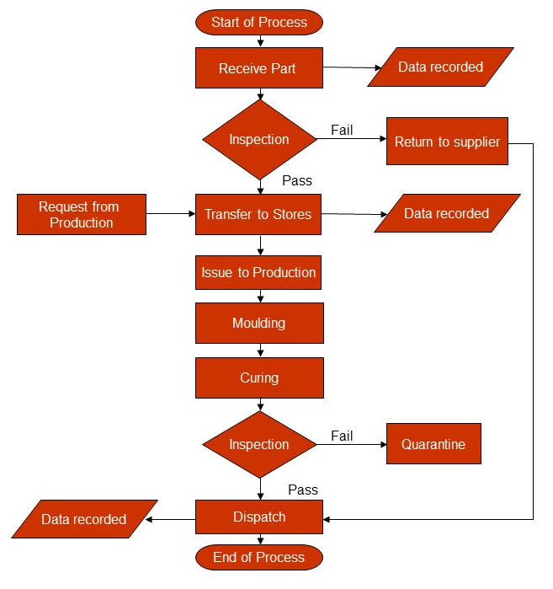
Figure 6 Example of Flow Chart

Pareto Analysis

Pareto Analysis is a simple decision-making technique for assessing competing problems and measuring the impact of fixing them. This allows you to focus on solutions that will provide the most benefit.
The 80/20 Rule.
Pareto Analysis uses the Pareto Principle – also known as the "80/20 Rule" – which was coined by Italian economist, Vilfredo Pareto, in his 1896 book, "Cours d'économie politique." [1]
The Pareto Principle states that 80 percent of a project's benefit comes from 20 percent of the work. Or, conversely, that 80 percent of problems can be traced back to 20 percent of causes. Pareto Analysis identifies the problem areas or tasks that will have the biggest payoff. The tool has several benefits, including:
- Identifying and prioritizing problems and tasks.
- Helping people to organize their workloads more effectively.
- Improving productivity.
- Improving profitability.
(Tools, n.d.)

Waste Type | Time in Mins | Cumulative Frequency | Cumulative Percentage
Waiting for Permit to work | 561 | 561 | 48.78
Job Cancelled Due to Scope Change | 286 | 847 | 73.65
Equipment Not Prepared | 230 | 1077 | 93.65
Waiting For Support Trade | 73 | 1150 | 100
Total | 1150

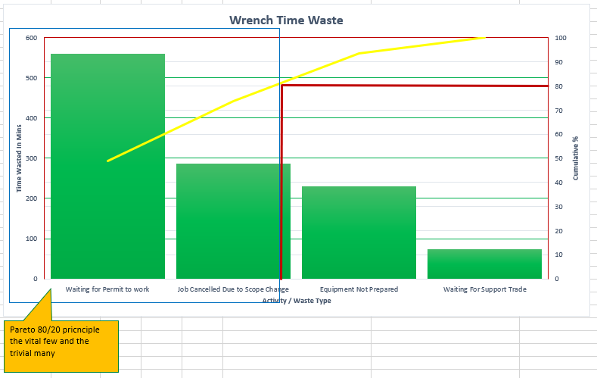

Figure 7 Pareto Bar Chart Wrench Time Waste

From the Pareto Analysis completed the area’s this quality tool data is pointing to concentrate on are ‘waiting for permit to work’ and ‘job cancelled due to scope change.

Using this analysis helps prioritising improvement opportunities and corrective actions and allows measurement of the impact of the corrective actions.

Scatter Diagrams

Scatter diagrams have not been used as one of the tools for my analysis but A Scatter diagram is one of the Seven Basic Quality Tools. It plots two sets of observations against each other; the horizontal axis represents one set of observations (independent variable) while the vertical axis represents the second set of observations (dependent variable).
Scatter diagrams allow you to examine relationships between variables visually. Both variables should be continuous variables. They are a powerful way to visualize and explore data, especially when there is no apparent linear relationship. You can also use them in conjunction with statistical tests such as correlation analysis or regression analysis.
You can use a Scatter Diagram (or Scatter Plot, Scatter Chart, Scatter Graph) when you have data in the form of pair, and you want to check the degree of relationship between them. For example, you have a dataset for 50 students in the class, including the number of hours studied and marks obtained in the exam. Using this dataset, you can evaluate the relationship between these two variables (number of hours studied and marks obtained). In addition, you can find the direction (positive, negative, or no relationship) and the degree of relationship (correlation coefficient between +1 and -1) as well.
(qualitygurus, 2022)
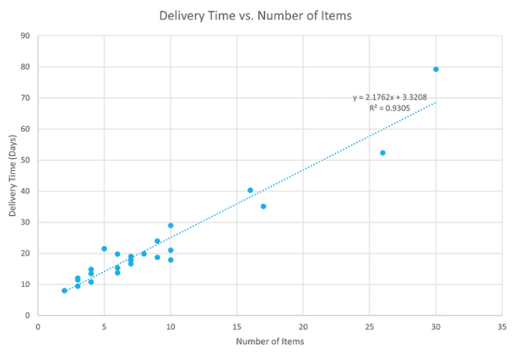
Figure 8 Example of Scatter Diagram

Control Charts

Control charts have not been used as part of my analysis as I don’t have the correct data to use this. From the Pareto analysis if we had the data of what time the permit delay started, we would find this would most likely be at the begging of the shift due to the number of permits that would need to be issued.
Control chart is also called as Shewhart Chart named after Walter A. Shewhart is basically a statistical chart which helps in determining if an industrial process is within control and capable to meet the customer defined specification limits.
The very purpose of control chart is to determine if the process is stable and capable within current conditions.
In Control Chart, data are plotted against time in X-axis. Control chart will always have a central line (average or mean), an upper line for the upper control limit and a lower line for the lower control limit. These lines are determined from historical data.
By comparing current data to these lines, experts can draw conclusions about whether the process variation is consistent (in control, affected by common causes of variation) or is unpredictable (out of control, affected by special causes of variation). It helps in differentiating common causes from special cause of variation.
Control charts are very popular and vastly used in Quality Control Techniques, Six Sigma (Control Phase) and plays an important role in defining process capability and variations in productions. This tool also helps in identifying how well any manufacturing process is in line with respect to customer’s expectation.
Control chart helps in predicting process performance, understand the various production patterns and study how a process changes or shifts from normally specified control limits over a period.
(whatissixsigma, n.d.)
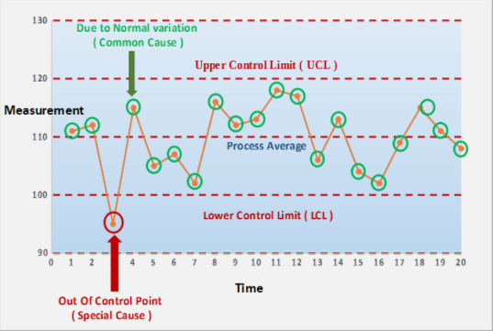
Figure 9 Example of Process Control Chart
(whatissixsigma, n.d.)

Conclusion.

The aim of this report and analysis was to identify key areas to improve wrench time for the site from 56.6% to >60% there have been multiple key areas for improvement with the focus being on actual waste and not incidentals as these are still in theory progressing what is required to achieve wrench time.
Data collection and stratification was completed for the sites wrench time analysis reporting tool and this was categorised into 3 main areas: -
- Wrench Time – This is actual time on tools executing the job / task in hand for the trade’s person or technician.
- Incidentals – This is time generally spent obtaining permits to work, obtaining tools and materials, and moving / traveling to the workface for execution. (This measurement is progressing the job for the required execution but not actual execution at the workface).
Waste – This time is actual waste, for example: - waiting for plant operator to issue permit to work, Equipment not prepared in time for on time issue of permit to work, job scope change for job that was originally planned, and waiting for support trade (E.G, waiting for rigging support to assist lifting equipment from or back to the production plant).
Histograms have given a visual aid in identifying key areas of waste for wrench time and an insight into the incidentals.
Cause & Effect diagram has highlighted some of the key reasons for permit issue delays, along with the pareto analysis identifying the key areas for focus with permit delays and scope change.
My conclusion is that there needs to be more permit issuers available for the trades when they arrive along with all required procedures and documentation for work to start to be ready. I believe a separate RCA analysis is required for delays from waiting for a permit to work as this is not part of this project scope. Also, another separate RCA in jobs being cancelled due to scope change is required to investigate further the reasons behind this, as this could be down to poor work notification being entered without a detailed scope or poor planning from maintenance planner with the task list of operations and job steps not being sufficient.
Transportation for maintenance techs in the form of work vehicles or bicycles would help reduce the traveling time to the workface as the site is large geographically. This may reduce the incidentals and increase some of the wrench time in turn.

11 References
Green, R., 2021. quality.org. [Online]
Available at: www.quality.org
[Accessed March 2022].
Group, P., 2019. Prometheus Group Wrench Time. [Online]
Available at: https://www.prometheusgroup.com/posts/5-things-you-need-to-know-about-measuring-wrench-time
[Accessed 19 March 2022].
Jenkins, J., 2022. Process Mapping & Flow Charts. Swansea: Jenkins, J.
qualitygurus, 2022. qualitygurus. [Online]
Available at: www.qualitygurus.com
[Accessed March 2022].
Tools, M., n.d. mindtools. [Online]
Available at: www.mindtools.com
[Accessed March 2022].
whatissixsigma, n.d. whatissixsigma. [Online]
Available at: www.whatissixsigma.net
[Accessed March 2022].

