Business Plan for

<SWEETS TRUCK/ HERITAGE SWEETS ON THE ROAD>

Produced By:

GROUP MEMBERS:
Student Name | Student No.
Mohammed Ali Haider | 2013121
Victoria Prodan | 2245322
Marinela Covasneanu | 1920078
Cristiana Staicu | 2026517
Ionel Babache | 2241659

Dated: 09/11/2024

Module Name: Entrepreneurship
Module Code: BMIH5001
Lecturer Name: Chris Wilkins

CONTENTS

 |  |  |  | PAGE
1. | Executive Summary |  |  | ……………3
2. | The Business Idea |  |  | ……………4,5
3. | The Team |  |  | ……………5,6,7
4. | Market Research |  |  | ……………8
5. | Marketing Plan |  |  | ………… ...9,10
6. | Key Resources |  |  | ……………11
7. | Finances & Start-Up Support |  |  | ………12,13,14
APPENDICES:
Appendix A |  |  |  | SWOT Analysis
Appendix B |  |  |  | PEST Analysis
Appendix C |  |  |  | Copy of Pitch Supporting Material

AI Declaration:

“I confirm that I have not used any AI tools in the research and creation of this assignment. I confirm that I have not presented any AI generated materials as my own work. I confirm I have copies of my drafts, notes, and other resources I used, which I may be asked to provide in evidence.”

1. EXECUTIVE SUMMARY

Heritage Sweets on the Road is an innovative baked goods business based in Cardiff, specialising in freshly baked cakes inspired by the rich culinary traditions of Türkiye, Italy, Romania, France, and India. Operating from a fully equipped kitchen in Tudor Street, our unique concept brings an international array flavour directly to the heart of Cardiff City Centre, catering to both locals and tourists. We offer a diverse menu featuring signature cakes from these five countries, each beautifully packaged in bags and boxes adorned with international flags emphasising cultural appreciation and authenticity. A government loan has been secured to cover initial expenses, including the purchase of the food truck, kitchen rent, equipment, and marketing efforts. With a strong marketing strategy and strategic location, we anticipate reaching break-even point within first year of operations, followed by a steady growth. We aim to become a beloved fixture in Cardiff’s culinary scene, offering a delightful fusion of global flavours that celebrate diversity and bring people together and with a dynamic marketing approach to position us for success and sustainable growth.

2. THE BUSINESS IDEA- Mohammed Ali Haider

2.1 The Product/Service
- Company name: Heritage sweet truck
- Location: Cardiff
- Industry: Bakery
- This business aims to sell sweets of different heritages. We have focused on 5 different heritages which are Türkiye, India, Romania, France, and Italy with the aim to expand further with more popularity.
- Features and benefits: traditional sweets on wheels – we offer a diverse menu of authentic sweets and an array of fusion desserts that blend traditional flavours with modern recipes. These traditional sweets will bring diverse cultures together.

2.2 SWOT Analysis Summary

Strengths: (Appendix A)

Offering a unique combination of ethnic homemade cakes.
- Mobility and flexibility due the caravan-based operation
- Personalized customer experience through the ability to go to distinct locations for the customer needs.

Weaknesses:(Appendix A)

Limited capacity for storage a step back on busy times.
- Weather conditions impact directly on the number of customers.
- Operational costs increased by moving and supplying the truck more frequently due to the limited storage space.

Opportunities: (Appendix A)

Event presence, easy to achieve due to the nature of the business

The rising demand for homemade and manufactured products (Hermayan & Perkantoran, 2023)
- Event caterers.

Threats: (Appendix A)
- Market competition: the location is in city center where are similar street vendors and dessert shops.
- Economic slowdowns: inflation and the rise in the cost of living.
- Law enforcement and regulations.

3. THE TEAM

3.1 Key Personnel

Name and Company Position:
Mohammed Ali Haider - Baker
Salary - £19837
Skills and Experience:
- 5 years - Takeaway owner - Led and directed team members on effective methods, operations, and procedures. Purchased adequate quantities of necessary stock (food, beverages, equipment, supplies)
- 7 years – Restaurant owner- Developed, implemented, and managed business plans to promote sales. Created positive atmosphere and ensured that each customer received exceptional food and services.
- Skills – effective communication skills, flexible worker, excellent timekeeping
- Present: Enrolled in Hotel Management-University Trinity Saint Davies- business and financial skills.
Role and Responsibilities:
Baking all goods. Ensuring a multicultural environment with food of multiple cuisines.

Name and Company Position:
Victoria Prodan- Seller, Cashier, and Product Finisher
Salary: £19837
Skills and Experience:
- Baccalaureate degree at high school - Moldova.
- 4 months - Cashier- Wisconsin Dells (United States)
- Level 4 in Certificate in Higher Education- Academy of Economic Studies, in Moldova.
- 1 year -Waitress in Albufeira (Portugal).
- 2 years- Assistant Sale Supervisor- ability to work with customers, effective communication, and leadership skills.
- Present – Enrolled in Hotel Management-University Trinity Saint Davies- business and financial skills.
Role and Responsibilities: Collecting payments, packing, and selling the products, health, and safety.

Name and Company Position:
Marinela Covasneanu- seller, cashier, and product finisher
Salary: £19837
Skills and Experience:
- Level three baccalaureate -Romania -physique and chemistry qualification.
- 11 years - children store- communication skills and balance my patience
- Level 4 in Certificate in Higher Education- management skills
- 11 years McDonalds-manager- communication, time management, leading and decision-making
- Present: Enrolled in Hotel Management-University Trinity Saint Davies- business and financial skills.
Role and Responsibilities: Health and safety, Packaging and selling products, collecting payments.

Name and Company Position:
Cristiana Staicu- baking sweets and cleaning.
Salary: £19837
Skills and Experience:
- Baccalaureate with intensive English in Romania.
- Law University finished in Romania at University Titu Maiorescu but without a bachelor's degree.
- For 2 years I worked for a communication company for USA and after that came in UK in 2019.
- For 2 years I used to work for Adecco company as a shift supervisor based in Amazon (managing people’s rota, payments, holidays)
- For 3 years working as a Trainer in a Logistic warehouse for H&M.
Name and Company Position
Ionel Babache- Truck Driver
Salary: £19837
Skills and Experience:
- Baccalaureate diploma with philology and history qualifications
- 10 years I worked for food company driver refrigerated van
- 3 years driver for Amazon delivery driver
- 2 years Manager at myself Transport Company
- Present: For 2 years worked as a taxi driver
Role and Responsibilities:
Truck Driver and restock the van

3.2 Skills Gaps & Key Partners

- 3.2.1 Additional Staff Requirements (Roles and Responsibilities):
Accountant to keep on tracks the company finances.

3.2.2 Training and Development:
No trainings as the company’s employees are the partnership members.

- 3.2.3 Outsourced Support / Key Partners:
- Insurance company
- Accountable company
4. MARKET RESEARCH- Victoria Prodan

4.1 Market Information, Trends and External Factors
Through the market research, the new business venture is required to identify several important statistics to support its business proposal. The population of Cardiff is approximately 366,300, based on the most recent census figures (Office for National Statistics, 2022). The popularity of food trucks in the UK has also grown exponentially in recent years, with a 13% rise in the number of mobile food vendors between 2018 and 2021 (Grand View Research, 2024). Some key trends we have identified that are important to our business idea are the increasing demand for convenience food products and growing interest in artisanal, international, and experiential dining options. The PEST analysis (Appendix B) also highlighted factors like the uncertain economic outlook, which may impact consumer spending power. However, government support for small businesses and entrepreneurs was another external factor noted, which we will investigate further to seek any applicable grants or incentives.

4.2 Customer Profiles: According to our competitor's customer profiles, our main target audience can be young professionals (ages 25-34), with more females, than males. (Similar Web, 2024), (Appendix H), office workers from the surrounding business district who are frequent visitors to the mall during their lunch breaks or after work to shop/socialise. Followed by people (aged 35-44), mostly with kids, who make regular trips to the mall for errands or leisure time. And retirees (aged 65+), often visit the mall during less busy mornings or weekday afternoons for social interaction and light shopping. (Appendix H).

4.3 Competitor Profiles: The food truck industry has seen significant growth in the last years (Appendix K). Our target market consists of selling international sweets in the town centre area, who are looking for unique snack option. Our main competitors are Cake Box Cardiff, Chummy’s Bakery, Muffin Break, who are selling sweet products, but we aim to stand out with our international desserts. Based on market research, our main competitor is Cake Box, with more customers per month than other competitors. (Similar Web, 2024), (Appendix G). Taken in consideration this fact, we aim to differentiate ourselves from the competitors by offering an international sweet taste.

5. MARKETING PLAN- Marinela Covasneanu

5.1 Price

Considering the diversity of people reunited in Cardiff, the actual inflation rates, and the multitude of competitors on the market, our prices had been created through cost advantage. The choice is lower prices value for high quality products (Ebbing, 2022) to attract the customer attention. Also, differentiation advantage by having diversity (5 country representative sweets) (Appendix D) and tailored packages with international flag design (Appendix F) will help in developing a loyal customer market and with time to slowly raise the price with the aim of making profit.

5.2 Product

Our products appearance is classic, based on representative baked sweets of the chosen five countries. We rely on the quality and amazing taste to give our customers an exceptional experience of flavours. (Appendix E)
We will have bags for individual products and boxes for international bundles customised with international flags printed on to accentuate the diversity background of our delicatesses. Also, the same design for cups, napkins and other accessories that accompanies the main product. (Appendix F)
The motto that will complement the sublime savour of our sweets will be “Embrace the sweet side of diversity and savour delicate moments”

5.3 Placement

The main method of selling the products will be on the location of our sweets truck (Appendix O), placed in Cardiff Center City. According to market research the customer target is based on middle aged and young working people, families, and retiree. (Similar Web, 2024) Lunch time location near factories or business buildings to benefit from break times. Weekends around parks and city centre mall to sweeten people promenades. With time will approach the online delivery through user friendly e-commerce websites, food ordering delivery and collaboration with local businesses to conduct joint promotions. (Sparviero, 2021)

5.4 Promotion

Social media Marketing- Platforms like Facebook, Instagram, and LinkedIn same as principal competitors. Mouth to mouth words through friends and family to share content and run targeted ads. (McGruer, 2020) (Appendix L) (Appendix N)
Email marketing- Newsletters, promotions and personalised offers sent by email. (Thomas et al., 2022)
Search engine optimization- Create an optimised website to rank higher in search engine results, driving organic traffic (Google, etc) (Mota Pinto, 2020) (Appendix M)
Events and Webinars- Presence to events, festivals, and private parties to engage with the customers and attract new ones.
Content marketing- Create videos with the manufacture of our goods to show openness and to build trust among the customers. (Sheridan, 2019)
Flyers- Present our business door to door, in the mailboxes and through main stores and busy locations. (Appendix N)

6. KEY RESOURCES- Cristiana Staicu

6.1 Premises

To be more practical and efficient the base of the business is a kitchen space rented near the busy city centre in Cardiff, with 1500£ PCM, partially equipped, (Appendix I) on Tudor Street, just on the outskirts of Cardiff City Centre. This will be the place where we prepare the desserts from where will be delivered to the sweet truck, with the location in the Cardiff City Center to be finalised and commercialised.

6.2 Equipment

The van is partial equipped with tools needed to be used such as: cash register, fridge, and small size oven. Display with heating will be added for 149.99£ with temperature display and temperature range between 30 to 85C. (Appendix I)
As the kitchen is partially equipped being a commercial kitchen, with most of the fixtures, fittings for a professional catering space, provided in the renting lease, in addition we will purchase a big oven for 1,280.40£ with 21000W and 3 cooking chambers tailored for our baking process. (Appendix I) For the future with the business growing upgrades will be done to improve production.

6.3 Key Suppliers

Our ingredients will be weel choose and in this way, we will deliver the best taste from different countries.
“BuyWholefoodsOnline.co.uk” will be our supplier for ingredients such as: flour, sugar, and other dry ingredients
“Riverford” will be responsible to offer us fresh supplies such as: butter, milk, and eggs.

7. FINANCES AND START-UP SUPPORT- Ionel Babache
The average revenue for the food truck can vary widely depending on location, menu, and operating costs. Based on recent data, the average revenue for a sweet truck is around £346,000 per year. Some food truck can generate significantly higher revenues with some reaching up to £4,20 million per year.
Our start-up costs for opening the business after adding all the fixed and variable expenses is situated around £25,082.00 and our start capital is £100,000.00

EXPENDITURE | Year 1  £
Company Registration | £ £60
Rent/Rates | £ 18,000.00/year
Staff Wages | £ 99,185.00/year
Travel/Accommodation | £ 5000.00/year
Telephone (mobile) | £ 864.00/year
Broadband | £ 330.00/year
Utilities | £ 8540.00/year
Marketing and materials | £ 9000/year
Insurance | £ 4240.00/year
Capital Expenditure/Equipment | £ 100,000.00  £ 29,929.00(van+)
Training & Development | £ N/A
Accounting/Legal | £ 520.00/year
Outside Services | £ 200,00/year
Stock/Materials Purchases | £ 102,000/00/year
Bank Charges | £ 6,600.00/year
Office Consumables | £ 1,800.00/year
Loans Repayments | £ 21,320/year
Total Expenditure | £ 300,988.00 /year
INCOME | Year 1  £292,500.00/year
Sales A? | £292,500.00/year
Sales B? | N/A
Sales C? | N/A
Capital Introduced | 100,000.00
Funding | N/A
Loans/Borrowing | 106.600.00
Total Income | £ 292,500.00

 | £
Total Income | £292,500.00
Total Expenditure | £300,988.00
Profit/Loss | £ (8488)

7.1 Financial Summary
The expenditure income for the business have been estimated based on research and the requirements of the business. Staff Wage £99,185 / year aims at paying competitive wage for human resources to keep quality personnel and employ both full and part-time employees.
Rent about £180000 /year is for the appropriate premises in area with a substantial number of potential clients.
Stock/Materials £102 000/year is the cost of supplies necessary for expected sales and priced according to supplier's quotes.
Marketing £9000 /year is employed to finance various promotional activities contained in the marketing plan, adverts through digital and printed media.
Loan Repayments 21,320 /year represent borrowed capital to fund the start-up cost, repayment is based on projected revenue.
Operational Expenditure £ 29,929 /year encompasses various necessary expenses.
The report reveals threat Sales A of £ 292500 yearly, derived from anticipated prices and product availability in target market.
Capital Introduced £ 100,000 & Loans 106,600 fund the initial outlay of the business and earliest cash flow requirement.
The total annual expenditure for the business is £ 300,988 while its annual income is only £ 292500 leaving the annual loss at £ 8,488 in the first year.
We e estimated a break-even point for our business after calculating (Total fixed price £268.728 /price per unit £3.25=£82,865.50-£117,540 variable costs=£ (-34,674.50) Break-even point) within in the first year. This indicates that we will surpass the break-even point in a year, and we already have the path to succeed and to generate profit.

APPENDICES

Appendix A – SWOT Analysis
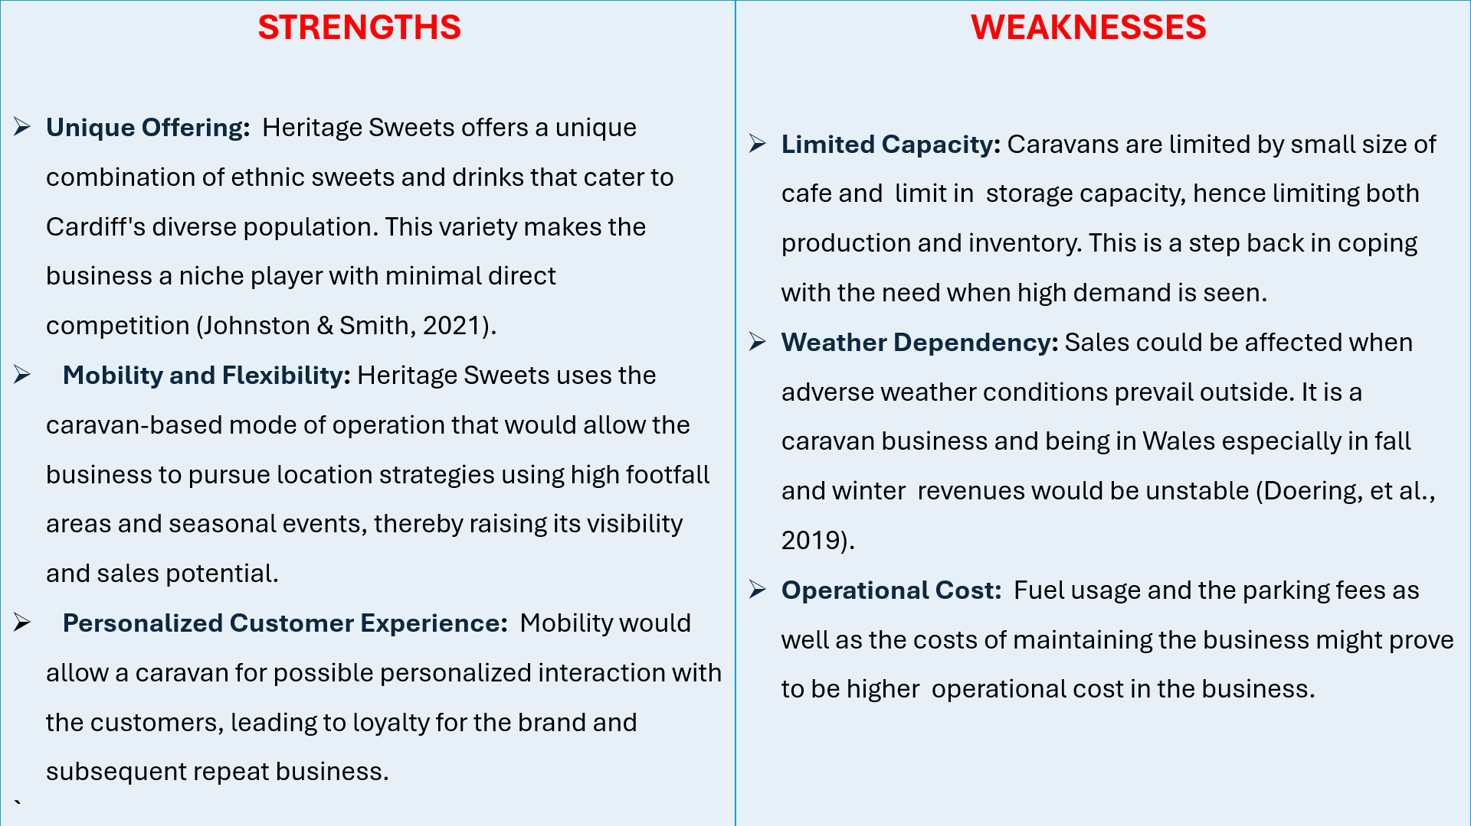
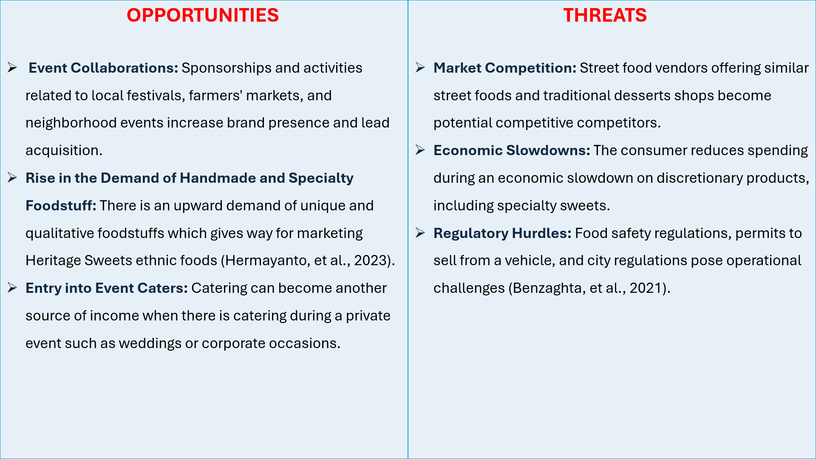

Appendix B – PEST Analysis
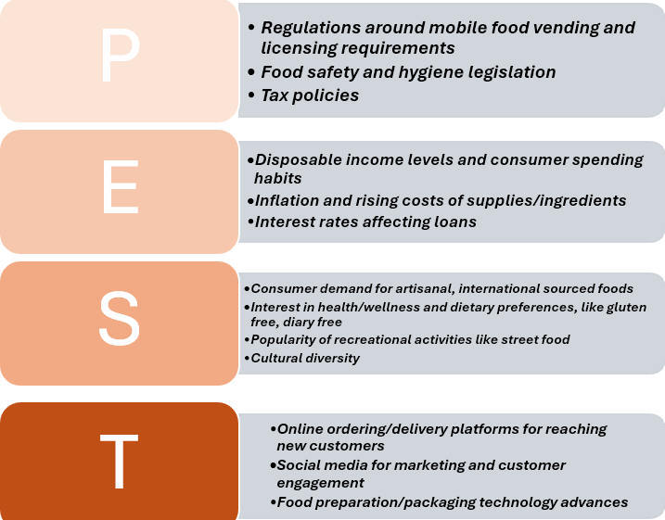Appendix C – Copy of Pitch Supporting Material
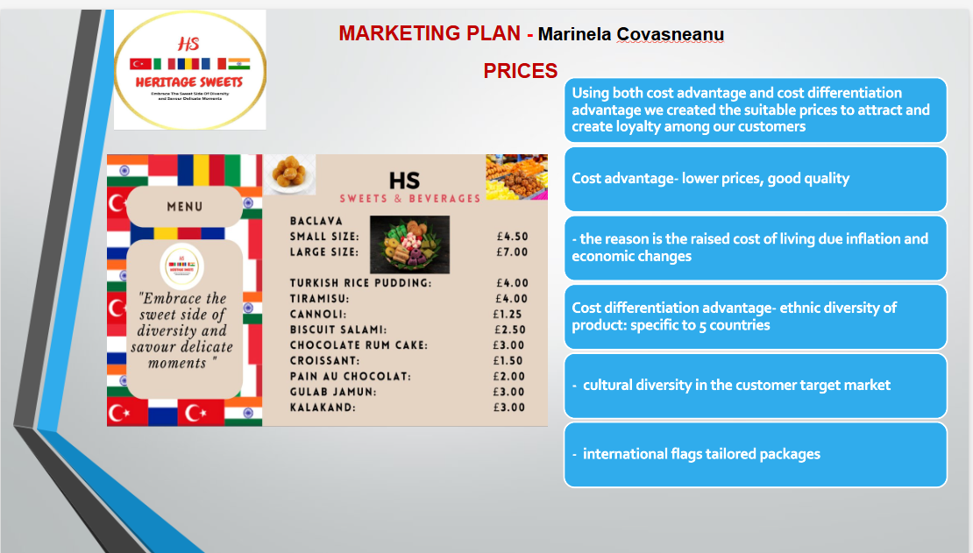

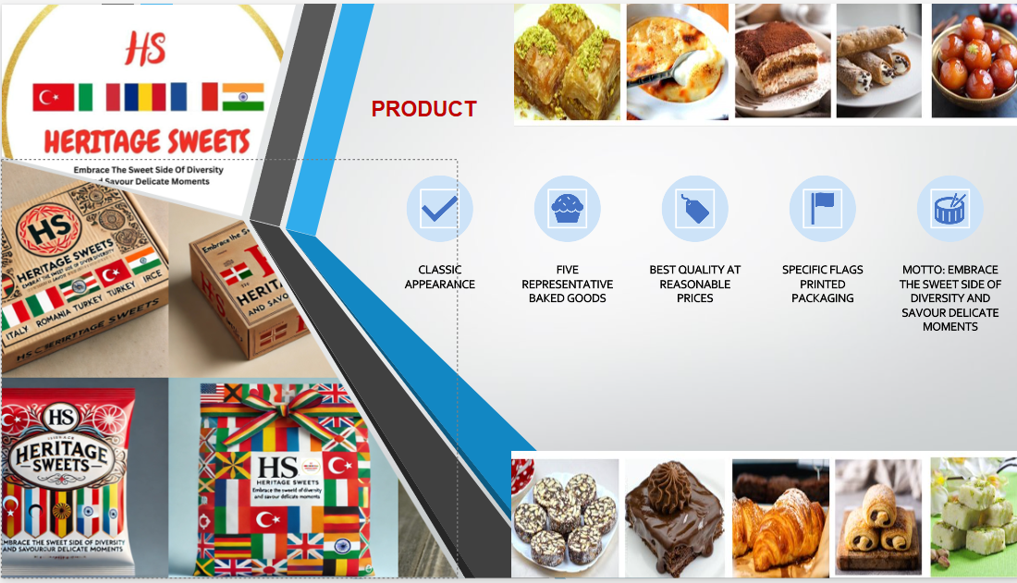

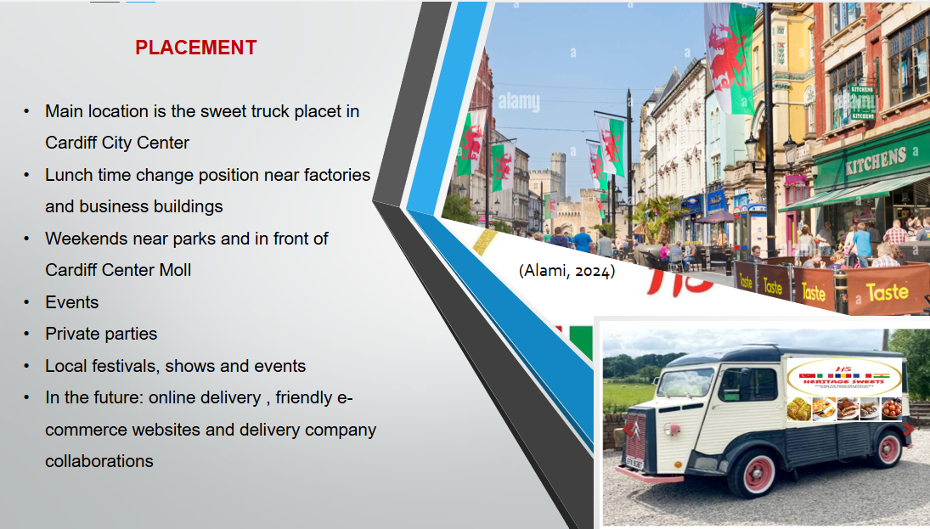

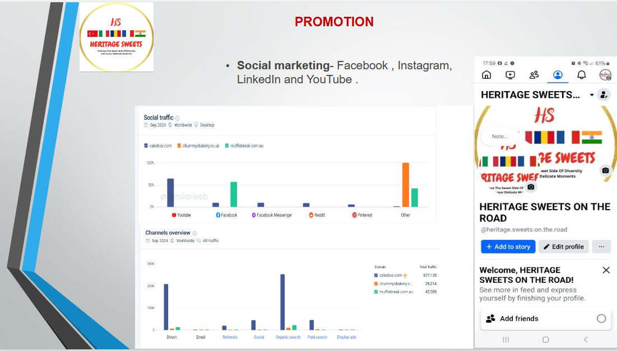

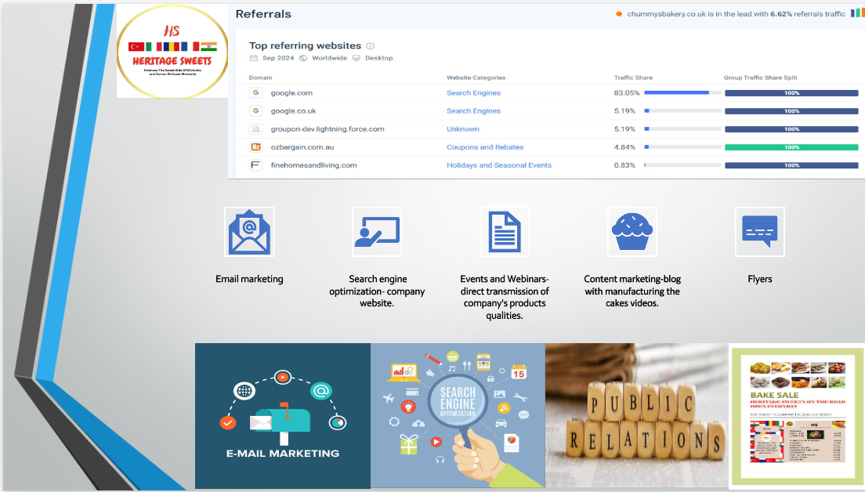

Appendix D
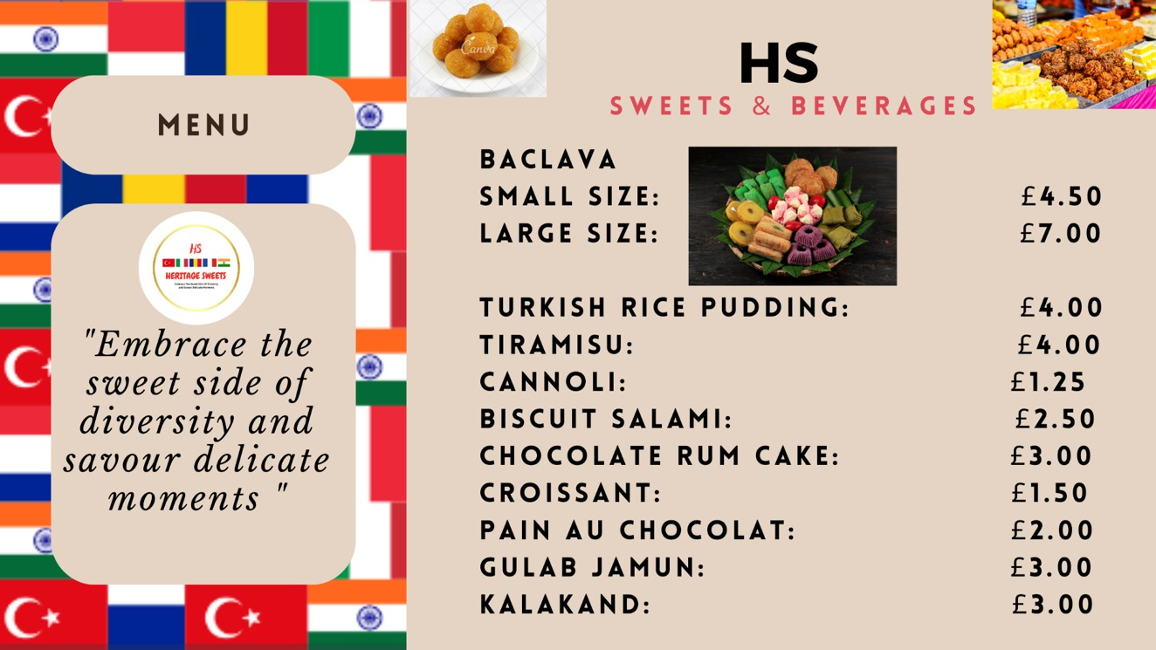

Appendix E

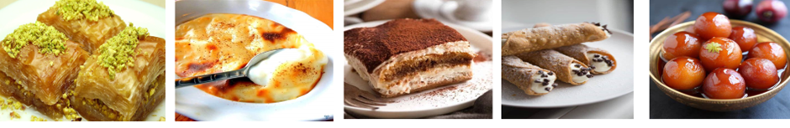
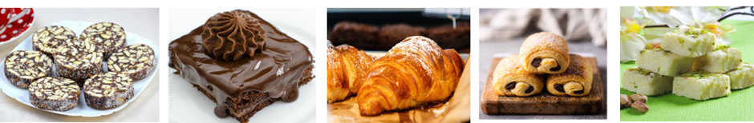

Appendix F
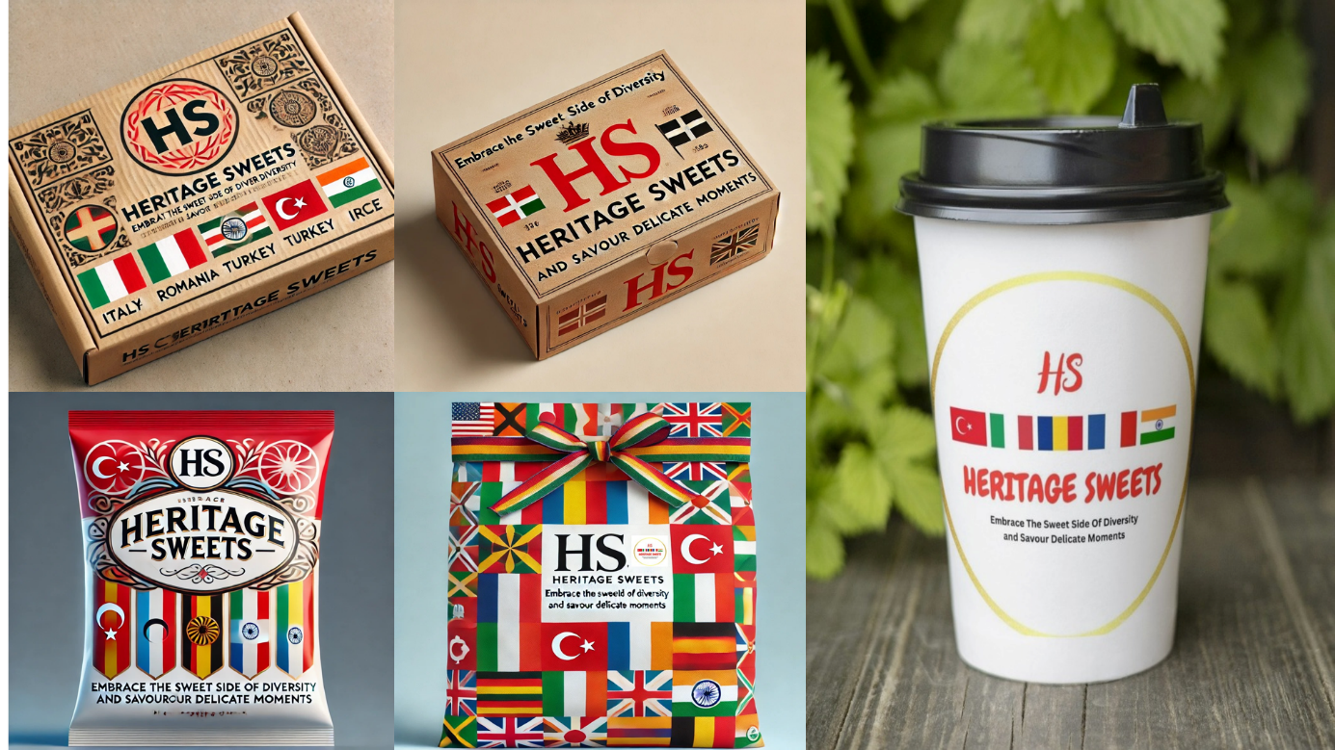

Appendix G
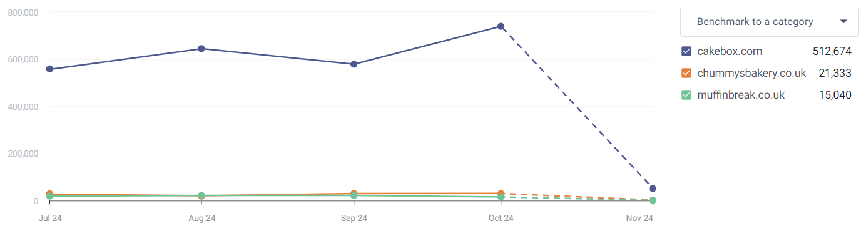
Traffic and Engagement (monthly visits, Oct.2024)

Appendix H

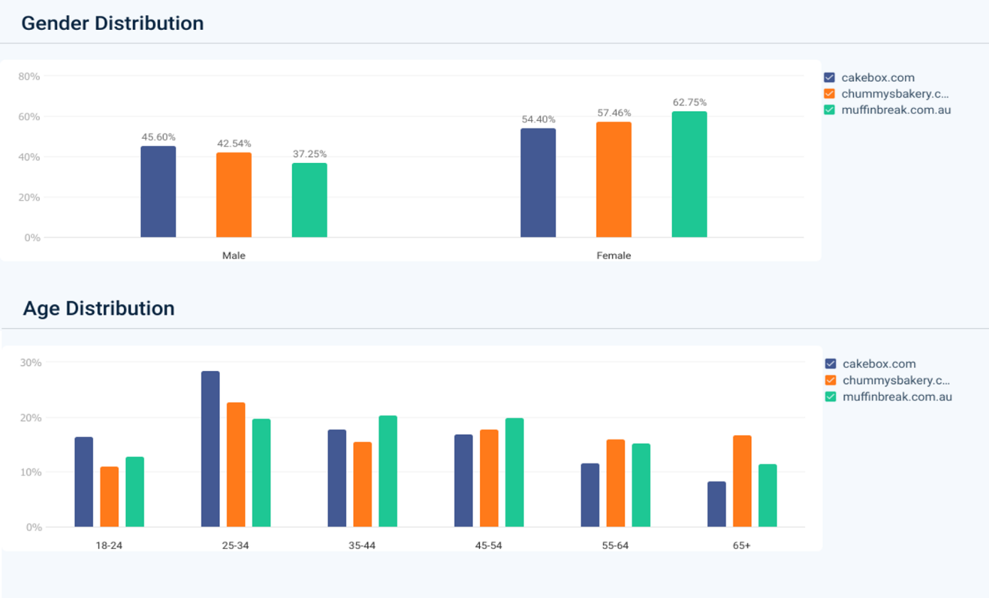
Target audience demographics
(Similar web, 2024)
Appendix I –Kitchen

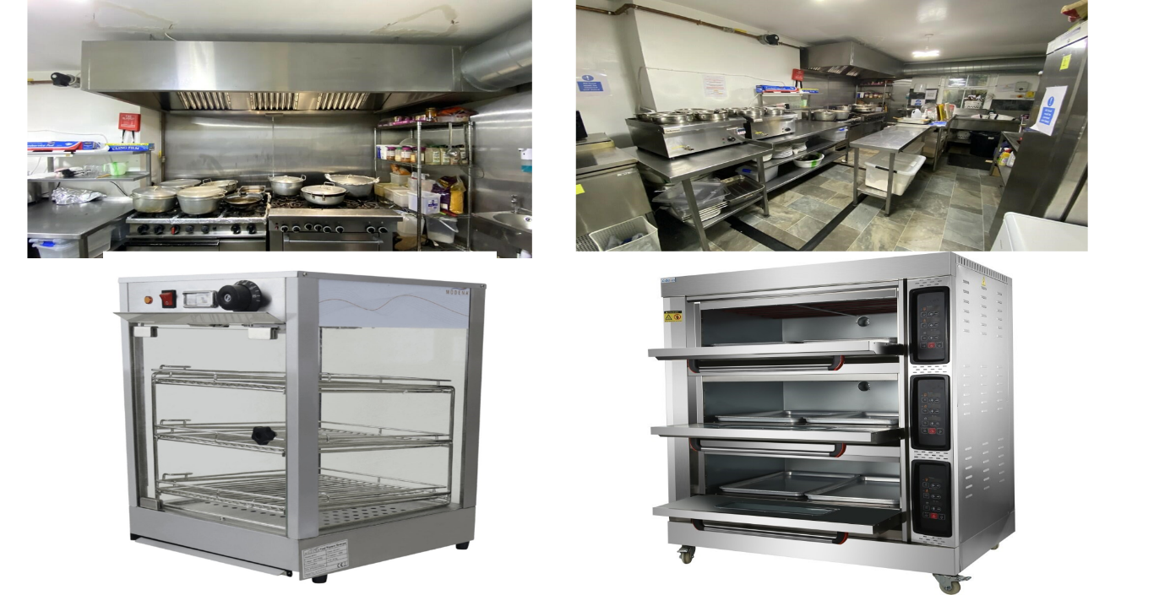

Appendix J –Key Supplies
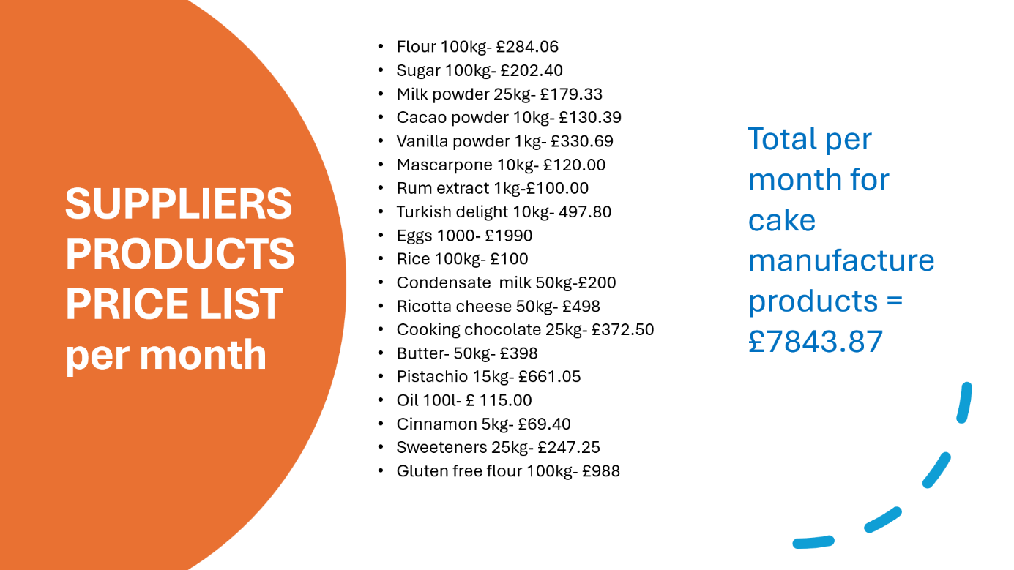

Appendix -K
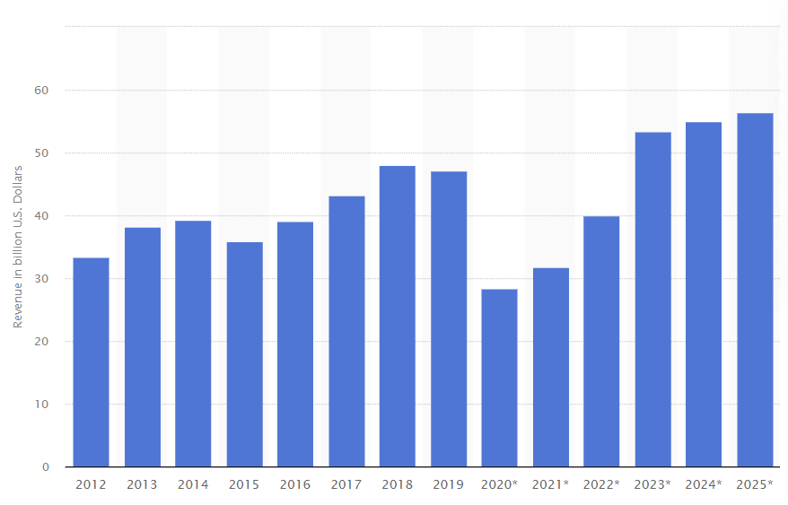
(Statistica Reasearch Department, 2023)

Appendix- L

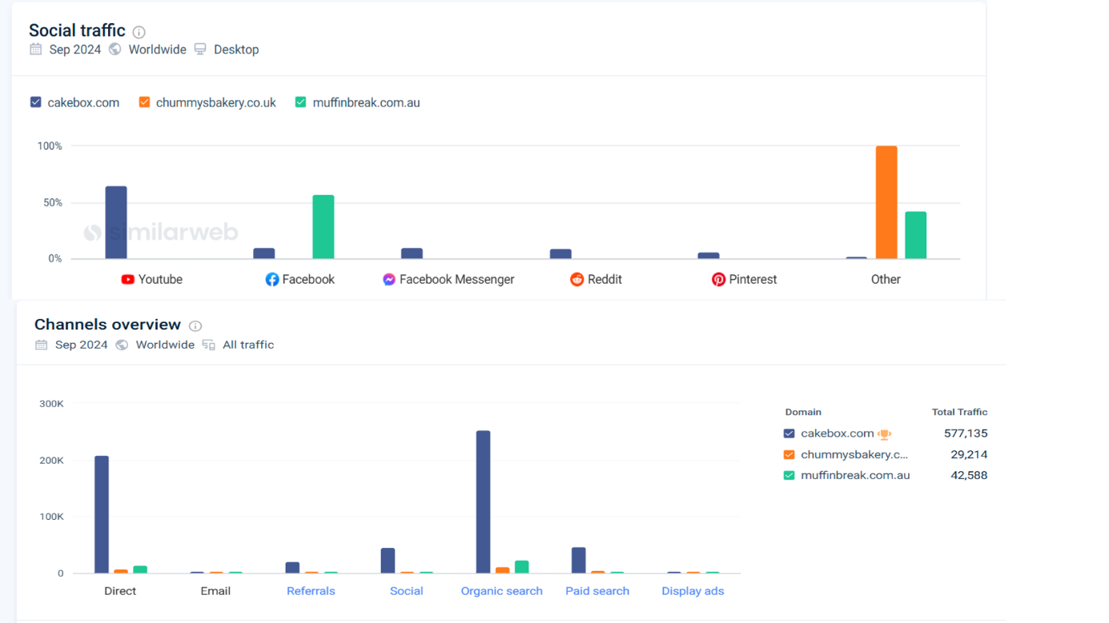
(Similar Web, 2024)

Appendix- M

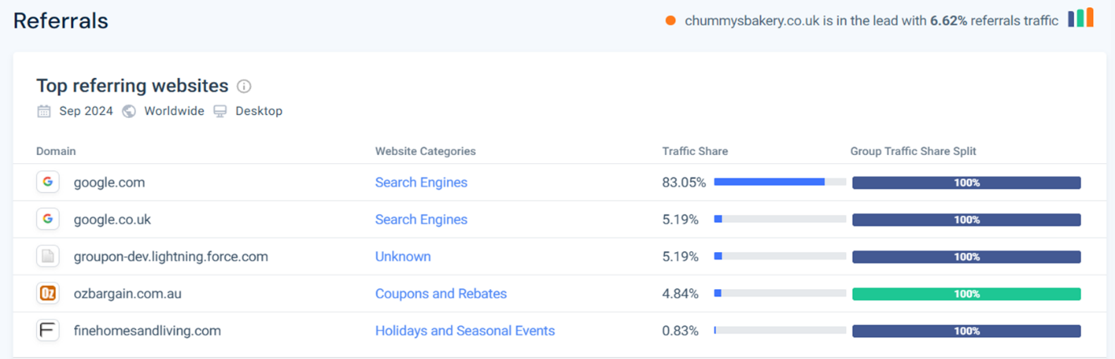

(Similar Web, 2024)

Appendix -N

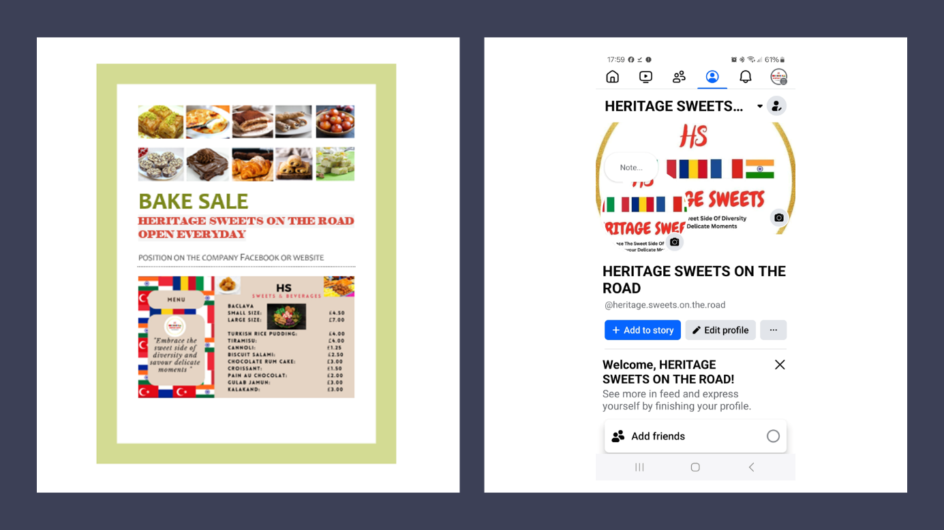

Appendix O

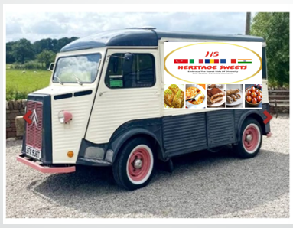

REFERENCE LIST:

Benzaghta, M. et al., 2021. SWOT analysis applications: An integrative literature review. Journal of Global Business Insights, pp. 55-73, available at: https://digitalcommons.usf.edu/globe/vol6/iss1/5/,(Accessed: 06 November 2024).
British Business Bank, (2024), available at:
https://www.startuploans.co.uk/about-the-loan/what-is-a-start-up-loan?gclid=Cj0KCQiArby5BhCDARIsAIJvjIR3gs_bvXUidGESZTG6zzrK8j6aVfkXyrYtQ8SRpXU5sySbSRa8rE8aAjosEALw_wcB&gclsrc=aw.ds, (Accessed:
08 November 2024).

Business Insurance, (2024) available at:
https://www.moneysupermarket.com/business-insurance/?utm_source=google&utm_medium=cpc&utm_campaign=1044418702&utm_id=1044418702&utm_term=business%20insurance&gclsrc=aw.ds&&cicp1=&source=GOO-0X0000048C2DEA2EDA&mckv=s|dc_pcrid_687850920899_mtype_p_kword_business%20insurance_2764ri918980_slid__pgrid_156438195503_ptaid_aud-2257923327747:kwd-10534611&uuid=11111111-1111-1111-1111-111111111111&Device=c&engine=google&gclid=Cj0KCQiArby5BhCDARIsAIJvjISrkm9O-xsyyzX9nPLnCjx9KvbQLTcSH5wFlP_01Sy8IDQHc6JwxeYaAseyEALw_wcB&ptaid=aud-2257923327747%3Akwd-10534611&adloc=1007053&pgrid=156438195503, (Accessed: 05 November 2024).

Business Mobile Phone, (2024), available at:
https://business-quote.co.uk/services/business-mobile/quote/v2/?header=Business+Mobile+Phone+Plans&utm_source=google&utm_medium=cpc&utm_id=15527594763&utm_content=139091520, (Accessed: 08 November 2024).

Baking Supplier, Riverford, (2024), https://www.riverford.co.uk/essentials/organic-dairy-eggs?srsltid=AfmBOorZD79wYGentzjD1PJd4es1Pde49ZmKvTK1o4HtYyQ3vApQYhWB (Accessed: 05 November 2024).

Baking ingredients Supplier, Buy Whole foods Online, (2024). https://www.buywholefoodsonline.co.uk/ accessed: 05.11.2024
Catering Equipment, (2024), Citroen Hy Fired Pizza/ catering van/coffee van/ Cumbria, available at: https://secondhand-catering-equipment.co.uk/listing/95010/citroen-hy-wood-fired-pizza-catering-van-coffee-van-cumbria, (Accessed: 05 November 2024).

Doering, T., De, J. J. & Suresh, N., 2019. Cogent Business & Management. Performance effects of supply chain integration: The relative impacts of two competing national culture frameworks, ProQuest, available at: https://www.proquest.com/docview/2352052925?accountid=130472&parentSessionId=INI7jgX83k%2B94fsNpPoHs1E0grrE8f%2BQ%2B0tK7XSPmVk%3D&pq-origsite=primo&sourcetype=Scholarly%20Journals, (Accessed: 06 November 2024).

Easy Equipment, (2024), Hot Food Display, available at: https://www.easyequipment.com/modena-spw1-electric-pie-warmer-hot-food-display.html?gad_source=1, (Accessed: 05 November 2024).

Ebbing Tobias (2022) Pricing of Consumer Innovations. [S. l.]: Logos Verlag Berlin. Available at: https://research-ebsco-com.ezproxy.uwtsd.ac.uk/linkprocessor/plink?id=3c10021f-c5ee-3a36-ac71-2e97cfb9b13e, (Accessed: 04 November 2024).

Electric Bakery Oven, (2024), Adexa Catering Equipment Direct, available at: https://adexa.co.uk/Commercial-Electric-Bakery-Oven-3-Chambers-21kW-Adexa-HEO36Q?search=Electric%20bakery, (Accessed: 05 November 2024).

Grand View Research, 2024. Food Trucks Market Size & Share Report, 2021-2028. Available at: https://www.grandviewresearch.com/industry-analysis/food-trucks-market-report . (Accessed: 25 October 2024).

Hermayanto, Ricky & Perkantoran, P. A., 2023. Effective Marketing Strategies in Business: Trends and Best Practices in the Digital Age. Journal Administrate, pp. 61-72.
Johnston, K. & Smith, L., 2021. Consumer Trends in Mobile Food Services., Cardiff University Press

Limited Company Accountants, (2024), available at: https://www.theaccountancy.co.uk/who-we-help/limited-company-accountants, (Accessed: 08 November 2024).

McGruer, D. (2020) Dynamic digital marketing: master the world of online and social media marketing to grow your business. Chichester, West Sussex, United Kingdom: John Wiley & Sons Ltd, available at: https://www-vlebooks-com.ezproxy.uwtsd.ac.uk/Product/Index/2255749?page=0&startBookmarkId=-1, (Accessed: 06 November 2024).

Mota Pinto, F. (2020) Digital marketing strategies and models for competitive business. Edited by F. Mota Pinto and T. Guarda. Hershey, Pennsylvania: IGI Global. Available at: https://doi.org/10.4018/978-1-7998-2963-8, (Accessed: 06 November 2024).

Office for National Statistics (2022) How the population changed in Cardiff: Census 2021, Office for National Statistics. Available at: https://www.ons.gov.uk/visualisations/censuspopulationchange/W06000015/. (Accessed: 25 October 2024).

Rightmove, (2024), Commercial properties in Cardiff, available at: https://www.rightmove.co.uk/properties/154449881?utm_campaign=property-details&utm_content=commercial-lettings&utm_medium=sharing&utm_source=whatsapp#/?channel=COM_LET, (Accessed: 05 November 2024).

Sheridan, M. (2019) They ask, you answer: a revolutionary approach to inbound sales, content marketing, and today’s digital consumer. Revised and updated. Hoboken, New Jersey: Wiley, available at: https://ebookcentral.proquest.com/lib/trinity/detail.action?docID=5844289&pq-origsite=primo, (Accessed: 06 November 2024).

Similar Web, (2024), Customer age and gender demographic distribution charts for cake shops, available at: https://pro.similarweb.com/#/digitalsuite/home, (Accessed: 05 November 2024).

Similar Web (2024) Traffic and Engagement Over Time. Available at: https://pro.similarweb.com/?ntflow=no_cc_flow#/digitalsuite/websiteanalysis/traffic-engagement/*/999/3m/?webSource=Total&selectedWidgetTab=Visits&key=cakebox.com,chummysbakery.co.uk,muffinbreak.co.uk&category=no-category. (Accessed: 05 November 2024).
Similar Web, (2024), Website analysis for cake shops, available at: https://pro.similarweb.com/#/digitalsuite/home, (Accessed: 05 November 2024).

Sky and Broadband (2024), available at:
https://www.sky.com/broadband?dcmp=knc-uk-ppc-ggl-20364868691-ACQ-SAB-Trading-PROS-Pmax-NA-New-NA_UF&gad_source=1&gclid=Cj0KCQiArby5BhCDARIsAIJvjIS6quYo_4DQ60UPtASdTm5WZZQRdyXFrC5jJafw7oeHm5HYjftStUAaAidREALw_wcB&gclsrc=aw.ds#broadband, (Accessed: 09 November 2024).

Sparviero, S. (2021) ‘A digital platform for ethical advertising and hybrid business models for news organizations: are they greening methods for “news deserts”?’, Media, culture & society, 43(7), pp. 1328–1339. Available at: https://doi.org/10.1177/01634437211040676date, (Accessed: 05 November 2024).

Statista Research Department (2023) Forecast: Industry revenue of ‘restaurants and mobile food service activities’ in the United Kingdom 2012-2025, Statista Research Department. Available at:
https://www.statista.com/forecasts/899977/restaurants-and-mobile-food-service-activities-revenue-in-the-united-kingdom. (Accessed: 07 November 2024).

Thomas, J.S., Chen, C. and Iacobucci, D. (2022) ‘Email Marketing as a Tool for Strategic Persuasion’, Journal of interactive marketing, 57(3), pp. 377–392. Available at: https://doi.org/10.1177/10949968221095552, (Accessed: 06 November 2024)

