Project brief

The title of my project is Hiraeth, my Welsh heritage is very important to my identity, I wish to explore my welsh heritage through the family members that I have lost. Cloth plays a very important role in the history of welsh culture so my experimentations will be mainly cloth based. In the article Clothing and Subject by Nnia Felshin, she discusses how “clothing more than any other object or possession is closely identified with the body of the absent wearer.”
Objects are cherished forms of memorabilia, they are a part of a past time, connections we once valued are embodied within these objects. Walter Benjamin states that for a collector “ownership is the most intimate relationship one can have to objects. Not that they come alive in him; it is he who lives in them.” Within us lies the importance of the object we identify the continuing bond with the object that embodies a loved one, I would like to explore this concept in my work.
My interpretation of this title will be relating to my memory of particular people, for example the clothing they wore, their smell, appearance, personality and how it takes you to a specific past time. My memories of the absent person will translate and shape the final pieces. Discovering old belongings of my grandparents and great aunts has inspired me to look at these objects not just as objects/ garments but exploring the attachment I have with them in virtue of the significance of the loved one it embodies.
This project will divide into sections each section for a different person. Every section with have a specifics methods that I will be experimenting with combining traditional and digital techniques and challenging materials and their qualities. Each garment will be connected through its imperfect quality of holes or imperfections. Also the poem ‘Cofio’ by welsh poet Waldo Williams has become a huge inspiration, the words in the poem resonates the feeling of loss a remembrance of a loved one, fragments of this text will appear in theses objects.

“Un funud fach cyn elo’r haul o’r wybren,
Un funud fwyn cyn delo’r hwyr i’w hynt,
I gofio am y pethau anghofiedig
Ar goll yn awr yn llwch yr amser gynt.”

“One fleeting moment as the sun is setting,
One gentle moment as the night falls fast,
To bring to mind the things that are forgotten,
Now scattered in the dust of ages past.”

Tommy Phillpot (Dadcu)
Having only been an infant when I lost my grandfather, I have no personal memory of him, the only sources of information I have of him are through photographs, stories and his belongs. My grandfather was an avid gardener even after his passing my grandmother kept the garden exactly how he left it. He planted every tree and flower in our garden and even today it is exactly how he left it. My garden is the place that I feel a strong connection to him. Through this I would like to experiment with plant and botanical processes using the plants in my garden and experiment with the idea of using my garden as a media. In order to create a jacket, since he was a miner by occupation and all of the photographs I have of him are of him wearing a flannel black jacket and his flat cap.

Arthur John Thomas (Dadcu)
Having been extremely close with my Dadcu spending nearly every day after school in his company, he played a very impotent role in my life. My most prominent memory are my Dadcu’s braces they would hold his tailored black trousers up over his rounded belly. He would always look smart, which was a necessity for him as he was an undertaker by trade, he would disappear into his office in a separate building in the yard where I would often pester him to use his photocopier or fiddle with the fax machine. Even after his retirement he still insisted on dressing smartly and he would often find him sitting in the kitchen completing his never-ending supply of crosswords and word searches whilst my Mamgu would wait on him hand and foot.

Millicent Ethel Phillpot (Mamgu)
One of my fondest memories of my grandmother is her leather handbag that was glued to her arm. This handbag would go everywhere with her. This bag would contain the most bizarre objects. She would always ask if I wanted a ‘loshin’ (sweet) and then she would delve into this bag and stuck to the lining of the bag were chapel sweets that had been there so long that they were now a part of the bag itself. The handbag has now been passed down to me after her passing, the wrinkled cracks in the leather and water stained exterior remain and even after a clean the lining of the bag still holds the stain of the chapel sweets, I would like to play with the idea of the lining of the bag showing. Jenni Sorkin in her paper Stain: on cloth, stigma and shame addresses the meaning of the stain in relation to art. She elaborates on a notion of stain as a negation of an area of cloth or a stain becomes marking the wearer, and as both evidence and memory, just like the chapel sweets stain that remains in the lining of the bag it becomes a marker of Mamgu’s existence a memory as well as material evidence.

Auntie Annie and Auntie Dorris (Great Aunts)
These were my Dadcu’s sisters two spinsters that lived next door to my grandparents and as children me and my brother would visit regularly we would get a very warm welcome and received a kitkat and a mini Schweppes lemonade can. My great aunts were very glamorous and well dressed women, but what I remember the most even well into their nighties they would squash they’re severely swollen feet into high heels, I will never forget the image of their ballooning non existent ankles. They’re house remains empty for years, left exactly how they left it, their belongs still remain in the cupboards and they’re hats still remain in their labeled boxes, this house has become my main source of inspiration. As this was a house that has been passed down through generations of my family from 1800’s the house is imbued with my welsh heritage.

I will be incorporating theses very prominent memories in my final pieces but I would like to use materials that are contrasting to the objects. My research for this project began by researching artists that used a contrasting material giving the object a whole new meaning.

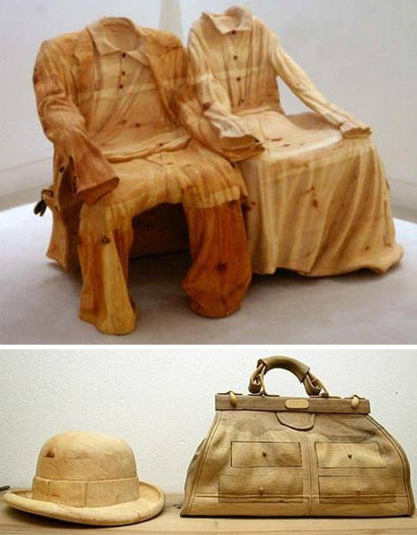

This hand crafted woodwork sculpture by Livio De Marchi questions the malleability of a material. The idea of reinventing these objects in a contrasting material, giving the objects new contradictory qualities for example the wooden chairs of the absent garments, the garments are now un-wearable which accents the emphasis on the idea of the absent garment.

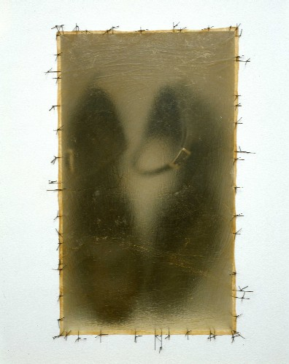
Dorris Salcedo, Atrabiliarios, 2014

Dorris Salcedo also uses contrasting materials in her work. Through her work she expresses the social conscience in Columbia where the process of memory has been obscured by the constant and pervasive violence of everyday life. These are the shoes that belonged to women that had ‘disappeared’ the shoes are visible the translucent animal skin. The work is a series that underlines the grief and pain of the unknown faces by the family that are left behind. The overall haunting ambiance of the installation is extremely potent, I think the subdued sepia effect of the animal skin provokes that perception.

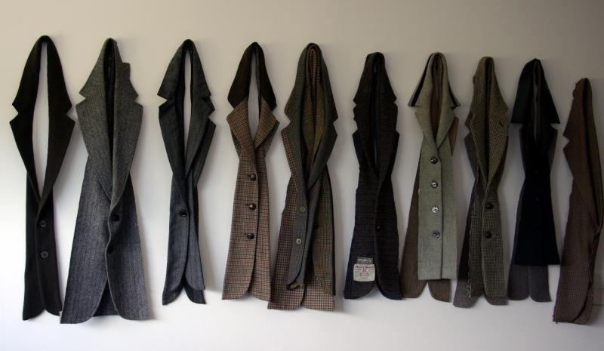
Rose McLeord, Memory and fabric, 2011

This textile installation is expressing a loss in the artist's life. The installation, which consists of deconstructed and reassembled men's woolen and tweed jackets, looks at male identity and the figure of the "old male" in contemporary dialogue. Fragmented pieces of clothing are put back together in new forms as part of a process of learning and investigation. McLeord explores dissection and the need to disassemble thoughts, the tangle of memories, in order to unlock oneself from the strong emotional force of such thoughts, the thoughts of a loved one.

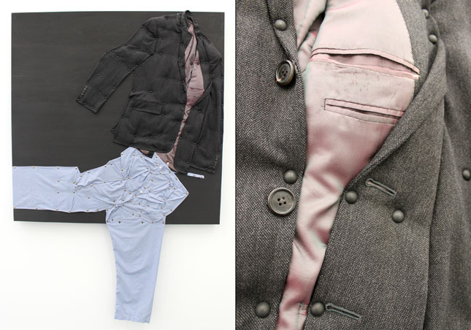

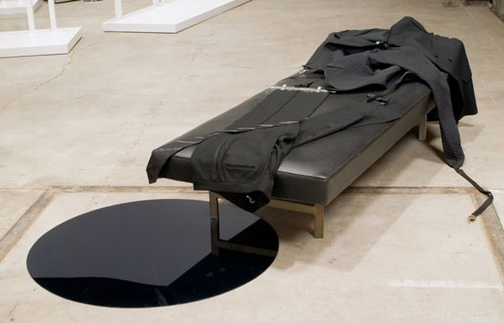
Tom Burr, Sentence, 2012

Tom Burr’s work goes beyond time to all sensory experiences, his sculptures are more of an exploration of moments. A sense of time surrounds his work relating between the object and their ownership, which remains ambiguous. There is a narrative to his work which suggest a certain story to each individual piece. I would like to explore a way of communicating a narrative in my work, expressing the memories I have of each loved one.

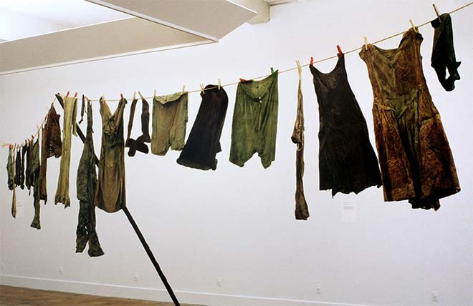Christine Hellyar, Country clothesline, 1976

Christine Hellyar’s 'Country clothesline' (1976) was a controversial piece of artwork in its time, consisting of 22 pieces of clothing dipped in rubber latex that hung from a primitive clothesline of flax rope with a wooden prop. The work has a feminist dimension, suggesting a reality of women's lives. In addition to its political undertones, it represented a departure from conventional sculpture and sculptural materials. Hellyar collected everyday and natural objects, interoperating the life cycle. I particularly am drawn to the dirty and disheveled look of the clothes and the contrast of being displayed on a clothing line where its purpose it to dry washed clothes, but these clothes appear to be dirty – overall making a bold statement, diminishing its use.

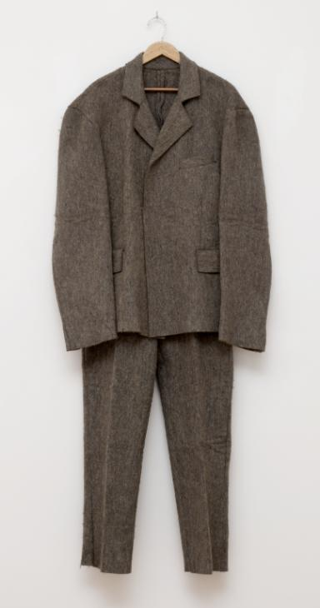
Joseph Beuys, Felt Suit, 1970

Felt Suit (1970) is a two-piece suit comprising of a jacket and a pair of trousers made from coarse grey felt. It is number seventy-seven in an edition of one hundred identical suits, all produced in the same year by artist Joseph Beuys. Hanging from a wooden coat hanger the jacket has lapels and pockets but unordinary there is no lining inside the jacket, nor does it have any buttons. The object having being a suit something that is considered as an everyday object with a practical function rather than a creative one. It is considered that Beuys may have been questioning the separation between fine art and domestic items. Objects are constrained to a function- can this also be said about artworks? I would like to translate this notion into my own work, how these functional everyday objects have now become relics and mementos, they’re past use and function have been diminished due to their sentimental value.

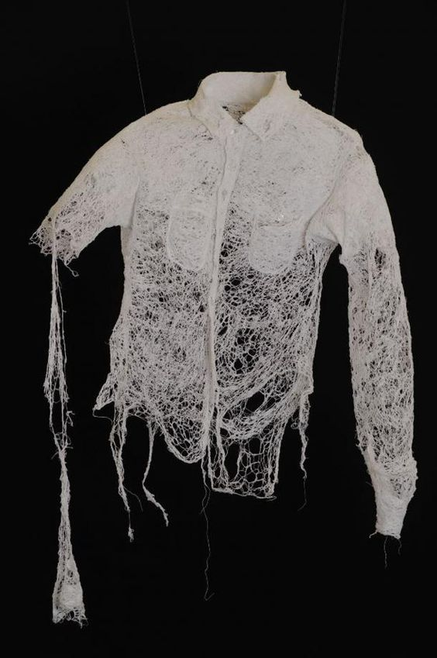
Shirley Boudreaux, Threads of imperfection

The Installation Threads of imperfection by Shirley Boudreaux
challenges the concept of “perfection” as it pertains to the family. Through the use of thread as a media, creating garments that suggest the family unit—in various stages of wholeness and disintegration ultimately highlighting that there is no such thing as a perfect family. These echoes of garments highlight the futility of the pursuit of perfection and the ideal family. Boudreaux herself states

“I want viewers to see themselves in this narrative, and re-evaluate their own perception of (im)perfection; and in that re-evaluation, accept that the ideal is unattainable. While perfection may exist in concept, it does not exist in reality. Imperfection is part of the human condition, and without our imperfections we would lose much of our individuality.”

The notion of the imperfection of the objects and clothing that simultaneously references a presence and absence of the body. The garments floating in space adorned in chaotically stitched thread as a means to visually articulate various states of ‘coming undone’, has given me an insight into how these object could be displayed suggesting the presence of a wearer.

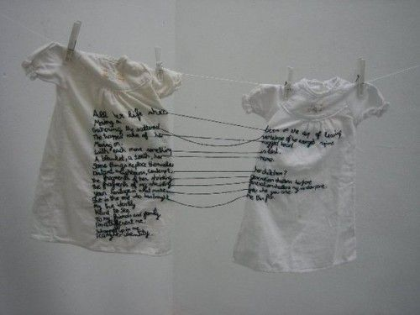Aya Haidar, The Stitch is Lost Unless the Thread is Knotted, 2008

The previous artists have inspired the use of techniques and processes that I will be experimenting with throughout this project. I intend on combining a variety of different media and materials in order to create finished pieces that will explore a specific memory object of mine that connects me to a loved one. Inspired by Livio De Marchi , the contrast in my work will be the clashing of materials, mixing the usual materials associated with the object with ones that arnt. After investigating into fabrics and materials for the final piece for each loved one. After evaluating the outcomes of these experiments, I will start the final pieces where I have allocated four weeks to complete a finished piece.
Through this process of experimentation I intend on critically analyzing my work by reviewing the experiments in my sketchbook and journal, contemplating if the experiments work and how I would develop them further. Correspondingly I also will be analyzing my ideas for the final piece and ideas of displaying the final outcomes in the exhibition weighing the positives and negatives of each idea against the other. Although the final piece will be based on a personal object of a loved one, I intent on provoking an emotional response from the viewers, hoping that the final piece will return them to a personal memory a loved one.

