A Guidance Handbook for Early Years Keyworkers During Childhood Transitions and Development Ages 2-3 Years

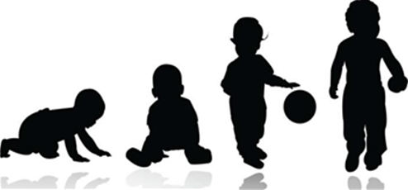
(Source: NHS Cambridgeshire Community Services 2020)

Human Development

EAEE4003
Elinor Griffiths- 2011225

Contents | Page
Introduction and Rationale | 3
Mission Statement | 4
Settling in Policy | 5
Transitions | 6
The Needs of the Child | 8
Role of the Adult During Transition | 9
Development | 10
Brain Development | 11
Nature verses Nurture | 11
Learning through Play | 12
Foundation Phase and Expected Outcomes | 15
Childhood Theorists | 16
Jean Piaget | 16
Abraham Maslow | 18
Partnerships and Interventions | 19
Parent Partnership | 19
Reference List | 20

Introduction and Rationale

The purpose of this handbook is to benefit early years childcare practitioners to learn and recognise the expected outcomes of a child. This handbook specifies the expected milestones of young children who are aged 2 to 3 years, this handbook is specifically designed for keyworkers, working with children in pre-school/playgroup (flying start) settings. This handbook highlights few of a child’s developmental journey towards the early years learning goals.

Understanding and acknowledging child development is vital to effective practice in the Early Years. This handbook addresses few of the key issues around transitions and how it affects child development, how play supports healthy development and why observing child development is so crucial. Theory and practice must go hand-in-hand, this handbook includes additional information of well-known theorists, Jean Piaget and Abraham Maslow. These theorists are few of the many who observe the needs children require. This handbook concludes with the importance of parent partnerships and early years interventions and how they are important for child development and can be included during transition periods.

Mission Statement

Every child has the right to a voice and Article 12 of the United Nations convention on the Rights of the child (UNCRC) ‘establishes the right of every child to freely express her or his views, in all matters affecting her or him, and the subsequent right for those views to be given due weight, according to the child’s age or maturity” (United Nations, 2009)

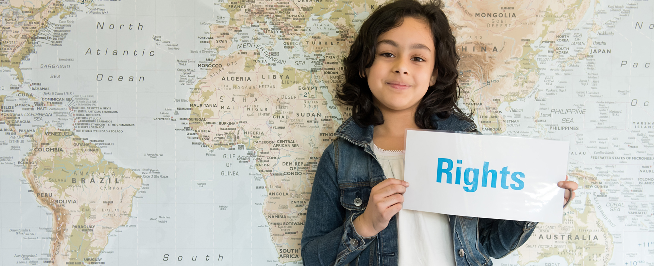
(source: Unicef UK 2020)

Settling in policy

The setting recognises the significance of parents and staff working together to comfort children settling in and develop self-assurance to participate in all the activities. Some children take longer than others to settle and we respond to their needs on an individual basis. This settling in policy will benefit parents and reassure them of their child in our care.

To help children settle quickly and feel comfortable in their new surroundings parents are advised to dress their child in clothes that are suitable for messy play and help their child towards independence (for example, toileting).
- The setting keeps spare clothes available for use in the event of an accident. (Parents may want to provide a change of clothes for their child)
- Parents and their child are invited to visit before registering so that their needs and requirements can be discussed
- Parents are welcome to stay with their child for the whole or part of sessions until they and their child feel assured
- Children may bring their comfort items with them until they feel assertive about being without them
- Parents are encouraged to discuss the settling in process for their child with managers at any time.

(Playgroup, 2020 p.1)
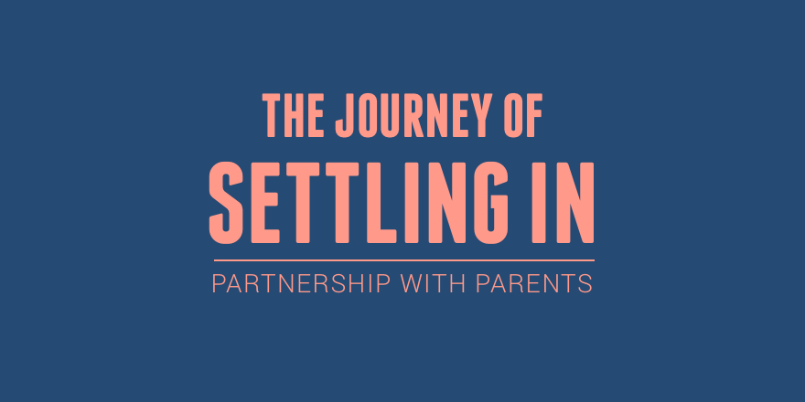
(source: Geelen, 2016)
Transitions

‘Research suggests that transitions are central to young children’s development and emotional well-being, and the way in which the first transitions are handled could have a significant impact on the child’s capacity to cope with change’ (Walker 2002 p.1). Transitions are key events in all our lives and all children experience transition in their lives. They typically occur when a child moves from one care/setting to another. Typical transfers can include starting a new setting, moving within a setting or home living arrangements.

Expected Transitions

Between the ages of 2-3 years, this handbook specifies children starting a nursery/playgroup, which is their first transition, and the second transition is when children move to a primary school setting once they reach the age of three.

Unexpected Transition

Not all transitions can be anticipated and can include the home living environment, which will affect their personal development and emotional aspects. These include
- Birth of a new baby
- Unexpected change of educational provision
- New home
- Family: violence, divorce separation/ new family
- Serious illness of death in family.
(Meggitt et al. 2011)

How Does Transition Affect Behaviour?

Transitions can have negative effects on some children and can causes changes in behaviour. Meggitt (2011b p.88) indicates young children could display more frequent outbursts of temper and aggression towards adults, often shouting or swearing, depending on what they’ve heard. Regression is also a sense of behavioural affects which means the child reverting to behaviour which is usually seen in younger children. A sign of this is when the child uses ‘babyish’ speech and words. Separation anxiety can occur, and this can be seen by young children becoming clingy either to their parent or key person to be reassured.

Effects of Transition

Transition can affect all areas of a child’s development. Stated by Meggitt (2011 p.87), there are four main areas that can be affected:

- Emotional- transition can affect a child’s emotional development as it affects personal experiences which may involve home events, for example: divorce/separation, grief and entering or leaving care.

- Physical- physical development can be disturbed if the child is moving to a new learning setting or a new home/care environment.

- Intellectual: intellectual development can be harmed if the child is moving from nursery to a primary setting as this is a big transformation for them.

- Physiological- physiological harm can occur later I life when a young person experienced puberty, and if the child has a long-term medical condition.

The Needs of the Child

You are likely to have a wide range of children in the setting, all of whom have different needs and abilities. It is important partitioners ensure the environment and practice meets their care, learning and play needs. An example of a child who will struggle during transition is a child with a diagnosed Autism Spectrum Disorder (ASD).

NHS Wales (2020 p.1) states that it is estimated that about 1 in 100 people in the UK has ASD, and these children will find changes extremely difficult when transitioning between home and the setting. Many children with ASD manage differently, and for some, structure in the setting can help children cope better than the unstructured they may have at home.

Manikiza (2015 p.32) advises practitioners to help children with Autism Spectrum Disorder’s, and they should:
- Be consistent with a routine both at the beginning and end of day
- Encourage parents to prepare the child for changes
- Prepare the child for the transition to school and arrange visits to the new environment well in advance.

Routines set by adults help children to know what to expect Forbes (2009 p.253) states that ‘there should be a degree of flexibility in them, as any routine should focus on meeting both individual and group needs’ when settling children into transition.

Role of the Adult During Transition

How does transition affect a child’s development?

Transition can affect all areas of development. Which occur when there are changes or movement from one position or stage to another, and all children will experience changes in their lives, as these are natural events in everyday lives.

How can practitioners support a child in transition?

Key Person

Practitioners must support young children during transitions as, just like adults, they experience feelings. In all early year’s settings, children must be assigned a key person ‘whom a child has more contact than other adults within the setting; this adult demonstrates a special interest in the child (and their family) through close daily interaction’ (Smith 2012 pg. 49) and the child’s key person must assist and ensure the child’s learning and care is amended to meet their individual needs. To cope with transition, the key person must reassure the child to maintain their feelings, help in adapting to different group situations and aid the child to adjust to different, and new, social rules and expectations.

To make a smooth transition for children, it is important for practitioners to have effective preparation in place. It is crucial this gets done, as during transitions, a child may experience a wide range of feelings and emotions. Children experience these emotions because they are losing familiar adults and possibly feel unsettles. In order to make an effective transition, practitioners must:
- Prepare the child before hand
- Listen to the child’s concerns and reassure them
- Be honest and truthful with them
- Be positive
- Arrange to visit new settings beforehand
- Allow children to freely discuss the transition as much as they like
(Forbes 2009 p.128)
Development

Development is the change in the child which arises and progresses actively. These changes follow a logical pattern of milestones which stride towards greater difficulty and improves survival.

There are five key periods of development which are:
- Prenatal development era is the first, which occurs from conception to birth (development in the womb)
- Infancy and toddlerhood development are the second, which occurs onwards from birth to age 2 years
- Early childhood development, which occurs between the ages of 2 to 6 years
- Middle childhood development, which occurs between the ages of 6 to 12 years
- Lastly, adolescence development occurs for older children between the ages of 12 to 19 years

It is central to remember that all children are diverse and development differently to other children it is also important not to compare and use this against them we must look at the individual child as a whole, and each will cope with transition in their own ways.

(King, R 2012 p.1)

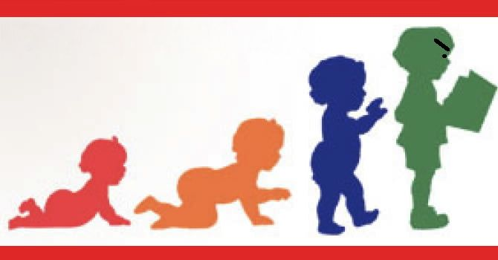
(source: Duvall, 2014)

Brain Development

The brain has more capacity than we can ever use and over time and through emotional and physical damage, synapses are destroyed. The brain of a young child develops through experiences and physical and neurological development is entirely linked. It is impossible for the brain to develop without physical experience.

Neglected Brain Development

According to Children’s Bureau (2019 p.3) “maltreatment can cause victims to feel isolated, fear and disrupt, which can translate into lifelong psychological consequences that can manifest as educational difficulties, low self-esteem, depression and trouble forming and maintaining relationships”. Therefore, increases the child’s risk of emotional, behavioural, cognitive and attentional disorders, highly during transition.

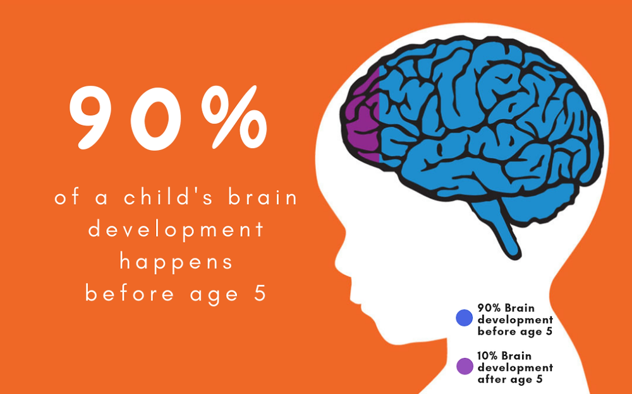
(Source: J.P. Kids & Company, 2019)

Nature verses Nurture

Nature and nurture both play an important role in child development as every characteristic of the child’s brain development is merged by both nature (children simply mature as they grow) and nurture (the environment shapes what children become) and according to Calk (2018) “nature refers to things like the genetic traits inherited from our parents and grandparents, while nature refers to the different environmental factors that have influenced brain development over the years”.
Learning Through Play

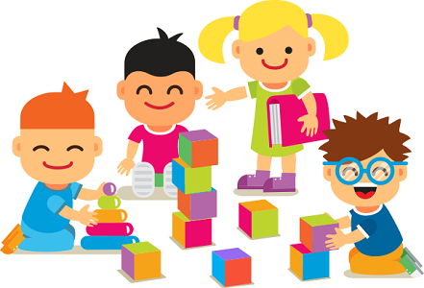
(Source: Edmentum Blog, 2017)

At the age of 2, play improves the child’s holistic developmental needs and its vital that children have access to effectual play experiences as they can learn about the world around them and skills they can improve on. Holistic development means seeing a child as a whole and ‘refers to human development that is meant to involve all parts of a person’ which means it accommodates a child’s physical, emotional and social development and mental growth. (Bajwa 2016 p.1). Play guides children and helps them to make sense of their learning and helps young children develop their intelligence and cognitive development and helps children make sense of their lives (Bruce 2001 p.43). Play can help children during transition as it helps them settle at ease.

How Does Play Support Development?

Play benefits and improves all areas of development and is an essential element of a child’s development as it creates opportunities for children to learn about the world in which the child inhabits. As children play, their brain develops, their muscles grow, and they develop good social skills. They improve life skills as they learn to share, take turns, make their own choices and understand the feelings of others.

Key Developmental Areas

Emotional- Emotional development emphases on the growth of children’s self-esteem, feeling and mindfulness of other feelings. Play can heal emotional pain as it can reduce fear, stress and anxiety to create more joy, intimacy, self-esteem and mastery. Play can also help a child improve their emotional flexibility and openness, and creates a sense of calmness, resilience and adaptability and ability of the child to help them deal with change and transition.

Social- Children’s participation in a wide range of activities through the Foundation Phase should be encouraging as the Welsh Government (2008 p.29) states that play ‘should encourage them to develop the appropriate skills to communicate and develop positive relationships with others to become independent learners and members of their communities’ and play can increase compassion, sharing and models relationships based on attachment rather than exclusion.

Physical- ‘Children are motivated by play opportunities and games that involve them in physical activity and increases a range of motions, agility, co-ordination, balance, flexibility and fine and gross motor skills’ Welsh Government, 2008 p.10). Play decreases stress, fatigue and depression and creates positive emotions and increases the efficiency of immune, endocrine and cardiovascular systems.

Language and communication- Some children use simple language in play and communicate understanding of basic instructions and listen to and join in with rhymes, songs and stories. Through play, children can communicate through verbal and non-verbal interactions. Play must allow children to express themselves, their needs and their feelings, also by using facial expression, body gestures and eye contact.

Observing and Assessing Children’s Development

Having up to date observations on a regular basis helps us see what a child is achieving and what we can do to follow up. By this we can incorporate their interests into their next stages of development. Practitioners must reflect on the child’s observations and developmental records and use them for planning the child’s next steps. According to Aussie Childhood Network (2015 p.1) ‘reflective practice is learning from everyday situations and issues and concerns that arise which form part of our daily routine while working in an early childhood setting. This enables us to develop and extend on children's learning and build upon their knowledge and skills.’ These observations can be reflected on own work in ways you can improve to help the child’s development.

Foundation Phase and Expected Outcomes

The Foundation Phase is set out by the Welsh Government to continuously expand the way in which the Foundation Phase is delivered and funded in schools and early years settings across Wales (Welsh Government 2016 p.4).

Between the ages two to three years, children should either start the setting the setting at an outcome 1 level, which depends on the child’s abilities and capabilities, and leave the setting on an outcome 2 level.

This means, when the child starts, socially the child should be capable of playing alone or parallel to a familiar adult or other children. They understand some behaviour is unacceptable and respond to social greetings from familiar and unfamiliar people.

Oracy, the child should be able to respond to one step instructions and show an understanding of simple phrases and use newly learned words in their play and begin to engage in word play.

Intellectually, the child should recite or indicate numbers 1-3 and outcome 2 up to number 10. They should also be able to explore regular 2D and 3D shapes and play.

Physically the child should be able to run in a straight line, avoid obstacles, jump with two feet and stop and start with ease. They should also be capable of holding a pencil or crayon use it all fingers and firm and scribble independently, including curves, straight lines and dots.

(Welsh Government 2015 p.1)



(source: Hwb Welsh Government 2020)
Childhood Theorists

The key issue for childcare practitioners relating to the promotion of positive development outcomes for children and young people consists of knowledge of theorists and understanding which theorists link to their developmental areas. A child development theory is a combined compilation of beliefs about why children and young people behave, think and feel as they do.

Purpose

The purpose of childhood theorists is to help guide practitioners and other childcare professionals by ensuring that there is an underlying purpose for routines and that the educational process of young children is carried out consistently.

Jean Piaget

Jean Piaget’s (1896-1980) theory is centred on the awareness that the developing child forms cognitive structures for understanding and responding to physical experiences within the environment. He formulates four stages of intellectual-cognitive development and the progression by which children progress through them. Which consists of sensorimotor stage, pre-operational stage, concrete operational stage and formal operational stage.
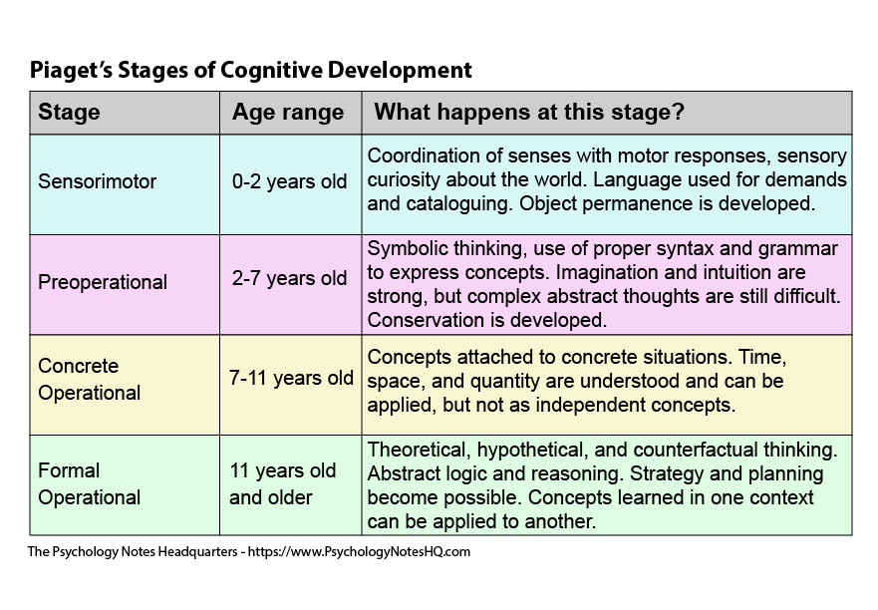
(Source: The Psychology Notes Headquarters, 2020)

Piaget was interested in intellectual development and Pound (2014) claims Piaget ‘argued that there was a natural sequence for the development of thought governed by what he termed ‘genetic epistemology’’. Tassoni (2005 p.1) also states that Piaget ‘believed that children develop a number of patterns of behaviour of actions, which then they apply to similar situations’ Piaget called these patterns ‘schemas’. Schemas in child development are biological and socio-cultural and are a natural part of children’s play and development and explains why some children show such determination and purpose to express actions in a certain way.

Here are the most common Schemas identified in early years settings. These are trajectory, containment, connecting, transporting, orientation and positioning. Picture diagram below, as shown by Sands (2014) states what to look for in a child with expected schema.

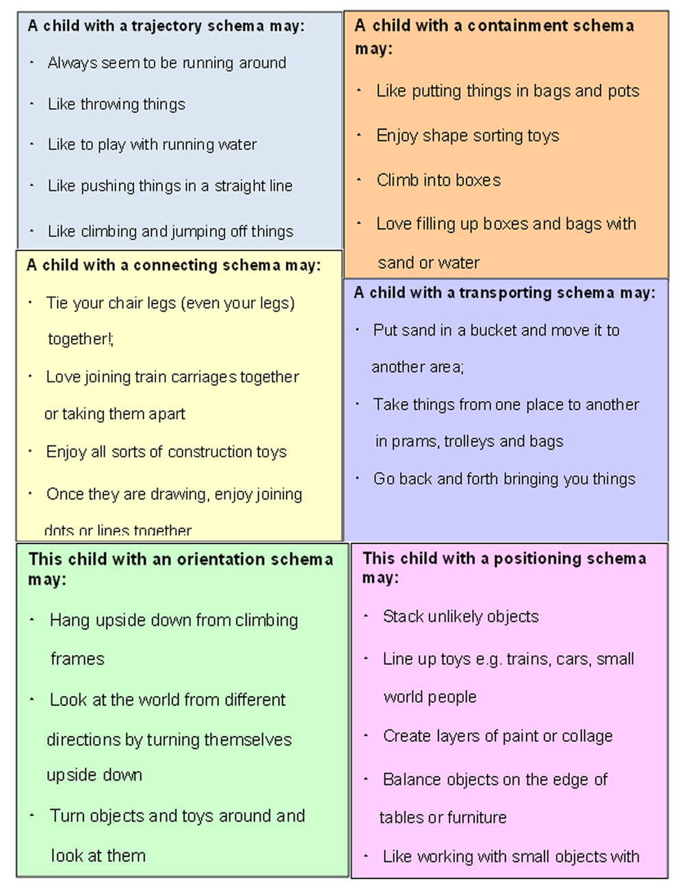
(source: Sand, C 2014)

Abraham Maslow

Abraham Maslow (1908-1970) was a humanist theorist who claims our movements are driven in order to achieve certain needs. He was best known for creating Maslow’s Hierarchy of Needs.

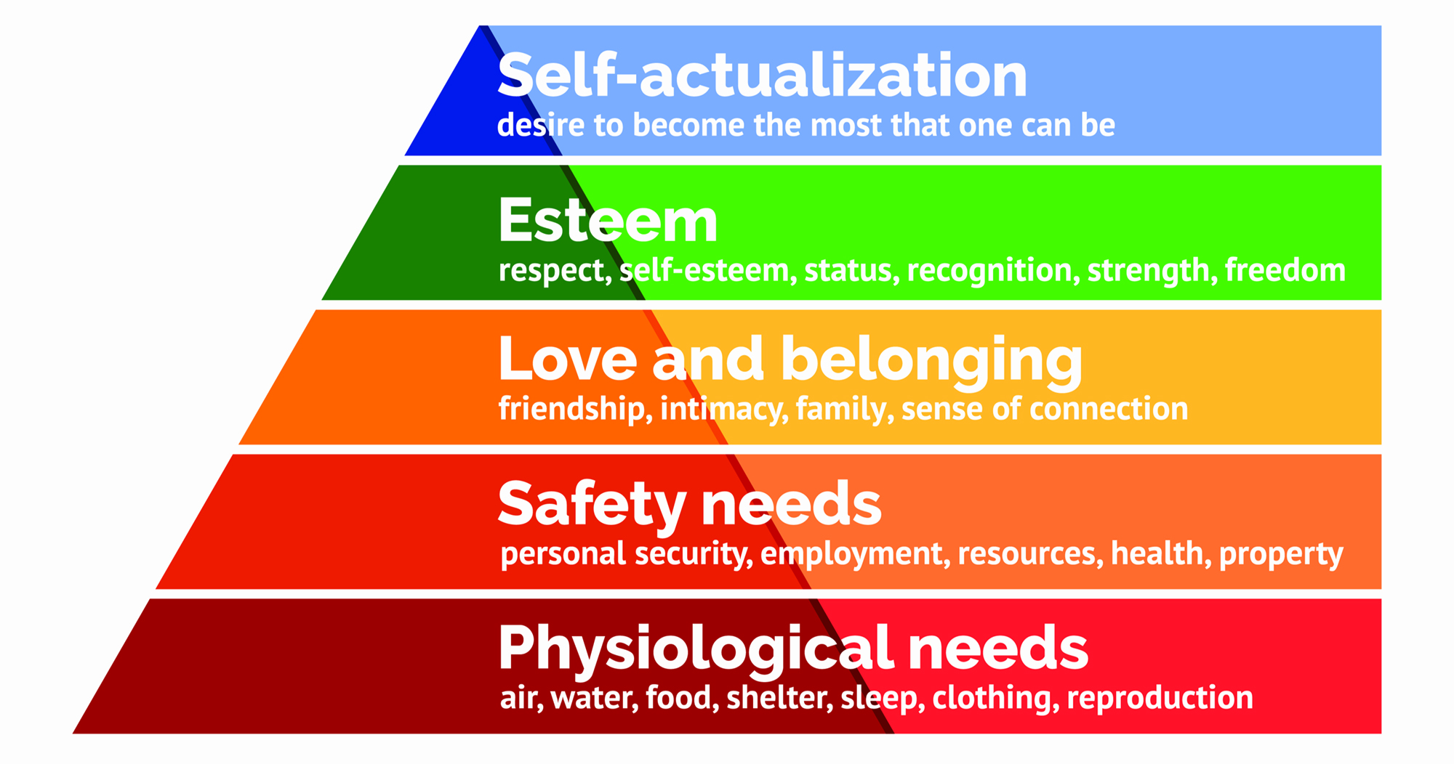
(source: McLeod, S. 2020)

The hierarchy is displayed as a pyramid because the lower level is made up of basic needs, whereas the more complex needs are located at the top. Khan (2016 p.1) explains that the five-stage model can be divided into basic needs and growth needs, which convey to children achieving their human potential.

Maslow considered every child is efficient and has the aspiration to move up the hierarchy. However, the progress can often be disturbed by failure to meet lower-level needs. This can happen due to transitions and how it affects the child’s feelings and emotions, causing them to regress.

Partnerships and Interventions

The following table diagram written by Forbes (2009c p.130) shows there are many agencies that work closely with young children, which can help practitioners, if there are concerns over a child’s development during transitions, particularly when newer and younger children start.

Agency | How can they help?
Child’s Doctor | Assesses the child’s health and growth and development.
Play Therapist | Assesses the child’s behaviour, expression and learning
Child Psychiatrist | Assesses the child’s emotion
Health Visitor | Looks at and assesses the child’s health, growth and development for children under 5.
Play Therapist | Assess and observe how the child plays and uses problem solving skills
SENCO | Special Education Needs Coordinator
Speech and Language therapist | Assesses the child’s speech and language capabilities

Parent Partnerships

According to Tassoni, P et al (2002 p.420) ‘it is important that a partnership with parents is at the centre of positive care and education for young children. It is this partnership that will help early years practitioners to gain the information they need about a child to facilitate effective communication.’ When having a stable relationship with parents makes them feel more involved in their children’s learning and development and they feel valued and respected. This helps parents and practitioners exchange information about their child before starting and helps us know more about the child’s capabilities outside and incorporate interests when starting to help settling.

Reference List

Aussie Childcare Network (2015) Reflective Practices in Childcare. Available from https://aussiechildcarenetwork.com.au/articles/childcare-programming/reflective-practices-in-childcare (accessed: 11th November 2020)

Bajwa, R. (2016). Holistic Development. Available at: https://www.slideshare.net/rashidhussain33/holistic-development-69809765 (Accessed: 8th November 2020)

Bruce, T. (2001). Learning through play: Babies, Toddlers and the Foundation Years. London: Hodder and Stoughton Education. (Accessed: 7th November 2020)

Chalk, E. T (2018). How Do Nature and Nurture Affect Brain Development? [Blog]. Available at: https://kidsrkids.com/greatwood-canyon-gate/2018/11/30/greatwood-canyon-gate-day-care-how-do-nature-and-nurture-affect-brain-development/ (accessed: 11th November 2020)

Children’s Bureau. (2019). Long-Term Consequences of Child Abuse and Neglect. [factsheet]. Available at: https://www.childwelfar.gov/pubPDFs/long_term_consequences.pdt (accessed: 11th November 2020)

Duvall, A. (2014). Student Development and Learning. [Image]. Available at: http://aduvall78.blogspot.com/2014/10/student-development-and-learning-as.html (accessed: 12th November 2020).

Edmentum Blog. (2017). In Defence of Playtime: 5 Ways Play Helps Your Child Learn. [Image]. Available at: https://blog.edmentum.com/defense-playtime-5-ways-play-helps-your-child-learn (accessed: 12th November 2020).

Forbes, S. Blake, L. and Hill, K. (2009). NVQ/SVQ Level 4, Children’s care, Learning and Development. Essex: Heinemann Education. (Accessed: 8th November 2020)

Geelen, A. (2016). The Journey of Settling In. [image]. Available at: http://tiptoptest.dreamhosters.com/?p=57 (accessed: 12th November 2020)

Khan, Z. (2016). Maslow’s Hierarchy of Needs. Available at: https://www.slideshare.net/ZahraKhan37/maslows-hierarchy-of-needs-66255332 (Accessed: 8th November 2020)

King, R. (2012). Child Development. Available at: https://slideshare.net/67701uhrig/child-development-14487267 (Accessed: 8th November 2020).

J.P. Kids & Company (2019). Early Childhood Education for Infants. [Image]. Available at: https://www.jpkidsandcompany.com/post/early-childhood-education-for-infants (Accessed: 12th November 2020)

Manikiza, J. (2015). Autism: A Guide for Early Years Setting. ASN National Development Lead, Welsh Local Government Association (Accessed: 7th November 2020)

McLeod, S. (2020). Maslow’s Hierarchy of Needs. [Image] Available at: https://www.simplypsychology.org/maslow.html (Accessed: 8th November 2020)

Meggitt, C., Kamen, T., Bruce, T., and Grenier, J. (2011) CACHE Level 3 Diploma, Children and Young People’s Workforce, Early Learning and Child Care. Oxon: Hodder Education. (Accessed: 7th November 2020)

NHS 111 Wales. (2020) Autism Spectrum Disorder. Available on: https://111.wales.nhs.uk/Autismspectrumdisorder/ (Accessed: 7th November 2020).

NHS Cambridge Community Service. (2020). Your Childs Development [Image]. Available at: https://www.cambscommunityservices.nhs.uk/Bedfordshire/services/health-visiting/you-child%27s-development (Accessed: 8th November 2020)

Playgroup, N. (2020) Setting’s Policies and Procedures: Admissions, arrivals and collections, settling in, failure to collect a child, and when a child goes missing, policy and procedure. Pembrokeshire. (Accessed: 17th November)

Pound, L. (2014). How children Learn, Educational Theories and Approaches- from Comenius the father of modern education to giants such as Piaget, Vygotsky and Malaguzzi. London: MA Education, Practical Pre-School Books. (Accessed: 11th November)

Sand, C. (2014). Children and Schemas- Understanding Different Play Behaviours. [Images}. Available at: https://www.childrensscrapstore.co.uk/blog/2014/07/parents-4-play-children-and-schemas-by.html-jgd5g (Accessed: 12th November 2020)

Smith, M., Kamen, T., Irvine, J., Armitage, M., and Barker, C. (2012). CACHE Level 3 Extended Diploma, Children and Young Peoples Workforce, Early Learning and Child Care. Oxon: Hodder Education. (Accessed: 7th November 2020)

Tassoni, P., Beith, K., Eldridge, H., and Gough, A. (2002), Diploma, Childcare and Education, Oxford: Heinemann. (Accessed 11th November 2020).

Tassoni, P. and Hucker, K. (2005) Professional Development, Planning and Play and the Early Years (2nd ed.). Oxon: Heinemann Education (Accessed: 11th November 2020)

The Psychology notes Headquarters (2020) The Piaget stages of Cognitive Development. [Image]. Available at: https://www.psychologynoteshq.com/piagetstheory/ (Accessed: 11th November 2020)
United Nations. (2009) Convention on the Rights of the Child. Available at: https://www2.ohchr.org/english/bodies/crc/docs/AdvanceVersions/CRC-C-GC-12.pdf (Accessed: 12th November 2020)

Unicef UK (2020) How we protect Children’s Rights with the UN Convention on the Rights of the Child. What is the UNCRC? [Image]. Available at: https://www.unicef.org.uk/what-we-do/un-convention-child-rights/ (Accessed: 12th November 2020)

Walker, E. (2020). Managing transitions in early years provisions. Available at: https://app.croneri.co.uk/feature-articles/managing-transitions-early-years-provision (Accessed: 7th November 2020)

Welsh Assembly Government (2008). Personal and Social Development, Well-Being and Cultural Diversity. Cardiff: Welsh Assembly Government (Accessed: 17th November)

Welsh Assembly Government (2008). Physical Development. Cardiff: Welsh Assembly Government (Accessed: 17th November)

Welsh Government (2015) Curriculum for Wales, Foundation Phase Framework. Cardiff: Welsh Government (Accessed: 17th November)

Welsh Government (2016). Foundation Phase Action Plan. Cardiff: Welsh Government (Accessed: 17th November)

Welsh Government (2020). Hwb Zones. [image]. Available at: https://hwb.gov.wales/zones (Accessed: 17th November)

