Marriott International - Marriott’s Response to the COVID Crisis

 Subject – Marketing Management
This Photo by Unknown Author is licensed under CC BY-NC-ND
Name – Aman R Gyani
Student ID Number – 2243885
Submission Date – 27-07-23

Table of Contents
Introduction 2
During the COVID-19 Crisis, what is marketing and why is it important? 4
Analyzing the SWOT Analysis Critically 5
Marketing Strategy Analysis and Stakeholder Impact: 6
A study of competitors: 7
Impact of Technology: 8
Evaluation of Strategy Success and Measurement Metrics 9
Critique of Strategy Effectiveness: 10
Managerial Implications on Marketing Strategies Implemented by Marriott International during the COVID-19 Crisis: 12
In the post-pandemic era, here are some suggestions for strengthening Marriott International's marketing strategies: 22
Conclusion: 24
References 25

Introduction

An unprecedented global disaster, the COVID-19 epidemic has caused significant disruptions across many businesses. Travel and tourism were among the industries that were severely damaged, because of travel restrictions, lockdowns, and people's fear of spreading the disease. Leading hospitality corporation Marriott International, one of the major competitors in this market, encountered significant difficulties during this crisis. As the pandemic spread, Marriott had to quickly adjust to the new environment while protecting the security and well-being of its visitors and staff.

The epidemic had a catastrophic effect on the travel and tourism sector, with domestic travel being drastically decreased and international travel almost halted. Marriott's operations were severely impacted by this, which led to a dramatic drop in occupancy rates, cancellations, and revenue losses. The corporation had to deal with hotel closings and layoffs, which made things worse.

Effective marketing becomes essential during times of crisis for firms to overcome obstacles and keep relationships with their stakeholders and customers. The pandemic highlighted the importance of flexible and cutting-edge marketing approaches for companies to thrive and maintain themselves under unusual situations. Businesses had to successfully communicate, establish trust, and show their dedication to safety and service while dealing with uncertainties and quickly evolving consumer behaviour. (marriott.com)

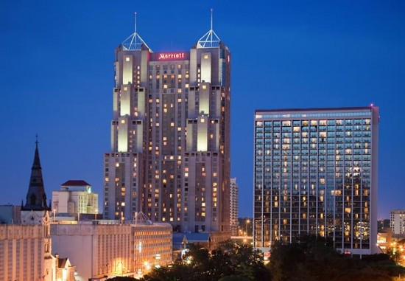 Purpose of the Report:
This Photo by Unknown Author is licensed under CC BY-NC-ND
The purpose of this paper is to examine critically the marketing concepts and tactics used by Marriott International during the COVID-19 epidemic. We aim to acquire an understanding of how the corporation modified its marketing strategy to accommodate the difficulties presented by the pandemic by looking at Marriott's answers to the problem. The success of Marriott's marketing initiatives in upholding consumer loyalty, resolving safety issues, and addressing customer involvement will be evaluated in the study.

This analysis will offer light on the company's decision-making procedures, messages, and platforms used to maintain contact with its clients and stakeholders during the crisis through a thorough examination of Marriott's marketing operations. Considering the unique challenges posed by the pandemic, the research will also assess the effect of these marketing efforts on Marriott's brand reputation and competitiveness in the hospitality sector.



During the COVID-19 crisis, which caused travel bans, lockdowns, and safety worries, Marriott International was confronted with never-before-seen difficulties. To sustain consumer trust, engagement, and loyalty while navigating these risks, Marriott had to implement successful marketing theories and methods. Let's examine each component of the critical evaluation in more detail.

During the COVID-19 Crisis, what is marketing and why is it important?

The COVID-19 epidemic caused companies in the travel and hospitality sectors to immediately change their marketing approaches. Marketing during the crisis involved more than just advertising goods and services; it also required understanding customer requirements, demonstrating empathy for those needs, and addressing safety concerns. Despite the challenges the epidemic brought, Marriott recognized how important it was to keep up relationships with suppliers and clients.
To strengthen its brand image and adjust to the changing market conditions, Marriott International dedicated resources to a variety of marketing initiatives. The business invested in digital marketing, using social media and internet platforms to interact with clients from a distance. Inspiring future travel plans, presenting pertinent information about safety precautions and travel norms, and providing value to clients were all made possible by content development.


This Photo by Unknown Author is licensed under CC BY-ND

For preserving ties with frequent passengers and members of reward programs, Marriott also put focus on customer engagement initiatives. As a result of these initiatives, customers felt valued and connected to the brand even during periods of limited travel. These initiatives included personalized emails, exclusive incentives, and virtual events.

Marriott was able to give clients more peace of mind by implementing flexible booking choices and updated cancellation policies, ensuring their freedom to change travel plans without taking any financial consequences. These customer-centred tactics seek to increase loyalty and trust in tumultuous times.

Analyzing the SWOT Analysis critically:
During the COVID-19 crisis, Marriott conducted a SWOT analysis to better understand the company's strengths, weaknesses, opportunities, and threats. The investigation accurately identified Marriott's strong brand recognition and global reach as key benefits that foster customer trust and enable the business to effectively target regional demand.

The analysis may have downplayed several flaws, like as excessive reliance on conventional marketing channels and large fixed expenses. These flaws made it difficult to adjust to digital trends and control spending during times of low demand.

However, Marriott made good use of the chances that were recognized to support domestic tourism and cater to remote workers. The business' work-from-hotel packages and regional tourist advertising successfully handled changing travellers tastes throughout the crisis.
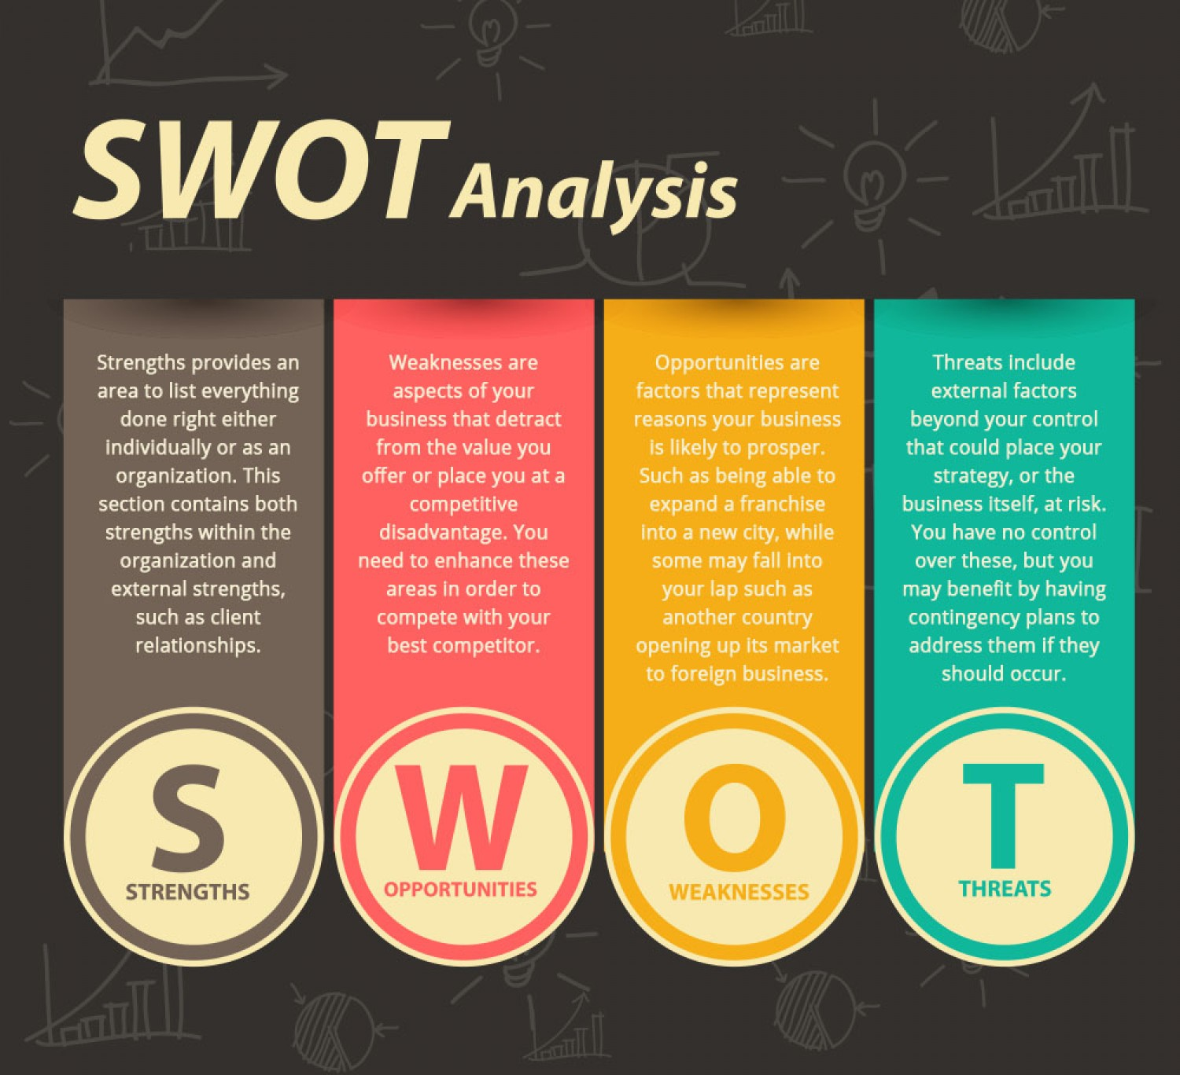

Marriott's response through targeted discounts and unique products demonstrated its competitiveness in the face of serious threats from other lodging providers like Airbnb.
(Lin, X., 2016)

Marketing Strategy Analysis and Stakeholder Impact:

Marriott's marketing initiatives during the COVID-19 issue had a significant effect on its internal and external stakeholders. Customers were positively impacted by the provision of flexible booking choices and updated cancellation procedures, increasing happiness and loyalty. Marriott showed compassion and understanding for customers' shifting travel plans by allowing customers to change or cancel reservations without incurring fees. (Nyangwe, S. and Buhalis, D., 2018)

In times of increased health concerns, improved health and safety standards reassured customers and staff, preserving brand trust. Marriott underlined its dedication to guest well-being by clearly outlining the safety procedures and hygiene measures used across all of its locations.

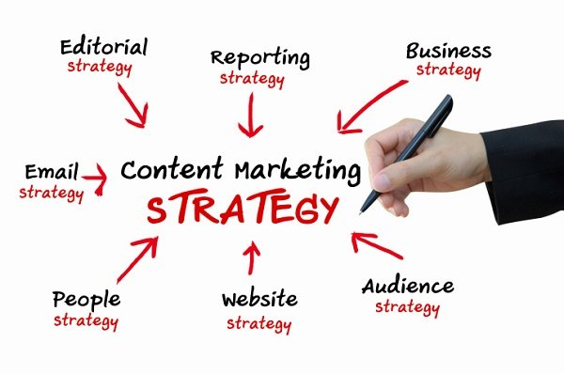
This Photo by Unknown Author is licensed under CC BY-SA-NC

Customers were kept interested throughout travel limitations with the use of content marketing and virtual engagement tactics. With the support of Marriott's educational and inspirational material, virtual events, and virtual tours, consumers were able to remain connected to their favourite places despite physical limitations.

Internally, Marriott's dedication to assisting and energizing its staff during trying times was reflected via employee well-being initiatives and remote working policies.

A study of competitors:

Even in the face of competition from other lodging options like Airbnb, Marriott was able to stay competitive thanks to its marketing strategies. While the demand for private and remote lodging surged due to Airbnb, Marriott's work-from-hotel packages and regional tourist campaigns positioned it as an excellent choice for guests looking for unique experiences.



Since loyal clients were more inclined to select Marriott properties for their travel needs, Marriott's well-established brand reputation and loyalty program also aided in the establishment of its competitive edge. ( Bashir, M. and Verma, R., 2016)

Impact of Technology:

During the COVID-19 crisis, technology was a key component of Marriott's marketing plans. To interact with clients remotely, the business used digital marketing, communication tools, and mobile apps. By utilizing technology, Marriott was able to stay in touch with its clients, convey pertinent information, and offer distinctive deals and services.

Technology enabled virtual engagement and virtual events, giving customers an alternate means of interacting with the company and maintaining their sense of normalcy in the face of travel constraints.



With internationalization tactics, Marriott was able to modify its marketing strategy to suit local market conditions. Marriott increased its exposure and market relevance by adjusting its messaging and services in accordance with regional norms and travel patterns. (Hormby, S., Morrison, J., Dave, P., Meyers, M. and Tenca, T., 2010)

Evaluation of Strategy Success and Measurement Metrics:

During the COVID-19 crisis, Marriott International evaluated the effectiveness of their marketing tactics using a variety of measures. Customer feedback, repeat business, and customer satisfaction ratings were important gauges of how well flexible booking alternatives and improved health measures worked. To make sure that its initiatives met customers' requirements and expectations, the corporation closely monitored changes in customer perception and feedback.



The success of content marketing and virtual engagement tactics was evaluated with the aid of engagement metrics on virtual platforms, such as website traffic, social media interactions, and attendance at virtual events. An increase in interaction suggested good brand connection and customer engagement.

Marriott gathered feedback from staff members for its initiatives to improve employee well-being through surveys and focus groups to better understand their attitudes, level of job satisfaction, and general well-being. To assess how well these programs were assisting and inspiring its workers, the corporation tracked employee satisfaction surveys and retention rates.

Critique of Strategy Effectiveness:

Most Marriott International's marketing initiatives during the COVID-19 issue were successful in preserving client loyalty, including stakeholders, and remaining competitive. The organization was able to successfully manage the epidemic thanks to its customer-centric strategy, use of technology, and agile answers to difficulties.

A more thorough review, however, might have focused on the specific flaws and potential areas for development in some tactics. For instance, the business could have improved internal communications, even more, to make sure that everyone was on board with the solution. Additionally, Marriott might have expanded the use of its alliances and partnerships to strengthen its dedication to communities during the crisis.

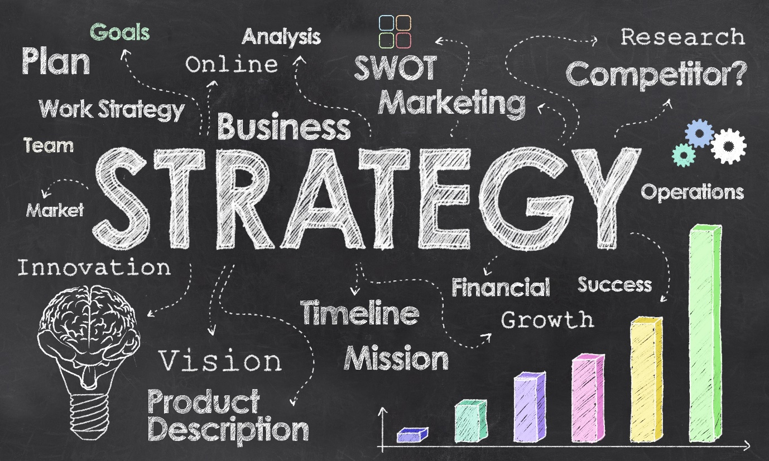

During the COVID-19 issue, Marriott International's marketing ideas and tactics proved successful in preserving consumer loyalty, involving stakeholders, and remaining competitive. The business was able to successfully handle the pandemic's hurdles thanks to its ability to leverage technology and react to shifting market circumstances.

Although the analysis offered insightful information about Marriott's strategy, a more complete investigation of Marriott's shortcomings, competition strategies, and the impact of technology may have improved the assessment. Making data-driven decisions and positioning itself for recovery when the situation improved required constant critical examination and analysis of plan performance on the part of Marriott. (Eschenbrenner, B., Zlatic, A., Bechtel, M., Collins, B., Straley, C. and Gubbels, G., 2023)

Managerial Implications on Marketing Strategies Implemented by Marriott International during the COVID-19 Crisis:

Customer-Centric Approach:
During the COVID-19 crisis, Marriott International introduced customer-centric marketing methods, which have proven to be quite successful. This strategy has shown how critical it is to comprehend and address consumer requirements and problems. Even when the crisis is over, managers should keep placing a high priority on client loyalty and happiness in their marketing strategy. (Cross, R.G. and Dixit, A., 2005)



Use data analytics to acquire insights into client preferences and expectations by conducting frequent customer feedback surveys. To improve personalized experiences and encourage long-term consumer loyalty, customize marketing messages and services to match the demands of particular customer categories.

Agility and Adaptability:
The impact of the crisis has been significantly reduced thanks to Marriott's ability to quickly modify its marketing techniques in response to shifting market conditions and consumer behaviour. The pandemic has brought attention to how crucial flexibility and agility are in marketing decision-making.

Implication: Promote an adaptable culture among the marketing team and the company at large. Create cross-functional teams capable of reacting quickly to market changes and new trends. To proactively modify marketing plans as necessary, keep an eye on market trends and rival strategies.

Emphasis on Health and Safety:
Because of Marriott's emphasis on health and safety precautions, its brand reputation has been improved and consumers have been reassured during the pandemic. Even once the crisis is over, customers are likely to continue prioritizing this kind of commitment. (Smith, N.M., Ali, S., Bofinger, C. and Collins, N., 2016)

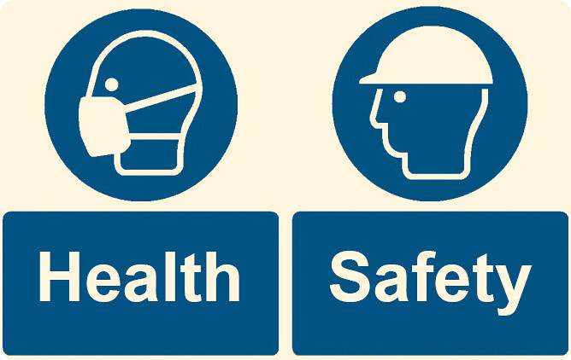
This Photo by Unknown Author is licensed under CC BY

Implication: Keep putting health and safety first in marketing messaging. To win clients' trust, invest in clear safety procedures and effectively convey them. To ensure adherence to the most recent health recommendations, work with the appropriate authorities and experts.
Leveraging Digital Channels:
The COVID-19 problem hastened the shift toward using digital channels for customer engagement and marketing. The importance of digital transformation in the sector has been underscored by Marriott's successful use of digital marketing, virtual events, and mobile apps.



Conclusion: To increase customer involvement and reach, invest in IT infrastructure and digital marketing capabilities. Utilize data-driven marketing techniques to tailor communications and offers. Make good use of online advertising and social media platforms to target customer categories.

Local and Domestic Tourism:
During the crisis, Marriott capitalized on the rise in demand for nearby getaways and staycations by concentrating on increasing domestic and local tourism. Customers looking for safer travel options embraced this tactic. (Jerenashvili, N., 2014)

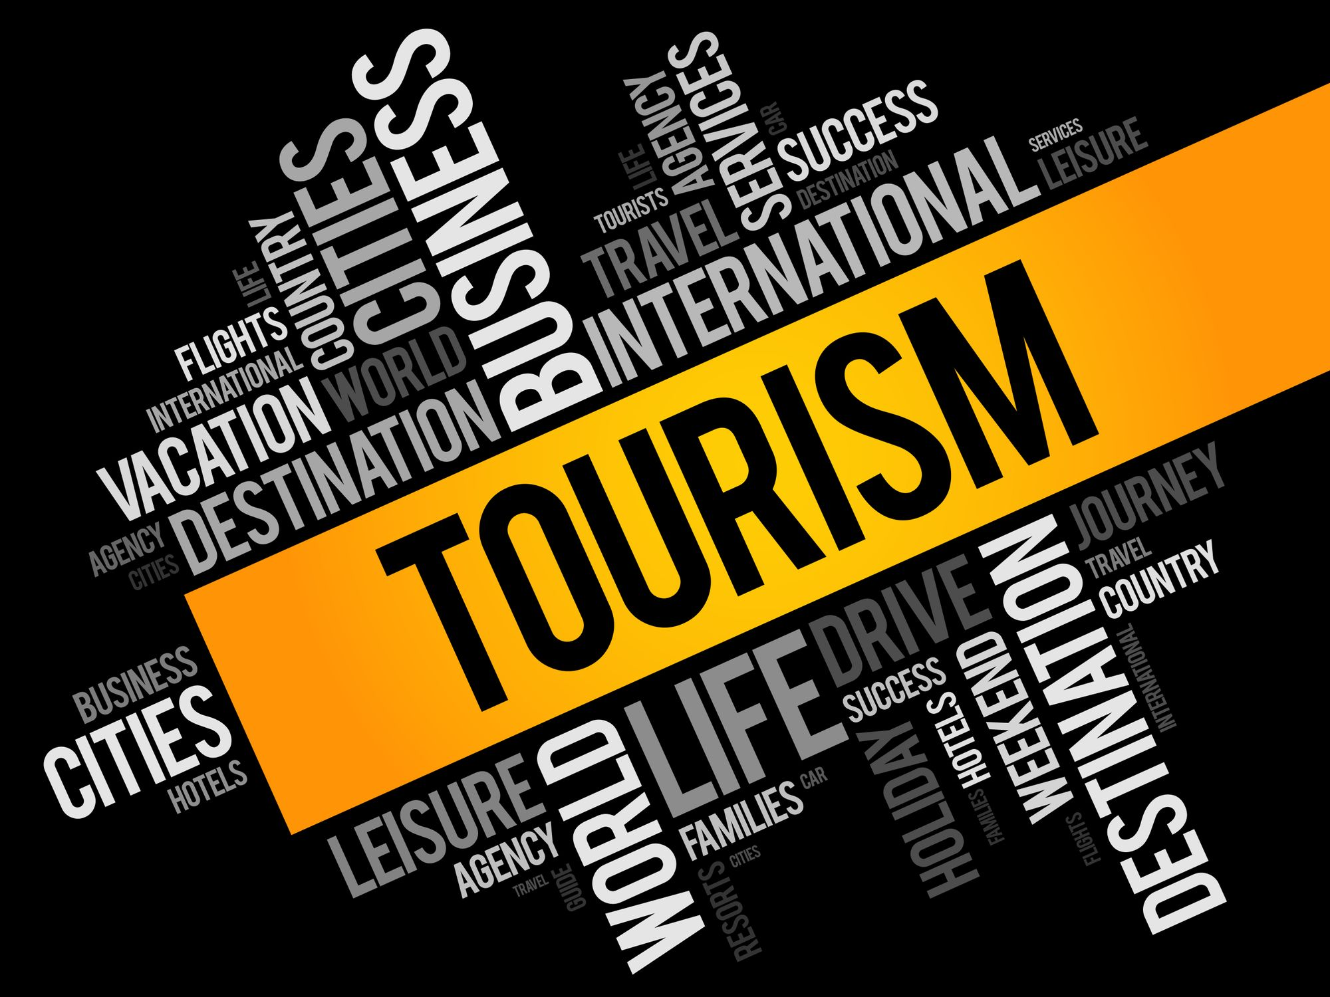

Implication: Continue to promote local tourism and think about the possibility of developing exclusive deals and packages for domestic tourists. Create alliances with regional companies to improve visitors' overall travel experiences and aid the regional economy.

During the COVID-19 crisis, Marriott International's dedication to employee well-being has proven to be a competitive advantage in keeping a motivated and committed staff. Not only is a strong emphasis on employee well-being essential during times of crisis, but it also significantly contributes to the organization's long-term success and sustainability. Let's go into more detail about the significance and effects of Marriott's employee well-being initiatives:

Employee Motivation and Job Satisfaction:
Employees have benefited from Marriott's work-life balance initiatives, wellness programs, and support for mental health because they feel appreciated and supported by the company. Employees are more driven to work hard and take pleasure in their work when they feel appreciated. As job satisfaction rises, employees become more committed to the mission and values of the business. (Chiang, C.C.S., 2010)



Enhanced Guest Experiences:
Positive guest experiences are produced by motivated personnel. Employees at Marriott are more inclined to go above and beyond to provide great customer service when they feel encouraged and supported. This results in unforgettable experiences for visitors and enhances the brand's reputation for first-class hospitality.


This Photo by Unknown Author is licensed under CC BY

Reduced Turnover and Increased Retention:
Marriott's measures to improve employee well-being have helped to foster a culture of dedication and loyalty among the employees. Employees are more likely to stick with an organization over the long run if they believe that it prioritizes their well-being. This lowers turnover rates, which may be expensive for firms, and aids in keeping important talent and knowledge inside the company.

Positive Impact on Brand Reputation:
The attention Marriott pays to employee welfare improves both the internal and external reputation of the brand. Internally, happy workers are more inclined to advocate for the company's brand, fostering a supportive workplace environment and luring top talent. Customers and the public perceive Marriott from the outside as a trustworthy and caring employer, which helps to build a positive brand image.

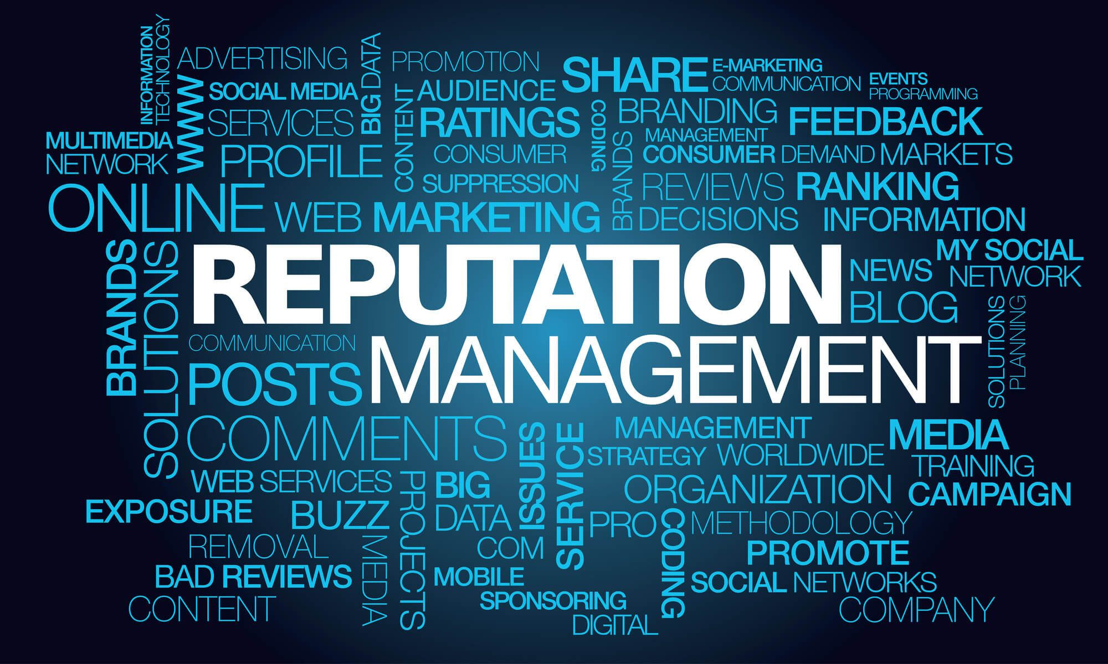
This Photo by Unknown Author is licensed under CC BY

Resilience in Challenging Times:
Incomparable difficulties were faced by the hospitality sector during the COVID-19 crisis. Initiatives for improving employee well-being at Marriott were crucial in strengthening the organization's resilience. Employees who experience assistance are better able to handle stress and uncertainty, which promotes higher adaptability and creative problem-solving in trying circumstances.

Health and Work-Life Balance:
Marriott's employee wellness initiatives support both physical and emotional health, resulting in a happier and more balanced workforce. Marriott makes sure that its employees may maintain a healthy work-life balance, lowering the risk of burnout and boosting general well-being by providing wellness programs, flexible work schedules, and mental health support.
Implication: Give employee well-being a priority and make investments in programs that advance professional development, mental health, and work-life balance. Employers should be thanked and rewarded for their contributions to foster a productive workplace that improves the standard of services provided.
.

A key element of Marriott International's performance throughout the COVID-19 problem has been its implementation of data-driven decision-making. Marriott has benefited from using data analytics to better understand consumer behaviour, assess the success of marketing initiatives, and make defensible judgments. Let's go into more detail on the significance and effects of data-driven decision-making at Marriott.

Customer Insights and Behaviour Analysis:
Marriott may compile thorough consumer information using data analytics, including preferences, booking trends, and feedback. Marriott can more effectively target its marketing messages and products to consumer segments by evaluating this data to better understand the wants and behaviours of its customers. This focus on the needs of the consumer improves loyalty and customer happiness. (Fagyas, C. and Datta, P., 2023)


This Photo by Unknown Author is licensed under CC BY-NC

Measurement of Marketing Effectiveness:
Marriott can accurately assess the success of marketing activities thanks to data-driven decision-making. Customer engagement, conversion rates, and return on investment (ROI) are a few key performance indicators (KPIs) that Marriott can monitor to determine which marketing techniques are most successful and allocate resources accordingly. With the help of this data-driven strategy, marketing efforts are tailored for maximum impact.
Personalization and Targeting:
Marriott can tailor its marketing messages and discounts for customers thanks to data analytics. Personalization makes marketing materials more pertinent, which boosts response and engagement rates. Marriott can improve customer experiences and increase conversion rates by focusing on the appropriate audience with the appropriate content at the appropriate time.



Real-time Decision Making:
Marriott can react swiftly to shifting market dynamics thanks to real-time information provided by data analytics. During the COVID-19 crisis, when the travel sector saw fast changes in demand and consumer behavior, this adaptability was especially important. In order to stay competitive and satisfy client expectations, Marriott can make quick revisions to its marketing plans, promotions, and price thanks to data-driven decision-making.

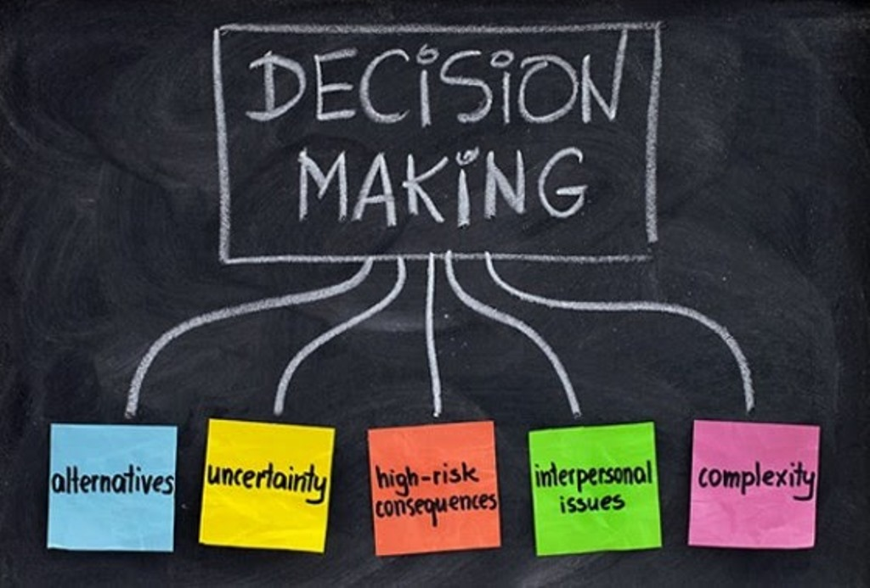
This Photo by Unknown Author is licensed under CC BY

Resource Allocation and Cost Optimization:
The allocation of resources and marketing expenditures are optimized by Marriott thanks to data-driven decision-making. Marriott may focus resources on projects with the best chance of success by identifying high-performing marketing channels and campaigns. This strategy increases the effectiveness of marketing expenditures and aids in cost management during unpredictable economic times.

Enhancing Overall Business Performance:
Beyond marketing, data-driven decision-making affects the whole success of the firm. To increase overall efficiency and service quality, Marriott can discover areas for improvement by examining operational data such as room occupancy rates, customer reviews, and employee productivity.

Community Engagement:
Marriott's community-focused marketing strategies have improved its reputation by fostering partnerships with partners and stakeholders.

Conclusion: Keep becoming involved in your neighbourhood and giving to charities that share your company's ideals. Form strategic alliances that support the mission of the company and show a dedication to social responsibility.

Customer-centricity, agility, digital transformation, and employee well-being are crucial management principles that may be learned from Marriott International's marketing methods used during the COVID-19 crisis. These conclusions are supported by established marketing theories and concepts and can act as a set of guidelines for managers in the tourism and hospitality sectors. Businesses can not only successfully handle crises by using these insights in their marketing strategies, but they can also forge long-lasting bonds with stakeholders, employees, and customers.

In the post-pandemic era, here are some suggestions for strengthening Marriott International's marketing strategies:

Customer-Centric Approach:
It is advised that in the post-pandemic age, maintaining high levels of client satisfaction and loyalty should remain a top marketing priority. To learn more about your customers' tastes and expectations, do frequent customer satisfaction surveys and data analysis. Use these insights to create customized marketing messages, offers, and experiences that appeal to various client categories.

Possibility: Marriott International already places a high priority on customer happiness, and it's possible that the necessary infrastructure for gathering data and conducting customer surveys is already in place. Marriott can successfully put this advice into practice by utilizing its current resources and data analytics skills.

Agility and Adaptability:
Encourage an adaptable culture within the marketing team and the corporation. Create cross-functional teams capable of reacting swiftly to market changes and new trends. To proactively modify marketing strategies as necessary, keep an eye on market trends, rival strategies, and consumer behavior.

Possibility: During the epidemic, Marriott showed that it could adapt. Marriott can continue to respond rapidly to shifting market conditions and keep its competitive edge by preserving cross-functional teamwork and investing in market intelligence technologies.

Emphasis on Health and Safety:
Maintain a strong focus on health and safety in marketing communications, it is advised. To earn customers' trust, keep making investments in clear safety procedures and explain them properly. Work together with necessary authorities and professionals to maintain continuing adherence to the most recent health recommendations.

Possibility: In the post-pandemic period, customers' top priorities will continue to be their health and safety. Marriott may expand on the procedures put in place during the crisis and allocate funds to keep the atmosphere for guests safe and secure.

Leveraging Digital Channels:
To further improve client interaction and reach, invest in expanding digital marketing capabilities and technical infrastructure. Utilize data-driven marketing techniques to tailor communications and offers. Use social media networks and internet advertising to successfully target customer segments.

Possibility: During the pandemic, Marriott had already embraced digital marketing. Marriott can sustain its digital transformation initiatives and keep up a strong online presence in the post-pandemic age by continuing to invest in digital marketing resources and personnel.

Local and Domestic Tourism:
Recommendation: In the post-pandemic era, keep promoting domestic and local tourism. Consider developing specialized deals and packages for domestic tourists. Create alliances with regional companies to improve visitors' overall travel experiences and aid regional economy.

Possibility: Customers may continue to Favor close-by vacations, therefore domestic and local tourism is likely to stay popular even after the pandemic. To provide passengers with distinctive experiences, Marriott may take advantage of its already-existing network and connections with nearby companies.

Employee Well-Being:
It is advised that employers place a high priority on employee well-being in the post-pandemic age by funding programs that support work-life balance, mental health, and career advancement. Employee appreciation and rewards can help to foster a productive workplace that improves the standard of services provided.

Possibility: Maintaining service quality and employee happiness depend on the well-being of the workforce. To cultivate a motivated and devoted workforce, Marriott can continue to commit resources to employee well-being programs and initiatives.

Data-Driven Decision Making:
In the post-pandemic age, it is advised to continue emphasizing data-driven decision-making. To help marketers glean insightful information from data and make wise decisions, spend money on training and marketing analytics tools.

Possibility: Marriott probably already has data analytics capability. Marriott can enable its marketing staff to successfully use data for making strategic decisions by continuing to invest in data analytics tools and training.

Community Engagement:
It is suggested to be active in local communities and support social causes in the post-pandemic era. Make strategic connections that advance the company's objective and demonstrate a commitment to social responsibility.

Possibility: Marriott's community engagement initiatives might continue by making the most of present partnerships and looking for new opportunities to help local communities.

Conclusion:



Marriott International's marketing plans face new opportunities and difficulties in the post-pandemic environment. Marriott may continue to prioritize health and safety while maintaining its customer-centric strategy by putting the recommendations based on the managerial implications identified in Task 2 into practice. A successful marketing plan in the new normal will focus on utilizing digital media, increasing domestic and local tourism, and putting employee wellbeing first. Marriott's market position and brand reputation will be further strengthened in the post-pandemic era through data-driven decision-making and community engagement.

References

- https://www.marriott.com/en-gb/marriott/aboutmarriott.mi

- Lin, X., 2016. Strategy analysis of a boutique and lifestyle hotel: a SWOT analysis.

- Nyangwe, S. and Buhalis, D., 2018. Branding transformation through social media and co-creation: lessons from marriott international. In Information and Communication Technologies in Tourism 2018: Proceedings of the International Conference in Jönköping, Sweden, January 24-26, 2018 (pp. 257-269). Springer
- International Publishing.

- Bashir, M. and Verma, R., 2016. Airbnb disruptive business model innovation: Assessing the impact on hotel industry. International Journal of Applied Business and Economic Research, 14(4), pp.2595-2604.

- Hormby, S., Morrison, J., Dave, P., Meyers, M. and Tenca, T., 2010. Marriott International increases revenue by implementing a group pricing optimizer. Interfaces, 40(1), pp.47-57.

- Eschenbrenner, B., Zlatic, A., Bechtel, M., Collins, B., Straley, C. and Gubbels, G., 2023. Marriott International: A Managerial Strategic Audit.

- Cross, R.G. and Dixit, A., 2005. Customer-centric pricing: The surprising secret for profitability. Business Horizons, 48(6), pp.483-491.

- Smith, N.M., Ali, S., Bofinger, C. and Collins, N., 2016. Human health and safety in artisanal and small-scale mining: an integrated approach to risk mitigation. Journal of cleaner production, 129, pp.43-52.

- Jerenashvili, N., 2014. Domestic tourism in Georgia: Quantitative analysis. European Scientific Journal.

- Chiang, C.C.S., 2010. How corporate social responsibility influences employee job satisfaction in the hotel industry.

- Fagyas, C. and Datta, P., 2023. An investigation of the factors associated with consumer behaviour at arrival, check-in and the check-out process: A case study Marriott International Inc. in the UK. Journal of Business and Retail Management Research, 17(2).

