
Smart Navigation with LEGO Spike
Laurel Black 2517390
Integrated Project
ACHA4008
University of Wales Trinity Saint David
Submitted 2nd June 2026

Abstract
Computer Science and Robotics continues to increase within society and organisations, including the scope of creativity and integration that could be included within these subjects.
Teamworking, in addition, remains a mandatory component to organisations and academic fields. Using LEGO Spike Prime, all these components will be observed within a two-stage challenge to conclude with a successful demonstration.
Contents
1. Introduction 1
2. Research and Background 2
3. Planning and Human-Robot Interaction 3
4. Robot Design and Strategy 4
5. Implementation and Coding 8
6. Testing and Evaluation 19
7. References 21

List of Figures
Figure 1 - Lego Spike Robot, aka "Buddy" 4
Figure 2 - Structural Inconsistencies 6
Figure 3 - Back View of Robot 7
Figure 4 - Full Lego Spike Code Blocks 8
Figure 5 - when program starts and setting variables 10
Figure 6 - Variables 11
Figure 7 – Following the Line, Entering the maze, beginning and end of program 12
Figure 8 - The Maze and camera sensor 14
Figure 9 - Following the line, testing errors 18
Figure 10 - The Gyro Turn and the yaw angles 18
Figure 11 - Testing and Evaluation 19
Figure 12 - Reflection and Conclusion 20

1. Introduction
LEGO was founded in 1932 by Ole Kirk Kristiansen, and still owned by the Kirk Kristiansen family. The name ‘LEGO’ is an abbreviation of the two Danish words “leg godt”, meaning “play well” [1]. LEGO bricks are popular for creative construction, which many people have enjoyed using, particularly through their childhood [2].
LEGO Spike Prime was used to solve a navigation challenge, including use of Lego Spike Prime sensors and LEGO Spike Prime Code Blocks.
LEGO Spike Prime introduces a robotics and computer programming component to the LEGO franchise range, which will be included throughout this paper.
The final challenge proposed included two stages.
In stage one, the LEGO Spike Prime robot follows a red tape, which will however be interrupted by an obstacle to navigate around, before returning to the red tape. It was permitted for measurements of the obstacle to be taken regarding the code.
Upon completion of stage one, stage two introduces a maze navigation component. A green marker signifies the entry of the maze. Sensors were tested and used throughout the trial and final demonstration of the LEGO Spike Prime Robot to complete the challenges which involve dead ends. Reaching the end of the maze will conclude with audio as well as flashlights on the Hub.
This challenge included a teamwork component.

2. Research and Background
LEGO Spike Prime is accessed via a computer. The primary student which is focused within this paper was solely responsible for bringing in a mobile computer to access LEGO Spike Prime regularly throughout the challenge.
The term “mobile computing” is used to describe a wide range of IT components. Mobile computing devices are becoming essential across academic settings and industries alike, boosting efficiency and creativity [3]. The laptop provides mobility throughout access of LEGO Spike Prime software and evidently invaluable for the entire challenge and team.
The “3-2-1” Method was applied to ensure recovery of the LEGO Spike Prime, should any Cloud or storage accidents occur, human or otherwise.
The Method claims that there should be at least three copies of the relevant data stored on two different pieces of data, one of which being off site [4]. This meant that the code was not only stored on the mobile computer of the student and the cloud service, but the entire teams academic USB flash drives.
In addition, frequent uploads of code versions were submitted via academically granted Cloud services. In the event of any team member requiring observations of the workload, as well as ensuring all backup strategies were met to the highest approved standard; implementation of a data backup strategy is the first step towards performance continuity [5], and ensuring the backups provided were working correctly via testing.

3. Planning and Human-Robot Interaction

The term “Robot” has numerous meanings. The Institution of Electrical and Electronics Engineers (IEEE) defines a robot as an autonomous machine that senses, computes, and acts in the real world [6].
Attitudes towards robots and skills to interact with robots are important human competencies regarding Human-Robot Interaction, or HRI. It is shown that experienced individuals who understand more robots are more likely to make better decisions concerning robot interactions. Robot literate individuals are more open to having interactions with robots [6].
In regards to the teamwork component of this challenge, Human-Robot Interaction is considered. Humans have different skills and abilities that should be considered in both individual and group goal settings, especially in consideration of team performance and wellbeing. Team communication should be a two-way interaction so both humans and the robot are aware of the others in terms of roles, work progress and the objective within the challenge, despite frustrations and criticisms, human trust may be improved through communication, with Human-Robot teamwork performances also increasing provided the team members proactively assist, guide and work together as a team rather than reactively participating in collaboration as and when needed [6]. For example, one team member excelled at the structural building of the robot, whereas another preferred the coding component of the challenge.
LEGO Spike Prime was first made aware to students on the 28^{th of} January 2026 Confidence using LEGO Spike Prime was established by the 18^{th of} February 2026. Research was investigated to build the robot, and code was taken place onwards, and the final demonstration took place on the 29^{th of} April 2026.

4. Robot Design and Strategy
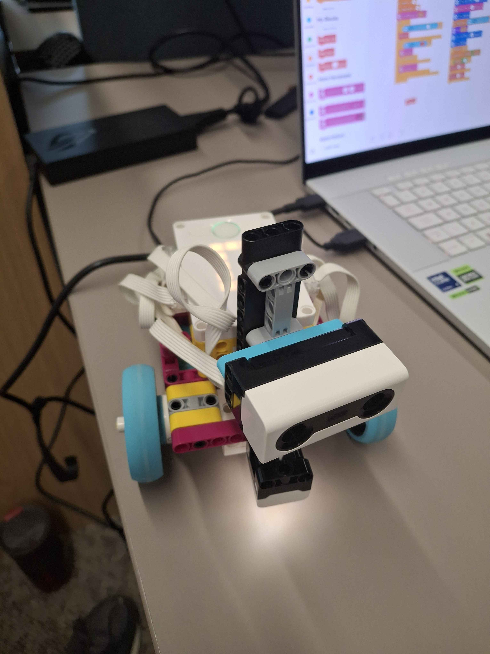
Figure 1 - Lego Spike Robot, aka "Buddy"

Sources of knowledge such as robotic technology are very scarce. Organisations sometimes rely on a broad range of online expert communities or publicly shared sources on the internet, such as Youtube, to obtain further knowledge [6].
Robótica, Maker & Etc. proposes an efficient prototype concerning the maze navigation component, concerning the use of sensors and Lego Code Blocks [7].
LEGO bricks are structured together by interlocking mechanisms, with layouts and designs being chosen typically based on their ability to be self-supporting [2].
The final Robot design, as shown in Figure 1, resulted in the most secure structure for the challenge. However, the entire stage of the challenge faced design and test challenges. Figure 2 concerns one of the final design tests prior to the demonstration, which resulted in the team ensuring pieces were as secure and supported as possible.
In addition, towards the final stages of testing and design, concerning the transition between the “following the line” and “the maze” obstacle, alterations needed to be making to the back and underside of the robot design. As shown in Figure 3, the robot uses a moving ball piece by LEGO to allow the motors to securely move on the Hub.
Issues which were faced and resolved will be addressed in further detail in Section 6. Testing and Development
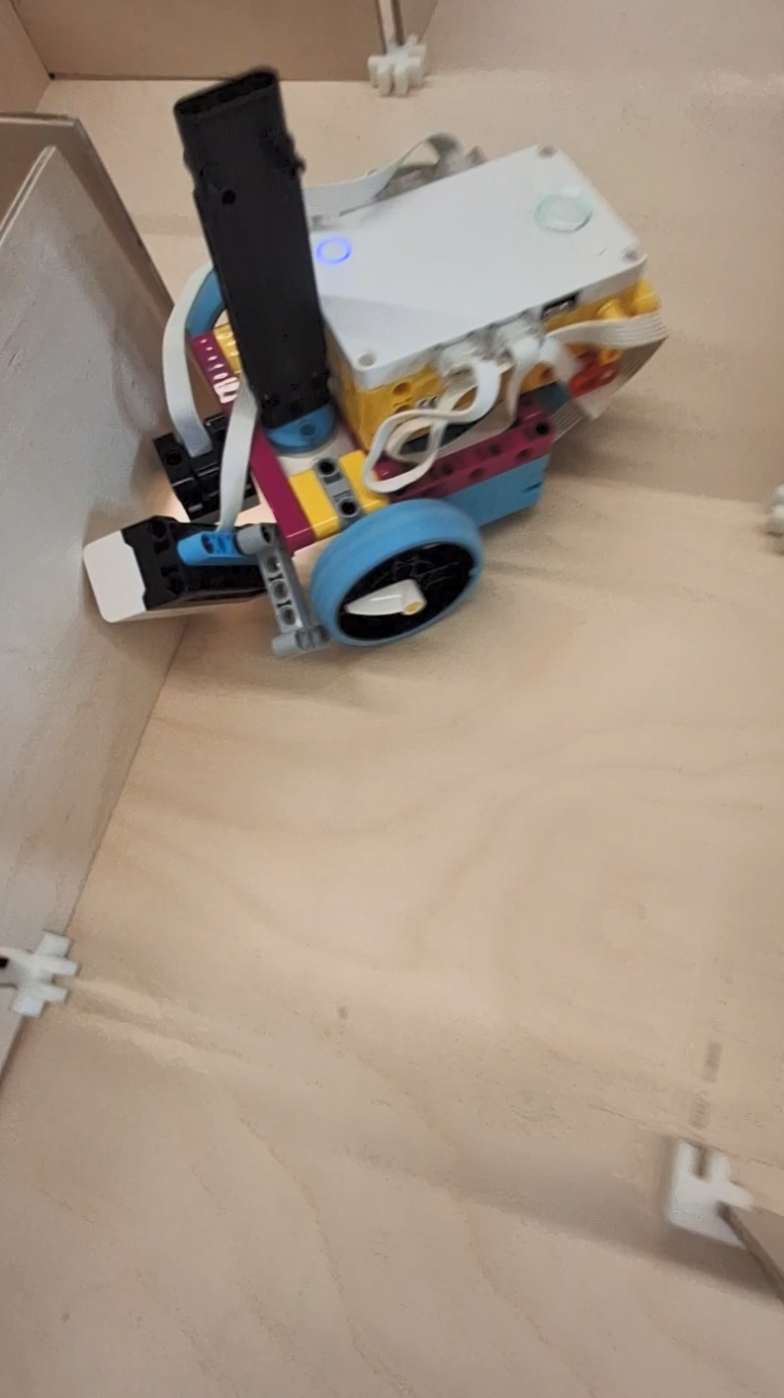
Figure 2 - Structural Inconsistencies
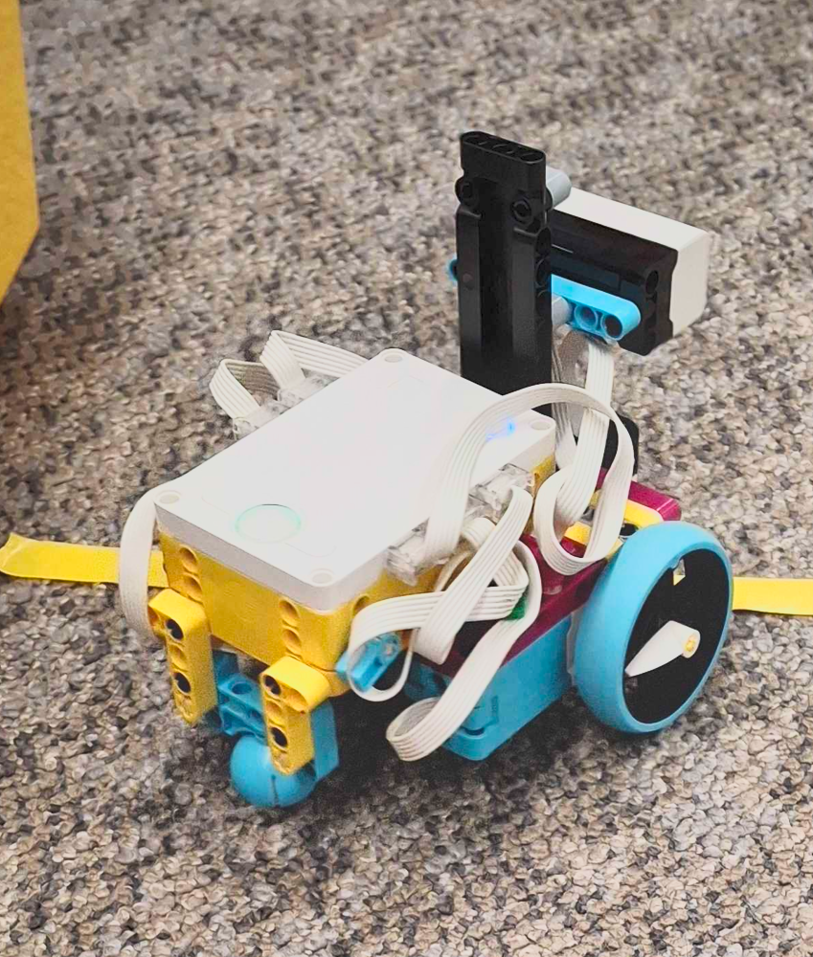
Figure 3 - Back View of Robot

5. Implementation and Coding
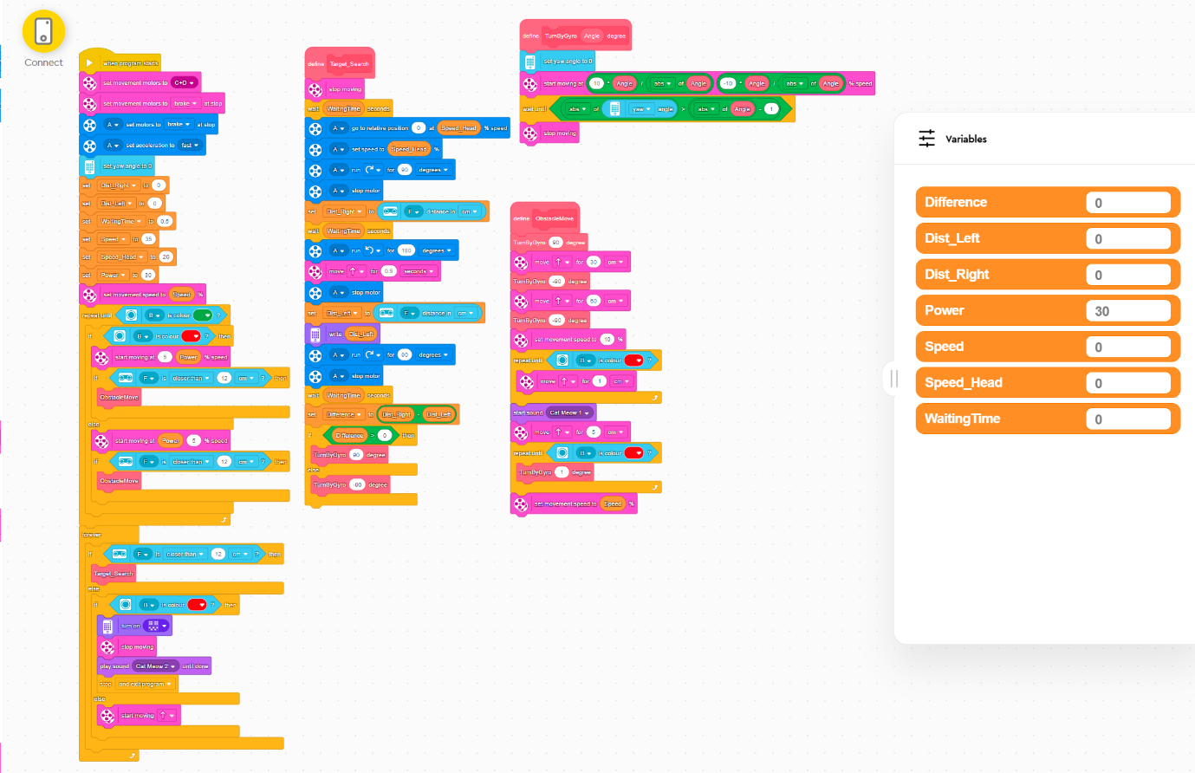
Figure 4 - Full Lego Spike Code Blocks
In this section, further investigation concerning the Lego Code Blocks will be observed.
Lego Code Blocks were concluded to be the most effective route concerning the overall task as opposed to Python, due to more ample resources concerning the Lego Code Blocks for this task.
Understanding each category of code blocks as shown in Figures 2 to 8 will be discussed.
In Lego Code Blocks, dark blue represents use of “Motors”, particularly shown in Figure 6 and the maze component.
“Movement” uses pink blocks, for following the line as shown in Figure 7.
Purple blocks are used for “Light” and “Sound”. As shown in Figure 5 the purple blocks were necessary to communicate the end of the maze component. As shown in Figures 6 and 7, purple blocks also propose an optimal solution to error handling.
Yellow blocks are the primary starting points to the program, or “Events”. In this program, no other block could start without yellow. Orange blocks concern “Control”. In this program, this concerns Variables as shown in 3 and 4 the most prominently, with the loops shown throughout Figures 2 to 8.
Light Blue concerns the “Sensors”. Such as the yaw angle for the robot to understand its position in accordance with the surroundings, the light sensor and distance sensor.
Green concerns “Operators”, as shown in Figures 6 and 8. Operators provided the challenge better optimisation in setting conditions, particularly for arithmetic logic such as “if Difference > 0 then”; resulting in the robot having more accurate conditions to navigate the maze.
Customised blocks were necessary to complete the challenge. Known as “My Blocks” in Lego Blocks and shown in Figures 6 to 8, “My Blocks” contained three primary custom blocks: “ObstacleMove”, “Target_Search” and “TurnByGyro X degree” “ObstacleMove” as shown in Figure 7 concerns following the line, “Target_Search” as shown in Figure 6 to navigate the maze, and “TurnByGyro X degree” as shown in Figure 8 to calibrate Hub positioning.
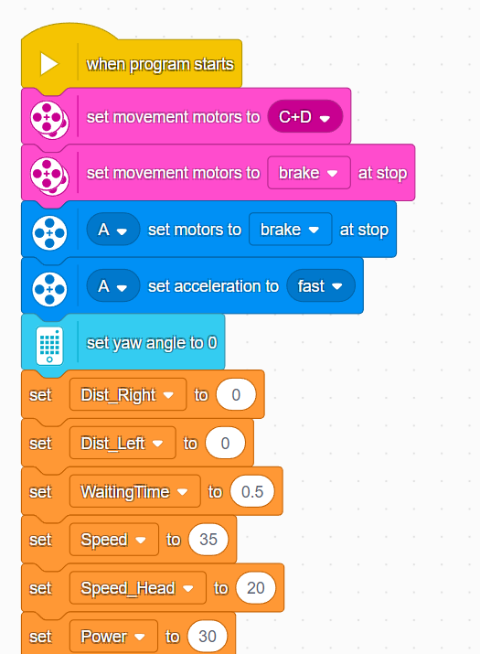
Figure 5 - when program starts and setting variables
As shown in Figure 3, constants are set before the challenge begins, and none of the program would successfully operate if not for the “Event” block positioned. The robot’s motors were set to C and D for the challenge.
For the end of the challenge, the end of the maze needs to be declared to break at the stop.
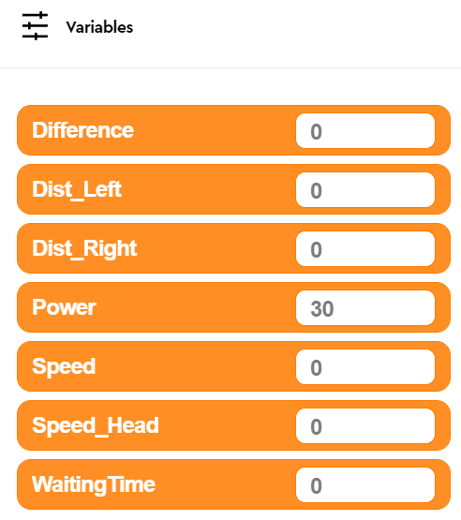
Figure 6 - Variables
As shown in Figures 5 to 7, Variables are mandatory concerning the maze and following the line alike.

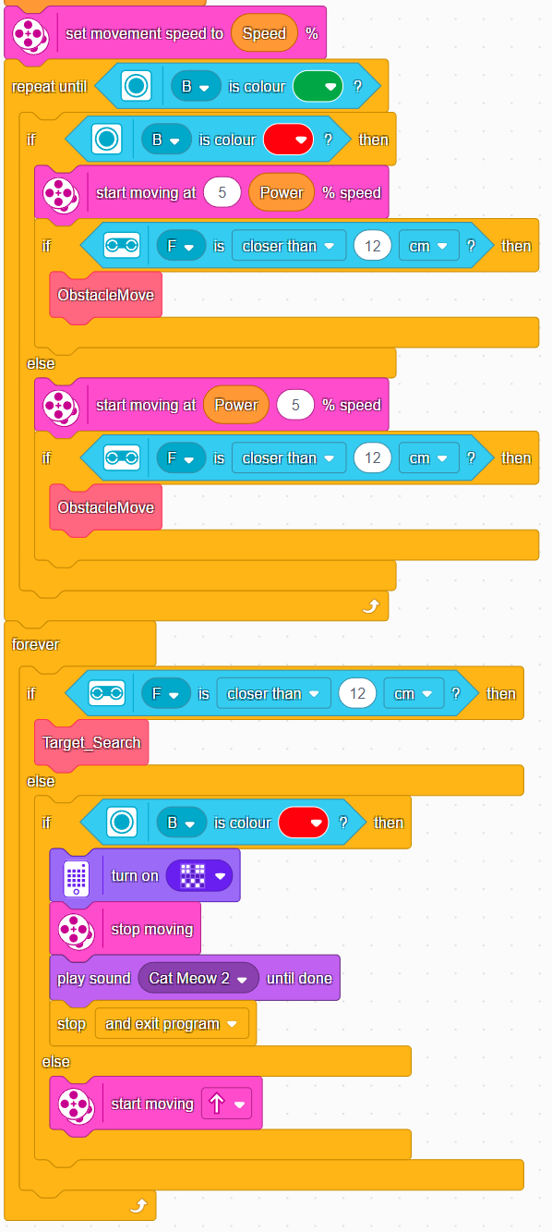
Figure 7 – Following the Line, Entering the maze, beginning and end of program
In Figure 5, following from Figure 3, the program will repeat the code blocks regarding following the line, or “ObstacleMove”, until the green marker has been detected from the colour sensor. 12cm was the optimal final distance on the obstacle component. In addition, Figure 5 shows the “Target_Search”, or maze component, upon the final red marker at the end of the maze being successfully met it will conclude in the playing sound, a light display and an official declaration of exiting the program.

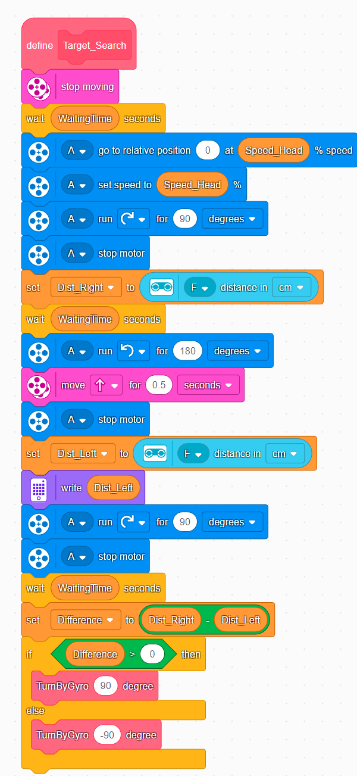
Figure 8 - The Maze and camera sensor
Concerning the Maze, Figure 6 shows the primary maze navigation proper, or “Target_Search”.Variables such as “Speed_Head” were necessary due to the final prototype of the robot. The distance sensor was attached to a “Head” of bricks as shown in Figure 1.
“Dist_Right” and “Dist_Left”, as shown in Figure 6, concerns the front camera sensor shown in Figure 1. This Variable allows the robot to check the left and right sides of the maze correctly, using the distance of each side it can turn to assess. Thus, turning the gyro (or the Hub) to the correct location within the maze.
Stopping the motors and the “WaitingTime” variables are essential; prior to these variables, the Robot could incorrectly sense its whereabouts, or bump into walls.

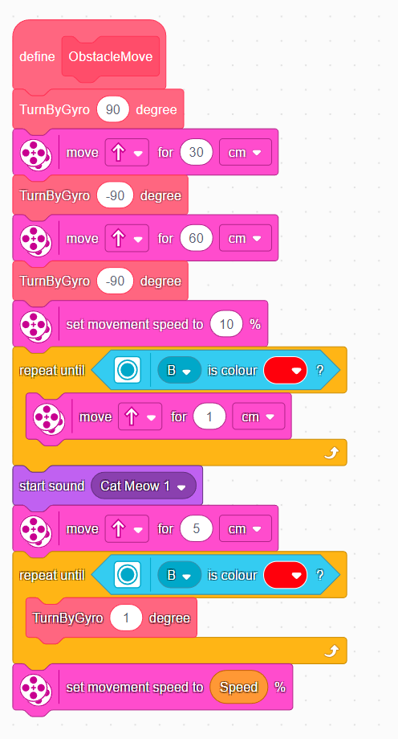
Figure 9 - Following the line, testing errors
Lego Spike Prime Coding Blocks proposed possible solutions which were considered upon completion of this challenge [8]. Figure 7 shows how following the line was completed during the Obstacle Move segment.
For the final prototype, the movement speed of 10% provided optimal accuracy for the robot to follow the line with reduced errors.
Due to previous code and robot sensitivity errors, Cat Meow 1 was included to ensure the robot was accurately detecting the line with the colour sensor.
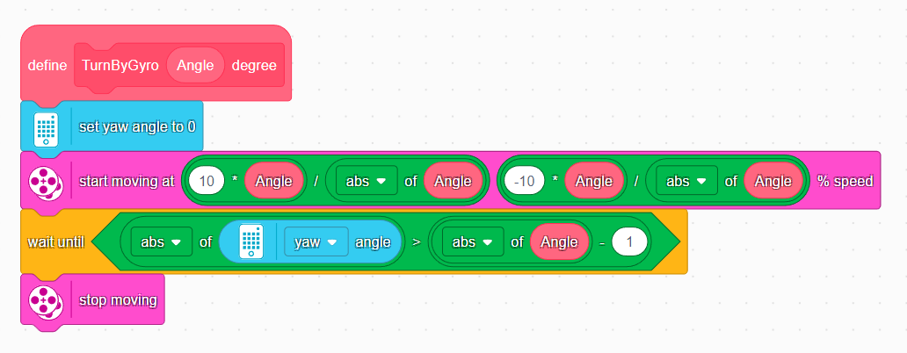
Figure 10 - The Gyro Turn and the yaw angles
The yaw measures the left and right turns of the robots Hub. The program includes the program moving the robot straight in correlation to the Hubs location, set to “0” as shown in Figure 8., with the turning conditions of the yaw angles being set within this figure.
Angles with a positive number turn the Hub right from “0”, and left turns requiring a negative number. However, the accuracy found with Lego Spike requires extra consideration regarding tuning these chosen numbers throughout use of the program. Faster speeds or turns are more susceptible to inaccuracies or performance detriments, as discussed by S. Reiher [9]. “Stop moving” pink blocks as shown in Figures 5, 6 and 7 allow better accuracy during the program being ran.

6. Testing and Evaluation
Working with robots continues to increase within organisations and groups. Human Robot Interactions can guide organisations that use collaborative robots for deployment plans and policies, wellbeing, and organisation development [6].
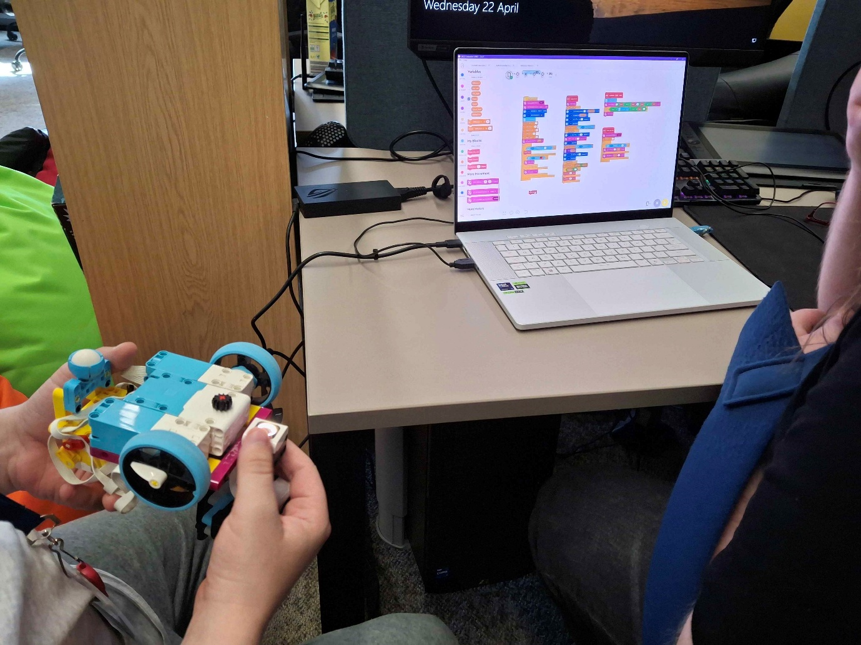
Figure 11 - Testing and Evaluation
Working with robots introduces challenges in human-robot relations. Effective communication and collaboration is required for a positive human-robot interaction. Psychological capital requires resources such as confidence, optimism and resilience for the growth and development of individuals, which contribute to well-being and performance [6].
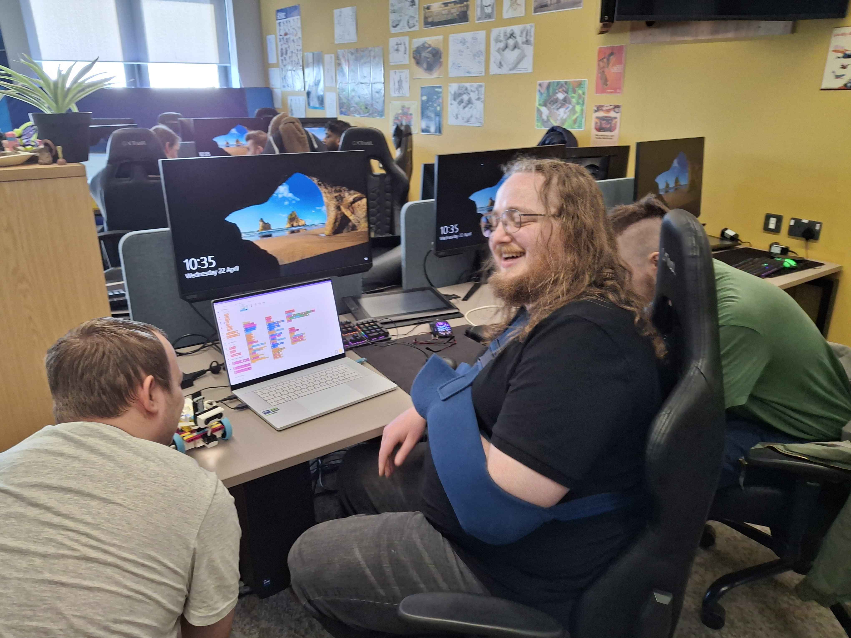
Figure 12 - Reflection and Conclusion
With an academic understanding of the importance of the findings discussed, the LEGO Spike Prime demonstration as a teamworking challenge was a success.
This current study is limited by the absence of exploring alternative methods of writing the code, such as Python or third-party software to code the LEGO Spike Robot, such as Pybricks [10].

7. References

[1] | LEGO System A/S, “About Us: The LEGO Group History,” LEGO, 2026. [Online]. Available: https://www.lego.com/en-us/aboutus/lego-group/the-lego-group-history?locale=en-us. [Accessed 26 May 2026].
[2] | S. J. Luo. et. al., “Legolization: optimizing LEGO designs,” ACM Digital Library Complete, pp. 222-222:2, November 2015.
[3] | S. S. Gill. et. al., “Modern Computing: Vision and challenges,” Telematics and Informatics Reports, vol. 1, pp. 3-6, March 2024.
[4] | W. Preston, “For secure data backup, here’s how to do the 3-2-1 rule right: The venerable 3-2-1 rule for backing up data remains a tried-and-true method for insuring the integrity of copied data that is essential to disaster recovery efforts, but it has to be done pr,” Network World (Online), 2020.
[5] | D. Mitchell, “Business Backup 2025,” The Network, PC Pro, pp. 96-97, November 2025.
[6] | K. Sehoon, “Working With Robots: Human Resource Development Considerations in Human-Robot Interaction,” Human Resource Development Review, vol. 21, no. 1, pp. 55-65, March 2022.
[7] | Robótica, Maker & Etc., “How I Coded a Lego Spike Prime Robot to Explore a Maze!,” 2025. [Online]. Available: https://www.youtube.com/watch?v=Sngw_sTZjBo. [Accessed 24 March 2026].
[8] | Lego Education, “Training Camp 3: Reacting to Lines,” Lego, 2026. [Online]. Available: https://education.lego.com/en-gb/lessons/prime-competition-ready/training-camp-3-react-to-lines/. [Accessed 22 April 2026].
[9] | S. Reiher, “Spike Prime Maze Escape: Five ways to Code Your Way Out! Tutorial,” Robot Man, 2025. [Online]. Available: https://www.youtube.com/watch?v=dVvet4CH7rg. [Accessed 2 February 2026].

