
APPENDIX GAxx

LEVEL 4 ASSESSMENT SPECIFICATION

Student name: | Oliver Larcombe | Student ID number: | 2117718
Programme: | Sport Management
Module: | Sport Physical Activity and Society
Module code: | BMSM4007 | Contribution to Overall Module Assessment (%): | 50%
Lecturer: | Andrew Thomas | Internal Verifier: | Mark Napieralla
Assignment Title: | Sport, Fitness and Physical Activity | Word count (or equivalent): | 1500
Submission deadline: | Please refer to assessment planner | Return date of provisional marks & written feedback: | Please refer to assessment planner
Submission method: | All written assessments, where practical and possible, must be submitted via Turnitin unless otherwise instructed by the Lecturer. (Please DO NOT put this assessment specification into Turnitin or it will match many similarities with other students’ submissions.)  Alternative submission method (if applicable):  Late submission of the assessment will result in a late penalty mark. Penalties for late submission: Up to one week late, maximum mark of 40%. Over one week late, 0%. Only the Extenuating Circumstances Panel may approve a change to submission dates.
Academic honesty / referencing: | Academic honesty is required. In the main body of your submission you must give credit to authors on whose research and ideas your work is based. Append to your submission a reference list that indicates the books, articles, etc. that you have used, cited or quoted in order to complete this assessment.

Contents
Front Cover Page (p) 1

Contents p2

1 Introduction p3

1.1 Exercise p3

1.2 Physical activity p3

1.3 Sport p3/4
2 Green exercise and its importance p4

2.1 Current perspectives on green exercise p4

3 Physical activity guidelines p5

1: Introduction
In this assignment my aim is to clear the blurred lines between Sports, Physical activity, and Exercise. To discuss how even though they’re frequently used terms to describe one broad subject, the three terms are actually the three different components that determine the quality of our life cycle, with each component the determinant part of a chain of psychological decisions, like whether you want to go for a run, or if going for a run is the last thing on your mind, or if you enjoy sports, or if you show no interest in it at all. The idea for this conversation is based off the self-improvement/self-evaluation hypothesis (MacIntyre, R. I. et al. (2020).

1.1: Exercise
Exercise is the planned physical exertion of your body, with the motivations of self-improvement. According to MacIntyre, R. I. et al. (2020) exercise is motivated and de-motivated by two contrasting hypothesis (self-improvement hypothesis/self-evaluation hypothesis) this hypothesis reflects greatly on a person’s motivation, or lack of, to take part in sports and physical activity. The self-improvement hypothesis shows that people with higher self-improvement motivations, show a greater determination to exercise daily, where as people who primarily self-evaluate show a lack of desire to exercise at all, which is attributed by MacIntyre, R. I. et al. (2020) to their self-evaluation causing greater amounts of body dissatisfaction.

1.2: Physical Activity
Physical activity differs from sport and exercise, in that it is not specific activity in which you choose to partake in, but what you do in your day-to-day routine, that contributes to your physical health, be it gardening, walking up the stairs or taking your dog out (12 physical activity, exercise and sports, 2021). A lack of physical activity can be caused by individual and environmental factors (Draper, & Stratton, G. (2018). These factors that act as de-motivators have an alignment in some cases with a poor mental state, especially in younger people, which can be brought on by too much self-evaluation (MacIntyre, R. I. et al. (2020). Psychological factors can be a lack of enjoyment from exercise and bad mental health, this can evolve into health issues like obesity and some chronic diseases like cancer, diabetes and stokes to name a couple. This was highlighted by Draper, & Stratton, G. (2018) with the two-factor theory, a list of factors both individual and environmental that have effects on the level of physical activity a person partakes in.

1.3: Sport
Sport is the combination and culmination of Physical activity and Exercise, played with rules, competition, and a goal at training and improving skills in desired sports (12 physical activity, exercise, and sports, 2021) for example football, rugby, golf, basketball etc… A person’s desire to compete in sports can be a direct result of their mindset, someone that wants to improve and excel in their desired sport will have, to an extent, motivation for self-improvement. This motivation will come from their will to exercise which according to MacIntyre, R. I. et al. (2020) is a direct result of their high levels of self-improvement and low levels of body dissatisfaction. Which in turn means that people with a higher level of body dissatisfaction, are less motivated to exercise, and therefore unable to motivate themselves to take part in a sport.

2: What is green exercise and why is it important?
Green exercise is when you combine nature, with exercise, using your natural surroundings and natures facilities to improve your health, both mental and physical (Li, H. et al. (2021). Exposure to nature can prevent diseases caused by “urban stressors” like air pollution, from car emissions, noise etc... (Li, H. et al. (2021). Due to urbanisation the opportunity for green exercise has become more and more limited over the years, having regular green exercise is important for a person’s health, which is why not only is it important to maintain regular amounts of regular of green exercise, but it is vital that we manage and maintain green infrastructure in cities (Akpınar, A. (2019). According to Akpınar, A. (2019), the increased distance to urban green spaces correlates with the low level of green exercise amongst adults.

What are the current perspectives on green exercise?
Green exercise is positive, evidence supported by Glover, N. & Polley, S. (2019) shows this, a 40-day physical activity intervention was put in place to collect data on green exercise and increase physical activity amongst the participants. This showed positive psychological impact on all the participants involved in this study. Green exercises positive impact on mental health can be backed by Mygind, L. et al. (2019) (refer to appendix for graph) as well as the intervention done by Glover, N. & Polley, S. (2019). The investigation done by Mygind, L. et al. (2019) showed that 65.7% of participants reported their mental health had improved after dedicating more time to green exercise.

Consider local, national, and international guidelines on physical activity.
Lagos, Nigeria reported an improvement in air quality because of the decrease in vehicular traffic after guidelines were put in place following the COVID-19 outbreak, this in turn resulted in more people showing a willingness to begin engaging in physical activity in Nigeria (Lambert, E. V. et al. (2020). Whereas the United Kingdom experienced a negative change of 21.3% according to Faulkner, J. et al. (2021).

Appendix
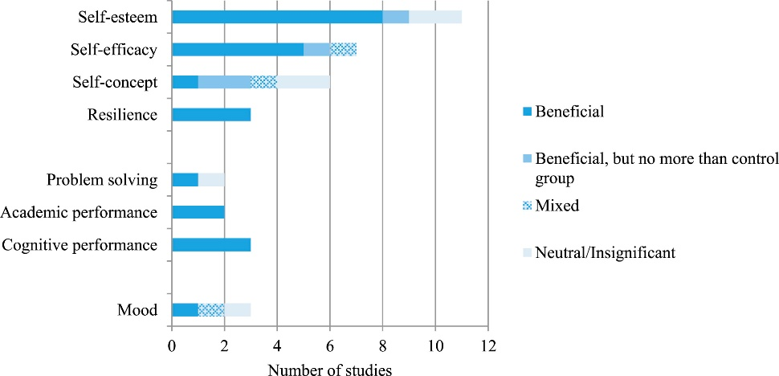
Reference Page
Akpınar, A. (2019) Green Exercise: How Are Characteristics of Urban Green Spaces Associated with Adolescents’ Physical Activity and Health? International journal of environmental research and public health. [Online] 16 (21), 4281–.
Draper, & Stratton, G. (2018). Physical activity a multi-disciplinary
Faulkner, J. et al. (2021) Physical activity, mental health and well-being of adults during initial COVID-19 containment strategies: A multi-country cross-sectional analysis. Journal of science and medicine in sport. [Online] 24 (4), 320–326.
Glover, N. & Polley, S. (2019) GOING GREEN: The Effectiveness of a 40-Day Green Exercise Intervention for Insufficiently Active Adults. Sports (Basel). [Online] 7 (6), 142–.
Lambert, E. V. et al. (2020) Making the case for ‘physical activity security’: the 2020 WHO guidelines on physical activity and sedentary behaviour from a Global South perspective. British journal of sports medicine. [Online] 54 (24), 1447–1448.
Li, H. et al. (2021) Green Exercise: Can Nature Video Benefit Isometric Exercise? International journal of environmental research and public health. [Online] 18 (11), 5554–.
MacIntyre, R. I. et al. (2020) An Ecological Momentary Assessment of Self-improvement and Self-evaluation Body Comparisons: Associations with College Women’s Body Dissatisfaction and Exercise. Body image. [Online] 33264–277. 1.3.1. Self-improvement hypotheses/1.3.2. Self-evaluation hypotheses
Mygind, L. et al. (2019) Mental, physical and social health benefits of immersive nature-experience for children and adolescents: A systematic review and quality assessment of the evidence. Health & place. [Online] 58102136–102136.
2021. 12 physical activity, exercise, and sports. [ebook] Nichan Zourikian B.Sc, Carolyn Jarock B.Sc, Kathy Mudler B.P.T, p.1.

