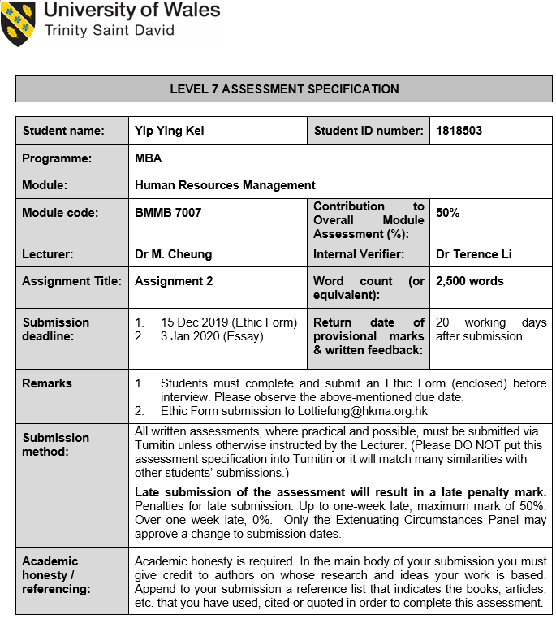

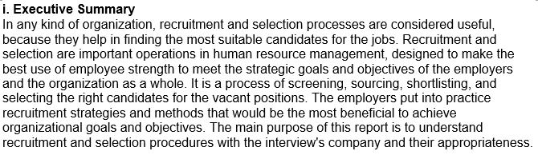

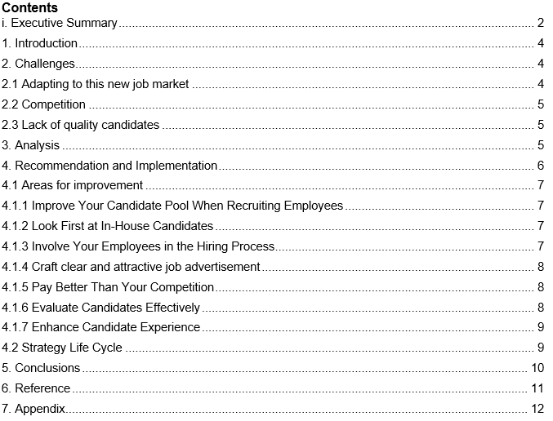

1. Introduction
Recruitment is the method of shortlisting, defining, interviewing and recruiting potential human capital to occupy the organizations ' vacancies. It is the core function of managing human resources (Mangum, 1983). Recruitment is the selection process for the right person at the right moment for the right position. Once hiring takes place, it is necessary to take into consideration the educational qualifications, expertise, talents and skills of the candidates. It is the process of appointing, selecting, attracting potential candidates to meet the organizations ' needs and requirements. Internally, i.e. within the company and internationally, i.e. from the use of external sources, selection takes place. Internal factors include institutional scale, recruitment policy, corporate identity and work description (Hampson et al., 2015). External factors include variables such as population, labour market, unemployment rate, labour law, legal considerations and rivals. Recruitment process performance increases profitability and promotes a good working atmosphere and good employee connections.

It also named a successful method with its strategy to draw as many applicants for vacant positions as possible (Anu, 2011). It is the method of defining and applying for the work for potential candidates. Every corporation has its own set of standards to control the workforce. I had interviewed two HR managers to produce this study and asked questions with the questionnaire about their company's current problem and pain-point on the recruitment subject. Below is the interviewer's organizational history.

ABC is a company based in Hong Kong that markets personal care, beauty, baby care and skincare items, often at discounted prices. The company has more than 280 retail shops in Hong Kong, Mainland China, Macau, Taiwan, Malaysia and Taiwan.

XYZ is a retail company with department stores in Hong Kong and Mainland China, offering luxury goods. It has over 50000 square meters of total retail space, including many store locations throughout China, and an online store.

2. Challenges
Hiring today is very different from what it was ten years ago, below is the main problems identified after interviewing ABC and XYZ HR manager.

2.1 Adapting to this new job market
One of today's greatest recruitment problems is that hiring managers do not behave as if they are in the search of a nominee. Unemployment is low and recruiting skilled people with new job opportunities is more challenging. Hiring managers, on the other hand, frequently involve a comprehensive interview process along with personality and ability tests. Often tests aimed at reducing the strain on the interview process are additions instead. That is where the issue lies. Candidates are being required to do more and more, but there is no shortage of jobs to encourage them to take part in a more rigorous process. Many candidates would eventually give up the cycle early. Someone who realizes it is the market of a candidate hires others and moves faster to make them an offer. Recruiters are being asked to find more and more applicants because of this, but they still operate in a limited market. It is a loop of self-perpetuation (Rozario, Venkatraman and Abbas, 2019).

2.2 Competition
In addition, the other obstacle is that we would have to contend with bigger companies for top talent, but now they are still competing with smaller start-ups. Such start-ups are often keen to provide unique benefits (high educational allocation, unlimited weekends,) that even large businesses are unable to provide. Not only that, start-ups often have higher wage expectations, as they are not constrained by a specific compensation structure such as larger organizations. While workers are conscious that the start-up company will be able to sell in a few years, the opportunity is still sufficiently attractive to create major rivalry for top talent.

Furthermore, one of their greatest challenges is to reach potential job candidates when hundreds of other recruiters at the same time reach them. The strategies that operated ten years ago or even five years ago are no longer effective. Candidates realize they have options, but standing apart requires a lot of effort. One way we have addressed the issue is by highlighting the benefits of working for us beyond the typical benefits/salary (fully stocked kitchen, happy hours for the team, dog-friendly workplace etc.). Candidates, especially millennials, need to know that if they even consider applying, you are a company that cares about its employees.

2.3 Lack of quality candidates
For contrast, today's other big recruitment problems apply to recruit tech talent. Having a strong engineering group in your corner becomes omnipresent with rising online shopping, smartphone access and the Internet of Things. In comparison to advertising or human resources, engineering is still an evolving field where the selection of job candidates is somewhat small. Such highly qualified applicants usually require robust new technology and frequently try to work remotely to do their job well. Your business has to negotiate with a slew of other businesses with skilled expertise in low supply to attract and keep someone that fits the needs of your organization (Kirkpatrick, 2000).

For example, higher-level positions appear to be harder to fill. You are generally dealing with a smaller pool of candidates. Many higher-level positions accept people who need to move or want to use the remainder of their Paid time off first before making a move. It is necessary to take into consideration all these personal and unique considerations. On the other side, lower-level positions appear to be easier to fill in a smaller amount of time because the filling of the job appears to have fewer hurdles. The lower-level positions are not without their own challenge, we are often confronted with a sea of people who appear the same with these jobs.

3. Analysis
It would indicate that both organizations also need to follow the Harvard model by identifying the issues through interaction with HR executives. It is one of HRM's most important and influential frameworks and works with five major components: HRM outcomes, HRM policies, stakeholder interests, situational factors and long-term consequences the organisation is set out to accomplish (Brunetto, Farr-Wharton and Shacklock, 2011).

The relationship between scenario conditions and stakeholder expectations greatly influences and helps shape HRM strategies, which should be applied to contribute to the optimal HR objectives (competence, congruence, commitment, and cost-effectiveness), according to this HR model. The desire to strengthen these four Cs will also contribute to beneficial effects on personal well-being, community well-being, and institutional performance. The Harvard Model fosters teamwork and positive strategies and empowers executives to invest in the business ' HR dimension. It is based on the belief that human resources will offer a major competitive advantage to any company, and workers should be viewed as assets instead of expenses.

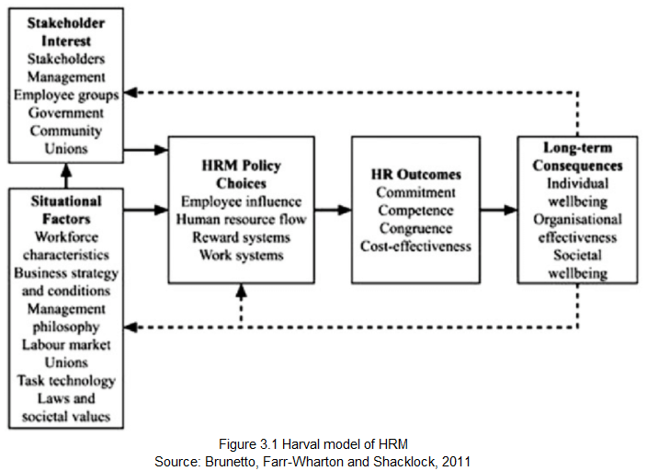

For both organizations, HRM's Harvard model should be applied as it recognizes workers to be the organization's most important asset. This offers workers with a great deal of information to help them understand the mission, structure, customers and rivals of the company. Also, ensure that employees and all other resources are considered equal by the company.

4. Recommendation and Implementation
Recruitment is one of the hardest things a business does, but it can pay off well. It is a challenge and an opportunity to find the best people you can fit into your culture and contribute to your organization.

4.1 Areas for improvement
To cope with the difficult environment with the above information, below are the keys factor on successful employee recruitment with an implementation plan. The recommendation is below.
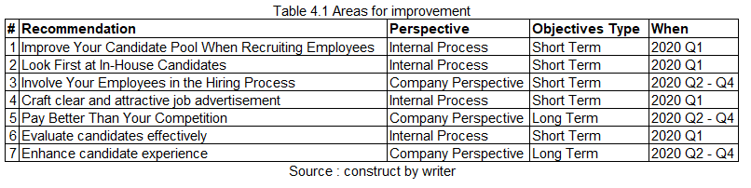

4.1.1 Improve Your Candidate Pool When Recruiting Employees
The best candidates are missing from companies that select new employees from the candidates who walk in their door or respond to an ad in the paper or online. Typically, they work for someone else and may not even look for a new role. The measures to be taken to improve the pool of candidates are below (Vincent, 2019).
- Spend time with college recruitment departments, recruiters and executive search companies in building partnerships.
- Allow current staff members to engage regularly in industry professional organizations and conventions where they are likely to meet successful applicants.
- Watch online job boards for potential applicants who may have electronic resumes even if they are not actively looking.
- Use magazines and websites for professional staff advertising.
- LinkedIn and other social media outlets search for potential employees. Encourage your staff to email the organization with contacts and professional colleagues they may meet online. Get in your best prospects before you need them.

4.1.2 Look First at In-House Candidates
Providing lateral opportunities and promotional for current employees enhances productivity favourably and helps the current employees feel appreciated for their strengths, expertise and achievements (Woellner, 1934). Sign roles publicly at all stages first. Give an interview to the potential candidates. It is a chance for you to better know them. You will know more about the organization's priorities and desires. A reasonable balance between the desires and theirs is sometimes sought.

4.1.3 Involve Your Employees in the Hiring Process
There are three ways in the hiring process to include the staff.
- Good applicants for your business can be suggested by the employees.
- Employees can support you in evaluating prospective applicants ' credentials and skills.
- Employees can help you interview people in your company to evaluate their potential "fit."
Organizations that do not use workers to test potential employee’s under-use one of their most important assets. People involved in the selection process were committed to facilitating the progress of the new employee. For you and the new employee, things cannot get any better (Bowen, 1986).

4.1.4 Craft clear and attractive job advertisement
Effective job advertisements help you assess candidates on job-related criteria (Frank, 2013). Work with the hiring managers of your company to create job descriptions which:
- Provide specifics regarding flexible positions that are valuable and precise. In mentioning job duties, include activities that may be performed by the new hire or by groups in which they will operate. Distinguish between the criteria for "nice-to-have" and "must-have" so as not to deter applicants who might be able to learn secondary skills at work. As a guideline, limit the "must-have" list to approximately 6 bullet points.
- Use simple job names. Be specific about the positions you employ. Stop utilizing terms such as "rockstar" and clickbait or suspicious titles and text (e.g. "Great new graduates opportunity!").
- Promote your firm. Describe what makes your company unique in giving compelling reasons for applications to candidates. Be specific: "We've recently opened three new branches" is more accurate than "We're growing fast." In addition, your company offers outline advantages and benefits.
- Use a language that is clear and accommodating. Remove terminology and complex words and talk directly to candidates (example using "you" instead of "the ideal candidate.") Use discriminatory language (for example: “salesman”, "fresh and energetic") and let voters know if your business is actively supporting inclusion.

4.1.5 Pay Better Than Your Competition
Every day you will listen to bosses thinking about how to get inexpensive jobs. It is a very bad practice. You will happily draw and retain an individual with incentives when they accompany their partner to a new community or need your benefits (Perry and Haluska, 2016). However, they are going to resent their pay scale, feel unwelcome, and abandon you for their first good job opportunity. Replacement costs for employees can range from two to three times the annual salary of the individual. In the job market, you get what you are willing to pay for.

4.1.6 Evaluate Candidates Effectively
An enhanced process of recruitment focuses on testing methods to help you find the most qualified candidates (Murphy, 2017). Here are some of the following methods:
- Check examples of jobs and tasks. Evaluate job examples from applicant resumes or invite applicants to complete tasks as part of your hiring process (e.g. an editing test for writer candidates). If you are seeking programmers, suggest using a software selection tool (e.g. codility) which facilitates programming problems and interactive professional interviews.
- Play with screening. Tell applicants for standardized testing. This approach can help you to reduce the number of candidates you interview, saving time for hiring managers. Testing is not flawless, so be careful to integrate it with other forms of testing (such as job samples) and evaluate outcomes before disqualifying applicants.
- Design the interviews (or semi-structure). Unstructured surveys are not reliably able to predict job performance. For order to add consistency to your interviews, plan the questions in advance and connect them with job requirements (e.g. schedule leadership interview questions to ask applicants applying for senior positions). It is a good idea to use the same questions for each applicant and rate the same amount of questions. The interview scorecards can be helpful in this way to arrange interviews.
In addition to these approaches, invest in your recruiting teams' practice. Interview training helps teams had better assess applicants, enhancing hire performance.

4.1.7 Enhance Candidate Experience
Each contact with candidates forms your company's impression. For your employer brand, a successful applicant experience is good and helps you create a healthy pipeline (Dale, 2007). Here are some factors that affect the experience of the candidate:
- Shorten the time of your application many people are leaving lengthy cycles of submission. In less than five minutes, requests that can be filled out draw more candidates. Ask applicants to submit their curriculum vitae and cover letter and address a few appropriate questions. Stick with queries that are clear and specific and avoid asking for details on applications or online profiles.
- Edit your career page. In order to learn more about your business, both active and passive applicants visit your job site.
  - Be helpful. Using tales or quotations from staff to explain the advantages of your business.
  - Make easy to use. To customize your site, add images and videos. To make the website easy to navigate and fun to look at, hire a developer if necessary.
  - Be real. Tell what makes your business a wonderful place to work and stop overused or meaningless words such as "fast-paced climate" and "core values."
- Keep in the loop the candidates. Candidates would like to be updated during the entire hiring process. Set reminders for screening or interviewing candidates to follow up. The built-in email templates will assist in promoting contact at each recruiting point. Sending rejection emails to disqualified candidates and offering interview feedback also is a good practice.

4.2 Strategy Life Cycle
Below is the best practices of the HRM strategy life cycle on how to make, implement and monitor the strategy on different phase that both company also can follow.
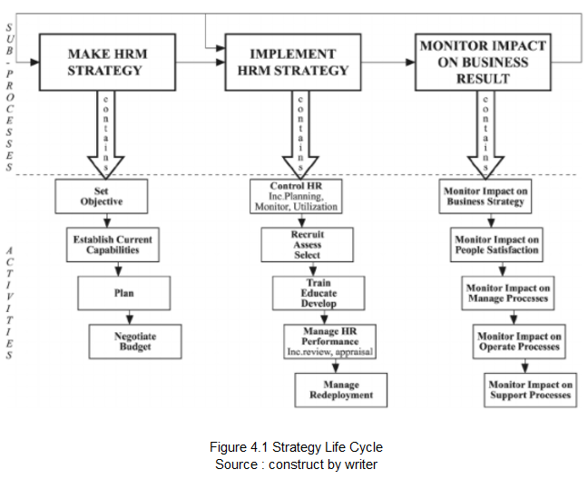

5. Conclusions
It is claimed that human resources are an integral part of any enterprise. Competent and professional workers may handle the work, duties, activities and procedures appropriately. Therefore, it is important to incorporate successful recruiting methods and selection processes within the organizational structure. When the organization's leaders become informed of the correct hiring and selection processes, they will allow the distribution of human resources in an appropriate manner. Within the organization and quality of all kinds of tasks and procedures, there are various work duties and roles which involve skills and abilities that can be enhanced by supplying the workers with adequate training.

Hired employees may be knowledgeable and experienced, but they undergo adjustments and transitions within organizations with regard to various aspects such as working climate requirements, quality of workers ' job duties, behaviours and attitudes traits, ways for enhancing efficiency, use of new strategies and processes, and so on. When choosing the workers, it is essential to be loyal and committed to the organizations. We should be committed to fulfilling job duties and exhibit the qualities of resourcefulness, dedication, and sensitivity. Ultimately, it can be mentioned that selection and recruitment procedures need to be applied by organizations with truthfulness, consistency, and specificity.
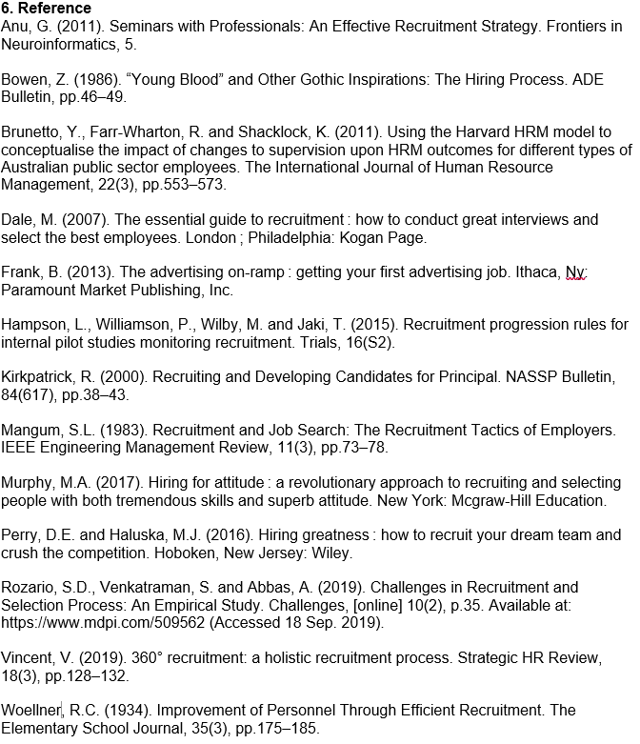

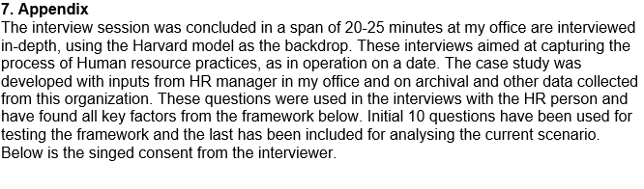
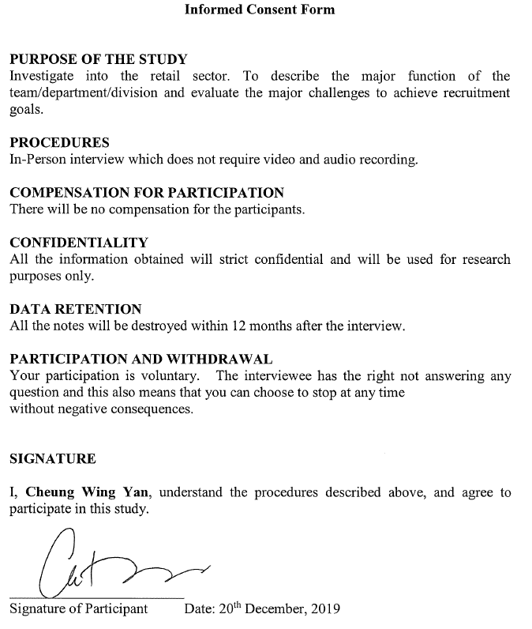
Document 7.1 - Consent Form 1
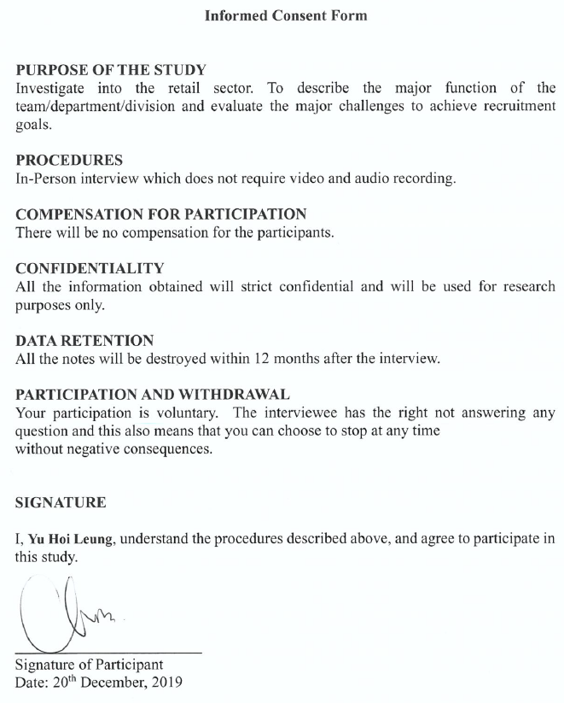
Document 7.2 - Consent Form 2



