Olesea Pecica (2027757)
ASSESMENT 2
Community engagement of Hounslow

Introduction

Well-managed community engagement will offer substantial advantages to the development of Neighbourhood area. Developing a good plan Plan and promoting participation of local people, organisations, companies, developers, and a variety of agencies. Benefits of significant, two-way community interaction it is developing confidence between the parish council(s), local residents, developers, and service providers.
Also, it allows local individuals and communities the ability to influence choices that will impact them. On the same page, knowledge of local concerns - it draws into local knowledge and expertise ensuring that Neighbourhood Plan is as well informed as possible by the people who know its challenges best, in this case local residents.
Eliminates physical, linguistic, and social obstacles that prevent communities from gaining access to information and expressing their needs and views.

The importance of Community Engagement
The most crucial role of a community manager is community engagement, which is a continuous activity. One of the most significant advantages of prioritising participation of residents is development of a community around case we are looking for. As a result, members develop a sense of belonging and loyalty is strengthened. The nature of the process – encouraging people to share their perspectives on sometimes complex infrastructure projects that may affect them in a variety of ways – is loaded with difficulties, some of which are related to language, communications, and even psychology. Good community participation may help people become active and involved, as well as resourceful, talented, and creative. Similarly, strong community engagement may assist parishes in being seen as quickly and passionately responding to their local communities' need for participation and cooperation.
There's very little can be achieve with community if it isn't active, whether is building a social movement around a shared cause, forming a support group around a certain topic, or simply bringing individuals with similar interests together.
Community participation should be integral to neighbourhood planning. Everyone should have the right to have their opinions heard and respected. Good community participation may foster new ties and strengthen old ones. Therefore, consideration should be made to the most effective means of reaching out to broader populations and removing obstacles for individuals who are typically under-represented in parish concerns and meetings. This includes individuals with diverse opinions and those whose voices are seldom heard, such as younger people, those living in isolated rural regions, and those whose first language may not be English. To reach as many possible participants as possible in community we need to use different techniques. Direct and indirect communication methods may be distinguished. Direct method refers to face-to-face, written, electronic, or telephone communication with persons. Examples of indirect approaches include flyers, advertisements, radio programmes, newspaper articles, and press releases.
‘Open Space’ meetings would enable participants to define their own agendas and debates in a less formal environment than a public gathering. Others jot down or propose topics at the beginning of the meeting, and then create smaller groups with people who share similar concerns to discuss possibilities and the way ahead. Participants may travel between discussion groups and participate in as many or as few as they feel comfortable with.

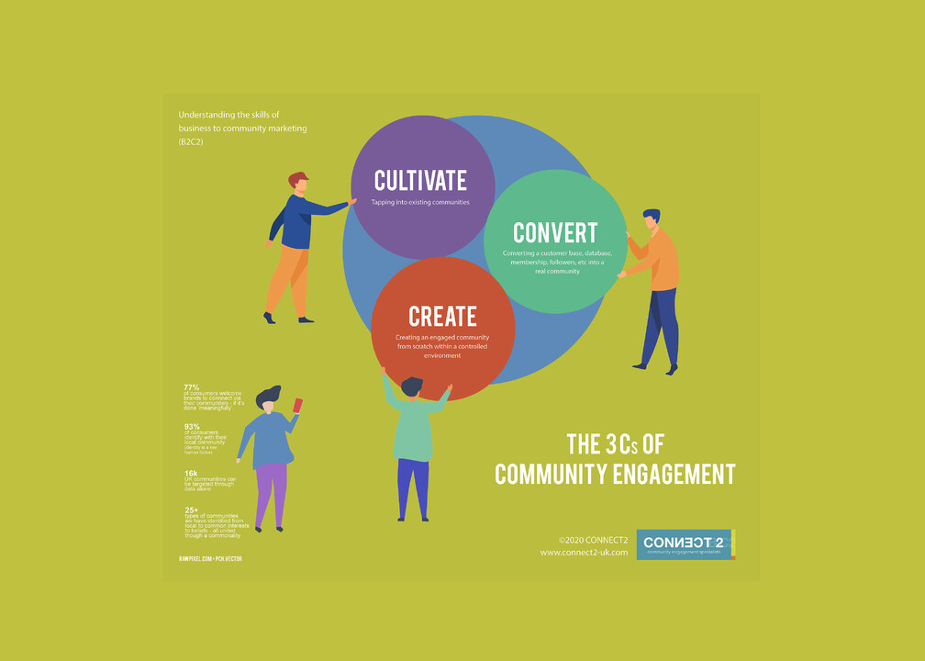

Methods of consultation with residents:
- Public events - A public meeting is open to the public and allows anyone to voice concerns, pose questions, and be heard. Answers that can be heard by others in the room.
- Roadshows and public expositions - We may communicate information using the idiom "a picture is worth a thousand words." These may be coupled with other activities and brought to where people already are, such as school activities or summer markets.
- Polls and questionnaires - The single most popular mode of interaction. Used to gather quantitative responses from which, provided the participants are representative, the broader public opinion may be ascertained.
- Local Workshops - Designed to allow individuals to work cooperatively and actively on a problem or job. Workshops may foster collaborative problem-solving and enhance a feeling of ownership over the outcomes.
- Newsletters and parish magazines - one of the cheapest and most efficient ways to keep people informed. The style of newsletters should be dynamic and concise. It is a good idea to add photographs of important personnel, with their permission, to make them seem less faceless; incorporate photographs taken during any consultation events.
- Open days and drop-in sessions - A technique to reach out to the community and seek casual interaction, particularly if you piggyback onto existing local events or locations, such as fetes, markets, and closed shops, etc.
- Web-based procedures - In recent years, web-based involvement mechanisms, such as parish council websites, Facebook, and Neighbourhood Planning-specific websites, have become increasingly prevalent.
- Consultation papers - A well-written document enables the consultees to describe in full the whole problem and pose particular queries.
- Focus groups - Groups of 6 to 12 persons carefully chosen to be representative of a certain segment of the population. Focus groups are qualitative methods that are useful for gaining a deeper understanding of how people think and feel about situations.
- Interviews - Can entail intense face-to-face discussions, telephone chats, or street corner interactions. This is an effective method for obtaining information from a person.
- Planning for Real - Is an engaging, hands-on way for determining what needs to be done to enhance your neighbourhood. It involves a big size 3D model or map of the neighbourhood.
- Place verifications tours - Place audits entail a group of locals doing a firsthand examination of their Neighbourhood Area. Similar to reconnaissance missions, but with mixed teams of locals and technological specialists.
- Citizens' panels - Panels of local residents are assembled to test their opinions on local problems on a regular basis. The makeup of panels may be made representative of the people whose opinions are sought, i.e., your community.
- Community fairs - Provide an enjoyable event that will attract people of all ages and backgrounds. It therefore affords the chance to enlighten and engage the community at a single event.
- Posters and leaflets - an efficient technique of publicising or communicating basic information on a bigger consultation.

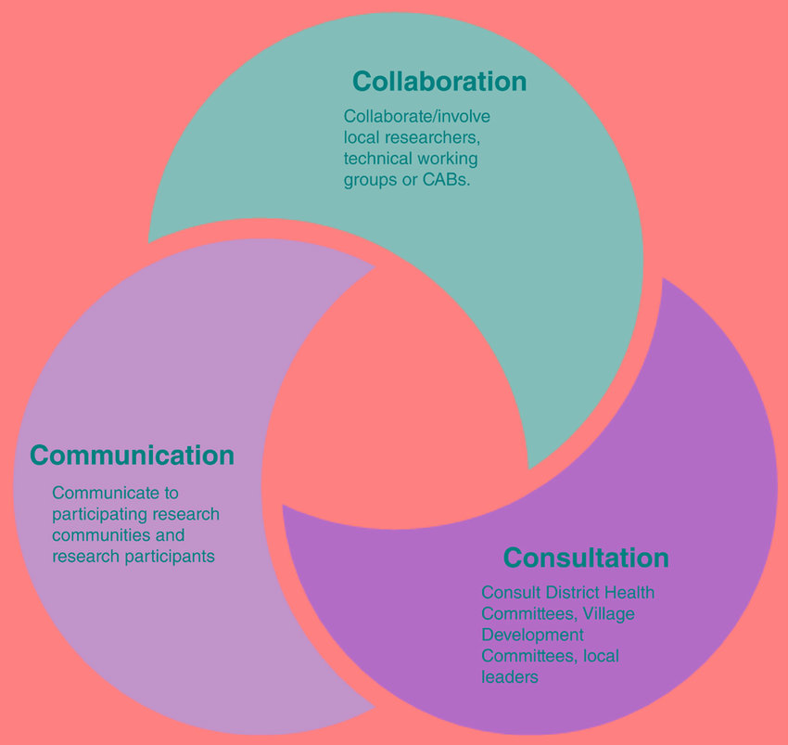

The main advises for a successful community engagement
- One of the main points is to have a well-defined objective.
Consultation entails soliciting public input on proposed changes. Notably, it provides for the community's active participation in shaping policy or decision-making. Engagement is a more comprehensive and continuing process of sharing information with the community and soliciting comments, without any obligation to act on the feedback. While this may seem to be a little distinction, organisations often utilise the two interchangeably. Ascertain from the start if you are conducting a true consultation in which input has an effect on the conclusion. Assuring that your community audience knows their true influence from the start can assist in managing expectations and avoiding a 'over promise, under deliver' situation.
- Another point is time allowed for certain task.
Most organisations recognise that offering adequate time for audience engagement is a critical component of a successful public consultation. Internal politics, on the other hand, often hinder teams from gaining a head start; worries about project scope, financial constraints, or governance approval may all stall the machine. Meanwhile, the possibility of information leakage grows. Suddenly, the local newspaper has the front-page exclusive that will impact your audience's perception of the project even before you break ground. There might be a substantial cost associated with relinquishing control of the story from the start. By and large, it is preferable to go somewhat early than to risk entering recovery mode. Prepare your communications strategy in advance, launch it early, and stay ahead.
- Learn your community
Each community will have its own unique influences. The "friends of the park" or local history organisation may not have a fancy job title or letters after their name (although some may), but they may have a direct route to local media or the MP. Understanding the community goes well beyond calculating the proportion of ABC1s that must be engaged. Determine who the major actors are and contact them as soon as possible; if businesses can recruit the most influential members of the community, they may be a significant asset. Companies that see stakeholder mapping as an administrative task are more likely to overlook chances to establish trust. An out-of-date Google map might lead to embarrassing errors; thus, it is best to walk and explain the route. You cannot aspire to know a community without physically interacting with it.
- Comprehension of community dynamics
Typically, communities consist of a broad assortment of individuals whose sole shared characteristic is where they reside. Regardless of how good a company's marketing is, public interactions may play out in communities like a mini referendum. Before breaking ground, it is crucial to study community dynamics and incorporate these insights into your communications plan. Try to comprehend the overall sentiment and perspective of the community. A few vociferous voices may often result in a misleading narrative. It is often true that those who are the most dissatisfied will voice their opinion the loudest, whether in a local community Facebook group or in a town hall meeting.
- Inform everyone
To avoid message creep on written content, playbooks and communications plans are required, and face-to-face encounters pose even larger hazards. Ensure that everyone who interacts with the media and stakeholders is on message. It might be your Community Engagement team, your Marketing Director, or your on-site personnel. They must be briefed if they are going to convey anything about the project to external parties.
- Consider the use of technology.
Traditional boots-on-the-ground interaction should never be replaced, but digital tools and technology should be used to augment it. Projects frequently include a large amount of visual content that highlights the endeavour. This is an ideal time to build engagement materials that will help you engage with the relevant audiences, in the right places, and through the right channels as the project progresses. To engage with the community, consider building a whole channel and content plan. When the content on social media is controversial, businesses generally avoid participating, yet their absence might be regarded as a lack of openness. Just because you're not on Twitter doesn't imply your target audience isn't talking about your project. Don't forget about the essentials, like making sure your web page or site is created with the user in mind. Small details can make a significant difference.
- Make long-term plans
When there is a lack of efficient communication from the start, negativity can quickly develop. Often, organisations see community consultation as something that must be done in order for the project to move forward. This strategy may result in the loss of all earned trust or the elimination of the prospect of trust ever being formed. Success should be judged not only in terms of getting the job done, but also in terms of how it affects the company's long-term reputation. A project's success criteria should include leaving a beneficial legacy on the community. Finally, ensure that it is a collaborative endeavour. Working on communications and engagement outside from the project team compromises the integrity of any public discussion. While it's true that public consultation isn't an exact science, it doesn't mean there isn't a formula that, when followed, will ensure that your process and organisation succeed.
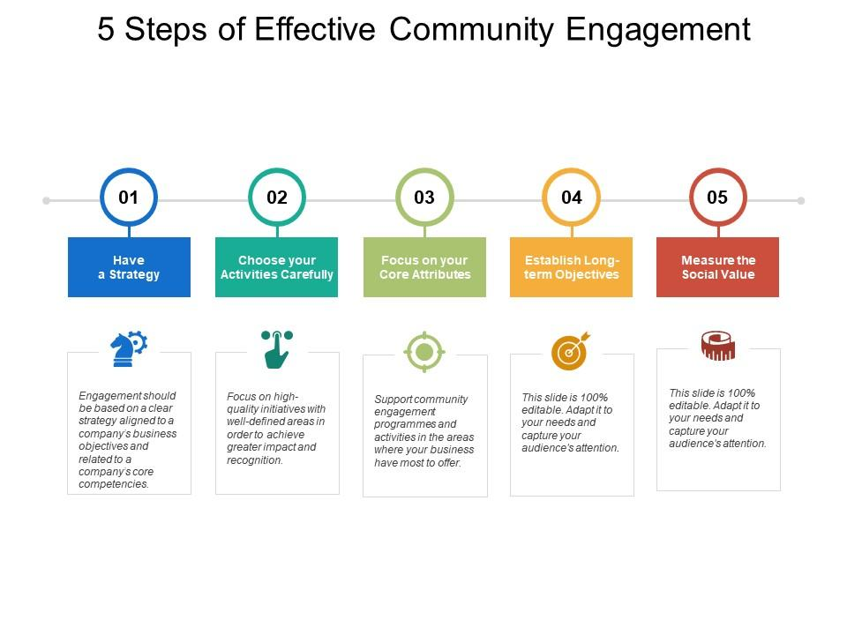

In Hounslow community, I can see how a small group of people creates diverse project, however, it is not included the whole community opinion, therefore, it is not taken in consideration many other issues which are facing residents. From my perspective I will suggest creating such an event where majority of people can participate and many culture might be include, per example for those not having the first language English. Applying some of the technique above will improve the quality of life in Hounslow and prosper the activity of Community Engagement.

Conclusion: In Conclusion we can see how important Community Engagement for a community is, and if is involved to improve people life then all the techniques above help us to reach out to all residents and see their real issue facing on a daily basic. In Hounslow community is needed to use some of them to get feedback from local people and focus on all which are mentioned. We cannot perform unless we have some sort of conversation with community and find the solution together.

References:

- Herefordshire Council, ‘Best practise community engagement techniques’, April 2013, revised 2015. Accesed on 7th of May, 2022, available at: https://www.herefordshire.gov.uk/downloads/file/3703/guidance_note_12_best_practice_community_engagement_techniques
- Ruaridh MacGregor, ‘ 7 top tips for successful community engagement’, 9th of December, 2021. Accessed on 9th of May, 2022, available at: https://webershandwick.scot/announcements/7-tops-tips-for-successful-community-engagement/

