Control System Design

Author: Joshua Luke Evans (2011912)
Course: BEng Ordnance, Munitions, and Explosives – Level 5 Instrumentation and Control (ACDB5011)
Faculty of Architecture, Computing and Engineering
Date of Submission:
Word Count: (excluding appendices and references)



Executive Summary
A Proportional-Integral-Derivative (PID) controller was designed and analysed for a Close-In Weapon System (CIWS). The controller’s objective was to achieve an overshoot of less than five per cent and a settling time of fewer than two seconds. The controller parameters were derived using the Controller Tuner App in SIMULINK, and the closed-loop system stability was analysed using Pole-Zero, Root Locus, Nyquist, Bode and Nichols plots. The PID controller was evaluated using step and disturbance responses to check the system performance. Results show that the controller met the objectives with an overshoot of 4.47% and a settling time of 1.17 seconds.

Contents
Executive Summary 2
1. Introduction 5
2. Simulation setup 6
3. Results 9
4. Analysis 11
Conclusion 12
References 13
Annexe A – Transfer Function Calculations 14
Annexe B – Robustness Analysis Charts 20

Figure 1 - PID Controller split into individual elements with algorithms displayed. [2] 5
Figure 2 - Circuit diagram of CIWS System 6
Figure 3 - CIWS system created in SIMULINK 7
Figure 4 - Pole-Zero Map of the Process Transfer Function 7
Figure 5 - Diagram showing how the location of poles on the Pole-Zero map can affect system response 8
Figure 6 - Scope output of CIWS system with no controller 8
Figure 7 - CIWS system with PID controller created in SIMULINK 9
Figure 8 - Step Plot for the tuned response of the PID controller 10
Figure 9 - System performance and robustness values for the given controller parameters 11
Figure 10 - Block diagram of the control system 14
Figure 11 - Transfer function as a pole-zero map 15
Figure 12 - The scope output from the untuned controller 16
Figure 13 - the scope output from the tuned PID controller 16
Figure 14 - A block diagram of the control system with a combined controller-process element 18
Figure 15 - The combined transfer function of the closed-loop system in SIMULINK 19
Figure 16 - Signal of the combined transfer function seen in the scope 19
Figure 17 - Nyquist plot of the forward transfer function 20
Figure 18 - Nyquist plot showing unit circle (hashed and dotted line) and M-circles (dotted lines) 20
Figure 19 - Bode plot of the forward transfer function 21
Figure 20 - Root locus of the closed-loop system 21
Figure 21 - Root locus table zoomed in view 22
Figure 22 - Pole-Zero plots for the individual process transfer function (left), controller transfer function (middle), and the closed-loop system transfer function (right). 22
Figure 23 - Nichols plot of the forward transfer function 23

Introduction
The design and analysis of control systems have a wide range of applications in engineering, including aerospace, chemical, electrical, mechanical and defence industries. The Phalanx Close-In Weapon System (CIWS) is one example which requires a fast and accurate control system to allow it to perform local area and personal defence of maritime platforms during operations when engaged by air or surface threats.
A control system is defined in [1] as: “an arrangement of physical components connected or related in such a manner as to command, direct, or regulate itself or another system”. This arrangement of physical components takes an input and processes it to give a desired output.
Several control methods can be used to design a control system, including Proportional-Integral-Derivative (PID) control, lead-lag compensation, and state-space control. This paper applies the PID method due to its wide application in control systems and its simplicity and effectiveness.
Figure 1 shows the three types of controllers being used in a system.
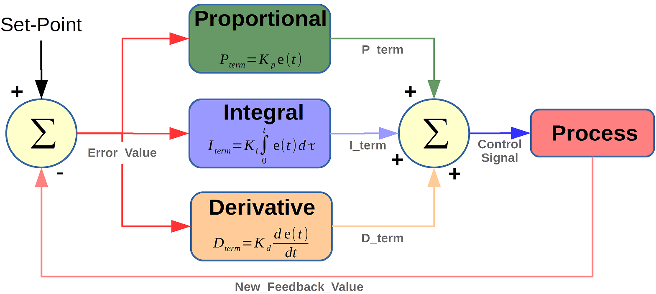
Figure 1 - PID Controller split into individual elements with algorithms displayed. [2]
The PID controller achieves the signal by adjusting the control input based on the feedback signal. The proportional term provides a control action proportional to the error signal at a given time; the integral controller provides a control action proportional to the integral of the error signal; and the derivative controller provides a control action proportional to the rate of change of the error.
This paper analyses the performance of a PID controller for a CIWS with a transfer function ( 1 ).
$$\frac{1}{9s^{2}+s+2}$$
( 1 )
The control system shall be designed and calibrated to train onto a target within two seconds, with no greater than five per cent overshoot allowed. The controller parameters were derived using SIMULINK, and the closed-loop system stability was then analysed using various system analysis methods.

Simulation setup
The design and calibration of the control system were performed in MATLAB, version R2022B. This software package is commonly used for control system design and analysis due to its circuit module in SIMULINK. Furthermore, it pairs well with MATLAB, as programming scripts and SIMULINK models can be combined in complex arrangements.
Figure 2 below shows a basic circuit diagram of the closed-loop system. Where:
- r = reference input
- e = error signal
- c = controlled output
- h = feedback elements
- b = feedback signal
- g₁ = process element
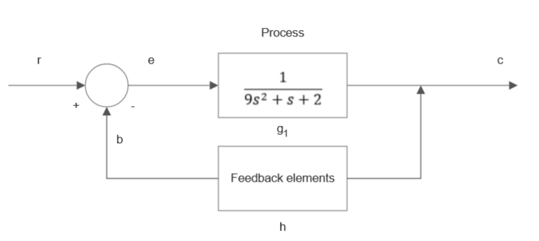
Figure 2 - Circuit diagram of CIWS System
To provide a benchmark, the system was produced in SIMULINK initially without a control element included (Figure 3). From this, a Pole-Zero plot was generated (Figure 4), which indicates the system's behaviour.
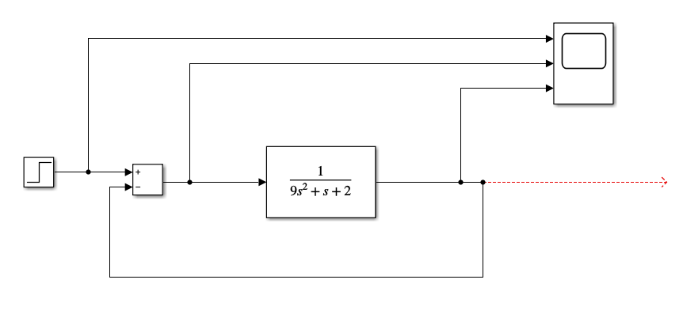
Figure 3 - CIWS system created in SIMULINK
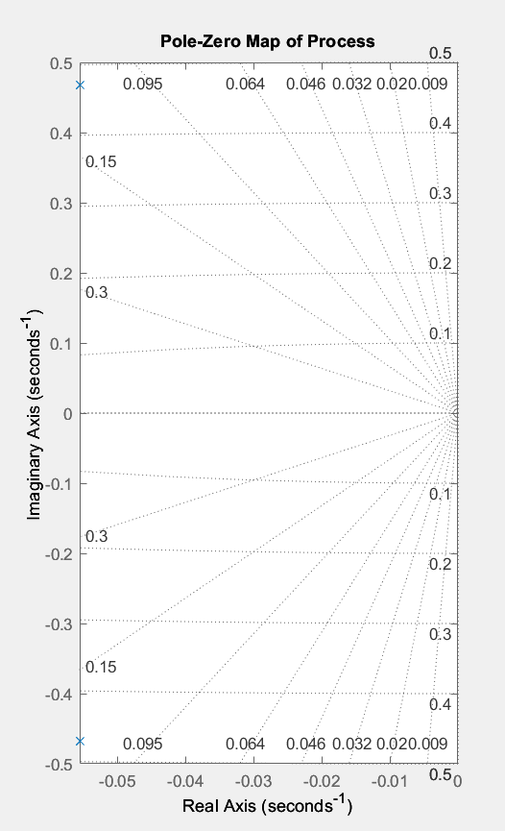
Figure 4 - Pole-Zero Map of the Process Transfer Function
From Figure 4, it can be seen that there is a complex conjugate pole pair that falls left of zero on the Real Axis, which indicates that the system will produce a decaying sinusoid waveform [3]. Figure 5 demonstrates how the system will perform depending on the location of the poles. The decay rate depends on how far the pole pair is from the origin point (zero on the Real Axis), with faster decay rates found closer to the origin. The scope exhibited the predicted behaviour of the system when created in SIMULINK (Figure 6).
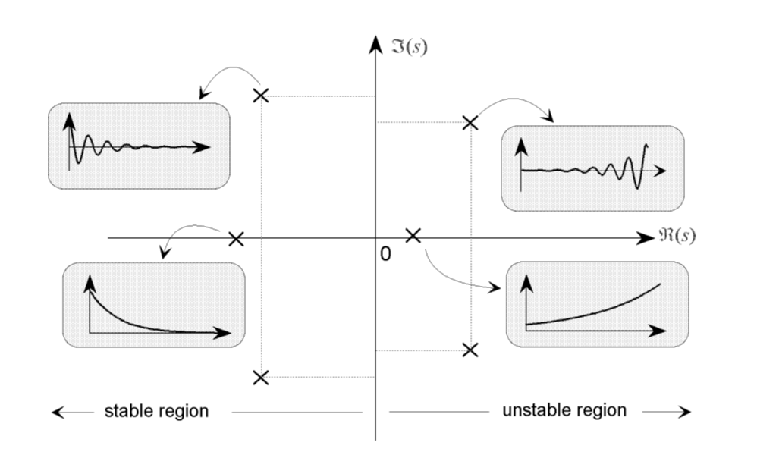
Figure 5 - Diagram showing how the location of poles on the Pole-Zero map can affect system response [4]
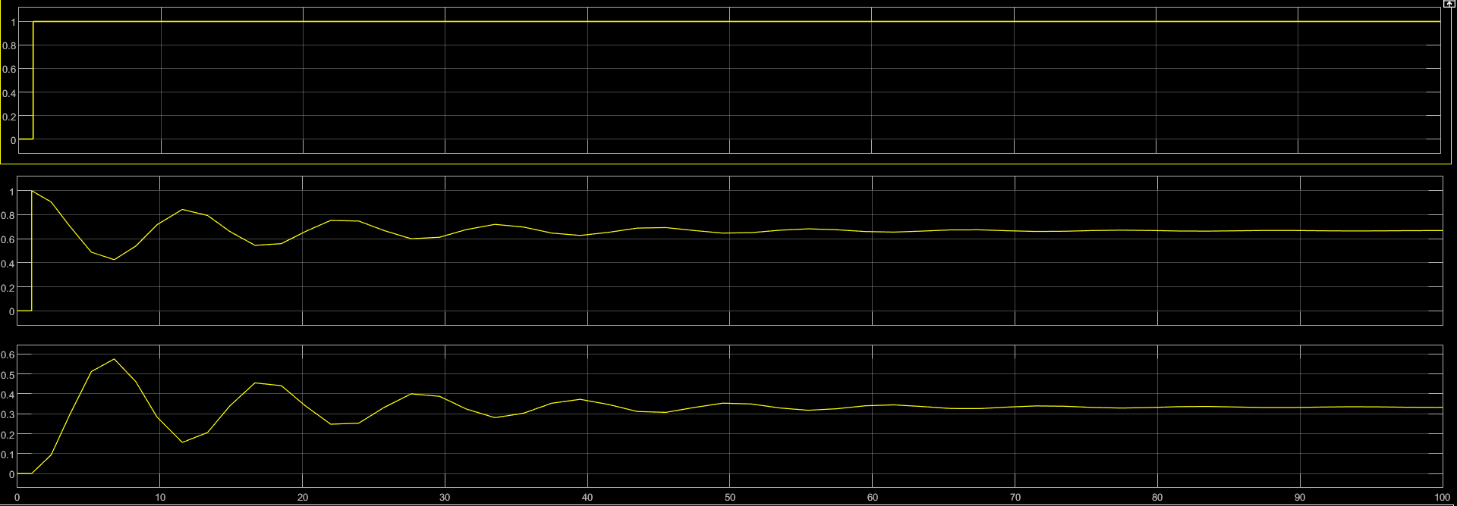
Figure 6 - Scope output of CIWS system with no controller
Therefore, this shows that the initial system is stable. However, the settling time and overshoot parameters would not be suitable for a CIWS as the gun’s turret would oscillate as it tried to train onto the target creating an inaccurate weapon. A PID Controller was added to the system (Figure 7) to reduce the settling time and overshoot characteristics. 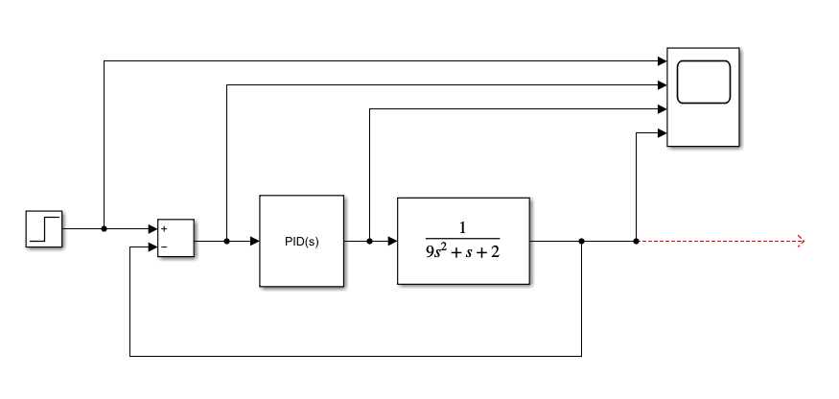
Figure 7 - CIWS system with PID controller created in SIMULINK
The built-in PID Tuner App in SIMULINK was used to change the Proportional (K_{p}), Integral (K_{i}), and Derivative (K_{d}) constants in addition to the filter coefficient (N) to bring the system to the required settling time and overshoot characteristics whilst ensuring the system remained stable.

Results
The resultant values for K_{p}, K_{i}, K_{d} and N produced by the PID Tuner App were as follows:
- K_{p} = 73.3451136729089
- K_{i} = 5.75651536338109
- K_{d} = 90.0058418550525
- N = 1149.14829164565
Figure 8 shows the Step Plot within the PID Tuner App with the above values applied. The performance and robustness characteristics are then presented in Figure 9, which shows that the controlled system has a settling time of 1.17 seconds and an overshoot of 4.47%.
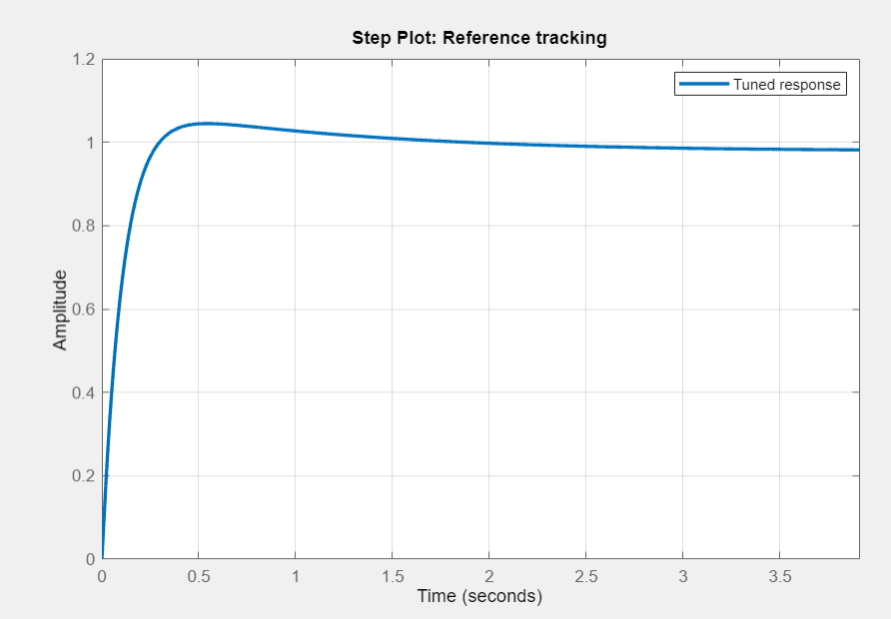
Figure 8 - Step Plot for the tuned response of the PID controller
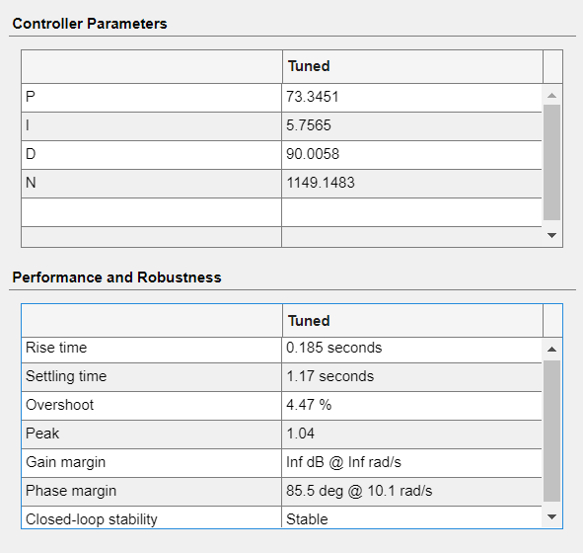
Figure 9 - System performance and robustness values for the given controller parameters
Nyquist (Figure 17 and Figure 18), Bode (Figure 19), Root Locus (Figure 20 and Figure 21), Pole-Zero (Figure 22), and Nichols (Figure 23) plots have been produced (refer to Annexe B) to analyse the system’s robustness. These are discussed further in the next section.

Analysis
Evaluating the system's robustness is essential as it determines how well it can cope with uncertainties and variations in the process model, which may arise from modelling inaccuracies or external disturbances such as temperature, humidity, or vibrations. Therefore, a robustness analysis was performed using a combination of Pole-Zero maps, Root-Locus, Nyquist diagrams, Bode plots and Nichols charts.
The system's response will be measured through these methods, and the critical point will be determined. The critical point is a specific operating point of the system where the behaviour of the system changes from stable to unstable or vice versa. The critical point is associated with a specific phase response in the frequency domain and can be defined in degrees. For example, in Annexe B, the critical point is located at a phase angle of -180 degrees.
Firstly, the Pole-Zero maps (Figure 22) compare the process's initial behaviour with the PID controller's programmed behaviour and the resulting closed-loop system's behaviour. The initial behaviour of the process was determined in Section 2 and again in Annexe A. The location of the poles and zeros can similarly indicate the behaviour of the controller and the closed-loop system. The poles and zeros on the resultant closed-loop system all fall at zero on the imaginary axis. They are negative on the real axis, indicating the system is stable and will not oscillate as the original process did in Figure 6.
The Root Locus is similar to the Pole-Zero map but shows how the poles move in the s-plane with different gain values. It provides an alternative perspective, but the same conclusions can be drawn concerning the oscillatory behaviour of the system. As all of the poles in the Root Locus plot are found to be zero on the imaginary axis, this shows no oscillatory decay or growth in the system. The poles are also negative in the real axis, which shows the system is stable.
The Nyquist plot provides a graphical representation of the frequency response of the transfer function. It plots the trajectory of the transfer function in the complex plane across the entire frequency range. In addition, this method captures the gain and phase margins, which helps analyse the forward transfer function’s absolute and relative stability. In contrast, other stability analysis methods (such as Routh and Hurwitz) only give approximate stability information [4].
From the Nyquist plot in Figure 17, it could be seen that the system did not cross the critical point along the frequency range. Figure 18 shows the point at which the frequency response hits the unit circle. At this point, the phase margin is calculated by measuring the angle between the frequency response and the critical point. This system measures the phase angle as 85.5 degrees from the critical point.
Additionally, the gain margin can be seen in the Nyquist plot in Figure 18. The gain margin is where the frequency response crosses the imaginary axis. The Nyquist plot shows that when the frequency response crosses zero on the imaginary axis, it is also at zero on the real axis. Therefore, the gain margin is infinite, as no matter the gain in the system, the frequency response will never cross the critical point.
Another method used to determine the system's stability is the Bode plot. The Bode method is similar to the Nyquist method in providing a graphical representation of the forward transfer function. However, the Bode method uses two graphs to represent the data. The top graph in Figure 19 plots the magnitude vs frequency data, which can be used to determine the gain margin, whilst the bottom graph measures phase angle vs frequency, and can therefore be used to determine the phase margin of the system. Both of these data points are used for measuring system robustness. Therefore, only using the Bode method in stability analysis is enough to provide suitable evidence of the system's performance.
The last stability analysis method applied was a frequency response method called the Nichols chart. [5] describes the Nichols chart as a modification of the Nyquist and Bode methods, in that the M- and N-circles found in the Nyquist method (M-circles can be seen in Figure 18) are converted into M and N contours, plotted on a magnitude vs phase angle plot. The Nichols plot presents similar data to both Nyquist and Bode methods. However, as the magnitude is plotted on the logarithmic scale, a more comprehensive range of magnitudes can be plotted compared to the Nyquist method.

Conclusion
In conclusion, this paper has presented a lab report on designing and analysing a PID controller for a Phalanx CIWS. The paper has shown that the PID controller produced in SIMULINK could reduce the settling time and overshoot system characteristics within acceptable margins while maintaining stability. The system's performance was further evaluated using various stability analysis methods such as Nyquist, Bode, Root Locus, Pole-Zero and Nichols plots. Finally, the analysis showed that the closed-loop system could cope with uncertainties and variations, proven by having an infinite gain margin and 85.5-degree phase margin. Overall, this paper demonstrates the effectiveness of a PID controller in designing and calibrating systems.

References

[1] | J. J. DiStefano, A. R. Stubberud and I. J. Williams, “Chapter One - Introduction,” in Schaum's Outline of Theory and Problems of Feedback and Control Systems, McGraw-Hill, 2011, p. 1.
[2] | “PID controller implementation using Arduino,” Microcontrollerslab, 2019. [Online]. Available: https://microcontrollerslab.com/pid-controller-implementation-using-arduino/. [Accessed 20 April 2023].
[3] | Massechusetts Institute of Technology, “Understanding Poles and Zeros,” [Online]. Available: https://web.mit.edu/2.14/www/Handouts/PoleZero.pdf. [Accessed 18 April 2023].
[4] | J. J. DiStefano, A. R. Stubberud and I. J. Williams, “Chapter 11 - Nyquist Analysis,” in Schaum's Outline of Theory and Problems of Feedback Control Systems, McGraw-Hill, 2011, pp. 246-298.
[5] | J. J. DiStefano, A. R. Stubberud and I. J. Williams, “Chapter 17 - Nichols Chart Analysis,” in Schaum's Outline of Theory and Problems of Feedback and Control Systems, McGraw-Hill, 2011, pp. 411-432.
[6] | J. J. DiStefano, A. R. Stubberud and I. J. Williams, “Chapter two - Control Systems Terminology,” in Schaum's Outline of Theory and Problems of Feedback and Control Systems, McGraw-Hill, 2011, pp. 15-38.
[7] | J. J. DiStefano, A. R. Stubberud and I. J. Williams, “Chapter 10 - Analysis and Design of Feedback Control Systems: Objectives and Methods,” in Schaum's Outline of Theory and Problems of Feedback and Control Systems, McGraw-Hill, 2011, pp. 230-245.

Annexe A – Transfer Function Calculations
The equation given for the transfer function is:
The given parameters were:
- a = 9
- b = 1
- c = 2
Which gave:
Figure 10 shows the control system as a simple block diagram.
Figure 10 - Block diagram of the control system
This closed-loop control system contains a feedback loop with a single input and output. The arrows in the block diagram show the direction of control energy or information [6]. The input and output variables and the element blocks are denoted using lower-case letters. These variables represent a function of time.
The first step was to find the value of s. From this, plotting a Pole-Zero Map to indicate the plant’s behaviour would be possible. The polynomial can be found for s:
j = √-1, therefore:
Figure 3 shows this as a pole-zero map.

Figure 11 - Transfer function as a pole-zero map
From the pole-zero map, it is possible to predict the behaviour of the control system. The conjugate pair of poles in Figure 11 indicates that the system will create a sinusoidal wave. Its distance from zero on the x-axis dictates its decay rate or exponential increase. As the poles in this system fall to the left of zero, a sinusoidal decay will be seen, proven when running the plant without the controller in SIMULINK and monitoring the signals in the scope (Figure 12).

Figure 12 - The scope output from the untuned controller
The “PID Tuner” function in MATLAB has been used to optimise the control system. The following values have been obtained:
- Proportional (Kp): 73.3451
- Integral (Ki): 5.7565
- Derivative (Kd): 90.0058
- Filter coefficient (N): 1149.1483
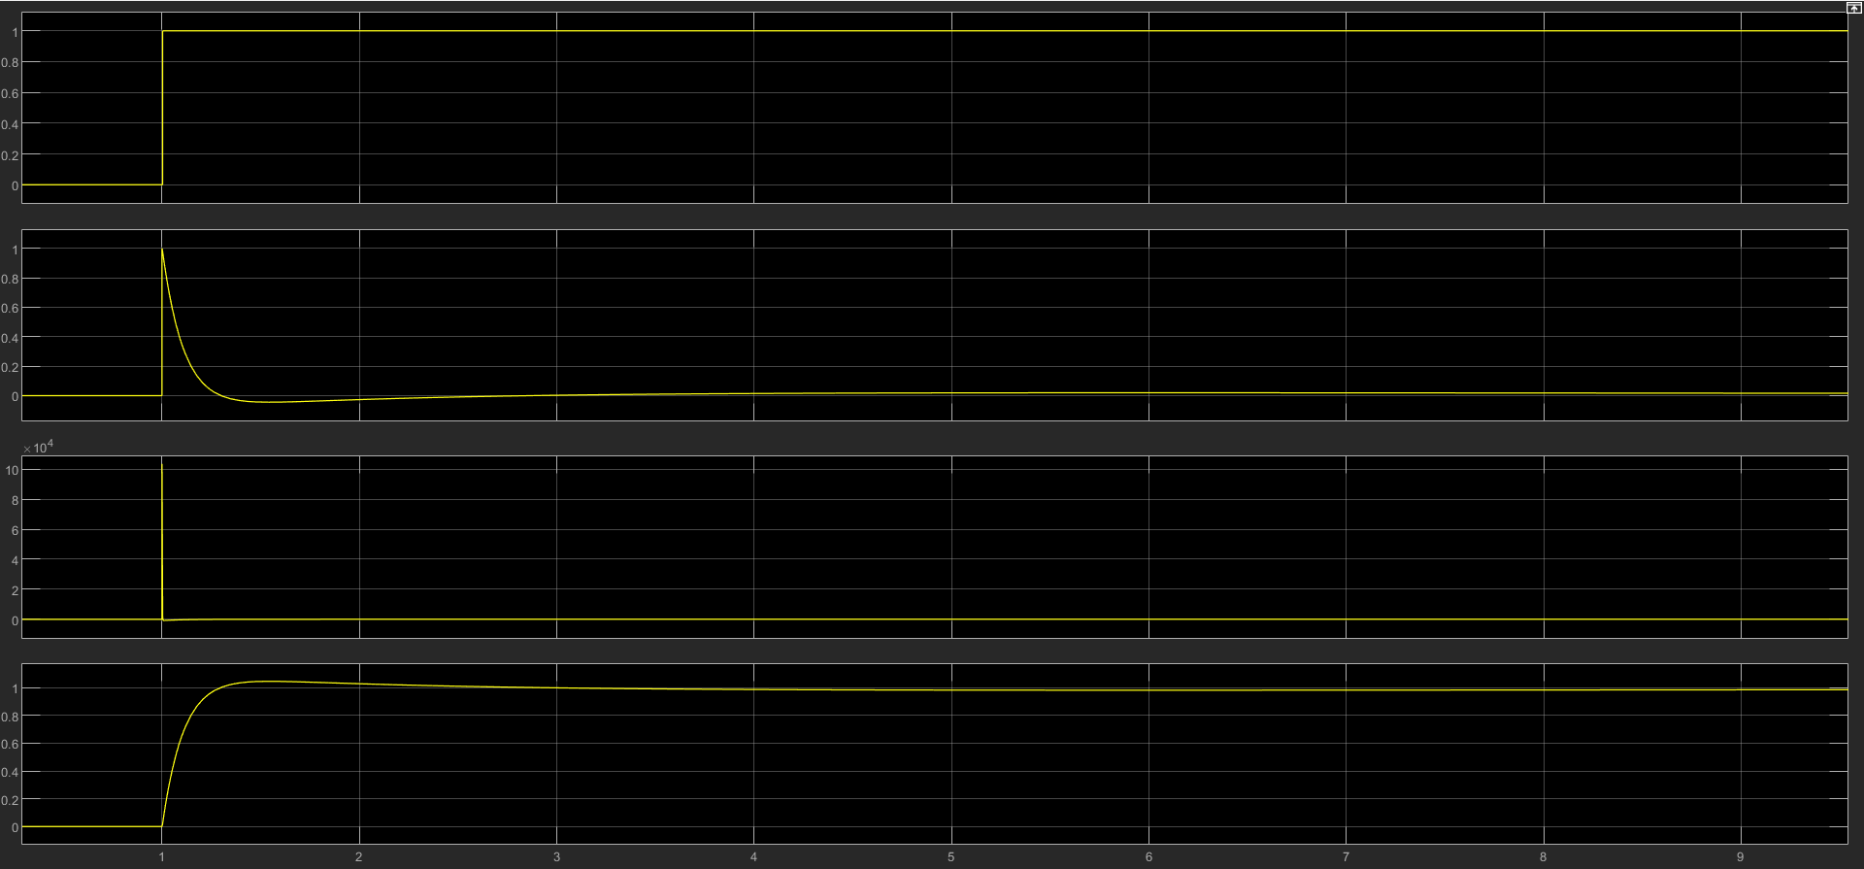
Figure 13 - the scope output from the tuned PID controller
The transfer function of the PID controller is, therefore:
The controller’s transfer function must be multiplied by the transfer function of the process to calculate the transfer function of the forward path of the system.

The block diagram can be redrawn to reflect the combined controller-process element (Figure 14).
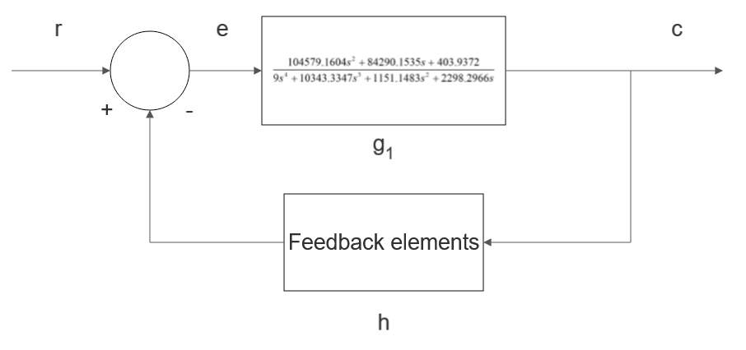
Figure 14 - A block diagram of the control system with a combined controller-process element
The next step is to remove the feedback loop so that the transfer function of the entire system can be found.
TF = transfer function of the whole system
G = the forward path transfer function
H = transfer function of the feedback loop = 1
When this transfer function was fed back into SIMULINK as one process (see Figure 15), the signal in Figure 16 is very close to that produced by the system containing the tuned PID controller and feedback loop in Figure 13.

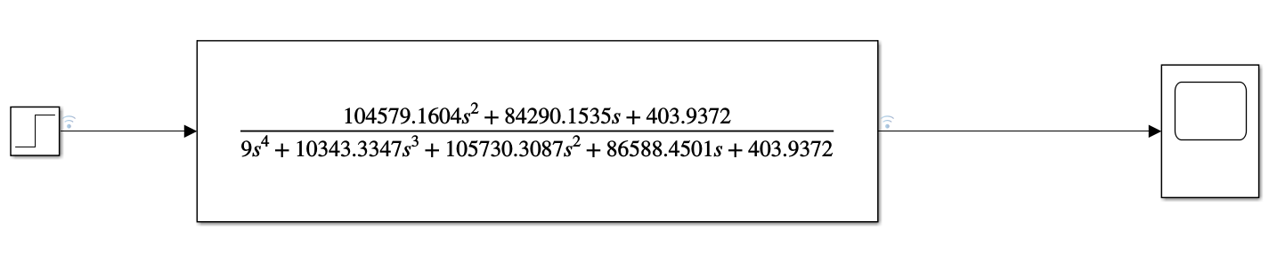
Figure 15 - The combined transfer function of the closed-loop system in SIMULINK
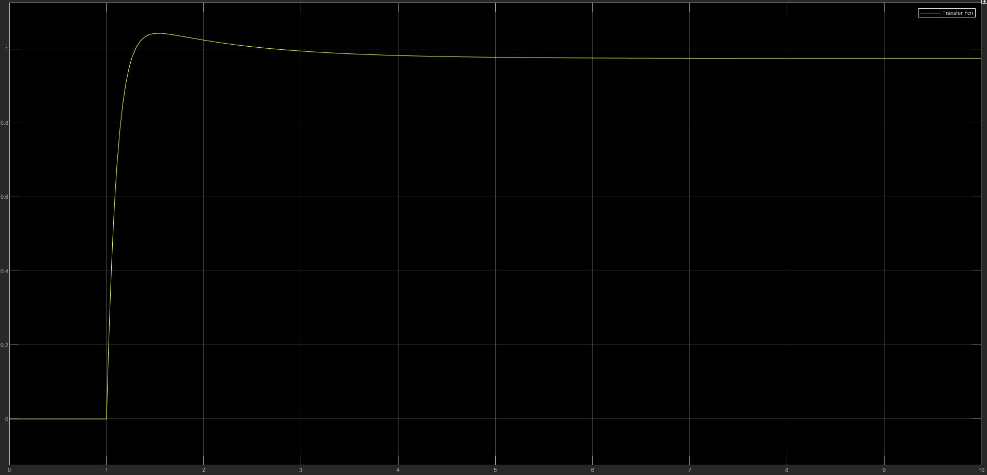
Figure 16 - Signal of the combined transfer function seen in the scope

Annexe B – Robustness Analysis Charts

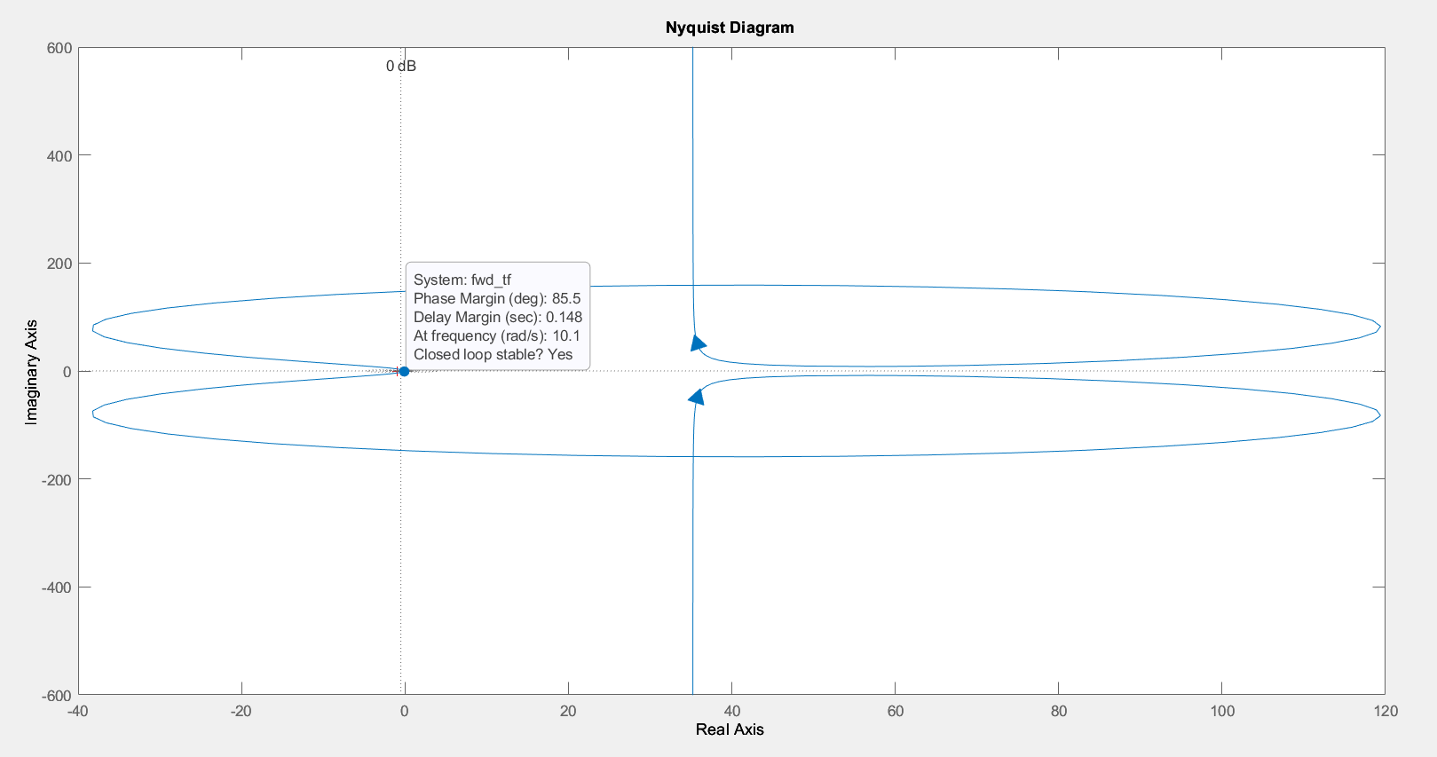
Figure 17 - Nyquist plot of the forward transfer function
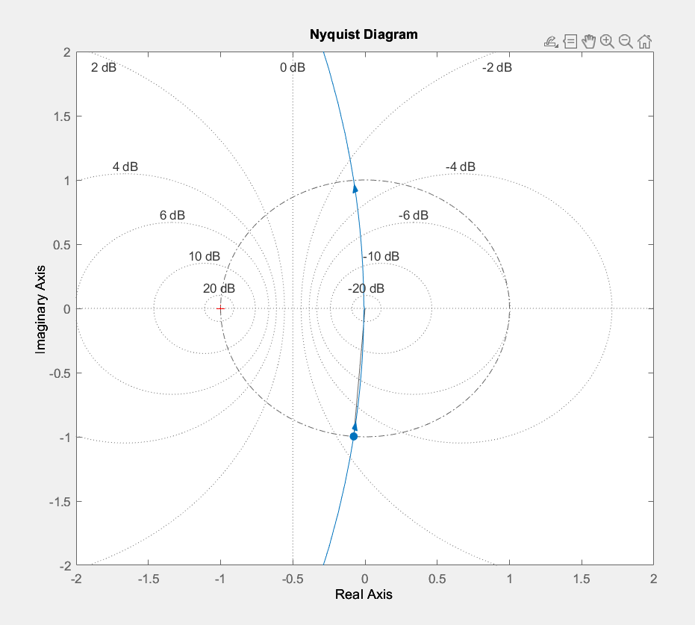
Figure 18 - Nyquist plot showing unit circle (hashed and dotted line) and M-circles (dotted lines)
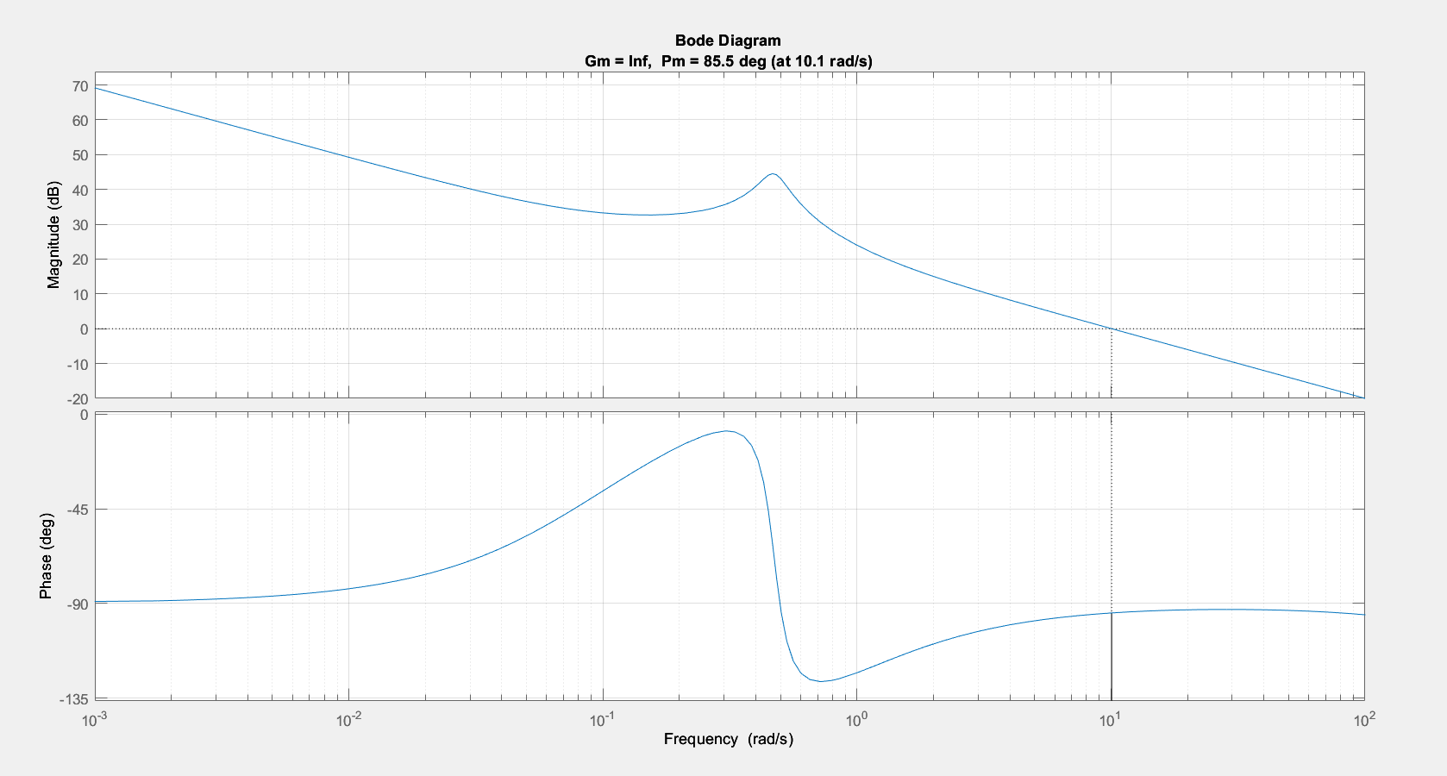
Figure 19 - Bode plot of the forward transfer function
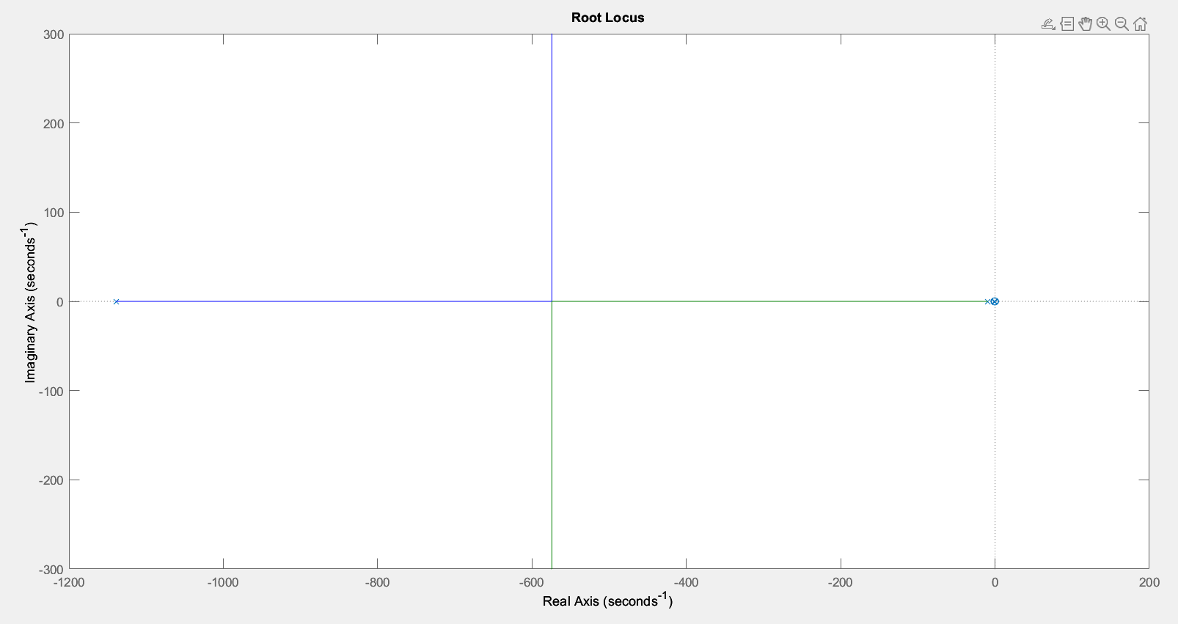
Figure 20 - Root locus of the closed-loop system
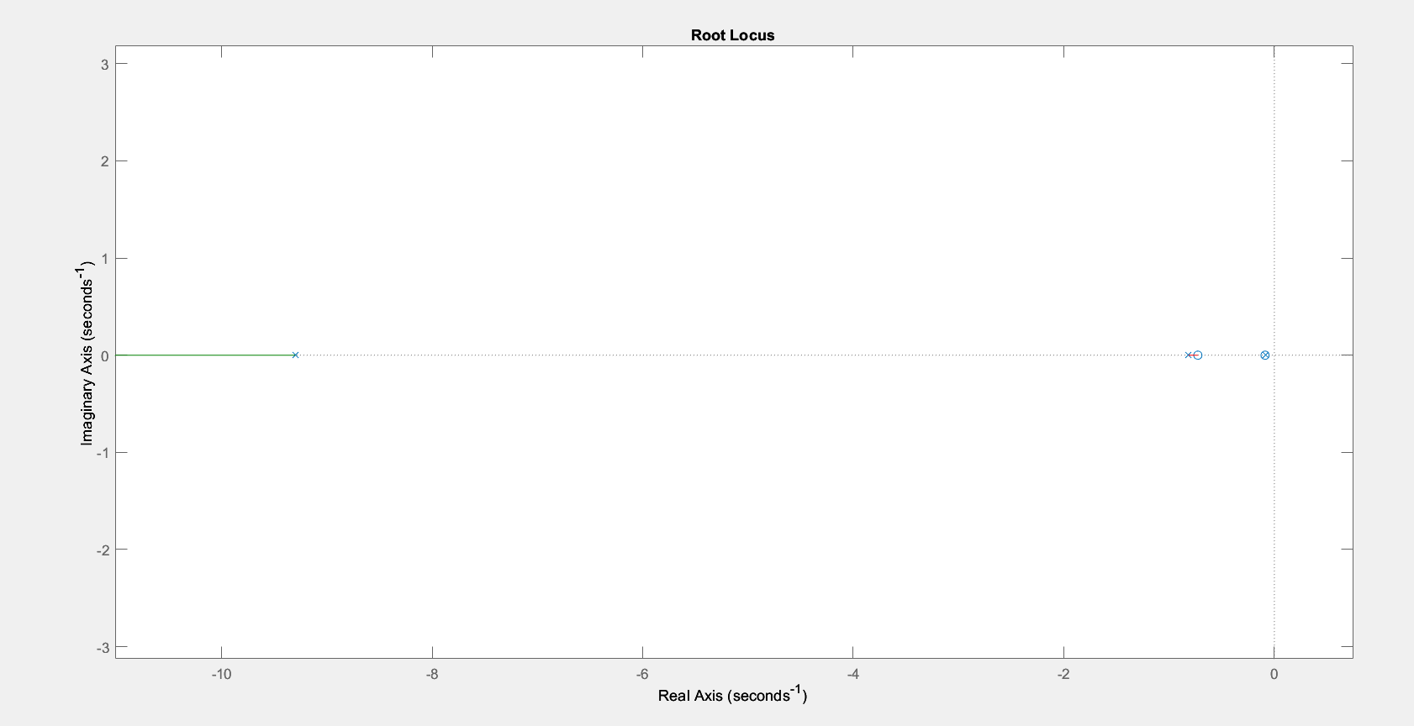
Figure 21 - Root locus table zoomed in view
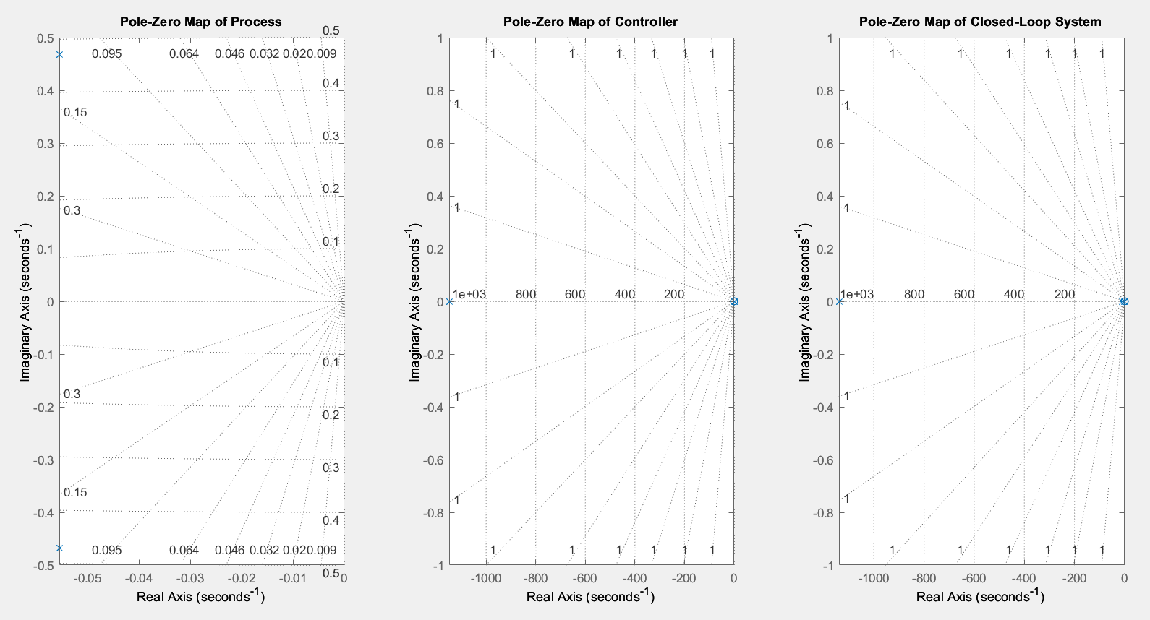
Figure 22 - Pole-Zero plots for the individual process transfer function (left), controller transfer function (middle), and the closed-loop system transfer function (right).
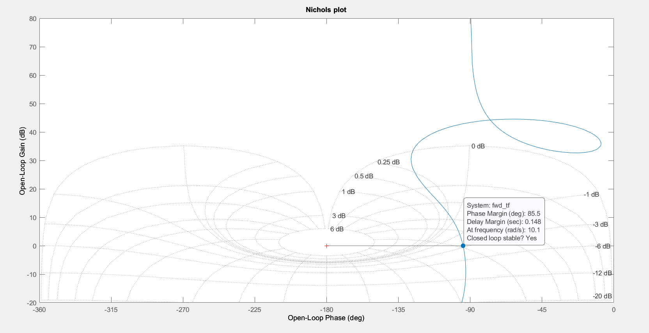
Figure 23 - Nichols plot of the forward transfer function

