Marketing Management : Assessment 2
Module Code: LCMB7001
Student Name: Sudhinrao Takkalapelly
Student id: 2105741
Lecturer Name: Tushara Balendran

Table of Contents
Introduction 3
PESTEL Analysis 3
Porters 5 Force Model 5
SWOT 6
Segmentation, Targeting & Positioning 7
Marketing Mix 9
Recommendations (Ansoff Matrix) 10
Conclusion 13
References 14

Introduction
The report is based on the marketing management of Unilever Plc, a multinational consumer goods company and its headquarter is in London, UK. The paper includes the external environmental factors which have influenced the marketing strategy of the company along with the internal factors, which play a role in implementing marketing strategy. The company has been evaluated based on the PESTEL analysis discussing the favorable and unfavorable aspects. In order to understand the environmental force which is more impactful to the company, the use of Porter 5 force models has been used. It also includes the SWOT analysis of the firm along with the evaluation on the other portions such as segmentation, targeting, and positioning of the company. The marketing mix also shows equal importance in providing the position of the company.

PESTEL Analysis
It is a strategical tool to analyze the macro environment of the company. The PESTEL of Unilever Plc can be understood with the factors given below:
Political- The international environment is peaceful and stable for the company, but in the UK, after Brexit, the development of the company is uncertain. The present free trade agreements are favorable for the company as no such restrictions have been imposed for the home-based company. The international patent law, along with worldwide law, has provided more opportunities for the company.
Economic- There was a downfall in the economy after the pandemic; the company itself has faced a decline of 1.6% after the outbreak of the virus. The company has still managed to reduce the negative impact with the help of good decision-making. The progress of Brexit has an impact on the profit of the company, with a drop of 21%; therefore, the economic system has an unfavorable impact on the company (Cheng, 2020).
Social- The standard of living has improved, and people are focusing more on hygienic products. Therefore the social factors are favorable for the company as they deal on the goods such as home care & personal care products and disinfectants both can meet the increasing demand of the people. The company's initiative during the pandemic has provided a positive influence on society.
Technological- The Company was highly embracing innovation and transformed them into digital platforms. They have started using artificial intelligence along with Human Resource specialists. It is favorable for the company as it has reduced the manual intervention and the accuracy of the data is high.
Environmental- The Company has also incorporated environment protection and sustainable development as their strategic approach for the firm. The company has introduced more approaches that include the development of ecosystem services and biodiversity. This is overall favorable for the company in the long run as well as for the environment.
Legal- The Company works on a dual-headed legal structure. This structure was not favorable in terms of the tea business. The legal framework of the company works of unification, due to which the sale in the UK showed no major changes. This shows that the legal structure is not fully favorable for the company (Unilever, 2021).
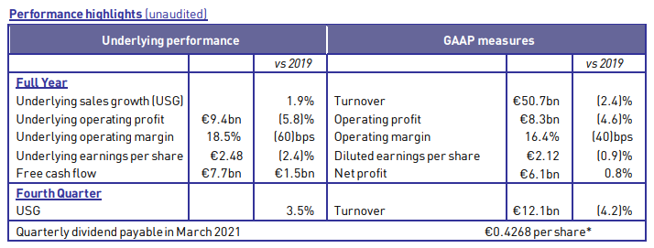
Figure 1: 2020 FULL YEAR RESULTS
Source: (Unilever plc, 2021)

Porters 5 Force Model
Bargaining power of buyers- The consumers of Unilever have high bargaining power and seek the minimum price, which acts more strain on the profitably of the firm. The customer's purchasing habit can be predicted on the given discounts or else offers.
Bargaining power of suppliers- Suppliers can be seen in the dominant position for the company, as they have the negotiating power to sell their raw material at higher prices with the firm. They can have an overall moderate impact on the firm.
Industrial rivalry- The Company is competitive in terms of personal care products. The rivalry may cause a steep fall in the price of goods and impact the firm's profitability.
The threat of substitution- It depends on the value proposition of the substitute, but for Unilever, the company itself provides various types of goods. Therefore there is a low threat of substitution.
The threat of new entrants- The existing product has more advantage more the new entrants, as the consumers have more information about the products sold in Unilever than the new seller.
Barraging power of buyers  high | Bargaining power of suppliers  medium
Industry rivalry
high
Threat of new entrant  low | Threat of substitution  low

SWOT
Strength- The Company’s stable finance and experienced leaders, are the main strength of the firm. They sell their product locally as well as in the international market. They have a diverse range of products with a lower price range and higher sales.
Opportunity- The internal environment within the UK is peaceful, and there has been an increase in the demand for consumer products as well as beauty products. The advancement in the technological aspect of the company has improved in providing customer services. Many local companies suffered due to pandemics; therefore, Unilever still has the chance to sustain itself in the market (Universitat Pompeu Fabra Barcelona, 2019).
Weakness- The company has a weak structure in terms of liquidity and the ability to meet its long-term debts. The company has failed in many acquisitions along with the rise in the entry of local companies. The lower price of the goods also encourages more competition.
Threats- The free trade agreement between the EU and The UK is uncertain after the Brexit. The global pandemic has caused more falls in the economy, and its re-entry into the globe is also uncertain. The changes in the international market can also be a great threat to the company.
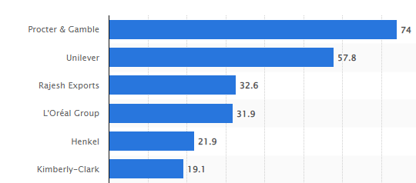
Figure 2: Sales of the leading household/personal care companies worldwide in 2020
Source: (Statista Research Department, 2021)

Segmentation, Targeting & Positioning
Segmentation- This concept divides the market into groups of distinct buyers. It can be seen that the company has focused on every section of the market. The buyers can be categorized in terms of gender, age, income, and personal needs. In terms of entry into the market, the company has always been flexible in implementing the strategy of domestic diversification. The company has more advantages due to its beauty products, as the different age groups of females invest more in their personal care, and now even men are also emphasizing more on personal care (Tien, 2020).
Targeting- The company's main target can be seen as female customers, as they are always attracted towards household goods and cosmetics. The given figure clearly shows the sale of personal care product is more in the market followed by the food and refreshments. Home care products also contribute to revenue generation. Since the major demand is for personal care products, the people belonging to the younger age, especially women, are more as compared to males.
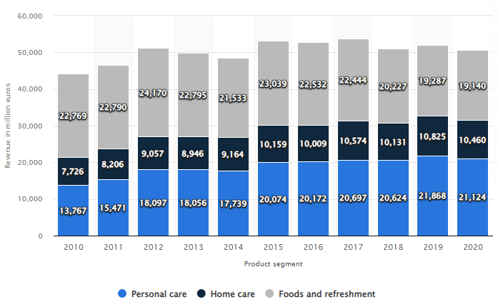
Figure 3: Global Revenue of the Unilever Group from 2010 to 2020
Source: (Statista, 2021)
Positioning- The products of the company have been able to meet the needs of the consumers. The company shifts its focus on the products according to the rising demand. Since there is a demand for cosmetics, they have invested in the acquisition of beauty products, but after the pandemic, the demand shifted more on hygiene and disinfectant, so the company focused more on such products. The company has been able to work flexibly as per the changing demand.

Marketing Mix
Marketing strategy of unilever analyses the brand with the marketing mix framework which covers the 4ps (product, price, place, promotion). The four Ps classification for developing an effective marketing strategy was first introduced in 1960 by marketing professor and author E. Jerome McCarthy.
Product- The Company provides a variety of goods containing over 400 brands. These products include personal care, beauty, disinfectant, household goods, food & beverages, and hygiene goods. They also include the selling of products belonging to different brands. The top brands in personal care include Dove, Rexona, and lifebuoy and in homecare Omo, Domestos and Cif are some leading in their sale (Reza, 2020).
Place- The products of Unilever are found in more than 190 countries. Apart from the UK, it has captured many international markets, such as it has stores in Eastern Europe, North America, South America, the Middle East, and the Asia Pacific. The company has many outlets in the major cities.
Promotion- The products can be purchased in a retail stores, malls, and online. Their products are advertised through various mediums such as TV ads, printed newspapers, and also in radios. The company has also promoted them on billboards around the UK. The digital platforms are more in use for promotions.
Price- The price range has been kept within a reasonable range, implementing the strategy of minimizing the input cost so that they can provide competitive prices for the consumers. However, the price of the product cannot always be kept low as it will have an impact on the firm's profitability.

Recommendations (Ansoff Matrix)
The common goal of the company to remain in the market with sustainable living has been able to keep hold of their suppliers, retailers, and consumers. The company has a long way to go if they can meet the demand of the consumers along with the positive impact on society. The company can also implement the Ansoff matrix to understand the situation of the market and prepare strategies that can help the firm to sustain itself in the market. The conservative environmental methods must be the main goal of the company. They must focus on reducing the use of plastics and other non-decomposable materials in their products, and both are harmful to society as well as the ecosystem (BS and Ambli, 2018). The company must also focus on using natural and organic material as the key ingredients in all the ranges of beauty products as nowadays people are shifting more towards natural and chemical-free products. The company must also focus on having people whose talent and skills will bring more innovation for the firm (Unilever, 2014). They must also focus on providing food items that provide positive nutrition to the consumers and are healthier. There are millions of people who are highly dependent on the company, as it is the only source of earning. It is the responsibility of the company to nurture them and educate them about their products so that they can also contribute to the growth of the company. The human resources of the company must also be taken care of when it comes to handling such a large multinational company. Their contribution helps in achieving the goal of the organization.
The company must also focus on spending more on the advertisement of the brands as well as keep updating the people with the introduction of new products in the market. They may also focus on the up-gradation of the store available in the market as the new ambiance in the market may attract more people. The company can also focus on optimizing its digital marketing. The world has already witnessed the ease of shopping from their home. The use of the internet has increased sharply after the pandemic, and the company can work on both online and offline marketing structures. The company must build a strong Research & Development program the company to keep its business strategy more innovative and updated. They may also work on the acquisition with the local brands to minimize their competitors (Zhang and Fan, 2020).
The company must also focus on improving the communication channel of the company so that it can help to work for the company goal in a team. The communication gap between the employees might give rise to conflict within the workplace, so to avoid such circumstances, they must build good communication. The company also works in the international market; therefore, it has become more important to understand the different cultural aspects. The employees working in the UK market also belong to a different region, so it is important to have a proper communication tool to be understandable for both entities. Working as a proper team can only be possible with the implementation of such effective communication (Onifade, Opele and Okafor, 2018).

Ansoff Matrix
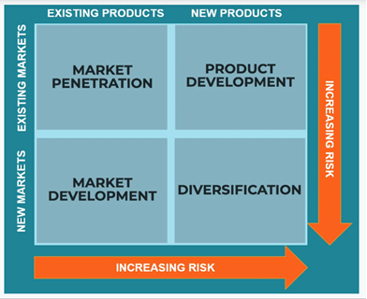
Figure 4: Ansoff Matrix
Source: (CFI, 2021)
The Ansoff matrix is a tool used to analyse and prepare strategy growth, and the matrix shows four sections of strategies that can help the firm to analyse the risk associated with different strategies and help the firm to grow using suitable strategies.
Market Penetration: The firm focus on implementing strategies that can help them to enter the market and increase their sale of existing goods, such as by selling at in cheaper rate or with the help of discount offers.
Product Development: The firm focus on introducing a new product in the market on the basis of the demand and, for example, introducing solar vehicles for hot places.
Market Development: The firms focus on the strategy to introduce their existing good in a new market. Such as selling UK based clothing in the US market.
Diversification: The strategy of the firm works on introducing a new product in a new market. Such as manufacturing of clothes by the company which manufacture paints.

Conclusion
The report has provided an overall assessment of how each segment of the market has been favorable and non-favorable for the company. It also provided information about each factor, such as the influence of the political force. The advancement in technology has helped the company to grow its market in a larger context. The company still has the opportunity to sustain itself in the market in the long run due to its concern about nature as well as they have invested more in-home care products and beauty products, which is increasing in demand. Even the figures show that Unilever plc is leading in the sale of household products.

References
B.S, V. and Ambli, S. (2018). Green HRM – An Innovative Approach to Environmental Sustainability. Green HRM – An Innovative Approach to Environmental Sustainability, [online] 8(01). Available at: https://ijemr.in/wp-content/uploads/2018/01/Green-HRM-An-Innovative-Approach-to-Environmental-Sustainability.pdf [Accessed 23 Dec. 2021].
CFI (2021). Ansoff Matrix - Overview, Strategies and Practical Examples. [online] Corporate Finance Institute. Available at: https://corporatefinanceinstitute.com/resources/knowledge/strategy/ansoff-matrix/ [Accessed 23 Dec. 2021].
Cheng, Y. (2020). Analysis on the Opportunities and Challenges of Unilever’s Differentiated Competition by Using SWOT and PEST. [online] Atlantis Press. Atlantis Press. Available at: https://www.atlantis-press.com/article/125952947.pdf [Accessed 23 Dec. 2021].
Onifade, T.A., Opele, A.M. and Okafor, L.I. (2018). COMMUNICATION: AN EFFECTIVE TOOL FOR EMPLOYEE PERFORMANCE IN UNILEVER NIGERIA PLC. [online] Academia. Available at: https://d1wqtxts1xzle7.cloudfront.net/60711679/Communication-An-Effective-Tool-for-Employee-Performance-in-Unilever-Nigeria-Plc20190926-35986-1168219-with-cover-page-v2.pdf?Expires=1640256472&Signature=P1m~I0iPFEBdUxKyeBaP3adM0WaCc3iSHTMqFf-gVYj65UqY3-IR3g2rbwaNVbU7ulJlYLGLOTPnuuCCXGXdA4K1fj6rnEk8KIODBEWAgXd90OlwpArs4s~Bn93CYU9vRibAZSbSHVXQrNZygt9pkQejG0-Tsm-3al6sL8OVnSg6FMVYzgk2-Gd3lgt8r6IeUwvnj1ksB2fchV9TBT6AvknkF2PHbXPgUEStGiTGd~IwwCBHaqILyxHsG2wyBvPO4QvI7fDvfU40cAmSm9JqnzmTxSGPXIjOKIdhfyKpkwE-Z9wj86Cz4wgUR3zeziOI2bUwFXy86uBOrrDeewrK4w__&Key-Pair-Id=APKAJLOHF5GGSLRBV4ZA [Accessed 23 Dec. 2021].
Reza, M.H. (2020). Marketing Strategy and Sustainable Plan of Unilever. [online] Researchgate. Available at: https://www.researchgate.net/publication/343539636_Marketing_Strategy_and_Sustainable_Plan_of_Unilever/link/5f2fec3a92851cd302ea6460/download [Accessed 23 Dec. 2021].
Statista (2021). Revenue of the Unilever Group worldwide 2005-2019, by product segment. [online] Statista. Available at: https://www.statista.com/statistics/269200/revenue-of-the-unilever-group-worldwide-by-product-segment/ [Accessed 23 Dec. 2021].
Statista Research Department, (2021). Sales of the leading household/personal care companies worldwide 2019. [online] Statista. Available at: https://www.statista.com/statistics/257973/sales-of-the-leading-household-personal-care-companies-worldwide/ [Accessed 23 Dec. 2021].
Tien, Dr.N.H. (2020). (PDF) Comparative analysis of multi-domestic strategy of P&G and Unilever Corporation. [online] ResearchGate. Available at: https://www.researchgate.net/publication/338719379_Comparative_analysis_of_multi-domestic_strategy_of_PG_and_Unilever_Corporation [Accessed 23 Dec. 2021].
Unilever (2014). ANNUAL REPORT AND ACCOUNTS 2014 STRATEGIC REPORT. [online] Unilever. Available at: https://assets.unilever.com/files/92ui5egz/production/39bbabc7955fe755dac8f5b0d4cbe674a2fcc340.pdf/ir-strategic-report-ar14.pdf [Accessed 23 Dec. 2021].
Unilever (2021). Unification of Unilever’s legal structure. [online] Unilever. Available at: https://www.unilever.com/news/press-and-media/press-releases/2020/unification-of-unilever-legal-structure/ [Accessed 23 Dec. 2021].
Unilever plc (2021). Annual Report and Accounts 2020 Highlights. [online] Unilever. Available at: https://www.unilever.com/investors/annual-report-and-accounts/ [Accessed 23 Dec. 2021].
Universitat Pompeu Fabra Barcelona (2019). CASE STUDY: UNILEVER1. [online] accid. Available at: https://accid.org/wp-content/uploads/2019/12/Unilever-cas-empresa.pdf [Accessed 23 Dec. 2021].
Marketing mix and strategies of Unilever. [online]. Available from: https://www.ukessays.com/essays/marketing/marketing-mix-and-strategies-of-unilever-marketing-essay.php?vref=1 [Accessed 23 Dec 2021].
Zhang, L. and Fan, Z. (2020). Analysis of Unilever’s Branding and Marketing Strategy in China. [online] Atlantis press. Available at: https://www.atlantis-press.com/article/125946177.pdf [Accessed 23 Dec. 2021].

