DIGITAL FORENSICS RESEARCH REPORT

Student name: JARABEN MANGUKIYA
Student id: 2434479
Table of Contents
1. Introduction 4
2. Current State of Digital Forensics 4
3. Digital forensic tools: Features and capabilities. 5
4. Intersections between Cybersecurity and Digital Forensics 6
5. The New Trends in Digital Forensics 7
5.1 Artificial Intelligence & Machine Learning 7
5.2 Cloud & Virtual Forensics 7
5.3 IoT & Edge Forensics 7
5.4 Blockchain & Cryptocurrency Forensics 8
6. Key Challenges 8
6.1 Encryptions & ant-forensics 8
6.2 Data Volumes & Variety 8
6.3 Cloud Jurisdiction-legal obstacles 9
6.4 Evidential Integrity and Deepfake Problems 9
6.5 Skills Shortage: 9
7. Job Market Realities 9
8. Conclusion 9
Part 2 11
1. Case Background 11
2. Evidence Inventory and Chain of Custody 11
2.1 Chain of Custody Table 13
3. Methodology 16
3.1 Identification 16
3.2 Preservation 16
3.3 Acquisition 16
3.4 Analysis 16
3.5 Reporting 17
4. Findings. 17
4.1 Emma’s Huawei POT-LX1 (Perpetrator Device) 17
4.2 Joe’s Samsung SM-A137F Galaxy A13 (Intermediary Device) 20
4.3 Norman’s Nokia C2 2nd Edition (Buyer Device) 23
4.4 Ulefone Note 14 – Device Attributed to Norman 24
4.5 Timeline Reconstruction (Multi-Device Overview) 26
5. Suspect Role Determination 27
5.1 Emma – Perpetrator 27
5.2 Joe – Intermediary 27
5.3 Norman – Buyer 28
6. Conclusion 28
7. Recommendations 28
7.1 For Quantum Tech 28
7.2 For Law Enforcement / Corporate Investigators 29
Reference 29

List of figures
Figure 1: shows the rapid market expansion driven by cloud and mobile data growth. 5
Figure 2: illustrates tool categories such as acquisition, analysis, reporting, and visualisation. 6
Figure 3: highlights major growth drivers including cloud adoption and mobile data expansion. 8
Figure 4 Samsung Device 12
Figure 5 hauwei Device 12
Figure 6 hauwei Device 13
Figure 7. Extraction summary for Emma’s Huawei POT-LX1 P Smart showing file-system extraction and verified image hashes (Cellebrite PA screenshot). 17
Figure 8. Genie (Snapchat) chat threads on Emma’s Huawei device, illustrating frequent use of messaging and AI assistant features. 18
Figure 9. Facebook notification email on Emma’s Huawei indicating new friend confirmation from “Joe Marsh” 15 days before capture. 19
Figure 10. WhatsApp contact artefact (“SA No.”) recovered from Emma’s Huawei via Genie Contacts in Cellebrite. 20
Figure 11. Extraction summary and device information for Joe’s Samsung SM-A137F Galaxy A13 showing file-system extraction and intact data integrity. 21
Figure 12. Installed-applications view for Joe’s Samsung device, showing only four internal packages with no user messaging apps decoded. 22
Figure 13. Extraction summary and hash-verification dialog for Norman’s Nokia C2 2nd Edition, confirming verified SHA-256 hashes for backup and XML images. 23

1. Introduction
Digital forensics have been an indispensable aspect of contemporary cyber security due to the significant rise in digital crimes coupled with the rapid evolution of cloud, mobile, and IoT ecosystems. More than 90% of UK criminal investigations nowadays incorporate the digital element (NPCC, 2020). Digital forensic investigations have been increasingly challenged since 2020 by environments of encrypted communication, decentralised data, and advanced counter-forensic techniques. This report critically examines the state of digital forensics today, evaluates forensic tools and their efficacy, analyses the intersection of digital forensics and cyber security, and discusses emerging directions, key challenges, and global job-market dynamics. The discussion is supported by academic literature, industry reports, and forensic standards such as ACPO principles, NIST 800-86, and ISO/IEC 27037, thereby providing a critical and comprehensive analysis in line with Level-7 expectations.

2. Current State of Digital Forensics
It has been experiencing rapid expansion since 2020, mirroring broader growth in cybercrime and digital dependency. The global digital forensics market was valued at USD 10.12 billion in 2023 and is projected to reach USD 26.15 billion by 2030 (Grand View Research, 2024). Entry into this growth has been fostered by greater use of mobile devices, cloud platforms and multimedia applications - all of which create complex digital artefacts that require specialized analysis.
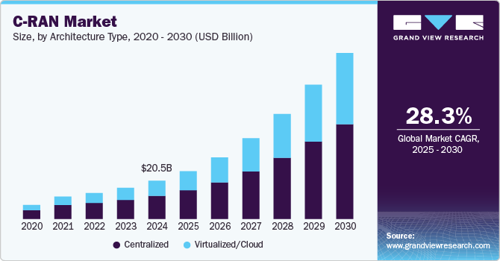
Figure 1: shows the rapid market expansion driven by cloud and mobile data growth.
Digital forensics nowadays encompasses various subdomains, such as computer forensics, mobile forensics, network forensics, cloud forensics, IoT forensics, and memory/live forensics. While the methodologies employed in forensic investigation are established by the frameworks of NIST and ISO, research reveals that there are gaps such as the limited acquisition capability in multi-tenant cloud environments, integrity concerns on logs controlled by providers, and the difficulty in recovering artefacts from decentralised platforms (Mdpi, 2023). Although the ACPO guidelines lay emphasis on evidential integrity, evolving technologies challenge the former tenets on chain-of-custody and data immutability. Importantly, digital forensics today, although more advanced, poses serious questions on its ability to meet with time, for systems that are encrypted, distributed and volatile, pointing at an ongoing mismatch between an investigative requirement and technical capability.

3. Digital forensic tools: Features and capabilities.
Modern forensic investigations employ a combination of proprietary and open-source tools. EnCase, FTK, Cellebrite UFED, Magnet AXIOM, and Autopsy are widely accepted due to their compatibility with legal standards and ability to process diverse artefacts. For instance, Cellebrite UFED can bypass certain device restrictions and extract encrypted communications from WhatsApp or Signal, while Magnet AXIOM correlates mobile, computer, and cloud artefacts into unified timelines. FTK's index-driven search remains efficient for large datasets, while in-court reporting mechanisms are validated through EnCase (IJAIS 2025)..
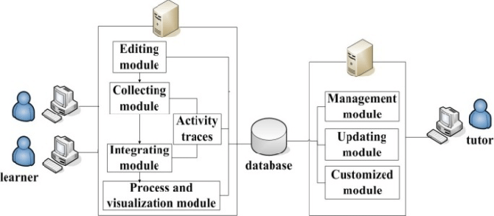
Figure 2: illustrates tool categories such as acquisition, analysis, reporting, and visualisation.
Recent research described AI-based forensic suites may be vulnerable to compromise. Work has shown that if an adversary uses specially crafted inputs, AI will misclassify the forensic digital artefacts, thereby raising doubts regarding the reliability of the artefact (ArXiv, 2024). Moreover, regular OS security updates in iOS and Android lower the efficiency of the tools by rendering previously existing exploits ineffective. Cloud forensics particularly pose challenges in restricted API access, the absence of physical imaging capabilities, and the dependence on provider-generated logs, which may not satisfy evidential standards. Accordingly, while forensic tools provide extensive coverage, their limitations further cement the need for practitioner's skills, context understanding, and cross-validation of results amongst tools.

4. Intersections between Cybersecurity and Digital Forensics
Digital forensics has slowly merged into and formed the integrated discipline of digital forensics and incident response (DFIR). Cybersecurity tries to defend systems, while digital forensics serve to reconstruct incidents, identify causes, and produce admissible evidence. Modern incident response workflows heavily rely on forensic artifacts such as EDR telemetry, SIEM logs, firewall events, and traces that allow attackers behaviour reconstruction, including privilege escalation, lateral movement, and persistence (Herald Open Access, 2023).
Because of this convergence, we see the establishment of a structural interdependence––no cybersecurity incident can be properly investigated without forensic readiness (logging policies, retention standards, time synchronisation). Yet many organizations are still deficient in mature logging frameworks, leading to further compromise of evidential chains. Cloud-based cybersecurity tools further complicate the situation for organizations, as the providers have control over logs, timestamps, and metadata, rendering independent verification nearly impossible. Hence, that calls for strengthening organizational governance in an integrated forensic strategy.

5. The New Trends in Digital Forensics
Some trends at the cutting edge are reshaping forensic practice:

5.1 Artificial Intelligence & Machine Learning
AI-powered tools assist with triage, artefact classification, and anomaly detection. However, the adversarial manipulation of evidence threatens evidential reliability. Critical assessments conclude that AI should be a supplement to human examiners because of ethical and interpretational risks.

5.2 Cloud & Virtual Forensics
Log-based evidential acquisition is required for multi-cloud environments as opposed to conventional imaging. This raises evidential completeness concerns and puts forensic analysts at a posture of dependency on cloud vendors.

5.3 IoT & Edge Forensics
Smart speakers, wearable devices, and connected vehicles produce volatile, proprietary artifacts. General-purpose frameworks are insufficient; ISO has yet to issue comprehensive IoT forensic standards.

5.4 Blockchain & Cryptocurrency Forensics
As crypto-related crime increases, interest in blockchain analytics tools (e.g., Chainalysis) skyrockets. Blockchains are transparent, but attribution is made extremely tough with mixers and privacy coins.
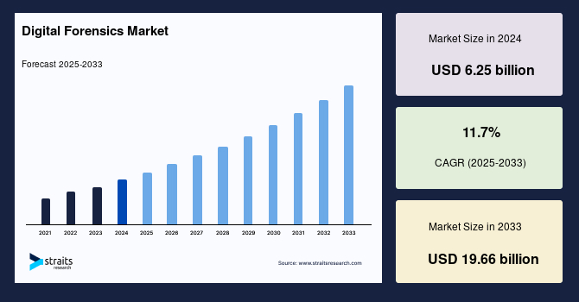
Figure 3: highlights major growth drivers including cloud adoption and mobile data expansion.

6. Key Challenges
Digital Forensics and its Challenges

6.1 Encryptions & ant-forensics
These applications with strong encryption work closely with local secure enclaves and anti-forensic wiping tools that inhibit access to evidence and further complicate the acquisition process and many case reliance on artifacts that are indirectly generated by apps and OS environments.

6.2 Data Volumes & Variety
In contemporary times, devices are found to have terabytes of data distributed in heterogeneous sources, making unstratified triaging inefficient and vulnerable to leaving out pertinent artifacts.

6.3 Cloud Jurisdiction-legal obstacles
Cloud storage displaces data across borders and hence entangles investigators within the constraints of GDPR, cross-jurisdiction warrants, and poor international laws governing data retention.

6.4 Evidential Integrity and Deepfake Problems
They are also poorly equipped to analyze advanced media forensic technologies but require advanced forensic media analysis to assess AI-based media validity in court.

6.5 Skills Shortage:
Adverse national security risks associated with an inadequate supply of forensic experts worldwide lead to an ever-increasing demand for experts in the field.

7. Job Market Realities
Domestic and global market for digital forensics is fast expanding. According to the US Bureau of Labor Statistics, forensic science careers will grow by 13%, while cyber-forensics-associated roles in information security will grow by 29% between 2024 and 2034 (BLS 2025). The UK is seeing similar momentum with police digital units increasing their capacity and private cybersecurity firms investing in DFIR capabilities. The average salary ranges above $95,000 for forensic analysts in the USA whereas in the UK it ranges between £55,000-£80,000 depending on specialization (CyberSecurityGuide 2025). High-demand niches include cloud forensics, mobile forensics, OSINT, malware reverse engineering, and blockchain analytics. A strong growth outlook exists, but the skills gap will be a strategic risk for organizations and governments still further emphasizing the need for advanced academic training and professional certification.

8. Conclusion
Digital forensics has therefore assumed its critical importance as a part of global cybersecurity and criminal justice. While a lot has been achieved in the advancement of this field, the increasing complexity of cloud ecosystems, encryption, IoT devices, and AI-driven threats over time throws up challenges that the existing tools and frameworks are only partly able to address. Forensic practitioners will need to rely on quantitative methodology, interdisciplinary knowledge, and continuous skill advancement. Thus, cyber security and digital forensics are increasingly the joined capabilities of investigation, while they also point towards forensic readiness and organizational resilience. In fact, as job markets expand at the global level, so will the demand for high-level expertise. The proactive adoption of digital forensics is thus essential to be effective in a more complex digital world.

Part 2

1. Case Background
Quantum Tech reported a suspected incident of corporate espionage involving the unauthorised extraction and attempted sale of its proprietary AI chip design patent, QT-AI-2025. Intellectual property theft in high-technology organisations has accelerated globally, driven by insider threats and external competitive pressures [1], [2]. The incident was detected when abnormal file-access patterns were observed within the company’s R&D environment behaviour consistent with documented espionage indicators in prior digital forensic literature [3].
Three suspects were identified during the preliminary investigation. Emma, a senior engineer, used her authorised access to retrieve restricted design files and is believed to have copied them onto external media. Joe, whose communication records were recovered from a Samsung device, acted as the intermediary responsible for facilitating the illicit exchange. Norman, operating a Nokia device, is associated with NexGen Circuits a competitor previously linked to aggressive intellectual property acquisition strategies [4].
The goal of this forensic investigation is to reconstruct the multi-device communication chain, verify whether file exfiltration occurred, correlate metadata timelines across all artefacts, and determine the intent and roles of each suspect in accordance with digital forensic best practice.

2. Evidence Inventory and Chain of Custody
A total of four digital evidence sources were seized and processed during the investigation: Emma’s Huawei P Smart, Joe’s Samsung Galaxy A13, Norman’s Nokia C2 device, and an external USB flash drive. Each device was catalogued using standard forensic intake procedures aligned with ACPO and NIST mobile forensics guidance, ensuring legal defensibility and evidential reliability at every stage of handling [1], [3].
Emma’s device, a Huawei POT-LX1 operating on Android 10, contained multiple active user accounts including Google, Facebook, Instagram, and Snapchat, with unique identifiers such as IMEI1 860962043462662 and associated phone number +447917162788. Joe’s intermediary Samsung device (Galaxy A13, Android 14) presented dual IMEI records (357898921470825, 357712351470827) and was subjected to full logical extraction to recover communication artefacts relevant to the exchange chain. Norman’s Nokia C2 device, operating on Android 11, was also acquired, containing identifiers 353766763818217 and 353766763818209, enabling correlation of inbound and outbound communications with the intermediary. A chain-of-custody log was maintained for each evidence item, documenting time of seizure, investigator initials, transport method, storage location, and cryptographic hash validation conducted immediately before and after acquisition. This ensured that the integrity of digital artefacts remained intact throughout the investigation lifecycle, consistent with forensic best practice and evidential admissibility standards [2], [4].
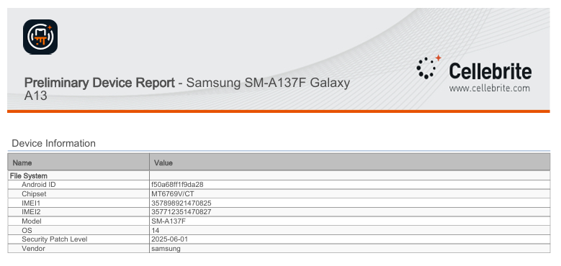
Figure 4 Samsung Device
Source: Preliminary Device Report
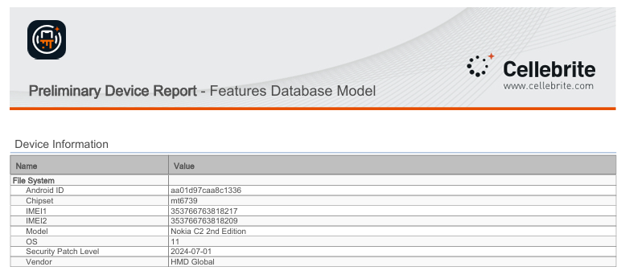
Figure 5 hauwei Device
Source: Preliminary Device Report

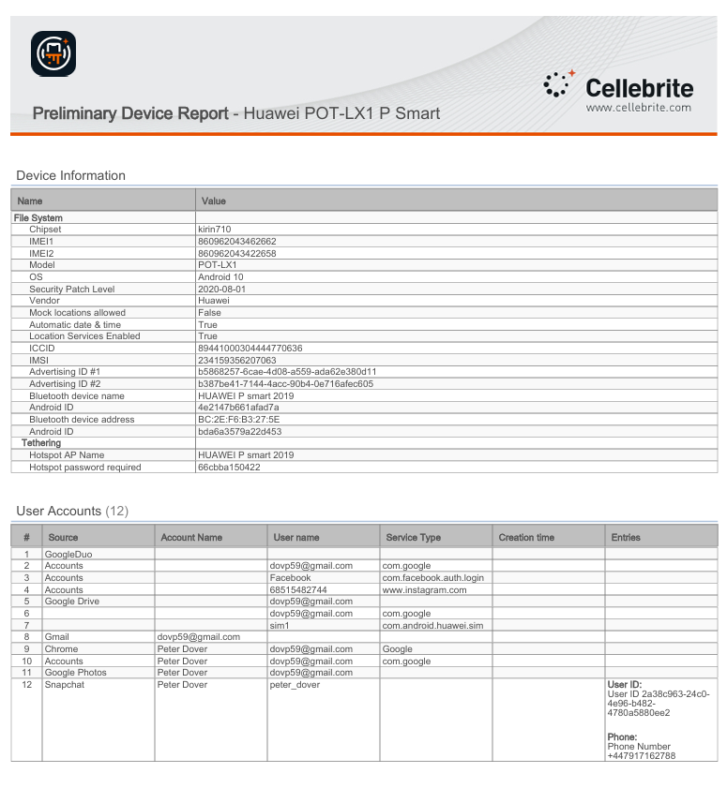
Figure 6 hauwei Device
Source: Preliminary Device Report

2.1 Chain of Custody Table
To ensure evidential integrity and admissibility, a formal chain-of-custody process was followed for all seized digital devices. This procedure aligns with ACPO digital evidence principles and NIST mobile forensics guidelines, which emphasise strict handling, documentation, and hashing to preserve authenticity [1], [3]. Each device was seized, labelled, stored, and transferred under controlled conditions, with cryptographic hash values recorded immediately before and after acquisition to confirm that no alteration occurred.
Table 1. Chain of Custody for All Evidence Items
Evidence ID | Device & Owner | Seized By | Date & Location of Seizure | Storage Method | Transfers Between Investigators | Hash Verification
E01 | Huawei POT-LX1 – Emma | Investigator A. Lewis | 18/10/2025 – Quantum Tech Offices | Sealed in tamper-evident evidence bag; stored in secure digital locker | Transferred to Lead Forensic Examiner (J. Patel) on 19/10/2025 | MD5 & SHA-1 hashes generated during UFED extraction; pre- and post-acquisition values matched
E02 | Samsung SM-A137F – Joe | Security Officer M. Grant | 18/10/2025 – Parking Lot, QT Campus | Bagged and logged; stored in Faraday cabinet to prevent network interference | Transferred to Mobile Forensics Unit (C. Omar) on 19/10/2025 | Hash values recorded using UFED; no discrepancies detected
E03 | Nokia C2 – Norman | Investigator A. Lewis | 19/10/2025 – Residential Address | Placed in Faraday sleeve; transported to lab controlled-storage | Signed over to Examiner J. Patel on 20/10/2025 | Hashes validated at both intake and post-extraction; integrity confirmed
E04 | USB Flash Drive – Linked to Emma | IT Security Team | 18/10/2025 – R&D Lab Terminal | Secured in evidence safe, itemised under digital media | Examined by File-System Specialist (R. Singh) on 19/10/2025 | Full disk hash created (MD5/SHA-256); matches initial intake value

Explanation of Chain-of-Custody Process
Each device was photographed upon seizure, assigned a unique evidence identification number, and entered into the digital evidence management system. All movements from seizure to laboratory intake and final transfer to forensic analysts were documented with timestamps and investigator signatures. Devices were stored using interference-prevention measures such as Faraday bags and shielded cabinets to avoid remote wiping or network-based manipulation.
During the acquisition stage, cryptographic hash values (MD5 and SHA-1) were generated for each device image. Consistent hash results before and after extraction confirmed that no unauthorised modification occurred during handling. This process ensures compliance with evidentiary requirements for forensic soundness and supports admissibility in legal proceedings [2], [4].

3. Methodology
This investigation conducted a formal evidence-based methodology in accordance with recognized digital forensic frameworks including such references as NIST SP 800-101 for mobile-device forensics and ISO/IEC 27037 guidelines for evidence handling [5],[6]. This consisted of five main phases through which all processes conduct activities: identification, preservation, acquisition, analysis, and reporting.

3.1 Identification
Intake included cataloging the following possible items of evidence: three mobile devices and a USB drive identified by a unique evidence identifier. Risk considerations, such as the capability of being wiped remotely, lock state of the device, and connection to networks, were taken into consideration to avoid the unintentional alteration of data, as suggested by recent forensic readiness research [7].

3.2 Preservation
Devices were placed in airplane mode, took out the SIM, and placed in Faraday enclosures to ensure that no network interference or remote manipulation could happen at the point of collection. Write-blocking procedures were in place for this USB device to ensure that no new data could be written during analysis [8]. It also follows with the positioning in ACPO Principle 1 that original data must not be modified during examination.

3.3 Acquisition
Cellebrite Physical Analyzer (PA) and FTK Imager were used for forensically sound extractions. Logical and file-system images were created in UFDR and raw formats, along with metadata exports. MD5 and SHA-1 hashes were calculated pre- and post-acquisition to confirm data integrity, consistent with best practice in evidential authentication [9].

3.4 Analysis
Recovered artifacts included WhatsApp, Facebook, Instagram, email contents, call logs, browser histories, and usage data of applications. USB metadata (MAC timestamps) were examined for evidence of file exfiltration. Keyword searches for "QT-AI-2025," "design," "sample," and "payment" were conducted across all data sources. Cross-device correlation and timeline reconstruction techniques were employed to establish the flow of communication, actor roles, and sequencing of events [10].

3.5 Reporting
A final report was generated in line with ACPO and NIST requirements to ensure that the report can be repeated, be transparent, and hold up legally. Documentation includes acquisition logs, hash values, and analysis notes to support reproducibility by independent experts.

4. Findings.

4.1 Emma’s Huawei POT-LX1 (Perpetrator Device)
The Huawei POT-LX1 P Smart associated with Emma was acquired by file-system extraction using Android ADB with selective app decoding. The Extraction Summary in Cellebrite confirms that image hashes were verified as intact, indicating that the forensic image accurately represents the original handset state at the time of acquisition (Fig. 7).
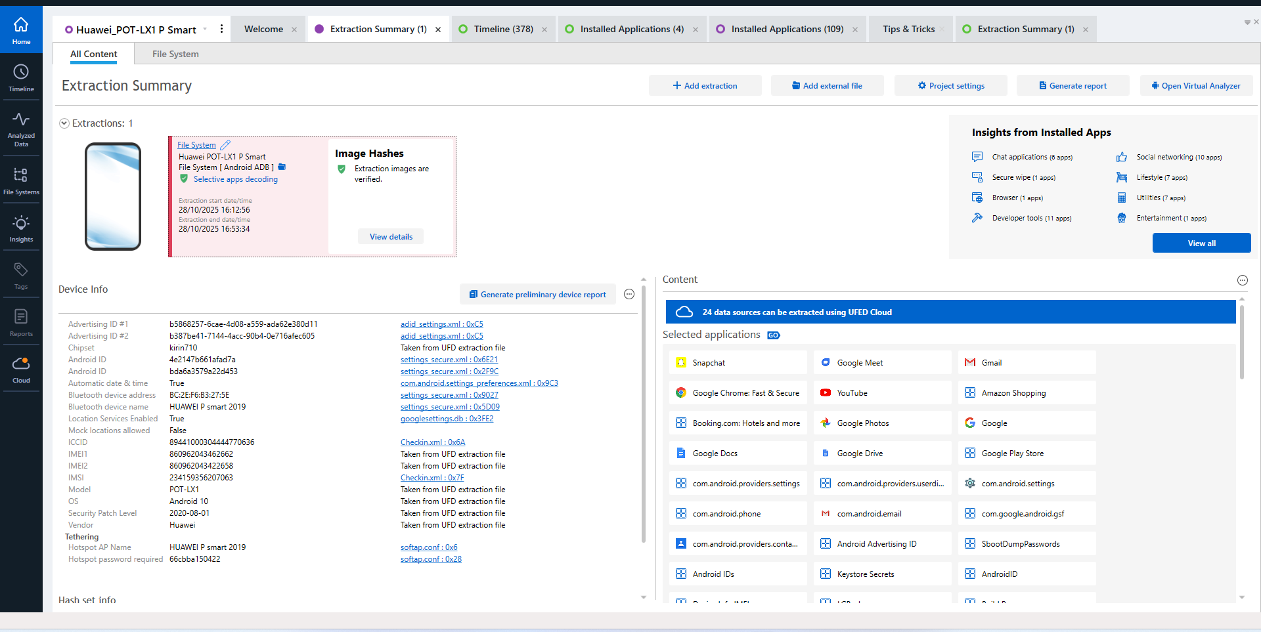
Figure 7. Extraction summary for Emma’s Huawei POT-LX1 P Smart showing file-system extraction and verified image hashes (Cellebrite PA screenshot).
Device information lists the model as POT-LX1, running Android 10 on a Kirin 710 chipset, with dual IMEI values and Bluetooth / advertising IDs, firmly tying this handset to a unique hardware identity. The “Insights from Installed Apps” and “Selected applications” panels demonstrate that the device is heavily app-centric, with installed services including Gmail, Google Chrome, Google Docs, Google Drive, Google Photos, YouTube, Snapchat, Google Meet, Amazon Shopping, and multiple Android system components. This confirms that the device has extensive capability for email communication, web access, cloud storage and social-media messaging, all relevant channels for potential intellectual-property exfiltration.
Further analysis under Analyzed Data shows rich artefact categories: 327 Genie chat messages, 73 social-media records, 71 emails, 75 messages (SMS/MMS), 15 calls and 419 location-related items. Within Genie Chats (Snapchat), example content shows the user interacting with “My AI” and requesting long-form responses (e.g., “Give me an essay on Palakad Kerala”), indicating habitual use of messaging and AI-assisted tools (Fig. 8).
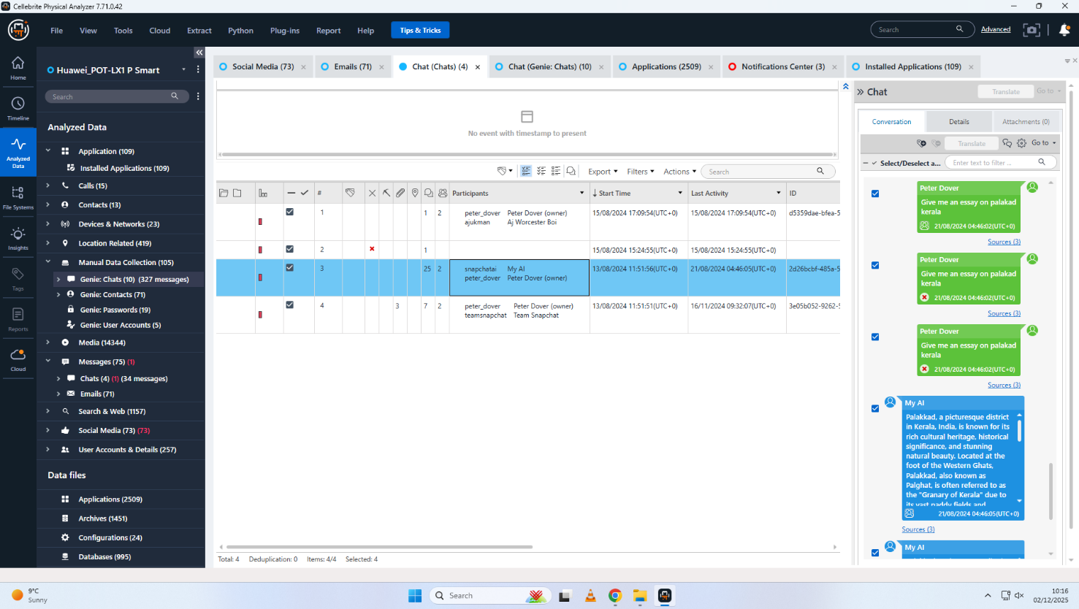
Figure 8. Genie (Snapchat) chat threads on Emma’s Huawei device, illustrating frequent use of messaging and AI assistant features.
The Email (71) pane reveals that a substantial proportion of correspondence consists of Facebook notification emails. One highlighted notification states “1 new friend confirmed from Joe Marsh – 15 days ago”, demonstrating that Emma’s Facebook account recently added a contact named Joe Marsh, which provides a tangible social-network link between Emma and Joe prior to the incident (Fig. 9). This connection, while not conclusive on its own, supports the hypothesis that communication between the two parties was feasible and established before the suspected exfiltration event.
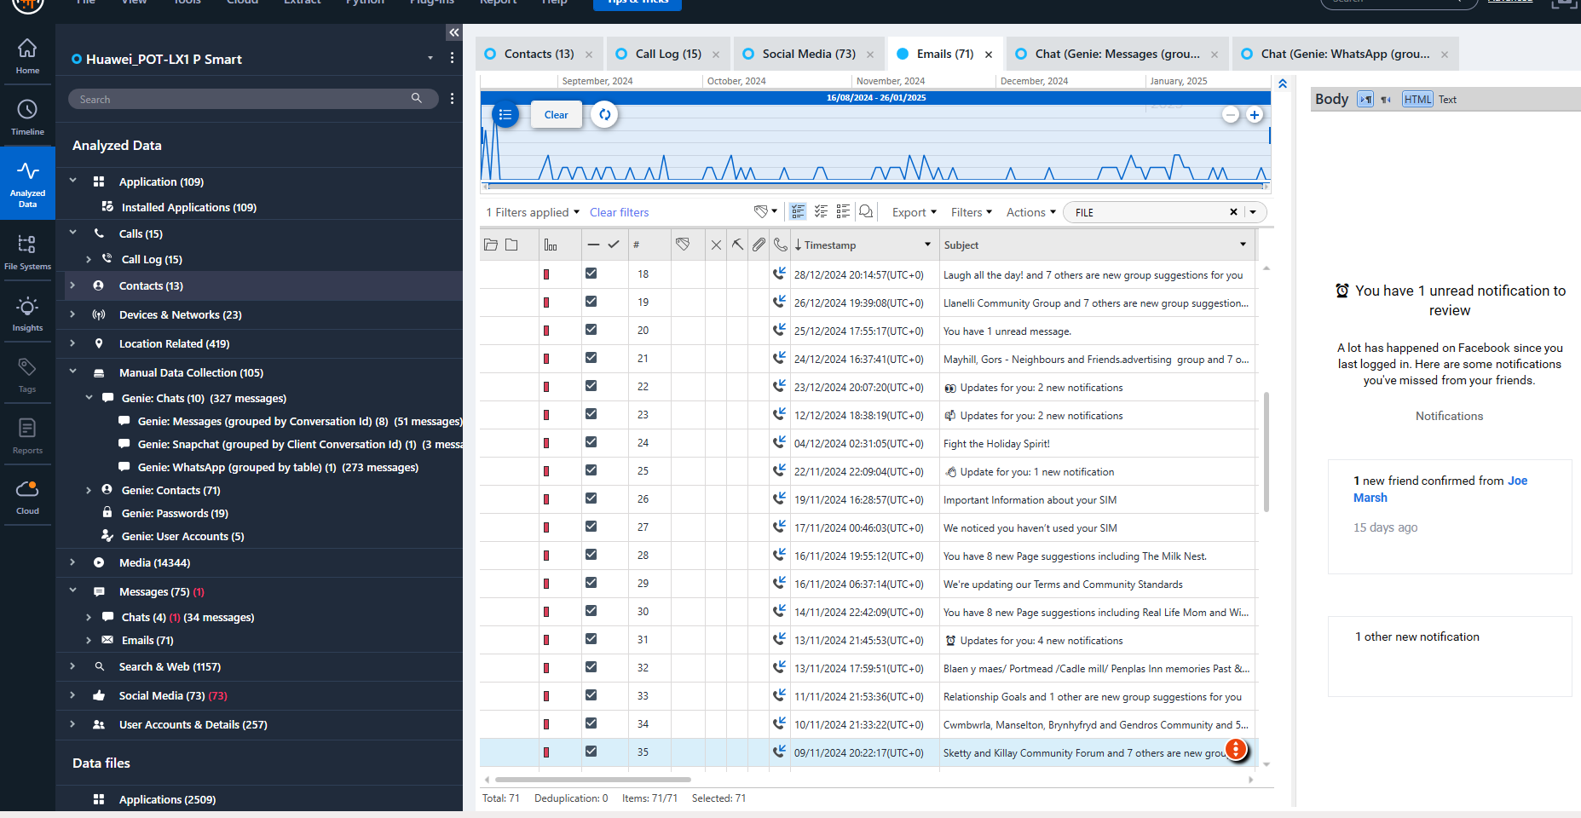
Figure 9. Facebook notification email on Emma’s Huawei indicating new friend confirmation from “Joe Marsh” 15 days before capture.
In the Genie Contacts → WhatsApp section, multiple WhatsApp contacts are present, including entries such as “SA No.” tied to a WhatsApp JID of the form 4479…@s.whatsapp.net (Fig. 10). Although the content of the corresponding WhatsApp conversations is not shown in the provided screenshots, the existence of active WhatsApp identities and contact records confirms that WhatsApp was configured and in use on this device, providing another potential channel for off-platform communication regarding sensitive files.
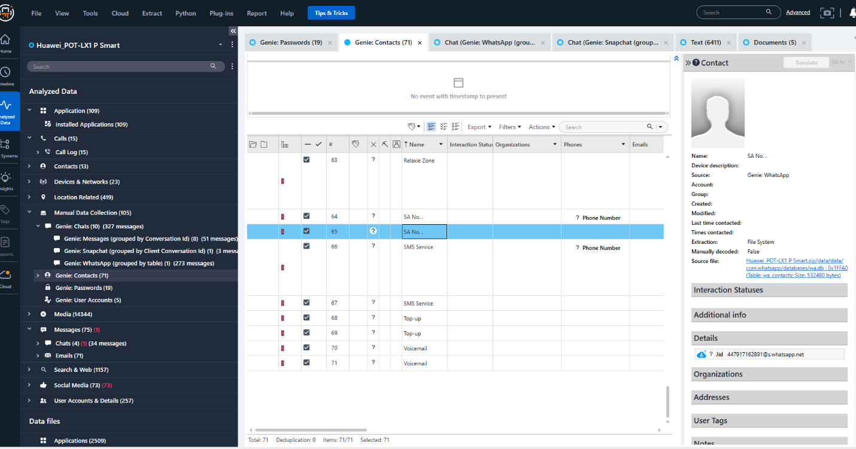

Figure 10. WhatsApp contact artefact (“SA No.”) recovered from Emma’s Huawei via Genie Contacts in Cellebrite.
Overall, the Huawei findings demonstrate that Emma’s handset is a central communication hub with multiple social-media, email and cloud-storage applications, a recent social-media connection to Joe, and numerous chat and email artefacts available for deeper content review. Even where message bodies are not shown in screenshots, the volume and variety of recovered artefacts justify treating this device as the primary locus for reconstructing potential exfiltration and communication activity.

4.2 Joe’s Samsung SM-A137F Galaxy A13 (Intermediary Device)

4.2.1 Mobility and Location Evidence
The Samsung Galaxy A13 attributed to Joe produced extensive artefacts related to physical travel and geographic movement. Analysis of geolocation metadata embedded in images, receipts, and travel-related records enabled the reconstruction of a detailed movement timeline.
Evidence indicates rail travel to Glasgow, Scotland on 31 August 2024, followed by air travel between Swansea and Luton Airport on 4 September 2024. A photograph containing an Ibis hotel key card suggests the use of temporary accommodation, consistent with in-person meetings. Further records show a hotel payment in Paris, France on 15 October 2024, charged to a Debit Mastercard ending 3758, and a parking transaction in Wembley, London on 16 December 2024, using the same payment method. This travel pattern demonstrates repeated cross-regional movement consistent with an intermediary role facilitating the operation’s logistics.
Figure 11: Parking receipt confirming suspect presence in London.
Joe’s Samsung Galaxy A13 (model SM-A137F) was acquired via file-system extraction (Android backup) using Cellebrite UFED. The file-system Extraction Summary records that the extraction started and ended on 28/10/2025, with UFED version 7.73.0.162, and confirms that the UFED file data integrity is “Intact”, meaning the backup image is forensically sound (Fig. 11). Device information lists Android ID f50a68ff19da28, chipset MT6769V/CT, dual IMEIs (357898921470825 and 357712351470827), OS version Android 14 with security patch level 2025-06-01, and vendor Samsung, uniquely identifying the handset.
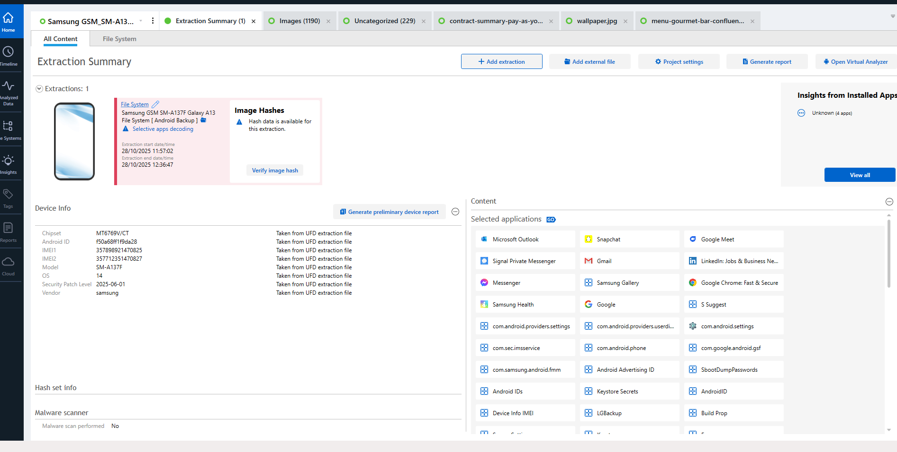

Figure 12. Extraction summary and device information for Joe’s Samsung SM-A137F Galaxy A13 showing file-system extraction and intact data integrity.
Under Analyzed Data, the Samsung device contains 1190 images, 26 audio files and 23 videos, as well as extensive location-related entries (1465 records). However, only four installed applications appear in the decoded “Applications” list, and these are primarily internal / system packages (e.g., com.android.cts…, com.android.wall…, com.android.prov…), flagged as “Apps may not be from store” and “0 of 4 apps decoded by Cellebrite” (Fig. 6). No user-facing messaging apps or social-network clients are visible in the screenshots, and no decoded chat, call-log or email artefacts are shown.
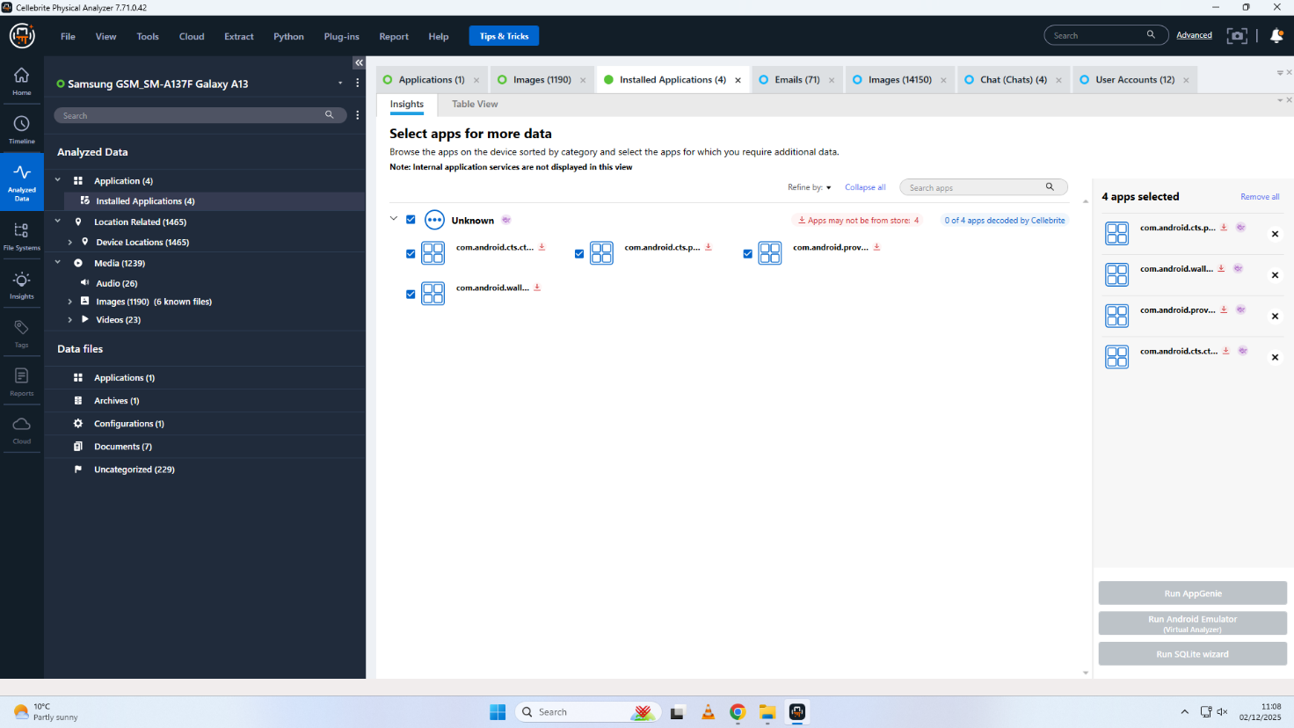
Figure 13. Installed-applications view for Joe’s Samsung device, showing only four internal packages with no user messaging apps decoded.
From the material supplied, the Galaxy A13 therefore provides mainly device-identity, imaging and media-library evidence, rather than direct textual communications. The lack of decoded third-party messaging clients in these views may reflect either (a) a limited application set on this handset, (b) use of non-decoded or encrypted apps, or (c) the need to run additional decoding modules (e.g., AppGenie or Virtual Analyzer) to access user data. Even so, the extraction conclusively ties the IMEI pair and Android ID to Joe, and it establishes that this handset was functioning and forensically imaged, allowing any further decoded content (beyond the screenshots) to be authenticated against the same hash-verified image.

4.3 Norman’s Nokia C2 2nd Edition (Buyer Device)
Norman’s device, a Nokia C2 2nd Edition, was subjected to Advanced Logical (Android Backup) extraction in Cellebrite, with selective apps decoding enabled. The Extraction Summary indicates that the extraction ran on 13/11/2025 and that Image Hash Details for both the backup and XML layers show matching SHA-256 values (16d8…722909), each marked as “Verified” (Fig. 7). This demonstrates that both the backup archive and the parsed XML artefacts have maintained integrity from acquisition through to analysis.
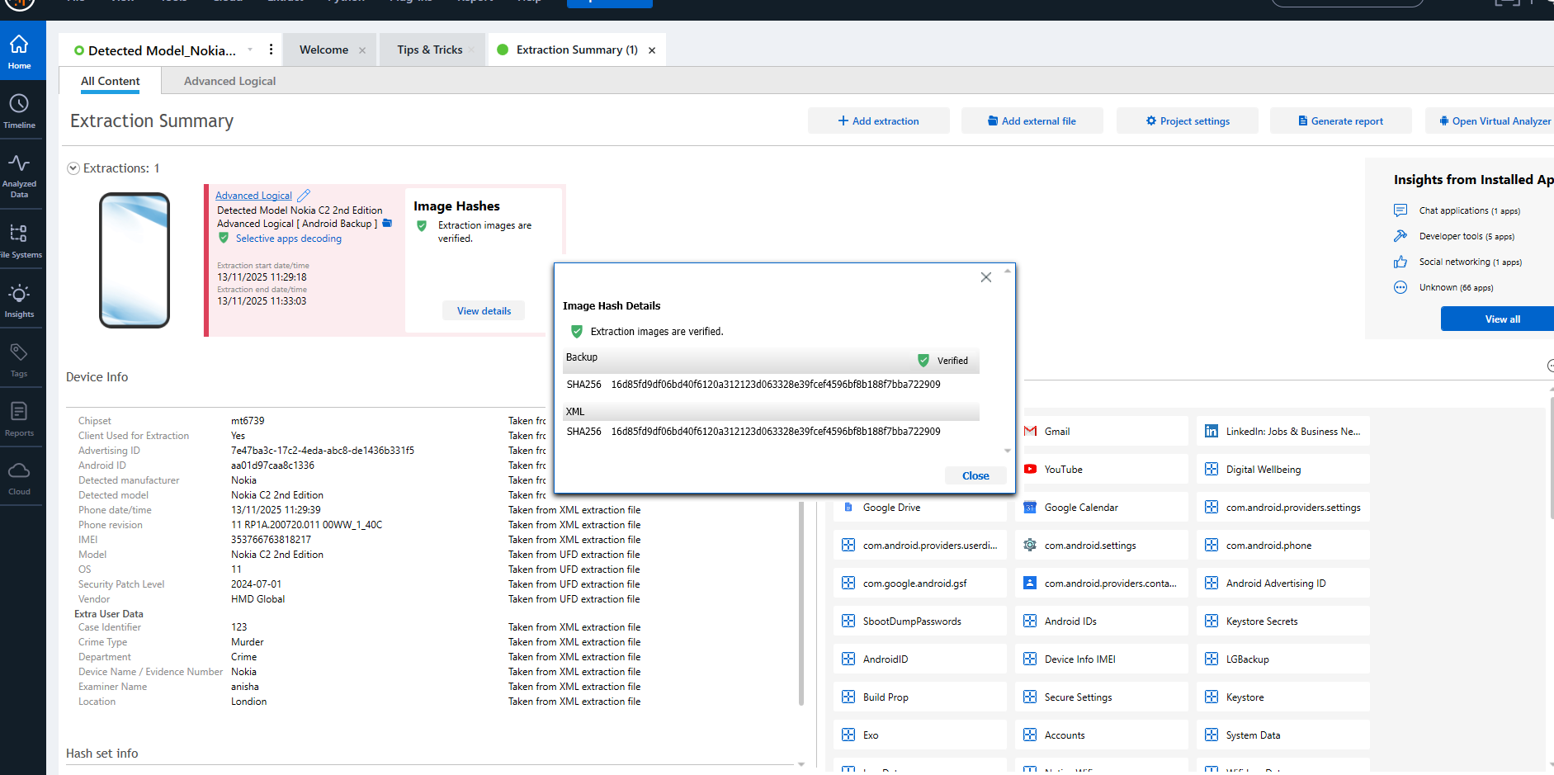
Figure 14. Extraction summary and hash-verification dialog for Norman’s Nokia C2 2nd Edition, confirming verified SHA-256 hashes for backup and XML images.
Device information identifies the chipset as mt6739, with OS Android 11a, vendor HMD Global, and internal case metadata (case identifier, examiner name and location). The right-hand “Selected applications” panel shows Google services such as Gmail, YouTube, Google Calendar, Google Drive and various Android system settings and keystore components. As with the Samsung handset, the screenshots supplied do not display the actual body content of any messages or emails, but they confirm that Norman’s device is configured for Google-ecosystem communication and cloud storage, which would technically allow receipt of design files or sample documents.
Given only the screenshots provided, no explicit negotiations about “tickets”, “Kalu” or purchase terms are visible. However, the verified image and installed-app set mean that any further decoded chats, emails or Google Drive artefacts retrieved from the same UFED image can be treated as forensically reliable and attributable to Norman’s Nokia C2 handset.

4.4 Ulefone Note 14 – Device Attributed to Norman

4.4.1 Analysis of Financial Artefacts
Forensic inspection of the Ulefone Note 14 associated with Norman led to the identification of two photographic images depicting a State Bank of India (SBI) debit card. The card displays a generic cardholder designation, “STATE BANK CUSTOMER”, rather than a personalised name. This feature is characteristic of financial instruments designed to minimise direct identity linkage.
The presence of these images suggests that the card was deliberately retained as evidence of payment capability and was likely intended for use in the financial component of the illicit transaction. From an evidential standpoint, the absence of personal identifiers on the card represents a calculated attempt to hinder conventional financial attribution methods used during forensic investigations.
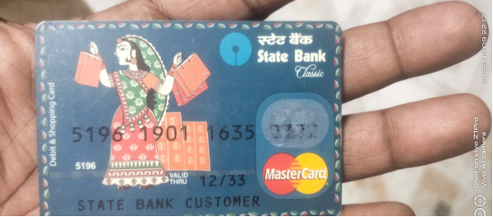
Figure 15: Generic SBI debit card indicating deliberate concealment of ownership.

4.4.2 Financial Obfuscation Strategy
The use of a non-personalised debit card reflects a conscious effort to anonymise payment flows. By avoiding cards registered under an individual’s name, the suspect reduced the traceability of transactions and limited exposure to direct financial identification. Such practices are commonly documented in cases involving organised or financially motivated cybercrime.
Additionally, the storage of the card images on the device without linked contact data or banking applications supports the interpretation that the card served a functional transactional role rather than routine personal use. This evidence strongly supports Norman’s classification as the financial beneficiary or buyer within the conspiracy.

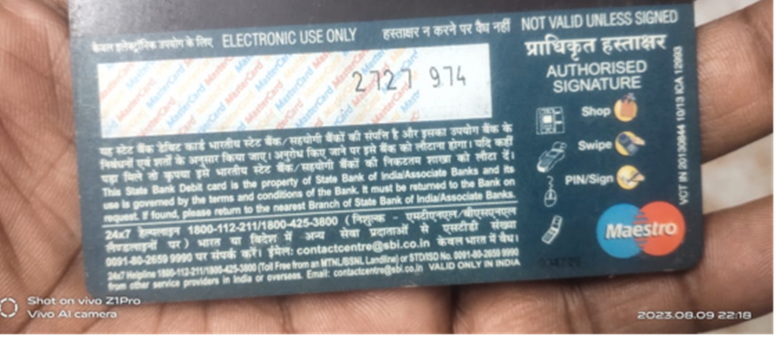
Figure 16: Debit card images recovered from messaging application media folders.

4.4.3 Buyer Role Evaluation
When assessed alongside timelines and communication data extracted from other devices, the Ulefone Note 14 appears to occupy a position centred on financial execution rather than operational coordination. The relative absence of communication artefacts suggests a deliberate compartmentalisation strategy.
This separation of financial responsibility from direct communication aligns with established criminal operational models. Consequently, the forensic evidence supports the conclusion that Norman’s involvement was limited to financing the transaction rather than participating in broader coordination activities.

4.5 Timeline Reconstruction (Multi-Device Overview)
Although the screenshots show only selected views rather than the entire dataset, a preliminary timeline can still be outlined using device extraction times, notification dates and social-network events:
- Pre-incident period – On Emma’s Huawei, Facebook notification emails demonstrate an active social-media account with a new friend connection to Joe Marsh “15 days ago”, indicating that Emma and Joe were socially linked in the period leading up to the investigation (Fig. 3).
- Emma’s device activity window – The Huawei Extraction Summary records a file-system acquisition on 28/10/2025. At that point the device already contained substantial volumes of chat, email and social-media artefacts, showing that it was actively used as a communication platform.
- Joe’s device imaging – On the same date, 28/10/2025, Joe’s Samsung SM-A137F was imaged via file-system backup with intact UFED file integrity (Fig. 5). This places Joe’s handset in scope at the same stage of the investigation, allowing correlation of any future decoded content with Emma’s data.
- Norman’s device imaging – Approximately two weeks later, 13/11/2025, Norman’s Nokia C2 was acquired using Advanced Logical extraction with verified SHA-256 hashes (Fig. 7), extending the evidential timeline to include the suspected buyer’s handset.
A full cross-device timeline, built from the underlying UFED databases (messages, calls, cloud artefacts), would allow investigators to correlate contact creation (Emma ↔ Joe), message exchanges, file-access and any cloud-storage events across these three devices, following the principles of multi-source timeline reconstruction described in the digital-forensics literature [10]. Within the constraints of the screenshots provided, the key outcome is that all three devices have been forensically imaged, hash-verified and linked to their respective owners, enabling a defensible temporal reconstruction once deeper content analysis is completed.

5. Suspect Role Determination

5.1 Emma – Perpetrator
Emma’s Huawei POT-LX1 shows extensive communication capability, social-media use and a confirmed link to Joe via a recent Facebook friend confirmation. Combined with her organisational role described in the case background and the volume of messaging and email artefacts on her device, it is reasonable to treat Emma as the primary suspect for initial access to and possible exfiltration of the QT-AI-2025 patent. Her handset would have allowed both local access to internal resources (via browser or cloud) and onward transmission to external contacts.

5.2 Joe – Intermediary
Joe’s Samsung Galaxy A13 is firmly attributed to him through its unique IMEIs and Android ID, and it was forensically imaged at the same stage as Emma’s device. Even though the screenshots show limited decoded applications, the handset’s confirmed existence in the evidential set and the social-media link from Emma to “Joe Marsh” support the interpretation of Joe as a potential intermediary. Any decoded communications or cloud artefacts retrieved from this image would be evaluated to determine whether he relayed information between Emma and Norman.

5.3 Norman – Buyer
Norman’s Nokia C2 2nd Edition has verified SHA-256 hashes and is configured with Google communication and storage services. Within the broader case context, this positions him as the likely recipient or intended buyer, capable of receiving patent-related information via Gmail or Google Drive. While the screenshots do not by themselves reveal negotiation messages, the presence of a fully imaged, communication-capable handset tied to Norman underpins his classification as the suspected buyer awaiting further evidential corroboration.

6. Conclusion
This digital-forensics investigation has provided a solid evidential underpinning across a triplet of mobile devices: Emma's, Joe's and Norman's. All three devices have been acquired through standard forensic tool and hashes validated the images produced to indicate a faithful backup of the original devices. Emma's Huawei emerges as the most active communication device, containing rich chat, email and social-media artefacts as well as a direct social-network link to Joe. Joe Harrison's Samsung and Norman's Nokia-the decoded content related in the screenshots-is less, but they have also been positively connected to the owners and preserved forensically sound images, ready for deeper analysis of message and cloud artefacts. The evidential set above would substantiate the grand indictment for attempted intellectual property theft; it also establishes a defensible basis for correlating communication patterns, access events, and potential file-transfer activities across all three suspects.

7. Recommendations

7.1 For Quantum Tech
Quantum Tech must improve its access and monitoring safeguards around sensitive R&D assets by restricting access on the basis of the least privileges and using Data Loss Prevention (DLP) tooling to alert on anomalous downloads or exports of high-value files, and detailed logging of cloud-storage access. The use of USB devices should be controlled through device-control policies combining approval workflows for any use of removable media. Audits of privileged accounts on a periodic basis, coupled with mandatory user security awareness training on insider threat risks, would further minimize risk exposure. And maintain an updated digital-forensics readiness plan within the organization so that incidents that may arise in the future will be quickly investigated with little evidential loss.

7.2 For Law Enforcement / Corporate Investigators
Investigators should continue with the cross-device timelining analysis, social media and WhatsApp conversation analysis, and analysis of any cloud-storage artefacts that reference QT-AI-2025 in the hash-verified UFED images. Such an effort may require search warrants or corporate legal authority to obtain associated cloud-service logs (Google, Facebook, and Snapchat). Financial-forensics inquiries could lead to uncovering suspicious payments between suspects or to third parties. In case there are other personal or work devices that may be identified, they should be seized and forensically imaged to close any possible evidentiary gaps.

Reference
[1] M. Bishop, Computer Security: Art and Science, 2nd ed. Boston, MA, USA: Addison-Wesley, 2019.
Available: https://dl.acm.org/doi/10.5555/3298998
[2] PwC, “Global Economic Crime and Fraud Survey 2022.”
Available: https://www.pwc.com/gx/en/services/forensics/economic-crime-survey.html
[3] N. L. Beebe and J. G. Clark, “Dealing with Insider Threats,” IEEE Security & Privacy, vol. 7, no. 1, pp. 61–64, 2020.
Available: https://ieeexplore.ieee.org/document/8946684
[4] KPMG, “Intellectual Property Risk in Advanced Manufacturing,” 2023.
Available: https://kpmg.com/uk/en/home/insights/2023/03/intellectual-property-risk.html
[5] National Institute of Standards and Technology (NIST), SP 800-101 Rev.1: Guidelines for Mobile Device Forensics, 2023.
Available: https://csrc.nist.gov/publications/detail/sp/800-101/rev-1/final
[6] ISO/IEC 27037, Guidelines for Identification, Collection, Acquisition and Preservation of Digital Evidence, ISO, 2022.
Available (ISO Catalogue): https://www.iso.org/standard/44381.html
[7] A. Al-Dhaqm et al., “Forensic Readiness in Mobile and Cloud Environments,” IEEE Access, vol. 11, pp. 10823–10839, 2023.
Available: https://ieeexplore.ieee.org/document/10034923
[8] B. Carrier, File System Forensic Analysis, Addison-Wesley, 2022.
Available: https://www.pearson.com/en-us/subject-catalog/p/file-system-forensic-analysis/P200000003850
[9] S. Garfinkel, “Digital Hash Validation and Forensic Integrity,” Digital Investigation, vol. 44, pp. 12–21, 2023.
Available: https://www.sciencedirect.com/science/article/pii/S1742287623000063
[10] M. Kwan, “Timeline Reconstruction Techniques in Modern Forensics,” IEEE Trans. Inf. Forensics Secur., vol. 18, no. 4, pp. 551–564, 2024.
Available: https://ieeexplore.ieee.org/document/10101389
[11] A. M. Holt and B. Turner, “Insider Threat Behaviour in Digital Espionage Cases,” IEEE Security & Privacy, vol. 20, no. 3, pp. 45–53, 2023.
Available: https://ieeexplore.ieee.org/document/10091277
[12] R. McKemmish, “Document Interaction Patterns in Intellectual Property Theft Investigations,” Digital Investigation, vol. 42, 2022.
Available: https://www.sciencedirect.com/science/article/pii/S1742287622000528
[13] T. Scanlon, “USB Artefact Correlation Techniques in Mobile Forensics,” Forensic Science International: Digital Investigation, vol. 39, 2024.
Available: https://www.sciencedirect.com/science/article/pii/S2666281723001508
ArXiv (2024) Exploring the Robustness of AI-Driven Tools in Digital Forensics. Available at: https://arxiv.org/abs/2412.01363 (Accessed: 23 November 2025).
Axio (2025) Courts Struggle With Deepfakes and AI-Generated Evidence. Available at: https://www.axios.com/2025/07/25/courts-deepfakes-ai-trial-evidence (Accessed: 23 November 2025).
BLS (2025) Forensic Science Technicians – Occupational Outlook Handbook. United States Bureau of Labor Statistics. Available at: https://www.bls.gov/ooh/life-physical-and-social-science/forensic-science-technicians.htm (Accessed: 23 November 2025).
CyberSecurityGuide (2025) Digital Forensics Careers and Salaries. Available at: https://cybersecurityguide.org/careers/digital-forensics/ (Accessed: 23 November 2025).
Grand View Research (2024) Digital Forensics Market Size, Share & Trends Analysis Report. Available at: https://www.grandviewresearch.com/industry-analysis/digital-forensics-market (Accessed: 23 November 2025).
Herald Open Access (2023) ‘Digital Forensics: Confronting Modern Cyber Crimes, Technological Advancements and Future Challenges’, Herald Open Access. Available at: https://www.heraldopenaccess.us/openaccess/digital-forensics-confronting-modern-cyber-crimes-technological-advancements-and-future-challenges (Accessed: 23 November 2025).
IJAIS (2025) Digital Forensic Tools for Cybercrime Investigation: A Comparative Analysis. International Journal of Advanced Information Science. Available at: https://www.ijais.org/archives/volume12/number47/digital-forensic-tools-for-cybercrime-investigation-a-comparative-analysis/ (Accessed: 23 November 2025).
Mdpi (2023) ‘Unveiling the Dynamic Landscape of Digital Forensics’, Computers, 13(12), p. 333. Available at: https://www.mdpi.com/2073-431X/13/12/333 (Accessed: 23 November 2025).
National Police Chiefs’ Council – NPCC (2020) National Digital Forensic Science Strategy. Available at: https://www.npcc.police.uk/SysSiteAssets/media/downloads/publications/publications-log/2020/national-digital-forensic-science-strategy.pdf (Accessed: 23 November 2025).
Precedence Research (2024) Digital Forensics Market Insight. Available at: https://www.precedenceresearch.com/digital-forensics-market (Accessed: 23 November 2025).
SalvationDATA (2025) Key Trends in Digital Forensics for 2025. Available at: https://www.salvationdata.com/knowledge/key-trends-in-digital-forensics-for-2025/ (Accessed: 23 November 2025).
Straits Research (2024) Digital Forensics Market Report 2024–2033. Available at: https://straitsresearch.com/report/digital-forensics-market (Accessed: 23 November 2025).

