- Evaluate the advantages and disadvantages of the organisation structure in your organisation (or an organisation with which you are familiar) and evaluate the advantages and disadvantages of one other organisation structure. Within the evaluation, you should include the reasons underpinning the structure. (AC 1.1)

Hierarchical structure can be visualised as ‘An echelon arrangement (“a pyramid organization”), which gives the impression of a pyramid’ (Saiti & Stefou, 2020). Therefore, the level of authority increases with the seniority of roles. This can bring a number of advantages and disadvantages. For example, within large organisation it may be more efficient to have a centralised decision making body (Egelhoff, 2010)to allow streamlined decision making in complex organisations (Campbell, 2002) and promote strategic thinking to coincide with organisational direction (Ambos & Schlegelmilch, 2007). Conversely, there may be a number of disadvantages associated with a hierarchical structure. For example, senior decision makers may lack the specialism in the decision being made (San & Fernandez, 2018). Further, organisations may be limited by their authoritative rigidity, which may impede innovation and positive change (Accard, 2015).

A matrix structure is an organization that shares its decision-making power across two or more dimensions (Horney, 2010). Therefore, there is a utilisation of department heads or project managers for decision making rather than a linear decision-making process. There are a number of advantages and disadvantages. As specialist teams are better synchronised there tends to be greater clarity on objectives, due to a shared understanding of the project (Danilovic & Sandkull, 2005). Subsequently, this may lead to greater efficiencies due to the decision makers involvement and understanding of the project (McPhail, 2016). Further, due to the nature of the structure, in that, it involves a number of leaders, inevitably, this results in free-flowing information (Habib, 2015). Conversely, there are a number of disadvantages. Due to the ambiguous nature of the structure, individuals can become uncertain as to who to report to and under which circumstances (Goold & Campbell, 2003). Further, the need to report to multiple people, can lead to a significant impact on the speed of development or decisions (Egelhoff, 2017). Finally, additional leaders within the decision-making process can ultimately lead to friction. In that, the more decision makers involved, may lead to differences in opinion and conflicting views (Pakarinen & Virtanen, 2016).

- Analyse connections between your organisation’s strategy (or an organisation with which you are familiar) and its products or services, and customers. (AC 1.2

Customer service has become a fairly standard foundational value across most service-based organisations. It usually feeds into several different aspects to drive business growth, both in pre and post sales (Shakouhyar, et al., 2020). Virgin Atlantic, for example encapsulates the service as a product to drive sales. Its ethos is to provide its customers with an experience (Virgin Atlantic, 2023), providing first class service within a highly price sensitive market (Nicolau, 2023). Further, the use of vibrant brand colours helps to create brand awareness in addition to adding improved aesthetics to customer experience (Tuncer, et al., 2021). However, the service it provides is solely based upon the employees who encapsulate its values, as it those who provide the experience. Therefore, Virgin must ensure that its employees’ ethos is tightly aligned with its strategy. This alignment can be processed through effective onboarding and training. Hence, with Its 3 core values; ‘Think Red, Make Friends, Be Amazing’ (Virgin Atlantic, 2023) Virgin and accurately pinpoint its new recruits to the expectations if the organisation. Promoting clear values helps to improve employee buy in and develop a greater understanding of the wider strategy (Jeske & Olsen, 2021). Virgin also attempts to differentiate itself through ethical agendas. Virgin publicises several promotions aiming at diversity, inclusion, environmental factors and supplier sustainability. Further, it regularly reports in its gender make up and pay (Virgin Atlantic , 2021). Subsequently, promoting wellbeing in the workplace and individualism can help with attraction, recruitment, and engagement with the consumer (Ablah, et al., 2019). Therefore, Virgin focus their differentiation on how their customers experience their services. Ultimately, Virgin’s basic product is providing the same service as all other airlines, in that, providing airline transport. Therefore, it must find ways to differentiate itself from its competitors. Clearly, with the combined efforts of strong marketing, brand awareness and clear onboarding Virgin is able to effectively translate its strategy into its product. Virgin is aware of the highly competitive nature of the market it services, through external brand identity and strong internal values it can project its strategy with precision onto the direct consumer.

- Analyse three external factors or trends currently impacting your organisation (or one with which you are familiar). The impact of these factors or trends could be positive, neutral or negative, some are short-lived whilst others are long-lasting. Identify organisational priorities arising from the factors or trends analysed. (AC 1.3)

A tool to analyse external factors is PESTLE. This tool is used to systematically identify external factors to be considered (Gupta, 2013). The tool is separated into 6 different external factors, in order to achieve an informed decision (Parera, 2017). The 3 factors that will be considered are; Political, Economic and Social. If we consider the 3 factors against the optics of a conveyancing law firm. The recent increase in costs has led to a nationwide cost of living crisis, which has led to a considerable strain on finances (JRF, 2022). This had led to a number of reactions within the economy. Firstly, with the inflation rates tipping 4% (and peaking at 9% in February 2023) (ONS, 2023) this has led to a reduction in spending, down 3% (ONS, 2023), leading to a drop in demand and ultimately, a drop in house prices (Land Registry, 2023). This culminates in a reduction in work for a firm specialising in conveyancing. Politically, this has lead to the government introducing the biggest ever increase in National Living Wage (GOV.UK, 2023), while this is positive news for employees, it adds further costs to a firm with a decreasing workload and revenue. Finally, social pressures may add additional pressures. Hence, since the pandemic there has been a shift towards flexibility and work-life balance, with around 22% of the working population spending at least one day working at home (UK Parliament, 2022). While this initially would be received as positive news for both a firm and employee, it has lead to some further pressures for the firm. For example, the average salary for a Solicitor in Wales is £46,000, while in London is £88,000 (Law Society, 2022). Whilst this has always been the case for most employment sectors, the additional flexibility has allowed employees to work fully remote, removing the geographic partitions and subsequent pay discrepancies within the regions.

In terms of alleviating the pressures, for issues relating to Economic pressures the firm may wish to review its marketing strategy, focusing on houses lower in the price bands, possible marketing promotions and looking at the rental market. For Political pressure the firm may wish to review its staffing levels, full-time and part time reviews and possible redundancies. For social, while the firm may not be able to compete financially, it may wish to seek alternative benefits, such as 4 day working weeks, flexitime and building on its cultural strengths.

- When setting out its view on automation, AI and technology, the CIPD states, ‘Automation, artificial intelligence (AI) and other workplace technologies are bringing major changes to work and employment.’ Assess the scale of technology within organisations and how it impacts work. (AC 1.4)

Technology and the potential impact on employment has been ongoing throughout history. Therefore, there has always been a fine balance between the speed of technological growth and the societal acceptance of its implications (Shumpeter, 1962). Technology has always had a large impact on the workplace, with around 800,000 job losses due to technology replacements (Deloitte, 2015). However, within the same time frame technology has created over 3.5 millions jobs (Deloitte, 2015). Therefore, it seems that while advancements can impact a particular skillset, it creates a shift in skills whereby individuals are deployed into other higher skilled, less repetitive environments.

The increasing use of IT throughout the workplace has lead to a number of benefits for employees and organisations. This has been the case since the pandemic, whereby, work patterns had to change to conform with temporarily rules. Working from home became the norm, and the utilisation of video conferencing, online meetings and online collaboration became necessary (Zoom, 2022). Subsequently, societal acceptance had improved as the technology promoted accessibility and helped to avoid organisational failure due to the restrictions at the time, with about 2.6 million simplifying their organisations through digital innovation (Lloyds Bank, 2021). This acceptance has lead to a continuation of working patterns and around 22% of the working population spending at least one day working at home (UK Parliament, 2022). While organisations may had been forced to innovate with technology during the pandemic, it is clear from the below chart that the technology implementation had resulted in benefits across the business functions

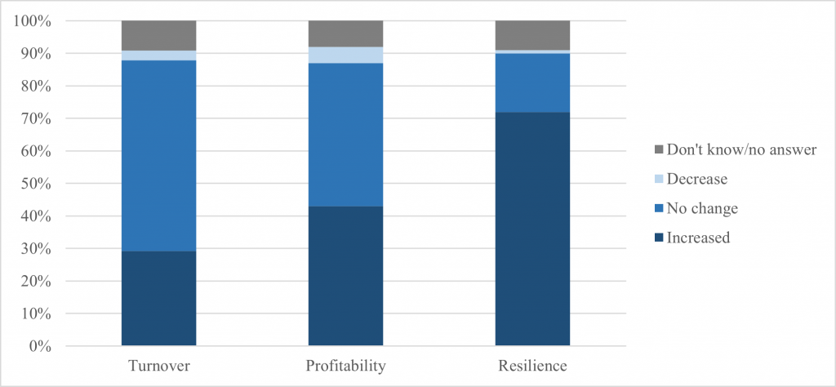
(Centre for Economic Performance, 2021)

As technology is further implemented and innovated, societal acceptance will evolve. As with AI and other developing technologies, resistance to change will continue; A simply online search on AI reveals top results, such as ‘Will AI take my job’ and ‘Top 10 jobs at risk to AI’. As technology continues to shape the economy, the risk to jobs will continue to factor into its growth rate. While practitioners assume the ‘human touch’ is irreplaceable (CIPD, 2023), with the rate of growth, and societal change, expectations on service delivery may evolve into people practice too.

- Explain Edgar Schein’s model of organisational culture and explain one theory or model which examines human behaviour. (AC 2.1)

Edgar Schein defines culture as ‘A pattern of shared basic assumptions learned by a group as it solved its problems of external adaptation and internal integration (…) A product of joint learning.’ (Schein, 2010). Therefore, culture is a culmination of shared expectations based on experiences such as history, external environment and leadership styles. Nonetheless, Schein attempts to identify culture through several defined layers; Artifacts & behaviours, Espoused Values and Basic Underlying Assumptions (Schein, 2010). Firstly, artifacts and behaviours are visible operations within the organisation. For example, artifacts may include a workplace who are all dressed in professional attire which may subsequently portray a formal working environment. Behaviours relate to communication styles, hierarchical structures and decision-making policies. Espoused values are those values outwardly portrayed by the organisation, such as mission statements and management messages, which usually include its strategies and aspirations. Finally, basic underlying assumptions are defined as They are comprised of unconscious thoughts, beliefs, perceptions, and feelings (Schein, 2004). Therefore, they are deep-rooted cultural conjecture, formed over a period of time. This layer is usually at the core of the organisation, so shapes its thinking and behaviour. For example, it may be widely known that the leader prefers appointments rather than the publicised open door policy.

Maslow’s Hierarchy of needs as a theory which sets a hierarchy of needs, set across five levels; Psychological, safety, love, esteem and self-actualisation. The needs are presented in a hierarchical pyramid form, with the basic needs the bottom and the high, intangible needs at the top, as set out below.

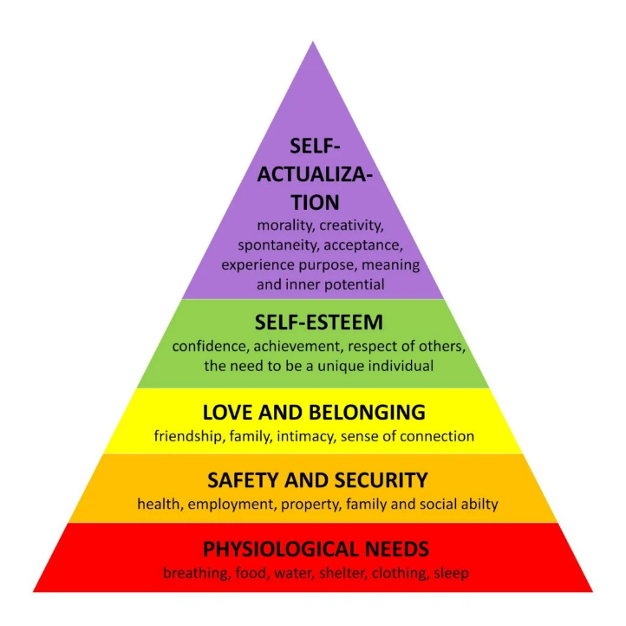

(Mcleod, 2023)

Maslow states that needs at the bottom of the pyramid must be fulfilled before moving up the hierarchy (Maslow, 1943). Maslow follows to confirm that people’s needs take precedence over others (Maslow, 1954). For example, the basic need for survival would precede all other, further up the pyramid needs. Maslow states that only once a person has passed through all levels of the pyramid, can they be fulfilled.

- Assess how people practices in your organisation (or one with which you are familiar) impact both on organisational culture and behaviour, drawing on examples to support your arguments. (AC 2.2)

‘What marks the competent organisation is its capability to create value through its people’ (Burke, 2016). People practice has the scope to positively impact organisational culture and behaviour. For a law firm operating with high-demand employees; people practice is integral to success, with rehiring costs set at almost triple that of retention of that same employee (Society For Human Resource Management, 2022). Subsequently, strategic practices to create a performance lead culture and dynamic behaviours to promote organisational success (Ivancevich, 2007). Strategic approaches can include; careful selection and hiring, sufficient induction to align culture, promote employee voice and reward. Further, simple onboarding policies provide clarity for employees, with a mutual understanding and synchronisation of the organisations goals and ambitions. Recruitment schemes must remain fair and aligned with the company agenda, the perceived unfairness can be enough to deter quality candidates (CIPD, 2023). Further, uncertainty or ambiguity within the recruitment campaign can lead to further cultural issues, such as cognitive bias (Whysall, 2018). Further, a lack of onboarding structure can result in the opposite effect, whereby cultural imbedding is not approached, as seen below in 2017 report on how employees felt during the onboarding process.
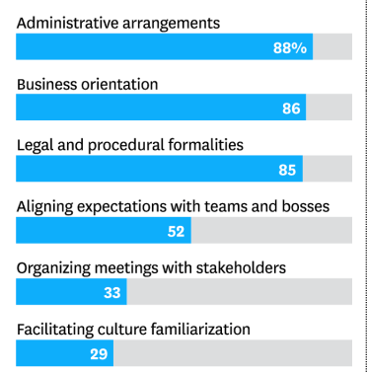
(Byford, et al., 2017)

As shown, cultural familiarisation is highlighted as very low, providing evidence that integration is an important aspect of onboarding.

People management is integration to continuing professional development. Those who are involved within active CPD tend to be more engaged and promote the desired behaviour. (Shuck, 2014). Further, consistent feedback sessions, such as appraisals, organisations can monitor how successful its synchronisation is with its employees (Bandura, 2012). Nonetheless, organisations need to remain vigilant using quantitative measures due to their binary nature external measures could be misinterpreted (Tangen, 2004).

People practices are intertwined within multiple aspects of the organisation, it can be the success or failure to successful integration of team members. Through successful recruitment, onboarding cultural awareness and understanding can drive behaviours. Those behaviours can be successfully aligned through regular appraisals, and vetted through constructive feedback sessions.

- Peter Cheese, current CEO of CIPD asserts, ‘People professionals are a vital function in supporting businesses to adapt to rapidly changing circumstances’. Explain two different models or theories to managing change. (AC 2.3)

Kotter’s eight steps of change
Kotter’s eight steps of change outlines that change requires strong leadership and decision making (CIPD, 2023). Firstly, Kotter suggestions creating a sense of urgency (Kotter, 1996), creating energy, motivation and employee buy-in (Kotter, 2008). Secondly, form a powerful coalition, within this step it is important to convince other, influential team members that change is necessary. Through strong leadership and coalition, momentum can expand into the wider organisation (Kotter, 2012). Thirdly, create a vision for change; this involves the creation of a clear vision and strategy which everyone will understand. This can help individuals understand the reasons why the change is being implemented (Kotter, 2003). Fourthly, communicate the vision; the communication of the strategy needs to be frequent, powerful and become intertwined into all business functions in order to provide motivation (Barrett, 2002). Step five is to remove obstacles; while the change is in effect, it is important to identify likely headwinds, such as people, procedures, compensation schemes (Mouazen, et al., 2023). Therefore, ensuring the organisation is promoting and rewarding the intended goal. Step six is to create short term wins; organisations may wish to create shorter and accessible goals to create positive reinforcement. Easy wins can help with motivation, and ensures the project is kept on track (Rebull, 2019). Step seven relates to Building on the change, therefore, ensuring that the wins within stage six form part of the wider goal, to maintain focus, and not acknowledge success prematurely. Step eight is Anchor the changes in corporate culture; this is to ensure the changes form part of the core to ensure its longevity

McKinsey 7s model
This model covers seven factors to influence change; Shared values; strategy, structure, system, skills, staff and style (CIPD, 2023). Strategy refers to the business plan and how it is formulated in conjunction with the organisational values (Corporate Finance Institute, 2023). Structure is simply the hierarchical nature of the organisation (Kaplan, 2005). System refers to the workflows and operational infrastructure (Alshaher, 2013). Skills relate to the capability and competence of the employees. Style is the culture outwardly relayed to the organisation by senior managers (Ashu, 2013). Staff is the HR related processes. Shared values are the core values and are intertwined with all other factors within the model (Chmielewkska, et al., 2022).

- A variety of models have been developed to explain how change is experienced. Discuss one model that explains how change is experienced. (AC 2.4)
The Kubler-Ross change curve was developed in the 1960’s to help to explain emotions and the five stages involved in the grieving process (Kubler-Ross, 1969). The curve helps to identify the key stages along a timeline, which individuals encounter, alongside the perceived performance along the axis. As shown below, the five stages include; Denial, anger, depression, bargaining and acceptance.
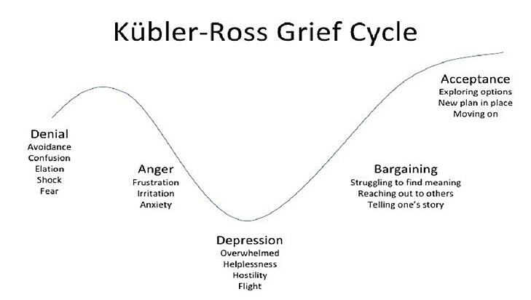
(Kubler-Ross & Kessler, 2005)
While the initial development focused on the way in which people grieve, it has since been adapted to help predict and explain the emotions involved within change management. Each stage explains the coping mechanisms involved as a person enters and exits a stage across the grief cycle (Leybourne, 2016). Denial and shock are usually the first reaction, this can sometimes be due to lack of information, fear or resistance to change and usually is short-lived, along with a temporary drop in performance (Malone, 2018). Stage two is Anger; this is where any frustrations and scepticism peak. This reaction is usually the result of realisation of the change happening, which may result in segregation within teams, with victimisation (Friedrich & Wustonhagen, 2017). Stage 3 is Depression; this can occur when motivation and performance are at their lowest, which can lead to hostility and attrition (Simpson, 2022). Stage 4 relates to Bargaining, this usually follows as people begin to accept the change is coming, but start to create compromises, in order to avoid accepting. Stage 5 is Acceptance as the change becomes the norm, as people begin to understand why change has taken place and how to contribute.

- The CIPD’s Health and wellbeing at work survey 2022 found, ‘There is less management focus on health and wellbeing compared with the first year of the pandemic’, and goes on to remark that this is disappointing. Assess the importance of wellbeing at work and factors which impact wellbeing. (AC 2.5)

Employee wellbeing should remain at the heart of organisational strategy. Nonetheless, a recent report by the CIPD highlights a negative impact on mental health compared to previous years (CIPD, 2023). However, there has been some improvements, which include career development and employer relations. The degrading of focus on wellbeing seems to be already influencing the UK absenteeism, with the highest reported rate at 7.8% (Moss, 2023). Further, short term illnesses such as mental health, stress being the most common (CIPD, 2023). These figures subsequently cost UK organisations over £45 billion a year (Deloitte, 2022). This report also highlights than young professionals are the most vulnerable demographic, being twice as likely to experience mental health issues.

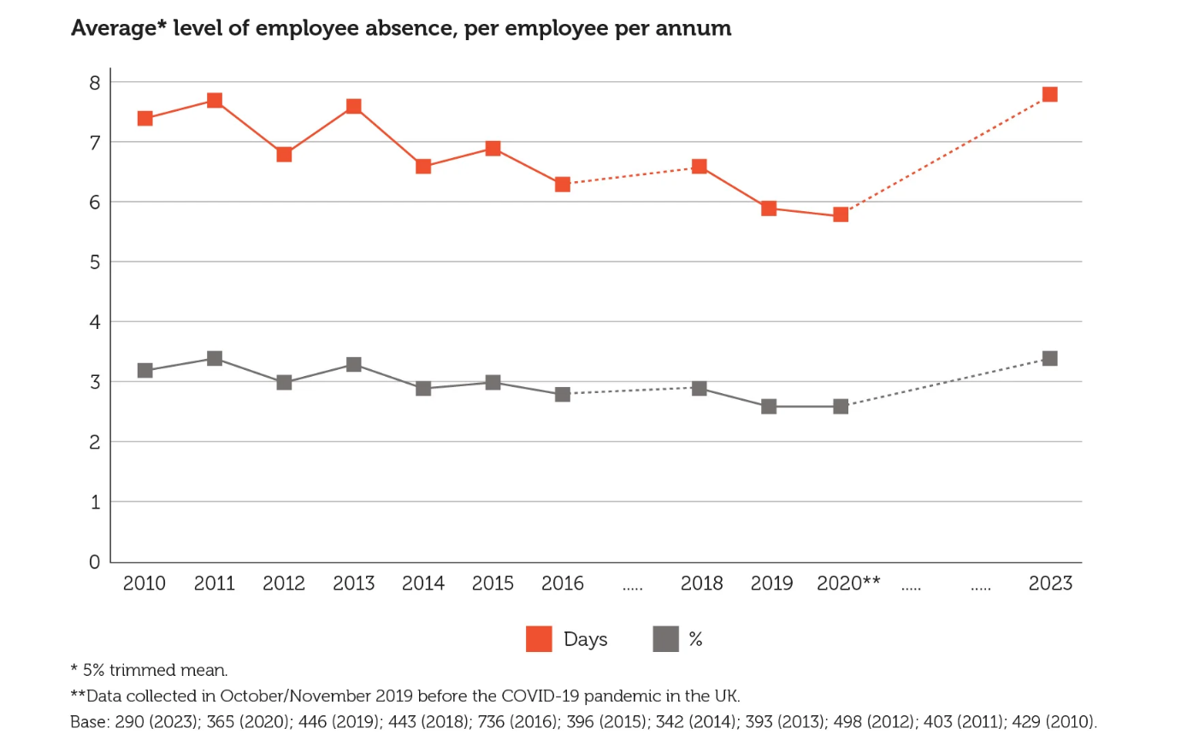
(CIPD, 2023)

It is evident that there is a clear relationship between employee wellbeing and organisational performance. Further, the cost of absenteeism cannot be ignored. Additionally, due to the vulnerability of young professionals, the ongoing absenteeism is going to continue to grow.

There are number of ways which organisations can improve their wellbeing policies.
The CIPD highlights 7 key domains of wellbeing (CIPD, 2023), Health, good work, values, social, personal growth, lifecycle and financial wellbeing. The domains set a baseline for organisations to effectively implement a successful wellbeing policy. Setting values can help to create a sense of mutual respect between employees and employers. Hence, the employer and employee relationship becomes much deeper than merely transactional, creating a stronger emotional connection, further developing a corporate social responsibility brand (Budhiraja & Yadav, 2020).

- The CIPD Profession Map states ‘People practices are the processes and approaches that we use across the employee lifecycle’. Discuss the links between the employee lifecycle and different people practice roles. (AC 3.1)

The CIPD published the employee lifecycle as below.

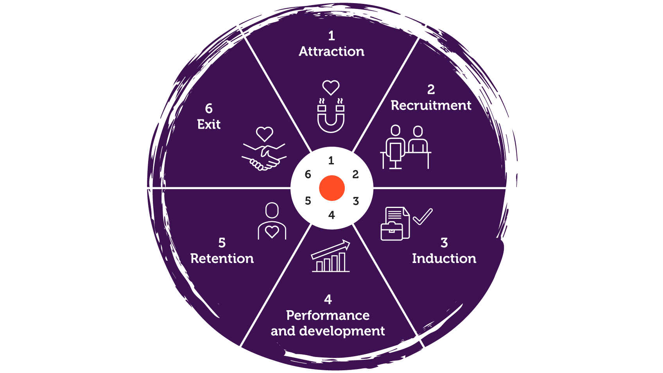
(CIPD, 2023)

The employee lifecycle involves several people practice roles.

Attraction
The attraction involves a combination of a number of roles. From recruitment, development and HR strategy. For example, an organisation with a strong brand for HR strategies, such as flexitime, wellbeing and diversity policies may attract better candidates (Wilden, et al., 2010). Highlighting strong branding through campaigns, employee feedback and social media promotions directly link to the likelihood for job applications (Santiago, 2019). Therefore the input of people practices are integral to the attraction of quality, diverse candidates. These roles would include recruitment, wellbeing and diversity officers, people analytics.

Recruitment
The successfulness of recruitment relies heavily on the impact of attraction, without a quality talent pool, the recruitment process will fail (Catanzaro, et al., 2010). Firstly, an understanding of recruitment cost and time must be appreciated; the indirect costs averaging over six thousand pound (CIPD, 2022). However, the recruitment process must be fair so that the right candidates are hired. These roles would include recruitment.

Induction
Successful onboarding requires clarity of company values and strategy (Cable, et al., 2013). Failure at this stage will result in higher attrition and lack of shared values (Bowers, et al., 2023). Therefore, organisational policies and values form a key role in the success of inductions. HR managers need to ensure that the core values are clearly relayed, alongside company culture. These roles would include employee relations, HR generalist.

Performance and development
Organisations can monitor its performance through its strategy and goals. Employee performance is analysed alongside the same parallels. Therefore, people practices through policies and values can enable HR managers to identify and manage individuals who are in need of support and those succeeding. Through practices such as appraisals, employee voice and career developing; organisations are able to drive motivation and engagement by identifying individual development needs and goals. Tailoring meeting to help carve individual career prospects and promotion. Therefore, talent management, employee relations, rewards, learning and development, health and wellbeing roles are integral.

Retention
Through understand why people leave, people practice can enable organisations to reduce their employee turnover (CIPD, 2023). With ‘lack of career development’ being one of the top reasons for employee turnover, (Gurchiek, 2022) the importance of the other sectors of the employee lifecycle is paramount. Hence, highlighting the importance of understanding employee voice, feedback sessions, cultural awareness and behaviours. Similarly, to attraction, retention is the culmination and effectiveness of the remaining sectors of the employee lifecycle. Therefore, the involvement of recruiters, HR managers, equality and diversity officers, organisational design officers are integral.

Exit
Exit interviews help to understand how the Lifecyle has failed. This information can provide candid data on the successfulness of the polices of the organisation

The entire employee Lifecyle and the people practice roles within it, help to provide valuable evidence to help HR business partners and those involved in organisational design to identify opportunities for change. Further, it is important that strategy from HR partners is clearly relayed to other HR functions, alongside multidisciplinary sharing and feedback.

- Analyse how people practice connects with other areas of an organisation and supports wider people and organisational strategies. (AC 3.2)
People practices are intertwined into almost every aspect of business function. There are a number of ways which these practices can support organisations. As stated by Peter Cheese ‘…The recent turbulent years of change have emphasised even more the important of people at the centre of business, and the need to align people strategy with business strategy…’ (Holbeche, 2022). Shared values, common goals and mutual understanding of business direction help to facilitate organisational growth and innovation (Baines, 2014). Practice such as employee voice and empowerment can help create shared values. Efficiently promoting clear core values through effective onboarding and appraisals can build common goals and understanding (Cesario & Chambel, 2019). Through people practices organisations can engage further with employees who share and understand its strategies and ambitions. Providing a supporting environment for employees to thrive promotes a health culture (Verma, 2020). Motivating employees also improves their performance. Further, engaged employees help to positively drive group culture, which promotes a healthy and happy team environment (Smith, et al., 2016). People practices can also help to assist managers to identify skills gaps through processes such as appraisals, employees can highlight any learning and development needs. People practices also integrate into external HR processes within the employee lifecycle, such as attraction and recruitment. The promotion of HR strategies can improve attraction to an organisation, such as flexitime, easing the investment in recruitment. Further, people practices, through implementation of policies and core values can enable managers to effectively identify and manage performance issues (CIPD, 2023). As people practices integrate into strategy, accounting, HR, marketing and other business functions; practitioners are able to provide multidisciplinary viewpoints. In that, the input may have considerations from various departments, rather than department specific requirements. This can provide invaluable feedback in the development of the overall business strategy.

- Discuss processes you have, or could use, for consulting and engaging with internal customers of the people function in order to understand their needs. (AC 3.3)

Employee voice is vital to the growth and agility of an organisation (Harley, 2020). With technological advances and the use of social media and sites such as Glassdoor, there has been a shift in the power dynamic, giving employees greater demands in job satisfaction, work life balance and personal growth (CIPD, 2021). Subsequently, the shift in demand has led to a turbulent labour market, creating competition for retention and attraction between organisations. (Giunta, 2023). Subsequently, organisations must remain relevant to the demands of their employees.

Surveys are an easy and powerful way to engage with a large number of individuals, enabling employees to engage with their employees with specific hot topics, at scale (Mitchell Hoffman, 2021). This type of engagement allows organisations to check culture, motivation and aspirations (Saks, 2019).Therefore, there are numerous advantages for organisations to utilise surveys (Wiley, 2010). However, surveys are usually limited by their quantitative nature (Queiros, et al., 2017). To gain deeper insight, qualitative methods are required.

Technology
Access to technology has increased over recent years, which has led to organisations seeking up to date methods of engaging with its employees (Bilqees Ghani, 2022). The use of social media and internal sites has given employees the platform to express their views (Peter Holland, 2018). Giving such access can promote engagement by creating empowerment, and a sense of purpose (Anusuya Yadav, 2022). However, the ease of such access gives opportunity for negative behaviour or a toxic environment (Graeme Martin, 2015). Therefore, strict policies and controls would need to be in place to minimise misuse. Conversely, organisations may wish to allow the same direct approach, but with more internal regulation, with the use of intranet and internal blogs (Kurth, 2020). While both forms of feedback can be rich in data, feedback itself can be more generic and widespread due to the fluid nature of forums and blogs (Ruck, 2015).

Focus groups.
Focus groups allows organisations to obtain a sample of views and culture. Focus groups can have major benefits for an organisation. Functionally, it provides a platform for qualitative employee voice, with the added benefit of live follow up questions or clarifications. However, it can also improve engagement, as employees become directly connected to business decisions (Othman, et al., 2018).

For organisations to utilise the above methods with stakeholders, they must ensure they is sufficient engagement. The level of engagement has a direct link to the quality of employee voice (Ruck, et al., 2017). Therefore, when engaging with employee voice, there needs to be clarity on the reasons why and how feedback is actioned (Menguc, et al., 2013). Further, organisations may be to encourage feedback through reward. Using drivers such as financial incentives and leave can help to promote engagement. However, the ideal environment would be whereby stakeholder engagement is organic, driven by culture, sometimes through perceived professional development, personal branding or shared goal (Özçelik, 2015).

Bibliography
Ablah, E. et al., 2019. Innovative recruitment strategies for a comprehensive worksite wellness initiative. Health Education Research, 34(6), pp. 569-577.
Accard, P., 2015. Complex hierarchy: The strategic advantages of a trade-off between hierarchical supervision and self-organizing. European Management Journal , 33(2), pp. 89-103.
Alshaher, A. a.-F., 2013. The McKinsey 7s Model framework for e-learning system readiness assessment`. International journal of advances in engineering & technology.
Ambos, B. & Schlegelmilch, B., 2007. Innovation and control in the Multinational firm: a comparison of political and contingency approaches. Stragetic Management Journal, 28(5), pp. 473-486.
Ashu, S., 2013. A study of role of McKinsey's 7S Framework in achieving organisational excellent. Organisation Development Journal, 31(3), pp. 39-50.
Baines, P., 2014. Doing Good By Doing Good: Why Creating Shared Value is the Key to Powering Business Growth and Innovation. Melbourne: John Wiley & Sons.
Baker, L., 2016. Integrating key risk and performance indicators: internal audit can leverage its risk knowledge to improve operational performance and reduce risk exposure. Internal Auditor, 73(3), p. 23.
Bandura, A., 2012. Cultivate Self-efficacy for Personal and Organizational Effectiveness. In: E. Locke, ed. Handbook of Principles of Organizational Behavior: Indispensable Knowledge for Evidence‐Based Management. s.l.:John Wiley & Sons , p. Chapter 10.
Barrett, D. J., 2002. Change communication: using strategic employee communication to facilitate major change. Corporate Communications: An International Journal, 7(4), pp. 219-231.
Bauer, T., 2012. Creating and Maintaining Environmentally Sustainable Organizations: Recruitment and Onboarding. Business Faculty Publications and Presentations., Volume 28.
Bowers, B., Thal, A. & Elshaw, J., 2023. Onboarding: just how important is it?. Stragetic HR review, 22(5), pp. 164-168.
Budhiraja, S. & Yadav, S., 2020. Sustainable Human Resource Management. In: Employer Branding and Employee-Emotional Bonding—The CSR Way to Sustainable HRM. Singapore: Springer, pp. 133-149.
Burke, E., 2016. Why organisations need to up their game on understanding, measuring and leveraging human capital, London: CIPD.
Cable, D., Gino, F. & Staats, B., 2013. Reinventing Employee onboarsing. MIT Sloan Management review, 54(3), pp. 23-28.
Campbell, G. &., 2002. Parenting in complex Structures. Long Range Planning, Volume 35, pp. 219-243.
Catanzaro, D., Moore, H. & Marshall, T., 2010. The Impact of Organizational Culture on Attraction and Recruitment of Job Applicants. Journal of Business and Psychology, Volume 25, pp. 649-662.
Centre for Economic Performance, 2021. The business response to Covid-19 one year on: findings from the second wave of the CEP-CBI survey on technology adoption, London: CEP.
Cesario, F. & Chambel, M., 2019. On-boarding new employees: a three-component perspective of welcoming. International Journal of Organizational Analysis, 27(5), pp. 1465-1479.
Chmielewkska, M., Stokwiszewski, J., Markowska, J. & Hermanowski, T., 2022. Evaluating Organizational Performance of Public Hospitals using the McKinsey 7-S Framework. BMC Health Services Research, 22(7).
CIPD, 2018. Creating and capturing value at work: who benefits?, London: CIPD.
CIPD, 2022. Resourcing and talent planning report 2022, London: CIPD.
CIPD, 2023. Automation, AI and technology. [Online]
Available at: https://www.cipd.org/uk/views-and-insights/cipd-viewpoint/automation-ai-technology/
[Accessed 5 12 2023].
CIPD, 2023. Change management: A guide for people professionals. [Online]
Available at: https://www.cipd.org/uk/knowledge/guides/change-management/#models-for-change
[Accessed 15 12 2023].
CIPD, 2023. CIPD Good Work Index 2023, London: CIPD.
CIPD, 2023. Employee turnover and retention. [Online]
Available at: https://www.cipd.org/uk/knowledge/factsheets/turnover-retention-factsheet/#Whendoes
[Accessed 14 12 2023].
CIPD, 2023. Fair Selection An evidence review, London: CIPD.
CIPD, 2023. Health and wellbeing at work. [Online]
Available at: https://www.cipd.org/uk/knowledge/reports/health-well-being-work/
[Accessed 15 12 2023].
CIPD, 2023. Learning needs analysis. [Online]
Available at: https://www.cipd.org/uk/knowledge/factsheets/learning-needs-factsheet/
[Accessed 14 12 2023].
CIPD, 2023. People analytics: Guide for people professionals. [Online]
Available at: https://www.cipd.org/uk/knowledge/guides/analytics-practitioner-guide/
[Accessed 16 12 2023].
CIPD, 2023. PESTLE analysis. [Online]
Available at: https://www.cipd.org/uk/knowledge/factsheets/pestle-analysis-factsheet/#what-is-a-pestle-analysis
[Accessed 11 October 2023].
CIPD, 2023. Wellbeing at work. [Online]
Available at: https://www.cipd.org/uk/knowledge/factsheets/well-being-factsheet/
[Accessed 15 12 2023].
Corporate Finance Institute, 2023. Mckinsey 7s Model. [Online]
Available at: https://corporatefinanceinstitute.com/resources/management/mckinsey-7s-model/
[Accessed 15 12 2023].
Danilovic, M. & Sandkull, B., 2005. The use of dependence structure matrix and domain mapping matrix in managing uncertainty in multiple project situations. International Journal of Project Management , 23(3), pp. 193-203.
Deloitte, 2015. From brawn to brains The impact of technology on jobs in the UK, UK: Deloitte.
Deloitte, 2022. Mental health and employers Refreshing the case for investment, London: Deloitte.
Egelhoff, W., 2017. Understanding matrix structures and their alternatives: The key to designing and managing large, complex organizations. In: s.l.:Springer, p. 28.
Egelhoff, W. G., 2010. How the Parent HQ Adds Value to a MNC. Management International Review, pp. 413-432.
Egon Zehnder/Genesis Advisers, 2017. Onboarding isnt enough, s.l.: Egon Zehnder/Genesis Advisers.
Friedrich, E. & Wustonhagen, R., 2017. Leading Organizations Through the Stages of Grief: The Development of Negative Emotions Over Environmental Change. Business & Society, 56(2), pp. 186-213.
Goold, M. & Campbell, A., 2003. Making Matrix Structures Work:: Creating Clarity on Unit Roles and Responsibility. European Management Journal, 21(3), pp. 351-363.
GOV.UK, 2023. Largest ever cash increase to the minimum wage. [Online]
Available at: https://www.gov.uk/government/news/largest-ever-cash-increase-to-the-minimum-wage
[Accessed 3 12 2023].
Gupta, A., 2013. Environmental and pest analysis: An approach to external business environment. Merit Journal of Art, social care and Humanities, 1(2), pp. 13-17.
Gurchiek, K., 2022. Report: HR Pros Rank Top Reasons for Turnover. [Online]
Available at: https://www.shrm.org/topics-tools/news/report-hr-pros-rank-top-reasons-turnover
[Accessed 16 12 2023].
Habib, K. A., 2015. How can conflict be managed when introducing the matrix organisation structure in growth markets: a case study in the Middle East. Edinbugh Business School.
Holbeche, L., 2022. Aligning human resource and business strategy. 3rd ed. Oxon: Routledge.
Horney, N., 2010. Leadership Agility: A Business Imperative for a VUCA world. HR People & Strategy , 33(4), pp. 1-28.
Ivancevich, 2007. Human Resource Management. New York: McGraw-Hill.
Jeske, D. & Olsen, D., 2021. Onboarding new hires: recognising mutual learning opportunities. Journal of Work-Applied Management, 14(1).
JRF, 2022. UK Poverty 2022: The essential guide to understanding poverty in the UK, London: JRF.
Kaplan, R., 2005. How the balanced scorecard complements the McKinsey 7‐S model. Strategy & Leadership, 33(3), pp. 41-46.
Kent, K., Enid, G., Aishwarya, R. & Freundlich, N., 2016. Promoting Healthy Workplaces by Building Cultures of Health and Applying Strategic Communications. Journal of Occupational and Environmental Medicine, 58(2), pp. 114-122.
Kotter, J., 1996. Leading Change. Boston: Havard Business School Press.
Kotter, J., 2003. What Leaders Really Do. In: A. Hooper, ed. Leadership Perspectives. s.l.:Routledge.
Kotter, J., 2008. A Sense of Urgency. Boston: Havard Business School Publishing.
Kotter, J., 2012. How the most innovative companies capitilise on todays rapid-fire strategic challenges - and still make their numbers. Havard Business Review, Volume November, pp. 45-58.
Kubler-Ross, 1969. On Death and dying. New York: Macmillan.
Kubler-Ross, E. & Kessler, D., 2005. On Grief and Grieving: Finding the Meaning of Grief Through the Five Stages of Loss. New York: Simon & Schuster.
Land Registry, 2023. UK House Price Index, London: Land Registry.
Law Society, 2022. How much do solicitors earn?. [Online]
Available at: https://www.lawsociety.org.uk/career-advice/becoming-a-solicitor/how-much-do-solicitors-earn
[Accessed 5 12 2023].
Leybourne, S. A., 2016. Emotionally sustainable change: two frameworks to assist with transition. Stragetic change management, 7(1), pp. 23-42.
Lloyds Bank, 2021. 2.7 million microbusinessessaved by technology during COVID-19 crisis, London: Lloyds Bank.
Malone, E., 2018. The Kubler-Ross Change Curve and the Flipped Classroom: Moving Students Past the Pit of Despair. College of vetenerian medicine, 1(2).
Maslow, A., 1943. A theory of human motivation. Psychological Review, 50(4), pp. 370-96.
Maslow, A., 1954. Motivation and personality. New York: Harper And Row.
Mcleod, S., 2023. Maslow’s Hierarchy Of Needs. [Online]
Available at: https://www.simplypsychology.org/maslow.html
[Accessed 6 12 2023].
McPhail, C. J., 2016. From Tall to Matrix: Redefining Organisational Strcutures. Change: The Magazine of Higher Learning, 48(4), pp. 55-62.
Menguc, B., Auh, S., Fisher, M. & Haddad, A., 2013. o be engaged or not to be engaged: The antecedents and consequences of service employee engagement. Journal of Business Research, 66(11), pp. 2163-2170.
Moss, R., 2023. Sickness absence rates soar to 10-year high. [Online]
Available at: https://www.personneltoday.com/hr/sickness-absence-rates-2023-cipd-simplyhealth/
[Accessed 15 12 2023].
Mouazen, A. et al., 2023. Transformational and Transactional Leaders and Their Role in Implementing the Kotter Change Management Model Ensuring Sustainable Change: An Empirical Study. Sustainability in Organizational Change and Leadership Development, 16(1).
Nicolau, 2023. The Impact of Loss Aversion and Diminishing Sensitivity on Airline Revenue: Price Sensitivity in Cabin Classes.. Journal of Travel Research, 62(3), pp. 685-698.
ONS, 2023. Consumer price inflation, UK: December 2023, London: ONS.
ONS, 2023. Cost of living insights: Spending, London: ONS.
Othman, A., Mahmud, Z., Noranee, S. & Noordin, F., 2018. Measuring Employee Happiness: Analyzing the Dimensionality of Employee Engagement. In: Advances in Intelligent Systems and Computing. Singapore: Springer, pp. 863-869.
Pakarinen, M. & Virtanen, P., 2016. Solving organisational conflicts in public matrix organisation. Qualitative Research in Organizations and Management, 11(4), pp. 232-252.
Parera, R., 2017. Introduction. In: The PESTLE analysis. s.l.:Nerdynaut, pp. 1-5.
Queiros, A., Faria, D. & Almeida, F., 2017. Strengths and limitations of qualitative and quantitative research methods. European Journal of Education Studies , 3(9).
Rebull, M., 2019. Sustainability in Organizational Change and Leadership Development. Strategic HR Review, 18(3), pp. 104-108.
Ruck, K., 2015. Exploring Internal Communication: Towards Informed Employee Voice. s.l.:Gower Publishing.
Ruck, K., Welch, M. & Menara, B., 2017. Employee voice: An antecedent to organisational engagement?. Public Relations Review, 43(5), pp. 904-914.
Saiti, A. & Stefou, T., 2020. Hierarchical Organizational Structure and Leadership. Oxford University Press.
San , C. & Fernandez, D., 2018. An Analysis of the main project organisational structures: Advantages, disadvantages and factors affecting their selection. Procedia computer Science, Volume 138, pp. 791-798.
Santiago, J., 2019. The relationship between brand attractiveness and the intent to apply for a job: A millennials’ perspective. European Journal of Management and Business Economics, 28(2).
Schein, E., 2004. Organizational Culture and Leadership. 3rd ed. San Francisco: Jossey-Bass.
Schein, E., 2010. Organizational Culture and Leadership. 4th ed. s.l.:John Wiley & Sons.
Shakouhyar, S., Shakoohyar, S. & Safari, S., 2020. Research on the influence of after-sales service quality factors on customer satisfaction. Journal of Retailing and Consumer Services, Volume 56.
Shuck, B., 2014. Human Resource Development Practices and Employee Engagement: Examining the Connection With Employee Turnover Intentions. Human Resource Development Quarterly, 25(2), pp. 239-270.
Shumpeter, J. A., 1962. Capitalism, socialism and democracy. New York: Harper & Row.
Simpson, J. M., 2022. Understanding change in the university workplace: are metaphors of bereavement helpful?. Perspectives: Policy and Practice in Higher Education , 26(3), pp. 96-101.
Smith, S., Peters, R. & Caldwell, C., 2016. Creating a culture of engagement - insights for application. Business management and research, 5(2), pp. 70-80.
Society For Human Resource Management, 2022. SHRM HR Benchmarking Report, s.l.: SHRM.
Tangen, S., 2004. Performance measurement: from philosophy to practice. International Journal of Productivity and Performance Management, 53(8), pp. 726-737.
Tuncer, I., Unsun, C. & Cobanoglu, C., 2021. Service Quality, Perceived Value and Customer Satisfaction on Behavioral Intention in Restaurants: An Integrated Structural Model. Journal of Quality Assurance in Hospitality & Tourism , 22(4), pp. 447-475.
Tuytens, M., 2012. Importance of system and leadership in performance appraisal. Personnel Review,, 41(6), pp. 756-776.
UK Parliament, 2022. The impact of remote and hybrid working on workers and organisations, London: UK Parliament.
Verma, M., 2020. Supportive Culture: A Transformational Strategy. In: Transforming Organizations Through Flexible Systems Management . Sinappore: Springer, pp. 177-188.
Virgin Atlantic , 2021. Gender Pay Reports, s.l.: Virgin .
Virgin Atlantic, 2023. Our Story. [Online]
Available at: https://corporate.virginatlantic.com/global/en/our-story.html
[Accessed 15 12 2023].
Virgin Atlantic, 2023. Our Values. [Online]
Available at: https://careersuk.virgin-atlantic.com/values
[Accessed 15 12 2023].
Whysall, Z., 2018. Cognitive Biases in Recruitment, Selection, and Promotion: The Risk of Subconscious Discrimination. s.l.:Palgrave Macmillan.
Wilden, R., Gudergan, S. & Lings, I., 2010. Employer branding: strategic implications for staff recruitment. Journal of Marketing Management, 26(1), pp. 56-73.
Zoom, 2022. How Zoom has Supported Young People in the UK During the Pandemic. [Online]
Available at: https://www.zoom.com/en/blog/how-zoom-supported-young-people-in-uk-during-pandemic/
[Accessed 5 12 2023].

