Software Development –Part C

Pseudocode
- Prototype random number function return int.
- Declare card array to hold 2D array with 3 rows, two columns.
- Declare int variables for flag, card 1(c1), card 2(c2), card position 1(cp1), card position 2(cp2), numchoice, turns =0, match =0.
- Declare int array variable to hold 6 random values(num). And int array to hold 12 values (usednum)
- Declare char variable: choice.
- Print on screen“do you want to play”
- Capture user input, store as choice.
- If choice equals y, continue to game. Else terminate game.
- For 6: num array gets 6 values from random number function
- Random number 1-3 is generated and numchoice variable is assigned outcome
- Switch is triggered from numchoice
  - Case 1: assigned 6 numbers twice to random cards
  - Case 2: assigned 6 numbers twice to random cards
  - Case 3: assigned 6 numbers twice to random cards
- Instructions are printed on screen.

User enters while loop (match less than 6), as match is set to zero.
- Card grid is printed.
- Print on screen requesting card position 1 is entered.
- User input collected and stored as c1.
- C1 is validated to ensure in range (1-12)
- Flag set to 1
- While (flag equals 1)
  - Flag equals zero
  - Counted loop, loops for 12 to check usednum array for any values already stored
IF usednum array holds same value as c1, flag is set to 1.
User enters different values
While loop is re-entered to check all values again, as flag is 1.

If no errors detected, flag is still equal to zero, so while loop is exited.
- Print on screen requesting card position 2 is entered.
- User input collected and stored as c2.
- C1 is validated to ensure in range (1-12), or not the same as c1.
- Flag set to 1
- While (flag equals 1)
  - Flag equals zero
  - Counted loop, loops for 12 to check usednum array for any values already stored
IF usednum array holds same value as c2, flag is set to 1.
User enters different values
While loop is re-entered to check all values again, as flag is 1.
- Cp1 stores value of c1
- Cp2 stores value of c2
- Switch is triggered from c1;
  - 12 cases, each assign c1 the value from cards array position selected by user input
- Switch is triggered from c2;
  - 12 cases, each assign c2 the value from cards array position selected by user input
- IF c1 equals value of c2
  - Print card values
  - Print success message
  - Match variable add one
  - Turns add one
  - Cp1 value added into usednum array
  - Cp2 value added into used num array
- ELSE
  - Print card values
  - Print failure message
  - Turns add one
- IF match less than 6
  - Print You have found *match variable value* number of pairs, keep trying
  - Print you used the following cards already:
    - Counted loop, loops for 12 to print values in usednum array.
- ELSE
  - Print you have found all pairs in *turns variable value* turns.
- Set choice to n to exit game.
Random function:
- Declare rnum, low, high.
- Set low = 1
- Set high = 100
- Generate random number, set as rnum.
- Return rnum

Code
#include <stdio.h>
#include <stdlib.h>
#include <time.h>
int getrandomnum(void); //prototype for random number function
int main(void); //protoype for main section

int main(void)
{
srand(time(NULL)); //declaring for randomisation (only once)
int flag; // declaring flag variable
int cards[3][4] = { {0,0,0,0 }, {0,0,0,0}, {0,0,0,0} }; //declaring array to hold card values
int num[6]; // declaring array to hold random numbers, to be placed into cards
int numchoice; //declaring int value for switch case
int usednum[12] = { 0,0,0,0,0,0,0,0,0,0,0,0 }; //declaring array to store used card positions
int c1 = -1, c2 = -1, cp1 = 0, cp2 = 0, i; //c1 c2 card values, cp1/cp2 card position values
int turns = 0, match = 0; //declaring, turns and matches and setting to 0 as at start of the game
char choice; //declaring choice char variable to capture user input if they wish to play game

printf("Do you want to play pairs? (Y/N)\n"); //prints on screen do you want to play
scanf("%c", &choice); // captures user input, into choice variable

if (choice == 'y' || choice == 'Y') //if user wishes to play 'y' will enter while loop. anyother input, terminates game.
{

for (i = 0; i < 6; i++) //loop to generate 6 random numbers
{
num[i] = getrandomnum(); //filling num array with random numbers,using random number function
// prints 6 numbers that cards can have
}

numchoice = rand() % (3 - 1 + 1) + 1; //selecting random number 1-3, to shuffle cards dependant on switch case

switch (numchoice) // switch case for shuffle
{
case 1: cards[0][0] = num[0];//row 1 //1st case for randomization
cards[0][1] = num[1]; //row 1
cards[0][2] = num[2];//row 1
cards[0][3] = num[3]; //row 1

cards[1][0] = num[4]; //row 2
cards[1][1] = num[5];//row 2
cards[1][2] = num[5];//row 2
cards[1][3] = num[4];//row 2

cards[2][0] = num[3]; //row 3
cards[2][1] = num[2];//row 3
cards[2][2] = num[1];//row 3
cards[2][3] = num[0];//row 3
break;
case 2:cards[0][0] = num[5]; //row1 //2nd case for randomization
cards[0][1] = num[5]; // row1
cards[0][2] = num[3]; // row1
cards[0][3] = num[4]; // row1

cards[1][0] = num[4]; //row 2
cards[1][1] = num[1];//row 2
cards[1][2] = num[2];//row 2
cards[1][3] = num[0];//row 2

cards[2][0] = num[0]; //row 3
cards[2][1] = num[3];//row 3
cards[2][2] = num[2];//row 3
cards[2][3] = num[1];//row 3
break;
case 3:cards[0][0] = num[1]; //row1 //3rd case for randomization
cards[0][1] = num[3];//row1
cards[0][2] = num[2];//row1
cards[0][3] = num[4];//row1

cards[1][0] = num[4]; //row 2
cards[1][1] = num[5];//row 2
cards[1][2] = num[2];//row 2
cards[1][3] = num[0];//row 2

cards[2][0] = num[3]; //row 3
cards[2][1] = num[0];//row 3
cards[2][2] = num[5];//row 3
cards[2][3] = num[1];//row 3
break;
}

printf("\n *** To play the game select 2 cards, one at a time, from the grid below.*** "); //prints instructions on screen for user

while (match < 6) //enters game while matches are less than 6 (once 6 matches are reached game is complete)
{

printf("\n\n 1 2 3 4 \n 5 6 7 8 \n 9 10 11 12 \n\n"); //prints grid advising user how to select card values
c1 = -1;
c2 = -1;
cp1 = 0;
cp2 = 0;

printf("Enter position of first card (1-12): \n"); //prints requesting user enter card position 1
scanf("%d", &c1); //collects user input for card 1

while ((c1 < 1) || (c1 > 12))//first card
{
printf("Please enter a value 1-12: \n"); //prints on screen requesting user input
scanf("%d", &c1); //collects user input
}
flag = 1; //flag set to 1, to enter while loop
while (flag == 1)
{
flag = 0; //flag is set to 0, if nothing is detected, will not meet requirements to re-enter while loop as still set to zero
for (i = 0; i < 12; i++)//counted loop for 12
{

if (usednum[i] == c1) //statement checks user input against array which stores value for cards which have already found a pair.
{
flag = 1; //if value is found that is the same, value is set back to 1 to reset counter and count from the start of the array
printf("\n Card has already found its pair, enter a diffrent value please: \n "); //print on screen requesting user input
scanf("%d", &c1); //collects user input

while ((c1 < 1) || (c1 > 12)) //validates that value is in range
{
printf("Please enter a value 1-12: \n"); //prints please enter value
scanf("%d", &c1); //collects user input
}
}
}
}

printf("Enter position of second card(1-12): \n");//prints requesting user enter card position 2
scanf("%d", &c2); //collects user input for card 2

while (((c2 < 1) || (c2 > 12)) || (c2 == c1)) //confirms user inoput is in range and not the same as card 1
{
printf("Please enter a value 1-12 & different to the first card: \n");
scanf("%d", &c2);
}
flag = 1; //same validation as card 1, conmfirming card position is not already selected.
while (flag == 1)
{
flag = 0;
for (i = 0; i < 12; i++)
{
if (usednum[i] == c2)
{
flag = 1;
printf("\n Card has already found its pair, enter a diffrent value please: \n ");
scanf("%d", &c2);

while (((c2 < 1) || (c2 > 12)) || (c2 == c1))
{
printf("Please enter a value 1-12: \n");
scanf("%d", &c2);
}

}

}
}

cp1 = c1; //card position variable (cp1) takes value of c1 (user input) as c1, is about to take value of the card in the cards array
cp2 = c2; //cp2 variable does likewise for c2.

switch (c1) // switch case, to assign c1 variable the value of the card in the array which user has selected.
{
case 1:
c1 = cards[0][0];
break;
case 2:
c1 = cards[0][1];
break;
case 3:
c1 = cards[0][2];
break;
case 4:
c1 = cards[0][3];
break;

case 5:
c1 = cards[1][0];
break;
case 6:
c1 = cards[1][1];
break;
case 7:
c1 = cards[1][2];
break;
case 8:
c1 = cards[1][3];
break;

case 9:
c1 = cards[2][0];
break;
case 10:
c1 = cards[2][1];
break;
case 11:
c1 = cards[2][2];
break;
case 12:
c1 = cards[2][3];
break;
}

switch (c2) // switch case, to assign c2 variable the value of the card in the array which user has selcted.
{
case 1:
c2 = cards[0][0];
break;
case 2:
c2 = cards[0][1];
break;
case 3:
c2 = cards[0][2];
break;
case 4:
c2 = cards[0][3];
break;

case 5:
c2 = cards[1][0];
break;
case 6:
c2 = cards[1][1];
break;
case 7:
c2 = cards[1][2];
break;
case 8:
c2 = cards[1][3];
break;

case 9:
c2 = cards[2][0];
break;
case 10:
c2 = cards[2][1];
break;
case 11:
c2 = cards[2][2];
break;
case 12:
c2 = cards[2][3];
break;
}

if (c1 == c2) //IF statement to check for match or cards
{
printf(" Card 1: %d card 2: %d \n", c1, c2); //prints card values on screen
printf("It's a match! \n"); //prints advising user of successful match

match = match + 1; //adds 1 to match varible
turns = turns + 1; //adds one to turn counter
usednum[match - 1] = cp1; //adds value of card postion 1 into used number array
usednum[match + 5] = cp2; //adds value of card position 2 in used number array

} /* cp1/cp2 is card postion, c1/c2 remembers value of card.*/
else //else statement for any outcome other than a match (failure)
{
printf("Card 1: %d card 2: %d\n", c1, c2); //prints cards values
printf("Cards do not match, try again please \n"); //prints advising user has not matched cards

turns = turns + 1; //adds 1 to turn coutner

}

if (match < 6) //check if match is not equal to 6 (will be below if not 6)
{
printf("\n\nyou have found %d pairs, keep trying\n", match); //prints how many pairs have been found
printf("\n you have already selecting the following cards: \n"); //prints out on screen
for (i = 0; i < 12; i++) //for loop printing out used number array values, advising user which positions have been selected already.
{
printf("%d , ", usednum[i]);
}

}

else
{
printf("\nYou have found all pairs, in %d turns!\n", turns); //indicates end of game if reaching else statement as only remaining outcome.

}

}
choice = 'n'; //choice set to n to end game

}

}

int getrandomnum(void) //gen random number fuction
{
int rnum; //declaring variable
int low = 1; //sets low random value to 1
int high = 100; //sets high value to 100

rnum = rand() % (high - low + 1) + low; //generates random number

return rnum; //return number to main fuction
}

Testing
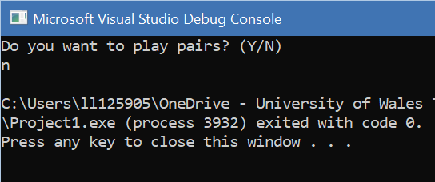
Game terminates as user has selected no (n)
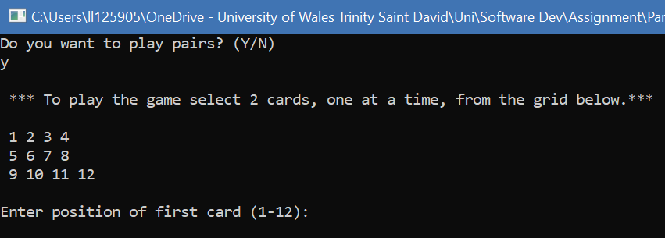
User enters game, as they have selected yes (y) input.
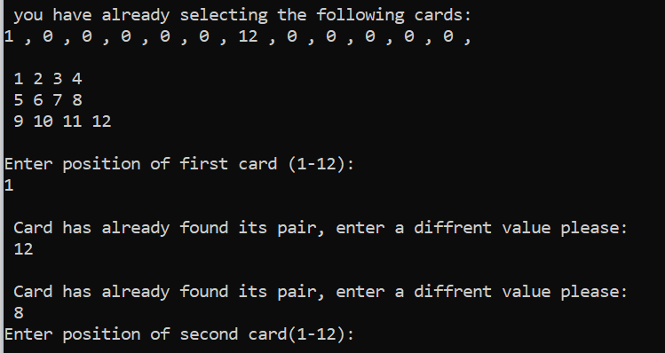
Card position 1 & 12 already selected, user is not allowed to re-enter these values.
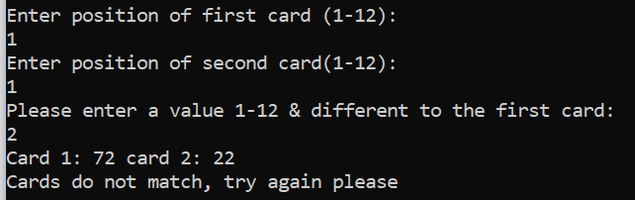
User is not allowed to enter same value for card 2 as card 1.
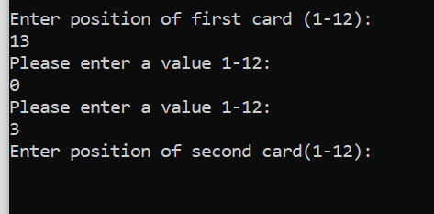
Value is user cannot enter values outside of range 1-12. User can enter a value within range however.
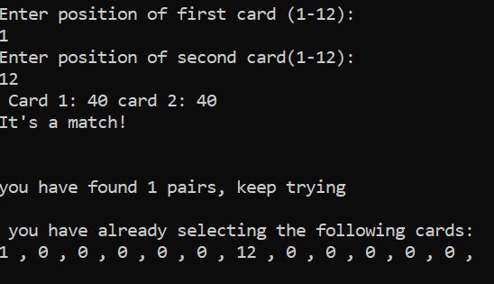
User finds card that are a pair, programme updates matches and prints on screen advising user has found a match.
Used number array is updated with the card positions so they cannot be used again.
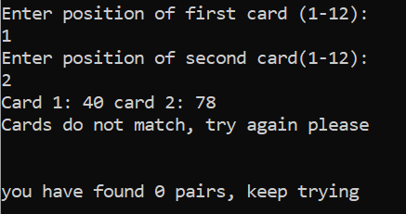
Values do not match, prints on screen advising cards do not match.
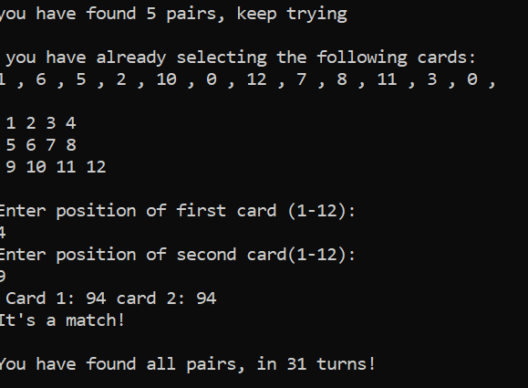
Game is completed as user has found final pair. Prints on screen in how many turns.
Also used number array printed after 5th pair is found, holds all correct values.

Analysis
Throughout the development of the pairs game, there were several problems encountered that required a solution to allow the game to function without issue. Such problems are outlined below:
  - Randomisation
To randomise the cards values, a function was implemented to generate random values to assign to the cards. One such issue that was apparent at first was when the range was between 1 and 6. When the range was so low, it meant that duplicate values were generated. This meant that there could be an odd number of pairs or that too many cards shared a value which simplified the game solution for users. To amend this, the range was changed to 1- 100.This meant that 6 different values were generated and then assigned to 2 cards.
  - Validation
Validation was another issue; it was required to confirm the user was entering in range values for card 1 and 2, also for card 2 to not be the same as card 1, and lastly cards already selected could no longer be chosen. The following loops were added;
“while ((c1 < 1) || (c1 > 12))” – prevents values that are out of range, only allowing values 1-12.
“while (((c2 < 1) || (c2 > 12)) || (c2 == c1))” - checks in range, and also that card 2 does not equal card 1.
“flag = 1;
while (flag == 1)
{flag = 0;
for (i = 0; i < 12; i++)
{
if (usednum[i] == c1) /
{flag = 1;“
The above loop, checks through the array “usednum”, which stores values for card positions already entered as matches by the user. It does so by using a flag as a reset counter. The flag is set to 1, the while loop then starts as the criteria is met flag equal to 1.
When in the while loop, the flag is set to zero. Next a counted loop is started to count through each value of the “usednum” array, if no values that match are found; the flag stays as zero and therefore does not re-enter the while loop. If a match is found, the flag is set to one again, meaning the count through the array is reset to the start point and checked again for the new value entered.
  - Other
Other problems included capturing the value of the cards. For example a switch case was used dependent on c1 & c2.
For example case 1: for Switch (c1) was:
“case 1: c1 = Cards[0][0];”
This meant c1 held the value of the top left card in the 2d array.
If to be redeveloped possibly, simplifying the code to have a 1 dimensional array with 12 values and the grid being 0-11. Then array could then be selected using code such as “cardarray[0]”. This would avoid the need to the switch to convert user input into a card position.

In Summary a more concise solution could have been implemented to achieve the same end product, and possibly using more functions too. However the array including card positions already selected work sufficiently to produce the pair’s game.

