
Skills for the Workplace
Module Assignment Submission
Student Name: | Sarah Jones
Student Number: | 1911102
Module No: | BMSK4002
Module Title: | Effective Team Working and Communication - Part 2

Statement of Confirmation of Authenticity
By the act of making this submission, the student declares that this is the work of the student named above. The work has not, in whole or in part, been knowingly presented elsewhere for assessment, or where assessment has been built on a previous assessment, this has been identified. Where materials have been used from other sources it has been properly acknowledged. If this statement is untrue, the student acknowledges that an assessment offence has been committed.
Attention is drawn to the plagiarism and unfair practice policies of both the University and of ILM.

Table of Contents
Part 2 - Communication 3
1.0 Communication Cycle 3
2.0 Assessing Own Communication Skills 6
Gap Analysis 7
PDP 7
References 9
Appendix A - Mind Tools Communication Quiz 10
Appendix B - Interpersonal Skills Self-Assessment 10
Appendix C – Communication SWOT Analysis 12

Part 2 - Communication

1.0 Communication Cycle

Communication is the sending and receiving of messages to create shared meaning. Understanding the importance of good communication is essential and having effective communication in the workplace is crucial for success. However, ineffective communication can lead to a decrease in employee engagement, conflict, fundamental errors and failure. In a study by Think Feel Know Coaching, Wood. (2010), they surveyed 4000 people and the results showed that 46% were unsure of what was being asked of them by their line manager when given certain tasks. They estimated around 40 minutes per person, per day was being wasted because of this breakdown in communication. By using these figures, we can see that a company with 1,000 employees could have around 83 employees doing nothing every day. Ineffective communication can make employees feel confused and employee morale will be affected. It can lead to a lack of trust between themselves and their manager and will stop the employee engaging with the manager which reduces productivity. These results show how important effective communication is within a business.
Effective communication should be embraced by everyone. A lot of times it isn’t bad communication that is the problem its miscommunication. A workplace example of this was when my manager asked at a team meeting for someone to complete a project for her. She did not assign the work to anyone specific, so it was not clear what the manager was expecting. The project was not completed! The manager should have communicated clearly who she wanted to complete the work. The team should have also asked her to be clearer so that they understood what was being expected of them. If this had happened at the beginning, there would be no confusion and the work would have been completed.
If we look at the Shannon-Weaver model of communication (1949) this model shows how messages are lost and distorted in the process of communication. It shows the sender is the person that creates and sends the message. The encoder is the transmitter that helps convert messages into signals. Channel is the type of medium used to send the message. Decoder is the person that receives the message and then breaks it down to understand it. The receiver is the recipient of the message. Noise is any disturbance that may lead to the receiver receiving an incorrect message. Giving feedback is the final step of the communication cycle. Just as with the senders in the initial phase of the cycle, the receivers must formulate clear feedback.

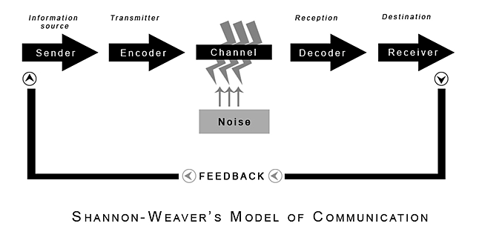

However, if we look at the model of communication by Barnlund, D. (1970) the transactional model of communication it shows both the sender and the receiver as “communicators”. The sender becomes the receiver just as fast as the receiver becomes the sender. This is because they are both sending messages simultaneously. Like the Shannon-Weaver model it factors in noise and shows how this can affect the flow of communication or how the receiver interprets the message. Certain factors may influence how the message is interpreted like body language and cultural differences.

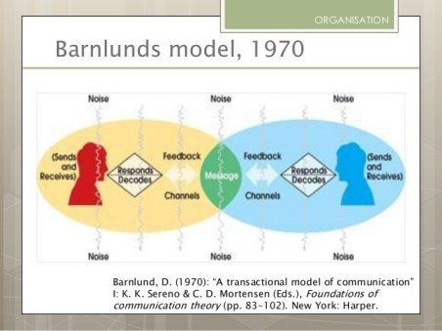

Transactional communication, Barnlund, D. (1970) Model puts everyone in control of the conversation, while linear communication, Shannon-Weaver (1949) only puts one person in control. Transactional models also show senders and receivers as communicators as they interchange roles, but linear communication have senders and receivers as different people. Role of context, environment and non-verbal communication are included in the transactional model whereas these are not included in the linear model.
We have recently been asked to work from home due to the Covid-19 pandemic. The RCN supplied us with the relevant systems and technology we needed to do this. My children have also been at home and my husband is a keyworker, so he is currently still going to work each day. I had a meeting with my manager. She was giving me relevant information from a team meeting that I was unable to attend, however, as my children were also home, I could not hear properly and could not concentrate on what was being said. This caused a breakdown in communication. I gave feedback to my manager that I could not hear her well and she agreed that she would speak to me later in the day when my husband was back from work so that I could have that conversation without the distractions. This worked well for me and my manager was very understanding of my circumstances.
We also had a situation where the business was looking to restructure all roles within the RCN. We had a meeting where the changes were explained to us, but we all felt a little blindsided by this and it made us feel that they were not being transparent with us. This was fed back to management and they took on our feedback and decided to change the process. We had smaller meetings which gave us the feeling that we were in control of the process and had more of an input into what was happening. We felt listened to. This was well received from everyone and we all pulled together. If this was not changed, I think all staff would have been unhappy with the outcome which would have resulted in frustration and a decline in productivity.

Active Listening

Active listening is very important in communication. It occurs when the listener receives, understands and processes the information before they respond. It is especially important for a leader to be an active listener as it has a major impact on their leadership, effectiveness in the workplace and the relationships they have with colleagues. Managers should not do a lot of talking but just listen carefully to what is being said as they can learn from this and build good relationships. It also helps managers to find solutions. If they are listening to formulate a response, they are thinking about themselves and not paying attention to what the speaker is saying or not saying. There are, however, obstacles that affect active listening. One examples that we could unintentionally create would be where the listener is busy trying to guess what the speaker is thinking or feeling instead of listening to what they are being told.
Managers could improve communication in the workplace by being an active listener. Employees will feel valued and appreciated. Managers should ask questions and give feedback so that employees feel that their opinions and ideas are valued. Managers should check in with employees frequently and encourage collaboration within the team. They should also have an open-door policy to ensure employees feel comfortable talking to them about anything. A client management system that is accessible to all employees so that they have access to documents and information easily also helps with communication in the workplace. Managers should try to build a sense of community and have a constant flow of communication. They should celebrate the success and achievements of each department so that they feel valued. Managers could also engage in company outings and activities so that communication and team morale is built upon. They should also try to have regular face-to-face meetings where they can discuss projects and tasks together. This helps to get everyone’s voice heard and builds good relationships.
I feel that my current manager is an active listener. She has an open-door policy and always pays attention when I’m talking with good eye contact. My manager always makes me feel that she is interested and asks relevant questions so that she fully understands. If she did not possess these skills, I would feel like she was not interested in what I was saying and that my issues or ideas were not valid. It would cause a breakdown in communication and there would be a lack of trust between us. It’s likely that it would also affect my work ethic.

Non-verbal communication

Non-verbal communication is another vital communication that managers should understand. It is the communication of emotions, attitudes, feelings and people’s thoughts through body movement, gestures and eye contact which is important when trying to understand nonverbal communication. However, all of these can also be misinterpreted. Every gesture they make is communicating something which is why a manager needs to understand and possess the ability to read this type of communication.
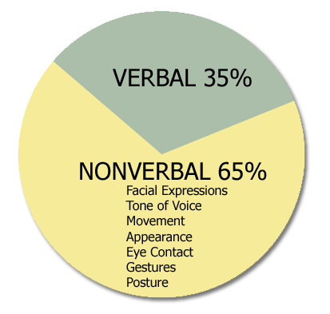

I have experienced a positive workplace example of exceptional non-verbal communication. We recently had a team meeting where the manager told us she had a piece of work for us to complete and had produced a timetable for this work. During the meeting she had noticed that three of the team members were showing signs of disapproval, non-verbally. They were shaking their heads and frowning, and their arms were folded. My manager expressed that she sensed they were not supportive of what she was delivering and asked if she could clarify anything for them. The team members responded saying that she was correct, they disagreed with her. They thought that the timetable was unachievable. My manager then asked the whole team how they felt about the timetable. As she was able to observe these non-verbal cues, she was able to open-up communication amongst the whole team and find a resolution to this problem early in the process. I think if she had ignored or was unaware of the non-verbal cues, she would have issues later down the line. The three team members may not have supported our manager which could have had serious implications to the completion of the work.

“The most important thing in communication is to hear what isn't being said.”
Drucker, P.F. (2001)

2.0 Assessing Own Communication Skills

I asked three of my team-mates at assess my communication was within the team. They gave me the following feedback; I tend to avoid large meetings and don’t contribute as much as I should. They feel that I have valid ideas and views but my confidence in expressing them in a large group hinders me. They felt that I am a good team communicator and always happy to listen and engage with them. I feel that they are correct in their feedback, I do lose confidence in large meetings and tend to avoid them if possible. My confidence holds me back and this is something that needs to be worked on so that I can be a better communicator. I feel I excel around colleagues that I know well. I am always interested in what others have to say and value their ideas.
I completed two questionnaires, Mindtools (2020) Skills your need (2020) to understand how I currently communicate (Appendix A and B). The results showed that I need to work on my listening skills by practising effective and active listening. Emotional intelligence was my highest score. I agree that this is one of my strengths. I can read emotions well and people tend to look to me for advice. I scored 61% in verbal communication. I need to work on saying the right things at the right time so that the communication process is enhanced. I scored very low in the communicating in groups section of the questionnaire. Having looked at my results it showed me that I need to work on building my confidence around other people maybe by practising communicating in social settings. If I work on my verbal communication this should also help to boost my confidence.

Gap Analysis
I have completed a gap analysis using SMART objectives, Drucker, P. (1955) Doran, G.T. (1991), the results from the completed questionnaires and feedback from colleagues. I have also completed Humphrey, (1960) S.W.O.T Analysis Table (Appendix C) to help with my Gap analysis.
Objective | Current Position | Deficiency | Action
What do I want to do? | What can I already do? | What am I lacking? | How do I fix this?
To be able to process thoughts into words more effectively during interviews and group meetings.  (Communicating in groups) | Take notes while listening so I capture the information to formulate a good response. | Confidence and belief that what I have to say is valid. | Practice talking out loud to myself every day. Record myself talking to listen to my speech more objectively so that I can learn my mistakes, weaknesses, and strengths and work on them.
Have more self-confidence to communicate in group settings. (Verbal communication) | Dress professionally so that people have a good first impression. Looking people in the eye and being interested. | Confidence and belief in myself to speak up or put myself forward for tasks without thinking I will fail. | Practise communicating in social settings to build my confidence. Work on my verbal communication. Listen to a motivational podcast or find an inspirational message online.
Develop better interpersonal skills.  (Interpersonal skills) | Competent and empathetic listener that shows interest through both verbal and non-verbal messages. | Having a positive deposition and letting people speak uninterrupted. | Remind myself that things can always change and improve. Consider some of the turning points in my life that have inspired personal growth and remember these opportunities can happen at any time. Be quiet and focus on what is being said. Really understand the message that’s being conveyed. Value what is being said.

PDP

Objectives | Tasks | Success Criteria | Time Frame | Resources
List your Goals | What do you need to do to achieve these goals? | How will you identify your success? | When do they need to be done by? | Who or what do you need to help you?
To be able to process thoughts into words more effectively during interviews and group meetings.  (Communicating in groups) | Practice talking out loud to myself every day. Record myself talking to listen to my speech more objectively so that I can learn my mistakes, weaknesses, and strengths and work on them.  Ask colleagues for feedback.  Identify areas where I could contribute more.  Actively seek other opportunities to practise skills.  Attend/contribute regularly in group settings and online lessons. | Seek feedback from others on my contribution.  Set aside time at the end of each meeting to review what went well and what could be improved next time and learn from it.  Self-evaluate at regular intervals and note improvements. | By the end of the course however, I will review after each group meeting to make sure I am on track.  (Difficult to achieve with Covid-19 now as large gatherings are not taking place) | Colleagues feedback.  Manager so that I can access other opportunities.  University online classes - Microsoft Teams.
Have more self-confidence to communicate in group settings. (Verbal communication) | Practise communicating in social settings to build my confidence. Work on my verbal communication.  Participate more to online lessons. Listen to a motivational podcast/videos or read a book. Find inspirational messages online. | Seek feedback from others on my contribution and confidence.  Set aside time at the end of each meeting to review what went well and what could be improved next time and learn from it.  Self-evaluate at regular intervals and note improvements. | By the end of the course however, I will review after each group meeting to make sure I am on track.  (Difficult to achieve with Covid-19 now as large gatherings are not taking place) | Colleagues and family feedback. Microsoft Teams and online lectures. Access to motivational podcasts, online videos and inspirational material. Access to library services.
Develop better interpersonal skills by having a positive deposition and let people speak uninterrupted.  (Interpersonal skills) | Remind myself that things can always change and improve. Consider some of the turning points in my life that have inspired personal growth and remember these opportunities can happen at any time. Be quiet and focus on what is being said. Really understand the message that’s being conveyed. Value what is being said. Access relevant communication training. | Seek feedback from others.  Set aside time at the end of each meeting to review what went well and what could be improved next time and learn from it.  Self-evaluate at regular intervals and note improvements. | Review after every meeting.  Complete training by October 2020. | Colleagues and family feedback. Access to communication training courses.

References

Al-Fedaghi, S. (2012). A conceptual foundation for the Shannon-Weaver model of communication. International Journal of Soft Computing, 7(1):12–19.
Barnlund, D. (1970) ‘A transactional model of communication’. I: K.K.Sereno & C.D. Mortensen (Eds.), Foundations of communication theory. (pp. 83-102). NewYork: Harper.
Blenkinsop, P. (2010) The Communication Cycle. [online] Available at: http://manyana-education.blogspot.com/2010/10/communication-cycle.html Accessed: 15/05/19
Doran, G. T. ‘There’s a S.M.A.R.T. way to write management’s goals and objectives. ‘Management Review’ 70.11 (Nov. 1981)
Drucker, P., (1955) ‘S.M.A.R.T Objective The practice of management’. London: Heinemann.
Drucker, P.F. (2001) The essential Drucker - The best of 60 years of Peter Drucker’s essential writings on management. New York: Harper Collins Publishers.
Humphrey, (1960) S.W.O.T Analysis [Online] available at https://www.professionalacademy.com/blogs-and-advice/marketing-theories---swot-analysis Accessed: 19/05/2020
MindTools (2020) How good are your communication skills? [online] Available at: https://www.mindtools.com/pages/article/newCS_99.htm Accessed: 15/05/20
Shannon, C. and Weaver, W. (1949) ‘The Mathematical Theory of Communication’. Urbana: University of Illinois Press.
Skills You Need (2020) Interpersonal Skills Self-Assessment. [online] Available at: https://www.skillsyouneed.com/ls/index.php/343479 Accessed: 15/05/20
Verdü, S. (2000). ‘Fifty Years of Shannon Theory. In: Verdü, S & McLaughlin, S. W. (Eds.). Information Theory: 50 Years of Discovery’. (pp. 13-34). New York: IEEE Press.
Woods, D. (2010) Poor communication between managers and employees wastes time and impacts productivity’. HR [Online]. Available at https://hrmagazine.co.uk/article-details/poor-communication-between-managers-and-employees-wastes-time-and-impacts-productivity Accessed: 19/05/2020

Appendix A - Mind Tools Communication Quiz
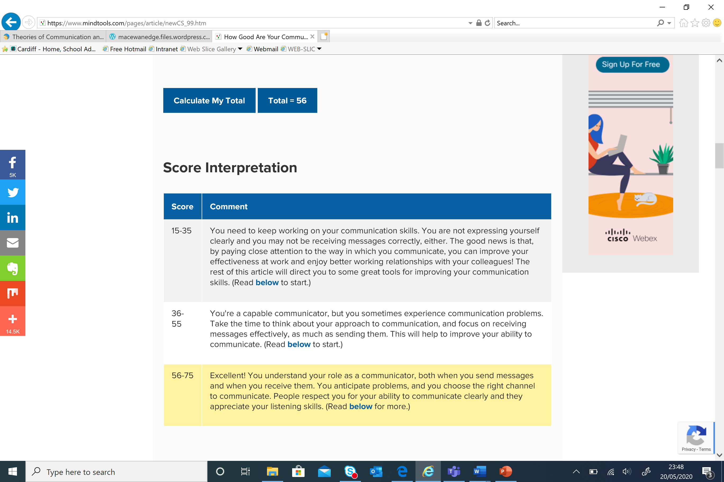

Appendix B - Interpersonal Skills Self-Assessment
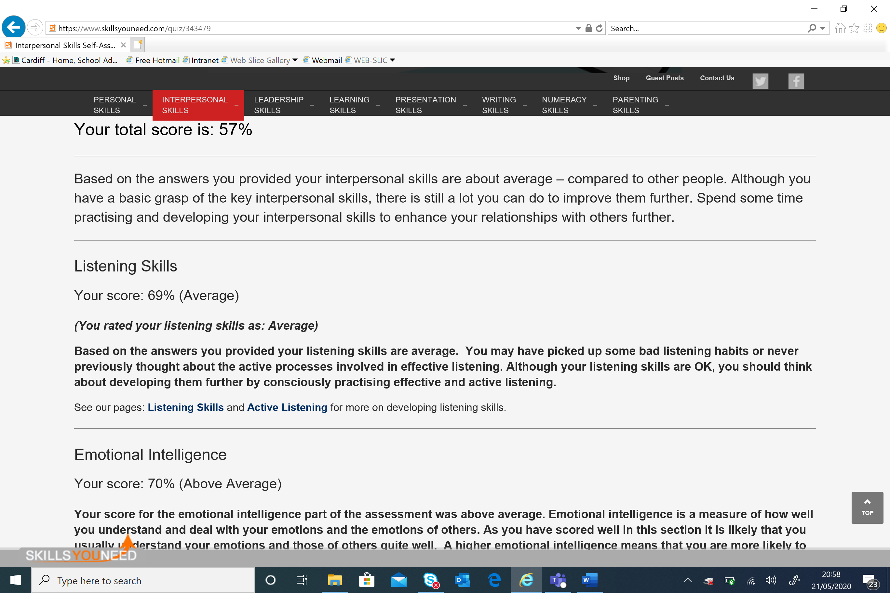
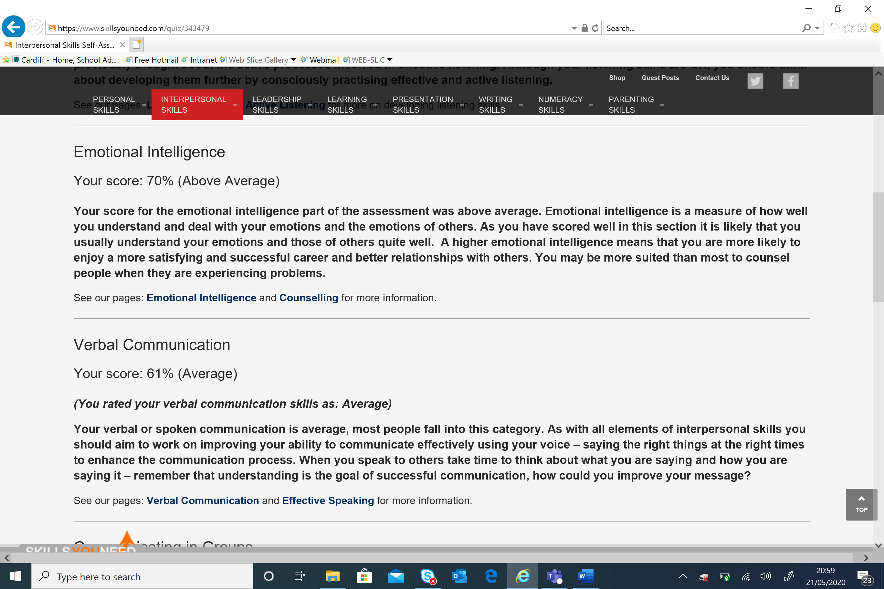
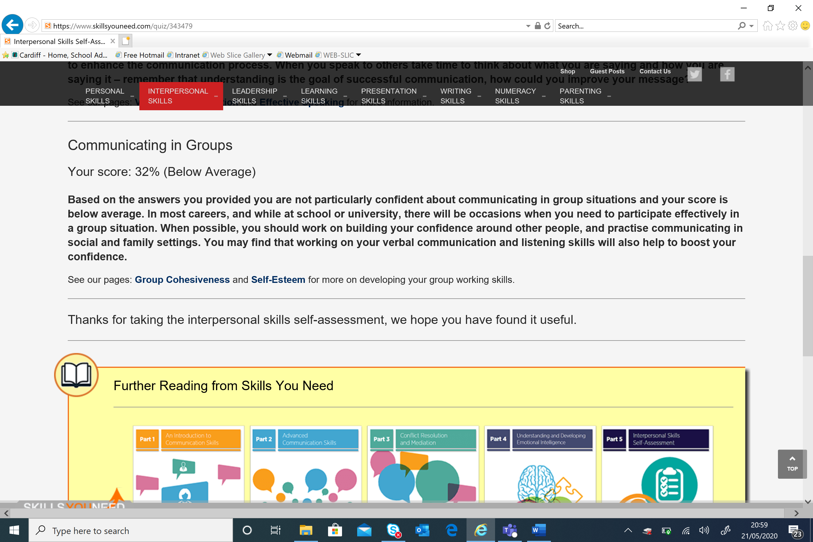

Appendix C – Communication SWOT Analysis

Strengths | Weaknesses
Communicate well within teams.  Committed to learn and develop through my university course and work.  Active listener. | Confidence around new people/groups.  Self-belief.  Negative deposition.  Interrupt to get my point across before I forget.  Can feel anxious presenting.
Opportunities | Threats
Personal growth (Presentation completed as part of my studies which has helped build confidence).  CertHe qualifications.  At work training opportunities. | Ineffective communication within teams.  Ineffective communication with a manager.  Domineering/passive team members.

