The skeleton system
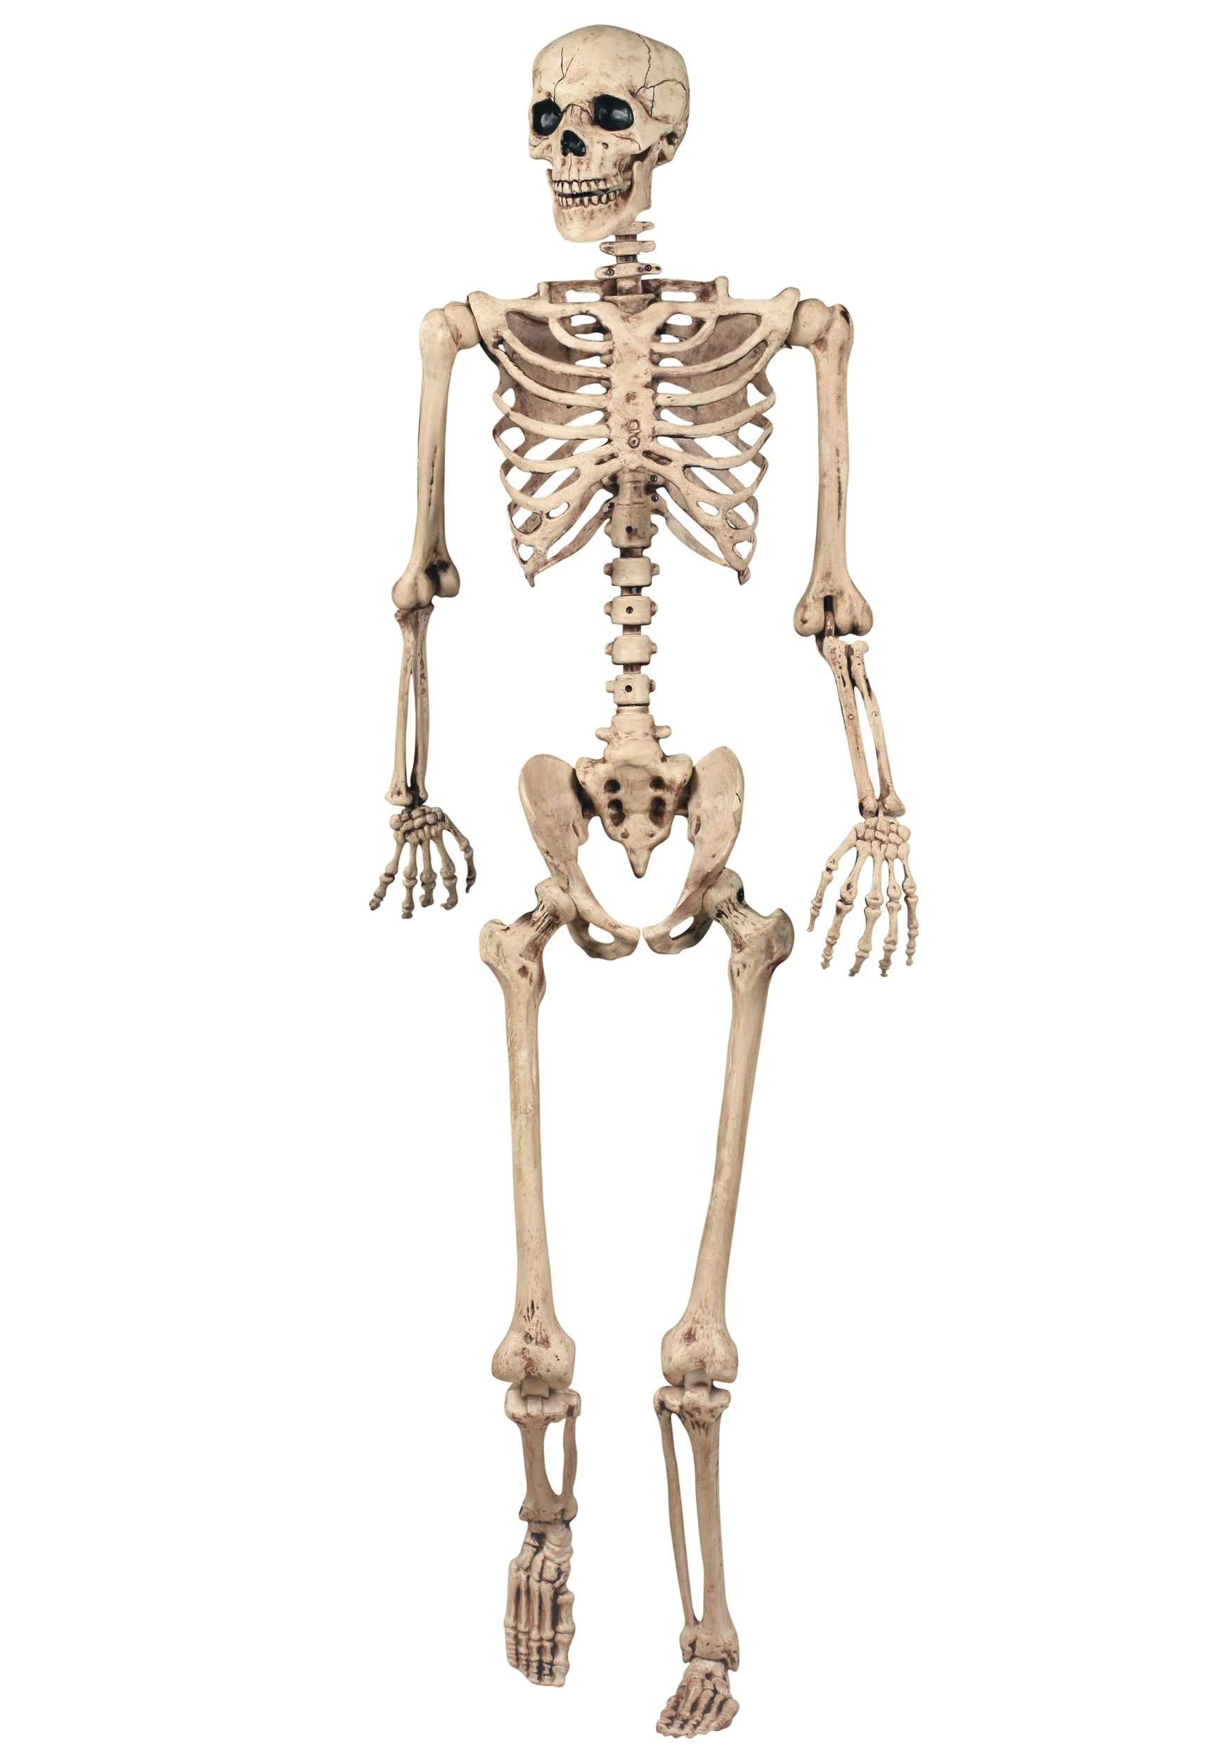

BSC health and social care (BMHP503_BIRM)
Introduction to physiology
Lecturer: Mumtaz Goolam
Student Name: Rashid khan
Student ID: 1809620
Table of contents
Title page.........................................................................................................................................1
The skeleton system poster............................................................................................................3
References.......................................................................................................................................5

The skeleton system poster
This is a labelled diagram of the interior design of a bone. Bones contain blood vessels and nerves. Bones have an outer layer of stronger and denser bones. On the inside, bones have a slightly more delicate bone known as spongy bone. In some bones there is a jelly like substance called bone marrow which regularly makes cells for the bones. fortunately, if broken they will fix themselves. 2
Our bodies have different types of bones. Together these bones design a skeleton. The skeleton protects the fragile internal organs such as the lungs and brains. It also gives shapes to our bodies and grants us movement. When we are born, our skeleton has an estimated 350 bones however when we become an adult, we have around 200 bones. The reasoning for this is because as we grow, some of our bones join. 1

The skeleton is made from the skull, ribcage, backbone and two pair of limbs. The Skull is the bony fracture which forms the head. Its purpose is to protect the sensitive brain. There are spaces in the skull so we can fit in our eyes, ears, nose, and mouth. There are 8 bones in our skulls which are the parental, frontal, occipital, temporal, ethmoid and sphenoid. These bones protect the brain. 4 The backbone is also known as the spine and has 33 small bones within it which is called vertebrae which forms the spinal column. The vertebrae column protects the spinal cord. Moving on to the ribcage, the ribcage is around the organs around the upper body.it protects the heart and lungs. The ribcage is made up of 12 pairs of bones which makes 24 individual bones. The ribcage joins on the back cords at the back. The upper 7 pairs of ribs are called true ribs and are attached to the bone towards the front. The remaining 3 pairs of ribs are called false and are attached to the lower 2 ribs in front. The lower two ribs are called floating ribs. They are called floating ribs as they are not connected to any organs at the front. They are also smaller than the other two ribs (true and false ribs). The upper limbs consist of 3 parts the forearm, arm, and hand. The arm is the bone between the shoulder and elbow. It consists of a long bone known as the Humerus. The forearm is between the elbow and the wrist, the hand consists of 3 parts the wrist, palm, and fingers. The Humerus is the longest bone in the upper limb. The lower limbs (legs) compose the bone of the thighs, legs, foot. The thigh is between the hip and knee and only has one bone known as the Femur and this is not only the strongest bone in the lower limbs but is the strongest limb in the whole body. 3

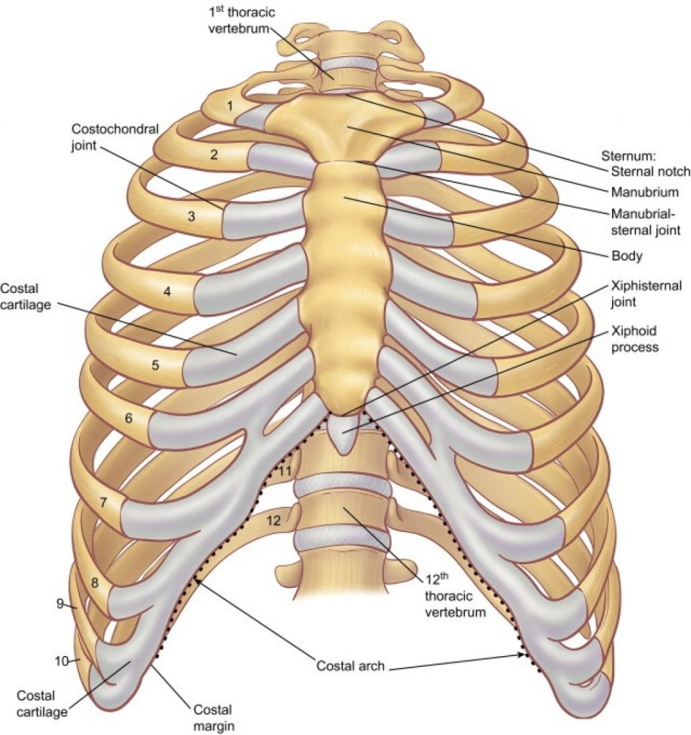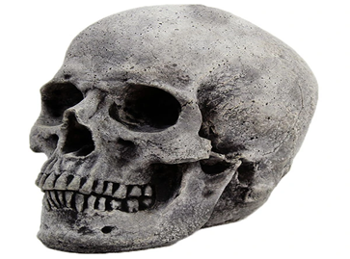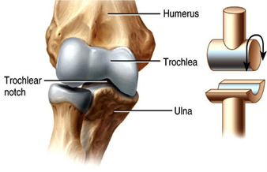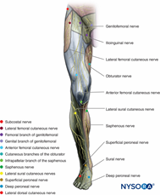

Skeletons can bend and move because of joints around the body. A stretchy tissue called ligament hold the bones together. There are different joints around the body which allow different types of movement. This does not include the joints in our skulls. They are not moveable. The lower jaw is the only joint in the skull which can move. 5
The Hinge joints (knee, fingers, toes, and elbow) are unable to move in more than two directions because the two bones connect perfectly at these parts of the body. This type of bones only moves two directions and are strong however they move easily. 6
There is a join between the skull and the first two vertebrae of the spine which is called Pivot joint. Its purpose is to move our heads upwards, sideways, and downwards. In Pivot joint a rounded surface of a bone is made into a ring. This only allows rotational movement in the skull. 7
Some of the long bones have a round ball structure at the end which fits into a socket shape part in another bone. This ball allows the bone to move in all directions and is known at the Ball or socket joint. An example of this joint is our hips and shoulders.
Wrists and ankles have joints s in them which allows the bones to slide over each other so we can move them. These are called Gliding joints. These joints allow us to bend, twist and turn our backs. If there was none of these joints in the back, then we would be like wooden puppets.
Around half the weight in the body are from muscles. Muscles allow us to move. They are made from unique tissue which can get shorter when they receive signals from the brains. Bones and muscles work together. Muscles are attached to the bones from a tissue which is very stretchy is known as tendons. When they muscle contract, they pull on the tissue (tendons) which causes bones and limbs move. There are more than 640 muscles in the body, and they work with bones. 8
Bones and muscles are very important as they are responsible for movement in the body. We should keep them in good shape and keep them healthy as it leads to a much healthier life. Food such as eggs, milks and meat help keep our bones strong. Exercising also helps the bones stay strong and developed. 9
Osteoporosis is a bone disease which causes more than 8.9 million broken bones across the world including men and women. There is osteoporosis bone break every three seconds. Osteoporosis is a serious medical condition which weakens the bones and makes them more likely to break. Many times, the condition is serious that even a simple sneeze can damage bones such as the ribcage. It is known of a silence disease because you cannot see or feel bone loss. The disease goes unnoticed until the first bone break occurs. Both men and women are a risk of this disease. Women are more likely to get this condition as results have shown women are 5 times more likely to suffer from bone break than men. The word health organisation (WHO) has considered osteoporosis as increasingly important. Many women remain untreated after an osteoporosis related fracture. It Is important to understand the risk relates to this condition to understand that anyone could be affected. Some of these effects are previous bone break as an adult, old age, low bone mineral density, parental history of hip fracture, low body weight and smoking. Vitamin D and weight exercising can help keep bones healthy however for people with osteoporosis it may not be enough to protect against a fracture. Osteoporosis and broken bones are not a normal part of ageing.

Poster References
1) Schulman J, health line, August 30th 2018, Skeletal system overview, available at https://www.healthline.com/human-body-maps/skeletal-system accessed on 4th November 2020.
2) Waugh A and Grant A (2014) Ross and Wilson, Anatomy and Physiology in health and illness. 12th EDN Churchill Livingstone, Elsevier.
3) Ballard, C., 1998. The Skeleton and Muscular System. Austin, Tex.: Raintree Steck-Vaughn.
4) Encyclopedia Britannica. 2020. Human Skeleton | Parts, Functions, Diagram, & Facts. [online] Available at: <https://www.britannica.com/science/human-skeleton> [Accessed 5 November 2020].
5) Editors, B., 2020. Skeletal System. [online] Biology Dictionary. Available at: <https://biologydictionary.net/skeletal-system/> [Accessed 5 November 2020].
6) Silverstein, A., Silverstein, V. and Silverstein, R., 1994. Skeletal System. New York: Twenty-first Century Books.
7) Riverside.k12.oh.us. 2020. [online] Available at: <https://www.riverside.k12.oh.us/Downloads/The%20Skeletal%20System2.ppt> [Accessed 5 November 2020].
8)Waugh A and Grant A (2014) Ross and Wilson, Anatomy and Physiology in health and illness. 12th EDN Churchill Livingstone, Elsevier.
9) Silverstein, A., Silverstein, V. and Silverstein, R., 1994. Skeletal System. New York: Twenty-first Century Books.
References
Ballard, C., 1998. The Skeleton and Muscular System. Austin, Tex.: Raintree Steck-Vaughn
Editors, B., 2020. Skeletal System. [online] Biology Dictionary. Available at: <https://biologydictionary.net/skeletal-system/> [Accessed 5 November 2020].
Encyclopedia Britannica. 2020. Human Skeleton | Parts, Functions, Diagram, & Facts. [online] Available at: <https://www.britannica.com/science/human-skeleton> [Accessed 5 November 2020].
Riverside.k12.oh.us. 2020. [online] Available at: <https://www.riverside.k12.oh.us/Downloads/The%20Skeletal%20System2.ppt> [Accessed 5 November 2020].
Schulman J, health line, August 30th 2018, Skeletal system overview, available at https://www.healthline.com/human-body-maps/skeletal-system accessed on 4th November 2020.
Silverstein, A., Silverstein, V. and Silverstein, R., 1994. Skeletal System. New York: Twenty-first Century Books.
References
Silverstein, A., Silverstein, V. and Silverstein, R., 1994. Skeletal System. New York: Twenty-first Century Books.
Waugh A and Grant A (2014) Ross and Wilson, Anatomy and Physiology in health and illness. 12th EDN Churchill Livingstone, Elsevier.
Waugh A and Grant A (2014) Ross and Wilson, Anatomy and Physiology in health and illness. 12th EDN Churchill Livingstone, Elsevier.

