Name of the Team: BCRD
Team Members
Student Name | Student ID
Benjamin | 2003557
charlie wilkinson | 2104032
rhys davies | 2104756
dylan jones | 2106499

Team Evaluation (Self Evaluate your Team) (1 – Worst, 5 – Best)
 | 1 | 2 |  | 3 |  | 4 |  | 5
Benjamin |  |  |  |  | x
Charlie |  |  | x
Rhys |  |  |  |  |  |  |  |  | x
Dylan |  |  |  |  | x
N/A
Rate your Teams Contribution with a scale of 1 to 5 (1 No Contribution and 5 Excellent Contribution)
Add your comments on Team Evaluation: (Justify your evaluation)
N/A:
Rhys: will contribute with the screenshots and writing
Dylan: will help with the screenshots
Charlie: will contribute to the work and help out
Benjamin: highly motivated and will get his work done

Table of Contents
Abstract 4
Introduction 4
Task 1 4
Task 2 11
Task 3: OBSERVATIONAL TASK 14
SOHO (Small Office / Home Office Network 14
Firewall 14
Strong Passwords 14
Antivirus Software 14
Education 14
Concepts to be considered 15
Hardware 15
Networking 15
Storage 15
Network Policy Draft 16
Purpose 16
Policies 16
Analysis of Security Risks 16
Monitoring of Security Operations 16
Reflection 16

Figure 1 This screenshot shows the windows computer accessing the local drive 5
Figure 2 This screenshot shows the folder being created in the local drive 5
Figure 3 This image shows the confidential file having its permissions changed 6
Figure 4 This image shows the full list of permissions and what permissions each user has for that specific file 6
Figure 5 This screenshot shows the user having their permissions changed 7
Figure 6 This screenshot shows the inside of the text document 7
Figure 7 This screenshot shows a user setting up a server in server manager 8
Figure 8 This screenshot shows the group policy management application being used to manage different policies for each user so they don’t access stuff they are not supposed to 8
Figure 9 This image proves that the main user cannot access the control panel after having their permissions revoked 9
Figure 10 This image shows the user adding a new organisational unit to the folder in the group policy managment program 9
Figure 11 This shows that the PC is the domain controller 10
Figure 12 This image shows the folder for the active directory and computer program being created 10
Figure 13 This shows the folder being moved 11
Figure 14 This image proves that the main PC cannot install programs onto the computer itself becuase there were restrictions put in place 11
Figure 15 This image shows the network cards information 12
Figure 16 This image shows the route the network traffic will take 12
Figure 17 This image shows an additional server being created 13
Figure 18 This image shows the computer management software on server 2 13
Figure 19 This image shows the internet information services manager options 14
Figure 20 This shows a successful ping has been completed 14

Abstract

Introduction

Task 1
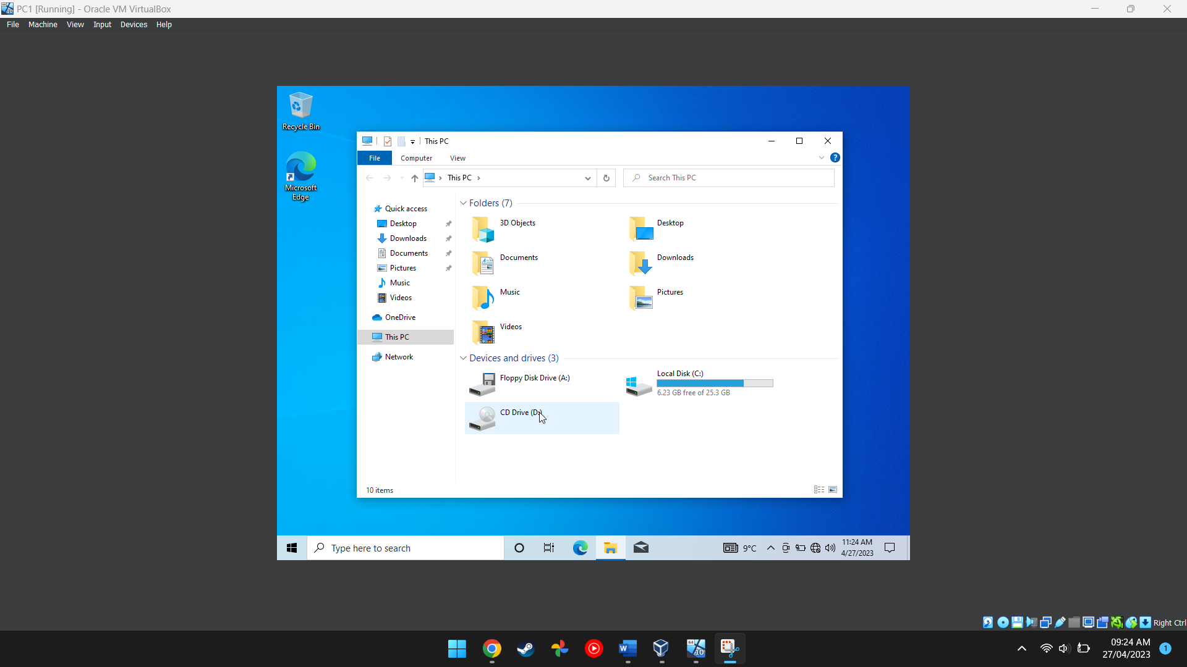
Figure 1 This screenshot shows the windows computer accessing the local drive
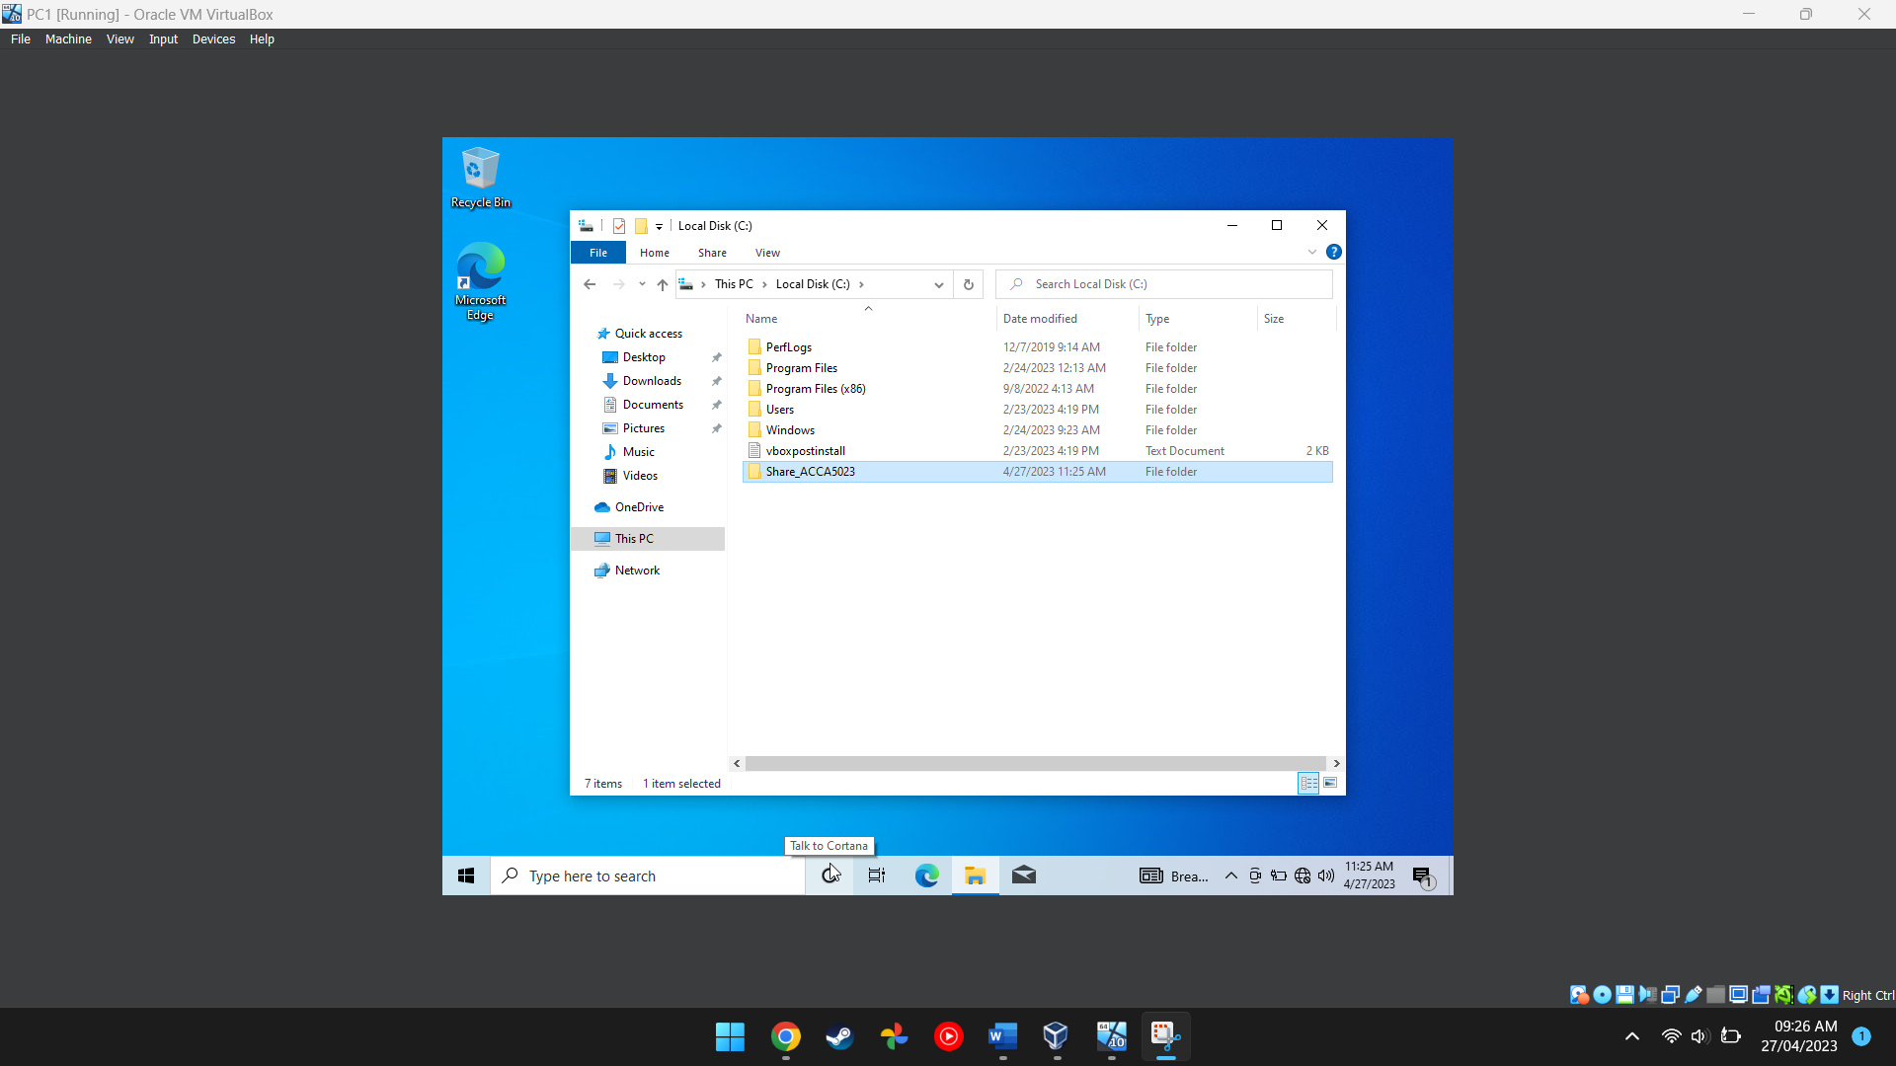
Figure 2 This screenshot shows the folder being created in the local drive
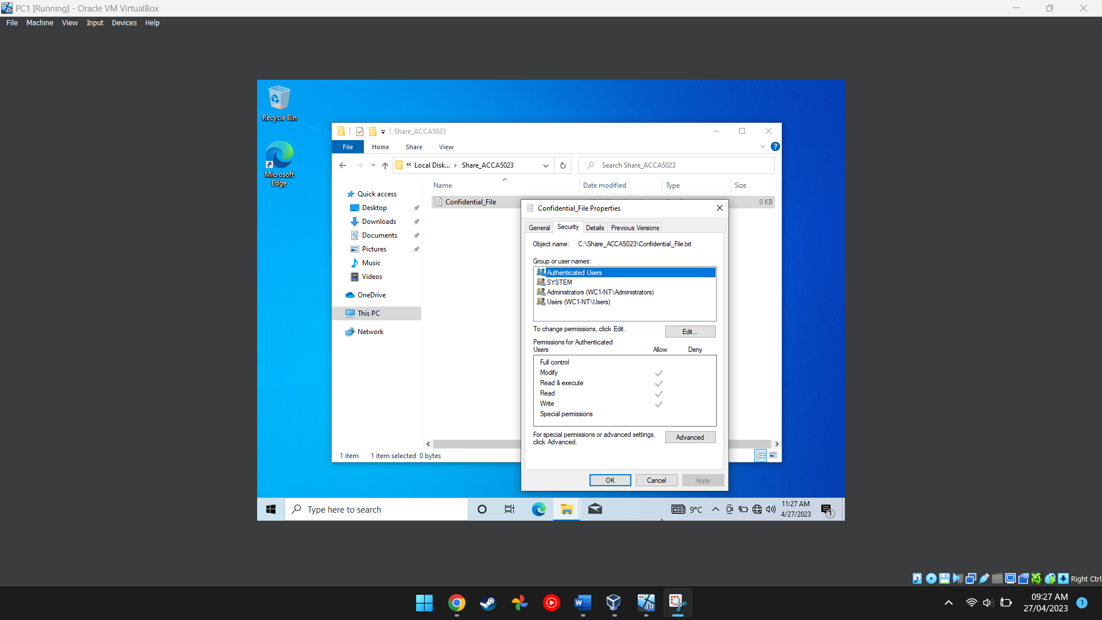
Figure 3 This image shows the confidential file having its permissions changed
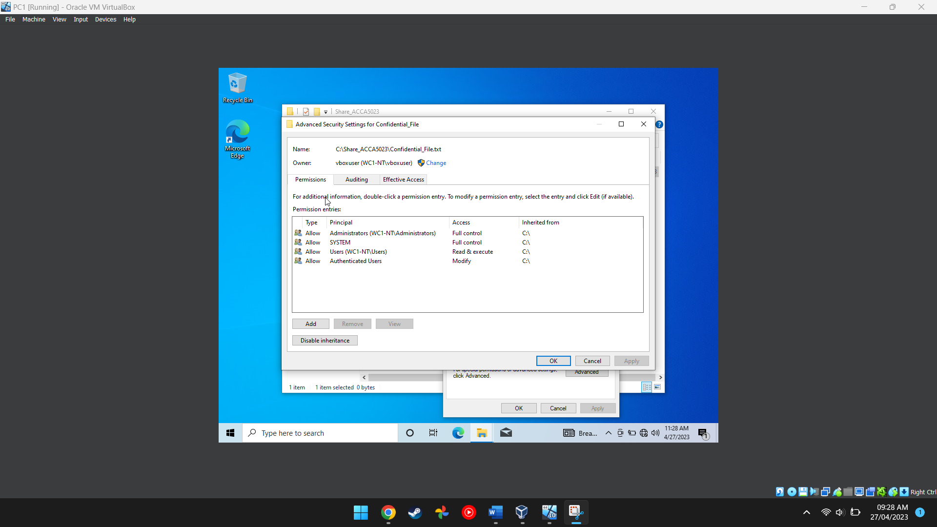
Figure 4 This image shows the full list of permissions and what permissions each user has for that specific file
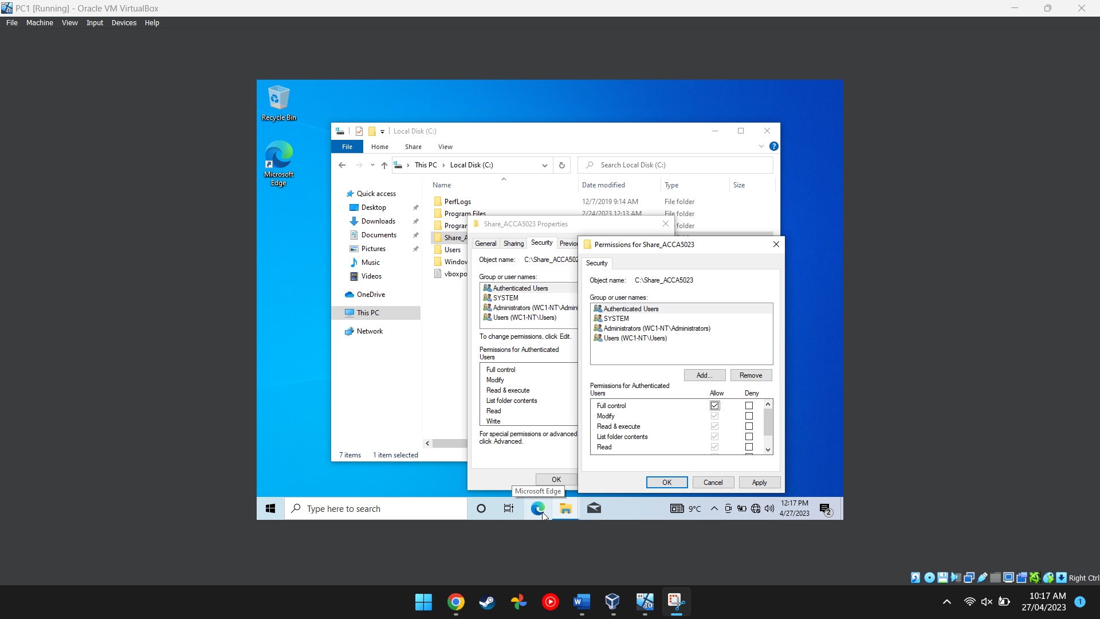
Figure 5 This screenshot shows the user having their permissions changed
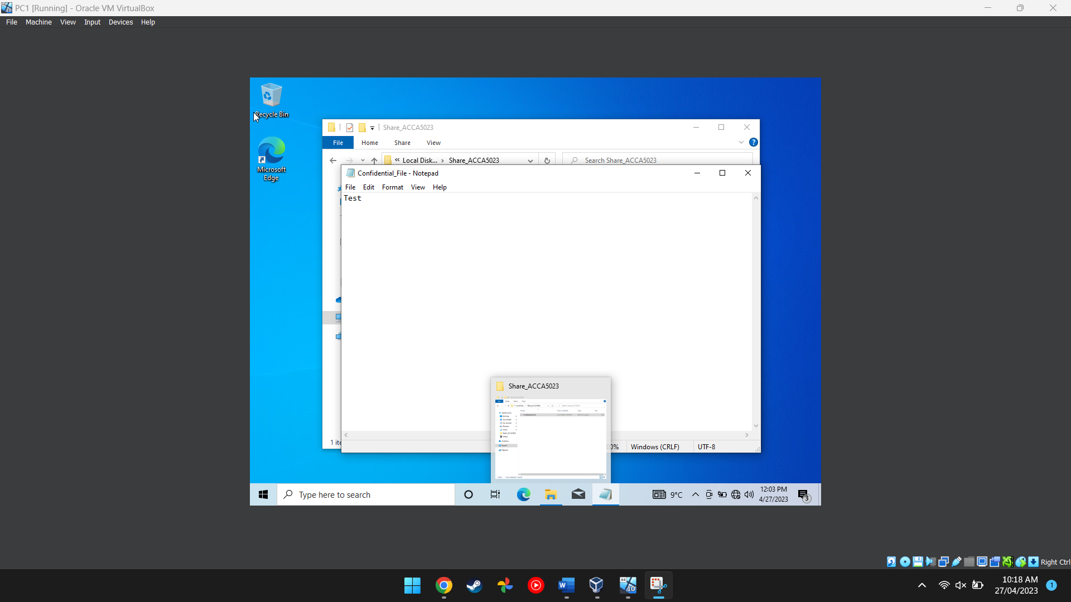
Figure 6 This screenshot shows the inside of the text document
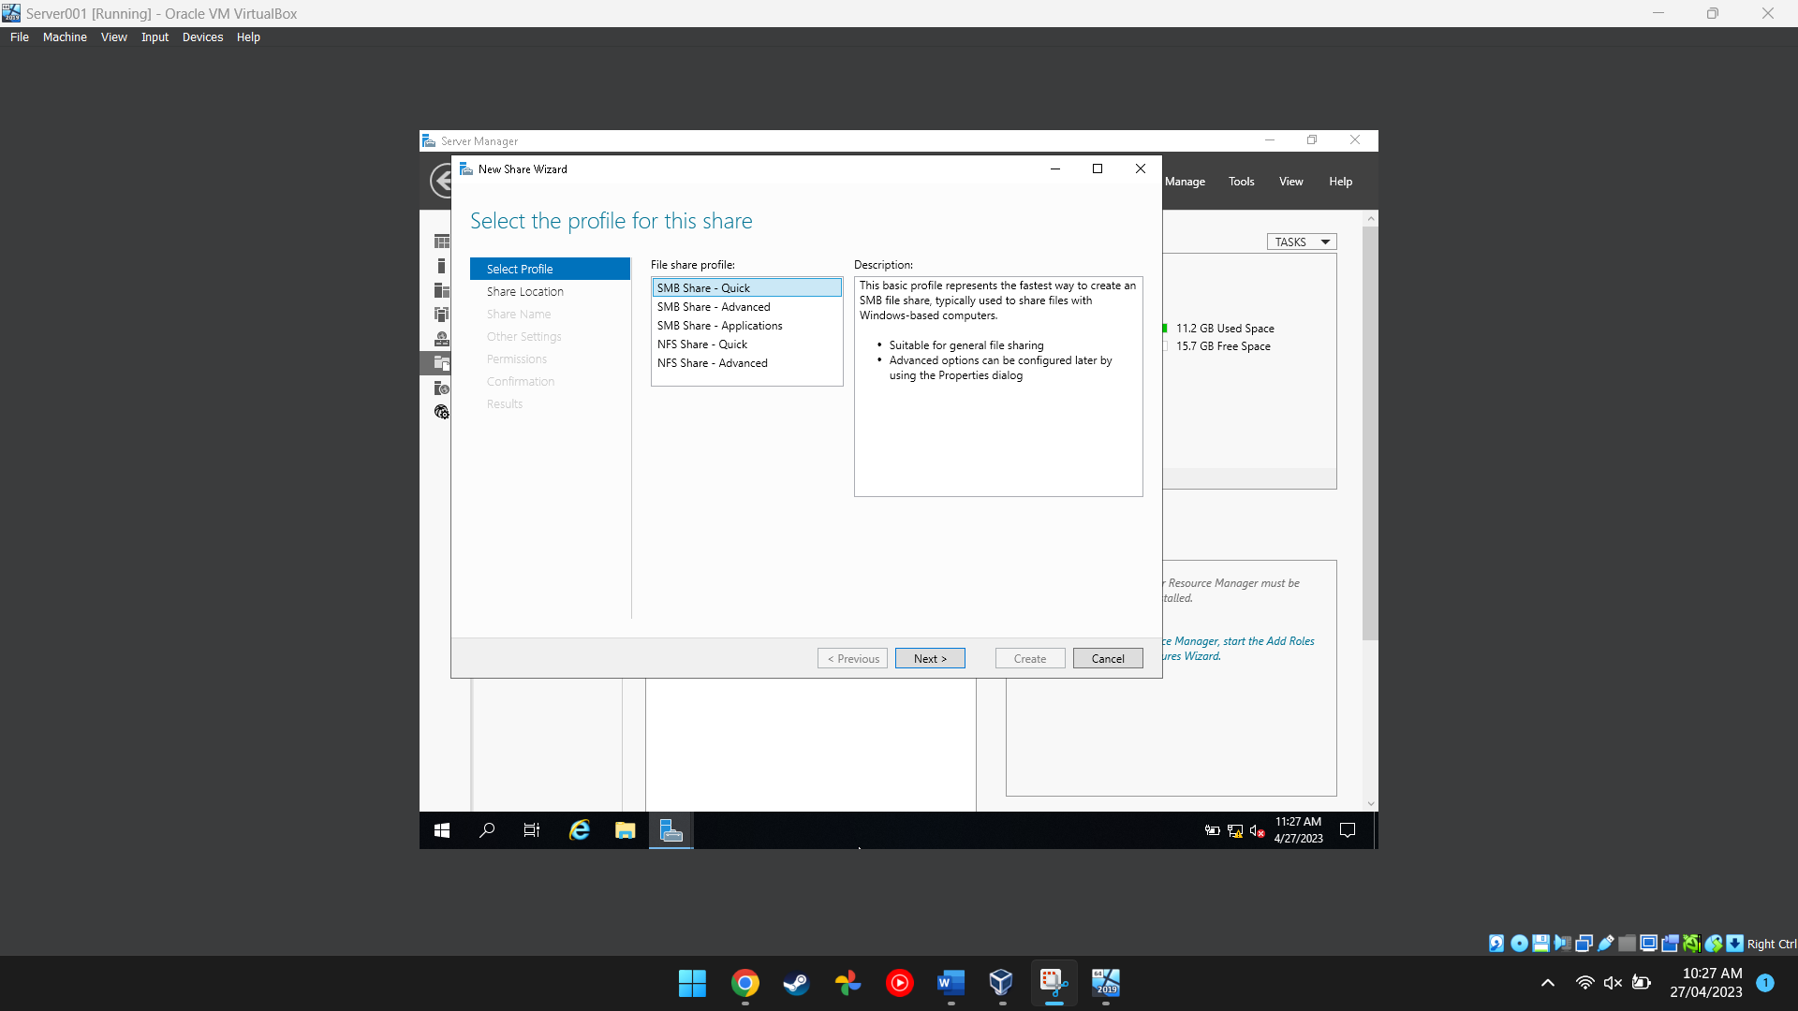
Figure 7 This screenshot shows a user setting up a server in server manager
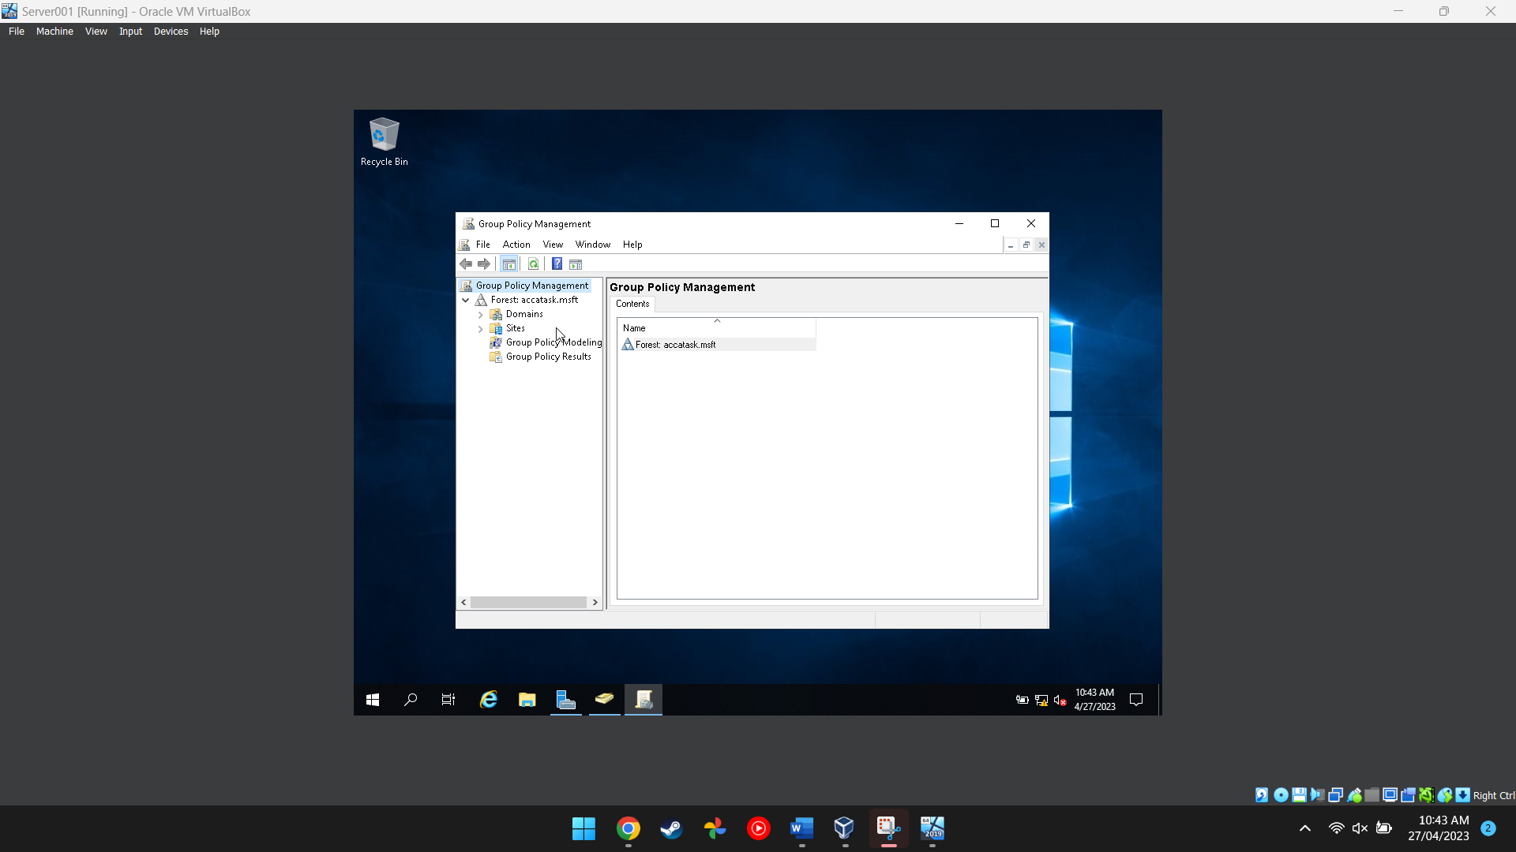
Figure 8 This screenshot shows the group policy management application being used to manage different policies for each user so they don’t access stuff they are not supposed to

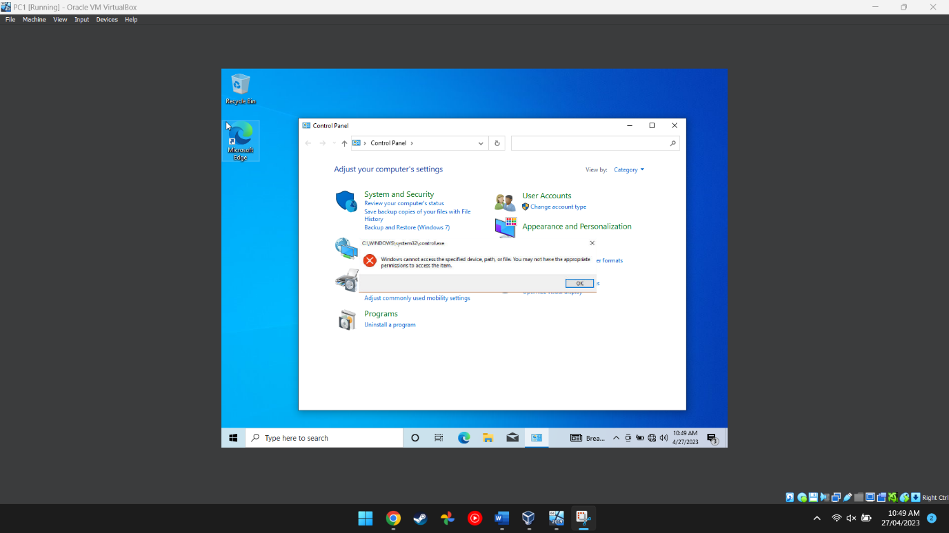
Figure 9 This image proves that the main user cannot access the control panel after having their permissions revoked

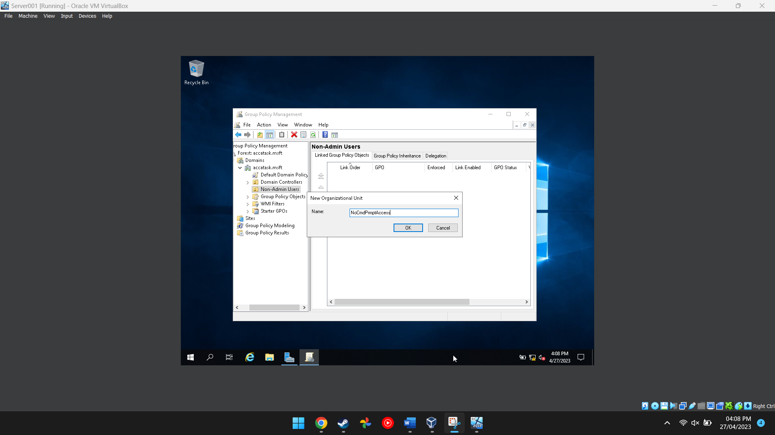
Figure 10 This image shows the user adding a new organisational unit to the folder in the group policy managment program
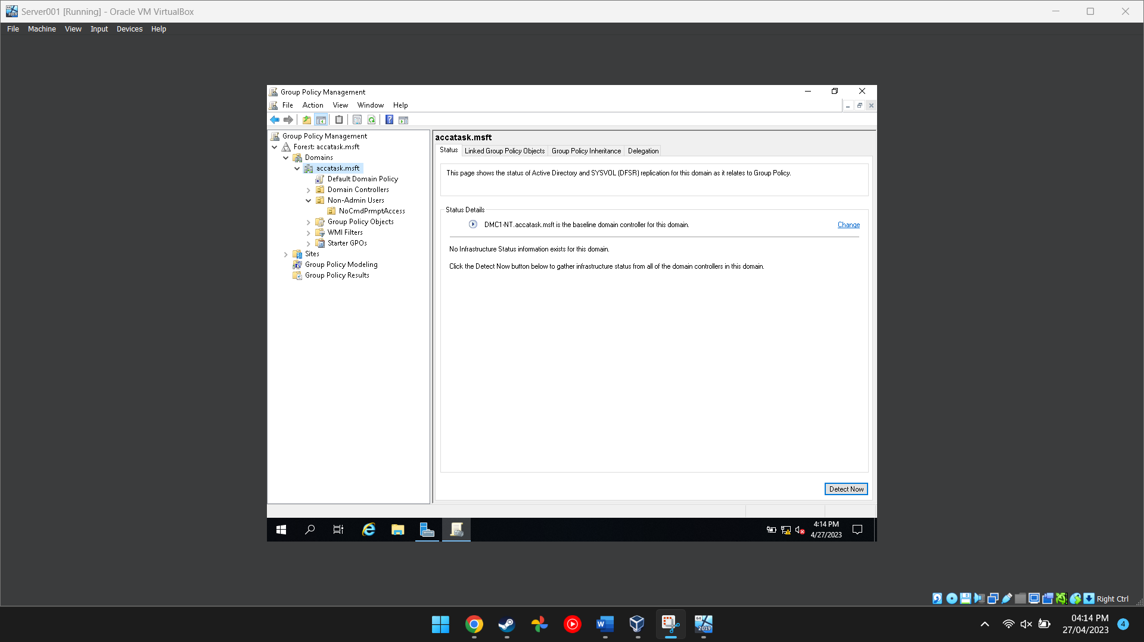
Figure 11 This shows that the PC is the domain controller

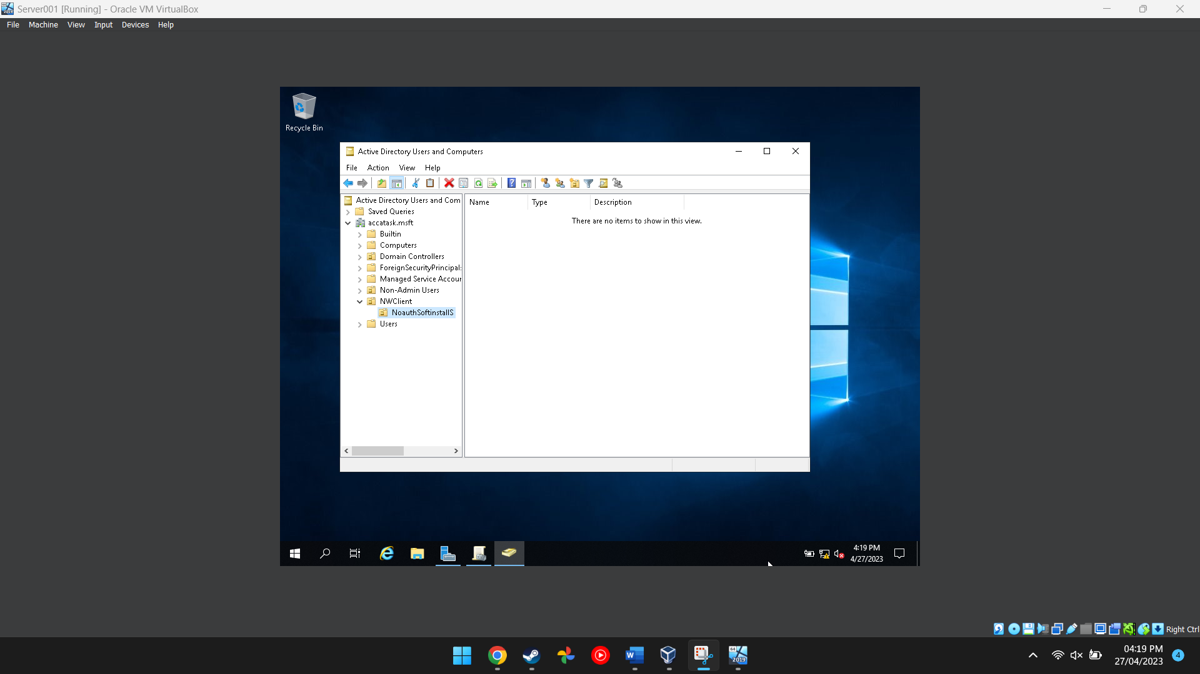
Figure 12 This image shows the folder for the active directory and computer program being created

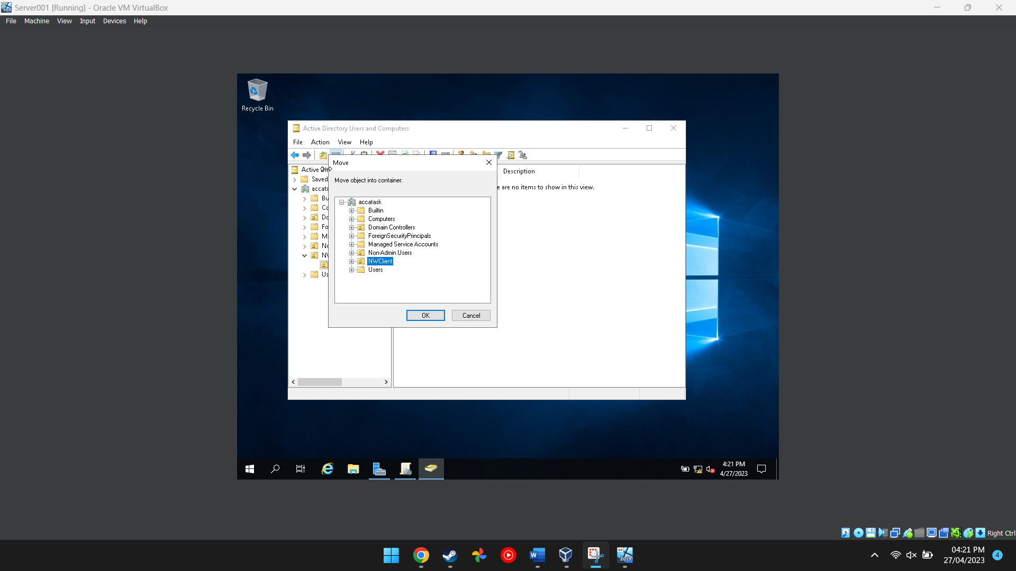
Figure 13 This shows the folder being moved

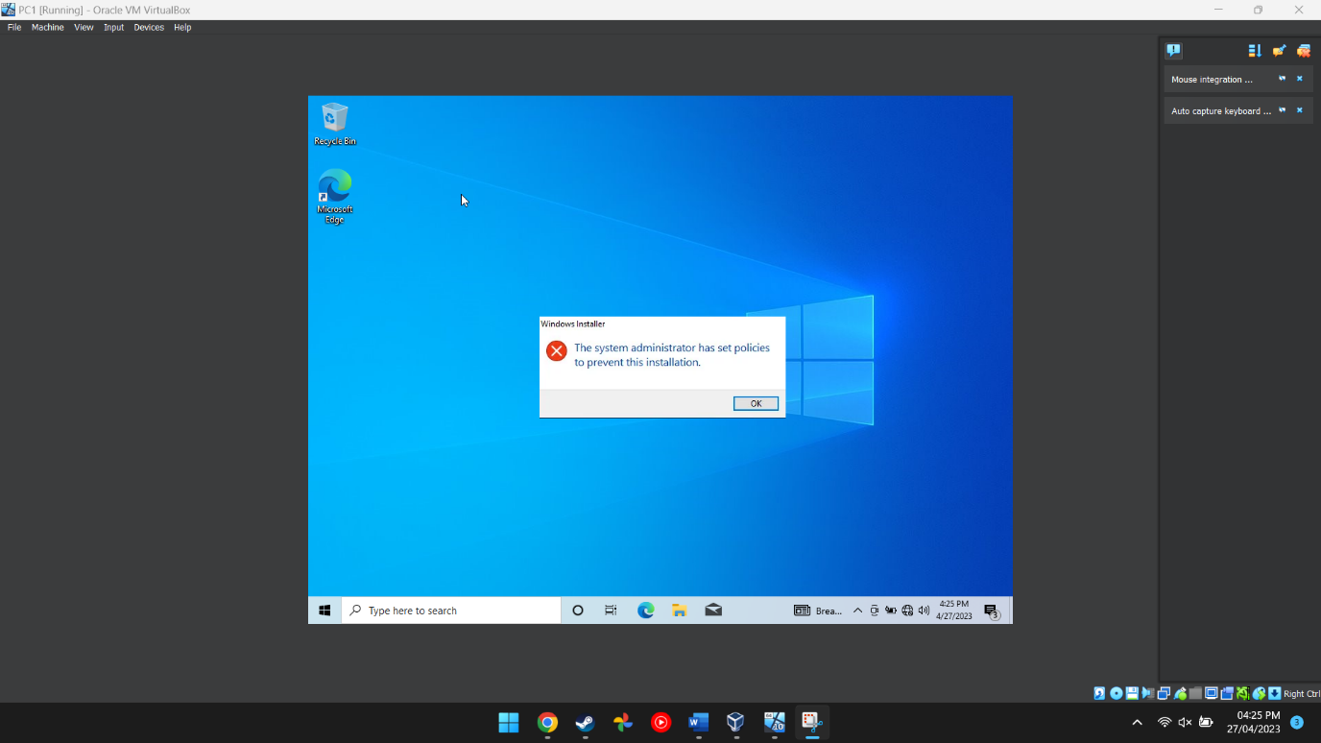
Figure 14 This image proves that the main PC cannot install programs onto the computer itself becuase there were restrictions put in place

Task 2
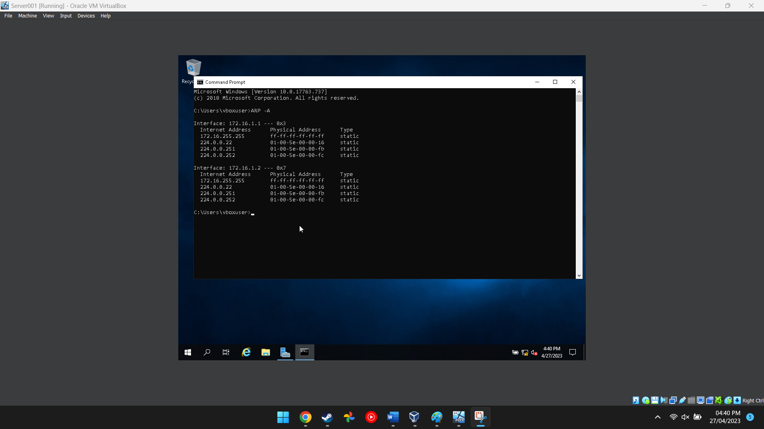
Figure 15 This image shows the network cards information
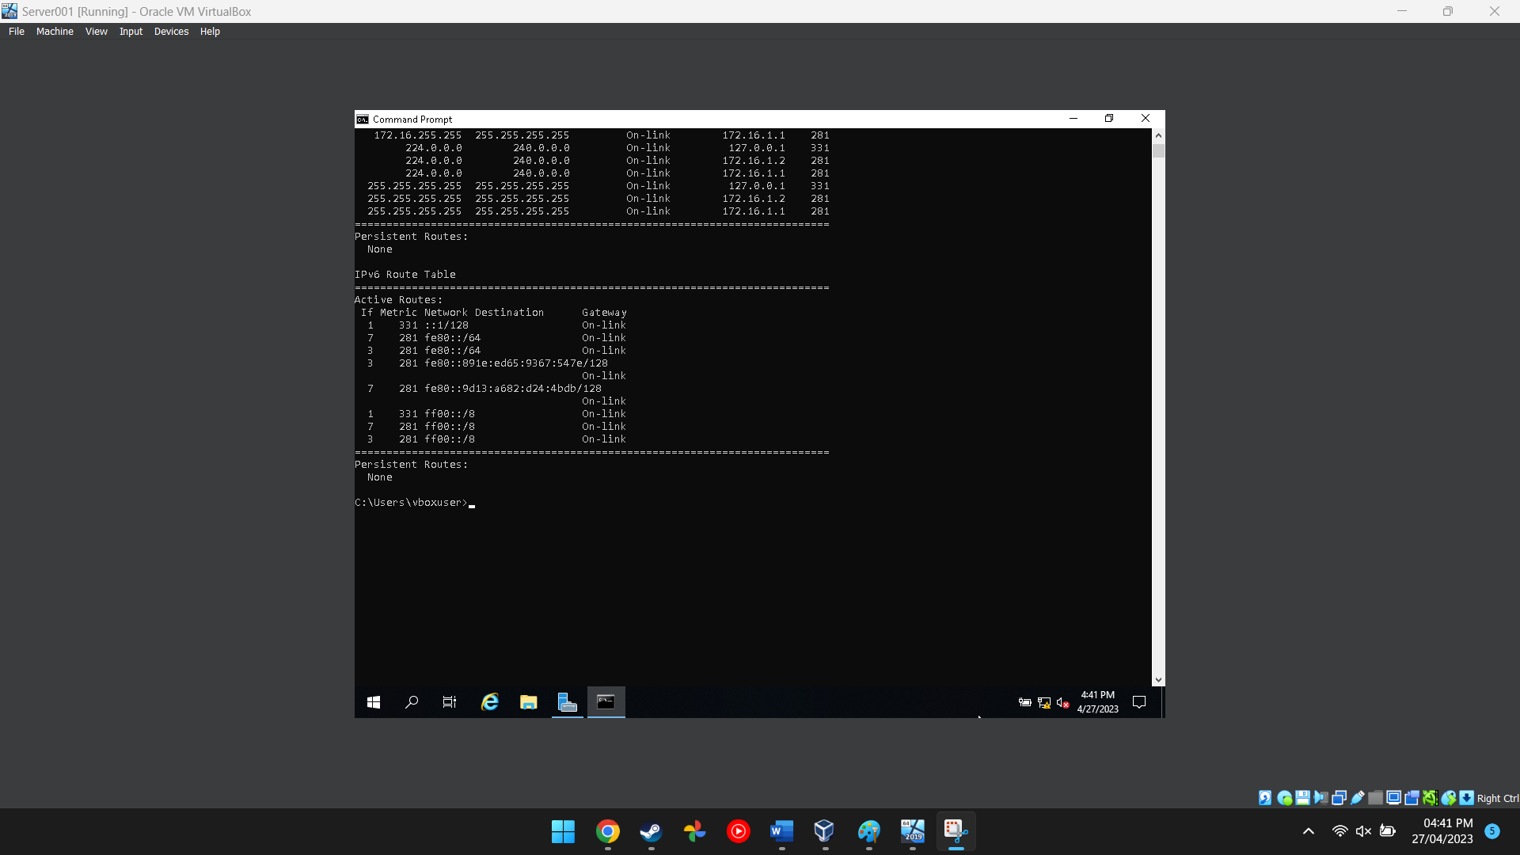
Figure 16 This image shows the route the network traffic will take
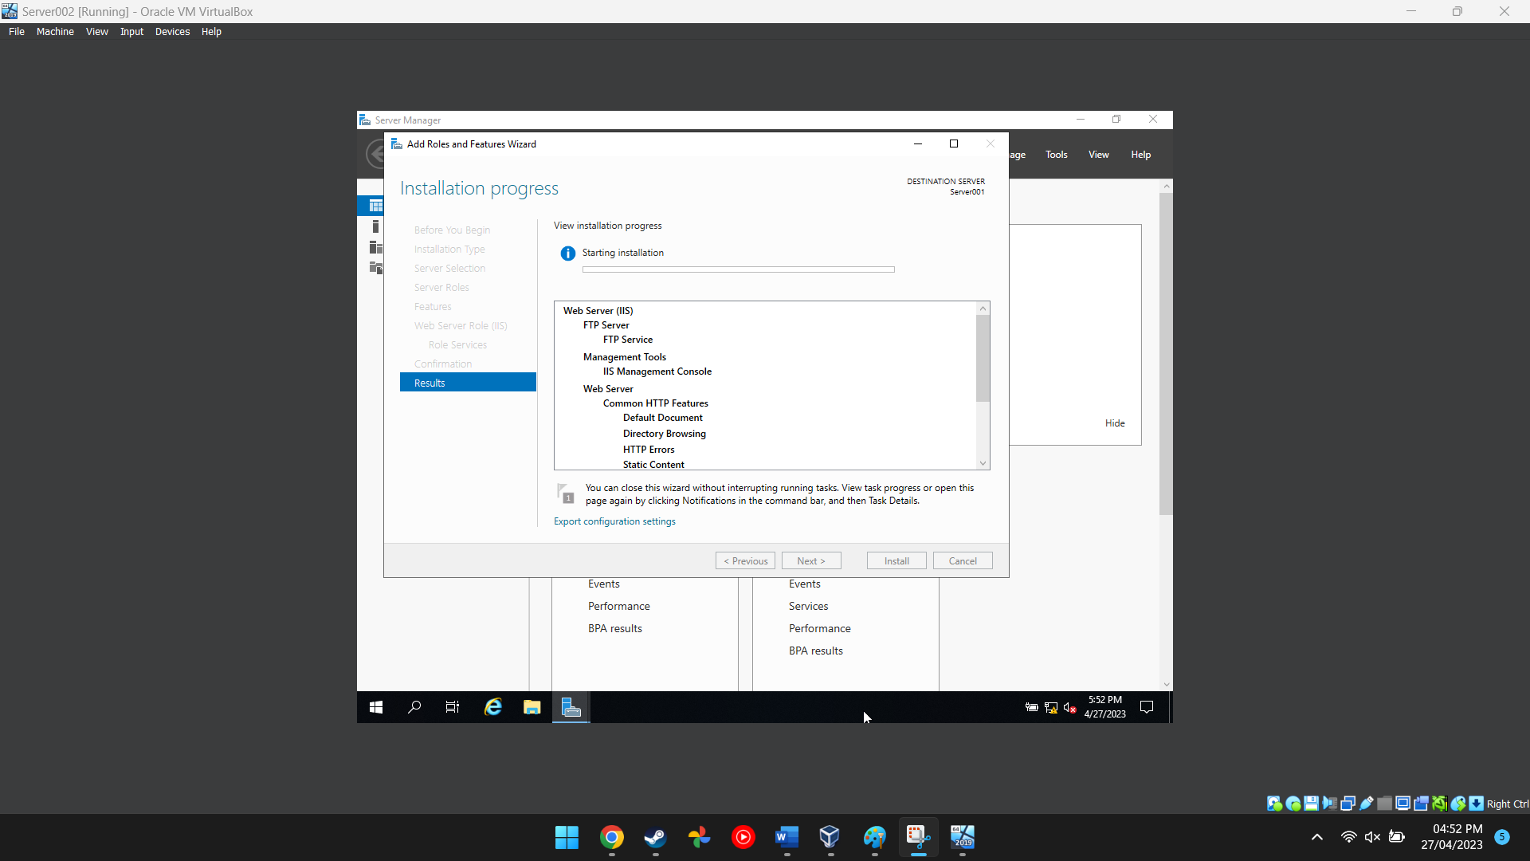
Figure 17 This image shows an additional server being created
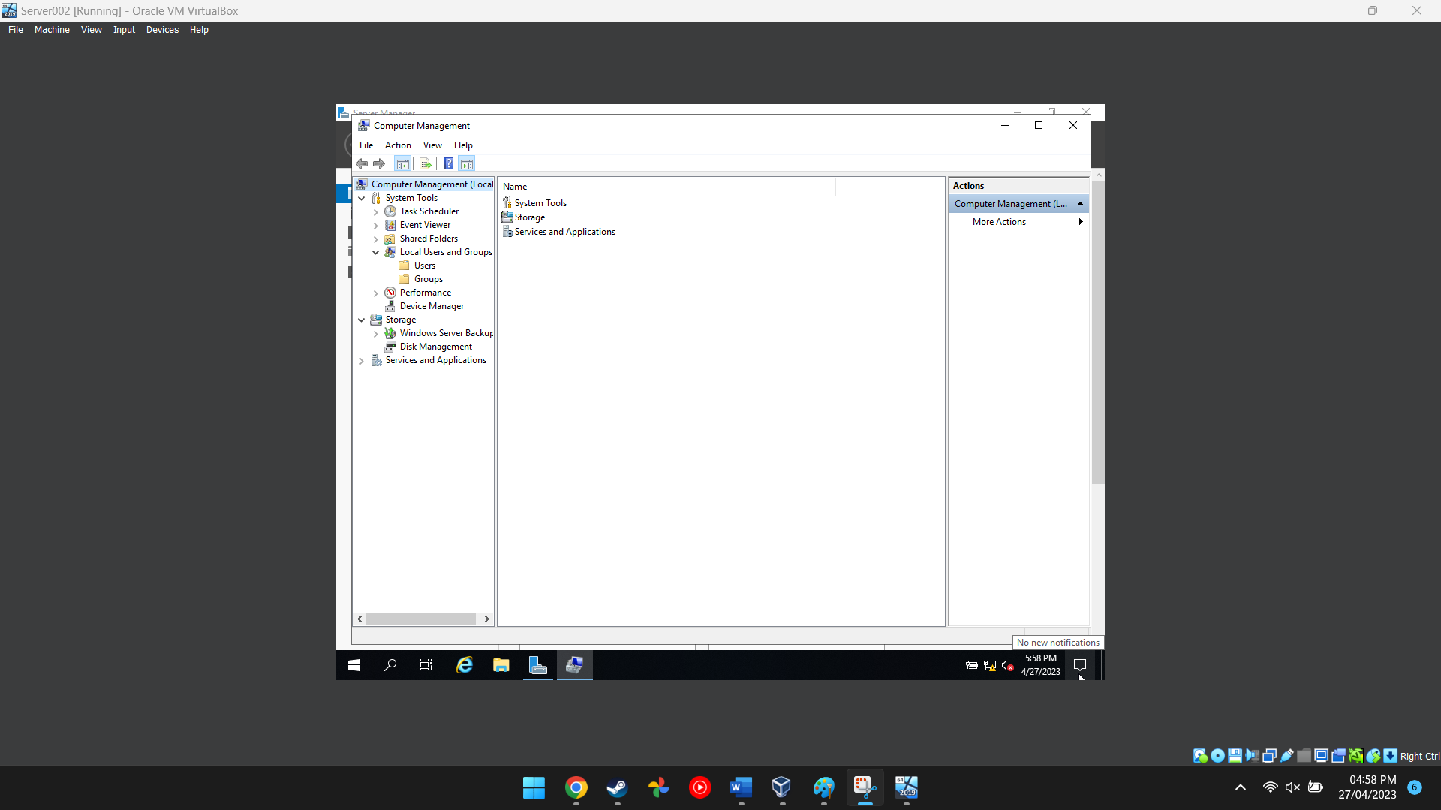
Figure 18 This image shows the computer management software on server 2
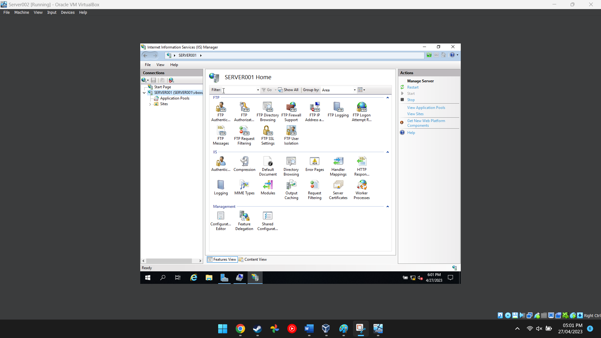
Figure 19 This image shows the internet information services manager options
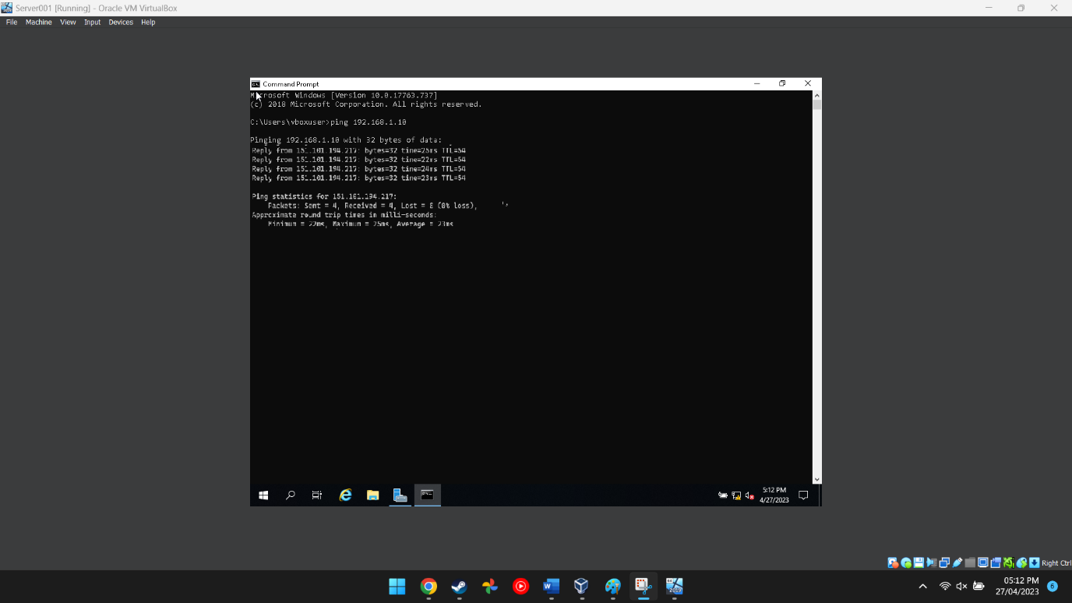
Figure 20 This shows a successful ping has been completed

Task 3: OBSERVATIONAL TASK

SOHO (Small Office / Home Office Network
- Small office and small home office work networks are very common in today's world because of the adaptation of working from home and working remotely which opens up more job opportunities [1] but it also opens up the risk of getting data stolen or spied on by hackers or other malicious attackers. There are a few ways a user can do to prevent any future attacks in the future. [1]

Firewall
A good and secure firewall is the first line of defence in a home/office network and it does a pretty good job of stopping DDOS attacks or sending malicious software over the internet to be remotely installed on a user's computer resulting in data loss or data theft. [2] A firewall can be configured to have certain security protocols to also prevent unauthorised access to the network. [2]

Strong Passwords
Many people neglect passwords and often choose a password that is simple to remember but this also makes a hacker's day easier, to prevent any unauthorised access from a weak password it's best to choose a password that is at least 12 characters long [3] and contains multiple different symbols to make it difficult for a computer to guess the password and if the password is long enough it will take years for a computer to crack a password. [3]

Antivirus Software
Antivirus software is essential for any computer due to its ability to detect and remove malicious files from a computer, antivirus software isn't always 100% accurate and may miss certain malicious files so picking the correct software is key to having a clean computer with no malware or ransomware installed. [4]

Education
The best way to not get infected is to not infect the computer itself therefore its essential to have basic cybersecurity and computer knowledge when dealing with files that cannot be guaranteed to be completely safe or malware. [5]
- A failover clustering is a technology that allows critical services to remain online and available when disaster strikes, it is several virtual machines that work together to create a high-quality backup that can be used in case of a system failure. [1] For example, if a hard drive fails the software can adapt and move all the data from that drive and separate it equally among the other healthy drives so the bad drive can be taken out to be either destroyed or repaired. [2]

Concepts to be considered
When deploying a Failover Cluster the software must have the correct resources and configurations so that it can perform both efficiently and without issues.

Hardware
The hardware that can be used in a failover cluster needs to be compatible and work efficiently with Windows Server because if it does not then the software may not run efficiently or may not run at all, which is not good for a backup system. This includes the server hardware itself like the SSDs, HDD and the networking cables and hardware which is essential for connecting devices and servers. [2]

Networking
The actual networking section in a failover cluster is extremely important for the transport of data and the ability of the cluster to do its job efficiently, therefore it is very important to have fault tolerance and redundancy in the system [2] because if the failover cluster itself was to go down it also has a backup that it can use to pick itself back up again. [1]

Storage
For large servers many different providers have mixed feelings on storage types, many prefer to use a traditional HDD which is high in capacity and lasts a long time but it often doesn't support high data transfer speeds unless the HDD is hooked up to a RAID which gets rid of this disadvantage. Other providers may prefer to use SSDs for smaller servers because of their fast data transfer speeds but they may not last several years and they are quite costly to purchase. [6]
A role that could be used within Windows Server is the “File and Storage Services” which gives an admin the ability to configure and manage storage spaces across different computers, this specific role can configure iSCSL (Internet Small Computer Systems Interface) [4]

Network Policy Draft

Purpose
The purpose of a network policy is to have a set number of rules that employees, workers and guests must follow to maintain a level of standards and security when accessing a network, if someone does not follow the rules set in place then there could be several dangers such as the network getting hacked, [2] a rogue member may hack into the network itself and stealing personal data or a member may install malware and have the entire network taken over by malicious actors. [7]

Policies
Several policies need to be put in place to create a safe and secure environment for everyone on the enterprise network.
- Access Control – Limiting or restricting access to individuals is essential for every network out there, giving the janitor the permissions of a senior cyber security analyst can result in stolen or corrupted data, the individual may not pose a threat but what he does with his device is a mystery and he may accidentally infect himself with a trojan. [8]
- Remote Access – Remotely accessing a computer or a server is a huge risk by itself so it's very important that before an employee uses a remote access software they will need to enable a VPN service that will hide their internet traffic and make the connection secure from any attackers. [8]
- Smartphones – phones are the biggest target for any cybercriminal so securing and protecting mobile phones is very important to keep the network safe, smartphones should disable Bluetooth when connected to the network because Bluetooth has been proven to not contain encryption and can be easily hacked by any decent hacker. [8]

Analysis of Security Risks
All networks will be attacked at some point and some may even get hacked themselves so if this does happen having a backup plan in place will make the process of recovery less tedious and time-consuming, the cyber security team will need to act upon the incident response plan to quickly gain back access to a hacked network and restore it to what it once was. The team will check out for any possible damage that may have been caused (physical or digital) and fix them to the best of their ability. [2]

Monitoring of Security Operations
To prevent any attacks or to detect attacks as they happen it is recommended to have network traffic tools that monitor all the connected computers on the network so that when an incident does happen they can look back at the traffic over a week and detect unusual patterns and then it can be narrowed down if the attack happened on the inside. [6]

Reflection
When going through this document I learned the step that needs to be taken to set up a secure and controlled networking environment with Windows Server and software that was installed on the virtual machines. Task 3 discussed points about different technologies to secure a home network, the failover cluster section described the concepts needed to upkeep and maintain a failover cluster and finally create a network policy that employees and guests must follow accordingly.

References

[1] | B. T. L. a. W. Zhou, Declarative networking, 1537 Fourth Street, San Rafael: Morgan & Claypoo, 2012.
[2] | H. J. M. D. M. a. A. G. M. E. Whitman, Guide to network security, International ed. Australia: Course Technology Cengage Learning, 2013.
[3] | M. P. Eve, Password, London, England: Bloomsbury Academic, 2020.
[4] | J. R. Johnston, Technological turf wars a case study of the computer antivirus industry, Philadelphia: Temple University Press, 2009.
[5] | E. d. Corte, Computer-based learning environments and problem solving, Berlin: Springer-Verlag published in cooperation with NATO Scientific Affairs Division, 1992.
[6] | J. L. H. a. D. A. Patterson, Computer architecture : a quantitative approach, Amsterdam: Morgan Kaufmann, 2012.
[7] | C. T. Marsden, Network neutrality : from policy to law to regulation, Manchester, England: Manchester University Press, 2017.
[8] | K. Odagiri, Strategic policy-based network management in contemporary organizations, Hershey, PA: CyberTech Publishing, 2017.

